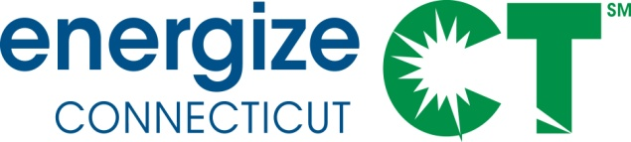

EEB Evaluation Committee Monthly Meeting

Monday March 7, 2016 – 10:00-11:30am

Department of Energy and Environmental Protection – Public Utilities Regulatory Authority, Commissioner's Conference Room, OCC, 10 Franklin Sq., New Britain, CT

Meeting Materials in Box folder: https://app.box.com/s/exhaksag8ufkjxzpfjb3e7kdjh3v9qps

NOTE: MEETING TO BE FOLLOWED BY 3 RESIDENTIAL PRESENTATIONS: R32, R33, R154 (11:45-1:45)
Call-In Number: 712/432-1680 Code 624802#
WEBINAR ACCESS: www.join.me/SkumatzEconomics

DRAFT AGENDA

- Public Comment

- Discussion of Notes from previous meeting provided, interim calls, and e-votes. (not Approval of Minutes). Lisa provides notes with votes for information purposes only. 5 min

- Non-Project Updates and Issues: 25 min
  - Review Thursday report and highlights;
    - Schedule of reports to review & upcoming reports – Note also meeting following this one including 3 residential presentations.
    - Review of interim votes and meetings – 2 interim calls / meetings; 4 interim e-votes, approving SERA invoice (Dec & Jan), C1630, C1639, and 2/26 memo on evaluation projects / budget, “fundamental” designation, and administrator budget.
  - Invoices from SERA – Discussion / votes (Total for February); for vote or e-vote; Dec and Jan invoices approved by e-vote.
  - Legislative report – preparing draft for early / mid-March
  - Other items – reminder of upcoming NEEP & other workshops (some info circulated)
  - Select dates – Need doodle poll – conducted SERA team presentation on impact evaluation training for committee. Other proposed upcoming SERA Team workshops for committee on Sampling & Surveys, and NEIs. Dates doodle poll.
  - Remaining Technical meetings/ presentations to be scheduled: R4Plus. Other.

- Discussion of Projects / Status (and data) – see Gantt & Project summaries 35 min
  - Walk-though of Projects / Monthly Status Report – focus on “changes” and status of new projects (including NEEP); update on results of call / meeting on “new” steps for projects
    - Scott’s Projects – focus on Gantt
    - Lori’s Projects – focus on next projects/ memo
    - Lisa’s Projects – focus on Gantt

- New Residential and Commercial Contracts Progress / Update 20 min

- Evaluation Plan Status / Memos 10 min

- Other items –

*** Supporting Materials in Box folder and attached, including:
- Updated Gantt Chart & Project Status Summary  - E-votes / call notes  - Invoices | - 2/26 memo  - Latest Thursday report  - Memo from Lewis on Com’l projects

