Connecticut HES Air Sealing, Duct Sealing, and Insulation Practices Report (R151)
DRAFT
December 23, 2015
SUBMITTED TO:
Connecticut EEB
SUBMITTED BY:
NMR Group, Inc.
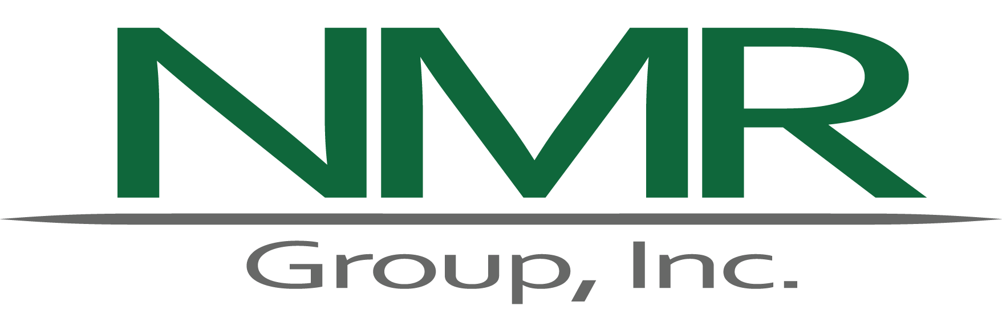

Table of Contents
Executive Summary I
Findings I
Program Focus and Goals II
Opportunities II
Participation Patterns IV
Vendor Practices IV
Quality Assurance and Quality Control V
Drivers, Motivations, Obstacles, and Barriers V
Recommendations VI
Considerations VII
Section 1 Introduction 1
1.1 Program Background 1
1.3 Study Objectives 3
1.4 Methodology 3
1.5 Report Outline 5
Section 2 Program Focus 7
2.1 Program Design and Implementation 7
2.2 Program Goals and Objectives 8
2.3 Detailed Findings Related to Program Focus 9
Section 3 Opportunities 13
3.1 Healthy and Safety Issues 14
3.2 Core Services Remaining Opportunities (Low-Hanging Fruit) 15
3.2.1 Air Sealing 16
3.2.2 Duct Sealing 17
3.3 Insulation 18
3.4 Detailed Findings Related to Opportunities 20
Section 4 Participation Patterns 29
4.1 Services Provided 29
4.2 Air Sealing 30
4.3 Duct Sealing 30
4.4 Insulation 31
4.6 Detailed Findings Related to Participation Patterns 32
Section 5 Vendor Practices 33
5.1 Overview of HES audit process 33
5.2 Vendor Practices – Vendor Business Approaches 34
5.2.1 Savings per Home 34
5.3 Vendor Practices – Work Quality and Completeness 35
5.3.1 Air Sealing 35
5.3.2 Duct Sealing 36
5.3.3 Insulation 37
5.4 Vendor Practices – Recommendations for Add-On Measures 40
5.5 Vendor Practices – Customer Perceptions 40
5.6 Detailed Findings Related to Vendor Practices 41
Section 6 Quality Assurance and Control 51
Section 7 Drivers, Motivations, Obstacles and Barriers 57
Appendix A Detailed Methodology A1
A.1 Description of Evaluation Elements A1
A.1.1 Program data tracking review A1
A.1.2 In-depth interviews with program staff A1
A.1.3 In-depth interviews with participating vendors A2
A.1.4 On-site quality inspections A2
A.1.5 On-site in-depth interviews with program participants A3
A.1.6 On-site in-depth interviews with participating vendors A3
A.1.7 In-depth interviews with program administrators for other leading programs A3
A.1.8 In-depth interview with program QA/QC vendor A3
A.2 Description of On-Site Inspection Protocols A3
A.2.1 Basement Air Sealing A3
A.2.2 Attic Air Sealing A4
A.2.3 Interior Air Sealing: Weather-Stripping Doors and Caulking A4
A.2.4 Insulation A4
Appendix B Potential QA/QC Protocol Opportunities B1
B.1 HES Quality Assurance Plan Criteria B1
Category A: General HES Safety, Site Arrival, and Visual Inspection B1
Category B: Safety Testing & Environmental Assessment B1
Category C: Blower Door / Flow Test / Duct Blaster B2
Category D: Other Measures B2
Category E: “Kitchen Table” Sales and Closing B2
Category F: Customer Service B2
B.2 Blower Door Operation: Assessing Basement Conditioning B2
B.3 Air Sealing Practices B4
B.3.1 HES Implementation Manual Guidelines for Air Sealing B4
B.3.2 HES Quality Assurance Plan Guidelines for Air Sealing B4
B.4 Duct Sealing Practices B5
B.4.1 HES Quality Assurance Plan Guidelines for Air Sealing B5
Appendix C Air Sealing, Duct Sealing, and Insulation Practices – Examples from Site Visits C1
C.1 Air Sealing Practices C1
C.2 Duct Sealing Practices C4
C.3 Insulation Practices C8
Appendix D Detailed Analysis of Program Tracking Data D1
D.1 Air-Sealing, Duct-Sealing, & Insulation Services Provided in 2014 D1
D.2 Services Provided by Utility D2
D.3 Air sealing D2
D.3.1 Air Sealing Services by Vendor D6
D.3.2 Air Sealing by Home Characteristics D6
D.4 Duct Sealing D12
D.4.1 Duct Sealing Services by Vendor D13
D.4.2 Duct Sealing by Home Characteristics D14
D.5 Insulation D15
D.5.1 Insulation by Home Characteristics D17
D.6 2014 HES Vendors D18
D.7 Participant Home Characteristics D21
Figures
Figure 1: HES Services Provided in 2014 2
Figure 2: Observed Opportunities for Additional Air and Duct Sealing 16
Figure 3: Quality of All Insulation Installs (Grade 1 = Best) 19
Figure 4: High Quality Blown-in Attic Insulation 37
Figure 5: High Quality Rim Joist Air Sealing Serving as Insulation 38
Figure 6: High Quality Rim Joist Air Sealing and Low Quality Basement Ceiling Insulation 38
Figure 7: High Quality Attic Insulation with Spray Foam 39
Figure 8: Quality of Attic Insulation Installs (Grade 1 = Best) 40
Figure 9: Incomplete Attic Air Sealing C1
Figure 10: Incomplete Basement Ceiling Air Sealing C2
Figure 11: Incomplete Sealing around Basement Ceiling Penetrations C2
Figure 12: Rim Joist Insulation and Incomplete Air Sealing C3
Figure 13: Inappropriate Basement Ceiling Air Sealing C3
Figure 14: Poorly Sealed Ducts C4
Figure 15: Poor Quality and Incomplete Duct Sealing C5
Figure 16: High-Quality Duct Sealing with Mastic C6
Figure 17: Unsealed Attic Ducts C7
Figure 18: Future Health and Safety Issue – Condensation Rusting Exhaust Vent C8
Figure 19: High Quality Blown-in Attic Insulation C9
Figure 20: High Quality Rim Joist Air Sealing Serving as Insulation C9
Figure 21: High-Quality Rim Joist Air Sealing and Low Quality Basement Ceiling Insulation C10
Figure 22: High Quality Attic Insulation with Spray Foam C11
Figure 23: Low-Quality, Non-HES Attic Insulation C12
Figure 24: HES Services Provided by Utility D2
Figure 25: Eversource Pre- and Post-Air Sealing ACH50 D3
Figure 26: Pre-Air Sealing CFM50/Heated Sq. Ft. D4
Figure 27: Post-Air Sealing CFM50/Heated Sq. Ft. D4
Figure 28: CFM50/Heated Sq. Ft. Reduction D5
Figure 29: Air Sealing Percent Air Leakage Reduction D5
Figure 30: Percent Air Leakage Reduction by Vendor D6
Figure 31: Percent Air Leakage Reduction by Vendor Quartile D7
Figure 32: Home Age by Vendor Air Sealing Quartile D8
Figure 33: Home Size by Vendor Air-Sealing Quartile D9
Figure 34: Tenure by Vendor Air-Sealing Quartile D10
Figure 35: Heating Fuel by Vendor Air Sealing Quartile D11
Figure 36: Percent Duct Leakage Reduction by Utility D12
Figure 37: Percent Duct Leakage Reduction by Vendor D13
Figure 38: Eversource Vendor Insulation Upgrade Eligibility and Installation Rates D16
Figure 39: Tenure D21
Figure 40: Home Age D22
Figure 41: Primary Heating Fuel D23

Tables
Table 1: Evaluation Tasks I
Table 2: Evaluation Tasks 4
Table 3: Research Questions and Tasks 5
Table 4: Detailed Findings (Program Goals and Objectives) 9
Table 5: Detailed Findings (Opportunities) 20
Table 6: Detailed Findings (Participation Patterns) 32
Table 7: Detailed Findings (Vendor Practices) 41
Table 8: Perspectives on QA/QC 52
Table 9: Perspectives on Drivers, Motivations, Obstacles, and Barriers 58
Table 10: Evaluation Tasks A1
Table 11: Air Sealing, Duct Sealing, & Insulation Services Provided in 2014 A1
Table 12: Percent Air Leakage Reduction by Home Age A7
Table 13: Percent Air Leakage Reduction by Home Size A8
Table 14: Percent Air Leakage Reduction by Tenure A9
Table 15: Percent Air Leakage Reduction by Home Heating Fuel A10
Table 16: Percent Duct Leakage Reduction by Home Age A14
Table 17: Percent Duct Leakage Reduction by Home Size A14
Table 18: Percent Duct Leakage Reduction by Tenure A15
Table 19: Percent Duct Leakage Reduction by Home Heating Fuel A15
Table 20: Homes that Installed Insulation A16
Table 21: Insulation Installation among Upgrade Eligible Homes by Home Age A17
Table 22: Insulation Installation among Upgrade Eligible Homes by Home Size A17
Table 23: Insulation Installation among Upgrade Eligible Homes by Tenure A18
Table 24: Insulation Installation among Upgrade Eligible Homes by Heating Fuel A18
Table 25: 2014 HES Homes Served by Vendors A18
Table 26: Average Home Size A23

Executive Summary
ES
This report presents the results of the Connecticut Home Energy Solutions (HES) Air Sealing, Duct Sealing, and Insulation practices study (R151). The Connecticut Energy Efficiency Board (EEB) contracted NMR Group, Inc., to conduct a study to identify opportunities for the program to increase savings related to these three measures of interest through the program. Due to the divergent ways in which participants enter the program, along with vendor and property owner decision making, this study does not include HES-Income Eligible or multifamily projects.
This study draws on multiple perspectives and consists of eight primary research tasks, as outlined below. In the detailed findings sections of the report, the related tasks and data sources are identified by the color scheme shown in Table 1. Data collection for some of these different tasks was closely coordinated with other research efforts, including R4 HES/HES-IE Process Evaluation and R157 Multifamily Initiative Process Evaluation. This coordinated approach sought to maximize efficient outreach to program stakeholders and minimize respondent fatigue.
Table 1: Evaluation Tasks
Task | Description | Data Source | Quantity
1 | Program data tracking and document review | Data Tracking and Program Documents | 17,968 homes
2 | In-depth interviews with program staff | Program Staff | 2
3 | In-depth interviews with vendors | Vendors | 23
4 | On-site quality inspections | Quality Inspections | 70
5 | On-site in-depth interviews with program participants | Participants | 70
6 | On-site in-depth interviews with participating vendors | Vendors | 10
7 | In-depth interviews with program administrators from leading programs | Program Administrators | 5
8 | In-depth interview with Quality Assurance and Quality Control (QA/QC) Vendor | QA/QC Vendor | 1
The research questions (detailed in the Methodology section) address five main areas: 1) energy-saving opportunities, 2) participation patterns, 3) vendor practices, 4) quality assurance and quality control (QA/QC), and 5) drivers, motivations, obstacles, and barriers. Each of the evaluation tasks addresses various aspects of these individual areas, and they collectively inform the overall objective to identify opportunities for the program to increase savings related to three specific measures through the HES program.

Program Focus and Goals
The HES program is delivered through a collaborative process between Eversource and UI staff, program vendors, and third-party QA/QC contractors. Program staff provide oversight and funding, set and communicate program guidelines, provide technical assistance to vendors, and coordinate program activities. Program vendors serve as the face of the program to customers—they conduct the energy audits, identify savings, and install energy upgrades. They also provide customer service and marketing. An assessment of the quality of vendors’ work with identification of areas for improvement is carried out by a third-party QA/QC vendor. The QA/QC vendor inspects the work of HES vendors, and the HES vendors receive a program scorecard, rating their performance against program targets and the QA/QC criteria.
The program is designed to help participants reduce their energy consumption and related costs. While program staff and vendors’ perspectives on program goals aligned, vendors expressed some concern regarding how best to achieve them. Vendors reported uncertainty as to whether the program’s goal was to provide deeper services to a smaller number of participants or lower-cost services to a greater number of participants. Program staff, on the other hand, expressed clarity on this subject: that vendors should always prioritize savings in each individual home, rather than attempting to maximize the number of homes visited. Vendors believe that attempting to be profitable while still achieving high-quality, cost-effective measure installations in each and every home is a substantial challenge. Additional analysis related to program focus and goals can be found in the Program Focus section.

Findings
The following summarizes the results of NMR’s research organized by the five main research topics.

Opportunities
The evaluation identified potential opportunities for increasing program savings. Health and safety issues limit the work of the HES vendors. If the program were able to mirror other successful programs by facilitating the remediation of these issues, the program could achieve greater savings. HES vendors also may be indirectly incentivized to schedule crews at more than one site per day (lowering per-site savings), to avoid wasting a whole day for a site with a significant health and safety issue that prevents participation.
Based on our on-site quality inspections, and confirmed by interviews with vendors and discussions with one QA/QC vendor, we know that HES vendors also leave readily achievable savings on the table at HES participant homes. NMR auditors saw readily accessible gaps and penetrations in the building shell or duct work in essentially every home visited. In cursory inspections, NMR auditors quickly saw easily visible, exposed penetrations that were sources of air leakage in basements and attics. Encouraging more time spent on-site and a greater attention to detail (including via program QA/QC oversight) could reduce this amount of “low-hanging fruit.”
For example, thorough attic air sealing, a program priority, is not a universal practice. NMR estimates that 42% of the accessible attics we saw (n=52) had no attic air sealing performed, and we confirmed that 46% of the attics had readily accessible air-sealing opportunities.
Here, we briefly summarize readily achievable opportunities observed for air sealing, duct sealing, and insulation. For additional analysis and details, please see the section on Opportunities in the main body of the report.
Air Sealing
- Basement rim joists: We observed readily visible and accessible opportunities for additional basement rim joist air sealing in 72% (48) of basements.
- Basement ceilings (frame floors): We observed readily visible and accessible opportunities for additional basement celling air sealing in 74% (49) of basements.
- Attic air sealing: We observed readily accessible opportunities for additional attic air sealing in 46% (24) of accessible attics.
- Attic hatches: Over one-half (56%) of attic hatches were either unsealed (33%) or poorly sealed (23%). These 56% of attic hatches represent opportunities for additional attic hatch air sealing.
Duct Sealing
At homes where duct sealing was performed, we observed readily visible and accessible opportunities for additional duct sealing in 53% of homes. Supporting this finding, among these 40 homes, program records indicate that six showed no improvement based on pre- and post-duct blaster tests performed by vendors. Sloppy duct sealing with foil tape may also fail over time and reduce expected savings; the program encourages mastic, which is more permanent.
Insulation
Of the 38 insulation jobs that NMR could assess on site, 23 (61%) of them were Grade I, based on RESNET standards, meaning high quality, with limited gaps and compression. Ten (24%) were Grade II (Good/Fair), and only four (11%) were Grade III (Poor). While the quality of insulation installation through the program is mostly high (particularly in attics), an opportunity exists for improvement in installation techniques for basement ceiling (frame floors), and rim joists. The program may also have an opportunity to increase measure persistence by discouraging vendors from using lower quality fiberglass batt insulation—especially in applications where it may sag or bunch, such as frame floors. In addition, an opportunity remains for the program to increase the proportion of customers who receive recommendations for attic insulation and also increase the rate of uptake in that measure.

Participation Patterns
The analysis of program participation sought to determine the proportion of eligible participants who received air sealing, duct sealing, and insulation, and whether any patterns emerged with regard to utility, vendor, or characteristics of particular homes. When looking at rates of overall participation, results revealed that 30 vendors provided services to 17,968 homes in 2014. One-third of these participants received two or more services (air sealing, duct sealing, insulation) through the program.
Air sealing was the most prevalent individual measure; 92% of homes received this service. These homes demonstrated an average reduction in air leakage of 21%. Homes in UI territory had slightly greater levels of reduction (24%) than those in the Eversource territory (20%), and renter-occupied homes had greater reduction (28%) than owner-occupied homes (20%).
Duct-sealing measures were installed in one-fifth of participating homes. Eversource customers and UI customers had comparable rates of average duct leakage reduction (24% and 23%, respectively). The analysis of duct leakage reduction by various home characteristics indicates that improvements in duct sealing did not vary by home age, size, heating fuel, or tenure.
Fourteen percent of participating homes received insulation through the HES program: 16% of the total Eversource homes and 9% of the total UI homes that participated in 2014. Renter-occupied homes were roughly four times less likely than owner-occupied homes to install insulation (14% versus 54%). The section on Participation Patterns explores these issues in greater detail and breadth.

Vendor Practices
Having vendors take part in the on-site visits for this evaluation allowed for an in-person assessment of vendor practices that complemented other evaluation activities, such as reviewing vendor’s in-field protocols, the quality and comprehensiveness of their actual installations, the recommendations they make to customers, and the customer’s perspectives on their practices. The Vendor Practices section of this report supplements the findings in Opportunities, which details the savings that remain after the audit.
The overall quality of vendors varied from company to company and even crew to crew, with each vendor operating under different financial situations and business models. Some vendors attempt to service as many homes as possible, while others delve deeper to achieve greater savings in each individual home (the latter strategy being the one promoted by HES program staff). Vendors agree, despite differences in their approach, that a great deal of ancillary work goes into conducting the home assessment beyond just performing air and duct sealing. Customers report overwhelming satisfaction with the technicians on site and the services offered, even in homes where the actual quality of air- and duct-sealing work was considered unsatisfactory through this study. Not surprisingly, customers appear to respond to the auditors’ politeness, punctuality, and behavior rather than making a determination of the quality of their work.
The technical quality of air-sealing work was acceptable, in general, but lacked completeness—almost all homes exhibited instances where more air sealing would have been achievable. The instances of duct sealing, however, exhibited issues with both completeness and general quality, particularly due to the widespread practice of hastily applied foil tape. Basement and wall insulation was rare in this set of site visits, although attic insulation was mostly of high quality.
A current goal of the program is increasing the upsell of measures—promoting add-on measures through the program once core measures have been installed. Not all HES technicians, however, possess the sales skills necessary for convincing homeowners of the benefits that come with installing add-on measures like insulation and HVAC upgrades as well as the payback that they will see from their initial investment. The Vendor Practices section goes into great detail on vendor practices related to all relevant measures and program processes.

Quality Assurance and Quality Control
The evaluation investigated the Quality Assurance and Quality Control (QA/QC) protocols from the HES program and HES vendors with an eye toward the adequacy of these protocols and any potential opportunities for improving the HES program’s QA/QC. Results of this study demonstrate that while the program has robust, formalized protocols in place, HES vendors do not perform internal QA/QC because of time and cost constraints. The finding that customer satisfaction does not predict the quality of service installations—discussed at length throughout this report—emphasizes the importance of the program’s QA/QC inspections in ensuring that HES vendors perform quality work, because customers themselves are not be able to accurately assess these measures.
These inspections occur for at least 5% of HES projects, with an attempt to inspect homes from all vendors proportionate to the number of homes they service. Vendor scorecards are reviewed on a monthly basis. While vendors appreciate these QA/QC efforts, they took issue with what they believed were some overly punitive inspectors, inspectors who do not offer on-site feedback, their limited opportunity to dispute negative findings, and some discord with inspectors about the most appropriate improvements.
Additional analysis of the Quality Assurance Plan and its handling of quality and completeness of work are addressed in both Quality Assurance and Control and Appendix B. Note that planned programmatic changes in the coming years include ramping up the percentage of sites reviewed by the QA/QC vendor to ensure quality work for new vendors.

Drivers, Motivations, Obstacles, and Barriers
Customers indicated that their main motivations to participate in HES were saving money, fixing their homes or identifying areas for savings, and saving energy; program staff correctly identified that participants generally seek out the audit to save money or conserve energy. A smaller contingent of the sample took part in the audit because it was a requirement for having solar panels installed. While the audit allows these customers to benefit from air and duct sealing, these customers have little motivation to pursue deeper savings.
Customers cited very few obstacles or barriers to participating: nearly nine out of ten respondents said they did not face any obstacles in their participation. The main obstacle cited by vendors and program staff was health and safety issues encountered in the home. Mold, asbestos, and gas leaks force technicians to pause or terminate the audit because measures can often not be installed until remediation. Vendors estimated that on average health and safety issues occur in roughly one-quarter of all jobs. The provision of incentives specifically to address these issues would allow for accessing greater savings.

Recommendations
Based on findings from this evaluation, NMR makes the following recommendations.
Recommendation 1: Although the current program is not permitted to fund remediation for health and safety issues, the EEB and program staff should carefully consider whether or not the HES program can be amended to include additional incentives or other possible strategies to aid customers in addressing health and safety issues. Program staff should consider creative solutions that fall within the scope of services offered through the program.
Rationale: According to available program records, 8% of Eversource homes have at least one health and safety issue. Some vendors estimate that the proportion of homes with health and safety issues is actually much higher—roughly 25% on average. Unaddressed health and safety issues may affect customer safety, customer satisfaction, and ultimately energy savings. Program staff cite regulatory barriers to providing incentives for remediation. Our review of five other leading HES-type programs revealed that all offer loan products which could provide limited funding to support remediation of substantial health and safety issues. Two of the five programs offer direct incentives for remediation.
Recommendation 2: The HES program should reinforce proper blower door protocols with HES vendors. Specifically, the implementation manual should state that finished or fully heated basements should be treated as conditioned space and included in the building envelope for testing purposes, in accordance with BPI and RESNET guidelines. To ensure consistency and comparability of results between vendors, the program could also require vendors to report on the physical characteristics of basement areas, including level of finish, insulation, and type of heating system present.
Rationale: Based on observations from quality inspection visits and walk-along visits conducted as part of a previous baseline study, NMR auditors noted that many HES vendors treat conditioned basements (finished, insulated, and/or heated) as unconditioned spaces and close them off from the house during blower door tests. Without clear guidance from the program, vendors may inflate their air sealing reductions by treating conditioned basements as unconditioned spaces, sealing penetrations between the basement and ambient conditions, and also isolating the conditioned basement from the rest of the house via weather-stripping the door to the basement. If the vendors have air-sealed a door that is not part of the thermal boundary and typically left open, the real-world savings may be lower than anticipated based on the blower door results.
Recommendation 3: The HES program should strongly encourage the use of mastic, rather than foil tape, for proper duct sealing, and ensure that any tape is firmly adhered to clean surfaces.
Rationale: Quality inspections revealed that HES technicians regularly use thin foil tape to seal ducts, and it is often applied to dirty surfaces, preventing firm adhesion. This leads to gaps in the duct sealing work, and premature tape failure. During on-site inspections alongside HES vendors, HES vendors occasionally expressed surprise that their teams were still using foil tape, because they knew the program encourages mastic.
Recommendation 4: The HES program should promote the use of two-part spray foam to fully cover rim joists in basements, rather than targeted air sealing of penetrations. The program could also consider incentivizing HES vendors for this measure as it can also serve as insulation.
Rationale: Quality inspections revealed that some HES technicians do not seal individual penetrations in basement rim joists, but rather coat the entire basement rim joist with spray foam. This increases the vendor’s materials cost, but air seals far more effectively than sealing individual penetrations (particularly on old homes). Using a spray-apply material, technicians can more easily seal gaps that are hard to reach with a standard air-sealing foam gun/wand. In addition, this can provide a high quality insulation benefit to the homeowners that may not currently be reflected in program savings estimates.
Recommendation 5: The HES program should consider incentivizing blown or spray-applied insulation materials rather than fiberglass batts. If homeowners choose spray-foam attic encapsulation, the program should also consider including additional incentives for any additional air leakage reductions that result.
Rationale: Quality inspections revealed that the highest quality insulation installations were either blown-in or spray-applied applications, including cellulose, fiberglass, and foam. While high quality fiberglass batt installations are possible, they are harder to achieve because more labor is required to ensure that the material is installed without gaps or compression, and is cut to fit around obstacles. Fiberglass batt installations in basement ceilings and basement rim joists appeared to be of particularly low quality – a problem not unique to the HES program. Finally, spray-applied insulation materials act as an additional air sealing measure and should be treated as both an insulation and air sealing measure.
Recommendation 6: The program should carefully consider if the amount of air sealing opportunities being left on the table, as shown in this evaluation, are acceptable. If not, the program should consider working with HES vendors and the QA/QC vendor to ensure that more air sealing opportunities are captured.
Rationale: We found that vendors left readily visible and accessible opportunities for additional air sealing at most homes. For example, NMR auditors observed readily visible and accessible opportunities for additional air sealing in 72% of basement rim joists, 74% of basement ceilings, and 46% of accessible attics. In addition, over one-half (56%) of the attic hatches were either unsealed (33%) or poorly sealed (23%). In addition, no air sealing at all was performed in 27% of basement rim joists, 27% of basement ceilings, and 42% of accessible attics.
Recommendation 7: The program should carefully consider if the amount of duct sealing opportunities being left on the table, as shown in this evaluation, are acceptable. If not, the program should consider working with HES vendors and the QA/QC vendor to ensure that more duct sealing opportunities are captured.
Rationale: We found that vendors left readily visible and accessible opportunities for additional duct sealing at most homes with ducts present. Of the 70 homes we visited, nearly three-quarters (72%) have ducts. Of these 52 homes, program records indicate that vendors did not perform duct sealing at 12 homes (23%). At homes where duct sealing was performed, we observed readily visible and accessible opportunities for additional duct sealing in 53% of homes.

Considerations
In addition to recommendations, we offer a few considerations for the program.
Consideration 1: HES vendors should consider implementing a two-stage audit approach, where technicians perform an initial walk-through to identify any issues (including health and safety) that might prevent them from performing core services, along with potentially installing direct install measures, such as light bulbs and water conservation measures. During the initial walk-through, vendors can assess what specific resources may be needed to achieve the greatest savings in the home, and assign the appropriate resources to return to the home and complete all core services. The program could aid in this effort by making clear to HES vendors that such an approach is allowed and encouraged—perhaps by adding it to the HES implementation manual as a recommended best practice.
Rationale: Given the typical structure of a HES visit – energy audit along with installation of lighting and core measures – many vendors reported that they face challenges with providing adequate services, specifically air and/or duct sealing, within the time constraints of the visit. A small number of vendors have addressed this problem by scheduling the audit prior to the core services visit for more in-depth measure installation. This approach is also supported by programs included in the study’s best practices review; many other programs like HES include an initial visit for the audit along with common direct install measures, followed by a second visit for more comprehensive services like air and duct sealing.
Consideration 2: The program should consider adjusting the QA/QC scoring criteria such that the quality and completeness of the weatherization service, such as air sealing, is categorized via more than one metric, allowing the QA/QC vendor to more fully capture and judge the quality and completeness of the vendor’s work separately. The program could establish minimum thresholds for both quality and completeness.
Rationale: The HES Quality Assurance Plan identifies air sealing as a key priority, but the QA scoring criteria groups quality, completeness, and attic prioritization into one scoring component. The QA vendor described being able to provide additional detail in notes and written reports, but that the scoring component for the work quality could be expanded.
Consideration 3: Understanding that program staff are in regular contact with HES vendors, evaluators believe that the program may benefit from convening a panel of the program’s most active vendors to provide regular feedback on the program. This may be important given the upcoming changes planned for the program since it will provide a feedback loop to determine how programmatic changes are affecting vendors and the program.
Rationale: Based on feedback from vendors solicited as part of this evaluation, many vendors do not have clarity on program goals and objectives. In addition, their efforts appear to be add odds in some cases with program focus.
Consideration 4: The program should carefully consider whether the pricing structure is properly motivating vendors to go after all easily accessible and achievable air and duct sealing opportunities.
Rationale: The program requires vendors to achieve a minimum savings per home on average and provides a pricing structure that rewards vendors for achieving greater savings. For the most part this structure appears to be working—80% of vendor fees were from variable incentives provided based on actual measures installed or CFM reduced. Still, fixed incentives per home are substantial as are incentives to install lighting. In addition, as discussed above, vendors are leaving air or duct sealing opportunities on the table at most homes.

Introduction
1
This report presents the results of the Connecticut Home Energy Solutions (HES) Air Sealing, Duct Sealing, and Insulation practices study (R151). Working with the EEB consultants, NMR designed this study with the primary objective of identifying opportunities for the program to increase savings related to these three measures through the HES program. This study does not include HES Income Eligible households due to the divergent ways in which participants enter the program and the vendor and householder decision-making process regarding which measures to install. For similar reasons, particularly related to the complexity of landlord decision making, multifamily projects are not included in this study. NMR Group, Inc. (NMR) conducted this study at the request of the Connecticut Energy Efficiency Board (EEB). The study results draw on the following eight research tasks:
- Program data tracking review
- In-depth interviews with program staff
- In-depth interviews with participating vendors
- In-depth interviews with program administrators for leading programs
- In-depth interview with program QA/QC vendor
- On-site visits with program participants
- On-site in-depth interviews with program participants
- On-site in-depth interviews with participating vendors

Program Background
The HES program is Connecticut’s flagship residential program designed to help customers lower their energy bills and improve their homes’ safety and comfort. The program serves as the entry point for many Connecticut residents seeking to increase the efficiency of their homes. The HES program is fuel blind and offers single-family homeowners a thorough home energy analysis, installation of core program measures that result in immediate energy savings, and, if eligible, recommendations for deeper energy-saving measures to put the homeowner on a pathway to increase the overall efficiency of their home.
A program vendor provides “core services” in the home. For $99, residential customers can have an energy audit conducted that will help them improve their home’s energy efficiency. During that initial visit, technicians conduct an assessment and provide core services, which include installing efficient light bulbs, faucet aerators, and showerheads, and performing air-sealing and duct-sealing services.
At the end of the core services visit, vendors engage participants in the “kitchen table wrap-up” in which they discuss potential energy efficiency upgrades to the home that would result in deeper savings. Many of these upgrades, including insulation, are eligible for Connecticut Energy Efficiency Fund (CEEF) rebates and financing. Such upgrades are installed at a later date, and homeowners can choose to hire a different installation contractor than the HES vendor.
Figure 1 displays the number and percentage of 2014 HES participants who received any combination of air sealing, duct sealing, and insulation. The majority (63%) of HES participants received air sealing only. Less than one-fifth (18%) of participants received air sealing and duct sealing, less than one-tenth (8%) received air sealing and insulation, and 2% received all three services. Five percent of 2014 HES participants did not receive air sealing, duct sealing, or insulation.
Figure 1: HES Services Provided in 2014
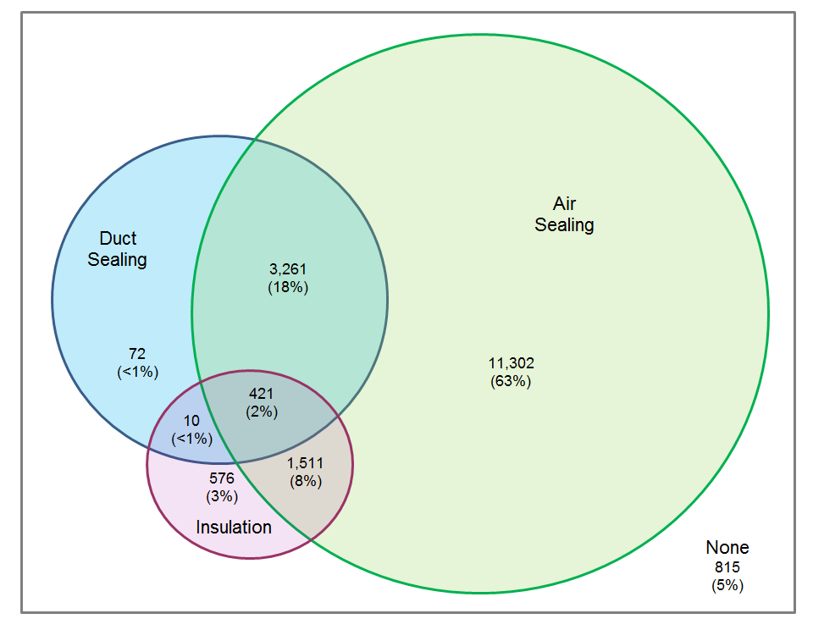

Study Objectives
The R151 study was developed for the EEB with the objective of identifying opportunities for the program to increase savings related to three specific measures through the HES program: air sealing (core service), duct sealing (core service), and insulation. The evaluation had the following research questions:
- Opportunities
- What opportunities exist to refine program implementation to capture greater savings and increase quality of implementation?
- What effect do health and safety concerns have on opportunities?
- Participation patterns
- What proportion of eligible participants receive air sealing, duct sealing, and insulation?
- Are there any patterns by utility, vendor, or home characteristics?
- Vendor practices
- What are vendor practices related to recommending measures?
- Are all savings opportunities being identified?
- Are all cost-effective savings being captured?
- What are vendor practices related to air and duct sealing installation?
- What are contractor practices related to insulation installation?
- QA/QC protocols
- What vendor-specific and program-based QA/QC protocols or procedures are followed to ensure quality installation?
- Are current QA/QC protocols adequate? If not, what opportunities exist to improve QA/QC?
- What tools or resources would help vendors increase measure quantity or quality?
- What QA/QC practices are other leading program administrators engaged in?
- Drivers, motivations, obstacles, and barriers
- What barriers or obstacles prevent recommending or implementing measures?
- What drivers or motivations lead customers to implement measures?
- What barriers prevent customers from implementing measures?
- How have other PAs leveraged drivers and motivations to achieve greater savings?

Methodology
The R151 study collected and analyzed data from eight sources, outlined in Table 2. For ease in identifying the data source of findings, in the detailed findings sections of the report we adhere to a color coding scheme included in the table below.

Table 2: Evaluation Tasks
Task | Description | Data Source | Quantity
1 | Program data tracking review | Data Tracking and Program Documents | 17,968 homes
2 | In-depth interviews with program staff | Program Staff | 2
3 | In-depth interviews with vendors | Vendors | 23
4 | On-site quality inspections | Quality Inspections | 70
5 | On-site in-depth interviews with program participants | Participants | 70
6 | On-site in-depth interviews with participating vendors | Vendors | 10
7 | In-depth interviews with program administrators from leading programs | Program Administrators | 5
8 | In-depth interview with Quality Assurance and Quality Control (QA/QC) Vendor | QA/QC Vendor | 1

Research Task Descriptions
Program data tracking and program document review: An analysis to explore patterns of air sealing, duct sealing, and/or insulation by utility, vendor, and home characteristics for 2014 program participants, as well as a review of relevant program documents including HES Implementation manual and QA/QC vendor manual.
In-depth interviews with HES program staff: One from Eversource and one from UI. These provided background on program goals, program design, program implementation, QA/QC protocols, and barriers to and opportunities for increasing savings.
In-depth interviews with participating vendors: Coordinated with R4 HES/HES-IE Process Evaluation and R157 Multifamily Initiative Process Evaluation. Questions focused on vendors’ practices related to air sealing, duct sealing, and insulation; barriers and opportunities for deeper energy savings; and the program’s QA/QC activities.
On-site quality inspections: NMR HERS Raters assessed the quality and completeness of the air sealing, duct sealing, and insulation work performed at HES participant homes. Most inspections lasted about an hour and focused on attic, basement, and interior work.
On-site in-depth interviews with program participants: A 20- to 30-minute in-person interview conducted with the homeowner during the on-site quality inspection. The interview discussed removal of measures, non-energy benefits, health and safety issues, financing options, recommendations, drivers of and barriers to participation, and customer satisfaction.
On-site in-depth interviews with participating vendors: Employees of the HES vendors that performed work at a given home accompanied NMR auditors to the site and, together, they inspected the work for quality and completeness. HES vendors provided candid feedback about their real-world practices and experiences with the HES program.
In-depth interviews with program administrators for other programs: Reviewed best practices from comparable programs, including reviewing program materials and interviewing program administrators. The interviews focused on increasing participation and uptake of add-on measures, and QA/QC strategies.
In-depth interview with program QA/QC vendor: The interview discussed program strengths and weaknesses, the quality of vendors’ work, and drivers and barriers the vendors face in participating in the program.
Table 3 provides a brief overview of which research tasks and methods map to research questions.
Table 3: Research Questions and Tasks
Research Question | Tasks | Methods
1 – Opportunities | Tasks 1 – 7 | - Data tracking and document review  - Staff interviews  - Vendor interviews  - Customer interviews  - Benchmarking  - On-site visits
2 – Participation patterns | Tasks 1 and 2 | - Data tracking review  - Staff interviews
3 – Vendor practices | Tasks 2-6 and 8 | - Staff interviews  - Vendor interviews  - On-site visits  - QA/QC interview
4 – QA/QC | Tasks 2-6 and 8 | - Staff interviews  - Vendor interviews  - QA/QC interview  - Customer surveys  - Benchmarking  - On-site visits
5 – Drivers, motivations, obstacles, and barriers | Tasks 2, 3, 5, and 8 | - Staff interviews  - Vendor interviews  - Customer interviews  - QA/QC interview

Report Outline
This report synthesizes the overarching findings that emerged from the individual evaluation tasks. The following outlines the overall structure of the main body of the report.
- Program Focus
- Opportunities
- Participation Patterns
- Vendor Practices
- Quality Assurance and Control
- Drivers, Motivations, Obstacles, and Barriers
Each section starts with a high-level summary of findings, followed by details on related topics for the section and a table of specific results from each evaluation task, as appropriate. The appendices to this report provide detailed results for certain topics identified in the main body, including:
- Detailed Methodology
- Potential QA/QC Protocol Opportunities
- Air Sealing, Duct Sealing, and Insulation Practices – Examples from Site Visits
- Detailed Analysis of Program Tracking Data

Program Focus
2
Drawing on information from in-depth interviews with program staff, vendors, and participants, as well as program data and documents, this section summarizes the general focus of the HES program, including a description of its design, implementation, and stakeholders’ perspectives on the program’s goals and objectives. The overall results are as follows.
Design and Implementation: Eversource and UI staff, program vendors, and third-party QA/QC contractors work together to deliver the HES program.
- Program staff are responsible for the overall design and implementation of the HES program, which includes providing the oversight and funding, setting and communicating program guidelines, providing technical assistance to vendors, and coordinating program activities.
- Program vendors are at the forefront with the public, conducting the energy audits, identifying savings, and, as appropriate, installing energy upgrades. Vendors also provide customer service and marketing activities.
- The third-party QA/QC contractors are responsible for assessing the quality of vendors’ work and identifying areas for improvement.
Program Goals and Objectives: Program staff and vendors stated that the program is designed to help participants reduce their energy consumption and related costs. Participants supported staff and vendors’ perspectives regarding these goals and objectives; approximately one-half (48%) stated that their energy bills had gone down since receiving HES services.
- Although program staff and vendors offered aligned viewpoints on the overall goals and objectives, many vendors voiced mixed opinions on how to achieve them. A number of vendors reported experiencing a tension between providing deeper services to a smaller number of participants versus shallow, lower cost services to a greater number of participants. Program staff reiterated in follow-up interviews that vendors are given explicit instructions to maximize savings in each individual home rather than prioritize the number of homes visited. Nevertheless, many vendors face a challenge with trying to maximize their profit while achieving high-quality, cost-effective measure installations through the program.

Program Design and Implementation
Eversource and UI staff oversee the design and implementation of the HES program. Program staff provide the oversight and funding for the program, while HES vendors deliver program services to customers. The Companies use third-party contractors to conduct quality assurance and quality control.
Program staff at Eversource and UI serve as the main contacts for the HES vendor network. They are responsible for setting and communicating program guidelines, providing technical assistance, and coordinating program activities.
Program vendors are primarily the public face of HES. Vendors are responsible for scheduling and conducting the energy audit, identifying savings and recommending measures, installing core measures, and, if needed, installing additional energy-saving upgrades such as insulation or providing referrals for such services. Vendors also provide general customer service and perform marketing and outreach activities for the program.
Each of the Companies uses a third-party contractor to assess the quality of vendors’ work. The contractors perform in-progress and post-completion inspections for at least 5% of projects. Program staff reported that they regularly evaluate vendors’ performance and take corrective measures, if needed. Staff noted that they also use customer satisfaction surveys as another source of information regarding the vendors’ performance.
Evaluators requested data on the quality of vendors’ work as reported by third-party contractors as part of this evaluation. Unfortunately, after several data requests, evaluators were unable to obtain aggregate data regarding quality inspections. Instead, evaluators were provided with individual quality reports in password-protected Excel files. The format of data prevented evaluators from aggregating data to explore for patterns. During on-site inspections where HES vendors accompanied NMR, the HES vendors brought paperwork with details about what work was performed on the homes, thus providing additional information that was not otherwise available to NMR auditors.

Program Goals and Objectives
The HES program helps residential customers reduce their energy use and related costs and assists them with improving the comfort of their homes. Program participants expressed strong satisfaction with their HES experience and reported that they had recommended the program to others. Nearly one-half of customers interviewed for this study (48%) reported that they had noticed a decrease in their energy bills. In addition to these primary goals and objectives, the staff indicated that the HES program plays an important role in helping participants to detect potential health and safety issues in their homes (e.g., gas leaks, carbon monoxide, mold, knob and tube wiring, asbestos insulation) and identify resources to remediate such concerns.
Although program staff and vendors were in agreement on the overall goals and objectives, comments from many vendors indicated a slight disconnect from program staff in terms of how to achieve the program’s goals and objectives. The in-depth interviews with vendors (via telephone and on-site visits) reveal a tension between whether the aim of the program is to provide deeper services to few participants or to provide more core or low-cost services to a greater number of participants. Overall, vendors reported that they work to maximize their profit through the program and noted some difficulty in maintaining profitability while achieving high-quality, deeper measure installations. Many, but not all, vendors cited inadequate time or incentive for high-quality installations. Faced with this challenge, most vendors indicated that energy savings opportunities often remain after completing an HES job. Balancing the directives of program staff to always prioritize achieving as many energy-saving opportunities as possible in each home while still remaining profitable, then, becomes the challenge most vendors are facing.
As the program moves toward a market-based program in 2016, it appears that there may be a need for program staff to reinforce the program’s goals and objectives and how vendors are expected to support them. Since the transition to a market-based program will involve substantially more program vendors, staff noted that they plan to conduct more QA/QC activities with vendors, which will provide additional opportunities to emphasize program goals and objectives.
Aside from the challenges of balancing depth and breadth of services, vendors also noted that health and safety issues are a significant barrier to achieving the program’s goals and objectives. The HES implementation manual makes it clear that energy testing and energy improvement are actually a third priority, behind safety and customer service. The manual states: “Safety takes priority over all else, including energy savings.” The “Priority Pyramid” detailed in the manual is described as “a reminder that safety is top priority, followed by customer service, and then energy savings.” The manual continues, “Safety is to be held as the highest priority over home energy testing and energy improvement.” In addition, the focus on customer service is explicit in the manual as well as the QA/QC procedures and documentation (see Section 6: Quality Assurance and Control for more details on the QA/QC procedures). As described in more detail below, a considerable number of program participants—8%, based on program records, although vendors estimate as high as 40%—are not able to benefit fully from the program because existing hazards prevent vendors from conducting diagnostic testing or limit measure installation. The program currently does not offer an incentive to participants to help with remediating such issues, and customers are not able to pursue many energy-saving opportunities through the program.

Detailed Findings Related to Program Focus
In this section, we present detailed findings from the study related to program focus. Findings in Table 4 are color coded based on data source, as described in the Methodology section.
Table 4: Detailed Findings (Program Goals and Objectives)
Program Staff | The HES program is designed to reduce energy consumption and related costs as well as improve participants’ comfort in their homes.
 | Improved energy efficiency goes hand-in-hand with participants’ comfort. That is, if a home is warmer in the winter and cooler in the summer due to the energy efficiency upgrades, the customer will be more comfortable in his or her home.
 | While addressing health and safety issues is not a primary goal or objective of the HES program, the energy audits help homeowners to identify such concerns, and vendors assist them in locating appropriate resources to help remediate those issues.
Data Tracking Records | The HES implementation manual makes it clear that energy testing and energy improvement are the third priority, behind safety and customer service. The manual states: “Safety takes priority over all else, including energy savings. The following ‘Priority Pyramid’ is a reminder that safety is top priority, followed by customer service, and then energy savings.” It continues, “Safety is to be held as the highest priority over home energy testing and energy improvement.”
 | In addition, the focus on customer service is explicit in the manual as well as the QA/QC procedures and documentation (see section 6, Quality Assurance and Control, for more details on the QA/QC procedures).
 | The three measures of interest for this study—air sealing, duct sealing and insulation—directly support the program’s overall goals and objectives.
Vendors | Vendors struggle with understanding whether or not the program goals are tied to number of homes completed or energy savings—or both. As one vendor offered, “Is energy savings the goal, or is number of houses served the goal? I’ve never gotten a clear answer on that. If goal is number of homes, then HES is really good. If it’s saving energy, then the program isn’t doing a great job.” Program staff, however, are very clear that quality work and energy savings in each and every home should always be prioritized over simply the number of homes visited. They indicate that this point is conveyed in myriad forms, through meetings with vendors, scorecard criteria, roundtable discussions, and QA/QC scoring.
 | This disconnect or understanding transfers into the quality of work completed by vendors—with vendors prioritizing finishing work quickly and moving onto the next home vs. taking necessary time to complete all work to a high quality standard.
A few vendors also thought that overall program messaging from both the utilities and EnergizeCT does not resonate well with customers and does not have much of an impact. One vendor remarked, “They have the generic EnergizeCT campaign, which absolutely means nothing and people have no idea what it means.”
Other vendors thought that the overall marketing was a start at connecting with customers, but that the messaging needs a “call to action” or a way to communicate a pathway to greater services for the customer, as evidenced in the following comment:
“They have that direct relationship with the customer, so communications through their bills and online engagement, those things are good, but it’s working on the calls to action and connecting to the actual program execution [that needs work].”
 | Vendors were similar to the PAs in their assessment of the program’s goals and objectives. When discussing the program’s strengths, they most commonly mentioned that customers improve their energy efficiency (9), benefit from the value of the core services (7), improve their knowledge of energy-efficient practices (5), and have access to rebates and incentives to help defray the costs of the upgrades (4).
Vendors mentioned the increase in administrative requirements (tablets, home energy scores) for which they are not compensated and which eat up time at the site. On-site, one vendor said the program “keep[s] adding requirements without compensation. It seemed like the program went from helping the customer to just information gathering.”
Another vendor described on-site how with a “two-man team, one is always entering data, and the other only does the [weatherization] work.”
On-site, yet another vendor described the difficulty of meeting the administrative requirements, particularly using their two-person crew approach. “The lead tech has to enter so much data. They have to do paper work, but they still write everything down [by hand] because the tablet program loses data. … We have to upsell, do paperwork, and do everything we can on-site, and we get angry letters [from the utilities] if we mess up.”
According to vendors, in order to make a profit, vendors commonly feel pressured to complete two sites per day, using only two technicians per site. The lead technician handles the bulk of the paperwork, and the assistant performs most of the core services. After paperwork and testing, technicians may have about one and one-half hours (at most) to do air sealing after they have wrapped up paperwork and testing requirements. Given the time constraint, they do not try to hit everything—just the big things or what they can accomplish in an hour and a half. Some vendors may do one site per day, but they reported that this was not a particularly profitable model.
The QA/QC vendor reported, “I’d say the average is two hours [of air sealing], using two people . . . for an 1,800-square-foot house.”
On-site, a vendor described how “we need a third person, because now, one person does 75% of the work due to all the tablet work and data collection. . . . A three-man team makes the work go smoother and more efficient, [but] financially that is hard to accomplish.”
Multiple vendors during on-site interviews suggested that the program encourage vendors to send one auditor to do a pre-assessment of homes before completing actual weatherization work; some have already started implementing this approach.
Under this program/business model, a single auditor visits the home, creates the home’s energy model, inspects the home for health and safety issues, and makes recommendations for core services and additional add-on measures, but typically would not perform actual weatherization work. Air sealing, duct sealing, and insulation work could then be scheduled for a subsequent appointment, and vendors could plan their staffing needs accordingly for each site, rather than risking sending too many or too few technicians to a home they have not yet inspected, as is the case with the current program model.
Another vendor that has already started pre-inspections said that this model helpfully identifies health and safety issues before he sends an entire crew out to the site. Since the auditor has fewer weatherization tasks to perform on that first visit, that initial technician has more time to upsell measures, helping to increase customer adoption of add-on measures. “It eliminates show stoppers, and [the initial auditor] sells all the insulation before even starting the HES process.”
Participants | In line with program goals, most participants we spoke with were motivated to participate in the program to achieve savings (48%), improve comfort, or identify opportunities for upgrades (41%). A small but important group of customers (~16% of visits) said they participated in HES only because it is a requirement for having solar or other energy efficiency measures installed.
 | Participants voiced strong satisfaction with the program, and many had recommended it to friends and colleagues. They see the program as a great value, expressing both surprise and satisfaction with the amount of work completed given the low upfront cost.
 | Reductions in energy use with accompanying increases in home comfort are cited as two of the main program goals, and these are corroborated to some extent by participants’ perspectives. Roughly one-half (48%) of the sample said they had noticed a decrease in their energy bill, with the remaining half not noticing a change or not being able to isolate changes to the audit. For those who saw a decrease, almost all (90%) said it was about what they expected.
UI QA/QC Vendor | In their current form, the QA protocols have a significant focus not just on energy savings, but on customer satisfaction. The QA/QC vendor described how many of the criteria they use to evaluate the work of vendors are focused on customer satisfaction, noting that the program’s QA inspection criteria have an “almost equal” focus on energy savings and customer satisfaction, with “savings a little bit more weighted.”
 | QA/QC is a powerful tool for achieving program objectives. The QA/QC vendor described their work as a tool that can implement program design changes: “The QA/QC process could be adjusted to drive whatever the program wanted to address at that particular time. If the program was having a problem, they could change their scoring so they could get that problem under control. They could use it as a tool to drive the vendors to suit the program’s needs.”

Opportunities
3
Drawing on information from all data sources, this section explores opportunities identified as part of the R151 study through interviews, program records, research on other program’s best practices, and on-site quality inspections.
The NMR team found that, while the program meets many of its energy savings and customer satisfaction goals, there are additional savings opportunities that the program could achieve. Health and safety issues remain a large opportunity for additional savings. Eight percent of HES participant homes in Eversource territory (according to program records) have at least one health and safety concern, limiting the work that can be performed in these homes. The HES program does not appear to be legally allowed to offer funding for the remediation of these issues, according to program staff, though other successful programs in other states are able to offer facilitation or funding for barrier mitigations, allowing more customers to improve their homes. By pointing out health and safety issues—particularly if the program cannot help remediate them—customers may be displeased with the program. Some vendors also report that they schedule more sites per day than they would otherwise do—achieving less savings at each—because they are trying to avoid having a crew idle all day due to a health and safety issue.
HES vendors consistently do not achieve all of the readily accessible savings that they could in homes. For example, NMR auditors saw readily accessible air-sealing opportunities in 46% of attics, 74% of basement ceilings, and 72% of basement rim joists. In homes with duct sealing, 53% still had readily visible and accessible openings that could have been sealed. According to the implementation manual, program staff, and vendors, the program encourages vendors to prioritize attic air sealing, but this is a remaining opportunity because this is not a universal practice. The program could promote attic encapsulation with spray foam because this serves as an excellent air sealing and insulation measure. NMR saw only four homes that had this service performed through HES.
Insulation quality is high overall through the program (61% of all the installations were high quality), particularly for attics; basement ceilings and rim joists appeared to be of generally lower quality, particularly if fiberglass batt insulation was used. In addition, one of the greatest program opportunities is to increase the proportion of customers who receive insulation recommendations and the rate of customer uptake for insulation. In 2014, 39% of HES customers were recommended insulation measures, but only half of them ended up installing it. Similarly, customers may benefit from greater explanation of the savings associated with pursuing add-on measures, such as insulation. Additional explanation of these measures, along with post-audit follow-ups on the phone or via e-mail may push more customers to adopt these measures. One vendor described using a call center to follow up with their customers, with successful results.
Measure persistence, particularly low-quality or noisy door weather-stripping and door sweeps, is an opportunity detected in the field; thin plastic v-seal weather-stripping is inexpensive and easy to install, and extremely common among HES vendors, but it can eventually delaminate from high-traffic doorways. Sloppy duct sealing with poorly adhered foil tape might also result in diminished savings from the program over time.

Healthy and Safety Issues
As discussed in the Program Focus section, the HES program strives to ensure that it does not adversely impact homeowners’ health and safety. Health and safety issues are also an area of opportunity for the program—program records indicate that 8% of 2014 HES homes in Eversource territory have at least one health and safety issue. Unaddressed health and safety issues affect each area of the Priority Pyramid described in the HES implementation manual. When issues are not addressed, customers are left in potentially unsafe homes (recognizing that the conditions existed before the program). In addition, pointing out health and safety issues to customers—particularly if the HES team cannot facilitate the remediation of the issue—could lead to dissatisfaction with the program. Finally, health and safety issues prevent the program from achieving deep energy savings.
According to program staff, Connecticut law and regulations prevent the program from directly providing incentives for remediation of health and safety issues. Still, the program offers some limited assistance for customers to address issues, including requiring vendors to provide a list of third-party remediators and working with finance partners to ensure that financing is available for remediation. In some cases, customers may be able to bundle the cost of remediation along with other rebated measures.
Our review of other leading programs revealed a similar concern with health and safety issues. All of the Program Administrators we interviewed indicated that health and safety issues were a consideration in their programs, and each program offers loan products that provide limited funding for remediation of substantial issues like vermiculite insulation removal, but do little to address more immediate concerns that would prevent initial testing during the audit. Two of the other programs NMR reviewed offer direct incentives for remediation:
- The Mass Save Home Energy Services program offers a pre-weatherization incentive for failed combustion safety (up to $300), knob and tube wiring (up to $250), and improper dryer venting (up to $250), and, as of 2015, the program has made available additional, potentially larger grants to assist with the cost of knob and tube removal and asbestos abatement.
- Rhode Island’s EnergyWise program offers a similar incentive (up to $250) for common barriers that prevent weatherization services.
By not facilitating the remediation of health and safety issues, not only are HES teams limited in the amount of savings they can generate on a given home, but it also encourages them to schedule two sites in a day rather than one (resulting in lower savings in each home). Vendors report that if they only schedule one site per day in an attempt to get greater savings at each site, they risk leaving a crew idle for the entire day if the scheduled site has a health and safety issue that prevents them from performing the full core services. By scheduling two sites in a day, vendor crews have a greater chance of having at least one site on a day where they can perform some amount of work.

Core Services Remaining Opportunities (Low-Hanging Fruit)
From the vendor in-depth interviews, both on site and over the phone, it is clear that vendors seek to address low-hanging fruit when they perform air sealing and duct sealing as part of core services, but on-site inspections showed that significant opportunities still remain in many homes. Based on site-inspections, vendors typically do not systematically seal everything that they could in a given home, and they are limited by time, effort, and access issues, in addition to health and safety issues. As detailed below, additional savings could be had by increasing the quality and completeness of air and duct sealing work. Vendors appear to run short on time when performing these services, resulting in a mix of sealed and unsealed gaps that could have been sealed given more time, attention, effort, and internal quality control.
Vendors often mentioned time constraints and the need to maintain profitability as barriers to completeness for air sealing and duct sealing. To make a profit, most vendors said they needed to do two sites per day, using two technicians per site. After paperwork and testing, technicians frequently have about two hours to perform air sealing and duct sealing, limiting the amount of air and duct sealing they can do in their allotted time per site.
While on site, NMR auditors reviewed air sealing, duct sealing, and insulation work performed through the HES program. We found that vendors left readily visible and accessible opportunities for additional air and duct sealing at many homes. Figure 2 provides counts of the number of homes where we observed opportunities, divided into the two categories: 1) homes where no HES work was done in that part of the home and 2) homes where some HES work was completed, but opportunities still remained. In the figure, the sample sizes (n) represent how many homes the particular measure was applicable in.
Figure 2: Observed Opportunities for Additional Air and Duct Sealing
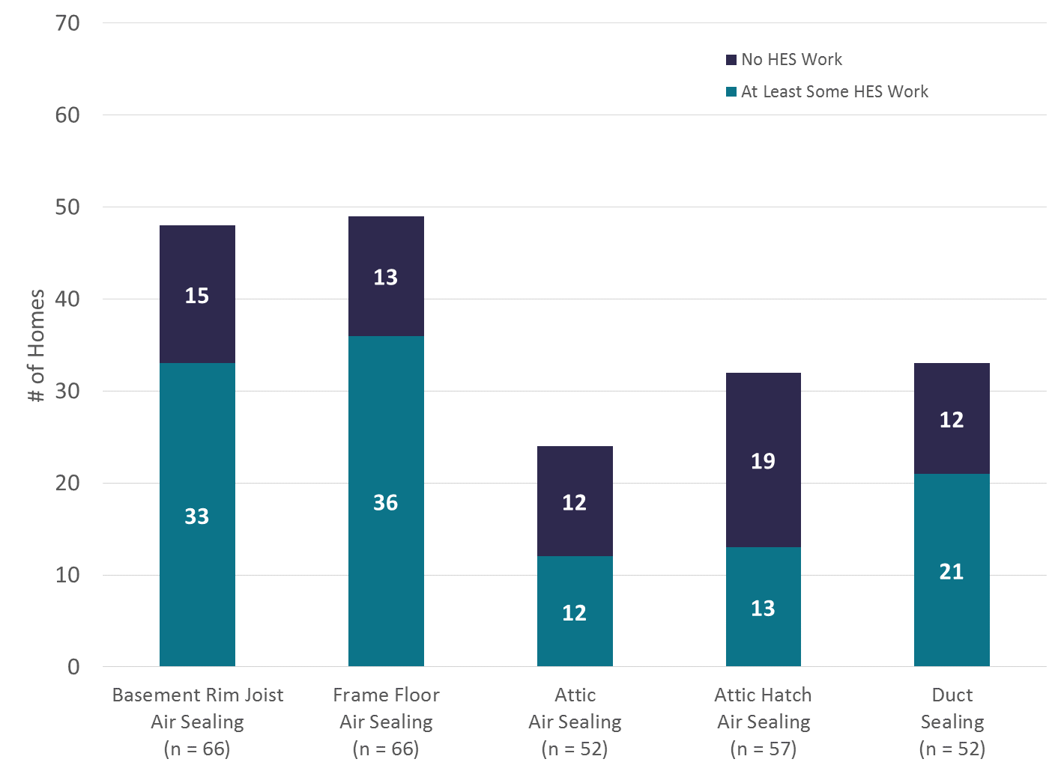

Air Sealing
While on site, NMR auditors observed numerous readily visible and accessible opportunities for additional air sealing. We break out our observations into four important air sealing areas in homes: basement rim joists, basement ceilings (frame floors), attics, and attic hatches. See Air Sealing Practices in Appendix C for detailed descriptions and photos of specific examples from the on-site quality inspections performed by NMR.
Basement rim joists: In total, 66 of the 70 homes visited had basements where an HES team could have air sealed. NMR auditors observed at least some rim joist air sealing in 73% of basements and no air sealing in 27% of basements. Looking at all homes with accessible rim joists—including those with some rim joist air sealing and those without—we observed readily visible and accessible opportunities for additional basement rim joist air sealing in 72% (48) of basements.
- Among homes that had at least some basement rim joist air sealing, NMR observed additional readily visible and accessible opportunities for further air sealing in 69% of homes.
- Among homes that had no basement rim joist air sealing, NMR observed readily visible and accessible additional opportunities for air sealing in 83% of homes.
Basement ceilings (frame floors): NMR auditors observed at least some basement ceiling air sealing in 71% of basements, no basement ceiling air sealing in 27% of basements, and we were unable to observe basement ceilings in one home. Looking at all homes with accessible basement ceilings—including those with some basement ceiling air sealing and those without—we observed readily visible and accessible opportunities for additional basement celling air sealing in 74% (49) of basements.
- Among homes that had at least some basement ceiling air sealing, NMR observed additional readily visible and accessible opportunities for further air sealing in 77% of homes.
- Among homes that had no basement ceiling air sealing, NMR observed readily visible and accessible additional opportunities for air sealing in 72% of homes.
Attic air sealing: NMR was able to assess attic air sealing in 52 of 70 homes. Among these homes, NMR auditors estimate that there was at least some attic air sealing in 58% of attics and no attic air sealing in 42%. Looking at all homes with accessible attics—those with at least some air sealing and those without—we observed readily accessible opportunities for additional attic air sealing in 46% (24) of accessible attics.
- Among homes that had at least some attic air sealing, NMR observed additional readily accessible opportunities for further air sealing in 40% of homes.
- Among homes that had no attic air sealing, NMR observed readily accessible additional opportunities for air sealing in 55% of homes.
Attic hatches: In 57 of the 70 homes, NMR observed accessible attic hatches where they could assess whether or not the hatches had been sealed by the program. (This excludes homes with fully insulated/encapsulated attics, those without attics, or those without attic hatches, etc.) Based on observations at these 57 homes, NMR concludes that HES vendors were inconsistent with how well they sealed attic hatches. Over one-half (56%) of the hatches were either unsealed (33%) or poorly sealed (23%). These 56% of attic hatches represent opportunities for additional attic hatch air sealing.

Duct Sealing
Of the 70 homes we visited, nearly three-quarters (72%; 52) have ducts. Of these 52 homes, program records indicate that vendors performed duct sealing at 40 homes (77%). At homes where duct sealing was performed, we observed readily visible and accessible opportunities for additional duct sealing in 53% of homes. Supporting this finding, among these 40 homes, program records indicate that six showed no improvement based on pre- and post-sealing duct blaster tests performed by vendors. See section C.3 in Appendix C for detailed descriptions and photos of specific examples from the on-site quality inspections performed by NMR.

Insulation
When it comes to insulation, one of the greatest opportunities for the program is in increasing the proportion of customers who follow through on recommendations to install insulation. However, it is important to note that insulation works best when installed after thorough air sealing (i.e., attic insulation works better in a tightly sealed attic). So additional insulation in the absence of increased air sealing diligence (as described above) may not result in higher realization rates. According to the Connecticut Energy Dashboard, in 2014, 39% of all HES visits included a recommendation for insulation, and one-half of these recommended rebates were completed through the program.
In general, the insulation work observed by NMR auditors in the field was good, but there was some room for improvement in installation techniques to ensure that measures performed as desired. Of all the insulation jobs that NMR could assess on site, 61% of them were Grade I based on RESNET standards, meaning high quality, with limited gaps and compression. These higher quality installations were mostly seen in attics and in the instances where HES vendors air sealed rim joists with spray foam so thoroughly that it served as insulation, even though the customer did not pay an additional fee for that service.
Figure 3: Quality of All Insulation Installs (Grade 1 = Best)
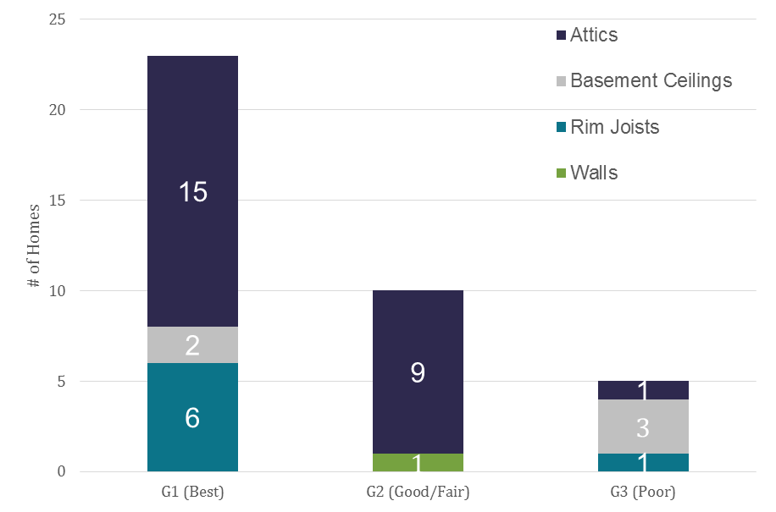

When fiberglass batts are used in certain applications, even distribution and installation of insulation material is difficult and may result in lower-than-expected savings. For this reason, the program may want to carefully consider whether it continues to support fiberglass batt insulation for all applications. See Insulation Practices in Appendix C for detailed descriptions and photos of specific examples from the on-site quality inspections performed by NMR.
Attic Insulation: NMR visited 30 homes with program-incentivized attic insulation. For installed attic insulation, most savings opportunities come from ensuring that there are limited defects in the installations, which would result in lower realization rates than expected. A full eighty percent of the attic insulation jobs observed were of acceptable or excellent quality (Grade 1 or 2 installations), one (3%) was of particularly poor quality (Grade 3), and 17% were not observable. There is also an opportunity to ensure that blown-in insulation is installed evenly; if not, the effective R-value is lower than claimed. NMR saw 26 instances of blown or spray-applied insulation in attics; 65% were extremely or mostly level, 23% were very uneven, and 12% could not be observed.
Rim Joist Insulation: NMR auditors observed only one instance of rim joist insulation that had been installed using HES program incentives. In this home, the insulation chosen was fiberglass batts and was installed poorly, meaning the insulation was forced into the basement ceiling joist cavities resulting in severe gaps and compression, rather than cutting the insulation to fit around framing, wires, plumbing lines, etc. (This is a common problem in homes, not unique to the HES program.)
Interestingly, at six homes, NMR auditors observed instances where vendors had almost completely insulated the rim joist areas using two-part closed-cell spray foam as an air-sealing measure (as a core service—not an insulation rebate). The foam air sealing served as an excellent insulator. An opportunity for additional savings would be for the HES program to encourage this combined air sealing and insulation measure and take credit for savings from this dual-purpose measure.
Frame Floor Insulation: NMR auditors observed seven instances of HES-incentivized frame floor insulation—four with fiberglass batts, two with spray foam, and one with dense-pack cellulose. The fiberglass batt insulation jobs were relatively poor; gaps, compression, and sag from the frame floor were common, meaning the measures were unlikely to perform as desired. The homes with foam and cellulose did not suffer from these same problems.
Wall Insulation: NMR auditors observed only two instances of wall insulation added by the HES program. Using an infrared camera, auditors were able to assess the evenness of one dense-pack cellulose installation. While the evenness of the insulation was generally good, uninsulated study bays remained above some of the windows. If this is common, predicted savings from the measure will likely be higher than realized savings.

Detailed Findings Related to Opportunities
In this section, we present detailed findings from the study related to opportunities. Findings in Table 5 are color coded based on data source, as described in the Methodology section.
Table 5: Detailed Findings (Opportunities)
Program Staff | According to staff, statutory limitations prevent the program from directly addressing health and safety issues. Still, identifying health and safety issues is viewed as an ancillary benefit of the program. Common health and safety issues include mold, moisture, asbestos, HVAC issues causing high CO, plumbing or gas leaks, and pests.
 | While no direct incentives are available for health and safety remediation, the program does offer some indirect assistance. Vendors must provide a list of third-party remediators who can address health and safety issues. In some cases, vendors may also be able to address certain health and safety issues in house.
 | If customers choose to have health and safety issues remediated, the program will return to their home to complete work at no additional cost—avoiding paying the $99 fee a second time for a return visit.
 | The program works with financing partners to ensure that customers who choose to remediate health and safety issues can acquire financing. In addition, in some cases, customers may be able to roll health and safety remediation into packages for rebated measures to help defray the costs.

 | As discussed in Section 2: Program Focus, the program’s objective is to achieve deep and comprehensive savings. Staff believe that the new minimum savings requirements and program metrics maximize savings through the initial audit and promotion of additional measures.
 | Although program staff reported that the program has a good representation of cost-effective offerings, they indicated that the current structure sometimes limits customers’ ability to fully pursue energy savings. For example, the ceiling insulation rebate requires that customers have less than R-30 currently installed, install a minimum of an additional R-19, and the final R-value must be greater than or equal to R-38. This means customers who are unable to reach R-38 due to space limitations (finished attics) or customers who would benefit from additional insulation but already have R-30 installed are excluded.
 | Staff noted that the presence of health and safety issues, particularly “show stoppers,” prevent installation of measures because technicians are not always able to conduct diagnostic testing. Although the identification of such issues is helpful to the customer, staff reported that lack of funding to help remediate these hazards prevents customers from fully benefiting from program services.
 | The incentive structure for vendors is split between a fixed per-home incentive and a variable incentive based on CFM reduction, services performed, and equipment installed. Based on data provided by program staff, the average cost per home for the program in 2014 was between $1,100 and $1,200. If we include the customer-paid fee of $99, it was between $1,200 and $1,300 per home. This figure is for core services only and does not include rebate costs for recommended measures.
Fixed incentives account for 16% to 18% of average incentives in 2014.
The cost breakdown is as follows: (Eversource; UI)
- Air sealing: $629 (52%); $735 (57%) [Variable incentive CFM reduced]
- Lighting: $233 (19%); $204 (16%) [Variable incentive # of bulbs installed]
- Site visit: $189 (16%); $174 (14%) [Fixed incentive per home]
- Duct sealing: $102 (8%); $117 (9%) [Variable incentive CFM reduced]
- Air flow test: $30 (2%); $29 (2%) [Fixed incentive per home]
- Direct hot water: $21 (2%); $25 (2%) [Variable incentive # of measures installed]
Data Tracking and Docs | In 2014, 8% of HES homes in Eversource territory were recorded as having at least one health and safety issue. Unfortunately, program records do not indicate which, if any, of these homes had issues remediated.
 | In 2014, 8% of HES homes did not receive any air sealing services. Health and safety issues occasionally prevent vendors from performing air sealing or duct sealing work—or even running blower doors to assess air leakage.
 | Among 2014 participants who received at least one service, nearly two-thirds (63%) received air sealing only. These homes represent a significant opportunity for additional measures. Less than one-fifth (18%) of participants received air sealing and duct sealing, less than one-tenth (8%) received air sealing and insulation, and 2% received all three services. Five percent of 2014 HES participants did not receive air sealing, duct sealing, or insulation.
 | According to the Connecticut Energy Dashboard, in 2014, 39% of all HES visits included a recommendation for insulation, and one-half of these recommended rebates were completed through the program. Increasing the conversion rate for insulation recommendations represents a significant opportunity for the program.
Vendors | Vendors indicate a potential disconnect between how they are paid and program goals. Vendors are working to be profitable in the existing system, which may mean vendors avoid homes that will be time sinks (extremely leaky or otherwise challenging homes), particularly if the homeowner does not appear to be interested in purchasing add-on measures.
 | Corroborating this, when asked about instances where core measures are not installed or pursued, one vendor said, “Yes, it happens frequently. They pay us to go after low-hanging fruit. Time is money, and it’s easier to get first instances of air sealing done, with lesser payback as you go further. Air sealing opportunities are almost always left behind. Sometimes we can’t even get a testing number to begin with; it’s so leaky [at the outset] we wouldn’t be able to know the savings afterwards. So we just don’t pursue them.” [Source: Telephone interview]
 | Some vendors do not formally market the program and rely on word-of-mouth referrals. Some vendors indicated that they would like to market the program but believe that the PAs are too restrictive with allowing vendors to market the program as they see fit. Additionally, they noted that the turnaround for approvals of branded materials is too long.
 | The lead technician does the majority of the customer interaction, while the assistant or secondary technicians perform the majority of upgrades and core services. Often, this results in work being completed by non-BPI-certified staff with limited oversight or quality review, particularly if the vendors are running short on time.
 | On site, a vendor estimated that about 20% of their sites have some kind of health and safety issue that causes them to delay or limit their core services. The prevalence of health and safety issues can result in some vendors rushing their work and scheduling two jobs per day because they want to avoid the lost time and wages associated with sending a crew to a site for a planned full day’s work only to find a health and safety issue that prevents them from doing any work.

 | On site, a vendor described using a call-center to follow up with customers after their audits to talk through the recommendations they received, which increased customer uptake of add-on measures.
Participants | Most customers (~60%) recall the auditor leaving a packet of information about available financing and rebate options for EE measures through the program.
 | A common reason for not moving forward with recommended upgrades (other than the cost of doing so) was that the issue was not bothering the customer enough to justify moving forward with expensive upgrade—customers do not always feel comfortable replacing a working appliance/mechanical system for a more efficient version.
 | Customers by and large thought that the information they received about financing was clear and the materials left were helpful. But since many do not have interest in moving forward with further energy upgrades, they do not spend much time looking through them.
 | Some customers (n=~10) said that while the packet of information is very thorough, it can be overwhelming. They suggested limiting information to the measures discussed and the specific needs of the client as determined by the audit. If the tech does not recommend a specific measure (usually because the customer does not need it), then including information about that measure and the rebates/financing available for it is not particularly helpful. They would have preferred a prioritized packet of information, specific to them.
 | “They gave us a list of things we could do and recommended some companies. Ultimately, if they had prioritized things for us, said, ‘This would be the best option for you and your home specifically,’ that would have helped. Leaving a big packet with all the options is kind of information overload.” [Source: On-site interview]
 | Still, customers appear to have varying information needs and wants. For example, three customers expressed a desire to receive updated offers from the program via email or with their energy bill. Another customer wanted detailed information on payback periods for each measure installed—with charts and graphs.
 | Roughly one-third of customers (32%) had removed some of the installed measures. These included CFLs (n=8), weather-stripping (n=6) and showerheads (n=5). Reasons for removal included general quality issues with the CFLs, weather-stripping that impeded the use of doors, and issues with the water flow from the showerheads. These all represent areas for improvement in the installation/general quality realms, but are unlikely to be a large opportunity area for the program.
Quality Inspections | Measure persistence, particularly door weather-stripping and door sweeps, is an opportunity detected in the field. Customers do not always like the sweeps on the doors, and the plastic v-strip used to weather strip doors gets damaged over time. It works well on the initial blower door test, but has limited longevity. There are more durable door weather-stripping kits than stick-on v-seal, and while some HES vendors may use them, they are more expensive and time consuming for vendors to install, so most vendors appear to use the stick-on v-seal material.
 | Some sites revealed evidence of post-audit work done outside of the program that essentially undid some of the improvements. Examples include duct system reconfigurations after sealing and new penetrations into floors due to renovations that go unsealed or uninsulated.
Air Sealing in Basement Rim Joists
“Low-Hanging Fruit”/Readily Accessible Penetrations. NMR auditors looked for “low-hanging fruit” in basements—meaning unsealed, easily accessible rim joist penetrations that did not require removing insulation to access them. In total, NMR observed readily visible and accessible opportunities for additional basement rim joist air sealing in 72% of homes.
 | NMR auditors observed rim joist air sealing in 73% of the basements they visited, and saw no rim joist air sealing in 27% of the basements.
 | In the basements where HES vendors did at least some rim joist air sealing (n=48), NMR observed readily visible and accessible additional opportunities to seal rim joist penetrations in 69% of homes.
 | In the basements where HES vendors had not done any rim joist air sealing (n=18), NMR observed readily visible and accessible additional opportunities to seal rim joist penetrations in 83% of homes. The remaining homes (3) were skipped due to health and safety issues.
In addition to looking for readily accessible rim joist penetrations, NMR also assessed the level of air sealing at rim joist penetrations that were accessible, but harder to see, such as those behind mechanical equipment or framing. While these were accessible areas, sealing them requires an additional level of time and effort beyond sealing those that are readily visible.
HES vendors most commonly skipped these opportunities and left them completely unsealed (54% of basements); they sealed most of them in 24% of those basements, and sealed some of them in 21% of those basements.
Air Sealing in Basement Ceilings (Frame Floors)
“Low-Hanging Fruit” – Readily Accessible Penetrations. NMR auditors looked for “low-hanging fruit” in basements, meaning unsealed, easily accessible frame floor penetrations that did not require removing insulation to access them. In total, NMR observed readily visible and accessible opportunities for additional basement rim joist air sealing in 74% of homes.
 | NMR auditors observed frame floor air sealing in 71% of the basements we could inspect, saw no such air sealing in 27%.
 | Where HES vendors did at least some air sealing of frame floor penetrations, we observed missed readily visible and accessible penetrations in 77% of homes.
 | In the basements where HES vendors had not done any air sealing of basement ceiling penetrations, NMR observed easily accessible rim joist penetrations in 72% of homes. There were health and safety issues preventing sealing in 17% of homes (3).
As with rim joists, NMR assessed frame floor penetrations that were not readily visible, but were still accessible, such as those concealed by mechanical equipment or behind framing in the basement ceiling.
HES vendors often skipped those penetrations and left them unsealed (41% of basements); they sealed some of them in 31% of those basements, and sealed most of them in 25% of those basements.
Attic Air Sealing
“Low-Hanging Fruit” – Easily Accessible Penetrations. In the 52 accessible attics where NMR auditors were able to make a determination about the presence of air sealing, we estimate that about 58% had some amount of air sealing done by the HES team, and 42% did not. While the HES implementation and QC manuals indicate that vendors should prioritize attic air sealing before work in the basement or other areas of the home, we observed limited air sealing work in attics. It appears vendors are avoiding work in attics, which can be time consuming, and instead focusing on addressing issues in basements, which are generally more accessible.
 | Among the 40 attics where NMR could make a determination about the extent of additional savings opportunities from air sealing, 60% had additional savings opportunities available in the attics.
 | In attics where HES vendors did air seal, easily achievable savings remained in 40% of homes. NMR could not determine the extent of additional opportunities in 33% of those cases.
 | In the attics where HES vendors did not air seal, easily achievable savings remained in 55% of cases. NMR could not determine the extent of additional opportunities in 27% of those cases.
Air Sealing at Attic Hatches. HES vendors were inconsistent with how well they sealed attic hatches, resulting in missed energy savings in many cases.
- 40% of attic hatches were well sealed (fully sealed on all edges with no visible leaks).
- 23% of cases were poorly sealed (with noticeable gaps or failing weather-stripping).
- 33% of cases were unsealed.
- We were unable to assess 4% of cases.
Rim Joist Insulation. NMR auditors saw only one instance of rim joist insulation (fiberglass batts) that had been installed using HES program incentives (2% of homes with basements). In six other instances (9% of basements), the initial HES vendors had almost completely insulated the rim joist areas using two-part closed cell spray foam as an air-sealing measure; this was installed at no cost to the customer, and treated as a core service. The one fiberglass installation was of low quality and the foam air sealing served as an excellent insulator apart from any gaps in its application.
An opportunity for additional savings would be for the HES program to encourage this combined air sealing and insulation measure, and take credit for savings from this dual-purpose measure.
 | Frame Floor Insulation. NMR auditors observed seven instances of HES-incentivized frame floor insulation; four were insulated with fiberglass batts, two with spray foam, and one with dense-pack cellulose. Overall, the insulation quality of the fiberglass batts was relatively poor; gaps, compression, and sag from the frame floor were common. The homes with foam and cellulose suffered less from most of these problems—not surprising, given the nature of the insulation materials themselves.
 | Wall Insulation. NMR auditors observed only two instances of wall insulation added by the HES program. In one instance—a dense-pack cellulose installation—uninsulated stud bays remained above some of the windows (confirmed by infrared camera). If this is common (which NMR cannot confirm based on this one home), predicted savings from this add-on measure will likely be higher than realized savings.
 | Attic Insulation. As with wall insulation, for installed insulation, most savings opportunities come from ensuring that there are limited defects in the installations, which would result in lower realization rates than expected. Most installations, however, were of good quality. See Vendor Practices.
 | Duct Sealing. Of the 70 homes visited, 74% (52) have ducts. Program records indicated that vendors had performed duct sealing in 40 of them (77%). NMR did not have access to records that would have explained why duct sealing was not performed in the remaining 12.
“Low-Hanging Fruit” – Readily Accessible Gaps in Ductwork. Among the 40 homes where program records indicated duct sealing, we found:
- 25% were fully sealed.
- 53% had opportunities for additional easily achievable savings.
- 20% were too difficult to access or had limited opportunities.
- We were unable to determine opportunities in one home due to lack of access (3%).

 | Additionally, among the 40 homes with duct sealing indicated in the records, six (15%) showed no improvement based on program records (0% CFM reduction based on duct blaster pre/post). In one case, NMR technicians observed duct sealing and thought that the lack of improvement might have been due to an error in duct testing or record keeping.
Program Administrators | All of the programs also offer loan products that provide limited funding for remediation of more substantial issues like vermiculite insulation, but do little to address more immediate concerns that would prevent initial testing during the audit.
 | The Mass Save Home Energy Services program offers a pre-weatherization incentive for the three most prevalent issues: failed combustion safety, knob and tube wiring, and improper dryer venting (up to $300 for combustion safety and $250 for knob and tube wiring and/or improper dryer venting). As of 2015, barrier mitigation grants were also made available through the program to subsidize the cost of knob and tube and asbestos removal.
 | Rhode Island’s EnergyWise program offers a similar incentive (up to $250) for the homeowner to address barriers (including health and safety hazards) which would prevent weatherization services.
QA/QC Vendor | The QA/QC vendor confirmed that while savings potential obviously varies from home to home, vendors leave savings on the table that may be cost-prohibitive or not profitable for them to pursue.  “In some houses, [core services] can be knocked out in four hours. . . . If it was up to me, I’d love to see them do one a day for the majority of houses. . . . Every house is different, [but] you can’t do two a day on every house; if you’re in a house, are they leaving opportunity on the table because it’s not worth going back for another day?”

Participation Patterns
4
This evaluation sought to respond to two main questions regarding program participation: 1) What proportion of eligible participants receive air sealing, duct sealing, and insulation? 2) Are there any patterns by utility, vendor, or home characteristics? This section primarily relies on 2014 program data to address these questions. A high-level summary of results is included below.
- Overall participation: In 2014, 30 vendors provided services to 17,968 homes through the HES program. Nearly one-third of participants (29%) received a combination (two or more services) of air sealing, duct sealing, and/or insulation.
- Air sealing: The majority of homes (92%) received air-sealing services.
  - The average air leakage reduction per home was 21% (including all homes, even those with no improvement).
  - The average percent air leakage reduction of 24% among UI homes was slightly greater than the average of 20% among Eversource homes.
  - Renter-occupied homes experienced an average air leakage reduction of 28%, compared to 20% among owner-occupied homes.
- Duct sealing: Vendors conducted duct sealing at roughly one-fifth (21%) of participating homes.
  - Eversource customers had a slightly higher average duct leakage reduction of 24% compared to 23% among UI customers.
  - An analysis of home characteristics showed that improvements in duct sealing did not vary by home age, size, heating fuel, and tenure.
- Insulation: Fourteen percent of participating homes received insulation through the HES program.
  - Insulation was installed in 16% of the total Eversource homes and 9% of the total UI homes that participated in 2014.
  - A review of data for homes where insulation opportunities existed in a home shows that renter-occupied homes were nearly four times less likely than owner-occupied homes to install insulation (14% versus 54%).
The remainder of this section explores these issues in greater depth.

Services Provided
According to 2014 program data, 30 vendors provided HES services to 17,968 homes. Twenty-two of the 30 vendors served both Eversource and UI customers, five served only UI customers, and three served only Eversource customers. In addition, six of the 30 vendors served over one-half (52%) of all homes that received services through HES. As noted above, the majority of HES participants (63%) only received air sealing, 18% received air sealing and duct sealing, 8% receive air sealing and insulation, and 2% received all three services. Five percent of HES participants did not receive air sealing, duct sealing, or insulation.

Air Sealing
Air sealing was performed at 16,490 of the 17,968 homes served through HES in 2014, or 92% of participating homes. Air-sealing services provided through HES reduced air leakage by an average of 21% per home. UI homes saw a slightly larger average reduction of 24% compared to 20% among Eversource homes. Overall, there was no reduction in air leakage for 755 homes (5%) that received air-sealing services. Program staff indicated that this might occur if a home is already sealed tight and does not have any room for improvement (e.g., the pre- to post-sealing is zero). Neither the UI nor the Eversource data sets contained a unique variable to explain why there was no improvement in air leakage, so this study is not able to determine the exact reasons for this occurrence.
Air leakage reduction in relation to home characteristics—including age, size, tenure, and heating fuel—are summarized below.
- Home Age: Newer homes (under 20 years old) had a higher average percent air leakage reduction than homes 20 years old and over (14% versus roughly 20%).
- Home Size: Smaller homes had a higher average percent air leakage reduction than larger homes. The average percent air leakage reduction among the smallest homes (0 to 999 heated sq. ft.) was 28%. Average air leakage reduction declined with each additional 1,000 heated sq. ft., to a low of 12% for homes with 5,000 heated sq. ft. or larger.
- Tenure: Renter-occupied homes had a higher average percent air leakage reduction (28%) than owner-occupied homes (20%).
- Heating Fuel: Average percent air leakage reduction was similar across home heating fuels, ranging from 17% for propane to 23% for electricity.

Duct Sealing
Duct sealing was performed at 3,764 of the 17,968 homes served through HES in 2014, or 21% of participating homes. Eversource customers had a slightly higher average duct leakage reduction of 24% compared to 23% among UI customers. Eight percent of the 3,764 customers that received duct-sealing services did not see any leakage reduction between the pre- and post-duct-sealing results. The data provided for this study did not indicate why the vendor’s duct sealing showed no improvement.
Improvement in duct leakage varies very little by home age, home size, tenure, and home heating fuel.
- Home Age: The average percent duct leakage reduction was similar across all home ages, ranging from 22% to 25%.
- Home Size: Average duct leakage reduction was similar across all home sizes, ranging from 22% to 26%.
- Tenure: Average duct leakage reduction was almost the same between owner-occupied (23%) and renter-occupied (22%) homes.
- Heating Fuel: Average duct leakage reduction was similar across all heating fuels, ranging from 22% to 24%.

Insulation
Insulation was installed at 2,518 of the 17,968 homes served through HES in 2014, or 14% of participating homes. A higher percentage of Eversource than UI homes had insulation installed through HES (16% versus 9%). Only the Eversource data set contained a variable indicating whether or not the opportunity to upgrade insulation existed per participant home. Insulation upgrade opportunities were identified in 31% of Eversource HES participant homes, and insulation was installed in 16% of participant homes. In other words, insulation was installed in just over one-half (53%) of Eversource HES participant homes in which auditors identified eligible insulation upgrade opportunities.
Among the Eversource homes, eligible insulation upgrade opportunities were most often identified in homes that were 1) owner-occupied, 2) 1,000 to 2,999 heated sq. ft., 3) 40 to 59 years old, and 4) heated with oil. A key finding is that insulation was installed in only 14% of renter-occupied homes in which eligible insulation upgrade opportunities were identified, compared to 54% of owner-occupied homes. The considerably lower installation rate among renter-occupied homes might indicate an area where program staff and vendors could focus efforts in the future.

Detailed Findings Related to Participation Patterns
In this section, we present detailed findings from the study related to participation patterns. Findings in Table 6 are color coded based on data source as described in the Methodology section.
Table 6: Detailed Findings (Participation Patterns)
Data Tracking Records | Nearly one-third of participants (29%) received a combination (two or more services) of air sealing, duct sealing, and/or insulation. Eighteen percent of participants received air sealing and duct sealing in combination. Another eight percent received air sealing and insulation in combination. Two percent of participants received all three services.
 | Vendors installed at least some air sealing at 92% of participating homes.
 | Air-sealing services provided through HES reduced air leakage by an average of 21% per home (based on pre/post CFM reductions in program records).
 | The opportunity for air-sealing savings is greater in renter-occupied homes. Renter-occupied homes, which represent a small (13%) proportion of 2014 participants, saw an average air leakage reduction of 28%, compared to 20% among owner-occupied homes.
 | Smaller homes had the greatest percent air leakage reduction. Homes with fewer than 1,000 heated square feet saw the greatest average air leakage reduction of 28%, followed by 23% among homes with 1,000 to 1,999 heated square feet.
 | Vendors performed duct sealing at 21% of participating homes.
 | Duct sealing provided through HES reduced duct leakage by an average of 23% per home.
 | Improvement in duct leakage does not appear to be related to home characteristics such as home age, size, heating fuel, and tenure.
 | Insulation was installed at 2,518 or 14% of participating homes.
 | Insulation was rarely installed in renter-occupied homes. Insulation was installed in only 14% of renter-occupied homes in which eligible insulation upgrade opportunities were identified, compared to 54% of owner-occupied homes.
 | Program-eligible opportunities to upgrade insulation were identified in around one-third of participating homes. Auditors identified program-eligible opportunities to upgrade insulation in 31% of Eversource participant homes.
 | Around one-half of participants eligible to upgrade insulation through the program elected to install insulation. Insulation was installed in 53% of the Eversource homes in which eligible upgrade opportunities were identified.

Vendor Practices
5
The evaluation investigated the real-world practices of HES vendors. The NMR team assessed the vendor’s in-field protocols; the factors that determine the depth vs. breadth of savings they attempt to achieve; the quality and comprehensiveness of their air sealing, duct sealing, and insulation services; the recommendations they make to customers; and the customer’s perspectives on the vendors’ practices. This section focuses on those issues, with a detailed discussion of the quality of the vendor’s work, as seen in the Quality Inspection visits completed by NMR. This supplements the findings reported in Opportunities, which details the savings opportunities that remain after the HES teams have completed their work.
In summary, the quality of HES vendors’ work varies from company to company, and from crew to crew, as each company operates under different financial realities and uses different business models, with some striving to service as many homes as possible and others attempting to delve deeper and get more savings in each home. Regardless of their approach, vendors all agree that there is a great deal of ancillary work that goes into conducting an HES assessment beyond actually performing air and duct sealing. As long as the vendors were polite and hard-working (which they almost all appeared to be, according to the homeowners), customers reported that they were overwhelmingly pleased with the technicians on site and the services offered—even on homes where NMR auditors saw deficient air or duct sealing work. This may in part stem from the fact that the participant cost share ($99) is only about 8% of the total cost of HES core services. So, even if opportunities are left, customers receive a high value for $99, including other measures outside of the scope of this particular evaluation, such as efficient light bulbs and water conservation measures.
For air sealing, the technical quality of the work is generally acceptable, though completeness is lacking; for duct sealing, while completeness is also an issue, work quality is a greater concern, particularly due to the commonly seen practice of hastily applied foil tape. While basement and wall insulation was only rarely seen in site visits, attic insulation appears to be mostly of high quality.
Improving the ability to upsell measures to homeowners is a program goal, as not all HES technicians currently possess the communication and sales skills needed to convince homeowners to spend more money on add-on measures, such as installation of HVAC upgrades.

Overview of HES audit process
Most HES vendors schedule a single “core services” visit with a customer, though some will split the visit, particularly if a health and safety issue limits what the team can do on an initial visit. Based on vendor interviews, most HES crews try to complete one or two sites in a day. Additional measures that the homeowner decides to install, such as attic or wall insulation, are installed at a later date, and the homeowner is free to choose a different contractor than the HES vendor that performed the core services.
During the initial core services visit, HES vendors conduct numerous activities in addition to performing energy saving measures such as air and duct sealing. These include safety tests and inspections, diagnostic tests (air flow, blower door, and duct blaster), measuring the size of the home, entering site data into program paperwork/software and calculating the Home Energy Score, making recommendations and explaining results to the homeowner, and so forth. The various tasks and data entry requirements take a substantial amount of time. Altogether, vendors estimate that site visits take between four and six hours—depending on home size and characteristics. Of this time, only a portion can be devoted to the actual air sealing and duct sealing core services.

Vendor Practices – Vendor Business Approaches
Vendors are given the freedom to meet the utilities’ savings goals by visiting more homes or achieving greater savings per home, and some try to accomplish two visits per day, while others try to do one. While two technicians per site is the most common, NMR saw sites with only one technician and as many as three.
Some vendors focus exclusively on HES core services and do not install add-on measures. Such companies may have partnerships with insulation contractors and receive a fee or commission for the referral to the insulation contractor.

Savings per Home
According to program staff, the program seeks to achieve deep savings through a combination of core services and rebated measures. The program provides direction to vendors by providing minimum savings requirements that must be achieved on average—these requirements have increased throughout the program’s history—and an incentive structure that rewards vendors for achieving greater savings. Based on data provided by staff, the cost per home (paid to vendors) was between $1,200 and $1,300 per home, on average. More than 80% of vendor fees (~$1,000) were from variable incentives provided based on actual measures installed or CFM reduced. Still, fixed-cost incentives per home averaged over $200.
Unfortunately, based on vendors’ interviews both on the phone and in the field, the current system may lead some vendors to avoid investing time in homes that they consider to be time sinks—preferring to maximize the number of homes rather than pursuing deeper savings per home, collecting more fixed incentives and variable incentives for lighting and direct hot water measures than variable incentives for envelope and duct leakage reductions. Vendors may also be more likely to avoid trying to spend longer at homes where the homeowner has little to no interest in purchasing add-on measures from the HES vendor. A vendor reported:
They pay us to go after low-hanging fruit. Time is money, and it’s easier to get first instances of air sealing done, with lesser payback as you go further. Air sealing opportunities are almost always left behind.
NMR did identify anecdotal instances that would seem to confirm that some HES vendors did not attempt to seal readily visible leaks in the ducts or envelope, leaving NMR auditors to speculate as to why the work was performed in such a cursory manner. These included sites with minimal or no air sealing in attics or basements when there was no discernable health and safety issue that would have prevented this work. In one instance, extremely cursory and sloppy work was done, the homeowner reported a single technician had come to the home for about one and a half hours, and the homeowner had not been told about any rebates for insulation; this homeowner went on to have insulation installed on her own, outside of the HES program, and it was of egregiously poor quality (see Figure 23). Even on these sites, customers could still be happy with the value of the work they received, factoring in light bulbs, door weather-stripping installed, the courteous HES team, and so forth.

Vendor Practices – Work Quality and Completeness
The following explores the quality and completeness of the vendors’ air sealing, duct sealing, and insulation practices. Assuming health and safety issues are not a concern, there exist two types of opportunities for additional savings within any given home after it participates in the HES program: opportunities to improve the quality of work completed through the program and opportunities to improve the completeness of work completed through the program. Quality refers to the actual work that was completed in the home—how good or bad the work is. Completeness refers to the extent to which all possible work was completed.
As an illustrative example, imagine a roofing company installs a new roof to exacting standards. After completing one-half of the roof, they leave the work site, never to return. The work on the roof that was completed could be said to be of high quality, while the level of completeness would be poor.

Air Sealing
NMR auditors typically saw air-sealing work that was of acceptable technical quality but was incomplete. Most vendors completely ignore key building components (such as attics and basement ceilings [frame floors]) or stop short of sealing all of the visible and readily accessible penetrations. Only two of the homes NMR auditors visited were close enough to the Building Airflow Standard that the vendors might have curtailed their air sealing. NMR auditors looked in basements for signs of readily visible penetrations that were not hidden behind anything—meaning not covered by insulation. Because attics are usually somewhat insulated, NMR considered readily accessible penetrations to include those that may not be visible without lifting insulation.
Examples of commonly deficient air-sealing practices include:
- HES vendors commonly perform no sealing in key building components, even when access is easy, and focus on interior air-sealing work instead (work that is more visible to the customer).
- Auditors commonly skip areas where access is complicated, including insulated attics and insulated basement ceilings.
- In the course of air sealing a given building component—e.g., a basement ceiling—vendors frequently missed penetrations that they could have easily seen and reached. Well-sealed penetrations often exist very close to completely unsealed gaps.
While health and safety issues were found in 11 of the visited homes, only three of the homes had issues that prevented the HES vendors from performing certain core services, such as rim joist air sealing. In one case, courtesy air sealing (weather-stripping, door sweeps, etc.) and duct sealing had still been performed in a home with attic mold; in another, the team had even done duct sealing in an attic duct system sitting on top of vermiculite insulation.
Door weather-stripping and door sweeps appear to be a weak point in the HES vendors’ air sealing practices. Most HES vendors weather-strip doors with an inexpensive, stick-on plastic v-seal, which may fail in high-use doorways; door sweeps that are not perfectly installed may annoy homeowners if they render a door harder or noisier to operate.
These differing practices can largely be explained by limits to vendors’ time or technician inclination (effort). Some teams might try to maneuver in tight spaces or seal top plates, but the technicians’ willingness to do so varies. The QA/QC vendor confirmed this assessment, describing how the work quality can vary greatly depending on the technician’s inclination or the business model of the vendor (more homes vs. greater savings in each home).

Duct Sealing
NMR auditors saw mixed quality in the duct sealing work performed by HES vendors, and poor-quality applications were seen across all of the common duct-sealing materials. NMR auditors regularly saw poorly adhered foil-face tape that was peeling off of the ducts, a key concern regarding savings persistence. NMR auditors saw HES vendors use a mix of mastic, foil-faced tape, and, in rare instances, thick foil-faced mastic/rubber tape or the same spray foam used for air sealing.
Vendor practices vary and can include:
- Sealing all visible seams
- Sealing seams near the air handler
- Sealing specific, large gaps
- Sealing insulated duct sleeves rather than the ducts themselves
Sealing insulated ducts (other than accessible, visible seams) is uncommon.

Insulation
NMR auditors saw that HES-incentivized rim joist insulation, basement ceiling insulation, and wall insulation are all rare. Attic insulation is more common and frequently of high quality in HES homes. NMR auditors graded all insulation jobs observed based on RESNET’s standard three-point scale: Grade I (high quality), Grade II (acceptable quality), and Grade III (low quality, but within specified limits). In general, insulation work quality was good, with 87% of the 38 insulation projects that NMR could assess receiving a rating of I or II. Figure 4 shows a high-quality example of blown-in fiberglass insulation in an attic. The insulation was deep, quite level, and also installed over a room that was difficult to access from the main attic space. The homeowner reported having to push the insulators to get them to insulate this harder-to-access space, but the final work product appeared to be of high quality.
Figure 4: High Quality Blown-in Attic Insulation
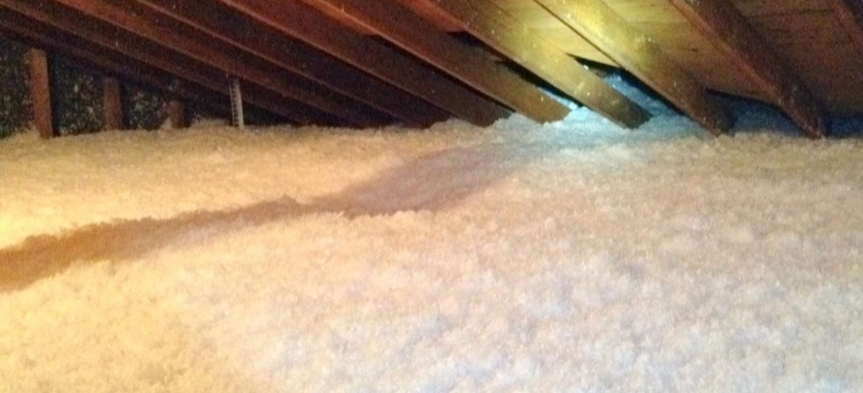
Figure 5 shows a basement rim joist that was completely insulated by the HES vendor using two-part closed-cell spray foam. This was installed, however, as an air-sealing measure, meaning that the homeowner received excellent air sealing, and also an insulation benefit, without having to pay separately for rim joist insulation. NMR auditors saw that some HES vendors thoroughly seal the entire rim joist area with spray foam to achieve higher savings than might be possible with targeting individual penetrations with a spray foam gun/wand.
Figure 5: High Quality Rim Joist Air Sealing Serving as Insulation
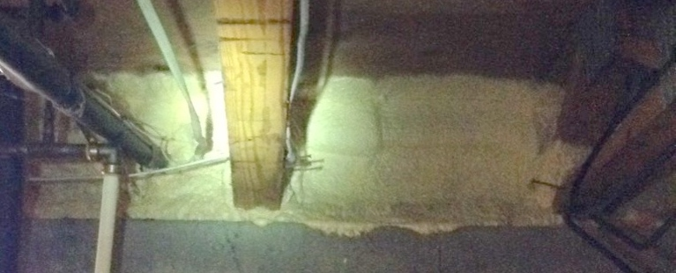
Figure 6 shows a rim joist that was well-insulated (and air sealed) with closed-cell spray foam, but an HES insulator had done a poor job of insulating the basement ceiling. The installation was extremely sloppy and had large gaps and severe compression; the fiberglass insulation was not cut or split to fit around any obstacles, and was forced into the ceiling cavities.
Figure 6: High Quality Rim Joist Air Sealing and Low Quality Basement Ceiling Insulation
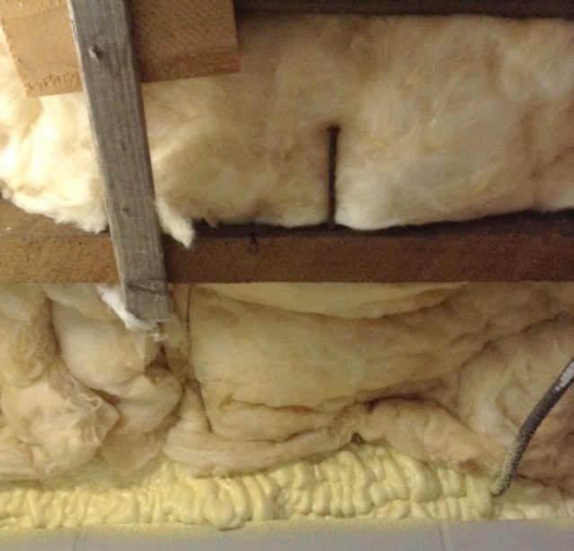

Figure 7 shows a high quality attic insulation job done with spray foam. The HES team had encapsulated the entire attic, turning this into conditioned space.
Figure 7: High Quality Attic Insulation with Spray Foam
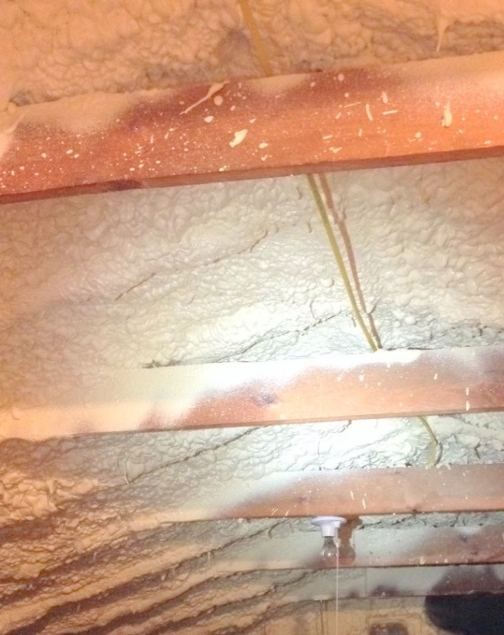

Basement Insulation
HES vendors rarely insulate basement ceilings or rim joists. When they do, this can be quite sloppy (Grade III, meaning severe gaps and compression), particularly if they use fiberglass batts.
Some HES vendors offer a strong value to customers by completely or substantially covering the rim joist areas with two-part, closed cell spray foam for no additional cost. This has a higher material cost to the vendor, but they can achieve greater air sealing reductions, and it provides homeowners with the added benefit of rim joist insulation.

Wall Insulation
Wall insulation is also a rare measure through the HES program. NMR auditors saw reasonably good installations in the two examples seen during quality inspections, but cannot generalize more broadly.
Wall insulation is reportedly a challenge for some vendors, with one vendor describing how they preferred to do more HES audits or simpler attic insulation jobs rather than taking on wall insulation jobs that are labor-intensive (removing siding, boring holes, risk of damaging plaster, etc.).

Attic Insulation
NMR auditors frequently saw high-quality installations of attic insulation, with limited compression and minimal gaps. The best installations also appeared to be the blown-in or spray-applied materials. NMR auditors estimate that about 60% of the attic insulation installs met RESNET’s Grade I standards (high quality). Insulation defects were most commonly seen in hard-to-access areas, where vendors had to work around low ceilings, storage, or other obstacles.
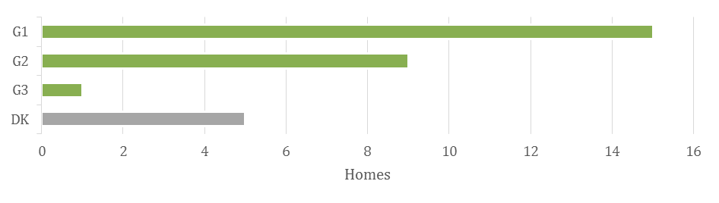
Figure 8: Quality of Attic Insulation Installs (Grade 1 = Best)

Vendor Practices – Recommendations for Add-On Measures
Program staff report that while they are pleased with most of their vendors’ performance, many vendors need to improve their ability to upsell add-on measures to customers, such as insulation. Getting customers to agree to purchase additional efficiency upgrades, such as discounted insulation or HVAC equipment, requires strong sales skills that all technicians may not possess, a problem that program staff recognize.

Vendor Practices – Customer Perceptions
Customers are pleased with the vendors who perform work in their homes. The vendors are perceived as friendly and hard-working, and customers believe they receive a good deal of work for the cost of the co-pay and recommend it to friends and family.

Detailed Findings Related to Vendor Practices
In this section, we present detailed findings from the study related to vendor practices. Findings in Table 7 are color coded based on data source as described in the Methodology section.
Table 7: Detailed Findings (Vendor Practices)
Program Staff | Program staff generally spoke positively about vendors’ performance. Areas that they said that vendors do a good job include scheduling and conducting the audit, identifying savings, collecting data during the assessment, and overall customer service.
 | Areas where staff identified variation among vendors’ performance include their ability to recommend measures via the kitchen table wrap-up and marketing and outreach efforts. In both instances, staff noted that “some vendors are better than others.” When speaking about the kitchen table wrap-up in particular, staff stated that this task requires communication and sales-related skills that not all technicians possess; staff have noted this as an area for improvement.
Data Tracking Records | As discussed in the Participation Patterns section, program records indicate:  - HES vendors air sealed in 92% of participant homes, and they reduced air leakage by 21%, on average.  - HES vendors performed duct sealing at 21% of participant homes, achieving just under 25% improvement, on average.  - HES vendors installed insulation in 14% of participant homes.
Vendors | Six vendors voiced mixed opinions on whether they have experienced any tension between providing comprehensive services and the demand for services—that is, how they decide whether to provide deeper services to few participants or more core or low-cost services to a greater number of participants.  One vendor stated that they opt to provide deeper services to their customers; another vendor, who stated that their company opts for depth over breath, stated that the program has specific guidelines, but the vendor has “leeway to decide whether to dig in or not.”  Others stated that budget constraints as well as the structure of the visit, which involves both the audit and the installation of core measures, limits the amount of work that can be accomplished. In phone interviews and on-site visits, multiple vendors were interested in a program structure that separates the initial audit from the installation of core services.

Some of the HES vendors that NMR spoke with on site do not perform wall insulation work. Some vendors subcontract the work out, while others refer homeowners to specific insulation companies that, in turn, pay the HES vendor a fee or commission for any insulation work performed for the homeowner.
An insulation contractor on site described how some vendors—HVAC companies in particular—achieve higher rates of add-on measure uptake because the people who call them are already interested in add-on measures, whereas HES-only companies may have more customers that are not interested in pursuing additional measures.
Quality Inspections | Overall Assessment of Quality and Thoroughness of Air-Sealing Work.  With occasional exceptions, NMR auditors saw good overall technical quality in the air-sealing work that was done by HES vendors, but the work was frequently incomplete.
 | Some vendors do a thorough job of air sealing and seal as much as could reasonably be sealed in a single visit. As discussed in Opportunities, a large number, however, completely ignore key building components, and most stop short of sealing everything they could, resulting in homes with a mix of well-sealed and un-sealed penetrations.
 | Differing practices can largely be explained by limits to vendors’ time, access issues (hard to reach, storage in the way, etc.), or technician inclination (effort). The QA/QC vendor confirmed this assessment, describing how the work quality can vary greatly depending on the technician’s inclination or the business model of the vendor (more homes vs. greater savings in each home).
Examples of commonly deficient air sealing practices include:
- HES vendors commonly perform no sealing in key building components, even when access is easy, and focus on interior air-sealing work instead (work that is more visible to the customer, in many cases).
- Auditors commonly skip areas where access is complicated, including insulated attics and insulated basement ceilings.
- In the course of air sealing a given building component—e.g., a basement ceiling—vendors frequently missed penetrations that they could have easily seen and reached. Well-sealed penetrations often exist very close to completely unsealed gaps.
- While health and safety issues were found in 11 of the visited homes, only three of the homes had issues that prevented the HES vendors from performing certain core services, such as rim joist air sealing.
Air Sealing in Basement Rim Joists.
Quality. Air sealing rim joist penetrations is a straightforward process from a technical perspective—injecting an expanding, liquid spray foam into cracks and crevices—and with some exceptions, HES vendors appear to do a reasonably good job of sealing these penetrations when they attempt to do so.
Some vendors also approach this work quite differently. Some skip the rim joist penetrations entirely, some use targeted air sealing of visible penetrations, and in a minority of cases, they almost fully cover the rim joist area with two-part spray foam, providing a high level of air sealing and also insulating the area.
Completeness. Additional opportunities for easily achievable air sealing frequently remain; some vendors do not seal rim joist penetrations at all, and most appear to frequently miss readily visible and accessible rim joist penetrations.
Air Sealing in Basement Ceilings (Frame Floors)
Quality. By sealing cracks and penetrations in the ceilings of unconditioned basements, HES vendors can reduce air infiltration due to the stack effect. NMR auditors saw many instances of HES vendors sealing gaps in basement ceilings around electrical wiring, plumbing pipes, and similar penetrations, mostly using liquid spray foam and occasionally using other materials to span larger gaps. This air sealing was typically of acceptable quality, acknowledging that some areas are harder to reach than others with the wand of a spray gun.
Completeness. As with rim joist air sealing, the completeness of basement ceiling air sealing was more of an issue than the quality of the work done. Some vendors skip frame floor air sealing entirely, and most miss at least some visible and accessible frame floor penetrations.
HES vendors also appeared to skip sealing penetrations in basement ceilings that were insulated; vendors would have to move the insulation in order to find and seal penetrations in such basements, substantially lengthening the time required to perform air sealing in basements. Interviews with vendors during on-site inspections confirmed that pulling down insulation to air seal penetrations in basement ceilings is a rare practice and might only be expected around suspected larger penetrations (chimney chases, large plumbing drain pipes, etc.).
Air Sealing in Attics
Quality. As with air sealing in the basement, HES vendors typically appear to do a reasonable job of sealing attic penetrations when they attempt to do so, but thorough air sealing work in attics was uncommon. NMR auditors generally saw liquid spray foam used to seal cracks or penetrations, though HES vendors mentioned a recent program change that required them to use a more fire-resistant material around chimney chases.
Completeness. Attics are difficult places to air seal thoroughly, and outside of their own time constraints, vendor teams can be stymied by limited access or safety concerns. However, based on the attics that NMR auditors could inspect, there appear to be significant opportunities for additional savings from attic air sealing, as discussed in Opportunities. Auditors saw that vendors often skipped air sealing in the attic or air sealed only the most obvious penetrations, focusing instead on air sealing in basements or interior spaces (spaces that also make for more pleasant working conditions). Homeowners with some regularity confirmed that the HES teams had entered their attics to assess insulation, but had not performed work in the attic.
Acknowledging that auditors could not fully assess the air sealing in some attics, the only methodical air sealing NMR auditors saw in attics was in those homes where the attics had been fully sealed and encapsulated at the rafters with spray foam, and in one instance where the HES team appeared to have done a thorough job of air sealing penetrations in the attic floor. They did not see any other instances of methodical air sealing in attics, e.g., thorough sealing of top plates.
During on-site visits, the vendors that NMR interviewed acknowledged the HES program’s stated goal of prioritizing air sealing in attics. They also highlighted many common challenges to actually achieving those savings, where it may be physically difficult to find and seal attic penetrations, including the following:
- Storage and clutter
- Flooring
- Low roof lines
- Small attic hatches
- Dirty working conditions
- Old insulation that may be damaged by disturbing it
- Homeowners who do not want vendors to disturb blown-in insulation
- Safety concerns
  - Unsure footing
  - Hot working conditions in summer
  - Hazardous materials (ALM, vermiculite, or mold, for example)
 | Vendors expressed a general desire to thoroughly air seal in attics, rather than just focusing on “big ticket” penetrations, but when asked to elaborate on their real-world practices, it did become clear that the above barriers can substantially limit the air sealing work that vendors will do in attics, and that these practices vary not just from company to company, but also from technician to technician. Some teams might try to maneuver in tight spaces, move blown-in insulation out of the way to find penetrations, or seal top plates, but the technicians’ willingness to do so varies.
 | Air Sealing at Attic Hatches. HES vendors typically sealed true attic hatches with a plastic weather-stripping material, and in some cases sealed them with caulk, while doors to walk-up attics were generally sealed similarly to exterior doors (weather-stripping and door sweeps).
Weather-Stripping Doors. Unlike air sealing in basements or attics, weather-stripping of doors by HES vendors was essentially ubiquitous, indicating limited opportunity here (other than for instances of failed or removed weather-stripping). NMR auditors saw HES-installed weather-stripping or door sweeps in 96% of the homes they visited—all but 3 of the 70.
The material used for door weather-stripping typically included rubber door sweeps (a common source of customer complaints due to noise or friction with the floor), and a plastic v-seal material, which appeared to have limited durability, as it had started to fail in some of the homes visited.
Vendors who accompanied the NMR auditors on site commented on vendors having the freedom to use their preferred material for weather-stripping doors, and that some chose to use a more durable but more expensive product, though most used the less expensive stick-on material due to its relatively low cost.
Interior Caulking. The caulking used inside homes was usually a clear material (making it hard to see except for its glossy sheen), applied along cracks at window and door frames, casings, and along baseboards and fireplaces. In one particularly egregious example of poor quality work, the vendor had used expanding liquid spray foam to seal a long seam between a wall and vaulted ceiling, leaving a large and unsightly bead of foam that the customer was left to cover themselves.
NMR auditors could not always see signs of interior caulking, and in some cases relied on customer feedback regarding whether or not the HES team had performed this air sealing measure. Auditors confirmed some caulking had been done in 54% of the visited homes, had not been done in 19%, and were unable to tell in 32%.
Duct Sealing
Quality. More than with air sealing, the quality of duct sealing was a clear issue in the homes that NMR auditors inspected. NMR auditors saw mixed quality in the duct sealing work performed by HES vendors, and poor quality applications were seen across all of the common duct-sealing materials. A key concern with poor application of foil-faced tape is the persistence of the savings from duct sealing.
Foil-faced tape was commonly used where mastic could have been applied, and the tape was frequently poorly applied. HES vendors simply did not appear to press the tape down hard enough to firmly adhere it; in many cases had already started to peel off. Mastic applications appeared to result in a more permanent duct-sealing solution, though gaps in mastic applications were still visible in some homes.
NMR auditors saw HES vendors use a mix of mastic, foil-faced tape, and, in rare instances, thick foil-faced mastic/rubber tape or the same spray foam used for air sealing.
Even the HES vendors that NMR spoke with on site expressed frustration that their own technicians were using foil-faced tape when they felt that they should have been using mastic or the thicker tape.
Completeness. The completeness of duct sealing was also an issue. Vendor practices vary and can include:
- Sealing all visible seams
- Sealing seams near the air handler
- Sealing specific, large gaps
- Sealing insulated duct sleeves rather than the ducts themselves
Sealing insulated ducts (other than accessible, visible seams) is uncommon—vendors reported that customers typically do not want them to remove insulation on ducts in order to seal them.
Rim Joist Insulation
Quality. The sole example of fiberglass batt insulation in the rim joists—installed with program rebates—was sloppily installed. The overall installation was judged to be poor quality (Grade 3), and there were areas that had uninsulated gaps and severely compressed areas that were worse than what a Grade 3 designation would allow, under RESNET standards.
The six foam installs—installed as a core air sealing measure, not an incentivized insulation measure—were Grade 1 installs where the foam was applied. While foam does not compress like fiberglass batts, there were gaps in five out of six installs that would be larger than what a Grade 3 designation would allow.
Frame Floor Insulation
Quality. Fiberglass Batts. The installation quality of the fiberglass batts was relatively poor, as is common when using fiberglass batts to insulate basement ceilings. NMR could only inspect three of these four installations.
- All three earned Grade 3 installation overall.
- All three had some severe compression that was also worse than the Grade 3 RESNET criteria.
- Two had gaps that were worse than what a Grade 3 designation would allow.
Only one had support hangers installed to keep the insulation from sagging; it was sagging in the other two homes
 | Quality. Foam and Cellulose. Two homes had spray-foam insulation installed, and one had dense-pack cellulose installed into an enclosed frame floor assembly. Compression and sag are generally less of an issue for foam and dense-pack insulation installs than fiberglass batts in frame floors. There were no noticeable gaps in the foam installs, though there were significant visible gaps in the cellulose install.
Wall Insulation
Quality. NMR auditors only saw two instances of HES-incentivized wall insulation (3% of visited homes), making overall judgments about work quality impossible. Insufficient temperature differentials between indoor and outdoor conditions limited the NMR auditors’ ability to make fully confident insulation grade designations in these cases (per RESNET standards).
In one of those two homes, NMR auditors saw what appeared to be a reasonably good quality installation of fiberglass batts, but this judgment was based only on the homeowner’s mid-construction photos. In the second home, NMR auditors saw what appeared to be a good quality dense-pack cellulose installation, except for several gaps in bays above windows that had been left uninsulated. Auditors could not determine if there had been settling in the cellulose wall insulation.
In one home, the HES vendor had incorrectly read the infrared camera results, telling the homeowner that the walls were insulated, when in fact they remained completely uninsulated.
Attic Insulation
Overall Quality. NMR auditors frequently saw what appeared to be high-quality installations of attic insulation overall, with limited compression and minimal gaps, though some gaps and imperfections were sometimes seen in hard-to-access areas. The best installations also appeared to be the blown-in or spray-applied materials.,
Auditors estimate that 15 of 25 installs (60%) were Grade 1 installations (high quality, according to RESNET standards), indicating very minimal gaps or compression. Grade 2 installs—of good quality, with minor gaps or compression—were seen in nine (36%) of those attics.
Only one—a fiberglass batt installation—was judged poor enough to be counted as a Grade 3 installation (poor) overall. An HES vendor joined NMR during that particular site visit, and judged it a "C-minus," agreeing that the batts had been sloppily installed, and pointing out that the insulators had failed to staple the baffles in place at the eaves and they were falling down as a result.
 | As with air sealing, the insulation defects were most commonly seen in hard-to-access areas, such as near the perimeter of the house where the sloping roof rafters meet the attic floor. Attic storage was also an issue, as some homeowners did not want to give up all of their attic flooring, resulting in reduced savings in some homes.
Blown-In Insulation Evenness
NMR auditors recorded the general appearance of any blown-in or spray-applied attic insulation (n=26). In most cases, the evenness of the insulation was acceptable or quite good:
- 39% of blown attic insulation installs (where we could determine the quality) showed evenly distributed insulation.
- 35% were acceptable or somewhat even (insulation varying by a couple of inches at most).
- 26% were very uneven, indicating a lower-than-expected effective R-value.
Participants | Participants had high praise for the technicians who conducted the audit. They described them as polite, thorough, knowledgeable, and punctual. These qualitative assessments were accompanied by high quantitative ratings of program satisfaction. These were as follows, each using a one-to-ten scale of satisfaction, with higher numbers representing higher satisfaction.  Satisfaction with  - Benefits received: 8.7/10  - Work completed: 8.8/10  - Program literature: 8.8/10  - Experience overall: 8.9/10  Likelihood of recommending  - 9.3/10 (most respondents indicated they already had recommended to friends, family, and co-workers)
Program Administrators | PAs from other programs cited a number of key program elements which the HES program already has in place:  - Using BPI standards and certified technicians  - Incorporating a sales effort through the kitchen table wrap-up  - Leaving materials behind outlining potential energy savings  - Offering air sealing as a core service  - Providing rebates and good financing options to customers
 | One distinguishing feature of other programs included in the best practices review is that the initial audit occurs before installing the three measures of interest. This approach helps with identifying health and safety issues prior to scheduling the work, but it also helps facilitate customer buy-in as they learn about the value of energy-saving measures offered through the program.
QA/QC Vendor | The QA/QC vendor reported that duct sealing is an inconsistent priority, and poorly functioning duct systems may limit the work vendors do.  “Very few duct systems get sealed. The majority of them don’t pass the flow test and/or are in conditioned space. . . . Originally, a lot [of vendors] just used tape; they’ve since moved to . . . mastic. Some companies do a phenomenal job; some companies try not to do it [duct seal]. A lot of . . . companies are trying to do two houses a day and not allocating enough time to properly do the work.”
 | The QA/QC vendor reported that attic insulation through the program is “generally . . . very good,” which supports the findings of the on-site inspections.
The program does not strictly dictate the exact practices and effort that each vendor has to expend on a given home. To reach their MMbtu savings goals, some vendors may be willing to serve more homes and achieve fewer energy savings at each, while others might take the opposite approach.
“Each vendor has their business practices that they decide how they’re going to do it or what they’re going to do. The most important area is the attic; but if a house has 16” of cellulose [insulation], most vendors aren’t going to move the insulation to get to the leaks because they’re concerned they’re going to wreck the insulation. Everyone’s business practice dictates what they’re going to do. . . . Every company is different, and they all perform the work differently. I’ve been instructed by utilities: Some companies do it one way, some do it another way.”
The QA/QC vendor confirmed NMR auditors’ perspectives, which is that work quality varied from job to job.
“Some [vendors] do a great job and some do a poor job. It’s also crew by crew. You might have one company that some of the crews do a really good job and some do a not-so-good job. The majority of them are pretty good. . . . Some guys work hard and get everything. Some guys are just lazy and need to get weeded out of the program. I think a lot of it has to do with time constraints. That would be what I would think is the majority of what’s happening. You [NMR auditor] see what’s required [of vendors], so if they’re going for a four-hour visit, they have to test in, test out, run the blower door, and there’s not much time left for air sealing.
“I think it’s company by company and crew by crew. Some companies’ main focus is in the attic, some spend a lot of time in the attic and do a great job in the attic. I see some where the crews don’t really care that much and do the minimal to get a paycheck.”
According to the QA/QC vendor, some vendors may rush jobs to increase profitability.
“A lot of . . . companies are trying to do two houses a day and not allocating enough time to properly do the work.”

Quality Assurance and Control
6
Quality assurance and quality control protocols (QA/QC) involve inspecting the work performed by a program vendor to ensure that the work is of high quality and is achieving the program’s goals. For the HES program, QA/QC is critical for ensuring that savings are realized, that customers are satisfied with the work, and that work is performed safely. This evaluation investigated the QA/QC protocols used by the HES program and HES vendors themselves, the adequacy of these protocols, what protocols are used by other programs outside of HES, and potential opportunities for improving the HES program’s QA/QC.
Overall, the HES program has strong, formalized QA/QC protocols in place, though HES vendors practice limited internal QA/QC. Because homeowners are not experts, and because much of the core services may occur outside of the customer’s view, customer satisfaction is not always related to the quality of the air sealing, duct sealing, and insulation work, emphasizing the importance of the program’s QA/QC inspections.
QA/QC vendors perform both in-progress inspections (monitoring an HES team while they perform core services) and post-inspections (visiting the home after the services are complete). QA/QC vendors inspect the work of HES vendors, and the HES vendors receive a “scorecard” from the program that rates their performance against program targets and the QA/QC criteria laid out in the program’s Quality Assurance Plan.
Program staff reported inspecting at least 5% of HES projects. The program attempts to inspect a number of homes from all vendors that is roughly proportionate to the number of homes serviced by each vendor. The program reviews vendor scorecards on a monthly basis and supplements these QA/QC scorecards with findings from customer surveys.
Based on our observations on site and discussions with HES vendors, vendors are not universally taking the time to check their own work while on site, nor do they typically perform their own post-inspections, making the program’s QA/QC processes all the more important. Time and cost appear to be key reasons they do not perform thorough internal QA/QC. The program’s QA/QC vendor also noted that getting homeowners to agree to post-inspections can be challenging because the audit has already been conducted and they view their participation as complete.
Vendors support the program’s QA/QC efforts (particularly when the inspectors provide real-time or on-site feedback about best practices), but many complained about specific issues, including the following:
- Overly punitive inspectors
- Inspectors who do not offer on-site feedback
- Limited recourse to dispute negative findings
- Disagreements with inspectors about the most cost-effective or appropriate improvements on site

The QA/QC vendor confirmed that inspections are critical to ensuring that program implementation follows program design, and they allow QA/QC inspectors to quickly identify good and bad vendor performance.
The QA/QC vendors inspect the HES vendors’ work based on criteria laid out in the HES Quality Assurance Plan. Many of these categories focus on safety practices and the overall customer experience, fewer (mostly in the “Blower Door / Flow Test / Duct Blaster” section) focus on the quality and extent of the actual air sealing and duct sealing work itself. There may be additional opportunity to separate the scoring of quality and completeness of work, such that these important metrics of performance can be more fully incorporated into the vendor scoring. Additional analysis of the Quality Assurance Plan and its handling of quality and completeness of work are addressed in Appendix B. It is also worth noting that, given expected programmatic changes in 2016 and onward which will involve increasing the number of HES vendors, program staff anticipate drastically ramping up QA/QC practices in order to ensure that both new and pre-existing program partners are familiar with the program practices and are conducting quality work.
The Quality Assurance Plan includes six categories of inspection areas, each with five or more sub-categories. The general categories are listed below. A complete list of categories can be found in Appendix B, where they are discussed in more detail.
- General HES Safety, Site Arrival, and Visual Inspection
- Safety Testing & Environmental Assessment
- Blower Door / Flow Test / Duct Blaster
- Other Measures
- Kitchen Table Sales and Closing
- Customer Service
Table 8: Perspectives on QA/QC
Program Staff | The Companies have implemented QA/QC procedures to ensure quality services and positive customer experiences. The QA/QC checks assess vendors’ performance in a number of areas, including health and safety testing, audit procedures and measure installation, kitchen table wrap-up, and overall customer service.
 | Program staff and vendors reported that their QA/QC contractors conduct in-progress inspections and post-inspections for at least 5% of projects.
 | Program staff stated that they review results from the vendor scorecards on a monthly basis and take corrective measures as needed. Staff also stated that they use customer satisfaction surveys as another source of information about vendors’ performance.
Data Tracking/Program Documents | QA/QC protocols for judging air sealing and duct sealing quality and completeness are described in the program’s Quality Assurance Plan, particularly in the “Category C: Blower Door/Flow Test/Duct Blaster” section, with relevant scoring categories including the following:  - Blower door in good condition/calibrated  - Blower door operated correctly  - Air sealing prioritized correctly (attic, then basement)  - HVAC Minimum Flow Test performed correctly  - Duct Blaster functional/calibrated  - Duct Blaster operated correctly  - Duct sealing prioritized correctly  The air sealing and duct sealing prioritization categories appear to consider the quality and completeness of work together as one metric for each of those core services rather than more fully separating the issue of quality and completeness.
Vendors | In general, vendors indicated that they support QA/QC activities. Using a scale of one to five, where one equals “not at all effective” and five equals “very effective,” vendors’ average rating was 3.3.
 | Although vendors said that they see the value in the QA/QC activities, the majority of vendors voiced concerns about how it is implemented, including challenges with inconsistent ratings from inspectors, technicians feeling that inspectors were there to harshly critique them rather than help them do better, and lack of opportunity to dispute QA/QC ratings.
During on-site visits with vendors, HES vendors described how they preferred QA/QC inspections to serve as training opportunities, rather than purely observational (or punitive, if the QA/QC vendor observes issues with the work).
The QA feels “punitive rather than rewarding or praising of good work. [As a manager] I want to focus on the positives for my own staff, not just the problems. More money and praise from the program [for good work] would show that they’re not just paying attention to the negative. The score card feels punitive, not rewarding.”
During on-site visits with vendors, a vendor described how they might have different perspectives on what air-sealing measures are worth pursuing than what the QA/QC vendor might prefer—particularly in cases where the customer is uninterested in add-on measures—which can result in being penalized on the vendor’s QA/QC scorecard.
“In [uninsulated] balloon-framed houses, the utility [QA/QC vendor] pushes blocking balloon framing at the rim joist, but that doesn’t pay. . . . They tell us to block balloon frame openings when my guys know what to seal and we waste time on site listening to the QA guy, because blocking those won’t get savings without insulating the walls too.”
When talking with vendors on site, many of them expressed concerns about the importance of QA/QC inspections to verify the blower door and duct blaster results and ensure that technicians’ reported work is verified.
Some “technicians just aren’t honest, it’s easy to cheat on test-in and test-out . . . and the QA inspector doesn’t show up on all the jobs. QC should show up mid-job, and could catch doing whatever they’re doing.”
Vendors appear to practice limited internal QA/QC of their own work. On site, lead technicians may feel that they are too busy to fully check the work of their assistant technician, and return visits for QA purposes appear to be uncommon.
On site, an HES vendor looking at their company’s work said, “I think the [HES] company should do more quality inspections because of what I saw here today. . . . I try to inspect my guys, but we’re short on time. If we didn’t have enough time [on this site], we should have come back a second day. . . . Duct sealing is worth a second day, and a full house with attic and basement and ducts is too much [for one day].”
 | HES vendors confirmed the presence of low-quality work during on-site visits, and in some instances took photos to bring back to their technicians to discuss how to perform core services properly. In one instance, a vendor looked at his team’s work and said, “They were just rushed and didn't do a good job. . . . [To prevent this in the future] we could do more internal follow-up inspections, [maybe] random inspection of the jobs being done.” If the utility company QC inspector had been on this site, they would point at these and say, “missed opportunity, missed opportunity, missed opportunity.”
Quality Inspections | On-site visits with HES vendors confirmed the lack of internal QA/QC practices with some vendors. The managers and lead technicians were frequently surprised and disappointed with what they saw, and in some instances took photos of the work NMR auditors pointed out to bring back to their teams to instruct them on improper air/duct sealing and insulation practices.
Participants | Not being experts in the field of energy efficiency, the participants are not particularly well-placed to comment on the quality of the work conducted in their homes, or the QA/QC practices of the vendors. Homeowners are not expert building scientists and much of the core services happen out of their view. The evaluation did reveal that participants’ high ratings of program satisfaction did not necessarily correlate with the quality of the actual installations in homes which showed large variations.
Program Administrators | The PAs of other programs outside of CT all conduct QA/QC activities to assess contractors’ performance. When asked about the strengths of their QA/QC process, they mentioned the following:  - Using in-progress inspections to monitor vendors and make real-time corrections.  - The HES program utilizes in-progress inspections, but vendors appear to withhold feedback until the end of visits.  - Using a “carrot and stick” approach to provide both positive reinforcement and negative consequences. For example, a few different programs tie vendors’ customer leads to their performance in the program.  - HES vendors seemed to feel that the inspections were often punitive rather than rewarding.  - Having the inspector utilize QA/QC activities as training opportunities or “teachable moments.” The PAs stated that this helps foster more of a mentorship relationship between the inspector and technician.
QA/QC Vendor | In-progress (when a QA/QC vendor accompanies the HES vendor on site) and post-inspections are valuable indicators of HES vendor quality. For in-progress inspections, QA/QC inspectors monitor the work, may ask questions about the team’s practices, may provide feedback at the end of the visit about problematic practices, and submit a report to the utility that gets conveyed to the vendor.  “We have in-progress and post-inspections. For in-progress inspections, [HES vendors] typically do a good job. The in-progress inspections are great because you can see what the technicians do. If you have a guy who follows the rules all the time, he’s going to be smooth and polished and be able to do it. If you’ve got a guy who cheats and shortcuts, he’s not going to be, and you’re going to know.”  “The value [of post-inspections] is very good; we can really go in and see what they did and talk with the homeowner. The homeowner is more comfortable talking to us when the people who did bad work are not present. We can validate what the vendor said they did—what did they miss, what else could they have done?  “For in-progress inspections, we can see if they’re doing everything properly, but they’re on their best behavior. With random post-inspections, they’re going to do their job and not know we’re there until after we’ve done the inspection.”
The QA/QC vendor reported that the QA/QC inspectors do not provide feedback about vendor practices during QA/QC in-progress inspections, and some may not provide feedback immediately after the visit.
“One thing I hear a lot of the vendors complaining about is [not getting] feedback until they get the report two weeks later. I think it’s very important that they get feedback right then. If they get something wrong, they can correct it on the next job. I think it’s very important that it be used as a teaching tool. If there’s somebody new, you can help them refine or learn how to do a better job.”
The QA/QC vendor sees their role as ensuring quality work, but also enforcing the rules of the HES program as stated.
“We have to do what it says based on the HES implementation manual.”
QA/QC vendors appear to only inspect add-on measures via post-inspections, which may be too late to influence the quality of the practices, though they do look for qualities such as ventilation, insulated hatches, depth measurement markers, and evenness of blown-in insulation.
“The only time we see [insulation] is on a post-inspection. We wouldn’t see insulation [being installed] on an in-progress.”
 | In its current form, the QA protocols have a significant focus not just on energy savings, but also on the customer experience. The QA/QC vendor described how many of the criteria they use to evaluate the work of vendors are focused on customer satisfaction, noting that the program’s QA inspection criteria have an “almost equal” focus on energy savings and customer satisfaction, with “savings a little bit more weighted.”
Training and quality QA/QC processes build vendor skill, but remaining profitable and retaining skilled technicians can be a challenge for vendors.
“Some of the newer, smaller companies may not know as much as they possibly should [about program protocols or weatherizing]. You’ve got to expect a guy who’s just started not to know what a guy who’s been doing it five years would know. The ability to retain some of the seasoned professionals is an important thing.”
The QA/QC vendor confirmed that the quality and completeness of air and duct sealing work is combined into one metric for each of these core services, and that there was room to separate out the assessment of these services into more factors that could be counted in the HES vendor’s QA/QC scorecard.
"Maybe there should be more scoring components for air sealing; maybe some kind of completeness issue. . . . Did they miss things? Right now, it’s all lumped into one category: priority air sealing with attic, then basement, then conditioned space. You know, it’s kind of lumped in one. I guess it works the way it is, but maybe it would be better if there were two items: 1) if they hit all the areas, 2) completeness.”
 | Judging the quality and completeness of work is “subjective,” but the QC vendor inspects the home to look for “areas they didn’t seal that are readily accessible, and try and see did they miss anything? Is there areas that they just didn’t do? And why didn’t they do them? So then you interview the homeowner . . . did you tell them you didn’t want them to work in some areas, [etc.]?”

Drivers, Motivations, Obstacles and Barriers
7
A focus of the evaluation was assessing what motivates customers to participate in the program, as well as the obstacles or barriers they face in that decision. When asking customers themselves to cite their greatest motivations to participate, saving money (48%), fixing their homes or identifying areas for savings (41%), and saving energy (35%) were the most common responses. These same reasons were echoed by program staff both from the HES program and from those working in similar program capacities from the best practices interviews who correctly identified that customers tend to be motivated by wanting to save money on their energy costs or by conserving energy in general. While mentioned by fewer customers (16%), another interesting theme across interviews was the motivation to participate in the program simply as a prerequisite for solar panel installation. Vendors corroborated that while the audit requirement for panel installation can be a driver for core measures, it may actually act as a barrier to add-on energy upgrades. The audit allows solar customers to benefit from the HES visit, but these customers tend to have little motivation to pursue deeper savings because their interest in the audit only extended to qualifying for solar panel loans.
Interestingly, customers themselves cited very few obstacles or barriers to participating in the HES program. The majority of respondents (85%) said they did not face any obstacles to participation. Those who did mention obstacles discussed difficulties they had with figuring out and completing the rebate application, issues with scheduling the visit, or procrastination on their own part.
The main obstacle cited by vendors (and confirmed by program staff) were the health and safety issues they often face when conducting the audit. The discovery of mold, asbestos, knob and tube wiring, vermiculite insulation, gas leaks, etc., frequently force technicians to halt the audit because some core measures cannot be installed until the issues are remediated. Vendors estimated that health and safety issues occur in roughly one-quarter of all jobs (with estimates ranging between 5% and 40%). Allowing the program administrators to provide incentives to help address health and safety issues would allow vendors to access greater savings in these homes.
Ultimately, the approach of sending a pre-inspector to observe homes before committing full vendor resources would likely be a benefit, particularly for addressing health and safety issues. The program as it is currently designed can accommodate this technique, but few vendors take the approach or believe that it is not a sanctioned strategy. Program administrators could consider revising training and making it a recommendation, perhaps by providing part of the incentive for the pre-inspection or allowing some vendors to only do pre-inspections and then pass homes to other vendors.

Table 9: Perspectives on Drivers, Motivations, Obstacles, and Barriers
Program Staff | Program staff said that customers’ decisions primarily stemmed from a desire to save money on energy costs or conserve energy.
 | Program staff and vendors consistently reported that health and safety issues are a significant barrier to program participation. Vendors estimated that the presence of health and safety issues prevents them from performing core services.
 | Besides health and safety issues, the upfront cost of the energy upgrades was frequently cited as a considerable barrier for customers.
Vendors | Vendors felt that the decisions to pursue deeper savings through add-on measures were driven by customers’ energy cost concerns; 22 vendors cited this a primary driver. Other reasons for participating in HES, according to vendors, include improved comfort (14), program rebates and incentives (9), energy savings (5), and environmental concerns (3).
 | Participating in HES as a prerequisite for solar panels was mentioned as a driver for core measures but a barrier to add-on energy upgrades. Some vendors stated that the visit allowed those seeking solar panel loans to benefit from the HES visit, while others stated that some customers who participated for this reason did not pursue deeper savings (insulation) because they were only interested in the HES visit to qualify for their solar panel loans.
 | Like program staff, vendors stated that health and safety issues present significant barriers to program participation. The most common issues cited by vendors include asbestos, mold, carbon monoxide leaks, and gas leaks. On average, vendors stated that health and safety issues represented roughly 25% of all jobs (their estimates ranged between 5% and 40%). This was confirmed during on-site interviews with HES vendors, a couple of whom estimated that about 20% of their jobs have health and safety issues.
 | Vendors reported that gas leaks are most likely to be remediated because of the immediate danger involved; asbestos is least likely because of the cost to the homeowner.
 | Other common barriers identified by vendors that might not completely prevent work but can limit the amount of work they can do include lack of access to equipment or areas of the customer’s house, as well as customers’ refusal to install measures because of aesthetics or fear of potential damage to the home.
On site, a vendor reported that it is easier for some types of vendors to meet the Companies’ MMbtu goals than it is for others.
“We are graded by program on MMbtu savings per house, but we can’t meet that goal without up-sell measures. . . . We have to service people fast, and because we are an insulation company, there is risk that all our customers don’t want services beyond the HES core services, whereas HVAC [HES] people are selling [up-sell measures] to every customer. We are taking a risk by not being guaranteed a sale.”
Quality Inspections | Barriers to Air Sealing  During on-site visits, HES vendors described—and this was confirmed via inspections—that their work could be limited by time, access issues (hard-to-reach, hidden behind insulation, storage in attics and basements, etc.) and technician effort. While access issues can be a problem, in most of the homes that NMR visited, access issues typically would have made the work more difficult, but rarely impossible.  Attic air sealing, a program priority, can be limited by:  - Storage and clutter  - Flooring  - Low roof lines  - Small attic hatches  - Dirty working conditions  - Old insulation that may be damaged by disturbing it  - Homeowners who do not want vendors to disturb blown-in insulation  - Safety concerns  - Unsure footing  - Hot working conditions in summer  - Hazardous materials (ALM, vermiculite, or mold, for example)
Barriers to Duct Sealing
Most of the barriers to performing complete air sealing apply to duct sealing as well, such as time limits, access issues, and limits to technician effort. In addition, duct sealing can be a challenge because when ducts are insulated, HES vendors are hesitant or unwilling to remove insulation in order to find and seal potential leaks, and customers usually seem to be unwilling to have vendors remove this insulation, according to HES vendors.
Barriers to Installing Insulation
The HES vendors that accompanied NMR on site visits described some of the challenges that insulators face in retrofitting insulation into homes.
  - Hassle
    - Preference of some vendors to avoid complicated/multi-day wall insulation jobs in favor of core measures
      - “We don't do much [wall insulating]. I use wall affiliates, and we get money back from them for sending them the work. . . . I like one-day jobs, like [insulating] attics, rather than walls.”
  - Safety issues
    - Knob and tube wiring
    - Asbestos-containing siding
  - Physical barriers
    - Hard-to-remove siding (fragile or multiple layers)
    - Brick facades requiring interior installation of insulation
    - Pipes, wiring, hidden framing members, etc., inside wall cavities
    - Pre-existing insulation preventing the addition of new insulation
Participants | 85% of customers did not think there were any obstacles or barriers to participating in the program. Those that cited any obstacles did not respond in one accord—issues included scheduling, procrastination on their own part, the rebate period having run out, or the rebate application being complicated. Of those who had insulation installed, 75% said there were no obstacles particular to the insulation installation.
 | Participants’ main motivations to be part of the program were saving money (48%), fixing their homes/identifying areas for savings (41%), and saving energy (35%).
 | Some customers (~16% of visits) participate in HES only because it is a requirement of having solar or other energy efficiency measures installed. In these instances, their insights are not likely to be as useful to the program because they have trouble differentiating any changes they have seen in their energy/electric bill between the audit and the solar measures. Most felt that solar panels have had more of an impact on any of the changes they have seen. There were also instances (n=~5) where the audit was a requirement for new windows/insulation rebates.
 | Other PAs expressed that they experienced similar drivers of and barriers to participation with their programs.
Program Administrators | Other programs have found a limited number of ways to address health and safety issues.  - The Mass Save Home Energy Services program offers a pre-weatherization incentive for the three most prevalent issues: failed combustion safety, knob and tube wiring, and improper dryer venting (up to $300 for combustion safety and $250 for knob and tube wiring and/or improper dryer venting).  - Rhode Island’s EnergyWise program offers a similar incentive (up to $250) for the homeowner to address barriers (including health and safety hazards) which would prevent weatherization services.  All of the programs also offer loan products which provide limited funding for remediation of more substantial issues like vermiculite insulation, but do little to address more immediate concerns that would prevent initial testing during the audit.
QA/QC Vendor | The QA/QC vendor reported that HES vendors face challenges in retaining skilled technicians. They say that their “pay is getting cut, benefits are being lost. So the morale is not very good. . . . The big picture of what these guys are complaining about is the bid prices continually get lower and lower . . . so the guys are expected to do more work for less pay and less benefits. . . . Some of the good companies that historically have been in the program are able to keep their better people . . . who can train the new people how to do the job properly.”

- Detailed Methodology
A
The R151 study collected and analyzed data from eight sources, including program data tracking records, program staff, participating vendors, program administrators at other leading programs, program participants, on-site quality inspections, and a program QA/QC vendor. Work completed for the study can be categorized into eight key evaluation tasks, as outlined in Table 2. For ease in identifying the data source of findings, throughout this report we adhere to a color coding scheme included in the table below.
Table 10: Evaluation Tasks
Task | Description | Data Source | Quantity
1 | Program data tracking and document review | Data Tracking and Program Documents | 17,968 homes
2 | In-depth interviews with program staff | Program Staff | 2
3 | In-depth interviews with vendors | Vendors | 23
4 | On-site quality inspections | Quality Inspections | 70
5 | On-site in-depth interviews with program participants | Participants | 70
6 | On-site in-depth interviews with participating vendors | Vendors | 10
7 | In-depth interviews with program administrators from leading programs | Program Administrators | 5
8 | In-depth interview with Quality Assurance and Quality Control (QA/QC) Vendor | QA/QC Vendor | 1
  - Description of Evaluation Elements
    - Program data tracking review
The evaluation includes an analysis of program tracking data to explore and identify any patterns of air sealing, duct sealing, and/or insulation by utility, vendor, and home characteristics. The review included 2014 participant program databases from Eversource and UI.
    - In-depth interviews with program staff
An initial task of the evaluation included in-depth interviews with two members of the HES program staff, one from Eversource and one from UI. These interviews served as a method for understanding program goals and objectives; providing background on the program’s design and implementation; identifying common barriers to and opportunities for expanding air sealing, duct sealing, and insulation; and determining current program QA/QC activities and program staff perceptions on the quality of installation of these three measures of interest.
    - In-depth interviews with participating vendors
Given the relatively small pool of vendors and overlapping research objectives, in-depth interviews with program vendors were coordinated with R4 HES/HES-IE Process Evaluation as well as R157 Multifamily Process Evaluation. This coordinated approach endeavored to maximize efficient outreach to program stakeholders and minimize respondent fatigue. The questions for this evaluation focused primarily on understanding vendors’ practices related to air sealing, duct sealing, and insulation, including assessing program protocols regarding quality installation, identifying common barriers and opportunities for deeper energy savings, and outlining the program’s QA/QC activities.
    - On-site quality inspections
During on-site inspections of HES-participant homes, NMR HERS Raters assessed the quality and completeness of the air sealing, duct sealing, and insulation work performed through the program. Most inspections lasted about an hour, and they ranged from about 30 to 90 minutes.
NMR auditors assessed the air sealing at the following locations, with a particular focus on finding readily accessible gaps that were not sealed and looking for signs of low- and high-quality sealing work:
- Rim joist penetrations
- Basement ceiling penetrations
- Attic penetrations (in accessible attics)
- Attic hatches
- Doors
- Interior living spaces
Auditors recorded the material used and assessed the quality and extent of duct sealing at:
- Air handler seams
- Accessible/visible duct seams/joints
Auditors rated the quality of insulation installations in accordance with RESNET standards and recorded other indicators of quality installation, such as the evenness of blown-in insulation. They visually inspected these installations whenever possible and used infrared cameras in the few instances of sufficiently cold weather. Auditors assessed insulation installed in:
- Attics
- Exterior walls
- Knee walls and foundation walls
    - On-site in-depth interviews with program participants
A 20- to 30-minute in-person interview was conducted with the homeowner by NMR staff while a second NMR technician proceeded throughout the home to assess the quality of installations. The in-depth interview assessed which measures the customer had installed and whether they had removed any measures, whether the customer had noticed any energy or non-energy benefits since having the audit completed, whether the vendor had found any health and safety issues during the audit, customers’ experience with financing options discussed during the kitchen table wrap-up, any drivers of or barriers to their participation, and their satisfaction with having been a program participant.
    - On-site in-depth interviews with participating vendors
In 10 instances, employees of the HES vendors that performed work at a given home accompanied NMR auditors to the site visit. The NMR auditors conducted in-depth interviews with vendors and asked them for candid feedback about their real-world air sealing, duct sealing, and insulation practices, as well as their experiences working with the HES program. In addition, the NMR auditor and HES vendor walked through the homes together, looked at the air sealing, duct sealing, and insulation performed at the homes, and talked about the quality of the work they saw; the NMR auditors probed the HES vendors to rate the work of their teams and discuss any challenges that the vendor faced at the home.
    - In-depth interviews with program administrators for other leading programs
The evaluation also included a review of best practices from other programs that address air sealing, duct sealing, and/or insulation. This involved a review of available program reports and documents as well as in-depth interviews with program administrators. The interviews focused on programs’ practices related to greater levels of installation of the measures of interest, strategies for increasing customer adoption, and approaches to QA/QC to assure that savings are being achieved.
    - In-depth interview with program QA/QC vendor
The NMR team conducted an interview with one of the HES program’s QA/QC vendors, which lasted over an hour. The interview discussed strengths and weakness of the QA/QC protocols, the quality of HES vendors’ work, and drivers and barriers the vendors face in implementing the services and participating in the program.
  - Description of On-Site Inspection Protocols
    - Basement Air Sealing
NMR auditors looked for signs of air sealing by the HES vendors in the basements they visited. They assessed the amount of air sealing at the following locations:
- Rim joist penetrations at the tops of basement walls, where ambient air can leak into basements
- Penetrations in the ceilings of unconditioned basements (also referred to as frame floors), where unconditioned basement air can enter the conditioned spaces above
In many cases, these penetrations are accessible and visible to HES vendors and are excellent opportunities for air sealing. However, NMR recognizes that some of these penetrations can be quite difficult to seal. Some are hidden behind insulation, framing, or other mechanical equipment, while others might be difficult to access due to an excessive amount of storage in a basement. In basements, NMR looked particularly for instances of “low-hanging fruit,” or penetrations that could have been easily sealed—those that were exposed and reachable without taking down insulation or moving a customer’s belongings—but had not been sealed by HES technicians.
    - Attic Air Sealing
Whenever possible, NMR auditors looked for signs of air-sealing work done in the attics of the homes they visited. They assessed whether or not the HES vendors had performed air sealing at:
- Attic penetrations visible from the attic space (gaps at top plates, electrical penetrations, and so forth)
- Attic hatches
In accessible attics, NMR auditors lifted easily accessible batt insulation and looked for reachable and visible penetrations near attic hatches that vendors would have been expected to target, but avoided disrupting freshly blown-in or deteriorating insulation. NMR auditors also asked homeowners to describe whether or not they recalled the HES vendors entering or spending time in the attics in order to provide clues about the level of air sealing done.
    - Interior Air Sealing: Weather-Stripping Doors and Caulking
As a part of the work plan for this project, NMR auditors did not plan to inspect for signs of interior air sealing, such as weather-stripping of doors or interior caulking of cracks, but the team decided to collect this information as an additional resource regarding HES practices.
NMR auditors looked for signs that the HES vendors had weather-stripped doors and done any interior caulking around baseboards, fireplaces, or window and door frames. Auditors did not assess the quality or amount of these air sealing measures because that would best be accomplished with a blower door running or with a vendor present, which was not always the case.
    - Insulation
NMR auditors inspected the insulation quality of building components that were insulated through the HES program, including the following:
- Wall insulation in exterior walls
- Attic insulation
- Rim joist insulation
- Frame floor/basement ceiling insulation
- Knee wall insulation
When possible, they inspected insulation visually and used an infrared camera in the few instances where it was sufficiently cold to render clear infrared images. Auditors attempted to record the following:
- Overall insulation grade (Grade 1: best, Grade 2: acceptable, Grade 3: fair/poor)
- Presence of gaps and/or compression worse than a Grade 3 install
- Visible settling at tops of walls or sag from the subfloor

- Potential QA/QC Protocol Opportunities
B
To ensure quality retrofit work, the Connecticut Home Energy Solutions (HES) program periodically assesses the performance of its vendors using Quality Assurance inspectors who accompany the vendors to customers’ homes. The inspectors evaluate the vendors’ performance against various criteria identified on the program’s Quality Inspections Form (QI Form), described fully in the program’s Quality Assurance plan (QAP). In order to ensure that customers have a positive experience with the HES program, many of the vendor behaviors subject to review go well beyond the actual performance of the weatherization work and relate to the vendors’ customer service and safety protocols.
This appendix discusses some of the specific practices mentioned in the QAP and the 2015 draft HES Implementation Manual to identify potential opportunities for providing additional guidance to HES vendors on how to meet the program’s goals.
  - HES Quality Assurance Plan Criteria
The QI Form requires QA inspectors to rate HES vendors on the following criteria. This memo discusses only those in bold in the third category, including blower door, air sealing, and duct sealing practices.

Category A: General HES Safety, Site Arrival, and Visual Inspection
- On-time arrival
- Parked safely/with HES logo
- Program explained to customer/obtain signed customer form
- Tech has synced on-site app prior to visit
- Walkthrough visual inspection
- Home area, volume measured, and maximum air-sealing limits calculated prior to sealing
- Fireplace checked/secured
- MSDS sheets available
- First aid kit available
- Fire extinguisher available
- HES vendor supplies and uses tools properly
- PPE worn
- Ladders used properly

Category B: Safety Testing & Environmental Assessment
- Report hazardous conditions (asbestos, CO, etc.)
- Ambient CO>35ppm = no blower door test
- Gas leak test
- Worst case depressurization test (back drafting)
- Test for flame interference from furnace burner
- Combustion appliance flue gas spillage tests
- Measure draft in flue pipes
- CO measured in combustion flue pipes
- Test out
  - CAZ, CO, draft, spillage, minimum duct airflow

Category C: Blower Door / Flow Test / Duct Blaster
- Blower door in good condition/calibrated
- Blower door operated correctly
- Air sealing prioritized correctly (attic, then basement)
- HVAC Minimum Flow Test performed correctly
- Duct Blaster functional/calibrated
- Duct Blaster operated correctly
- Duct sealing prioritized correctly

Category D: Other Measures
- CFL mercury clean-up explained
- Light sockets inspected for bulb replacement
- Bulb installation and customer engagement
- Hot water pipes wrapped
- Water-saving hardware installed and explained

Category E: “Kitchen Table” Sales and Closing
- Restore power and original settings to equipment
- Clean up and remove waste
- Summarize work to customer
- Summarize potential work, rebates, and financing options
- Leave survey form

Category F: Customer Service
- Techs introduce themselves, present ID
- Proper language used
- No smoking
- Clean attire and appropriately dressed
  - Blower Door Operation: Assessing Basement Conditioning
To properly perform blower door tests and perform air sealing, HES auditors must use their judgment and experience to determine the boundaries of a home’s thermal envelope. Basements in existing homes can prove to be particularly challenging because it may not be immediately clear, even to those with building science training, whether a given basement is best considered to be within the thermal envelope or outside of it. To decide if a basement is fully conditioned, building scientists have to consider the level of finish of the basement, the amount of insulation in the basement, and the type and amount of intentional heating or cooling being introduced to the space.
Key Questions
How do vendors assess basement conditioning?
Are vendors indirectly incentivized to call basements “unconditioned”?
The HES implementation manual itself provides limited guidance for vendors on this topic, relying instead on the program’s training and the vendors’ own experience and certifications to ensure that they are adequately trained to make such determinations. The following excerpts from the March 2015 draft implementation manual comprise the HES implementation manual’s sole references to identifying the level of conditioning of basements:
- “Note at this time whether the basement is conditioned, unconditioned, or ‘hybrid.’” (Section II.E.3)
- “If the basement is deemed intentionally ‘conditioned,’ the door to the basement should remain open during the [blower door] test.” (Section II.G.1.c)
If there is ambiguity in the HES guidelines, vendors may be unintentionally incentivized to err on the side of whichever option allows them the greater CFM50 reduction. For example, vendors may achieve better blower door results by treating partially conditioned basements as unconditioned spaces, sealing penetrations between the basement and ambient conditions, and isolating the partially conditioned basement from the rest of the house, thus resulting in improved blower door results. On a previous baseline study where NMR auditors accompanied HES vendors to customer homes, NMR auditors did notice that the HES vendors often considered basements to be unconditioned, even when they arguably could have been considered conditioned spaces (such as if they were finished and insulated).
To ensure consistency and comparability of results between vendors—and to ensure that vendors are not sealing off finished areas that would typically be included in blower door tests—the program could require vendors to report on the following physical characteristics for each distinct basement area:
- Is the basement area fully finished or fully heated?
- Are the foundation walls a) completely insulated, b) partially insulated, or c) uninsulated?
- Is the frame floor above the basement insulated?
- Are there minor vents cut into the basement ducts?
  - Air Sealing Practices
    - HES Implementation Manual Guidelines for Air Sealing
While the evaluation criteria measure performance relative to approved HES practices, the 2015 draft HES implementation manual provides little in the way of specific air-sealing instruction for vendors (Section II.G.1.). Along with identifying seven unacceptable temporary measures, a summary of the program’s guidance for air-sealing practices includes the following:
- Use foam, caulk, or weather-stripping
- Seal the attic, then basement, and then living space
- Seal large leaks first
- Do not seal homes tighter than the calculated minimum Building Airflow Standard (BAS; this would trigger mechanical ventilation to offset the tightened envelope)

The program appears to offer mostly general rather than detailed guidance in the implementation manual regarding air-sealing practices, indicating that the program prefers to rely less on the implementation manual and more on the program trainings and vendors’ own professional experience and certifications to ensure best practices for air sealing.
Just as the manual identifies seven clearly unacceptable practices, the program could consider adding a greatly abbreviated version of some of the training materials from its own vendor trainings (or from BPI) to provide reminders of specific best practices, such as a checklist of common air-sealing opportunities, in addition to the limited and general guidance identified above.
    - HES Quality Assurance Plan Guidelines for Air Sealing
The HES QAP identifies air sealing as a key program priority. Quality assurance inspectors rate the HES vendors’ air-sealing practices against the following statement using the four criteria that follow:
“Priority blower door sealing was done starting with attic first and then basement.
  - “E[xceeds program expectations]: Priority sealing performed properly as per approved procedures, opportunities for sealing identified and performed; exceptional effort expended to seal in attic, basement and attached garage (if present).
  - “M[eets program expectations]: Priority sealing performed properly as per approved HES core procedure. All program level opportunities for sealing are addressed.
  - “P[artially meets program expectations]: Envelope sealing not prioritized or outside the heated envelope barrier, an obvious opportunity skipped (inspector to document what is missed here)
  - “U[nsatisfactory; has not met program expectations]: Envelope sealing not prioritized, several obvious opportunities missed, areas not accessed for invalid reasons, areas sealed in error, sealing inefficiently beyond scope, sealing outside of customer direction (inspector to document these items)”
A key difference between receiving an assessment that the vendor’s work “exceeds” or “meets” program standards for air sealing revolves around the vendor’s use of “exceptional effort” to seal the home. In some instances, HES vendors will be able to tighten a home’s envelope sufficiently to reach the home’s minimum Building Airflow Standard—the threshold at which mechanical ventilation is needed to introduce fresh air into the building; the QA standards do not address how “exceptional effort” relates to the building’s performance relative to the BAS. The program could consider clarifying for HES vendors how the QA inspectors assess the performance of vendors who meet the minimum BAS during their air-sealing work, particularly in those instances where “exceptional effort” was not needed to meet that goal, such as a home that was already relatively well sealed.
If it does not do so already, the program could track homes that were sealed to the minimum BAS and use them as an additional performance metric for vendors. Vendors may not always need to exert exceptional effort to meet the BAS (though they typically will) and, conversely, they may not always be able to meet the BAS even if they do exert exceptional effort, but this is likely a good indicator of consistent, high levels of performance.
  - Duct Sealing Practices
    - HES Quality Assurance Plan Guidelines for Air Sealing
The HES QAP identifies duct sealing as a key program priority. Quality assurance inspectors rate the HES vendors’ duct-sealing practices using the following rating criteria:
“Priority Duct Blaster sealing was done.
  - “E[xceeds program expectations]: Exceptional effort expended when properly performing sealing per the HES Implementation Manual and BPI Standards. All opportunities for sealing identified and performed.
  - “M[eets program expectations]: Sealing performed properly as per HES Implementation Manual.
  - “P[artially meets program expectations]: At least one obvious sealing opportunity missed as documented by inspector.
  - “U[nsatisfactory; has not met program expectations]: More than one obvious sealing opportunity missed as documented by inspector.”
The QAP guidelines defer to external criteria such as the HES implementation manual and BPI standards, but the implementation manual provides little specific guidance for duct-sealing practices. Other than the proper materials (mastic or the appropriate tape) and direction to focus on areas near the air handler, the manual defers to the vendors’ experience or participation in program training to ensure that they are adequately trained to best seal ducts.
- Air Sealing, Duct Sealing, and Insulation Practices – Examples from Site Visits
C
During their visits to HES participant homes, NMR auditors photographed examples of the air sealing, duct sealing, and insulation practices seen on site in order to show examples of good, bad, and typical practices. Below are examples of the practices that auditors saw in homes during these quality inspections, with photos and brief descriptions.
  - Air Sealing Practices
NMR auditors inspected the quality and completeness of the HES vendors’ air-sealing practices in basements, attics, and interior spaces.
Figure 9: Incomplete Attic Air Sealing
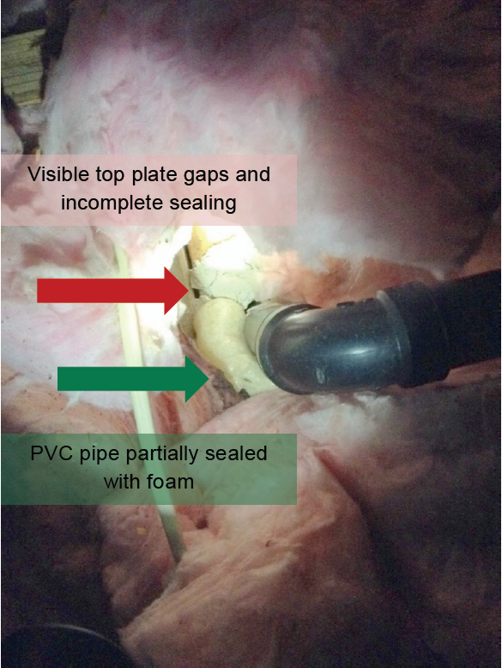
Figure 9 shows a common problem with attic air sealing; insulation covers the attic floor, making attic penetrations harder to see. In this case, however, the HES vendors saw a major penetration around the black PVC pipe, but they only partially sealed it and left the top plate gaps right next to it unsealed. The team did not otherwise seal any top plates in this home and left a large duct chase completely open.

Figure 10 shows the ceiling of an unconditioned basement. On the right, the HES vendors sealed a large penetration around water lines and framing members using a combination of tape, bubble wrap, and spray foam. However, on the left, a large gap around framing members that was only one foot away was left unsealed; seeing well-sealed and unsealed penetrations in close proximity was common in the homes NMR visited.
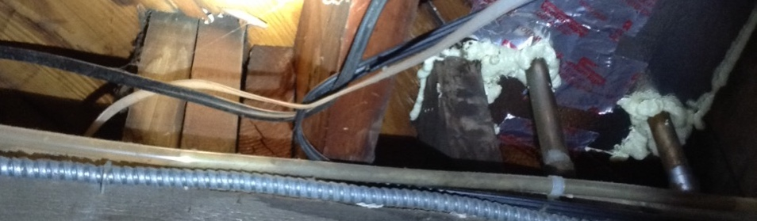
Ceiling gaps sealed
Gaps around framing unsealed
Figure 10: Incomplete Basement Ceiling Air Sealing
Figure 11 shows air sealing around a plumbing drain pipe that comes down from the first floor into the basement. The HES vendor used spray foam to seal about three-quarters of the large gap around the plumbing penetration. A gap also remains between the black pipe and the white sheathing material.
Figure 11: Incomplete Sealing around Basement Ceiling Penetrations
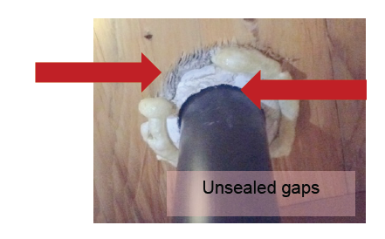
Figure 12 shows a basement rim joist that the HES team mostly covered with two-part closed cell spray foam as an air-sealing measure. It was applied at no additional cost to the customer, and where it covered the wood it served as an insulation measure as well. However, the team missed a large, visible hole around a water line, which remained as a source of air leakage into the basement.
Unsealed gap
Figure 12: Rim Joist Insulation and Incomplete Air Sealing
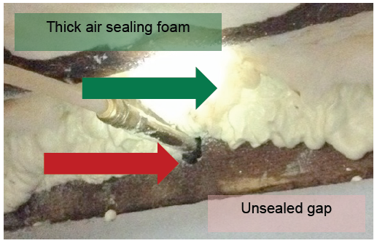
Figure 13 shows an example of an HES team using a temporary measure—clear plastic tape—to seal a large opening in a basement ceiling. This was an intentional opening/grate (over one square foot) that was likely used to allow warm air from a since-removed basement heating system to rise up into the first floor living space. The tape the HES team applied was peeling off, and the initial blower door reduction numbers the HES team achieved do not represent persistent savings.
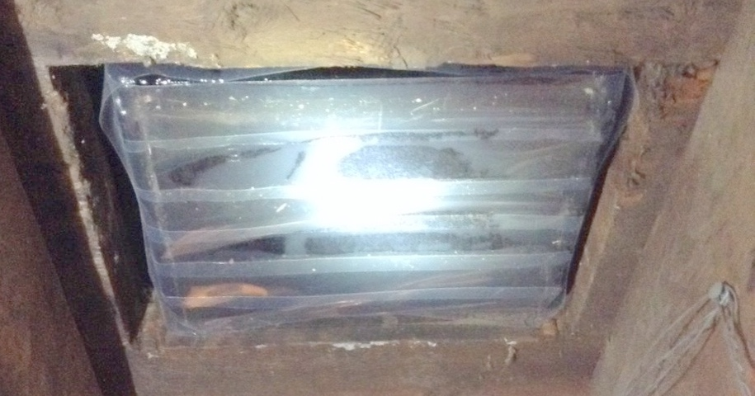
Non-permanent/peeling tape used to cover large grate
Figure 13: Inappropriate Basement Ceiling Air Sealing
  - Duct Sealing Practices
NMR auditors also inspected the quality and thoroughness of duct sealing seen in HES participant homes. The following photos show a mix of good and bad work quality on the part of the HES vendors.
Figure 14 shows a poorly sealed duct system. This portion of duct work was located at chest height and was readily accessible. The photo shows poorly adhered foil tape that was peeling off, a large hole that could fit at least two fingers into the opening, and a smaller, unsealed hole at a junction between duct sections. Sloppy tape applications were a common problem in the visited homes.
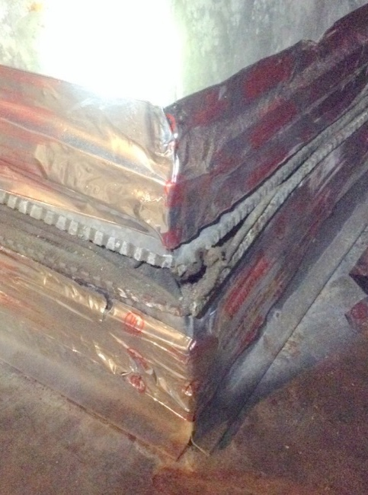
Small hole
Large hole
Peeling tape
Figure 14: Poorly Sealed Ducts

Figure 15 shows an attic duct system where the HES technician had sloppily applied foil tape, and it was peeling off. The technician had also not applied tape to the underside of the flex duct junction, leaving it unsealed. This was a particularly poor example of duct sealing seen during on-sites.
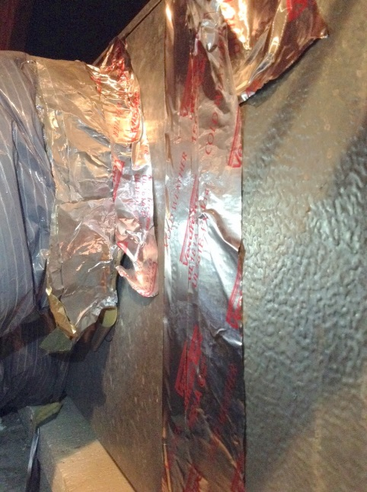
Peeling tape
No tape applied to underside of ducts
Figure 15: Poor Quality and Incomplete Duct Sealing

Figure 16 shows a high-quality example of duct sealing with mastic. The mastic was thick and covered all accessible seams. NMR auditors saw multiple instances of such high-quality duct sealing services during on-site visits.
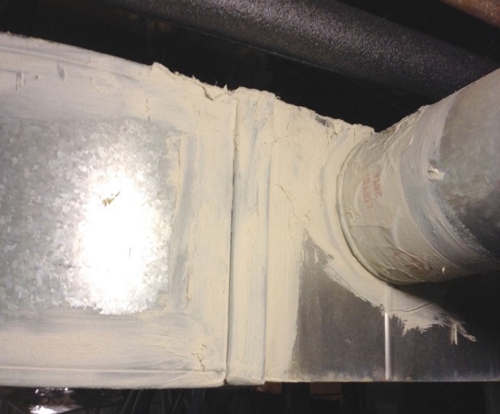
Figure 16: High-Quality Duct Sealing with Mastic

Figure 17 shows an example of a poorly sealed duct system in an attic. The photo shows the panned return cavity on the attic floor; the sheet metal enclosing the wood return cavity was completely unsealed (the gap was about 10 linear feet in all), and there was a large opening at the bottom of the return cavity—it was not sealed to the attic floor. A large amount of attic air was pulled into this HVAC system, and even though the HES vendor had done some air sealing, they had not sealed this readily accessible source of duct leakage that was located directly in front of the attic hatch.
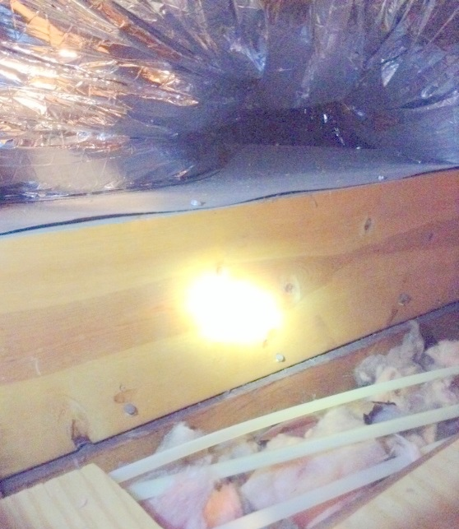
Gap between wood and attic floor
Gap between sheet metal and wood
Figure 17: Unsealed Attic Ducts

Figure 18 shows a future health and safety issue that the HES team did not address, but likely could have. The last few inches of an AC refrigerant line were uninsulated, and condensation was forming and dripping onto the furnace’s exhaust vent, causing rust and corrosion. A pie plate below was catching the condensate. Fixing this may not have strictly been within the scope of the HES team’s work, but they most likely had foam pipe insulation (that they use for insulating domestic hot water lines) that could have been used to fix this problem for the homeowner.
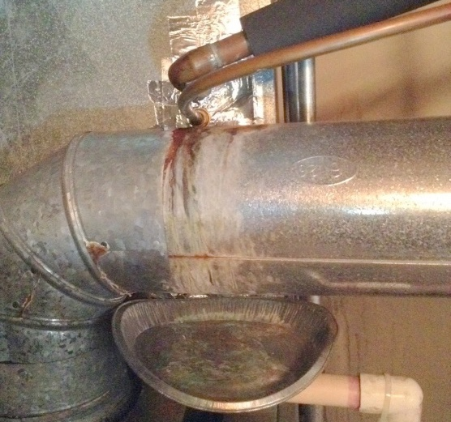
Uninsulated refrigerant line causing rust on exhaust vent
Figure 18: Future Health and Safety Issue – Condensation Rusting Exhaust Vent
  - Insulation Practices
The following are examples of good, bad, and typical practices related to insulation installations by HES vendors.
Figure 19 shows a high-quality example of blown-in fiberglass insulation in an attic. The insulation was deep, quite level, and also installed over a room that was difficult to access from the main attic space. The homeowner reported having to push the insulators to get them to insulate this harder-to-access space, but the final work product appeared to be of high quality.
Level insulation
Figure 19: High Quality Blown-in Attic Insulation
Figure 20 shows a basement rim joist that was completely insulated by the HES vendor using two-part closed-cell spray foam. This was installed, however, as an air-sealing measure, meaning that the homeowner received excellent air sealing and also an insulation benefit without having to pay separately for rim joist insulation. NMR auditors saw that some HES vendors thoroughly seal the entire rim joist area with spray foam to achieve higher savings than might be possible with targeting individual penetrations with a spray foam gun/wand.
Figure 20: High Quality Rim Joist Air Sealing Serving as Insulation
Foam covering rim joist
Figure 21 shows a rim joist that was well-insulated (and air sealed) with closed-cell spray foam, but an HES insulator had done a poor job of insulating the basement ceiling. The installation was extremely sloppy and had large gaps and severe compression; the fiberglass insulation was not cut or split to fit around any obstacles and was forced into the ceiling cavities.
Compressed fiberglass insulation
Foam covering rim joist
Figure 21: High-Quality Rim Joist Air Sealing and Low Quality Basement Ceiling Insulation

Figure 22 shows a high-quality attic insulation job done with spray foam. The HES team had encapsulated the entire attic, turning this into conditioned space.
Foam covering roof rafters
Figure 22: High Quality Attic Insulation with Spray Foam
Figure 23 shows an egregiously bad example of attic insulation, but this had not been installed by an HES contractor. The homeowner participated in an HES core services visit and, according to the homeowner, the HES vendor did not tell the homeowner about the available incentives for insulation, and the homeowner had hired someone to install the attic insulation without benefit of any rebate or discount. The insulation job—performed outside the HES program—was an inferior installation; the insulator had rolled out the thin fiberglass material and draped it over the ducts on the attic floor, lifting the insulation over a foot off the attic floor. They had also failed to insulate the whole attic, leaving over half of the attic completely uninsulated.
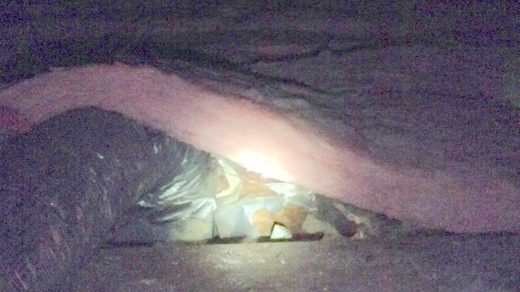
Insulation draped over ducts, lifted off attic floor
Figure 23: Low-Quality, Non-HES Attic Insulation

- Detailed Analysis of Program Tracking Data
D
The following examines findings from 2014 HES program data. Results include in-depth analyses of air-sealing, duct-sealing, and insulation services and patterns in program participation by utility, vendor, and home characteristics.
  - Air-Sealing, Duct-Sealing, & Insulation Services Provided in 2014
All but 5% of 2014 HES participants received some combination of air sealing, duct sealing, and insulation. Ninety-two percent of participants received air sealing, 21% received duct sealing, and 14% received insulation. Sixty-three percent of participants received air sealing only, 18% received air sealing and duct sealing, 8% received air sealing and insulation, 3% received insulation only, and 2% received all three services.
Table 11: Air Sealing, Duct Sealing, & Insulation Services Provided in 2014
 | Eversource |  | UI |  | Total
 | Count | % | Count | % | Count | %
Total HES Visits | 12,432 | 100% | 5,536 | 100% | 17,968 | 100%
Air Sealing Only | 7,568 | 61% | 3,734 | 67% | 11,302 | 63%
Air Sealing & Duct Sealing | 2,229 | 18% | 1,032 | 19% | 3,261 | 18%
Air Sealing & Insulation | 1,508 | 12% | 3 | <1% | 1,511 | 8%
None | 549 | 4% | 266 | 5% | 815 | 5%
Insulation Only | 97 | 1% | 479 | 9% | 576 | 3%
Air Sealing, Duct Sealing & Insulation | 421 | 3% | 0 | 0% | 421 | 2%
Duct Sealing Only | 50 | <1% | 22 | <1% | 72 | <1%
Duct Sealing & Insulation | 10 | <1% | 0 | 0% | 10 | <1%
Air Sealing Total | 11,726 | 94% | 4,769 | 86% | 16,490 | 92%
Duct Sealing Total | 2,710 | 22% | 1,054 | 19% | 3,764 | 21%
Insulation Total | 2,036 | 16% | 482 | 9% | 2,518 | 14%
  - Services Provided by Utility
Eversource customers made up the majority (69%) of the 17,968 HES participating homes that were served by Eversource and UI combined. Eversource (18%) and UI (19%) customers were about equally as likely to receive air sealing and duct sealing in combination (Figure 24). UI customers were more likely than Eversource customers to receive insulation or air sealing in isolation of each other. All 421 of the HES participants who received the combination of air sealing, duct sealing, and insulation were Eversource customers.
Figure 24: HES Services Provided by Utility
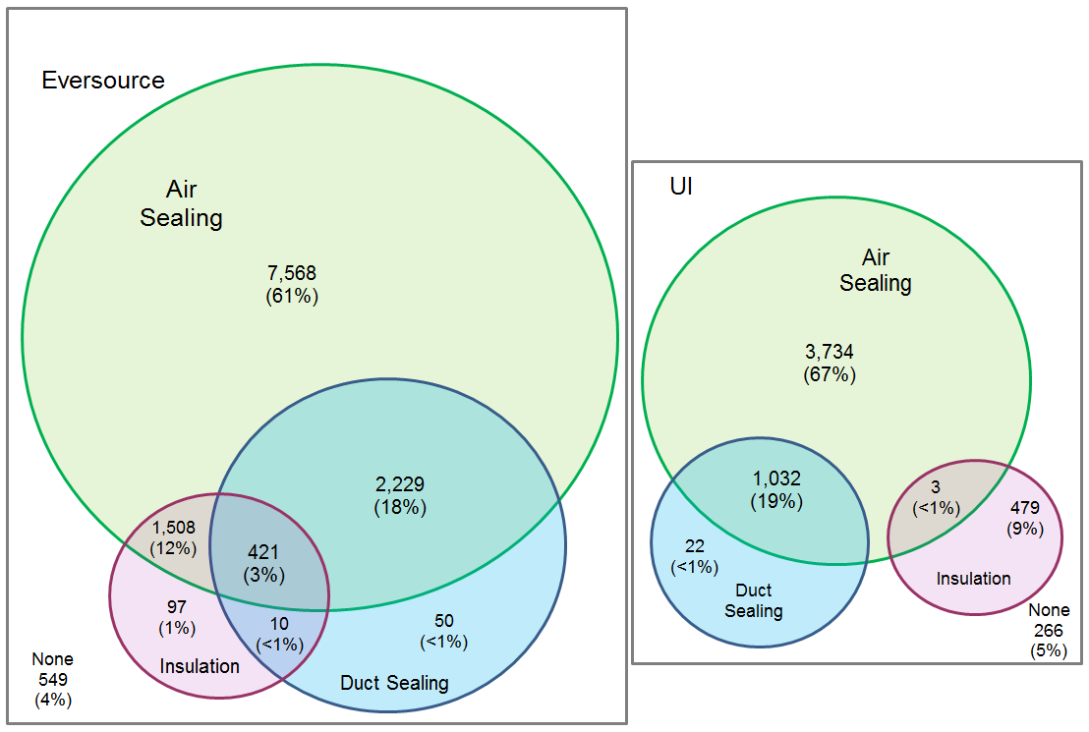
  - Air sealing
Air sealing was performed at 16,490 of the 17,968 homes served through HES in 2014, or 92% of participating homes. Air leakage is commonly measured in air changes per hour at a specific air pressure (typically 50 pascals), and is calculated as follows:
$$ACH50=\frac{CFM50×60}{volume}$$
Where CFM50 is the rate of airflow between a building and its environment in cubic feet per minute when the building is depressurized to 50 pascals. Pre- and post-air sealing CFM50 rates and heated area (square feet) were available in both the Eversource and UI data sets; however, heated volume (cubic feet) was available only in the Eversource data set. As a result, we can calculate ACH50 values only for Eversource customers. However, because volume and minutes/hour are constants that apply to both the pre- and post-air sealing ACH50 values, we can still estimate the percent air leakage improvement for both Eversource and UI homes with the CFM50 data alone, as follows:
$$\left[\left(\frac{{CFM50}_{pre}×60}{volume}- \frac{{CFM50}_{post}×60}{volume}\right)÷ \frac{{CFM50}_{pre}×60}{volume}\right]×100$$
Where CFM50_{pre} is the pre-air sealing airflow rate and CFM50_{post} is the post-air sealing airflow rate. In the remainder of this section, we present results in units of ACH50 for Eversource customers, followed by CFM50/square foot (sq. ft.) of heated area and percent air leakage reduction for both UI and Eversource customers.
A total of 11,726 Eversource homes received air sealing services through HES in 2014. This analysis used the CFM50_{pre}, CFM50_{post}, and heated volume values to calculate the pre-air sealing ACH50, post-air sealing ACH50, and the reduction in ACH50 per home. The box plots in Figure 25 characterize the distribution of the pre-air sealing ACH50, post-air sealing ACH50, and ACH50 reduction among Eversource homes that received air-sealing services. The pre-air sealing ACH50 ranged from 1.3 to 171.7, with an average of 12.7 ACH50. The post-air sealing ACH50 among these homes ranged from 1.3 to 145.6, with an average of 10.0 ACH50. The difference between the pre- and post-sealing ACH50 (i.e., ACH50 reduction) ranged from 0.0 to 30.2, with an average of 2.8 ACH50. There was no difference between the pre- and post-air sealing ACH50 for 684 (about 6%) of these 11,706 Eversource homes.
Figure 25: Eversource Pre- and Post-Air Sealing ACH50
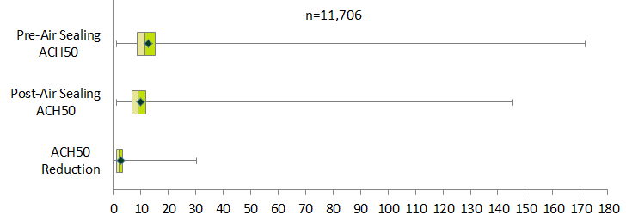

This study estimated the air leakage relative to home size by dividing the pre- and post-air sealing CFM50 measurements by the heated area (sq. ft.) per home for the 16,490 homes that received air-sealing services. Prior to air sealing, air leakage among all participating homes ranged from 0.2 to 22.9 CFM50/heated sq. ft., with an average of 1.9 CFM50/heated sq. ft. (Figure 26). On average, UI homes (2.3 CFM50/heated sq. ft.) were associated with higher leakage rates than Eversource homes (1.7 CFM50/heated sq. ft.), although among all participants, the home with the highest leakage rate was an Eversource home.
Figure 26: Pre-Air Sealing CFM50/Heated Sq. Ft.
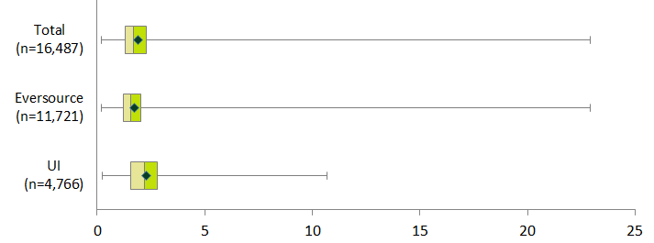
After receiving air-sealing services through HES, air leakage among participating homes ranged from 0.2 to 19.4 CFM50/heated sq. ft., with an average of 1.5 CFM50/heated sq. ft. (Figure 27). The post-air sealing airflow rate among Eversource homes was 1.3 CFM50/heated sq. ft., compared to 1.7 CFM50/heated sq. ft. among UI homes.
Figure 27: Post-Air Sealing CFM50/Heated Sq. Ft.
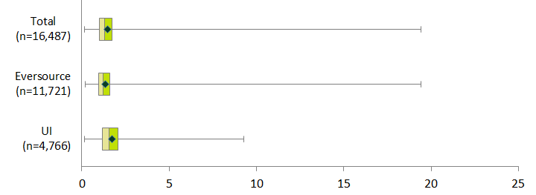

Air leakage reduction per home ranged from 0.00 to 4.61 CFM50/ heated sq. ft., with an average of 0.43 CFM50/heated sq. ft. (Figure 28). UI homes saw a larger average reduction in air leakage of 0.57 CFM50/heated sq. ft. compared to 0.37 CFM50/heated sq. ft. among Eversource homes.
Figure 28: CFM50/Heated Sq. Ft. Reduction
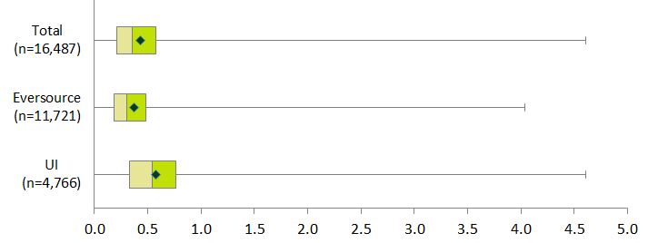
Air-sealing services provided through HES reduced air leakage by an average of 21% per home (Figure 29). UI homes saw a larger average reduction of 24% compared to 20% among Eversource homes. There was no reduction in air leakage for 755 homes (5%) that received air-sealing services. Program staff indicated that this might occur if a home is already sealed tight and does not have any room for improvement (e.g., the pre- to post-sealing is zero). Neither the UI nor the Eversource data sets contained a unique variable to explain why there was no improvement in air leakage, so this study is not able to determine the exact reasons for this occurrence.
Figure 29: Air Sealing Percent Air Leakage Reduction
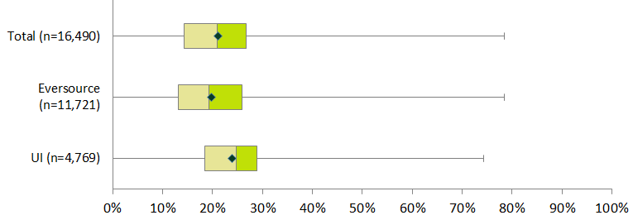
    - Air Sealing Services by Vendor
Twenty-eight of the thirty HES vendors performed air-sealing services in 2014. Figure 30 displays the average percent air leakage reduction per vendor, which ranged from 12% to 27%. This analysis groups the 28 vendors that performed air sealing services into quartiles based on the average percent air leakage reduction in order to identify characteristics common to the top- and bottom-performing air-sealing vendors. Vendors in the third quartile provided air sealing services to the most homes (5,853), while vendors in the first quartile provided air sealing services to the fewest homes (2,382).
Figure 30: Percent Air Leakage Reduction by Vendor
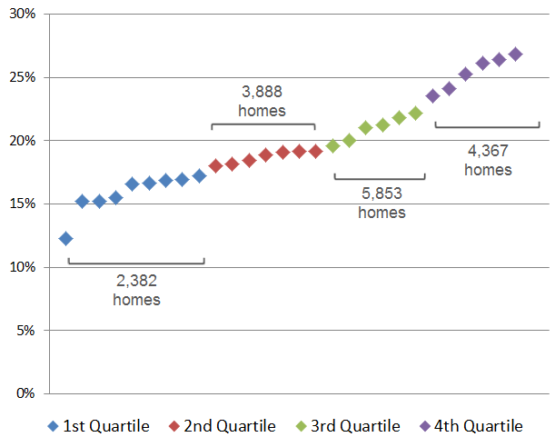
Differences in vendor performance appear to be explained by differences in the types of homes they served. Vendors in the fourth (i.e., top-performing) air-sealing quartile served smaller homes, on average, than vendors in the three other quartiles. Conversely, vendors in the first (i.e., bottom-performing) air-sealing quartile served the largest homes, on average. In addition, vendors in the fourth quartile served the largest proportion of renter-occupied homes: 46% of homes served by vendors in the fourth quartile were renter-occupied, compared to less than 5% of homes in the three other quartiles.
    - Air Sealing by Home Characteristics
This analysis grouped vendors that performed air-sealing services into quartiles based on the average percent air leakage reduction per vendor in order to identify characteristics common to the top- and bottom-performing air-sealing vendors. The average percent air leakage reduction among vendors in the fourth air-sealing quartile was 25%, compared to 21% among the third quartile, 19% among the second quartile, and 16% among the first quartile (Figure 31).
Figure 31: Percent Air Leakage Reduction by Vendor Quartile
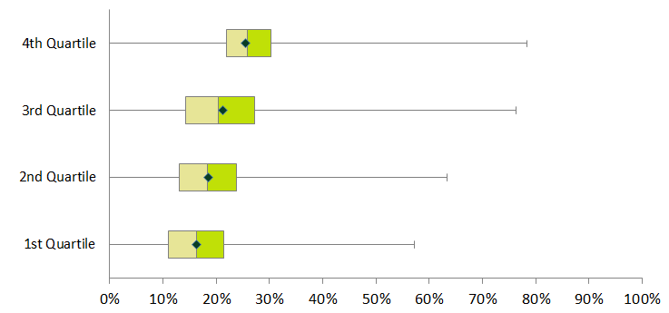
With the exception of the newest homes, air leakage reduction was similar across all home ages. Homes 40 to 59 years old represent the largest group (6,153) and had the highest average percent air leakage reduction of 23% (Table 12). Not surprisingly, newer homes (less than 20 years old) had the smallest percent air leakage reduction (14%).
Table 12: Percent Air Leakage Reduction by Home Age
Home Age  (Years) | Count of Homes | Average Air Leakage Reduction
100 or more | 885 | 20%
80 to 99 | 1,422 | 23%
60 to 79 | 2,177 | 22%
40 to 59 | 6,153 | 23%
20 to 39 | 3,813 | 20%
0 to 19 | 2,009 | 14%
Unknown | 11 | --
Total | 16,490 | 21%

The average age of homes served was similar across vendor quartiles, ranging from 48 to 56 years (Figure 32).
Figure 32: Home Age by Vendor Air Sealing Quartile
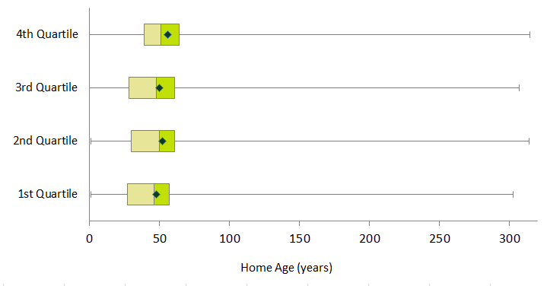
Table 13 displays a pattern of increased air leakage percent improvement as home size decreases. The smallest homes (0 to 999 heated sq. ft.) had the greatest average percent air leakage reduction (28%), while the largest homes (5,000 or more heated sq. ft.) had the smallest average percent air leakage reduction (12%).
Table 13: Percent Air Leakage Reduction by Home Size
Home Size  (Heated Square Feet) | Count of Homes | Average Air Leakage Reduction
5,000 or more | 470 | 12%
4,000 to 4,999 | 646 | 13%
3,000 to 3,999 | 1,886 | 15%
2,000 to 2,999 | 4,778 | 19%
1,000 to 1,999 | 6,279 | 23%
0 to 999 | 2,431 | 28%
Total | 16,490 | 21%

On average, vendors in the fourth air-sealing quartile served the smallest homes (1,590 heated sq. ft.), while vendors in the first, second, and third air-sealing quartiles served larger homes. The average home size was similar across vendors in the first, second, and third air-sealing quartiles, ranging from 2,270 heated sq. ft. for the second quartile to 2,435 heated sq. ft. for the first quartile (Figure 33).
Figure 33: Home Size by Vendor Air-Sealing Quartile
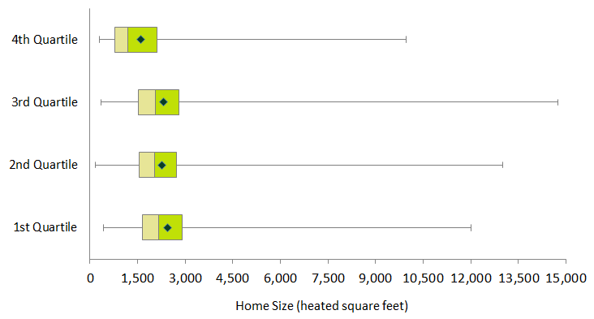
The majority (14,128, or 84%) of homes that received air-sealing services were owner-occupied. Renter-occupied homes had a greater (28%) average air leakage reduction than owner-occupied homes (20%; Table 14). When asked about this difference between owner- and renter-occupied homes, one program administrator posited that the difference may be due to more rental properties being older buildings, which is consistent with the finding above regarding greater air leakage reduction in older homes.
Table 14: Percent Air Leakage Reduction by Tenure
Tenure | Count of Homes | Average Air Leakage Reduction
Own | 14,128 | 20%
Rent | 2,360 | 28%
Unknown | 2 | --
All Homes | 16,490 | 21%

Vendors in the fourth air-sealing quartile served the largest (46%) proportion of renter-occupied homes than any of the other quartiles (Figure 34). Vendors in the first, second, and third quartiles served relatively few renter-occupied homes (4% or less).
Figure 34: Tenure by Vendor Air-Sealing Quartile
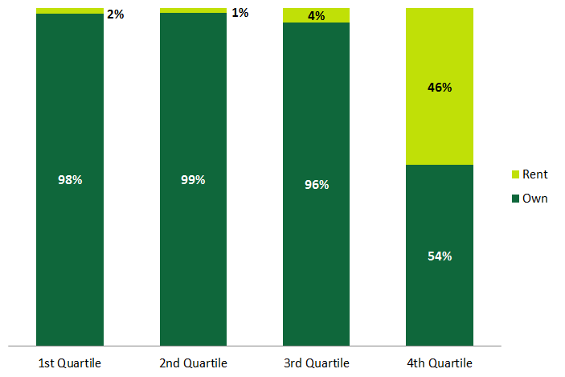
Air leakage reduction was similar across all home heating fuels, ranging from 17% for propane to 23% for electricity (Table 15).
Table 15: Percent Air Leakage Reduction by Home Heating Fuel
Heating Fuel | Count of Homes | Average Air Leakage Reduction
Electricity | 1,237 | 23%
Gas | 5,466 | 22%
Oil | 9,102 | 20%
Propane | 685 | 17%
Total | 16,490 | 21%

Vendors in the fourth air-sealing quartile served the largest proportion of homes fueled by electricity (9%) and natural gas (56%) and the smallest proportion of homes fueled by propane (3%) and oil (33%) compared to the three other quartiles (Figure 35).
Figure 35: Heating Fuel by Vendor Air Sealing Quartile
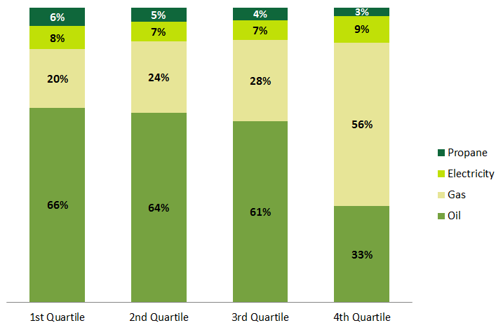

  - Duct Sealing
Duct sealing was performed at 3,764 of the 17,968 homes served through HES in 2014, or 21% of participating homes. Duct leakage is measured in cubic feet of air flow per minute at 25 pascals (CFM25). The percent duct leakage reduction per home was calculated by dividing the difference between the pre- and post-duct sealing CFM25 (i.e., the reduction in duct leakage) by the pre-duct sealing CFM25. On average, duct leakage was reduced by 23% for homes that received duct-sealing services through HES in 2014 (Figure 36). Eversource customers had a slightly higher average duct leakage reduction of 24% compared to 23% among UI customers. Eight percent of the 3,764 customers that received duct sealing services did not see any reduction between the pre- and post-duct sealing CFM25s. The data provided for this study did not indicate why the vendors’ duct sealing showed no improvement.
Figure 36: Percent Duct Leakage Reduction by Utility
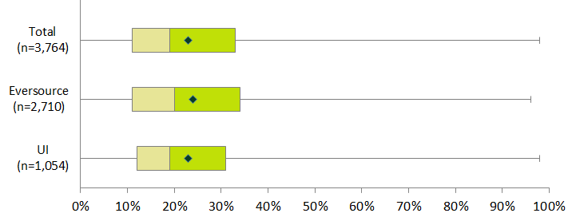

    - Duct Sealing Services by Vendor
Twenty-seven of the thirty HES vendors performed duct-sealing services in 2014. Figure 37 displays the average percent duct leakage reduction per vendor and is color coded based on the number of homes at which each vendor sealed ducts. The average percent duct leakage reduction per vendor ranged from 10% to 58%. Most vendors performed duct sealing at 200 or fewer homes in 2014. One vendor performed duct sealing at over 600 homes, with an average duct leakage reduction of 30% per home.
Figure 37: Percent Duct Leakage Reduction by Vendor
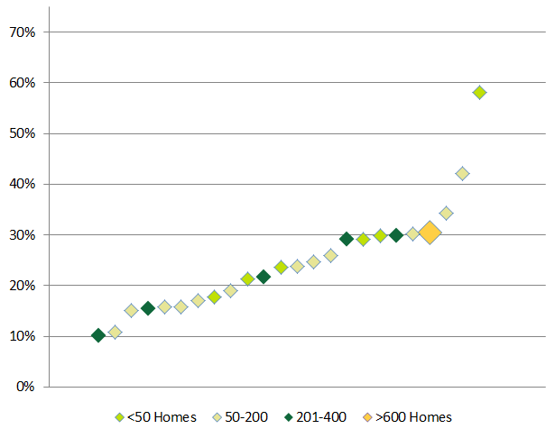
    - Duct Sealing by Home Characteristics
While there is a pattern of increased duct leakage reduction as home age increases, in general duct leakage reduction was similar across all home ages and ranged from 22% to 25% (Table 16).
Table 16: Percent Duct Leakage Reduction by Home Age
Home Age  (Years) | Count of Homes | Average Duct Leakage Reduction
100 or more | 191 | 25%
80 to 99 | 174 | 24%
60 to 79 | 549 | 24%
40 to 59 | 1,291 | 24%
20 to 39 | 940 | 23%
0 to 19 | 618 | 22%
Unknown | 1 | --
Total | 3,764 | 23%

Duct leakage reduction was similar across all home sizes, ranging from 22% to 26% (Table 17).
Table 17: Percent Duct Leakage Reduction by Home Size
Home Size  (Heated Square Feet) | Count of Homes | Average Duct Leakage Reduction
5,000 or more | 225 | 22%
4,000 to 4,999 | 229 | 24%
3,000 to 3,999 | 570 | 23%
2,000 to 2,999 | 1,160 | 23%
1,000 to 1,999 | 1,372 | 24%
0 to 999 | 208 | 26%
Total | 3,764 | 23%

Improvement in duct leakage was almost the same between owner-occupied (23%) and renter-occupied (22%) homes (Table 18).
Table 18: Percent Duct Leakage Reduction by Tenure
Tenure | Count of Homes | Average Duct Leakage Reduction
Own | 3,542 | 23%
Rent | 222 | 22%
All Homes | 3,764 | 23%

Duct leakage reduction was similar across all home heating fuels, ranging from 22% for propane to 24% for oil (Table 19).
Table 19: Percent Duct Leakage Reduction by Home Heating Fuel
Heating Fuel | Count of Homes | Average Duct Leakage Reduction
Oil | 2,215 | 24%
Electricity | 127 | 23%
Gas | 1,197 | 23%
Propane | 225 | 22%
Total | 3,764 | 23%

  - Insulation
Insulation was installed at 2,518 of the 17,968 homes served through HES in 2014, or 14% of participating homes (Table 20). The percentage of homes in which insulation was installed is greater for Eversource customers (16%) than UI customers (9%).The Eversource data set contained a variable indicating whether or not the opportunity to upgrade insulation existed per participant home. Insulation upgrade opportunities were identified in 31% of Eversource HES participant homes, and insulation was installed in 16% of participant homes. In other words, insulation was installed in just over one-half (53%) of Eversource HES participant homes in which auditors identified eligible insulation upgrade opportunities. In the remainder of this section, we focus on the 3,825 Eversource homes in which eligible insulation upgrade opportunities were identified.
Table 20: Homes that Installed Insulation
 | Eversource |  | UI |  | Total
 | Count | % | Count | % | Count | %
Total HES Visits | 12,432 | 100% | 5,536 | 100% | 17,968 | 100%
Insulation Upgrade Eligible | 3,825 | 31% | -- | -- | -- | --
Insulation Installed | 2,036 | 16% | 482 | 9% | 2,518 | 14%

Twenty-seven of the thirty HES vendors installed insulation in 2014. The box plots in Figure 38 display the distribution of 1) the average percentage of homes in which insulation upgrade opportunities were identified per vendor among Eversource homes, and 2) the average percentage of homes in which insulation was installed per vendor among Eversource homes. The percentage of Eversource homes eligible for insulation upgrades ranged from 11% to 72% per vendor, with an average of 33%. The percentage of Eversource homes in which insulation was installed ranged from 0% to 25% per vendor, with an average of 14%.
Figure 38: Eversource Vendor Insulation Upgrade Eligibility and Installation Rates
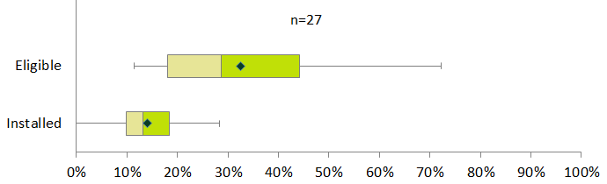

Eligible insulation upgrade opportunities were most often identified in homes that were 1) owner-occupied, 2) 1,000 to 2,999 heated sq. ft., 3) 40 to 59 years old, and 4) heated with oil. Insulation was installed in only 14% of renter-occupied homes in which eligible insulation upgrade opportunities were identified, compared to 54% of owner-occupied homes. The installation rate of 60% among homes 40 to 59 years old was higher than the overall installation rate of 53%. More detailed information on the characteristics of homes in which insulation was installed is provided in D.5.1.
    - Insulation by Home Characteristics
Table 21 breaks out the installation rate among homes eligible for insulation upgrades by homes grouped by age. Insulation installation rates range from 38% to 60% by home age category. Homes that are 40 to 59 years old represent the largest group with eligible insulation upgrade opportunities (1,616) and were most likely to receive insulation (60%).
Table 21: Insulation Installation among Upgrade Eligible Homes by Home Age
Home Age  (Years) | Count of Homes Eligible for Insulation Upgrade | Percent of Eligible Homes that Installed Insulation
100 or more | 295 | 42%
80 to 99 | 233 | 38%
60 to 79 | 652 | 53%
40 to 59 | 1,616 | 60%
20 to 39 | 787 | 51%
0 to 19 | 240 | 45%
Unknown | 2 | --
Total | 3,825 | 53%

Table 22 breaks out the insulation installation rate among homes eligible for insulation upgrades by homes grouped by size. Insulation installation rates range from 46% to 55% by home size category. Homes of 1,000 to 1,999 heated sq. ft. represent the largest group with eligible insulation upgrade opportunities (1,798) and were the most likely to receive insulation (55%).
Table 22: Insulation Installation among Upgrade Eligible Homes by Home Size
Home Size  (Heated Square Feet) | Count of Homes Eligible for Insulation Upgrade | Percent of Eligible Homes that Installed Insulation
5,000 or more | 93 | 46%
4,000 to 4,999 | 127 | 51%
3,000 to 3,999 | 448 | 52%
2,000 to 2,999 | 1,223 | 52%
1,000 to 1,999 | 1,798 | 55%
0 to 999 | 136 | 47%
Total | 3,825 | 53%

The majority of 2014 HES homes were owner-occupied. Table 23 shows that renter-occupied homes were much less likely than owner-occupied homes to receive insulation.
Table 23: Insulation Installation among Upgrade Eligible Homes by Tenure
Tenure | Count of Homes Eligible for Insulation Upgrade | Percent of Eligible Homes that Installed Insulation
Own | 3,742 | 54%
Rent | 83 | 14%
Total | 3,825 | 53%

As shown in Table 24, the majority of homes eligible for insulation upgrades heat with oil (2,614). Insulation installation rates range from 44% to 57% by home heating fuel among homes eligible for insulation upgrades.
Table 24: Insulation Installation among Upgrade Eligible Homes by Heating Fuel
Heating Fuel | Count of Homes Eligible for Insulation Upgrade | Percent of Eligible Homes that Installed Insulation
Oil | 2,614 | 55%
Gas | 798 | 50%
Electricity | 257 | 44%
Propane | 156 | 57%
Total | 3,825 | 53%

  - 2014 HES Vendors
Table 25 displays all of the vendors that provided HES services in 2014, including the number and percent of homes served by each vendor. Next Step Living performed the most HES visits in 2014 (16%), followed by Lantern Energy (12%), EcoSmart by R Pelton Builders (7%), and New England Smart Energy (7%).
Table 25: 2014 HES Homes Served by Vendors
Vendor | Eversource |  | UI |  | Total
Next Step Living | 2,078 | 17% | 730 | 13% | 2,808 | 16%
Lantern Energy | 525 | 4% | 1,708 | 31% | 2,233 | 12%
EcoSmart by R Pelton Builders | 1,124 | 9% | 139 | 3% | 1,263 | 7%
New England Smart Energy | 936 | 8% | 269 | 5% | 1,205 | 7%
Victory Energy Solutions | 780 | 6% | 193 | 3% | 973 | 5%
Energy Efficiencies Solutions | 858 | 7% | 54 | 1% | 912 | 5%
Energy Resource Group | 378 | 6% | 97 | 2% | 840 | 5%
Competitive Resources | 480 | 4% | 297 | 5% | 777 | 4%
New England Conservation | 578 | 5% | 194 | 4% | 772 | 4%
Wesson Energy | 641 | 5% | 66 | 1% | 707 | 4%
Aiello Home Services | 575 | 5% | 51 | 1% | 626 | 3%
Handyman Express Energy Solutions | 172 | 1% | 430 | 8% | 602 | 3%
EFI | 0 | 0% | 541 | 10% | 541 | 3%
Tri City Home Energy Services | 287 | 2% | 234 | 4% | 521 | 3%
Energy PRZ | 743 | 3% | 37 | 1% | 415 | 2%
Gulick Building & Development | 302 | 2% | 100 | 2% | 402 | 2%
Santa Fuel | 236 | 2% | 100 | 2% | 336 | 2%
Uplands Construction | 241 | 2% | 46 | 1% | 287 | 2%
BCB Conservation Group | 247 | 2% | 35 | 1% | 282 | 2%
Home Doctor of America | 233 | 2% | 42 | 1% | 275 | 2%
A Plus Installation | 229 | 2% | 0 | 0% | 229 | 1%
Climate Partners | 93 | 1% | 96 | 2% | 189 | 1%
Molina & Associates | 127 | 1% | 46 | 1% | 173 | 1%
Greenbuilt Connecticut | 167 | 1% | 0 | 0% | 167 | 1%
Fox Heating Services | 155 | 1% | 0 | 0% | 155 | 1%
Hoffman Energy | 108 | 1% | 28 | 1% | 136 | 1%
R&W Heating | 122 | 1% | 0 | 0% | 122 | 1%
AC Development | 17 | <1% | 0 | 0% | 17 | <1%
Nutmeg | 0 | 0% | 2 | <1% | 2 | <1%
MAZ | 0 | 0% | 1 | <1% | 1 | <1%
Total | 12,432 | 100% | 5,536 | 100% | 17,968 | 100%

  - Participant Home Characteristics
This section compares 2014 HES participants’ home characteristics to those of the state of Connecticut overall. The majority (84%) of 2014 HES participants own their home, compared to 68% of Connecticut residents (Figure 39).
Figure 39: Tenure
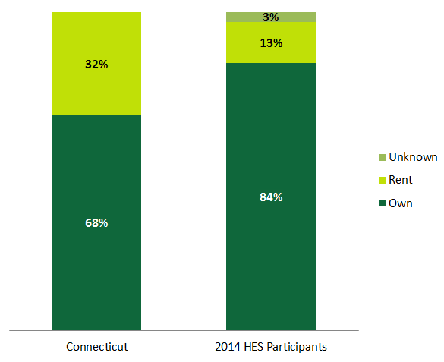

Just over one-third (34%) of 2014 HES participants reside in homes that are 36 to 55 years old. Thirty-one percent of 2014 HES participants reside in homes 35 years old and newer, while 35% live in homes over 55 years old. Figure 40 shows that the homes served by HES in 2014 included 1) a larger proportion of homes 15 years old or less and 2) a smaller proportion of homes over 75 years old compared to the Connecticut housing stock.
Figure 40: Home Age
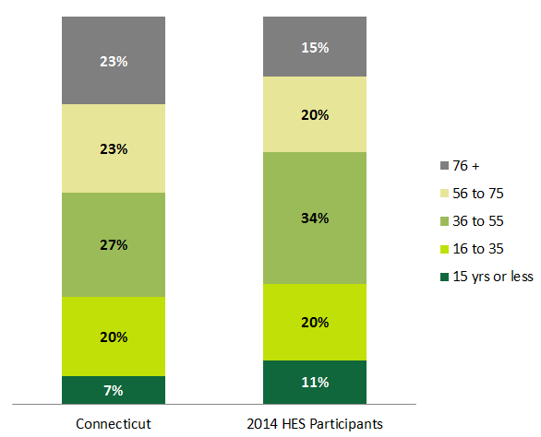
Over one-half (55%) of 2014 HES participants heat their homes with oil. Compared to the Connecticut housing stock, 2014 HES participants were more likely to heat with oil and less likely to heat with electricity (Figure 41).
Figure 41: Primary Heating Fuel
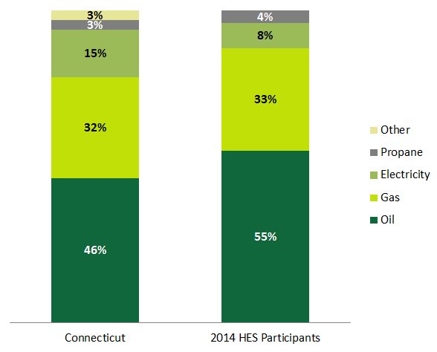

The Residential Energy Consumption Survey (RECS) reports total heated square footage of homes and total housing units by census division and for certain states. Dividing total housing units by total heated square footage yields average home size in heated square feet. The most current year for which RECS data are available is 2009, and the smallest geographic area encompassing CT comprises the combination of the following states: CT, ME, NH, RI, and VT. As shown in Table 26, the average home size for CT, ME, NH, RI, and VT in 2009 was 1,800 heated square feet. This compares to an average home size of 2,057 heated square feet among 2014 HES participants.
Table 26: Average Home Size
Average Heated Area | CT, ME, NH, RI, VT | HES Participants
Square Feet | 1,800 | 2,057

This percentage likely underestimates the amount of homes with additional attic savings opportunities, as the 52 referenced attics include 16 (31%) where NMR auditors could confirm whether or not there was some amount of air sealing performed, but could not see the extent of it due to access issues. Of the homes where NMR could fully assess this (40 attics), 60% of them had air-sealing opportunities remaining.
Importantly, the R91: Review of Impact Evaluation Best Practices notes that factors including quality of installation of measures by vendors or persistence of measures installed may contribute to lower realization rates—such as those developed as part of the previous R16 HES impact evaluation.
The sister program—HES-Income Eligible—was not included in this study due to the divergent ways in which participants enter the program and the vendor and householder decision-making process regarding which measures to install.
The program is not targeted to a specific fuel/heating source, and customers of any heating fuel type are eligible to participate.
The core services may in some cases be provided across two separate visits. For example, if an HES vendor identifies a potential health and safety issue, they may postpone completing the core services until the homeowner remedies the issue.
It is important to note that homes that reportedly did not receive any of the measures of interest for this study may have received courtesy air sealing as well as other direct-install measures such as efficient lighting or water saving measures.
In attics, this means openings that may not be visible without moving insulation, but in basements, this includes openings that were readily visible and did not require moving any insulation in order to see them. These were visible gaps and penetrations that NMR auditors could see on a relatively brief inspection.
This includes attics, walls, basement ceilings, and basement rim joists. It also includes examples of air sealing in the basement rim joists that was so thorough that NMR views it as an insulation measure, though it was only recorded as an air sealing measure.
Importantly, the data NMR was provided by program staff did not contain a specific health and safety variable—instead we base our analysis on a variable materials, to inform this analysis.
http://www.masssave.com/residential/expanded-heat-loan
We exclude opportunities in homes where health and safety issues would have prevented work, or where access issues limited the NMR auditor’s ability to make a judgment.
Note that, based on program records, post-blower door tests show that only two of these homes were close enough to the building airflow standard to have curtailed air sealing.
We treat attic opportunities differently than basements. Due to the emphasis on attic air sealing (both as a program priority and building science best practice), “readily accessible opportunities” in attics include penetrations that were both readily visible and located underneath moveable insulation.
Note that this figure and the chart below excludes installations where NMR was unable to determine the installation quality (typically due to limited access).
Some of these homes could have had hourly “courtesy” air sealing performed without benefit of a blower door test to measure improvement.
It is important to note that homes that reportedly did not receive any of the measures of interest for this study may have received courtesy air sealing as well as other direct-install measures such as efficient lighting or water-saving measures.
Only two of the visited homes appeared to have been close enough to the minimum Building Airflow Standard such that vendors might have curtailed their air sealing.
NMR auditors could see examples of sealed and unsealed penetrations in the same basement.
NMR auditors identified that about 90% of the basements they visited had such visible rim joist penetrations that were accessible for air sealing, but harder to see.
In one case (2%), NMR auditors could not inspect for this.
Auditors could not inspect for air sealing in the remaining one instance (2%).
NMR auditors identified that about 87% of the basements they visited had such visible basement ceiling penetrations that were accessible for air sealing, but may not have been readily apparent to vendors.
The remaining 3% represents two homes where the NMR auditor could not assess these penetrations.
NMR auditors did not make a distinction for attics between “visible and accessible” and “hidden but accessible” as they did for basement penetrations, because almost all attics have some amount of insulation, making the vast majority of penetrations somewhat hidden, whereas many New England basements do not have insulation in the basement ceiling or rim joist area, making the sealing of penetrations even easier in basements.
These percentages exclude attics that were inaccessible to HES vendors (permanently sealed with no hatch, n=4) and the attics that were both inaccessible to NMR vendors and where the homeowner did not know if air sealing had been done (n=13).
Due to access issues, NMR auditors could not always tell if HES vendors had missed easily sealable sources of air leakage in attics—“low-hanging fruit”—but they categorized this whenever possible.
One homeowner would not grant access to this area for inspection.
Cape Light Compact does not include the dryer venting repair as a pre-weatherization initiative measure since it is addressed through their home energy assessments.
The UI Eversource data set did not indicate whether or not the opportunity to upgrade insulation existed per participant home. Therefore, results regarding insulation opportunities are limited to Eversource homes.
It is important to note that homes that reportedly did not receive any of the measures of interest for this study may have received courtesy air sealing as well as other direct-install measures such as efficient lighting or water-saving measures.
The UI and Eversource data sets contained blower door CFM__{pre} and CFM__{post} variables. Neither data set contained a unique variable indicating if air sealing had been performed at a home. Therefore, this study assumes that non-blank, non-zero sets of blower door CFM__{pre} and CFM__{post} values implied that air sealing had been performed at a home. There was no difference between the blower door CFM__{pre} and CFM__{post} values for 684 Eversource and 71 UI homes.
Data regarding duct sealing did not identify whether ductwork was present and if a home was eligible for duct sealing. Therefore, all duct sealing results include all participating homes.
Only the Eversource data set contained a variable indicating whether or not the opportunity to upgrade insulation existed per participant home.
HVAC companies may also be HES vendors, and might achieve higher rates of add-on uptake because the customers calling them are already interested in HVAC equipment.
Reviewing costs, this appears to be a valid strategy for vendors, but a disservice to the program. If a vendor were to visit a home and install lighting and direct hot water measures, they would be able to collect more than $400, on average—about one-third of the total average value per home.
There was no mention of meeting the BAS in the program records provided to NMR. In one of these instances, the homeowner commented that the vendor team was concerned about hitting the BAS in the already tight home, but according to NMR’s calculations, the team did not come particularly close to the BAS. In the other home, the home did appear to be near the BAS, though the homeowner had no recollection of the vendor team mentioning this.
Note that this figure excludes installations where NMR was unable to determine the installation quality (typically due to limited access). All six of the Grade 1 rim joist installations are actually extremely thorough air-sealing measures that also fully insulated the rim joist, at no additional customer cost.
This problem is not unique to the HES program; NMR auditors typically see poor quality installations of this insulation material in rim joists or basement ceilings, where contractors often do not cut the insulation material to fit around obstacles and instead force it into the cavities, compressing it and reducing its R-value.
RESNET standards provide detailed criteria for grading insulation on a “1” to “3” scale: Grade I (high quality), Grade II (acceptable quality), and Grade III (low quality, but within specified limits).
NMR auditors inspected these homes without the benefit of having a blower door fan running during these tests; thus, these inspections were visual, and the amount of air leakage at these penetrations could not be verified. However, NMR auditors are experienced HERS Raters and building scientists and are trained to identify signs of air leakage, even without the use of a blower door fan.
Spray foam was overwhelmingly the most common material used to seal gaps in frame floors; occasionally, vendors used foil-faced bubble wrap or sheet metal with spray foam at the edges to seal larger openings. HES vendors typically used the yellow spray foam in the homes NMR auditors visited, though the fire-retardant bright orange variety was occasionally used.
As previously noted, NMR auditors inspected these homes without the benefit of having a blower door fan running during these tests; thus, these inspections were visual, and the amount of air leakage at these penetrations could not be verified. However, NMR auditors are experienced HERS Raters and building scientists, and are trained to identify signs of air leakage, even without the use of a blower door fan.
NMR auditors could not fully inspect this attic as it had been newly insulated, but all penetrations and top plates that NMR auditors inspected had been nicely sealed.
NMR confirmed that the weather-stripping and door sweeps installed were put in place by the HES team.
A reasonable approach for modeling the performance of these foamed rim joists would be to model the well-insulated areas a Grade 1, and model the uninsulated areas separately.
NMR auditors saw attic insulation that had been installed through the HES program in 30 of the visited homes with attics (44%). Auditors were able to visually inspect the attic insulation in most of these homes, and relied solely on IR cameras in only three cases. In one instance, the homeowner had photos that were taken inside the attic that had since been sealed, and the NMR auditor used those to assess the insulation quality as best as possible.
These require less effort to fill voids around joists, electrical wiring, and mechanical equipment than do fiberglass batts.
NMR auditors could not move freely through freshly insulated attics, but made their best assessments of the overall insulation quality. Auditors did not specifically assess the adequacy of ventilation, presence of eave baffles, or presence of depth markers for blown-in insulation, though these are important aspects of quality insulation jobs. NMR auditors focused on the quality and distribution of the insulation itself.
These figures exclude the five attics where NMR auditors could not ascertain the installation grade due to lack of access.
Auditors did not specifically address this point, but this is an issue of which NMR analysts are aware.
Cape Light Compact does not include the dryer venting repair as a pre-weatherization initiative measure since it is addressed through their home energy assessments.
These can also be referred to as frame floors; this is the framed basement ceiling that supports the floor above.
NMR auditors were prepared to assess such installations, but saw no examples of either in the field.
Home Energy Solutions: Vendor Evaluations (Quality Assurance). Revision 10-13c.
March 13, 2015, draft version.
If the program tracks frequency of meeting the BAS standard, it might also consider separately analyzing the results in older, uninsulated homes. In a limited amount of time, one would not necessarily expect a vendor team to bring an uninsulated, balloon-framed home (with a great deal of potential for air movement through building cavities) to the minimum BAS.
Of the 11,726 homes that received air sealing, there were valid CFM50_{pre}, CFM50_{post}, and heated volume values for 11,706 homes in the Eversource data set.
Of the 16,490 homes that received air sealing, there were valid CFM50_{pre}, CFM50_{post}, and heated area values for 16,487 homes.
The UI and Eversource data sets contained blower door CFM__{pre} and CFM__{post} variables. Neither data set contained a unique variable indicating if air sealing had been performed at a home. Therefore, we assumed non-blank, non-zero sets of blower door CFM__{pre} and CFM__{post} values implied that air sealing had been performed at a home. There was no difference between the blower door CFM__{pre} and CFM__{post} values for 684 Eversource and 71 UI homes. Note that this unit of analysis is different from the ACH50 air sealing reported above.
Three vendors that performed duct-sealing services at six or fewer homes are excluded from Figure 10. Two of these three vendors had extreme average percent duct leakage reduction values, including 0% and 100%.
The source for statewide data is the American Community Survey 2013 five-year estimates.

