PROJECT SPONSOR:
Energize CT
AUTHORS:
Liz Kelley, Alex Dunn, Illume Advising, Inc.
PROJECT:
X2022 - Connecticut Education, Workforce Development, and Community Engagement Evaluation

July 22, 2021

Acknowledgements
ILLUME Advising, LLC is a forward-thinking consulting company at the rare intersection of insight and execution. Founded in 2013, the company has quickly grown to include a deep bench of quantitative and qualitative research experts. ILLUME uses cutting edge research strategies to help build a resilient energy ecosystem to enrich lives, improve global health, and ensure a more secure and sustainable future.
For this effort, we would like to acknowledge, first and foremost, Bob Wirtshafter and Lisa Skumatz. We would also like to acknowledge the ILLUME team members Alexandra Dunn, Liz Kelley, Mallika Jayaraman, Kimberly Jaeger-Johnson, Riana Johnson, Emily Morris, and Lauren Rhodes.
PREPARED FOR:
Energize Connecticut
Client address
PREPARED BY:
ILLUME Advising, LLC
440 Science Drive, Suite 202
Madison, WI 53711
CONTACT:
Alexandra Dunn
Alex@illumeadvising.com

Table of Contents
Abstract 6
Executive Summary 7
Evaluation Activities: 7
Overall Findings: 7
Evaluation Findings: 10
1. Introduction and Evaluation Activities 14
2. CrossCutting Findings and Recommendations 17
Initiatives need strong, action-oriented goals focused on changing behavior and practices 17
Initiatives should specify the outcomes they are trying to achieve to ensure program designs match goals 21
Initiatives need to ensure activities conducted directly contribute to the initiative outcomes and goals 24
Initiatives should link goals and outcomes to potential energy savings 26
Initiatives need to incorporate continuous improvement mechanisms into program design 28
3. Workforce Development Trainings 30
Review of Workforce Development Programs in the US 31
Existing Research on the Impact of Workforce Development Trainings 34
Workforce Development Best Practices 37
Case Study: ComEd Diverse EESP Incubator Program 40
Adult Education Best Practices 42
How is Energize CT Doing? 43
Energize CT Workforce Development Efforts 43
EE Workforce Development Program Review 46
Primary Research 51
In-Depth Interviews with Trainers and Attendees 57
Recommendations 63
4. Develop the Workforce: Green STEP 68
High School Job Training Program Best Practices 69
Green STEP Initiative Goals and Activities 72
Green STEP Activities 78
Recommendations 88
5. Educate the Students: eesmarts 91
Student Energy Education Best Practices 91
Education Program Review Findings 91
How does Energize CT Align with these Best Practices? 96
Cataloguing Education Efforts 98
Connecticut’s Education Efforts: eesmarts 98
2022 – 2024 Plan 100
Recommendations 101
6. Educate the Public 104
Cataloguing Educate the Public Efforts 104
Community Partnerships for Energy Efficient Engagement 105
Current Community Partnerships effort visualized 106
Community Partnership Best Practices 108
How does Energize CT Align with these Best Practices? 115
Community Partnership Recommendations 119
7. Customer Engagement 123
Cataloguing Customer Engagement Efforts 123
Eversource Customer Engagement Software: Website Widgets and Monthly Insights Email 124
Digital Customer Engagement Best Practices 124
How is Energize CT doing? 127
Digital Customer Engagement Recommendations 131

Tables
Table 1: 2019-2021 Planned expenditures and 2019 actual expenditures 14
Table 2. Activities and status by initiative 14
Table 3. Evaluation activities by initiative 15
Table 4. Assessment of Goals by Initiative 18
Table 5. Goal Setting Example from ComEd’s Workforce Development Program 20
Table 6. Example Goals, Outcomes, and Metrics 23
Table 7. Link between Initiative Activities and Goals 25
Table 8. Example of Energy Savings Rough Estimate and Cost Assessment 28
Table 9. Workforce Development Initiative Planned and Actual Expenditure 30
Table 10. Metrics Tracked by Workforce Development Program (blue = metrics tracked by some CT trainings) 33
Table 11. Quantified Energy Savings Impact Evaluations of Workforce Development Trainings 36
Table 12. C&I and Residential Trainings Offered in 2019 – 2020 44
Table 13. Contractor changes in behavior after training 54
Table 14. Contractor response to whether the training impacted the way they work by training attended 54
Table 15. Technical Training Responses for Level and Expectations of Training 56
Table 16. Workforce Development Initiative Planned and Actual Expenditure 68
Table 17: Alignment of Priority Areas in 2022 – 2024 C&LM plan and Green STEP Activities 75
Table 18: Planned and actual Educate the Students Expenditures 91
Table 19. Summary of Evaluation Focus for Educate the Public and Community Engagement Initiatives 104
Table 20. Recommended Application Assessment Criteria, Requested Information, and Evaluation Metrics 121
Table 21. Summary of Evaluation Focus for Educate the Public and Community Engagement Initiatives 123
Table 22. Recommended Digital Customer Engagement Evaluation Metrics 133

Figures
Figure 1. Example of How ComEd’s First Workforce Development Program Goal Meets Four Requirements 21
Figure 2. Workforce Development Programs Reviewed 32
Figure 3. Utility Workforce Development Best Practices 38
Figure 4. ComEd Workforce Development Best Practices 41
Figure 5. Potential program design outlining goals, outcomes, and activities 47
Figure 6. Annotated GPRO Training Description 50
Figure 7. Annotated Compressed Air Challenge Training Description 50
Figure 8. Survey Respondent Breakdown 52
Figure 9. How to Create a Developed Workforce 53
Figure 10. Education Programs Reviewed During Secondary Research 92
Figure 11. Utility Energy Education Program Best Practices 95
Figure 12. Qualitative Comparison of the Impact and Ease of Behavioral Change Strategies 97
Figure 13. Current Community Partnership Initiative 107
Figure 14: Potential Program Revisions: Community Partnerships Initiative 108
Figure 15. Utility Community Partnership Best Practices 109
Figure 16. Spectrum of Community Engagement to Ownership (Facilitating Power) 112
Figure 17. Energize CT Community Partnership Best Practices (Prospective) 115
Figure 18. Utility Digital Customer Engagement Best Practices 125
Figure 19. Eversource Digital Customer Engagement Best Practices (Prospective) 128
Figure 20: Current Customer Engagement Initiative 130
Figure 21. Potential Adjustments to Customer Engagement Initiative 131

Abstract
Abstract in process. Final text to come.

Executive Summary
This report includes the findings and recommendations of the evaluation of the Energize Connecticut (Energize CT) education, workforce development, and community and customer engagement efforts, grouped under the following initiatives: “Educate the Students,” “Educate the Workforce,” “Educate the Public,” and “Customer Engagement. For this evaluation, ILLUME (referred to as the team or the evaluation team) conducted a review of Energize CT initiative activities, a review of best practices from other similar utility programs and initiatives around the country, and primary research on several targeted initiatives to refine our findings.

Evaluation Activities:
For each initiative, the evaluation team conducted interviews with program and implementation staff; conducted a secondary literature review that included reviews of published evaluations of other education, workforce development, and community and customer engagement efforts both within the energy efficiency sector and outside the industry. This secondary literature review also included conference papers and published report of best practices and other findings related to workforce development, education, and community and customer engagement.
The team conducted primary research to understand additional details related to the program experience for two initiatives within the “Educate the Workforce” initiative: the workforce development trainings, and the Green STEP program. The team is planning to conduct primary research related to the Community Partnerships program. That research was planned for Spring 2022 but has been delayed as a result of delays in the program start up. The team did not conduct primary research for the eesmarts™ initiative within the Educate the Students portion of the portfolio nor for the customer engagement initiative. Our findings and recommendations related to these initiatives are based only on secondary research and interviews with program and implementation staff.

Overall Findings:
Finding 1: Initiatives need, but do not currently have, strong, action-oriented goals focused on changing behavior and practices
Program goals need to be well defined, specific, and outline what the program is meant to accomplish. As such, goals should focus on the end-result the program hopes to create. It should specify the target groups and approach that will help create the desired end-result. Program goals should be 1) specific, 2) focus on changes beyond awareness, 3) promote energy efficient behavior changes that can – directly or indirectly – lead to energy savings, and 4) be measurable in some way to show progress toward the goal.
Currently, most initiative goals are specific, but do not go beyond building awareness and most are not worded in a way that the initiative can track progress toward the goal. For example, the goals for the Green STEP program are to provide students with the opportunity to become more work ready for the clean energy workforce through technical certifications, internships, and work studies in their related fields and trades before they graduate from high school. While this goal is specific and does go beyond awareness, there is not a clear way to track progress toward the goal nor is it clear that the program activities will result in changes to behavior that lead to energy savings.

The goal for eesmarts™ is to facilitate students’ understanding of EE technologies, renewable and non-renewable energy sources, how electricity is generated, transmitted, and distributed. This goal does not go beyond raising awareness.
Finding 2: Initiatives should specify the outcomes they are trying to achieve to ensure program designs match goals
Outlining program outcomes is a vital process to ensure program activities link up with the goals stated for the program. Outcomes serve as the middle ground between the specific program activities – what the program is doing day to day – and the high-level goals the program is trying to achieve across several years. Like program activities, these outcomes need to be tracked, but unlike activities, metric tracking for outcomes is more complex and requires some analysis of data rather than simple counts. With few exceptions, the Connecticut Education and Engagement initiatives do not have outcomes that link activities to goals. For example, in the Educate the Students initiative, the initiative outlines a specific goal - Facilitate students’ understanding of EE technologies, renewable and non-renewable energy sources, how electricity is generated, transmitted, and distributed, and conducts three activities – Presentations to students, professional development workshops for teachers, and a student contest, but has no outcomes linking the activities to the specific goal.
In other cases, the initiative is tracking activities as outcomes. For example, the Educate the Workforce initiative is tracking some metrics, but those metrics are directly related to the activities of the initiative, such as how many people attended a particular training. They are not tracking the impacts, or outcomes, the initiative is having in terms of subsequent actions. For example, the utilities’ data does not have any record that after participating in a training, the contractors make any changes to their practice.
Finding 3: Initiatives need to ensure activities conducted directly contribute to the initiative outcomes and goals
The Educate the Students, Educate the Workforce, Educate the Public, and Customer Engagement initiatives consist of meaningful activities to promote understanding and awareness of energy efficiency in the relevant areas. However, the goals of the initiatives as articulated in the C&LM Plan do not always align with the activities that are being conducted and the activities often are not sufficient to create change. For example, Green STEP conducts workshops, career, and science fairs. While these each do help promote energy efficiency as an option to technical high school students, they are not directed or effective enough to meaningfully create a work ready clean energy workforce.

Across initiatives, the activities being conducted do not uniformly and consistently support the stated goals of the program. In many cases, the activities are in line with the goals , but they do not robustly support the goals nor are they sufficient to create behavior change. In general, current activities promote understanding and awareness of energy efficiency, however, to be effective, they need to be more focused on moving from awareness into taking actions.
Finding 4: Initiatives should link goals and outcomes to potential energy savings
Education and outreach initiatives are not subject to the formal benefit-cost screening that resource programs such as the Home Energy Solutions program are required to pass. Nevertheless, because they are using Public Goods funds that could be used instead to fund more resource acquisition activities, they need to qualitatively produce benefits commensurate with those achieved by resource acquisition programs. Accordingly, for education and outreach programs to be justified they need to lead to actions that save energy This energy savings can be direct actions taken by program attendees or indirect effects such as may occur if activities lead to an expansion in or better performance of trade allies.
Initiatives funded as part of the EE programs (resource or non-resource) should be able to tie—directly or indirectly—to energy savings. Other than the community partnerships initiative, the current initiatives are not able to tie to energy savings. To do this, the initiatives need to show how the education and engagement activities link to changes in energy behavior and/or create energy savings. For instance, a workforce development training should catalog behaviors changed as a result of a specific training, such as documentation that attendees of a BPI infiltration and duct leakage training increased use of duct sealing or use of an improved air-sealing technique as a result of the training. If desired, the program can assign energy savings related to this change in behavior.
The evaluation team recommends program staff incorporate the following process into their program planning. Identify behavior changes from associated measures/activities from each training.
- Calculate the proportion of contractors that changed their behaviors after the training
- Link the targeted behavior change to specific energy savings using deemed savings (TRM)
- Calculate energy savings for an average number of projects for attendees
- Calculate the effectiveness of behavior change savings by dividing the deemed energy savings by the expenditure made to obtain that behavior change
- Each initiative may result in many different behavior changes that are linked to energy savings – for each initiative, add the quotients together to assess initiative-level linkages between expenditures and potential energy savings
Finding 5: Initiatives need to incorporate continuous improvement mechanisms into program design
Since non-resource programs are not evaluated with the same frequency as resource programs, setting up continuous improvement mechanisms is vital to ensure each initiative is operating as intended and performing well. Currently, some initiatives, such as Green STEP, collect information from trainers, teachers, and attendees, but this is conducted in an ad hoc fashion and is not tracked. For example, Educate the Workforce, eesmarts™ and the customer engagement initiatives do not have feedback or assessment processes that inform the program on the effectiveness of current activities. As part of this continuous improvement mechanism, initiatives should also annually assess the effectiveness and cost-effectiveness of each initiative and redesign or eliminate poor performers. Staff should internally assess the effectiveness of each initiative annually by reviewing progress in metrics and comparing performance and costs over time and between programs. If initiatives, programs, or specific activities are not yielding the planned behavior and practice changes, staff should redesign the interventions or consider eliminating poor performers. In the corresponding section of this executive summary that follows, we outline specific recommendations that program teams should consider to improve the programs. In some cases, these include fairly substantial redesigns of the program, for instance, one of our recommendations for eesmarts is that initiative be funded through other funding mechanisms (not rate-payer dollars) as it is unlikely to generate energy savings.

Program Specific Findings and Recommendations:

Workforce Development

Evaluation Findings:
- In some cases, there is currently a disconnect between the goals and activities of the Develop the Workforce initiative.
  - Example of where activities link to goals: The program has a goal of offering trainings to the residential and C&I vendors; since trainings are designed to meet the needs of existing vendors and are well attended, we find that the Companies activities align with this goal.
  - Example of where activities do not link to goals: One of the goals of the program is to create a nationally recognized workforce development program and ensure that Connecticut and the Northeast region have a well-trained, diverse energy efficiency workforce that supports both the residential and C&I portfolios. Since the trainings are marketed only to existing known contractors, the activities cannot effectively expand the workforce.
- Courses do not conform to best practices in adult learning, which include:
  - Assess needs before designing training.
  - Provide clear objectives for each training
  - Focus on changing behaviors
  - Limit course content
  - Design activities to meet diverse backgrounds and experience
  - Design activities to enable learner-to-learner interactions and allow time for interactivity, exchange of ideas, questions
  - Incorporate post-training reinforcement
- Most people who took the trainings took the required health and safety training, suggesting limited impact of trainings.

Evaluation Recommendations:
- Develop Goals, Outcomes, and associated Activities to expand and enhance the Contractor Base. These goals should also focus on developing behavior change in the contractor base with an aim to generate energy savings.
- Develop Course series that cover breadth and Depth of key topics and use adult learning principles
- Develop metrics to accurately track progress towards energy saving and behavior change and codify current tracking standards. Ensure these metrics link to outcomes and show how goals are being achieved.
- Increase diversity of participants within trainings
- Create training marketing/recruitment strategy
- Provide additional resources for attendees

Green STEP

Evaluation Findings:
- Current activities overlap and occasionally compete with CTECS’ curriculum.
  - Example of overlap: CTECS’ curriculum covers latest energy efficiency technology in its HVAC program, including providing BPI certifications
- Green STEP programming is more effective with greater teacher buy-in.
- The program does not currently have systems in place to connect with students after graduation, although this is something they are working on.

Evaluation Recommendations:
- Identify overlap and Gaps between Green STEP activities and CTECS core curriculum and activities and adjust Green STEP to fill those gaps and enhance what CTECS is already doing related to Clean Energy
- Increase funding for new E-houses and updates to current E-houses
- Create a tool Lending Library
- Create magnet programs by investing more heavily in a limited number of schools
- Integrate milestones and tracking of metrics that link to behavior changes leading to energy savings into the program processes

eesmarts

Evaluation findings:
The program is not currently set up in a way that will generate savings. In order to be able to claim savings the program will need to incorporate strategies that are tied with energy savings, particularly through involving school staff. The current eesmarts program activities are structured to meet the current eesmarts goal of “facilitating sutdents understanding of EE technologies, renewable and non-renewable energy sources, how electricity is generated, transmitted, and distributed”. However, the overall goal and activities do not adhere to identified best practices.
The evaluation team identified six best practices of successful K-12 energy education programs:
- Integrate behavior change strategies
- Reinforce lessons
- Ensure consistent content delivery
- Develop a supportive school community
- Create a school-to-home connection
- Integrate evaluation
The two best practices that eesmarts aligns with are ensuring consistent content delivery and reinforcing lessons.

Recommendations:
- Establish program goals and outcomes that tie to energy savings. Develop metrics to accurately track progress towards energy saving and behavior change and codify current tracking standards. Ensure these metrics link to outcomes and show how goals are being achieved.
- Create a connection with families to expand the reach of the program and enable data tracking
- Leverage known behavior-change strategies to motivate energy saving
- Build collaboration between all school staff Into Program Processes
- Expand multiple training approaches
- Establish state-wide goals but focus locally to ensure diverse and equitable participation.
- Use other funding streams (not rate-payer dollars) to support this program

Community Partnerships

This evaluation is still in progress as the program partners only recently began their activities. The evaluation team plans to conduct interviews with the municipal and community partners in Q3 2022 and will circulate a memo to update this report with findings based on those interviews.

Best Practices:
The evaluation team identified six best practices used by effective community partnership programs:
- Develop trust
- Involve partners throughout the program lifecycle
- Pursue partnerships with agencies with a non-energy focus
- Build personal connections
- Minimize the participation burden
- Set realistic expectations
The evaluation team found that the Energize CT program is in full alignment with two best practices (minimize burden and develop trust) and partial alignment with the remaining four best practices.

Recommendations:
- Review pre-and post-intervention data and coordinate with evaluations of other Energy Efficiency programs to assess impact
- Track longitudinal metrics to understand progress over time.
- Consider using metrics from the E3 report (Goals 2 and 3) to identify priority communities to reach
- Ensure that key determinants of success are aligned with best practices
- In future program cycles, engage with community partners to understand whether offering align with community needs and whether any gaps exist.

Customer Engagement

Best Practices:
The evaluation team identified six digital customer engagement best practices from the reviewed programs:
- Engage emotional decision making
- Change customer behaviors
- Look at all points of interaction
- Create a dialogue
- Personalize communications
- Maximize convenience
The evaluation team found that the customer engagement initiative is in alignment with two best practices (Change customer behavior and personalize communication) and partial alignment with the remainder.

Recommendations:
- Define the specific outcomes the sub-initiatives aim to achieve and how this fits into the broader customer engagement strategy
- Define metrics for the sub-initiatives that capture customer behavior change as well as engagement
- Include emotional appeals in the messaging of website widgets and monthly insights emails
- Track metrics for the sub-initiative

- Introduction and Evaluation Activities
This evaluation covers the Educate the Students, Educate the Workforce, Educate the Public and Customer Engagement initiatives within the 2019 – 2021 Connecticut Conservation and Load Management Plan. Because this evaluation spans the prior 2019-2021 and current 2022-2024 plans, the evaluation team cite findings relevant to both plans and make note of relevant changes or adjustments made in the 2022 – 2024 plan.
Connecticut has made a significant investment in these programs. In Table 1 the evaluation team show the planned expenditure by initiative for the 2019 – 2021 plan years and the actual expenditure in each year.
Table 1: 2019-2021 Planned expenditures and 2019 actual expenditures
Initiative | 2019-2021 C&LM Plan | Total Actual expenditure | 2019 Actual Expenditure | 2020 actual expenditure | 2021 Actual Expenditure
Educate the Public | $3,271,742 | $2,311,546 | $1,151,467 | $419,653 | $740,426
Customer Engagement | $7,789,510 | $4,423,560 | $1,577,907 | $1,831,501 | $1,014,152
Educate the Students | $1,757,099 | $1,468,470 | $514,221 | $459,028 | $495,221
Educate the Workforce | $1,789,487 | $1,160,978 | $150,290 | $533,265 | $477,423
Total | $14,607,838 | $9,364,555 | $3,393,886 | $3,243,447 | $2,727,222
Each initiative conducted substantial activities in 2019-2021 and adjusted spending and approach during Covid-19. Table 2 shows the activities conducted by each Initiative and its status.
Table 2. Activities and status by initiative
Initiative | Activities | Status
Educate the Public | Community Partnerships for Energy Efficient Engagement | Beginning stages
 | Mobile Museum Exhibit | Planned launch
 | Statewide/Clean Energy Communities Dashboard | Ongoing
 | EPA Portfolio Manager | Ongoing
 | Clean Energy Communities | Discontinued
 | University Community Partnerships | Discontinued
 | Museum Partnerships | Discontinued
 | Energize CT Center | Discontinued
Customer Engagement | Eversource Customer Engagement Software: Website Widgets | Launched 2021
 | Eversource Customer Engagement Software: Monthly Insights Email | Launched 2021
Educate the Students – Green Step | Deliver in-person and virtual workshops | Ongoing
 | Certification testing | Ongoing - optional support
 | 11th grade career fair | Ongoing - optional support
 | Guidance and support for Science and Engineering Fair participants | Ongoing - optional support
Educate the students – eeSmarts | Grades K-3: Bright Kids | Ongoing
 | Grades 4-5: The Energized Guyz: Powered Up | Ongoing
 | Grades K-12: NGSS aligned energy curriculum | Ongoing
 | Grades K-12: Annual student contest | Ongoing
 | Professional development for teachers | Ongoing
Educate the Workforce | In-person training sessions | Paused due to Covid-19
 | Online training sessions | Ongoing
 | Workforce outreach | Ongoing
The team conducted several evaluation activities for this evaluation, tailored for each initiative. The team interviewed program and implementation staff, reviewed program documentation, and conducted literature reviews for each initiative to identify best practices. Table 3 shows a summary of evaluation activities. Each initiative-specific chapter provides more detail on the evaluation activities.
Table 3. Evaluation activities by initiative
Activities | Community partnerships | Customer Engagement | Green Step | eeSmarts | Workforce Development
Program staff interviews | x | x | x | x | x
Implementation staff interviews | x | x | x | x | x
Program best practices literature review | x | x | x | x | x
Curriculum review |  |  | x | x | x
Training documents review |  |  | x | x | x
Trainer/teacher interviews |  |  | x |  | x
Adult education best practices literature review |  |  |  |  | x
Contractor interviews |  |  |  |  | x
Contractor surveys |  |  |  |  | x
Community organization interviews |  | forthcoming
This evaluation report contains initiative-specific chapters summarizing the initiative activities, best practices identified from the literature review, and findings and recommendations emerging from the evaluation activities summarized in Table x above. The report is structured as follows:
- Chapter 2: Crosscutting findings and recommendations – provides findings and recommendations relevant across all initiatives evaluated.
- Chapter 3: Workforce development program findings and recommendations
- Chapter 4: Green STEP program findings and recommendations
- Chapter 5: eeSmarts program findings and recommendations
- Chapter 6: Community partnership findings and recommendations
- Chapter 7: Customer engagement email and widget findings and recommendations

- CrossCutting Findings and Recommendations
Each initiative evaluated has an initiative-specific chapter in this report, however, as the team evaluated each initiative and identified, through our primary and secondary research, findings and recommendations tied to each initiative, the evaluation team also identified findings and recommendations relevant across all initiatives. As such, this chapter presents findings and recommendations relevant for all workforce development and education initiatives. Each subsequent chapter in this report will provide additional findings and recommendations specific to that initiative.
Because this chapter is crosscutting, the evaluation team draws some details and examples from individual initiatives to explain each recommendation. Program-specific chapters provide more detail and direct links to the evaluation activities that founded these findings.

Initiatives need strong, action-oriented goals focused on changing behavior and practices
Program goals need to be well defined, specific, and outline what the program is meant to accomplish. As such, goals should focus on the end-result the program hopes to create. It should specify the target groups and approach that will help create the desired end-result. The initiative goals, as currently written in the C&LM Plan, focus on raising EE awareness through educational programming, workforce development trainings, and customer engagement efforts. Most evaluated initiatives lack action-oriented goals focused on changing behavior or practices. While the Community Partnerships initiative does have strong goals, the team finds that the goals for workforce development, Educate the Students and Customer Engagement (website widgets) are not strong enough to justify public goods funding as it is not clear how these initiatives can meet the goals laid out, or how the goals support other programs cost effectiveness.
Goals need to be:
- specific,
- focus on changes beyond awareness,
- promote energy efficient behavior changes that can – directly or indirectly – lead to energy savings, and
- measurable in some way to show progress toward the goal.
Currently, most initiative goals are specific, but do not go beyond building awareness and most are not worded in a way that the initiative can track progress toward the goal (see Table 4). Table 4 shows the goals for each program as specified in the Connecticut Conservation and Load Management Plan with our assessment of how each goal adheres to the four criteria listed above.
Table 4. Assessment of Goals by Initiative
Goal | Specific | Goes beyond awareness | Promotes EE behavior change | Can assess progress toward goal
Workforce development
2019-2021 – Develop and maintain a sustainable workforce | No | Yes | Somewhat | No
Offer technical trainings to the Residential and C&I vendor community | Somewhat | Somewhat | Somewhat | Somewhat
2019-2021 - Short-term goal: Identify all workforce training opportunities and market them through the EE Board’s calendar, EnergizeCT website, and targeted e-mails to contractors, trade allies, vendors, stakeholders, and customers | Yes | Somewhat | Somewhat | Somewhat
2019-2021 – Long-term goal: Create a nationally recognized workforce development program by broadening outreach beyond the state of Connecticut | No | No | No | No
2022-2024 - Ensure that Connecticut and the Northeast region have a well-trained, diverse energy efficiency workforce that supports both the Residential and C&I Portfolios | Yes | Yes | Yes | No
Green STEP
Provide students with the  opportunity to become more work ready for the clean energy workforce through technical certifications,  internships, and work studies in their related fields and trades before they graduate from high school | Yes | Yes | Somewhat | Somewhat
eesmarts
Facilitate students’ understanding of EE technologies, renewable and non-renewable energy sources, how electricity is generated, transmitted, and distributed | Yes | No | Somewhat | Somewhat
Customer engagement website
Raise customer awareness of energy usage through information presented while customers are signed in to the Eversource website. | Yes | No | Somewhat | Yes
Community partnerships
Increase participation in Energize CT energy efficiency programs | Yes | Yes | Yes | Yes
Increase participation of underserved customers in Energize CT programs | Yes | Yes | Yes | Yes
The eesmarts initiative is a useful example to provide a bit more detail: that program has a goal of facilitating student understanding, using activities that include professional development workshops, assemblies, and classroom presentations for students, curriculum lessons and a student contest. While the activities could be meaningful, the team does not find that facilitating student understanding, by itself, is adequate for justifying public goods funding. Goals should go beyond awareness and understanding to creating actions, and those actions should relate to and support progress in those core goals.
Similarly, Eversource’s Customer Engagement Initiative aims to increase awareness of energy use among customers and promote behaviors to save energy. The initiative provides energy usage insights and recommendations digitally via website widgets and monthly emails. However, the evaluation team observes that the metrics tracked through this initiative do not align with behavior change leading to energy savings. Instead, the initiative tracks metrics around engagement with the emails and widgets, which may or may not translate into energy-saving behaviors.
Not every goal for a program or initiative needs to meet all four criteria. For example, the study highlights ComEd’s Diverse Energy Efficiency Service Provider Incubator program, which illustrates several best practices in workforce development programs. The ComEd program outlines four major goals. Some of these goals are not specific or do not promote energy saving behavior changes. However, each of these goals are specific, serves to flesh out a major component of the program, and, in combination, go beyond awareness, promote energy saving behavior change, and progress can be assessed (See Table 5).
Table 5. Goal Setting Example from ComEd’s Workforce Development Program
ComEd Workforce Development Goals | Specific | Goes beyond awareness | Promotes EE behavior change | Can assess progress toward goal
Establish a pool of trained installers who will be able to work on the distributed generation and community solar projects FEJA seeks to develop. | Yes | Yes | Yes | Yes
Assist in the development of a workforce with the requisite knowledge, skills, training, experience, and competence to perform installations in the electric industry, including but not limited to installations enabled by FEJA. | Yes | Yes | Yes | Somewhat
Fund job training programs through community-based, diversity focused organizations that strive to provide participants with development, economic or career-related opportunities within, but not limited, to the electric industry. | Yes | Yes | Somewhat | Yes
Identify partnership opportunities within training programs to maximize the societal benefits of the funds provided pursuant to Section 16-108.12 of the Public Utilities Act. | Yes | Yes | Somewhat | Yes
Figure 1 shows how ComEd’s first goal meets the four criteria.
Figure 1. Example of How ComEd’s First Workforce Development Program Goal Meets Four Requirements
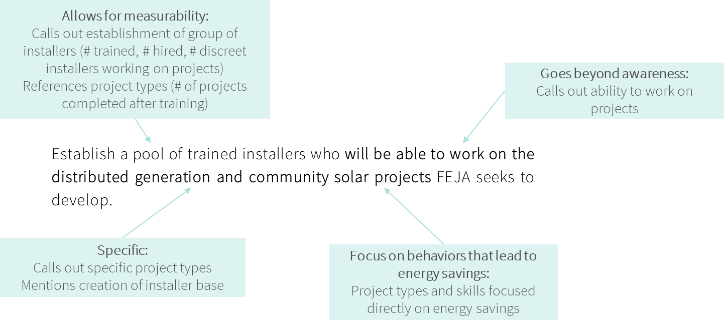
For each Initiative, CT should create goals that include these four elements. Once established, these goals will serve as the foundation of the Initiative. The activities the initiative chooses to implement and the steps showing how those activities meet those goals (the outcomes of the activities), should all be derived from these goals.

Initiatives should specify the outcomes they are trying to achieve to ensure program designs match goals
Outlining program outcomes is a vital process to ensure program activities link up with the goals stated for the program. Outcomes serve as the middle ground between the specific program activities – what the program is doing day to day – and the high-level goals the program is trying to achieve across several years. Like program activities, these outcomes need to be tracked, but unlike activities, metric tracking for outcomes is more complex and requires some analysis of data rather than simple counts. With few exceptions, the Connecticut Education and Engagement initiatives do not have outcomes that link activities to goals.
In some cases, the team found no clearly defined outcomes for the metrics to be tied to, as seen in the Educate the Students initiative, where the initiative outlines a specific goal, and conducts three activities, but has no outcomes linking the activities to the specific goal.
In other cases, the initiative is tracking activities as outcomes. For example, the educate the workforce initiative is tracking some metrics, but those metrics are directly related to the activities of the initiative, such as how many people attended a particular training. They are not tracking the impacts, or outcomes, the initiative is having in terms of subsequent actions. For example, the utilities’ data does not have any record that after participating in a training, the contractors make any changes to their practice, or whether high school students who receive Sustainability Technical Education Program (Green STEP) content go on to do anything with it.
The result of the lack of defined outcomes is that the evaluation team could not find evidence showing how each initiative was meeting their goals.
To create measurable outcomes, Initiatives will need to define the behavior changes they anticipate initiative activities will create. For example, for California’s K-12 education program, an outcome of conducting technical high-school trainings is:
- Increased student knowledge and skills related to fundamental concepts, emerging technologies, best workplace practices and utility programs
- Increased use of skills related to fundamental concepts, emerging technologies, best workplace practices, and utility programs
Both outcomes directly feed into the larger program goal of an increased presence in the market of skilled workers. Furthermore, these outcomes can be tracked by:
- Measuring student knowledge of concepts, technologies, workplace practices, and utility programs
- Assessing whether there is an increase in the use of concepts, practices, and emerging technologies
While outcomes can be measured using simple counts of trainings, most outcomes that provide evidence that the program is meeting its goals require thoughtful measurement and assessment metrics. When outcomes are expanded beyond raising awareness to taking action, there is a fundamental change in the educational objective. To be successful courses must not only raise awareness but give the student the skills and motivation to use that information to effect a change. To create measurable outcomes beyond raising awareness, the program should:
- Explicitly outline what the outcomes are
- How they link to goals
- Propose potential methods to assess the outcome
A major reason creating outcomes is vital to showing program progress toward goals can be seen in contractor responses to CTs workforce development trainings. Contractors stated they are not necessarily learning the concepts they need to learn, or the trainings are not at the right level for them. Specifically, less than one-half of surveyed contractors (42%) reported they have sharpened existing skills through the training, and only about a third (32%) indicated they have learned a new skill in the trainings. Similarly, less than one-half (45%) of respondents indicated they can take on more complicated projects because of what they have learned through the trainings.
“I'm sure there were people there that had that engineering background; I have a business management background, so I wasn't versed in that type of talk or language.” – a new-to-the-industry attendee
In response to these findings, the workforce development trainings can outline outcomes that address the mismatch between knowledge of attendees and level of content in the training. Specifically, the initiative can specify the creation of a comprehensive set of trainings that contractors can enter based on experience as a critical outcome of the program. The program can then show progress toward this outcome by identifying contractor needs (as scoped in the 2022-2024 CL&M plan), showing the creation of a plan, the trainings created and measuring contractor views on the training level appropriateness.
The team outlines this example, and other potential outcomes that inform the larger Initiative goal in Table 6. The evaluation team also provides some potential metrics the program can use to assess the outcome’s progress toward the initiative goal.
Table 6. Example Goals, Outcomes, and Metrics
Goal | Outcome | How to assess progress
Workforce development
Develop critical workforce to foster energy efficiency upgrades in homes and businesses | Creation & implementation of an outreach plan that incorporates government and community group partnerships | # of activities government and community groups partnering with program undertake, formulation and implementation of outreach plans by partners
 | Comprehensive set of trainings that contractors can enter into based on experience | Market study identifying contractor needs, Curriculum plan, Trainings created, Trainings attended, attendee assessment of training level appropriateness, continued trainee engagement across curriculum
 | Create training experiences that go beyond awareness, developing competence and actions. | Market study to assess contractor energy saving behaviors, training participation, awareness.
 | Increased engagement with existing and potential workforce through trainings, internships, and apprenticeships | Cross initiative engagement, calculation of repeat engagement, attendee interest in and participation with green STEP internships
Green STEP
Develop critical workforce to foster energy efficiency upgrades in homes and businesses | Creation of pipeline from technical high schools to contractor workforce | Change in # of students entering EE workforce across time
 | Create training experiences that go beyond awareness, developing competence and actions. | Student exit survey to assess energy savings behaviors, awareness of job options, engagement post-high.
 | Provide work study training options in schools | # of internships created, # of students in internships
 | Increased engagement with potential workforce through trainings and internships | Change in training attendance across time, Change in repeat training engagement by individual students
eesmarts
Promote energy saving behaviors and practices at individual, classroom, school, household, and community level | Facilitate students' understanding of EE beyond awareness | Measure student awareness and knowledge of EE concepts
 | School staff change EE behaviors at school | Change in EE behaviors in school (post interventions - baseline)
 | Students push behavior change in homes, schools, and communities | Student engagement as measured by home, school and community surveys
 | Increased engagement by facilities staff with EE | Change in EE behaviors by facilities staff (post interventions - baseline)
 | Increased participation in EE programs | Change in regional participation pre vs post

Initiatives need to ensure activities conducted directly contribute to the initiative outcomes and goals
The Educate the Students, Educate the Workforce, Educate the Public, and Customer Engagement initiatives consist of meaningful activities to promote understanding and awareness of energy efficiency in the relevant areas. However, the goals of the initiatives as articulated in the C&LM Plan do not always align with the activities that are being conducted and the activities often focus on raising awareness, which is unlikely to spur behavior change.
Across initiatives, the activities being conducted do not uniformly and consistently support the stated goals of the program. In many cases, the activities are in line with the goals, but they do not robustly support the goals nor are they sufficient to create behavior change. In general, current activities promote understanding and awareness of energy efficiency, however, to be effective, they need to be more focused on moving from awareness into taking actions.
Table 7 shows current initiative activities and their effectiveness toward addressing the initiative goal. Except for conducting trainings, assemblies, and sending out monthly emails, the team found current program activities do not robustly help address initiative goals. Red, downward pointing arrows indicate minimal to no linkage between the activity and the goal, yellow bars indicate marginal linkage between the activity and goal, and green, upward pointing arrows indicate a good linkage between the activity and goal.
As noted earlier, this lack of linkage between activities and goals is a result both of initiative goals that are not specific and action oriented and activities that are not directly linked to those goals. For example, Green STEP conducts workshops, career, and science fairs. While these each do help promote energy efficiency as an option to technical high school students, they are not directed or effective enough to meaningfully create a work ready clean energy workforce.
Table 7. Link between Initiative Activities and Goals
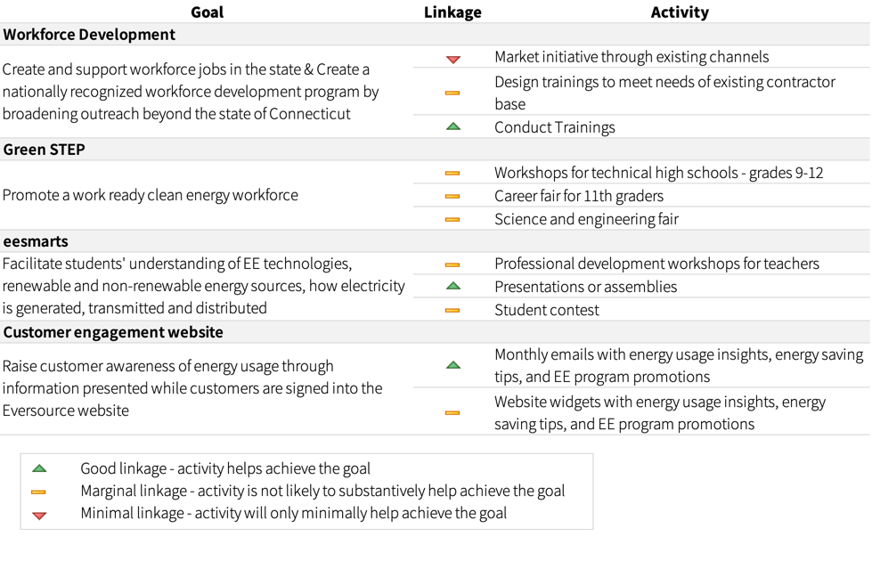

Initiatives should link goals and outcomes to potential energy savings
Education and outreach initiatives are not subject to the formal benefit-cost screening that resource programs such as the Home Energy Solutions program are required to pass. Nevertheless, because they are using Public Goods funds that could be used instead to fund more resource acquisition activities, they need to qualitatively produce benefits commensurate with those achieved by resource acquisition programs. Accordingly, for education and outreach programs to be justified they need to lead to actions that save energy This energy savings can be direct actions taken by program attendees or indirect effects such as may occur if activities lead to an expansion in or better performance of trade allies.
Many of the requirements for a good outreach program are similar to those required of a resource acquisition program. Finally, most germane to this report, outreach programs need to be evaluated, and perhaps surprisingly techniques used are quite similar to those used in resource acquisition evaluations. Process assessments must both test the program logic and design and its delivery. There is even an impact evaluation task that identifies the actions taken though it does not normally quantify the savings associated with those actions. Given this framework, the evaluation team describes the actions taken in this evaluation. The evaluation team outlines the criteria used to judge whether the programs are working as envisioned and how the research and understanding of best practices in evaluation are used to formulate recommendations.
Initiatives funded as part of the EE programs (resource or non-resource) should be able to tie—directly or indirectly—to energy savings. To do this, the initiatives need to show how the education and engagement activities link to changes in energy behavior and/or create energy savings. For instance, a workforce development training should catalog behaviors changed as a result of a specific training, such as documentation that attendees of a BPI infiltration and duct leakage training increased use of duct sealing or use of an improved air-sealing technique as a result of the training. If desired, the program can assign energy savings related to this change in behavior.
The evaluation team understands that initiatives may be designed to meet other policy goals that are not directly related to energy savings, such as educating and training a diverse workforce. However, as an initiative funded through charges on customer bills, and included as part of the Conservation and Load Management Plan, it is imperative that energy savings, even if indirect, are a result of the initiative activities. If, on further consideration, the initiatives are serving to raise general awareness of energy and EE without any impact on actions, then it is the opinion of the evaluation team that the initiative budget may need to be funded through a marketing or outreach fund, rather than through rate-payer EE dollars.
Because education initiatives are non-resource programs, they do not have to provide evidence of direct energy savings as resource program do. However, there are ways education staff can estimate – however qualitatively – that their initiatives are linked to savings. This calculation does not have to be formalized or as rigorously evaluated as resource programs, but it should be used as a directional tool by program staff to prioritize some activities over others.
Other training programs outside of CT, have estimated energy savings. BOC courses are not designed to just teach attendees about boilers but are instead focused on identifying ways that attendees can improve operations of the boilers they operate. Many BOC evaluations use a self-reported rating of the training’s influence on the participant’s decision to take actions to identify the behaviors changed because of the training. They then linked those behaviors changed to energy savings. Similarly, evaluators of the Compressed Air Challenge, a training geared toward managers of facilities with compressed air systems, surveyed training participants to identify the number of respondents who made operational or capital improvements because of the training. They were then able to associate savings with those operational or capital improvements to calculate the training’s overall energy savings.
The evaluation team recommends program staff incorporate the following process into their program planning. Identify behavior changes from associated measures/activities from each training.
- Calculate the proportion of contractors that changed their behaviors after the training
- Link the targeted behavior change to specific energy savings using deemed savings (TRM)
- Calculate energy savings for an average number of projects for attendees
- Calculate the effectiveness of behavior change savings by dividing the deemed energy savings by the expenditure made to obtain that behavior change
- Each initiative may result in many different behavior changes that are linked to energy savings – for each initiative, add the quotients together to assess initiative-level linkages between expenditures and potential energy savings
Example energy savings from CT Initiatives. Most programs focused on changing behaviors do not track data that show whether trainings affect target behavior changes. CT initiatives, like most programs in the US, do not have sufficient data to quantify energy savings from targeted behavior changes. But, with some targeted surveys, CT can calculate rough energy savings estimates. In Table 8, the evaluation team provides a hypothetical example calculation for an air sealing workforce development training, showing what data CT currently has, what data it can derive from other sources, and what data needs to be tracked.
Table 8. Example of Energy Savings Rough Estimate and Cost Assessment
Back of the envelope estimate of savings for a duct sealing training | Example Data | Current CT program data status
Cost of training | $4,000 Dollars | Partially tracked - need to incorporate cost of developing training
Number of attendees to the training (NumAttendees) | 100 attendees | Tracked
Total who said they changed their duct sealing behaviors (NumBehChanged) | 50 attendees | Not tracked - need follow-up survey data from contractors
Percent who changed their behavior (PropBehChanged) | 50% | Calculated (NumBehChanged/NumAttendees)
Average number of air sealing projects done in a year (AvgProj) | 80 projects | Not tracked - need data from contractors
Average natural gas savings for a project (take from EE program evaluation data) (AvgSavings) | 25.5 therms | Can be obtained using EE evaluation data
Rough estimate of annual savings from one training (SavingsPerTraining) | 1020 therms | Calculated (AvgProj*AvgSavings*PropBehChanged)
Savings for dollar investment | 0.26 therms/$ spent | Calculated (SavingsPerTraining/CostofTraining)
As shown in Table 5, workforce development initiatives may be able to quickly assess whether attendees change their behavior by asking targeted questions about energy-savings behaviors related to the training before the training takes place, as part of the enrollment process. Following the training, between 3 to 9 months after the training, staff can ask attendees what their current energy-saving behaviors are. Once these data are gathered, staff can estimate energy savings as described above.
The one exception to this assessment is the current customer engagement email initiative. That initiative is being evaluated using a randomized control trial design. The evaluation team excludes this from the assessment because this initiative has been moved outside of the education and workforce development portfolio.

Initiatives need to incorporate continuous improvement mechanisms into program design
Since non-resource programs are not evaluated with the same frequency as resource programs, setting up continuous improvement mechanisms is vital to ensure each initiative is operating as intended and performing well. Currently, some initiatives collect information from trainers, teachers, and attendees, but this is conducted in an ad hoc fashion and is not tracked.
Green STEP staff have engaged with teachers to learn what teachers need and want as well as barriers to engaging with the program. As a result, staff have learned that:
- Contractors do not want to take on the liability of employing workers under 18, thus making it challenging for the program to promote internships
- The tech schools already have a formalized internship program in place and teachers say they have sufficient opportunities to place students, but that the students cannot get to the job site due to lack of transportation
- Students can complete some certifications in the program, but the certifications are seen as only a small part of a larger career journey
- The program needs buy-in from the top down, including the Superintendent and principals to allow the program to build the program curriculum into school’s curriculum, to ensure teachers do not treat the program as optional
Each of these facts are vital learnings that suggest the program could focus on a smaller set of schools willing to engage deeply with the program. Other, out of the box interventions, such as carpool or driving services to worksites may also prove beneficial in helping the program meet its goals. Further, the team recommends that as program staff encounter these barriers, they document them, and integrate them into a continuous improvement mechanism that could reshape the program to provide greater value and more meaningful impacts.
As part of this continuous improvement mechanism, initiatives should also annually assess the effectiveness and cost-effectiveness of each initiative and redesign or eliminate poor performers. Staff should internally assess the effectiveness of each initiative annually by reviewing progress in metrics and comparing performance and costs over time and between programs. If initiatives, programs, or specific activities are not yielding the planned behavior and practice changes, staff should redesign the interventions or consider eliminating poor performers.

- Workforce Development Trainings
This section presents the detailed findings and recommendations for the workforce development trainings within the 2019-2021 and 2022-2024 Conservation and Load Management Plan (C&LM)’s Develop the Workforce Initiative. The Workforce Development trainings has the following primary objective: “Develop and maintain a sustainable workforce”. Table 9 shows the annual and total investment for the workforce development initiative. This initiative includes the workforce development contractor trainings and Green STEP.
Table 9. Workforce Development Initiative Planned and Actual Expenditure
Planned Expenditure | Actual Expenditure
2019-2021 C&LM Plan | Total 2019-2021 | 2019 | 2020 | 2021
$1,789,487 | $1,160,978 | $150,290 | $533,265 | $477,423
While this study explored program activities in 2019 and early 2020 under the 2019-2021 C&LM Plan, the evaluation team reports findings and recommendations in the context of the 2022-2024 plan, where possible, to optimize relevancy and usefulness. These findings and recommendations are based on the following evaluation activities:
- Program staff interviews
- Implementation staff interviews
- Program best practices literature review
- Curriculum review
- Training documents review
- Trainer/teacher interviews
- Adult education best practices literature review
- Contractor interviews
- Contractor surveys
The evaluation team reviewed the 2019-2021 and the 2022-2024 C&LM Plans to understand Energize CT’s goal for the program, how the program supports both the Workforce Development and Education Initiatives, and how the program supports the plans’ priority areas (Equity, Decarbonization, Energy Affordability). The evaluation team reviewed the following materials in our evaluation of the workforce trainings:
- Training materials and curriculum
- Training event schedules and activities
- Training data tracking – attendee counts
- Program reports
Developing a workforce is not an easy task. Critical elements of developing a workforce lay not just with the utility, but also with community organizations and governing bodies across the state. However, utilities can and do create programs that develop their workforce and create energy savings in doing so. These programs are not easy to create and often take multiple years to realize program goals. To be successful, workforce development programs must:
- Identify critical needs of their workforce and design trainings and programs to address these needs
- Design courses and programs that can both enhance the current workforce and expand it
- Integrate adult education principles to create interactive, hands-on trainings
- Obtain post-training data to assess the effectiveness of a training or set of courses
Current workforce programs such as Building Operator Certification (BOC) training, and internship/externship programs, such as District of Columbia Sustainable Energy Utility (DCSEU) workforce development program show that success is possible in both enhancing and expanding the energy efficiency workforce. However, these programs took time and ongoing evaluation to be successful. In the subsequent sections we:
- Review current and prior workforce development programs across the US
- Outline best practices of successful workforce development programs
- Review CT’s current workforce development activities
- Summarize survey and interview responses from CT training attendees
- Provide granular steps staff can make to improve the current workforce development initiative

Review of Workforce Development Programs in the US
The evaluation team reviewed workforce development programs from other utilities, municipalities, and broader literature on workforce development to identify practices that have led to successful program implementation. The evaluation team classified best practices by identifying patterns successful practices across the program evaluations and documents reviewed. The evaluation team reviewed 17 utility and EE program evaluations of their workforce development programs, shown in Figure 2.
Figure 2. Workforce Development Programs Reviewed
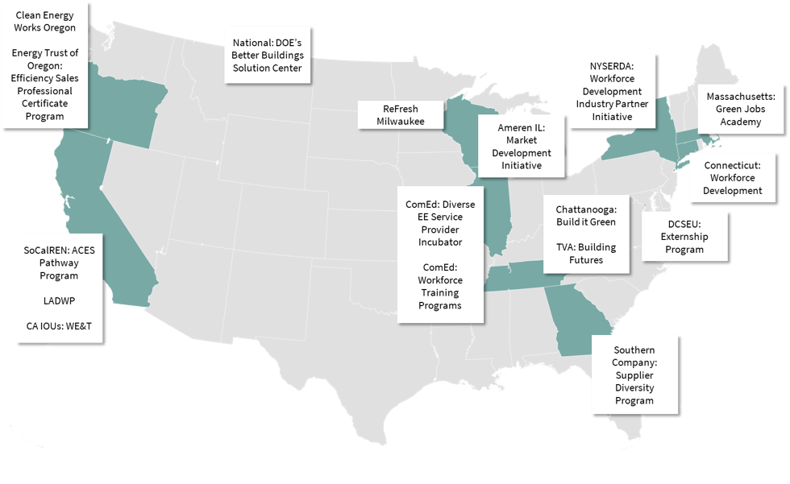
The evaluation team cataloged the metrics tracked by each of the programs, shown in Table 3. The most tracked metrics were demographic information (n = 13), promotions or employment after the training (n = 11), the number of enrolled participants (n = 10), and the number of people who completed the training (n = 10). Notably, only one utility program is currently claiming energy savings associated with its workforce development efforts: NYSERDA’s Building Operations and Maintenance Partnerships Initiative.
The metrics that will better allow for initiatives like Energize CT’s Develop the Workforce to verify goal achievement are:
- promotions or employment post training,
- enrolled participants,
- completion of program,
- career at time of training,
- quality of work post-program activity, and
- EE jobs completed after the training.
Post training metrics are especially important to be able to inform the instructor and program on current program strengths and future program needs. For example, a post training follow-up may discover that attendees’ misinterpreted course material, or that instruction was insufficient in familiarizing students with a critical piece of equipment.
It may suggest future training needed or areas of current courses that could be de-emphasized. In addition to this critical feedback, post training follow up can document that there was an impact of the training on the labor market. For example, knowing the job placement rate after trainings will allow the Companies to verify that they have created jobs, and tracking EE projects completed after a training could lead to calculations of energy savings. NYSERDA, ComEd (Diverse Energy Efficient Service Provider Incubator and general workforce training programs), and the Clean Energy Works Oregon programs were the leaders; Energize CT is somewhere in the middle. Table 10 shows the metrics that are tracked by workforce development programs the evaluation team reviewed.
Table 10. Metrics Tracked by Workforce Development Program (blue = metrics tracked by some CT trainings)
Metric Tracked | Count of Programs that Track Metric
Demographic information about participants | 13
Promotions or employment post training | 11
Enrolled participants | 10
Completion of program | 10
Community partnerships | 8
Participants' career field/employment at time of training | 6
Participants who receive certification | 5
Track EE projects completed by trained participants | 4
Additional Professional Development (joined professional network) | 3
Number of trainings/hours of training | 3
DBE contracts | 2
Quality of work post program | 2
Trainers trained | 1
Participating small business revenue growth | 1
Track energy savings | 1

Existing Research on the Impact of Workforce Development Trainings
The team reviewed evaluation reports and impact estimates for some of the trainings offered by the Energize CT Develop the Workforce initiative.
The evaluation team reviewed documentation on trainings to understand the impact of the trainings on energy savings, job performance, and job creation (see Appendix X for a full list of documents reviewed).

Quantification of Energy Savings
As the evaluation team has noted above all education and outreach programs must document that energy savings has occurred. The team has identified at least eight studies have taken the next step to quantify those energy savings typically using follow-up surveys. Estimating energy savings can take many forms – from robust impact analyses using consumption data to estimates based on the behaviors changed due to the trainings. With exception of largescale efforts like BOC trainings, the evaluation team does not recommend these initiatives calculate energy savings with a high degree of rigor. However, the evaluation team does recommend all trainings - and the initiative as a whole - understand and catalog the energy saving behaviors created or changed by each training. With these data, the initiative can calculate a ‘back of the envelope’ energy savings estimate.
To estimate energy savings, each training will need to document the behavior changes it induces, then the program can estimate the energy savings related to those behavior changes – both within a training and across trainings, and finally, the program can estimate savings by taking the product of the number of behaviors changed and energy savings related to those behaviors.
Few of the training programs the evaluation team reviewed had information on estimated energy savings impacts. This could be due to the fact that publicly available documentation is often evaluation focused, and therefore tends to focus on energy savings for larger education programs using consumption data. The team found estimates of national training programs like BOC and the Compressed Air Challenge. Other trainings, such as PG&E’s tool lending library, did estimate savings based on the ‘back of the envelope’ approach the evaluation team recommends. The evaluators noted, however, that while they can estimate energy savings based on the tools used, the attribution of energy savings based on the tools used is harder to estimate. As such, the evaluators cautioned using energy savings estimates as the sole indicator of the program’s value.
Documented evidence showing trainings lead to quantification of energy savings. Studies of BOC training participants collected information about actions taken because of training participation. The BOC evaluations used a variety of methods to determine the training’s contribution to estimate savings from implemented measures. These included control group comparison or self-reported rating of the training’s influence on the participant’s decision to take actions.
Evaluators of the Compressed Air Challenge, a training geared toward managers of facilities with compressed air systems, employed similar methods. Based on a survey of 100 training participants, the evaluators found that 76% had made operational or capital improvements because of the training, with a mean estimated compressed air system energy savings of 7.5%.
For residential trainings, the evaluators reviewed a recent DOE-funded study to determine whether investment in education and training related to energy codes produces measurable energy savings. The researchers used energy models to estimate average baseline energy use in a sample of new homes across seven states based on code compliance rates. After the implementation of a series of energy building code trainings across the same region, the researchers collected data on code compliance and modeled expected energy usage. By comparing the change in mean modeled energy used in buildings built after the trainings to the baseline, they could estimate the savings impact of the trainings.

Indirect energy savings
Some trainings may not directly lead to energy savings but may indirectly save energy through new sales practices or job creation within the energy industry. Several evaluations of trainings targeted venders and salespeople in the energy efficiency field with follow-up surveys and interviews to assess how participants used training materials in their jobs. For example, 52% of participants from the vendor-targeted version of Compressed Air Challenge reported that their companies began offering new efficiency services after the training.
Several evaluations have assessed the impacts of Energy Sales Professional (ESP) “Boot Camps” on participants’ sales practices and self-reported performance., For example, based on survey responses, 70% of ESP participants in Oregon reported positive impacts on their sales practices and performance resulting from the training. Presumably, this outcome would indirectly produce energy savings. Table 11 describes the evaluation results of some of the trainings that are included in the Energize CT Develop the Workforce initiative.
Table 11. Quantified Energy Savings Impact Evaluations of Workforce Development Trainings
Training | Savings (units) | EvalUATION Methods
Building Codes Training Pilot | 3.9% average reduction in EUI (kBtu/ft²·yr) | Field data collection of code compliance for samples of new homes before and after implementation of codes training program across seven states. Code-compliance data was fed into EnergyPlus models to estimate energy savings.
Building Operator Certification (BOC) Trainings | 0.364 average electric savings (kWh/ ft²·yr·student)  0.011 average gas savings (therm/ ft²·yr·student) | Weighted mean from review of eight evaluations of BOC trainings from 2001-2014. Methods varied between evaluations, but all used a combination of follow-up surveys of training participants and engineering-based savings estimation for measures implemented.
Compressed Air Challenge Training Program | 76% of participants implement savings measures  148,563 average electric savings (kWh/yr)  7.5% average system energy use savings  5-year average payback period | Based on follow-up interview with 100 end-use participants, information gathering on project/facility specs and savings calculations.
Pacific Energy Center’s Tool Lending  Library | Saved $18 million dollars per year and 185 kWhs/year with the caveat that the tool library may not be fully attributable for these savings | Extrapolation of survey results from those who obtained tools through library.
California Advanced Lighting Controls Training Program (CALCTP) | Qualitative analysis describes how CALCTP fills an important role within the lighting controls system market for a “one-stop-shop” training resource that is brand-agnostic, unlike trainings offered by manufacturers | Review of the available training materials offered by manufacturers and the CALCTP supplemented by in-depth interviews of installers who participated in trainings and training providers.

Workforce Development Best Practices
The evaluation team conducted a literature review of secondary research and primary program information related to EE workforce development programs. The team also looked at best practices in adult education outside the EE industry. The team includes details on our best practice review in Appendix C. Based on the industry literature and program review, the team identified six practices used by effective workforce development programs:
- Collect post-training data
- Include diversity as a goal
- Utilize community partnerships
- Assess regional needs
- Recruit widely
- Utilize government partnerships
Figure 3 and the subsequent descriptions summarize each best practice.

Figure 3. Utility Workforce Development Best Practices
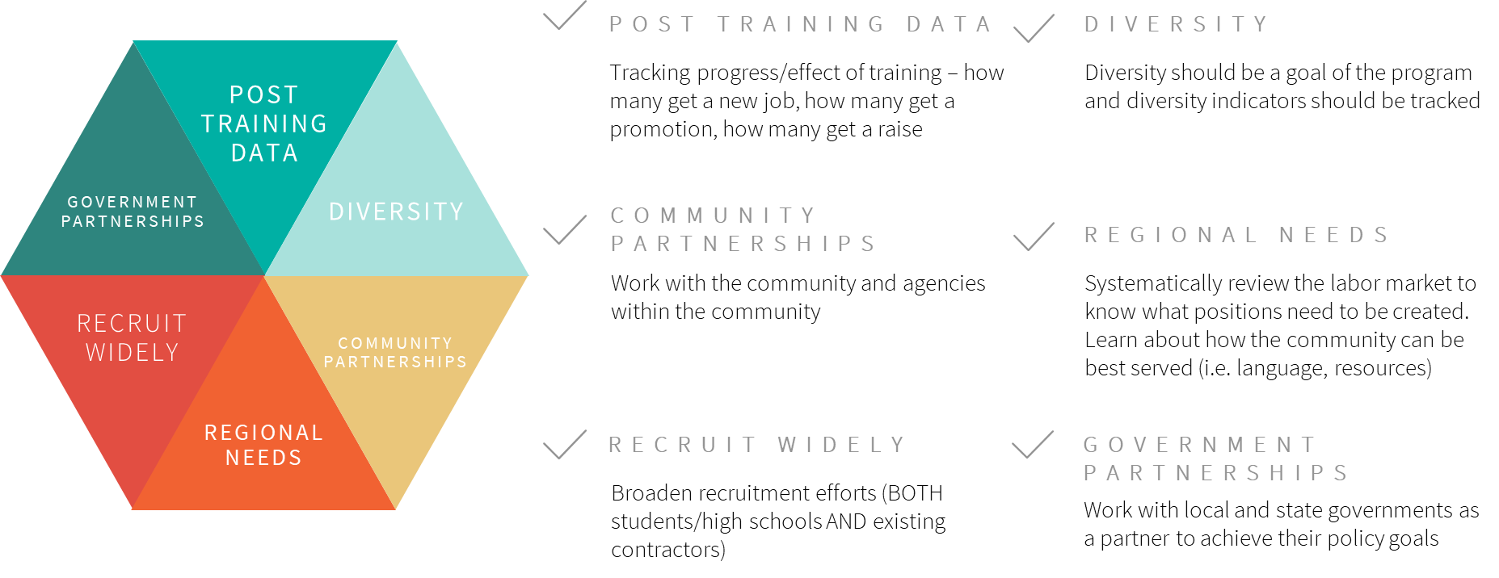
Post-Training Data: Implementation teams need to track certain metrics after the training to understand the effect of the trainings on participants and the workforce overall. Collecting post-training data can range from a conducting a participant survey immediately following the training, following up with participants months after the training, or working with employers to confirm/ask about trainings when they hire participants. The data collected can also vary depending on the goals of the program. Data can be collected on the types of work completed, job placement and/or field of new job, effect on current work, and/or satisfaction about the training. All metrics tracked should help the program understand its progress towards achieving its goals.
Diversity When expanding the workforce, it is important to consider who is included in expansion and how the workforce can best serve the market. One of the elements of the recent DEEP E3 vison statements is to “Recognize and work to remediate past harm by prioritizing historically overburdened and underserved communities.” Ensuring that the workforce is representative of the market in which it works can build a more robust workforce, provide valuable resources back to the community, and start to remediate past harm on these communities.
Many programs the evaluation team reviewed are currently adding diversity targets to their goals. Some, like the ComEd Diverse Energy Efficiency Service Provider (EESP) Incubator, are even adding full-scale programs that target diverse or underrepresented populations in the community. Codifying efforts to make the workforce more diverse by including them in goals can help diversify the EE industry and can better provide for the community at large.
Community Partnerships: Many of the programs the evaluation team reviewed work with their communities to engage at a grass roots level. Working with communities directly allows for the implementation team to learn about what the community needs and existing resources that can be leveraged to enhance the program. It is important to engage with the community to understand the pool of potential employees and how to create a useful workforce that is tailored for that community’s needs. Community organizations often have access and insight to what the community needs. They may have a list of people looking for jobs, understand and have access to hard-to-reach populations, and can offer insight into how best to reach and tailor content for community members. Community organizations can range from trade organizations, community or cultural centers, or local employment organizations. Partnering with these actors can help ensure that the workforce is developed strategically and can increase efficiency when searching for potential participants and tailoring curriculum. In addition to working with community organizations, a program could partner with industry leaders or members of a contractor network.
Regional Needs: Successful workforce development programs are tailored to the local needs of the area and address market needs for the local region. To learn what the region needs, program designers should systematically review the labor market and customer needs. Where are there gaps in the services needed, and what is the workforce currently able to provide? A systematic review could reveal that there are other barriers to workforce expansion and customer engagement such as language or financial constraints. For example, in some regions there are higher proportions of homes that need asbestos abatement before weatherization could occur. Or, in some communities there may be a higher proportion of contractors who do not speak English and need in-language training materials. Conducting a systematic review of the labor needs of the region and the needs of those who could enter the workforce allows for the program to better reach and meet customers and potential employees.
Recruit Widely: Creating a robust workforce means adding new employees to the workforce and enhancing the existing employee pool. This means that recruitment should occur within traditional channels (e.g., trade fairs or through employers) and outside of traditional channels to engage a wider audience. Programs the evaluation team reviewed had innovative ways of recruiting from outside the traditional channels. They recruited via internships, through community organizations that work with at-risk youth, and, like the Energize CT initiative, through trade high schools.
Government Partnerships: Governments have a vested interest in the workforce of a region, and many have existing dollars and resources going toward workforce development promotion. Utilities can partner with governments to tap into these existing networks and provide their expertise on ways to improve the energy efficiency workforce within the region. Governmental organizations may have more insight into the needs of the current labor market, financial resources, pathways to fund programs, and goals that coincide with what utilities are looking for. A robust workforce development program will leverage governmental resources.

Case Study: ComEd Diverse EESP Incubator Program
ComEd is a leader in the industry for their workforce development programs overall and their Diverse EESP Incubator program. ComEd has set goals for a percentage of their supply chain spend to come from Diversity-Certified Suppliers. EESPs include contractors or other firms trained on ComEd’s EE Program processes and procedures that execute ComEd program projects and help customers implement EE improvements with program incentives. The Diverse EESP Incubator program is an eight-week training program that provides ongoing support for commercial suppliers that are owned, controlled, and managed by at least one individual who is socially and economically disadvantaged. Participating in the Diverse EESP Incubator program provides these businesses with a pipeline into ComEd’s EESP network. The Diverse EESP Incubator program goals include increasing the number of Diversity-Certified Suppliers in the EESP network, representing the program portfolio to customers, and ultimately completing additional EE projects.
ComEd’s Diverse EESP Incubator program provides a model for how a utility program can expand their participating contractor network to include more Diversity-Certified Suppliers. The program works by setting a specific goal of completing EE projects and focusing on both technical and business subjects to support participants. The program structure is noteworthy: the Diverse EESP Incubator program uses the “Network Model”—similar to Tennessee Valley Authority’s (TVA) Building Futures initiative and Ameren Illinois’ Market Development Initiative (MDI)—to bring diverse businesses into the utility trade ally network. ComEd tracks projects completed by participating businesses and loosely associates the savings to the program. These projects could not have been completed had the business not joined the EESP network. Unlike a single, one-off training in many workforce development programs, the network-model of the Diverse EESP Incubator program ensures that participants have an ongoing, long-term relationship with the utility.
ComEd’s Diverse EESP Incubator program integrates four of the best practices, as shown in Figure 4 and described below.
Figure 4. ComEd Workforce Development Best Practices
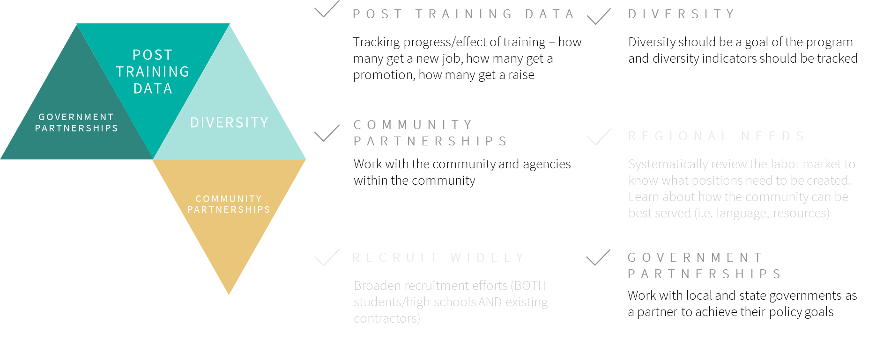
Post Training Data: This program tracks post-training data in at least eight different metric categories, including the number of graduates and projects completed. The program remains closely connected with participants after the trainings due to its structure and is therefore able to track information like projects completed. The 2019 and 2020 program results include 37 cohort members graduated, 17 counties represented, 24 participants accepted into the EESP Network and 11 EE projects completed. The program also tracks the number of EESPs in various fields like HVAC, lighting, and engineering. According to an ACEEE report, in 2020, ComEd recruited 20 cohort members into the Diverse EESP Incubator program, 17 of whom graduated and eight of whom were accepted into the EESP network, with the remaining graduates pending acceptance.
Diversity: Diversity is integral to the structure of this program. This program uses targeted recruiting to achieve the specific goal of increased diversity in their program provider network. The 2020 goal was to achieve 40% Diversity-Certified Supplier spend. The definition of Diversity-Certified Suppliers is from the National Minority Supplier Development Council, Women’s Business Enterprise National Council, and the U.S. Small Business Administration. The ComEd Diverse EESP Incubator is an example of a program that directly addresses a lack of diversity in the trade ally network with a comprehensive approach to address diversity and clear program goals to measure progress.
Community Partnerships: ComEd’s Diverse EESP Incubator Program also leverages community-based agency partnerships to support the program goals. Community-based organizations and trade associations provide promotion assistance, internal business solutions, and software training. The program uses email, phone, and presentations for promotion and marketing. The support of community-based organizations and trade associations is critical to achieving the program goal of addressing barriers to building a successful business in the energy efficiency industry.
Government Partnerships: The State of Illinois enacted the Future Energy Jobs Act (effective in 2017) with the goals of training solar and other electric industry installers, funding job training programs through community partnerships, and identifying additional partnership opportunities. FEJA prompted the creation of both ComEd’s Diverse EESP Incubator Program and their workforce training programs, including the Solar Training Pipeline Program, the Solar Craft Apprenticeship Program, and the Multi-Cultural Jobs Program. In addition, the ComEd energy efficiency programs, for which the network contractors will work, are funded by the state. Aligning their workforce development goals with those of state policy is an example of the ComEd Diverse EESP Incubator Program positively leveraging government partnerships.

Adult Education Best Practices
The evaluation team also reviewed best practices for adult education. The evaluation team reviewed several best practice reports and summarized the key best practices relevant for CT workforce trainings. Best practices in adult education leverage the needs and preferences of adult learners. The team identified the following as best practices that should be integrated into the Energize CT workforce development trainings:
- Assess needs before designing training: Adult learners come to a training with a diversity of needs and experiences. Successful programs ensure that content is tailored to meet the current needs of participants.
- Provide clear objectives for each training: Adult learners are busy and often incorporating training or educational activities on top of other work and life responsibilities. Clearly communicating what the objects of a training are and what participants will leave with can help ensure that people sign up for the right training and are invested in being there.
- Focus on changing behaviors (not just knowledge dissemination): Effective programs focus on changing behaviors rather than disseminating knowledge. The training should be applied, including hands-on practice, where possible, and very practically applicable to have the desired effect of changing behaviors.
- Limit course content: A pitfall of adult education courses can be when there is too much content without adequate time for comprehension and mastery. Limiting course content and ensuring that the most important elements are introduced first and reinforced at the end can lead to better retention.
- Design activities to meet diverse backgrounds and experience: Adult learners bring a diversity of experiences to the classroom. Effective programs tailor activities to meet the needs of diverse learners and leverage the experiences that people bring.
- Design activities to enable learner-to-learner interactions and allow time for interactivity, exchange of ideas, questions: Adult learners benefit from interactive activities and opportunities to learn from their peers. Exchanging ideas, questions, and interactivity benefit and enhance learning.
- Incorporate post-training reinforcement: Reinforcing training after-the -fact is a key component of ensuring that the lessons learned during a training are integrated into practice.
The Energize CT programs should incorporate these best practices into their trainings. These best practices are drawn from other evaluations and grounded in other evaluation studies. For additional information, see Appendix C.

How is Energize CT Doing?
Currently, the Energize CT Develop the Workforce initiative achieves one of the six best practices: utilizing community partnerships. Energize CT partners with the community by working with existing contractors to learn about what trainings would be helpful for the current workforce. Energize CT is in touch with the CT community and are learning about how best to serve CT citizens by interacting with community members. Program staff described their diligent efforts to work with existing contractors to learn about what they need from Energize CT and how the program can best address the workforce’s needs. In the future, Energize CT should consider reaching out to community organizations to see if they would be amenable to partnerships.

Energize CT Workforce Development Efforts
Energize CT workforce development consists of a set of trainings provided by Energize CT and its implementation partners. The evaluation team reviewed the Energize CT Workforce Development documentation in the C&LM Plan to understand the overall goals of the Develop the Workforce initiative. The workforce development initiative outlined three main goals in the C&LM Plan.
- Create and support jobs in the state
- Create work ready clean energy workforce
- Develop critical workforce to foster energy efficiency upgrades in homes and businesses
To guide the design of the workforce development initiative, program staff conducted a working session with participating contractors in the Companies’ EE programs. The session was designed so the Companies could gather information on how to better tailor the Develop the Workforce initiative to contractor needs. After this, the Companies developed the current suite of trainings. During that session, contractors requested trainings for the following broad topics:
- HVAC equipment and controls, lighting, and lighting controls
- Compressed air
- Controls
- Incentives and rebates
- Comprehensive projects (how to sell projects, calculate incentives, and apply)
- Energy management systems (EMS) and building management systems (BMS)
- Submitting a project application and the Companies’ approval process
- Natural gas (how to identify energy efficiency and demand reduction opportunities)
As a result of this session, the workforce development initiative conducted a series of trainings focused on these needs. According to the training data, 738 people took a commercial & industrial (C&I) training and 1,067 took a residential training in 2019 – 2020. The Companies offered 33 trainings in 2019 and 2020: (Table 12). The Health & Safety trainings offered in 2020 as a response to the COVID-19 pandemic were highly attended. The trainings range in their scope and intended outcomes. The trainings moved to an online format during the COVID-19 pandemic.
The trainings developed do focus on the needs contractors noted, however, the companies may need to further identify specific trainings contractors need and want. For example, for HVAC equipment, the companies should assess what aspects of HVAC equipment contractors need to be successful in increasing energy saving behaviors. While a training reviewing HVAC systems is important, some contractors are likely to need very specific courses focused on specific energy efficient equipment, such as courses on how to distribute and size a multi-head heat pump system.
Table 12. C&I and Residential Trainings Offered in 2019 – 2020
Training | Year | Type | Attendees | Hours / Session | # Sessions
Air Cooled HVAC Systems | 2019 | In-Person | 38 | 4 | 1
Commercial Energy Code Best Practices for Field Testing / Measurement in New Construction | 2019 | In-Person | 13 | 2 | 1
Compressed Air Challenge | 2019 | In-Person | 19 | 8 | 1
Compressed Air Challenge I (added class) | 2019 | In-Person | 15 | 8 | 1
Connecticut’s Energy Code - What it means for existing commercial buildings | 2019 | In-Person | 17 | 2 | 1
CT Sales Training | 2019 | In-Person | 60 | 7.5 | 1
Energy Management Systems | 2019 | In-Person | 33 | 4 | 1
Energy Reduction Using Energy Utilization Assessment Six Sigma, Kaizen, 5S, lean Manufacturing and Behavioral Energy Change | 2019 | In-Person | 28 | 4 | 1
ENERGY STAR Portfolio Manager Information and Training Seminar | 2019 | In-Person | 27 | 2 | 1
Energy Storage Systems | 2019 | In-Person | 25 | 4 | 1
Gas Efficiency | 2019 | In-Person | 29 | 4 | 1
GPRO Training | 2019 | In-Person | 63 | 8 | 3
Network Lighting Controls Training | 2019 | In-Person | 46 | 8 | 1
Plan Review – Best Practices and Field Inspection Techniques for Commercial Buildings | 2019 | In-Person | 29 | 4 | 1
Re-Tuning Small Commercial Buildings for energy savings and Better Performance | 2019 | In-Person | 17 | 2 | 1
SBEA CT Auditors Training CTAT | 2019 | In-Person | 21 | 3.5 | 8
Understanding Energy using Systems and their Energy Reduction Opportunities | 2019 | In-Person | 45 | 8 | 1
Understanding, Making and Using Energy Metrics | 2019 | In-Person | 49 | 4 | 1
Variable Refrigerant Flow Systems Design and Opportunities | 2019 | In-Person | 45 | 4 | 1
Advanced Duct Sealing | 2019 | In-Person | 50 | - | 1
BPI Infiltration and Duct Leakage | 2019 | In-Person | 66 | - | 1
Heat Pump Training | 2019 | In-Person | 75 | - | 1
S.E.E.: Sell Efficiency EffectivelyTM (L2SEETM) Training | 2019 | In-Person | 100 | - | 1
BPI Building Analyst | 2020 | Online | 57 | - | 1
BPI Building Envelope | 2020 | Online | 59 | - | 1
BPI Infiltration and Duct Leakage | 2020 | Online | 201 | - | 1
OSHA Attics and Crawl Spaces | 2020 | Online | 80 | - | 1
BPI Building Science Principles | 2020 | Online | 30 | - | 1
ResCaz 3D Combustion Appliance Safety Simulation | 2020 | Online | 47 | - | 1
Health & Safety Training | 2020 | Online | 680 | - | 1
Enhanced Health & Safety Guidelines for Customer Contact | 2020 | Online | 153 | - | 1
Enhanced Weatherization Health & Safety Guidelines for 1-4 family residential buildings | 2020 | Online | 21 | - | 1
Enhanced Energy-Efficiency Health & Safety Guidelines for Customer Contact: All sectors | 2020 | Online | 546 | - | 1

EE Workforce Development Program Review

Energize CT Metrics Tracked
As noted earlier, the 2019-2021 C&LM Plan workforce development plan has three goals:
- Create and support jobs in the state
- Create work ready clean energy workforce
- Develop critical workforce to foster energy efficiency upgrades in homes and businesses
However, while the 2019 – 2021 C&LM Plan states “The Companies will develop workforce development metrics that include attendees, number of trainings, certifications, and workforce impacts.” Neither the plan, or the program outlines how the initiative activities and measured metrics lead to the goal of creating and supporting a clean energy workforce. Further, some, but not all, of the trainings track the metrics outlined in the plan. Currently, some trainings catalog the following metrics:
- Enrolled participants
- Completion of program
- Participants who receive certification
- Participants' career field/employment at time of training
- Number of trainings/hours of training
While these metrics are important to track, they do not inform the “workforce impacts” element described in the plan. Workforce impacts can encompass many elements, including energy savings, career advancement, workforce expansion in disadvantaged communities, among others. These impacts are the critical element needed to assess whether the initiative is successful, and they require data collection outside of the training itself. For example, to assess whether trainees have changed their behavior, the initiative should survey trainees several months after the training to assess whether contractor behaviors have changed. To identify workforce impacts, the initiative will need to outline which activities lead to which desired outcome, and how those outcomes lead to attaining the initiative goal. Next, staff should identify what metrics are needed to assess whether the activities lead to the outcomes and goals.
For example, Figure 5 provides a potential program design consisting of three goals (yellow boxes), three outcomes (grey boxes), and five activities (blue boxes). In addition to tracking the number of attendees, number of trainings and hours of training, this design would require the program to gather the following data:
- Plan covering all barriers and constant assessment of effectiveness.
- Feedback surveys directly after training
- Follow up surveys 6 months after trainings
These additional data allow for calculating workforce impacts directly related to changing behaviors, career advancement, and job creation.
Figure 5. Potential program design outlining goals, outcomes, and activities
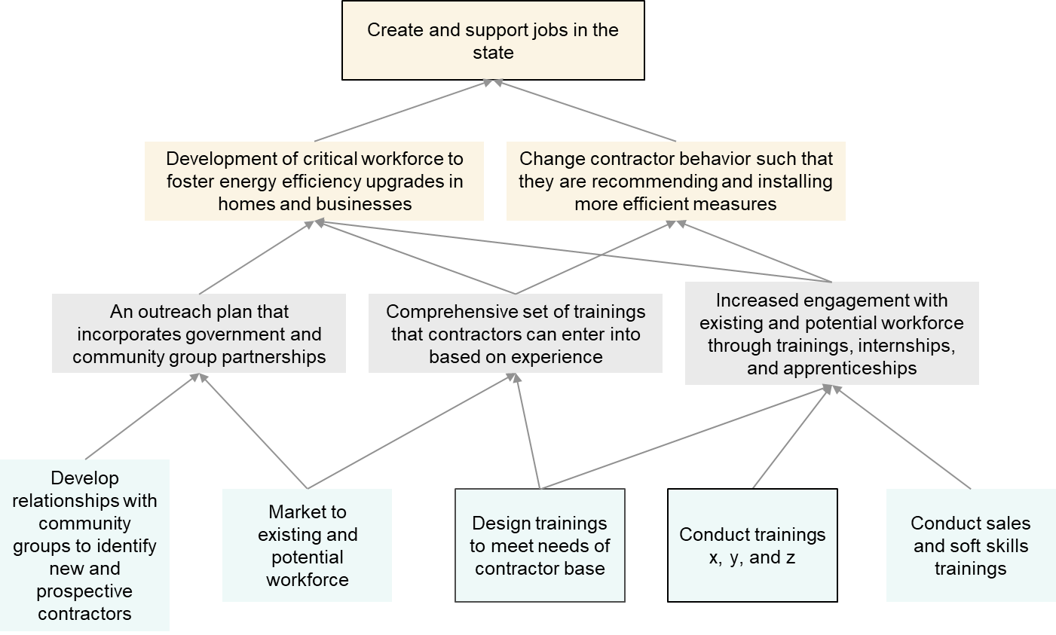

Curriculum Review
The evaluation team reviewed curricula for eight trainings from seven third-party trainers. For each training, the evaluation team interviewed at least one trainer or trainee who taught or participated in the training. The evaluation team reviewed:
- Training materials provided by trainers
- Descriptions of trainings from trainers and attendees
- Publicly available curriculum information
Five of the trainings had content tailored to contractors or program trade allies, and two of the trainings had content tailored to end users (e.g., building managers or system engineers). More details on the methodology and additional findings can be found in In-Depth Interviews with Trainers and Attendees section
All trainings that the evaluation team reviewed are practically applicable. They center on relevant, timely, and industry-specific topics that are relevant to maintain a knowledgeable and skilled workforce. They also each provided clear objectives and goals to the attendees at the beginning of the training and in the materials. These goals were to provide attendees new or improved knowledge, skills, or certifications that would improve how they perform tasks as part of their jobs. Most of the trainings had skills covered in the trainings that employers would specifically need. These skills were mainly in the context of preexisting employment rather than building new skills with people new to the industry. Further, many of these trainings are informational in format, and do not provide as many hands-on, interactive components as adult-learning best practices recommends.
Adult education best practices review. Our evaluation occurred during the Covid-19 epidemic. This shifted how trainers were able to conduct their trainings. In our interviews, they noted that they were able to incorporate more adult learning principles in their in-person curriculums. They noted that in-person trainings were more interactive and flexible, enabling them to tailor in-person trainings to the attendees’ interests and skill level.
The Energize CT Workforce Development training lineup should include trainings that accomplish the following (more can be found in the Non-Industry Workforce Development Best Practices section above):
- Assess needs before designing training. The Companies ask participating contractors and trainers what needs they have before deciding which trainings to provide. Companies may be missing some needs from contractors outside their network.
- Provide clear objectives for each training. Trainers provide clear objectives for each training.
- Focus on changing behaviors (not just knowledge dissemination). Most trainings during Covid-19 were focused on knowledge dissemination. All trainings should be reviewed to highlight energy-saving behavior changes, not just information dissemination.
- Limit course content. Adult learning principles suggest limiting content to three major elements. As trainings move to in-person or hybrid models, trainers will need to review the content to ensure the course does not place too much information within one training session.
- Design activities to meet diverse backgrounds and experience. Trainers currently provide activities that meet the needs of most of its attendees. Trainers should review content and tailor activities enable participation across both entry and mid-level attendees. If activities cannot be tailored, trainers may need to provide separate “level 1 and 2” type courses rather than one course.
- Design activities to enable learner-to-learner interactions. With the shift to online courses, trainers tried to provide interactive elements, but this proved challenging given the format.
- Allow time for interactivity, exchange of ideas, questions. Trainers worked to provide time for questions and the exchange of ideas but noted with the shift to online learning that this was more challenging.
- Incorporate post-training reinforcement. Two trainings used post-training reinforcement in the form of take-home materials or certification maintenance. While attendees often mentioned having access to training materials after the training, these two trainings had the goal of actively keeping the content fresh in the attendees’ heads. Trainers should consider follow-up training sessions that allow attendees to come back and discuss what changes they have made, what has worked and what has not.
While the trainings the evaluation team reviewed were technically sound, met the objectives they stated, and aligned skills with what employers or technical staff needed, some of the trainings lacked other best practices for adult education. The training organizations used to date by the Program have establish their own curriculum, and the Companies have not had much say in how to adjust the curriculum. Courses developed for a national audience may not always be directed towards the needs of Connecticut workers and employers. The Companies may want to have a larger role in designing custom curriculum tailored to their audiences.
Given the ongoing presence of Covid-19, trainers will likely need to explore hybrid online and in-person curriculum for the workforce development initiative. This should include ways to provide in-person, hands-on trainings at education centers, coupled with live and self-paced online training components.

Training Descriptions
In addition to reviewing the curriculum, the evaluation team reviewed the descriptions of the 2019 Energize CT workforce development trainings. There were 30 trainings offered in 2019. The evaluation team found that 17 of these trainings had a target audience described in the “target audience column” within the training description. Not all of the trainings had pricing or the number of seats available, and not all are clear about what the attendees will take away from the training. There were two training descriptions, the (GPRO) training and Compressed Air Challenge training, which should serve as a template for all courses offered. These course descriptions included information about how long it would take, what you will learn, and the value the course would provide to the attendees. In Figure 6 and Figure 7, the evaluation team includes the descriptions provided for the GPRO and Compressed Air Challenge trainings and highlight the most successful elements.
Figure 6. Annotated GPRO Training Description
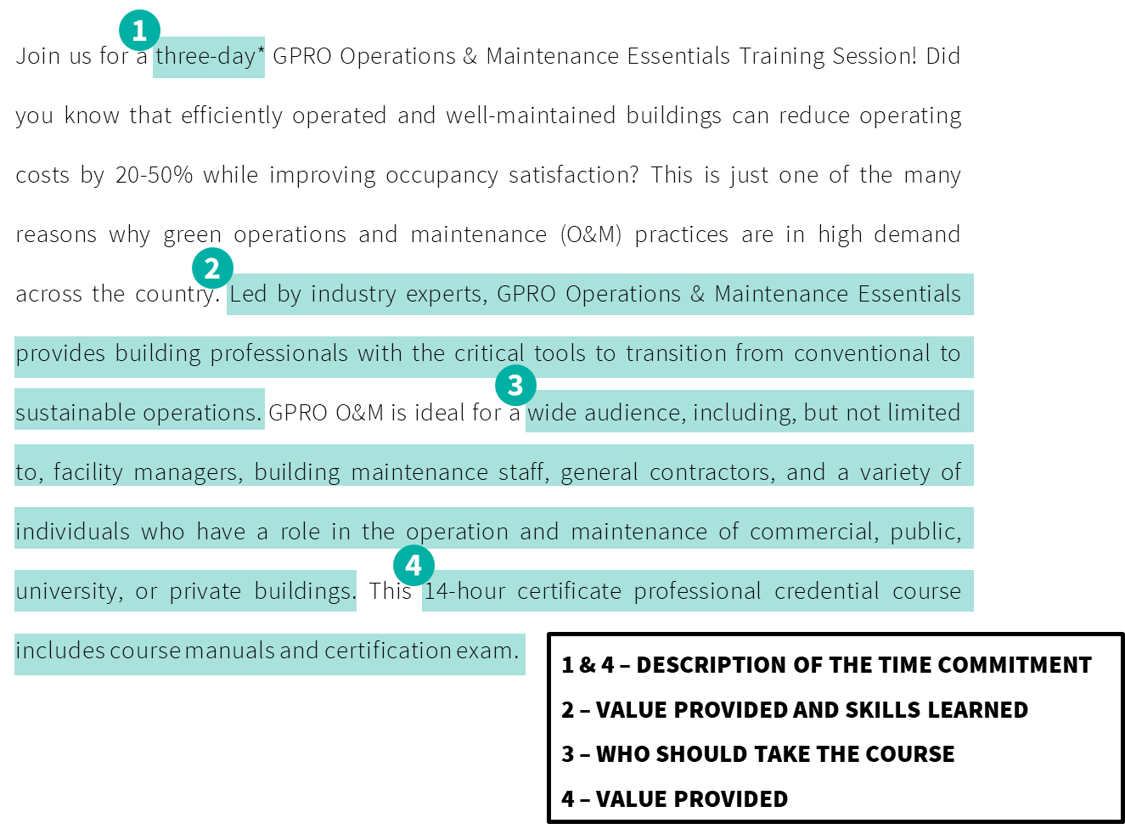
Figure 7. Annotated Compressed Air Challenge Training Description
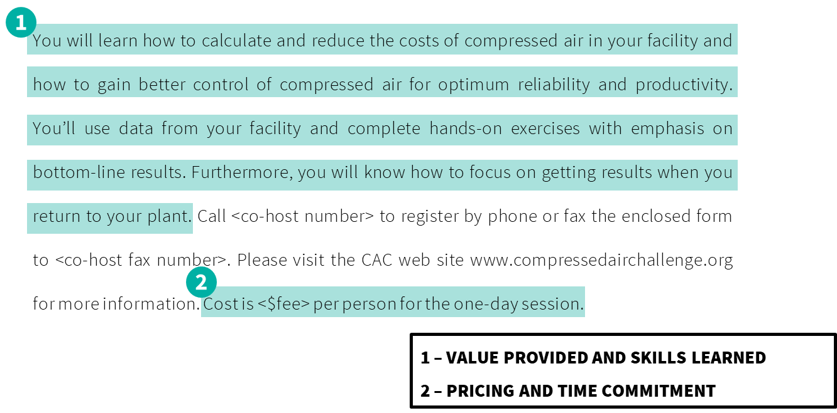

Primary Research
The evaluation team conducted three primary research activities to understand the Energize CT Develop the Workforce initiative:
Survey of training attendees. The evaluation team obtained 107 survey responses, 45 respondents only took a compulsory Covid-related health and safety training, 62 respondents took a technical training. Our analysis in this main chapter focuses entirely on those who took a technical training. Appendix X provides responses for all who took the survey.
Trainer interviews. The evaluation team spoke with six staff that provide trainings, three staff provided administrative support to trainings and did not conduct trainings themselves.
Attendee interviews. The evaluation team spoke with ten contractors who had attended at least one training and completed the survey.
Since our research was conducted during the COVID-19 pandemic, many of the trainings the evaluation team reviewed (via interviews or surveys) took place virtually. Some respondents described liking the freedom and flexibility that virtual trainings can provide, while others described difficulties with the medium. Some trainers said it was hard to engage attendees and that some of the more technical content was difficult to relay without in-person examples. Similarly, attendees said it was difficult to stay engaged in an online setting. As the pandemic continues and its effects linger, the Companies will need adjust online or hybrid approaches to engage attendees and provide examples that work in a distance setting.

Who Took the Survey
The evaluation team surveyed 107 past participants in the Energize CT workforce development trainings. Of these respondents, 45 took the survey for the health and safety trainings. While this information is valuable, the evaluation team wanted to understand what the participant reaction was to the technical trainings. The evaluation team had 62 respondents who took the survey for a non-health and safety training.
Figure 8 shows the demographic breakdown of the respondents to this survey.
Figure 8. Survey Respondent Breakdown
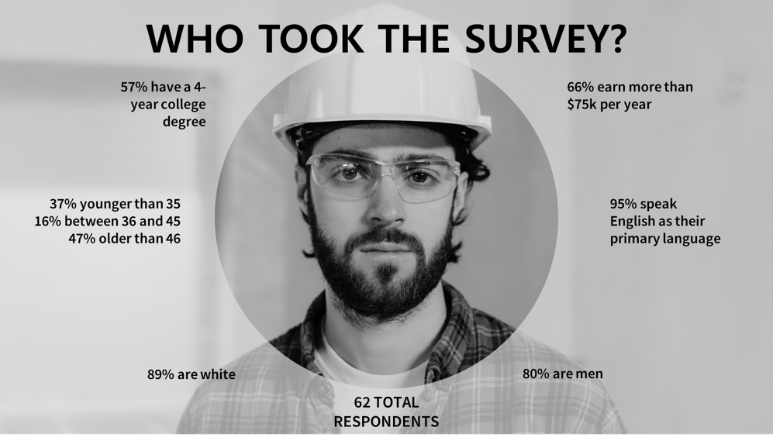
These numbers reveal the narrow lens of the audiences currently reached by Energize CT workforce development trainings. Comparing the respondents to this survey with the population of Connecticut for gender and race, the audience currently reached by Energize CT workforce development trainings are more limited than an average sample of people living in Connecticut (based on the 2019 United States Census).
As the identified best practices indicate, demographic diversity and increasing program inclusion for underserved communities are indicative of a leading workforce development program. The attendees the evaluation team reached in this survey resemble the majority of demographic groups within Connecticut in terms of gender and race, but the respondents are more educated and affluent than the average citizen of Connecticut.
Utility versus non-Utility Attendees. Ten of the 62 survey respondents said they worked at a utility. While utility personnel may see value in workforce development trainings, they are not the target audience for them. The evaluation team took measures to exclude utility attendees from this survey by excluding emails from utility sources, however, some attendees did not use their utility-supplied email address.
Since these utility respondents are not the target audience for this evaluation, the evaluation team excluded them from the survey analysis and reporting.
Target respondents represent fields like home improvement and building automation in a mix of roles including technicians, salespeople, and contractors.

Enhancement vs. Expansion of the Workforce
As noted earlier, there are two avenues for creating a robust workforce: enhancement and expansion (Figure 9). Enhancement focuses on the existing members of the workforce. Members of the workforce take trainings to hone their skills and improve in their current jobs. This can happen through learning about a new product or ways to improve upon an existing process. Expansion is bringing new employees into the field by training someone outside of the industry or training someone in the industry in a new field. (e.g., an HVAC installer who becomes a PV installer). Both enhancement and expansion are necessary for accomplishing the goals of the program.
Figure 9. How to Create a Developed Workforce
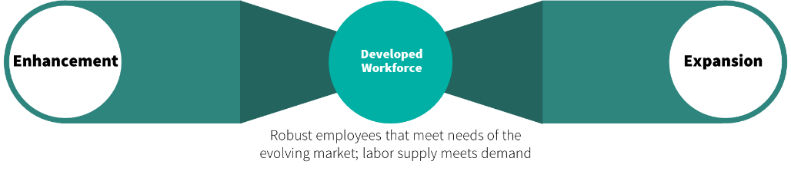
The Energize CT workforce development trainings effectively enhance the workforce. Most respondents reported the training has influenced them in some way. Ratings of almost half of technical training respondents indicate they have changed their behavior as a result of the training they took. Specifically, 40% (22 of 52) of respondents rated “mostly agree” or “completely agree” on all of the following statements:
- I am better at my job because of the training
- I still use the skills learned in the training
- I completed energy efficient project(s) using new knowledge or skills from this training
Over half (52%, 27 of 52) of the non-utility technical survey respondents reported the training had an impact on the way they work, with under a third noting the training changed the products they recommended or installed (Table 13).
Table 13. Contractor changes in behavior after training
Change after training | Count | Percent (n=52)
The products you recommend or install | 16 | 31%
The way you sell those products | 12 | 23%
The way you install or maintain the products you work with | 7 | 13%
The way you inspect work | 7 | 13%
Total overall impact | 27 | 52%
Contractors’ assessment of whether the training impacted the way they work may vary by the type of training they took (Table 14). However, given the low number of responses for each training, the evaluation team cannot compare impact across trainings with any certainty. Qualitatively, the virtual presence training had less impact on contractors than the CT sales training.
Table 14. Contractor response to whether the training impacted the way they work by training attended
Did the training have an impact on the way you do your work? BY Training | Yes | No | Total
Elements of Virtual Presence | 5 | 3 | 8
CT Sales Training | 6 | 1 | 7
Green Training USA | 4 | 1 | 5
Understanding, Making and Using Energy Metrics | 4 | 1 | 5
Variable Refrigerant | 3 | 1 | 4
BPI Infiltration and Duct Leakage | 2 | 1 | 3
Understanding Energy | 1 | 2 | 3
All Energize CT Lighting Trainings |  | 2 | 2
Gas Efficiency Training by ERS |  | 2 | 2
LinkedIn Training |  | 2 | 2
SBEA |  | 2 | 2
Compressed Air Challenge | 1 |  | 1
Eversource Business Partner Rollout | 1 |  | 1
ALCS Training for External Invitees |  | 1 | 1
BOC Online Trainings |  | 1 | 1
CT Energy Code Existing Buildings |  | 1 | 1
Energy Start |  | 1 | 1
Energy Storage Systems Training by ERS |  | 1 | 1
GPRO O&M Essentials Training |  | 1 | 1
New Incentive Forms |  | 1 | 1
Total | 27 | 25 | 52
Respondents provided some open-ended assessments of how the training did or did not impact the way they work. These open-ended assessments varied substantially, with some respondents noting the trainings provided helpful information but did tot effect their work, while another noted the training helped them better address duct leakage in their home. Sample of responses from contractors who noted the training did affect the way they worked:
- The training helped me to better address duct leakage in homes
- looking for ways to measure and verify compressed air energy savings.
- The overall approach to presenting & selling measures
- Make sure to recommend solutions for customers that will maximize utility-recognized savings and incentives.
- Improved air seal skills
- The training provided a new holistic perspective on the products recommended to clients based on the energy metrics.
Sample of responses from contractors who noted the training did not affect the way they worked:
- The trainings assist us with giving guidance to our sales force on the CT Save incentive program. It does not affect our business other than how we participate with the program and the changes that occur with the program.
- It was helpful information, but it did not impact my role.
- I found the training to be quite surface level. All of the tips about improving my LinkedIn profile for visibility and network, I'd already known and updated prior to the training.
- I took the course to understand other energy savings measures. However, it was very convoluted and not exactly what I was looking for.
Because of the breadth of technical trainings encompassed in the survey, the evaluation team cannot identify which specific behaviors attendees changed or the potential energy savings attached to those changes. The evaluation team also does not know whether attendees made major or minor behavior changes, but this provides some evidence that trainings are helping to change how attendees do their work.
Most respondents were satisfied with their trainings, with more than two-thirds (67%) of technical training respondents noted the trainings were at the right level (35 of 52), and 90%of respondents said the trainings met or far exceeded their expectations. Utility respondents provided slightly higher ratings than non-utility respondents (Table 15).
Table 15. Technical Training Responses for Level and Expectations of Training
Level of training | Non-Utility Respondents
 | n | %
Far too high | 1 | 2%
Somewhat too high | 1 | 2%
Appropriate for my level of experience | 35 | 67%
Somewhat too low | 12 | 23%
Far too low | 3 | 6%
Total | 52
Expectations of training | Non-Utility Respondents
 | n | %
Far exceeded your expectations | 2 | 4%
Somewhat exceeded your expectations | 5 | 10%
Met your expectations | 39 | 76%
Fell somewhat short of your expectations | 4 | 8%
Fell far short of your expectations | 1 | 2%
Total | 51
Half (50%) of the respondents indicated they plan on attending future trainings, and over half (53%) of respondents noted they had already taken more than one training. Respondents were interested in trainings about EE (e.g., energy conservation, energy auditing, weatherization), renewable energy (e.g., solar, thermal, geothermal, fuel cells), and sales and marketing. More generally, the program attracts repeat participants. For example, one survey respondent had taken 12 trainings, and one person in the full participant data set had taken 64 trainings/classes.

Assessing how trainings expand the workforce
The survey could not assess how trainings are expanding the workforce in depth because of the way trainings are advertised to contractors – through a listserv of existing contacts. As such, the evaluation team is limited in assessing how current trainings help expand the workforce.
To continue to enhance the workforce, the Companies should:
- Create hybrid in-person and online trainings
- Increase the hands-on components of trainings
- Gather feedback directly after the trainings
- Follow-up with attendees to identify elements of the training have changed behaviors
To expand the workforce, the Companies should:
- Engage with the participating and non-participating contractor base in CT to assess needs across both groups
- Provide trainings that meet the needs of a larger contractor base, spanning basic to advanced trainings
- Expand recruitment using non-traditional methods, including engaging with community centers, and linking with technical high school and junior college curriculums
- Provide tuition-wavers or incentives to take trainings for those with substantial barriers to participating in trainings

In-Depth Interviews with Trainers and Attendees
The evaluation team conducted in-depth interviews with the individuals who led Energize CT workforce development trainings as well as those who took the training. The evaluation team spoke with six trainers and leaders of training organizations (one sales trainer and five technical trainers) to learn more about the trainings and the curriculum. Three of the people the evaluation team spoke with are administrators at their organizations and do not actually conduct the trainings. The evaluation team also spoke with 10 people who took the trainings to learn more about their experience in the courses.

Enhancement vs. Expansion
First, the trainers and attendees of the trainings described how the Energize CT workforce development trainings fit within the enhancement vs expansion model. The evaluation team found the trainings are more focused on enhancement of the workforce. The structure of the workforce development trainings and the Energize CT recruitment strategy focus on those who are already in the workforce. Energize CT recruits for the trainings using email newsletters to those who are in the trade ally network. Attendees described learning about the trainings through an email sent by the Energize CT team. They said this was an effective way to learn about the trainings, but program managers said this is the only way the trainings are marketed. This means only those on the email list can learn about the trainings. One attendee said he learned about a training in 2009 from the Hartford Business Journal; he was so inspired he entered the industry. Marketing the training in non-industry venues could attract people outside of the industry to the field.
He said, “That [training] is why I do what I do now, and if I didn't go to that, I wouldn't be talking right now. I figured a lot of things out that morning, just sitting in the training. That one was definitely a good one. I went and the rest is history.”
In addition, many of the trainings are geared towards those who are already in the workforce. This is reflected in the subject matter of the training or the explicit or implicit requirement of participants having a certain amount of time in the industry to take the training. Both the marketing strategy and the training pre-requisites make it difficult, if not impossible, for non-industry people to take the trainings as they are currently designed and marketed.
One new-to-the-industry attendee said, “I'm sure there were people there that had that engineering background; I have a business management background, so I wasn't versed in that type of talk or language.”
Attendees said they took the trainings to refresh their memories on existing skillsets or to stay up to date on existing technologies.
One attendee said, “Some good reinforcement. I don’t know that there were any earth-shattering, new ideas, but we all tend to get complacent, sometimes. Attending something like that is always a good reinforcer and good reminder of good habits.”
Several trainers and attendees talked about the importance of expanding the workforce and had ideas on the best ways to do this. Trainers discussed the current labor shortage and the aging workforce in the EE trades.
One trainer said, “We're pushing for more professionalism within the market to make it more desirable, so it's not just sort of job of last resort. It's been a been a push of ours for years, to get off get out of the bottom tier of jobs and create career paths for people and focus on making it more attractive through workforce training.”
To expand the workforce and bring new and young employees in, some of the trainers recommended 1) describing the industry as a career and highlighting professional credentials that they can get; 2) working with local schools and community organizations to host job fairs or informational sessions about the benefits of a career in EE; and, 3) training existing lighting contractors on other trades such as air compressors or HVAC, as the industry moves away from lighting.
One trainer said, “We're presenting opportunities right now to hopefully attract more people into the industry. Not to make it so that you just need to know how to swing a hammer and pull things together, but show the related occupations, and I think if we can get more people attracted to the construction industry, that will begin to trickle down more to the labor market.”
Attendees were less concerned about the aging workforce but talked about the importance of recruiting new people into the industry and making up for a general labor shortage within the trades. Attendees also recommended working with local high schools and community colleges to provide training and information on EE trades. In addition, attendees discussed the value of networking as a means of recruiting new people to the industry.
Two trainers mentioned they think the Energize CT team could market the trainings more effectively. Some trainers mentioned there are many Eversource employees who attend the trainings. One trainer said, “I'm assuming internally, some of the Eversource employees are required to go to classes, other times it is people who are doing compressed air projects. I see people from the engineering group in my class quite often; and sometimes it might be the second or third time that they're taking the same class.” Trainers and attendees recommended recruiting from local high schools and colleges and speaking with career counselors to train them about the benefits of EE jobs. In addition, both trainers and attendees recommended Energize CT advertise for the trainings in places where non-industry people might see (e.g., LinkedIn). One attendee said, “A lot of the people that I know, we are heavy on LinkedIn, for networking purposes and understanding the industry, so that would be a good place to post something. I’m hoping it finds its way to people new to this industry that are looking to learn more.”

Best Practices
The trainers and attendees the evaluation team interviewed corroborated some of the best practices the evaluation team learned about in other streams of research. Interviewees indicated some of the trainings incorporate the best practices previously mentioned; and some described their ideal training in similar terms to the best practices. The interviews corroborated the following best practices:
- Need for diversity
- Providing a description of the training to attendees
- Making it easy for people to take the trainings
- The importance of hands-on trainings/adult education
- The importance of reiterating information and providing them with take-home resources
- The importance of data collection and feedback
Need for Diversity. Two trainers discussed the need for diversity within the EE industry and the trainings themselves. One trainer said as the industry changes because of climate change, post-pandemic, labor shortages, and changes to utility goals and technology, the industry should also work to diversify the workforce. She said, “I don’t think the construction industry is all that well-positioned labor wise. We don’t use Black labor, we don’t use women labor, it’s very much white-dominated and increasingly Hispanic.” Another trainer said he noticed the demographic breakdown of the trainings in terms of gender were like that of the industry. He said, “The demographics are more about their job positions, so maintenance people are typically male. Plant engineers, facility managers, again typically men. Occasionally, you’ll get a woman in the class.” He said the demographics of people in the classroom reflected the demographics of facility and plant managers and engineers: primarily men. While these trainings are not less diverse than the current workforce, the industry itself should push to become more inclusive of gender and race.
Descriptions of the Training. Some attendees described wanting more information about the skill level of the training before they sign up. A few attendees said the training was far more advanced than they had expected; a few said the training was far too basic. One attendee who thought the training was too easy said, “I think the communication of it could be better. If I had better envisioned what it was going to be, I don’t think I would have joined it.” Conversely, one attendee who did not understand the information said, “When I went in, it was a lot more in-depth than I was anticipating, in the sense that the formulas were way over my head and went way too fast to follow.” Had these attendees known what the training entailed before they went, they could have signed up for a different training and/or would not have attended the training. Providing information about pre-requisites or a list of covered materials would be useful for attendees.
Ease of Attending. Trainers and attendees discussed the importance of making it as easy as possible for attendees to take trainings. Trainers talked about properly incentivizing trainings and making them convenient. They said incentives can include paying for the attendees’ time or providing continuing education credits for the course. Several attendees described similar incentive structures. One attendee, who takes over 160 hours of professional development courses per year, works at a company that actively promotes continuing education. He said his company requires him to take at least 40 hours of trainings a year. He is paid for his time at the training and receives a bonus for trainings he completes. He said, “It’s to keep up in our industry. The requirement, company culture, and bonus for taking trainings are helpful in developing our internal workforce.”
Trainers and attendees said if incentives are not possible, Energize CT should make the trainings as easy to take as possible. Trainers recommended offering multiple sessions of the same training or a full day of trainings with different sessions in the morning and afternoon. This would allow for attendees to make the most of their days off work. In addition, they said offering breakfast and lunch during the training can be a good way to provide value without paying an incentive. Attendees recommended offering more sessions for the trainings at different times of the day and in different mediums. The evaluation team spoke with two attendees who said they could not attend many trainings because they were on the road at customers’ houses most days. They said virtual trainings or podcast style trainings would make it easier for them to attend. One attendee said, “I think virtual meetings can be an effective way to reach us on the road. I listen to podcasts a lot, especially on the road. They are a good tool, and I think training recordings like podcasts would be helpful.” Interestingly, one trainer said they offer the training in podcast format, and it has been well received: “We have all the lessons in the entire program in audio-only format grouped into podcasts, of about a half an hour to an hour each, so you can listen to that while you're driving to and from work.”
Hands-on Instruction and Take-Home Materials. The trainers described creating and teaching their courses in a way that aligns with the training best practices the evaluation team found in Tasks 2 and 3. Trainers described providing hands on opportunities, presenting the objectives of the course at the onset, being available for ongoing support after the training, and structuring the course to be more than just a PowerPoint (e.g., including audio, visual, and practical instruction). Most attendees corroborated this. Attendees said they often had access to the trainers after the training was over as well as course materials for them to take home after the course. A few trainers and attendees said hands-on activities were more difficult in virtual trainings, but they understood the limitations of the medium.
Data Collection and Feedback. The evaluation team found that all trainers collect feedback at the end of their courses by asking questions about the attendees’ satisfaction with the training, trainer, and materials. Some trainers ask questions about the skills learned and if attendees will be able to use the skills going forward. One trainer said they have conducted follow-up interviews with attendees to ask about the long-term effects of the training. She said, “We have done surveys of our students about their progression, whether it’s receiving a promotion or a pay increase. Usually, 60 – 70% of our graduates report seeing a pay increase or a promotion as the result of completing the training.” In addition, the trainers said they always send their results to their clients. Some of the information gathered in these surveys may not be effective in measuring progress to program goals but knowing the general satisfaction with the trainings could be a useful marketing tactic. And, given there are already expectations of a post-training survey, attendees may be willing to take a short survey to ask about program goals. It may not be feasible for trainers to include program related questions in their surveys.
While the evaluation team was conducting the interviews with trainers and attendees, we found some discrepancies in the data provided to the evaluation team. The evaluation team found the contact information for the trainer was incorrect for three of the six trainers the evaluation team spoke with. In addition, one attendee the evaluation team spoke with had signed up for the training but had not completed it. The data indicated he had completed the training. It is important to collect data and to ensure it is properly entered and updated as necessary.

Training impacts
Trainers and attendees reported it would be difficult to measure the savings impacts of trainings. One training does have a calculated per-unit savings value for it. Two other trainers described evaluations of their trainings that found positive savings impacts from them. One training had been evaluated through a DOE study with a pre-/post- model to evaluate the impact of the training. Another training was linked to a certification, which the trainer said validated the cost of the training and proved the savings impacts from it. They have internally calculated savings and provided a list of public evaluations (Table 5) that were able to verify savings.
Despite hearing from attendees in the survey that the trainings had a direct impact on work, the evaluation team did not hear this from the ten attendees the evaluation team interviewed. Many of the attendees the evaluation team spoke with said the trainings were more informative rather than skill based, or the trainings were not closely related to the attendees’ current job. One attendee said, “Overall, my takeaway was getting a basis and idea of what other measures might be. I was expecting something different.” Another said, “I wouldn’t say I learned skills, more a basic understanding of the gas efficiency industry. My job is not connected to gas savings but being in the industry I understood how electricity can be applied to that.” This is most likely due to the people the evaluation team recruited for the interviews more than the trainings themselves. The trainers the evaluation team spoke with taught trainings with more practical applications; the attendees the evaluation team spoke with were veterans in the industry or took trainings that were not related to their current job.
Many attendees said one of the reasons they participate in Energize CT trainings is to meet peers and colleagues in the industry. One attendee said, “I take the trainings to keep up with what’s going on in the industry and see what is new, and to interact with peers.” They like hearing what their colleagues are working on, learning tips and tricks, and having an opportunity to learn about leads. One attendee described an event he went to where trade allies were given the opportunity to interact with program staff. He said it was very useful to have face time with program staff and fellow trade allies. In addition, one attendee said he met an influential mentor at an event. He said, “Having a mentor is almost necessary when starting this program, and I found that’s hard because other companies don’t really want to help, so you have to rely on Eversource, but they don’t have mentoring staff. I was lucky enough to find this person who helped me, what he’s doing in his company, and I was able to pick up a lot from there.” Providing more explicit opportunities for networking through workforce development trainings may be of interest to trade allies. Or, using networking as an explicit added benefit to the trainings could help recruit additional attendees.

Training Content and Interactions with Energize CT
Trainers described having a set curriculum based on their organizational purpose and history. The trainers the evaluation team spoke with offer these trainings nationally. Some of the trainings are managed/sponsored by government organizations or large companies. Because of this, most of the trainers said they have little discretion in the curriculum. Some said they can adjust their training style and some of the details based on location (e.g., a code trainer said they change the training depending on the state) or attendees. For example, they can adjust their engagement style based on the audience participation levels or the medium through which the course is taught. One trainer said, “We always have to do some research to make sure we’re giving them knowledge they can use. We always have to keep things updated, we don’t want things to get outdated, and that can happen over the course of a few years. We have the capacity to modify any of our trainings.”
No trainer referred to Energize CT as “Energize CT.” Instead, they referred to them as “Eversource” only. On the other hand, attendees did refer to Energize CT as “Energize CT.” Both attendees and trainers were looking for more interactions with the program team. A few trainers described wanting more time to interact with the Energize CT team and request more opportunities for trainings. Attendees were looking for more programmatic support from the Energize CT EE program teams. Some attendees said they went to workforce development trainings to learn more about the Energize CT programs (e.g., program requirements). For example, one attendee said, “I take the trainings to see what will be covered under the incentive. On the program website, it’s difficult to access information and it is out of date”. Some attendees said they were interested in what Eversource, and United Illuminating were planning for the next five to ten years as lighting measures go away. While both topics are out of scope of the workforce development program, it is important to listen to what the trade allies and energy service companies (ESCOs) are asking for.

Recommendations
The following section describes our recommendations for the Energize CT Develop the Workforce initiative. These recommendations are based on what the evaluation team has learned from our secondary research, materials review, and primary data collection. While these recommendations would make any workforce development program better, the evaluation team also advises the Companies to revisit the current initiative goals to ensure they are in line with the needs of stakeholders and citizens of Connecticut.
Develop Goals, Outcomes and associated Activities to expand and enhance the Contractor Base
There is currently a disconnect between the goals and activities of the Develop the Workforce initiative. The current activities do not match the goals. The evaluation team recommend the Companies should first review the current goals and ensure they are in line with the needs of the initiative, utilities, and the state. Once these goals have been reviewed and updated, the Companies can then think about the outcomes the utilities and their stakeholders want to see, then establish the activities that would lead to those outcomes.
When crafting the outcomes and goals for the initiative, the Companies should meet with various stakeholder groups to learn more about the market and understand the broader needs of the workforce. Example stakeholders are listed below. The Companies can coordinate with DEEP or ESB to facilitate these meetings.
- Connecticut citizens
- Office of Workforce Strategy or the Workforce Investment Boards
- Existing contractors and employers
- Community college and high school career counselors
- Program administrators and workforce development program coordinators from neighboring state utilities
Further, the utilities should continue to engage contractors, asking them what their needs are. The evaluation team also recommends utility staff reach out to non-participant contractors to see how Energize CT can address their needs. This engagement can be informal and should be continuous, so the program can continuously assess:
- Where are there holes in the labor market?
- Where is there labor demand?
- What is the existing labor supply?
- Which groups are underrepresented and what do they need to participate?
- What barriers exist to participate in trainings?
- How do current training offerings support the labor needs of the state?
- Where are there gaps in the training offerings?
Learning about the labor market and understanding how the current training offerings fit into the labor needs will allow the Energize CT initiative to better address the workforce of the state. The evaluation team found the current Energize CT Develop the Workforce initiative focuses more on enhancement of the workforce. Learning about the labor market and the gaps within the current set of trainings would allow for Energize CT to better strategize on how to expand the workforce.
Develop Course series that cover breadth and Depth of key topics and use adult learning principles
Using information utility staff have obtained from both participating and nonparticipating contractors, utilities should develop course series that cover the diverse needs of the CT contractor base. This includes higher-level scans, such as a review of current HVAC practices, but also includes detailed trainings on specific behaviors the program wants contractors to change, such as how to install multi-head heat pumps.
Once topics and course content has been identified, trainings need to be designed using adult learning principles, including:
- Assess needs before designing training.
- Provide clear objectives for each training
- Focus on changing behaviors
- Limit course content
- Design activities to meet diverse backgrounds and experience
- Design activities to enable learner-to-learner interactions and allow time for interactivity, exchange of ideas, questions
- Incorporate post-training reinforcement
Finally, trainers should receive instructional training prior to conducting any trainings with contractors.
Develop metrics to accurately track progress towards goals and codify current tracking standards
Once the utilities have outlined program goals and activities, the utilities should define and track metrics that will allow the workforce development trainings to be assessed. The Companies should collect baseline metrics before the training, like current employment status and position. In addition, the Companies should collect post-training metrics, such as position obtained. Metrics that track job placement (e.g., success at new position, skills used in new positions, improvements to the workforce) can also help measure the initiative’s progress towards goals.
Annual reviews of data quality should be conducted to ensure all trainer information is up to date. In addition, current tracking practices for the trainings should be standardized. Currently, the data tracked are not consistent across trainings. Each training should have the same level of data and the same populated fields so they can be compared to each other. In addition, data should capture all attendees and their final participation status. The evaluation team found some respondents who had not completed the training but were marked as attendees in the data. The evaluation team also recommends collecting data from the trainers (e.g., feedback surveys) in one consolidated location. Creating a training ID that is attached to each unique training and its training materials could help keep this information organized.
Increase diversity of participants within trainings
The evaluation team recommends adding goals to the initiative to start actively recruiting businesses and/or attendees who are underrepresented in the industry. The Companies could use the Network Model to diversify the training audience by incentivizing and actively recruiting contractors who are currently underrepresented. Programs like the ComEd Diverse EESP Incubator or TVA Building Futures are good models of how this can be structured.
To increase the diversity of contractors attending trainings, the Companies should also consider:
- Expanding marketing efforts to include people who are not currently in the industry (i.e., not trade allies or current utility employees). Targeting those in trade schools, or in community colleges can help to diversify those attending trainings.
- Expanding the scope of the initiative to include internships or apprenticeships for potential employees. The Companies could partner with current trade allies or among their organizations to create jobs for potential employees. These would be intensive internships or apprenticeships where new employees would learn how to work in the industry from experts. To ensure that these internships help expand diversity in the workforce, the evaluation team recommends utilities speak contractors and community groups to identify what barriers workforce entrants face and how CT workforce programs can address some of these barriers.
- Working with job agencies, career counselors, and/or high school and community college counselors to promote EE jobs. This would pair well with an internship or apprenticeship program.

Create training marketing/recruitment strategy
The Companies should develop a broader workforce development marketing strategy where training success and satisfaction can be highlighted at a higher level. Attendee testimonials, overall trainer credentials, and high-level statistics about the initiative could be shared as a broader marketing strategy. This marketing strategy should include ways to reach non-industry members. The evaluation team recommends the Companies engage nonparticipating contractors and technical schools to identify the best channels and phrasing for promoting the Develop the Workforce initiative to non-industry members. In addition, Energize CT could partner with existing companies who may have a pipeline into prospective employees.
For the existing outreach strategies, training descriptions should be updated to include more detail on the courses, including learning objectives and what the attendee will get out of the training. Descriptions should also include information about the audience, timing and pricing, and skills and information provided. Descriptions from the trainers could be updated to include this information, or a standard description template could be provided to trainers as part of the contract. In addition, the Energize CT website should be up to date with future trainings and include an easy way to sign up to receive training update emails.
Provide additional resources for attendees
Attendees are looking for additional ways to interact with Energize CT program staff and to attend the trainings. Given that attendees often go to the trainings for networking or interacting with others, the Companies should consider offering explicit opportunities for networking with peers and program staff. This could be virtual events, tabling events, or dedicated time before or after trainings with the express purpose of encouraging networking and social connection. Given that some attendees are looking for more information about program details and the future of utility programs, the Companies could consider offering an annual summit to provide new information (e.g., changes to program requirements) and what the coming year holds for the utilities.
In addition to providing resources for networking, the Companies should consider alternative delivery methods for the trainings that would allow for more people to attend the training. For example, the Companies could offer a virtual option even after the pandemic has ended or record the trainings (virtual or in-person) and offer them as podcasts. This would allow for contractors who cannot easily take time off to participate in the trainings on their own time. The Companies could work with existing trainers to discuss how to create podcasts.
Utilities should also consider 1) co-sponsoring training opportunities with national organizations, 2) partnering with neighboring state utilities, and 3) planning in-house trainings and conference opportunities.
To accomplish this, the Companies should consider:
- Reviewing current co-sponsored training opportunities in Connecticut and outside of the state and assessing their effectiveness. The trainings should be analyzed for participation rates relative to other trainings, proportions of attendees coming from Connecticut vs. elsewhere, and barriers for Connecticut residents to attend the trainings. Note, this may be different during the COVID-19 pandemic, and future opportunities for cross-state trainings could be broadened by using virtual platforms. If the data are not currently available to analyze for these metrics, the Companies should consider adding them for future assessment of cross-state trainings.
- Reviewing current partnerships with national organizations and neighboring state utilities. This will ensure that these partnerships have been created and the goals and action items are shared across entities.

- Develop the Workforce: Green STEP
This section presents the detailed findings and recommendations for the Green Sustainable Technical Education Program (Green STEP) offering within the 2019-2021 Conservation and Load Management Plan (C&LM)’s Develop the Workforce Initiative and the 2022-2024 C&LM’s Education Initiative. Green STEP efforts reside within the Develop the Workforce Initiative. Specifically, in the 2019 – 2021 plan, Green STEP falls under the purview of the Workforce Development initiative which has the following primary objective: “to provide students with the opportunity to become more work ready for the clean energy workforce through technical certifications, internships, and work studies in their related fields and trades before they graduate from high school.” Table 16 shows the annual and total investment for the workforce development initiative. This initiative includes Green STEP, but also includes contractor trainings.
Table 16. Workforce Development Initiative Planned and Actual Expenditure
Planned Expenditure | Actual Expenditure
2019-2021 C&LM Plan | Total 2019-2021 | 2019 | 2020 | 2021
$1,789,487 | $1,160,978 | $150,290 | $533,265 | $477,423
In the 2022-2024 Conservation and Load Management Plan (C&LM), Green STEP was moved to the Energy Education Initiative (career and trade school trainings). The evaluation team reports on the program in the Workforce Development section because it was listed under the 2019-2021 C&LM Plan’s Workforce Development Initiative, which aligns with the study period and timeline of data collection for this evaluation.
While this study explored program activities in 2019 and early 2020 under the 2019-2021 C&LM Plan, the evaluation team reports findings and recommendations in the context of the 2022-2024 plan, where possible, to optimize relevancy and usefulness. These findings and recommendations are based on a review of program materials, a review of best practices of other K-12 education programs, and interviews with program stakeholders.

The evaluation team reviewed the 2019-2021 and the 2022-2024 C&LM Plans to understand Energize CT’s goal for the program, how the program supports both the Workforce Development and Education Initiatives, and how the program supports the plans’ priority areas (Equity, Decarbonization, Energy Affordability). The evaluation team reviewed the following materials in our evaluation of Green STEP:
- workshop curriculum
- educational event schedules and activities
- certification course schedules and activities
- participant tracking data and survey responses (where available)
- data tracking tools and processes
- program reports
The evaluation team also conducted interviews with several program stakeholders to understand recent changes to the program curriculum or program design, program value to stakeholders, and any variations in perceptions of program goals and/or program value.

High School Job Training Program Best Practices
At the outset of the evaluation, the team conducted a literature review of high school job training programs to identify program design best practices to help create a work-ready clean energy workforce. On the basis of this literature review, the team identified several best practices for workforce development program. The evaluation team suggests that workforce education programs like Green STEP should include the following best practices:
- Offer creative and tailored as well as participation incentives to address barriers to participation
- Collaborate with industry employers to reinforce the workforce development pipeline
- Align curriculum with the needs of the market
- Focus on hands-on experience
- Provide end-to-end career support
- Plan for evaluation
The evaluation team provides additional details on each of these best practices below.
Offer creative and tailored participation incentives to address barriers to participation. A common design element the evaluation team found in successful programs was participation incentives like apprenticeships, paid internships, college credit, and transportation resources. These incentives do not need to be only financial, but could include access to other resources, for example transportation. Programs that offer paid hands-on experience not only incentivize student participation but also reduce income-based barriers to participation such as lost income from time spent in school. The opportunity to earn an income while in school can be a motivator for all students regardless of income status and can increase overall program participation rates. Additional participation motivators include a history of high participation rates and access to college credit, job placement services, in-demand skills training, and career connections.
Case Study: BGE Smart Energy Workforce Development
BGE’s Smart Energy program creates a career pathway from high school job training to Smart Energy internships to full time jobs. BGE runs an 8-week summer internship program that offers eligible participants Utility Trainee positions after high school graduation. This program is not focused on energy efficiency, but on workforce development at the utility. Participants include juniors and seniors from vocational technical high schools interested in trades that include automotive technology, carpentry, computer-aided design, construction, electrical, engineering, and plumbing. During the paid internship, transportation is provided for students via chartered transportation or bus passes. An additional incentive for students to participate in the program and to apply for positions with BGE is the tuition reimbursement program BGE offers their full-time employees
Pre- and post-program support includes professional readiness and team building skills before the internship, and a free test prep course for the mandatory Construction and Skilled Trades test (CAST) after the internship, through a partnership with the South Baltimore Learning Center. Interns also have the opportunity to attend one-on-one career days with trade professionals.
The program shows success based on placement in full time jobs. Between 2016 and 2020 there have been 180 students in the program, and 15 hires of former interns at the utility.

Collaborate with industry-specific employers to reinforce the workforce development pipeline. Another effective program design element was inclusive and consistent collaboration with relevant industry employers. Programs collaborate with and leverage industry employers who play a vital role throughout the high school to workforce pipeline, this enables employers to lend their expertise which program planners can use to inform curriculum changes that ensure students are prepared for in-demand careers. The BGE Smart Energy case study (see side bar) highlights a case study of a successful talent pipeline. Successful programs showcase trade careers at student career fairs, and they often provide internship and job opportunities for students and graduates. The inclusive nature of these partnerships ties education to community needs and generates strong buy-in from participating employers.
Another example of a successful workforce development program for high school students is the West Sound STEM program, a regional network currently leading career-connected learning experiences in Kitsap County, Washington. According to an ACEEE report on the topic, “The organization has partnered with employers, unions, labor groups, and several other regional community and technical colleges to establish a controls programmers apprenticeship program for youth and adults (England and Andrade 2019). To create a talent pipeline, the program involves educators from elementary to postsecondary institutions in work site and industry interactions and development of competencies and standards. These connections help educators and guidance counselors understand the career pathways available and what skills are needed to succeed.”
The evaluation team understands that the program teams have struggled to support an internship program due to concerns about the liability of hiring people under 18 years of age. This challenge is not broadly mentioned in the literature, but the team notes that other states have apprenticeship programs in relevant fields. For example, the Smart Buildings Center in Washington sponsors the Washington State Controls Specialist Apprenticeship. This apprenticeship program includes two tracks, a 4-year program for participants 18 years or older and a 2000-hour program for youth 16 years and older and enrolled in a high school or equivalent credit recovery program. The program standards and protocols are approved by the Washington State Department of Labor and Industries and include limits to the amount and type of work that those under 18 may participate and the necessary protections, for instance: “Where the term “troubleshoot” is used it is limited to work on the building automation system and will not involve installation, replacement or repair work on any of the underlying mechanical systems, low-voltage electrical circuits, motors, and pumps.” (p. 9 of the Apprenticeship Program Standards). The Companies and program teams may want to consider supporting Apprenticeship Programs such as this.
Ensure course and training curriculum align with needs of​ the job market and communicate this to teachers and school administration. Successful workforce development program materials have clear and motivating objectives, content that reflects the needs of the market, and basic professional skills (teamwork, time management, etc.). High school programs host job fairs and meet-and-greets with potential employers. Effective programs review the labor market by coordinating with current industry employers to update trainings as needed. Where offered, certification exams align with employer-recognized skill standards. Successful programs have open communication between the school administration, teachers, and program teams so that all parties are aligned about workforce needs and how the program offerings address those needs.
Further discussion of where the Energize Connecticut programs could be better aligned with the needs of the job market are detailed below. The evaluation team notes that while the Green STEP program implementer is conducting some of these activities, the findings of the primary research with CTECS teachers suggests that there is opportunity to improve this alignment.
Focus on hands-on​ experience at multiple levels. Successful programs provide practical experience through tools like a practice home and creation of an internship program to provide on-the-job training. BGE’s Smart Energy program brings students and interns to the company’s offices or facilities to give interns sight into what can be expected from an energy career.
End-to-end​ career support through professionalization skills and follow up after graduation. Effective job training programs give guidance to students before, during, and after trainings, host job fairs with potential employers, and align certification exams with employer-recognized skill standards. Additionally, they provide general professional skills, such as teamwork, interpersonal communication, and time and work management. There is emphasis on how marketable certifications can strengthen academic and job applications.
Integrate evaluation and feedback as a central part of the program. Feedback and evaluation are critical to ensuring that programs remain relevant and aligned with current needs of schools and employers. Successful high school workforce development programs retain contact information for graduates of the program, track job placement and certification rates. Doing so enables the program to measure the impact of participation in the program, respond to feedback from recent participants, and integrate those new employees into other workforce development efforts.
The EnergizeCT Green STEP program currently does not incorporate all of these best practices in a rigorous manner. In the sections below the evaluation team highlights opportunities for the program team and implementation team to integrate best practices more consistently.

Green STEP Initiative Goals and Activities
Program goals provide the foundation for the program, including program activities and their desired outcomes. In our review of the Green STEP goals for both C&LM plans, the companies improved upon their 2019 goals to create specific, actionable, and promote energy efficiency behavior change in the 2022-2024 plan.

Program Goal according to C&LM plan
According to the C&LM plan, the primary objective of the Companies’ Workforce Development initiative is “to provide students with the opportunity to become more work ready for the clean energy workforce through technical certifications, internships, and work studies in their related fields and trades before they graduate from high school.” In particular, the Plan states that the Companies “will implement a vendor-managed Career and Technical Education program approach focusing on certifications, trainings, and job fairs for students attending one of the 18 Connecticut Technical Education and Career System (CTECS) schools across the state, as well as students enrolled in energy management degrees at a Connecticut community college.”
As discussed in Chapter 2 Crosscutting Findings and Recommendations, program goals ought to be
- specific,
- focus on changes beyond awareness,
- promote energy efficient behavior changes that can – directly or indirectly – lead to energy savings, and
- measurable in some way to show progress toward the goal.
The evaluation team notes that the criteria of ‘leading to energy savings’ may not be direct, but through training laborers who then go on to install energy efficient equipment, there may be an indirect impact on energy savings. While the goal for the Green STEP program does go beyond awareness, the evaluation team does not find that this goal is specific, that it promotes EE behavior change, or that it is designed such that progress toward the goal can be assessed and measured. Furthermore, as the evaluation team will discuss in more detail in subsequent sections, the evaluation team does not find that the program is particularly effective at developing the workforce, which is the explicitly stated goal of the program.

Goals based on Program Implementation
According to the 2019 Memorandum of Understanding (MOU) between the Companies and the Capitol Region Education Council (CREC), the program designer and implementer, agreed to “provide management, energy education, technical training, and events management to CTECS students and educators in the form of the Green STEP program.” The MOU describes that under the terms of this agreement, CREC would collaborate with the Companies and CTECS administrators to identify key milestones for 2019-2020 school year, to develop curriculum in alignment with NGSS standards, and to identify curriculum goals for individual workshops. As a result of this effort and later curriculum updates, the program goal became, “to help technical high school students attain skills and experience needed for jobs in energy and green building construction”.

Individual goals of each workshop were:
- Introduction to Green STEP (Grade 9) - to introduce the Green STEP program and its goals, descriptions of program milestones, trade related trainings, certification options, the science fair, and future career paths
- Introduction to Energy and Sustainability (Grade 10) - to teach sustainability concepts including renewable vs nonrenewable energy, provide examples of clean energy jobs by trade, and conduct activities to think through energy use in different building types
- Introduction to the CT Science & Engineering Fair (Grade 10; science fair event and Green STEP trainer support open to all grades) - to prepare and guide students to submit clean energy projects to the CT Science and Engineering Fair
- eesmarts Solar Energy Workshop (Grade 11) – to teach students about solar energy through a series of activities:
  - Activity 1: measuring light absorption
  - Activity 2: measuring light energy converted to electric energy via photovoltaic cell using various angles of incidence and apply findings to solar electricity installation
  - Activity 3: measuring and quantify differences light energy converted to electric energy via photovoltaic cell with various shading/color media and screens
- Technical Training (Grade 12) - to teach trade-specific or equipment-specific lessons: Blower Door, Duct Blaster, Heat Pump Water Heaters, Energy Efficient Lighting & Building Code
Looking at the goals of the specific trainings as well as the overall objectives outlined in the MOU, the team finds that the goal of “help[ing] technical high school students attain skills and experience needed for jobs in energy and green building construction” does not meet the criteria of being 1) Specific or 4) measurable, although this goal does meet the criteria of going beyond awareness and potentially resulting in behavior changes that lead to energy savings.

2022 – 2024 C&LM Plan Program-Specific Goal
In the 2022-2024 Conservation and Load Management Plan (C&LM), the Companies outline a new phase for the Green STEP program. In the plan, the Companies explain that they have maintained a collaboration with CTECS since 2010 to provide educational training to, “…increase the knowledge and awareness of energy efficiency and clean energy technologies to CTECS instructors and students.” More specifically, the plan describes that the Green STEP program is designed to provide the following outcomes for CTECS students:
- Gain 1) knowledge, 2) expertise, and/or 3) certification to implement
  - a) sustainable building practices,
  - b) energy efficiency renovations, and
  - c) energy efficient equipment upgrades.
As discussed in Chapter 2 Crosscutting Findings and Recommendations, program goals ought to be
- specific
- focus on changes beyond awareness,
- promote energy efficient behavior changes that can – directly or indirectly – lead to energy savings, and
- measurable in some way to show progress toward the goal.
Using this framework, the evaluation team finds that the 2022 – 2024 goals are specific and focus on changes beyond awareness. However, the program will only be justified if it expands the workforce and in such a way that these newly trained workers install energy-saving equipment. Given that the focus of most of the activities listed above is to raise awareness, it may be difficult to justify these awareness activities as leading to an expanded workforce. If the program can do so, then it will be in alignment with best practices.

C&LM Plan Priority Areas and Initiative-Level Goals
In the 2022-2024 plan, the Companies developed priorities areas including Equity, Decarbonization, and Energy Affordability. Each priority area sets initiative-level goals. The evaluation team assessed how Green STEP program efforts may support Workforce Development and Education initiative-level goals. The evaluation team describes findings from this assessment by priority and initiative below in Table 17.
Table 17: Alignment of Priority Areas in 2022 – 2024 C&LM plan and Green STEP Activities
Priority | Relevant initiative goal | Assessment of Goal | Findings
Equity | Relevant Workforce Development Initiative-Level Goal: ensure that Connecticut’s energy efficiency workforce is as diverse as the communities the workers serve. | This goal can be measured based on certain characteristics of program participants and their post-participation careers. | Green STEP does not currently collect information about participating student characteristics that could potentially inform Energize CT’s progress toward this goal. The main reason for this is that most students are under 18 and are considered a vulnerable population. If this is indeed a barrier for the program, the program could work with the CTECS high schools to obtain contact information for graduates. The program could also consider measuring by counting the number of successful graduates into the workforce or internships compared to the locations of the schools to understand where in the state the program may be having a greater impact.
Decarbonization | Relevant Energy Education Initiative-Level Goal: inspire students and educators to become energy advocates who understand the inextricable link between energy consumption and climate change. | This goal can be measured based on relevant knowledge gain that leads to energy efficient behavioral change that occurs among program participants and because of their involvement with program activities. | Green STEP’s current program design collects some information to help measure progress toward this goal, but it is not sufficient. There is little information to confirm that the content of the workshops for Grade 9 and Grade 10 are valuable in practice., The program should consider gathering information including: participation data, post-participation surveys or interviews (where applicable), long-term post-graduate tracking and feedback. At the time of this study, a long-term tracking system was not fully developed. A limitation may be related to separating the impact of CTECS curriculum and other educational opportunities from Green STEP impacts.
Energy Affordability | Relevant Energy Education Initiative-Level Goal – help students explore how their school building uses energy and water and guide the students toward energy efficiency recommendations for their school | This goal can be measured based on relevant knowledge gain that leads to energy efficient behavioral change that occurs among program participants and because of their involvement with program activities. | Green STEP did not include this activity during the time of this study, however, during the 2022-2024 plan period, the Green STEP vendor is exploring opportunities to add it.
Demonstrating achievement of the 2022-2024 goals will require measurement and verification efforts beyond what was completed in the 2019 -2021 cycle, including creating mechanisms to keep in touch with students after graduation, and, as the evaluation team will discuss in more detail below, better differentiation of how Green STEP is creating impacts above and beyond what the CTECS curriculum already offers.
The evaluation team finds that the program as described has many positive attributes but the evaluation has not revealed any evidence compiled by the program or available through the evaluation sufficient to demonstrate an impact commensurate with the investment of public goods funds, The expenses may be justified if the result of the program is that there are new workers entering the field. However, there is insufficient evidence to indicate that at this point. The primary research (discussed further below) suggests there are barriers related to less than full buy-in from individual schools or teachers. For this reason, the evaluation team recommends the program focus its efforts on only a few schools.
Opportunity for Enhancement: At these early stages of the 2022 – 2024 plan implementation, it is an optimal time to ensure that structures are in place to measure progress toward and achievement of the goal that CTECS students gain 1) Knowledge; 2) expertise, and/or 3) certification to implement sustainable building practices, energy efficiency renovations, and clean energy equipment upgrades beyond what is currently afforded through CTECS. To do so, the evaluation team recommends that the program team identify specific metrics through which to gauge the impact of Green STEP activities, for instance, looking at the number of students who achieve particular certifications or who complete internships in clean energy.

Green STEP Activities
In 2019, the Companies hired the Capital Regional Education Council (CREC) provide technical and project management of Green STEP. Green STEP conducts the following activities:
- Deliver in-person and virtual workshops
- Provide optional career development opportunities
  - certification testing
  - a career fair for 11th graders
  - guidance and support for CT Science and Engineering Fair participants
At the time of this study, 17 technical high schools in Connecticut participated in Green STEP. Through this program the utilities conducted Green STEP workshops with over 2,800 students in 2019 and 2020.
Overlap and competition with CTECS’ Curriculum. Outside of the Green STEP program, CTECS require students to reach a certain number of hours in each of their academic and trade-specific curricula to graduate. Like the Green STEP model, students in grades 11 and 12 have more hands-on training requirements and can earn credits through internships or paid employment. Green STEP is not a requirement to graduate and may be seen by students as an add-on to the normal requirements. Instructors mentioned that it can be difficult for students, teachers, and other curriculum stakeholders to balance requirements and electives within the constraints of the school year.
“There’s already a crazy curriculum with the trade schools. They have their academics, half [of their education] is trade hours, then we’re adding in this information [Green STEP]. We have to narrow it down to what’s attainable, we’d love to do more.”- Green STEP Instructor
Due to this overlap with CTECS curriculum, Green STEP’s influence on students and the program’s ability to meet its goals is limited. While there is substantial effort put into creating a Green STEP curriculum that is attainable and informative, the program would ideally be integrated into the curriculum rather than an add-on or separate offering. As a first step, the program should:
- Identify which current activities provides added value to students and can help attain CT’s lofty goals
- Expand activities that add value to students and eliminate activities that do not
- Identify additional barriers that keep students from fully engaging in energy efficiency training
- Design interventions that directly address those barriers

Curriculum Development
The Green STEP curriculum development process typically happens annually and is a collaborative process balancing the requirements of multiple stakeholders. The curriculum development process is collaborative, including the utilities, CREC, instructors, and high school consultants. The purpose of the review is to verify content relevancy to the current job market.
CTECS administrators come to the design table understanding that it is paramount to CTECS success to demonstrate high rates of student job attainment. CTECS consults with members of the Career and Technical School Advisory Committee (CTEAC), which is made up of trades employers, about the needs of the current job market. This input is highly influential and informs the annual updates to the CTECS core curriculum. While the bulk of the core curriculum currently does not have an emphasis on clean energy, some core curriculum concepts overlap with Green STEP Workshop Curriculum. For example, energy efficient building concepts, solar panels, and EV charging. It is unclear how much these lessons overlap. This is something that should be explored further to help the Companies determine the extent to which students learn the concepts from Green STEP workshops versus through core classes.
Utility input is highly guided by their current energy savings initiatives and program offerings, and utility initiatives are heavily guided by decisions from DEEP and the Energy Efficiency Board in Connecticut. Because the utilities are the funders, each year curriculum developers (CREC being the general entity responsible for development/adaptation) submit the curriculum for each Green STEP course to the Connecticut utilities to approve. While the utilities have not asked for many changes, they could influence the curriculum during the annual review process.
Opportunity for Enhancement: Given the way in which the CTECS curriculum is established, if there are no clean energy employers on CTEAC, it’s not likely that CTECS would adapt the core curriculum to more formally teach clean energy job skills. Green STEP could support the clean energy career pathway by recruiting clean energy employers to join CTEAC. A second opportunity for Green STEP to enhance the program would be to explore the extent to which core curriculum overlaps with Green STEP content. Doing so could enable the program to ensure that the content they provide is supplemental to and not duplicative of the CTECS curriculum.
Another solution is to invest more heavily in a sub-set of schools (one or two) to create a kind of magnet program where students could receive training specifically tailored to the needs of green jobs. This approach has several advantages:
- It creates a competition for schools to be awarded support rather than potentially pressuring less-interested schools to pigeon-hole the program into their curriculum.
- Competition would require chosen schools to document their progress to be re-selected, thus embedding some outcome-tracking in the process.
- It provides more money to a few schools enabling a greater impact in those schools.

Workshop Curriculum
At a high-level, Green STEP provides introductory lessons on energy efficiency basics to 9th and 10th graders and more trade-specific skill development lessons and activities to 11th and 12th graders. Most lessons include hands-on activities to keep students engaged. This approach mirrors the CTECS approach to core curriculum where upperclassmen focus on developing expertise in a specific trade.
Supplemental high school (grades 9-12) trade training. Green STEP lessons supplement the core curriculum and sometimes overlap (i.e., efficiency and lighting). The high schools offer trade tracks that include bioscience environmental technology, carpentry, electrical, HVAC, masonry, plumbing, heating, cooling, and sustainable architecture. Some curriculum is adapted from the eesmarts curriculum.

Career Pathways Curriculum
Career Fair. Green STEP hosts employer and career fair events for grade 11 students to connect them with energy, home performance, and sustainability companies in Connecticut. These companies participate to build their workforce by attracting trained students. Green STEP job fairs are or could be an excellent way to link students to contractors for jobs. In 2021, the career events were all virtual due to COVID-19. Data identifying the number of events, student attendees, or company attendees was unavailable at the time of this study.
Workshop Add-ons and Personal Referrals. While not a formal component of the program design, some Green STEP instructors incorporate opportunities for students to connect with potential employers by leveraging their professional networks to invite companies to visit the classroom or create informational videos, share job postings, or offer work-based learning or job shadowing opportunities. In addition, the Green STEP Instructors, CTECS teachers, and other CTECS staff the evaluation team spoke with described using their personal connections to help refer students to potential employers like these companies. In an interview, the program implementer/CREC described how they support students in job attainment by encouraging them to make their own connections: “If students are interested in speaking with someone from one of the [career pathway] resources provided, we encourage them to…set-up a video call to talk face to face (virtually) and learn more about what they do.”
Opportunities for Enhancement: Identify ways to expand upon and formalize Green STEP’s career pathway building activities. For example, keep records of the workshop add-ons and personal referrals from Green STEP Instructors (i.e., counts of add-ons, counts of referrals, counts of students reached through these activities, counts of internships or job hires that result from these activities). Consider creating a requirement or informal expectation or reward for Green STEP instructors to provide referrals for some percent of students to internships or work-study opportunities. Consider working with employers to track counts of students they recruit through career fairs and of those, how many become interns or employees. Prior to annual curriculum updates, assess how the program’s career pathway building activities add value to CTECS’s existing pathway activities. Use the information from the assessment to modify the program as needed and to clearly document Green STEP’s unique contribution.
Certification courses. Green STEP offered two certification courses:
GPRO - Fundamentals of Building Green
- The GPRO course is a six-hour course on the fundamentals of green buildings, including LEED design and energy saving strategies. Up to 50 students can be enrolled at a time.
Building Science Principles: Certificate of Knowledge, by Building Performance Institute (BPI)
- The BPI-BSP certification covers the fundamentals of energy efficient home performance. It is a 10-hour training held regionally over a 2-day period with a web-based certification exam available at the end. The course is an elective delivered on demand for students in grade 12 who, 1) have shown interest, and 2) were recommended by a teacher to participate.
Half of the Green STEP Instructors (3 of 6) were trained to offer the GPRO certification course and the Building Science Principles certification. Three students enrolled in GPRO 2019; no students enrolled in the BSP certification course. In 2020, the BSP certification course was canceled due to lack of enrollment.
Low enrollment in the BSP certification may be linked to the longer time commitment or possible implications of COVID-19 restrictions. There may also be financial barriers with additional certification courses that require payment, or the opportunity cost of attending a course in lieu of paid work.
The evaluation team also does not have a sense for the value that potential employers placed on these certifications and trainings. It is possible that low enrollment reflects a lack of interest from employers and resulting lack of interest from potential employees.
One Green STEP Instructor said that student interest was generally mixed. This instructor thought students who are more engaged during workshops, or that attend workshops with interactive lessons planned by the instructors, were more likely to express interest in a certification course later. Another instructor suggested that the program add new certification options. For example, BPI offers certifications that relevant to Green STEP such as Solar Training, a LEED certification, and HERS Rater Training. In the 2019 MOU, CREC outlined staff and program partner qualifications including several instructor-level certifications:
- USGBC GPRO Instructor - Construction Management
- USGBC GPRO Instructor - Essentials of Operations and Maintenance
- BPI / HEP/ LEAD Instructor & Test Center
- BPI / HEP Proctor
Instructors reported that when students want to opt into certifications or certificates of knowledge, teachers can put forward students for those opportunities. In general, student interest is mixed but improves with highly active lessons and involved teachers.
Opportunities for Enhancement: Continue supporting Green STEP Instructors to prepare interactive workshop lessons to keep students engaged. Identify the potential costs and benefits of offering additional certifications to students. Should the benefits justify the costs, recruit Green STEP Instructors that can provide them. If not already a regular practice, the program should consult with CTECS about insights they receive from the CTECS Career and Technical Education Advisory Committee to ensure the certifications that the program offers align with current employer needs. The program may want to go beyond the CTECS Advisory Committee to identify what firms are looking for workers and what qualifications and skills they’re looking for. Inviting employers to a job fair is not sufficient.
CTECS (Non-Green STEP) Clean Energy Programs and Internships. CTECS offers or has offered in the past an E-Houses program and the Work-Based Learning (WBL) program. As structured at the time of this study, Green STEP did not provide opportunities for students to work on E-Houses or gain work experience beyond what CTECS provided through these programs. The evaluation team describes these programs and related opportunities for enhancing the Green STEP program below.

E-Houses
As structured at the time of this study, E-Houses were not a part of the Green STEP Curriculum. E-Houses were run by CTECS, with funding provided by the Companies through Energize Connecticut. While the E-Houses are not a Green STEP activity, this evaluation shares insights gathered through the study.
Since 2010, CTECS high schools have used E-Houses as an on-site (at school), hands-on learning opportunity for high school students. As students build E-Houses under the guidance of their teachers, they learn construction, plumbing, and electrical concepts including how to install solar panels, electric vehicle car charging equipment, smart home systems, and other energy efficient equipment. E-Houses also created an interactive learning platform to teach students about residential energy savings. As of 2019, CTECs students had completed nine completed E-Houses with three more near completion, and an additional six that were delayed due to funding and construction issues. It’s unclear if the E-Houses are currently offered in schools.
The evaluation team heard feedback about the relevancy of the E-Houses during interviews with CTECS teachers. One teacher referenced E-Houses as a still relevant tool. “We have an E-house which is a demonstration of all energy savings [technology]. They started 5-6 years ago. Some of that cutting edge tech is not quite as cutting edge, but still pretty relevant.” The positive feedback from teachers and instructors about the E-houses suggests this is a worthwhile initiative that the Companies should continue to fund and potentially expand, for instance through additional e-houses at other locations to enable more students to have the opportunity for hands-on learning in this fashion or to develop Green STEP curricula and workshops that take advantage of the E-houses where possible.
Positive feedback on the E-houses suggests that those may have been a better investment of utility dollars than Green STEP workshops that add more into a crowded curriculum. The Companies should prioritize investment of state-of-the-art equipment that technical schools need but likely cannot fund themselves.

Internship and Job Opportunities.
Green STEP instructors encourage students to pursue careers in green building and have informally connected to students to internship or job opportunities. For instance, one instructor shared how they leverage personal connections to refer students to open positions. School teachers the evaluation team spoke with described taking similar actions with their students. The program may want to consider formalizing these through an internship or externship program.

CTECS requires students to obtain hands-on experience to graduate and offers the Work-Based Learning (WBL) program through a partnership with SkillsUSA CT and the Career and Technical Education Advisory Committee (CTEAC). As structured at the time of this study, Green STEP did not provide a formally structured job pathway for students beyond the opportunities that CTECS provides through the WBL program. Therefore, the Companies cannot currently claim that Green STEP activities lead to student internships in any trade. That said, CTECS administrators the evaluation team spoke with described that the internships they currently have for students do not clearly align with clean energy jobs.
Similarly, when asked how the core CTECS curriculum (outside of Green STEP) aligns with energy efficient or green building practices, one teacher explained that CTECS curriculum teaches students about solar panel installation, automated smart building systems, energy efficient sensors, and other energy savings technology. The teacher noted that this technology was considered the norm and employers he consults with from CTEAC do hire for these skills. The teacher alluded to other, more cutting-edge technology like wind generation and pointed out that no one he knew on CTEAC was a wind generation manufacturer. There is an opportunity for Green STEP to fill that gap by identifying employers with internship or job opportunities for students that correlate to Green STEP workshop curriculum or to develop workshop curriculum that better correlates to available clean energy jobs.
This opportunity may be ahead of its time, however, given that some clean energy jobs are not considered mainstream just yet. To better understand the current job market for clean energy, the Companies should conduct a market assessment or other research to identify employers in Connecticut with clean energy skilled labor needs and explore skills Green STEP can teach to better prepare students for these jobs.
Future evaluations may consider assessing the types of internships that CTECS students do attain through WBL, which could be considered clean energy jobs, and what the need truly is to support CTECS in finding more clean energy employers to consult with.

Opportunities for Enhancement: Based on current activities, the Companies cannot do not have the evidence to claim that their initiatives were responsible for increasing the number of Green jobs filled or internships that CTECS students participate in. Currently, Green STEP is a supplemental part of the curriculum at most schools. The program team may want to consider whether there are opportunities to enhance the E-Houses opportunities that CTECS offers. Similarly, the team may also want to consider formalizing a structure for internships that could be integrated into but supplement the current internship offerings. Doing so would enable the Companies to directly tie the Green Steps training to the skills in demand by employers. This should increase the impacts that the Green STEP program is having on the local EE workforce.

The Student Experience
In the absence of any program collected feedback from students, the evaluation team attempted to get this feedback from current or former students. The evaluation team pursued but did not receive approval to use an anonymous survey to conduct primary research with high school students (many of whom are under age 18). The absence of student feedback and their level of future involvement in the green workforce is a major deficiency in this program. For this evaluation, the evaluation team was forced to rely on the opinions of the Green STEP Instructors. The evaluation team reports these findings in the following section.

Key Insights from Green STEP Instructors
The evaluation team conducted in-depth interviews with Green STEP curriculum instructors with the goal of understanding the program process from their perspective, their program experience in delivering the curriculum to students in the classroom, their perceptions of the curriculum content, quality of training and training materials, impacts of the curriculum on student energy saving behaviors, and potential opportunities to enhance programming. The interviews highlighted the firsthand experiences of the instructors, which, along with the other primary research activities, provided a better overall understanding of student engagement in the curriculum and how the program can further promote sustainable engagement in green career pathways. In this vein the evaluation team’s research focused on how technical high school graduates use what they learned in Green STEP after they graduate in their clean building or other careers.
The team conducted three in-depth interviews with instructors who had a variety of experience with the Green STEP program. All instructors were highly qualified, typically with multiple years of experience. One of the instructors helped build the pilot program, one worked as an instructor in the technical high school system for ten years, and one had limited in-classroom experience with Green STEP but had worked on curriculum development for eeSmarts as well as Green STEP.
All of the instructors taught trades courses including plumbing, heating, electrical, carpentry, and HVAC, and two of the instructors additionally taught masonry and sustainable architecture.
One of the instructors was also a contracted evaluator for CREC, providing recommendations on the program to CREC every year for CREC to communicate to the Companies. CREC’s goal for those evaluations was to gauge if the students are learning the information that the instructors are providing, by conducting pre- and post-workshop surveys and measuring the change in student knowledge. The evaluation team recognizes that, while the evaluating instructor was highly qualified, there is inherent bias when one evaluates their own work. The best practice is for the evaluation to be completed by a third-party researcher. That said, the team also recognizes that the Companies may be limited in their ability to direct CREC in what evaluations they conduct or who they work with to get the evaluations done. Therefore, the evaluation team does not suggest a related opportunity for enhancement as part of this study.
Two of the three instructors said a successful in-classroom experience was dependent on teacher involvement. Teachers and Green STEP instructors work together in the classroom on the days of the Green STEP lessons and at other times less often. The Green STEP instructors noted that teacher involvement was integral to student engagement. Instructors mentioned that it helps the program when teachers help build trust between the students and instructors and get buy-in from the students to help student engagement. When there is less buy-in, as is the case with some teachers who do not understand the Green STEP curriculum, it is harder for the instructors to effectively bring the Green STEP curriculum into the classrooms. One instructor mentioned that professional development for teachers could be helpful to involve teachers further, but unlikely because teachers have their own requirements and priorities for continuing education credits.
"I always want to get buy-in from the teacher who is in the room with me to help them make the connection with their students and have a bigger takeaway."
In the revised 2020 MOU with CREC, the program designer and implementer, several new activities appear to be aimed at enhancing the teacher experience. These include:
Professional Development (PD) Workshop
- Stipends per Summer Institute workshop
- Workshops on PD days – Districts want teachers in district as they cover a variety of district initiatives as well as PD and districts want to know that their teachers are receiving the required PD time
- Builds capacity – teachers will use lessons from summer workshop year after year
- Reaches greater number of students per workshop

Train–the–Trainers – 2020 - 2022
    - Recruit and train department heads in school districts
    - Enroll 10 teacher in one year one pilot.
    - Distressed communities focus
    - Incentivize completions of Professional Development
    - Provide Schools $500 in School Supplies to attend training and require teachers to present a professional development workshop in district per year with a minimum of 10 teachers each.
    - After teachers present a professional development workshop in their district, they will receive up to $1000 in additional supplies for lessons per district

Teacher Mini-grants – 2020 - 2021
    - Provide high school teachers with Mini – Grants to develop an energy lesson/learning sequence
    - Award $500 in school supplies to the top 5 winning lessons
    - Pick a theme like renewable energies or wind
    - Use top lessons to develop a summer workshop
    - Winners maybe invited to present their lessons at the summer institute
This evaluation did not hear feedback about these activities, which is likely because they had not yet begun at the time the evaluation team conducted our primary research. The evaluation team notes that these enhancements may lead to better training and additional resources for teachers. However, the participating schools get relatively small support from the program. The Companies may want to consider investing more heavily in a few schools rather than distributing diluted resources across the state.
Opportunities for Enhancement: The program may want to consider scaling back operations to focus on classrooms and schools where there is full involvement from the teachers and administration. This would ensure that the resources available are put to the best use and have the biggest impact. In addition, the program may want to consider creating a tool lending library where schools can borrow equipment, and, where relevant, a technician who could demonstrate proper use. This might be more valuable than the additional supplies available.

Instructors emphasize interactive and hands-on learning because of the noticeable improvement in student engagement. Student's levels of engagement depend on class sizes, teacher involvement, and the ability to do interactive lessons. All instructors placed high value on engaging students with hands-on learning and interaction with employers. Hands-on learning serves as an opportunity to develop technical skills and teamwork skills to ready students for their careers. Instructors mentioned the eHouses as good opportunities to experience what working on a home construction job is like, having to work together with teammates of different expertise in home building. Other hands-on lessons in the classrooms that instructors mentioned included working with solar panels and doing experiments with hot water collectors.
Students also get to talk with potential employers if companies participate in one-on-one discussions or create videos for classrooms to watch about career opportunities at their companies.
“The whole class would go on a bus and go visit a zero-energy house that is under construction… They would meet with the builder, and they would meet with the homeowner and so they would get to hear the ‘why’ about why people want to build like this… Then they would get to hear from the builder and the contractor about what goes into this type of construction and the teachers loved it [because] students loved it.”
“Any time a student has the opportunity to be hands-on there’s a greater ability to retain that information.”
Two of the three instructors said the program processes to schedule classroom time were easy for them, but instructors also had several suggestions for improvement of the program. Most of the instructors were satisfied with scheduling classroom time and coordinating logistics for their curriculum. All respondents in some way mentioned how additional funding resources for Green STEP and the high schools could improve the program. The suggestions included continuing the eHouse projects that were postponed because of funding, having a high school staff person be a dedicated liaison for Green STEP, building out a professional development program for teachers, and having more time to coordinate with teachers on the curriculum.

Recommendations
There are several opportunities for Green STEP to align with the industry’s best practices in high school career programs.​
Identify overlap and Gaps between Green STEP activities and CTECS core curriculum and activities and adjust Green STEP to fill those gaps and enhance what CTECS is already doing related to Clean Energy
The program team should consider a review of the CTECS core curriculum and related activities, including E Houses and the internship program to identify potential overlap where Green STEP curriculum or activities are duplicative of what is covered in the core curriculum and to identify area where Green STEP could supplement in substantive ways to expand opportunities for student learning related to clean energy. Given that CTECS has a curriculum advisory committee, it may make more sense for the program to ensure that EE and green building companies are represented on that committee rather than providing workshops that supplement the school program.
Similarly, since CTECS offers internships and work experience as part of the core curriculum and has practical e-houses as part of the building trades educational offering, the Green STEP program should emphasize ways of enhancing and expanding these offerings, for instance through working to ensure that energy efficiency and clean energy employers are on the curriculum advisory committee for CTECS, and ensuring that students have access to energy efficiency and clean energy internships or work opportunities.
CTECS already offer internships, apprenticeships, and work study opportunities to students. Utility Program staff have shared that there is a barrier to placing interns at participating trade ally businesses due to challenges with hiring someone under 18. The Programs should look to successful externship programs such as the DCSEU Workforce Development program or the Washington State Controls Specialist Apprenticeship as models of how to support such a program. Solutions could involve, for instance, providing a stipend to the company to cover insurance or the cost of the interns’ wages.
Increase funding for new E-houses and updates to current E-houses
The positive feedback the evaluation team heard about the E-houses suggest that these offer value to students and teachers. Energize CT may want to consider funding additional E-houses, particularly in areas where the school or other budgets have eliminated, especially in disadvantaged or distressed communities. The program may also want to consider updates to the E-houses that were constructed more than 5 or 6 years ago to ensure that the exercises and activities for students use state-of-the-art tools and techniques in EE.
Create a tool Lending Library
The Companies should consider creating a tool lending library such as the one that is part of a PGE program. Such a library would offer access to tools as well as training resources to demonstrate how to use them.
Create magnet programs by investING more heavily in a limited number of schools
The Companies may want to consider limiting the number of schools they support in order to invest more substantially in those schools, for instance, through funding additional e-houses. The evaluation team notes that spreading resources over many schools dilutes the impact.
The program may want to nurture a few excellent programs (in areas of disadvantage) rather than providing broad, but weaker, support across the state. If in-depth investment in schools proved valuable, the programs could replicate the model elsewhere.
Integrate milestones and metrics tracking into the program processes
The evaluation team finds that the 2022- 2024 goals for Green STEP are more specific and actionable than the previous goals articulated in the 2019-2021 plans. However, in order to achieve these goals, the program team will need to identify specific milestones and metrics that can be used to track progress toward these goals. This will include ensuring that systems are in place to connect with graduates who have participated in Green STEP and gone on to school or to enter the workforce. It will also include identifying not only how many students participated in a given workshop but what the effects of participating in a workshop were.

- Educate the Students: eesmarts
This section presents the detailed findings and recommendations for the Educate the Students Initiative, the eesmarts™ platform as outlined in the Energize Connecticut 2019-2021 Conservation and Load Management Plan (C&LM). These findings and recommendations are based on a review of the program materials as well as a review of best practices of other K-12 education programs. The evaluation team did not conduct primary research on this program as there was no way to contact parents or other community members.
The planned and actual initiative investment for each year is shown below in 18.
Table 18: Planned and actual Educate the Students Expenditures
Initiative | 2019-2021 C&LM Plan | Total Actual expenditure | 2019 Actual Expenditure | 2020 actual expenditure | 2021 Actual Expenditure
Educate the Students | $1,757,099 | $1,468,470 | $514,221 | $459,028 | $495,221
This section chapter presents detailed findings and recommendations specific to the eesmarts™ education platform offering within the Educate the Students initiative.

Student Energy Education Best Practices

Education Program Review Findings
The evaluation team conducted a literature review to understand the landscape of energy education programs across the country and identify key elements to program success in planning, implementation, and evaluation. The evaluation team reviewed 19 energy education programs, 18 other education programs, 18 papers, presentations, and evaluations, and interviewed two subject matter experts who had experience evaluating education programs. A full list of the references the evaluation team consulted can be found in the references list in Appendix D. Figure 10 highlights the energy education programs run by utilities and state administrators that the team reviewed as part of this task.
Figure 10. Education Programs Reviewed During Secondary Research
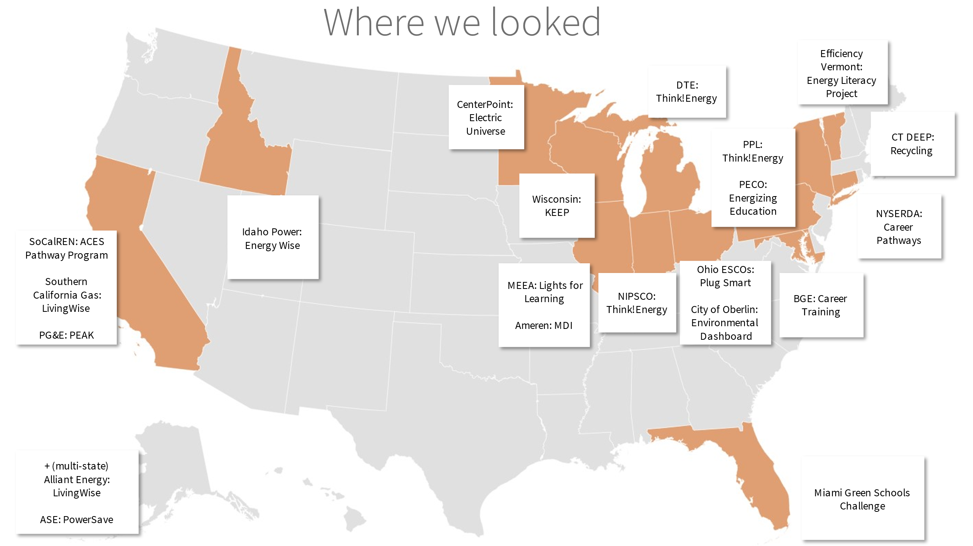

Energy Savings in Education Programs
Utilities have a long history of offering energy education to schools. However, when the funding for those programs come from rate-payer funds designated to reduce current and future energy investment, education programs have a higher requirement to demonstrate that programs lead to energy savings. Across the K-12 education programs reviewed, the evaluation team found three primary ways that utility energy efficiency programs encourage energy saving actions that in some cases could be tracked and officially claimed as saved energy: take-home kits, building upgrades, and behavioral strategies. Currently, the eesmarts effort does not incorporate any of these strategies.
Take-Home Kits: The first, and most common, strategy was to provide a kit of EE measures sent home with students. These programs claim savings through deemed energy savings on the measures sent home with students. Typically, to calculate these savings and ensure that deemed savings accurately reflect install rates, the kit includes a contact form that families send back to the utility so that they can be contacted later. Providing such a form for adult family members to fill out avoids the challenges of contacting students, who are a vulnerable population. For more details on this strategy, see our case study of Wisconsin’s K-12 Energy Education program (KEEP) below. However, the evaluation team notes that kits are no longer as prominent in these programs since the measures in kits no longer save substantial energy.
Upgrading Buildings: The second mechanism through which energy education programs achieved savings was by integrating improvements to the building itself, such as upgrades to lighting or other retrofits. Whether deemed or calculated energy savings, such improvements to the building can be measured and attributed to the program when identified and completed in the context of an energy education program. For more details, see the case study of the PowerSave Schools program below, which trains students to conduct a building-wide energy audit.
Energy Efficiency Behavior Change: A third strategy that programs used, sometimes in combination with the prior two, was to integrate behavioral change strategies that resulted in energy savings. These strategies can include pledge forms, challenges, feedback, awards, or honors to encourage behavior change outside the classroom and the school. Depending on the program, these strategies could take place at the building, classroom, and community levels. For more details on this strategy, see our case study of Wisconsin KEEP below.
Programs that demonstrated energy savings typically incorporate multiple strategies, for example, sending home an energy kit with students along with a challenge or pledge. Other strategies of successful programs include leveraging school infrastructure and opportunities to connect classroom learnings with building operations, whether through energy audits, conservation challenges, or renewables. Professional development for teachers is frequently a component of successful energy education programs. Six programs the evaluation team reviewed included professional development as a primary component, including Wisconsin KEEP.
In addition to teachers and students, successful programs often incorporate custodial staff and administrators in the audience and may have a single champion at the school who can spearhead conservation and EE efforts.

Evaluating Energy Efficiency Behavioral Strategies in School Programs
As a caveat to the above, the evaluation team notes that behavioral strategies in school-based programs have not been consistently or systematically tied to energy savings. An American Council for an Energy-Efficient Economy (ACEEE) report on behavior programs notes, in reference to K12 programs, that “when energy savings are estimated, the methods and details of evaluation are not reported. We had difficulty judging the quality of reported findings in this area because these programs lack systematic controlled experiments and third-party evaluations” (Sussman and Chikumbo 47). The same report does acknowledge evidence that “School-based programs can increase children’s knowledge and concern about climate change and alter their (self-reported) behavior to mitigate it (Lee et al. 2013).”
However, the authors conclude that while “these programs are likely important for changing behavior in the long term […] precise energy savings may be difficult to assess because they pay off over extended periods and in a variety of behavioral domains” (Sussman and Chikumbo: 47). The evaluation team includes this caveat for the Companies’ consideration as they work to evolve the current program offerings.
As the evaluation team will discuss in further detail below, the current eesmarts program does not incorporate any of these strategies that are linked to energy savings in other utility energy education programs. Lacking these strategies, it is not feasible at present for the evaluation team to identify or measure the impact the program is having in terms of energy savings.

Best Practices
The evaluation team identified six best practices of successful K-12 energy education programs:
- Integrate behavior change strategies
- Reinforce lessons
- Ensure consistent content delivery
- Develop a supportive school community
- Create a school-to-home connection
- Integrate evaluation
Figure 11 and the subsequent descriptions summarize each best practice, followed by case studies highlighting two of the reviewed programs that successfully model the best practices.
Figure 11. Utility Energy Education Program Best Practices
Successful programs integrate behavioral strategies at the classroom, building, and community level to drive energy savings
INTEGRATE BEHAVIOR
CHANGE STRATEGIES
Identify a program champion at the school or district level, build a team of teachers, administrators, school staff (energy/custodial) to encourage a public commitment to savings
DEVELOP A SUPPORTIVE
SCHOOL COMMUNITY
Deliver interactive content relevant to learning objectives; Provide follow-up activities as opportunities for students to reinforce learning; Leverage academic standards to help improve students’ grades in regular courses by integrating curriculum with Common Core or NGSS
REINFORCE LESSONS
Manage family energy savings and feedback via opt-in postcards or pledge forms included in home energy kits sent home to parents. Evaluable home energy savings are driven by promoting a school-to-home connection
CREATE A SCHOOL-TO-HOME CONNECTION
Retain contact information for parents, gather progress reports and other data from families to understand changes they made and to encourage program momentum
PLAN FOR EVALUATION
REINFORCE LESSONS
INTEGRATE BEHAVIOR CHANGE STRATEGIES
DEVELOP A SUPPORTIVE COMMUNITY
ENSURE CONSISTENT CONTENT DELIVERY
PLAN FOR EVALUATION
CREATE A SCHOOL-TO-HOME CONNECTION
Provide teacher training on lesson delivery to increase consistency across teachers, classroom, and schools
ENSURE CONSISTENT CONTENT DELIVERY
Adopt Behavior Change Strategies​: Successful programs integrate behavioral strategies at the classroom, building, and community levels to drive energy savings. Where possible, integrating custodial and administrative staff and leveraging current building energy management systems can increase the impact within a school. The AES PowerSave program, discussed in our case study below, quantified average program savings through school utility manager software, with savings ranging from 5 – 15% in the first year and 10 – 20% in the second year, compared to a predicted baseline use (counterfactual).
Reinforce the Lessons: Successful programs help teachers deliver interactive content relevant to learning objectives and provide follow-up activities as opportunities for students to reinforce learning. Program curriculum leverages academic standards to help improve students’ grades in regular courses by integrating curriculum with Common Core or Next Generation Science Standards (NGSS). Content is interactive with hands-on participation relevant to the learning objectives and age appropriate.
Ensure Consistent​ Content Delivery: Successful programs invest in teacher training on lesson delivery to increase consistency across teachers, classrooms, and schools. Programs may offer continuing education credits to teachers and provide support for their professional development. The Connecticut eesmarts program currently includes professional development for teachers.

Develop a Supportive​ School Community: Successful programs have a champion at the school or district level and build teams of teachers, administrators, and other school staff (energy/custodial) to encourage public commitments to savings. Collaboration between teachers, students, administration, and custodial staff (district-wide shared savings approach) has been linked to evaluable energy savings.
Create a School-to-​Home Connection: Programs that have a home component, such as a kit or a pledge of some kind, manage family energy savings and feedback via opt-in postcards. These contact cards allow utility evaluators to measure energy savings resulting from energy conservation as a part of the program pledge, behavior changes that accrue to the program, or savings based on kit measures that remain installed. In this way, evaluable home energy savings are driven by promoting a school-to-home connection. Commitments and pledges go hand-in-hand with rewards and recognition, creating a positive feedback loop. Progress reports and other forms of data and feedback encourage program momentum.
Plan for​ Evaluation: The best practices above align with successful program evaluation. From the school-to-home connection, some programs retain contact information for parents and gather progress reports and other data from families to understand changes they made. Data from school energy savings are also metrics for evaluation. These practices not only encourage the behavior change to drive savings but also show evaluable energy savings.

How does Energize CT Align with these Best Practices?
In this section, the evaluation team assesses where the 2019-2021 Energize CT Educate the Students initiative aligns with the six best practices identified above. Currently, the Energize CT eesmarts program does not incorporate several of the best practices of similar utility energy education programs that result in energy savings. The two best practices that eesmarts aligns with are ensuring consistent content delivery and reinforcing lessons.
As currently structured, the eesmarts program contracts with vendors to provide in-school (or virtual) performances. Since the vendors are consistent, the content is likely to be delivered in a consistent fashion. Beyond that, the program offers professional development workshops for teachers, which also helps to ensure consistent content delivery and enable teachers to reinforce lessons in their classrooms.
Below, the evaluation team discusses the best practice strategies that are not currently integrated in the Energize CT eesmarts program.
The program does not currently leverage energy efficiency Behavior Change Strategies: Our evaluation team did not find evidence that the program is integrating behavior change strategies at the classroom, school, or community level. Figure 12 qualitatively illustrates the kind of impact that behavioral strategies such as at-home pledges, whole-school integration, classroom feedback, and other behavioral strategies might have on the program in terms of creating energy savings, compared with the relative ease or difficulty to implement these strategies. While some strategies that could have a substantial impact on energy savings, such as instituting classroom or whole-building feedback mechanisms, could be relatively difficult to implement, there are other opportunities, such as classroom challenges or an at-home pledge, that would be comparatively easier to implement.
Figure 12. Qualitative Comparison of the Impact and Ease of Behavioral Change Strategies
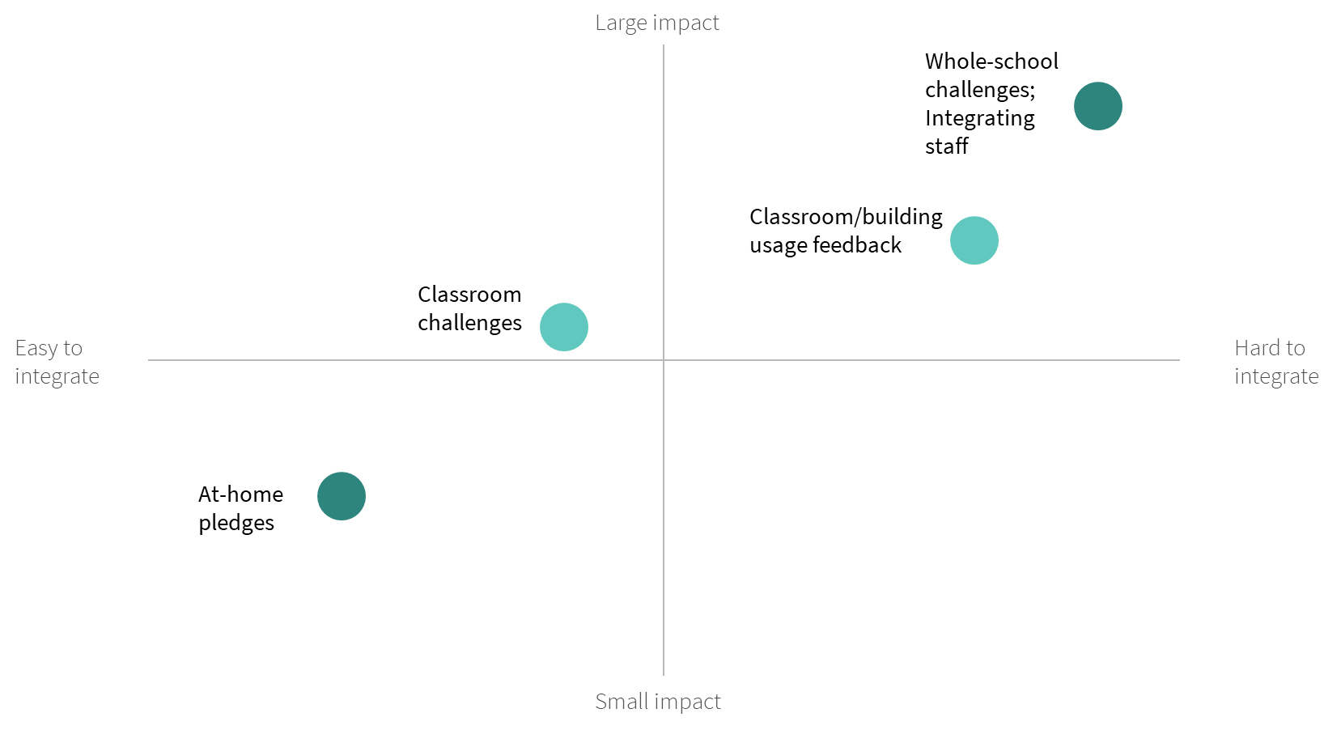
Develop a Supportive School Community: The program currently focuses on curriculum offerings, assembly presentations, and professional development, along with a student contest. To the evaluation team’s knowledge, there is currently no program effort to integrate school staff more broadly or to create a connection between energy conservation or energy efficiency in the school and what is covered in the classroom lessons.
Create a School-to-Home Connection: Our understanding is that while specific curriculum materials and worksheets may be distributed to students, there is not a specific effort to engage families more broadly.
Plan for Evaluation: While teacher contact information is captured, student information is not collected which, given that the students are the focus of the program, creates a challenge for evaluation.

Cataloguing Education Efforts
The evaluation team gathered, and reviewed program materials and participation data related to the eesmarts program to inform our development of a catalogue of program activities and information. This included conducting an analysis of curriculum, activities, participant tracking data (where available), and prior reports and surveys. The evaluation team gathered and assessed information on participant outputs and outcomes to demonstrate impacts of current program efforts.

Connecticut’s Education Efforts: eesmarts
The primary goal of eesmarts is to facilitate K-12 students’ understanding of energy-efficient technologies, renewable and non-renewable energy sources, and how electricity is generated, transmitted, and distributed to residential and C&I buildings across the electric grid. Eesmarts has a vision ‘to facilitate students’ understanding of the science, math and technology related to clean, renewable energy and electricity to create an energy-efficient ethic among all school-age students in Connecticut (eesmarts 2019 summer institute).
There are several subprograms within eesmarts, including:
- Grades K-3: Bright Kids
- Grades 4-5: The Energized Guyz: Powered Up
- Grades K-12: NGSS aligned energy curriculum
- Grades K-12: Annual student contest
- Professional development for teachers
The evaluation team includes details on these subprograms in Appendix E.

Current efforts
Although the primary goal of the eesmarts initiative is to “facilitate students’ understanding of energy-efficient technologies, the difference between renewable and non-renewable energy sources, and how electricity is generated, transmitted, and distributed to residential and C&I buildings across the electric grid,” the program has several other priority objectives (C&LM plan, 203).

These include:
- To engage municipal officials, educators, administrators, and facilities personnel to work toward more energy-efficient and sustainable schools
- To expand outreach and ensure the equitable distribution of energy education resources statewide, especially to urban and hard-to-reach communities
- To facilitate collaboration and connections among educators and energy and environmental advocates
- To inspire students (K-12 and higher education) to be agents of change in their schools, colleges, universities, and communities and to promote energy efficiency and its positive effects on protecting our environment.
The evaluation team does not find that the program activities – professional development workshops for teachers, assemblies or presentations for students, and a student contest – are sufficient to achieve these goals. Our review shows that the activities conducted in eesmarts do not link to the program goals. Furthermore, the evaluation team sees no specific outcomes that tie activities to goals. Two of the stated sub-goals, “create connections among educators and energy and environmental advocate” and “Engage municipal officials, educators, administrators, and facilities personnel to make schools more Energy Efficient” do not appear to have linked outcomes or activities. Furthermore, the metrics the initiative is tracking do not sufficiently show progress toward equitable distribution of EE education and nor toward engagement or behavior change goals.

2022 – 2024 Plan
At the time of this report writing, the Companies have filed their Conservation & Load Management plan for 2022- 2024. As part of that plan, they detail their energy education efforts, which includes eesmarts.
While the goals of the Energy Education initiative are similar to the previously stated goals of eesmarts in the 2019-2021 plan, the evaluation team notes that the 2022-2024 plan includes some modifications that will bring it into closer alignment with the best practices identified above. In particular, the plan includes the note that “the Companies will implement a tracking survey or evaluation form to obtain valuable feedback from the implementors of energy efficiency curriculum in the classroom—the educators. Some outcomes from these surveys may include finding out that educators need additional materials to conduct lessons in the classroom or that they need additional training. Throughout the 2022-2024 term, the Companies will solicit educator feedback and execute modifications that enhance program delivery.” Integrating regular feedback mechanisms was a recommendation this evaluation team provided the Companies in 2021 and the evaluation team finds this addition to the program to be a valuable one that will enable better refinement of the program throughout the plan cycle.
Other modifications to the program the Companies will make this cycle include expanding online offerings to ensure that content is available virtually, which will expand access to include home schoolers, distance learners, and parents.

Recommendations
Currently, the Connecticut eesmarts program does not incorporate several of the best practices of similar utility energy education programs that result in energy savings. By implementing the elements of successful programs, the Companies could increase their impact on energy savings and other outcomes. The utilities can use the following recommendations while planning investments in programs to maximize potential impact and minimize barriers to implementation.
Establish program goals and outcomes that tie to energy savings
The program goals currently are not aligned with specific outcomes, nor do they tie to energy savings or behavior changes related to energy savings. The evaluation team recommends that the program team revisit the program goals to ensure that they relate to measurable outcomes and lead to energy savings in some measurable fashion. This could include incorporating a take-home kit, building energy efficiency upgrades, or through behavioral strategies such as challenges and pledges.
Create a connection with Families to expand the reach of the program and enable data tracking
The Companies should prioritize collection of contact information for participating teachers and parents/families of students, potentially via postcards included with energy kits or informational materials sent home. By tracking the lifecycle of each program component, from outreach to teacher requests to completed requests to feedback, and specifically participation in the annual student contest as well as how many teachers have used the NGSS curriculum, the Companies will be able identify barriers that need to be remedied and procedures that are working well or could be expanded. The feedback survey that the program will be instituting with teachers in 2022-2024 is a good first step in this process.
LEverage known behavior-change strategies to motivate energy saving
The Companies should incentivize energy-saving behaviors while fostering community level awareness with public pledges, regular challenges, and motivational feedback for participants. The current program focus is on providing professional development for teachers and educational programming for students (e.g., assemblies on basic energy conservation, classroom materials). ​
The evaluation team recommends updating the curriculum to identify what motivates students to internalize the practices and change their behaviors and their families’ behaviors (e.g., climate change, equity)​. Expanding the current curriculum to include behavior change is relatively easy to integrate but will probably have a small impact on the overall energy savings attributable to the program. The evaluation team recommends providing more take home materials to emphasize energy concepts at home and involve parents and families in the curriculum as well as creating materials for ongoing goals to lengthen the curriculum and window of opportunity for energy savings and energy efficiency education.
Build collaboration between all school staff Into Program Processes
I program should support collaboration between teachers, students, administrators, and custodial staff. To do so, the evaluation team recommends integrating behavioral strategies to involve the whole school, such as pledges, challenges, and feedback, which can provide motivation and momentum and lead to greater energy savings. ​These strategies also can provide opportunities to see the concepts covered in curriculum materials and applied in practice.​ While more collaboration can be harder to integrate, the Companies should consider the bigger impact of this strategy.
Expand multiple training approaches
The current program includes multiple channels for content delivery, including in-class lessons and assemblies. The evaluation team recommends that the Companies continue with this approach. For professional development, past participation was heavily linked to the location of the in-person training and the ability to travel to the training. During the COVID-19 pandemic, the programs added more virtual material, such as prerecorded online classes to take at one’s convenience, and other free online tools. The evaluation team recommends that virtual trainings be continued even after the pandemic no longer requires it. Diversity in training approaches for teachers and students expands reach and can thereby encourage energy saving behavior change.
EstablisH State-wide goals but focus locally to ensure divers and equitable participation.
The program currently does not target specific regions or distressed communities within the state. The evaluation team understand that there is substantial repeat participation among teachers. While this suggests the program is valued by teachers, it also suggests that participation may be concentrated in the areas of the state where there is already high participation. The evaluation team recommends refining the diversity and inclusion goal of reaching distressed communities and build out program targets to show measurable impact in reaching those targets.
Use Other funding Streams (not Rate-payer dollars) to support this program
Based on this evaluation, the likelihood of this program to generate energy savings is quite minimal. However, the evaluation team sees the value in raising awareness among children and youth about energy conservation, efficiency, and the energy infrastructure our contemporary world relies on. The Companies may want to consider funding these valuable programs through other funding streams that are not ratepayer funded as these education programs likely will not meet cost effectiveness standards required of programs funded through rate-payer dollars.
- Educate the Public
This section presents the detailed findings and opportunities for improvement of the Educate the Public initiative that were identified through evaluation Tasks 2 and 3.

Cataloguing Educate the Public Efforts
The evaluation team reviewed a variety of sources to identify and understand activities within the Energize CT Educate the Public initiative. Through our review, the evaluation team identified 8 sub-initiatives falling under the Educate the Public funding stream. For each sub-initiative, the evaluation team documented the implementation status, planned budget, and whether it is prioritized for evaluation. See Table 19 for a summary of our findings.
Table 19. Summary of Evaluation Focus for Educate the Public and Community Engagement Initiatives
Sub-Initiative Name | Implementation Status | 2022 Planned Budget | Prioritized for Evaluation?
Community Partnerships for Energy Efficient Engagement | Launched summer 2021 | $500,000 for Community Outreach | Yes, literature and data collection (forthcoming)
Mobile Museum Exhibit | Planned launch 2021 | $300,000 for Mobile Initiative | Yes, limited literature review
Statewide/Clean Energy Communities Dashboard | Ongoing | $200,000 for Other Initiatives | No
EPA Portfolio Manager | Ongoing | $280,000 for Portfolio Manager | No
Clean Energy Communities | Discontinued | N/A | No
University Community Partnerships | Discontinued | N/A | No
Museum Partnerships | Discontinued | N/A | No
Energize CT Center | Discontinued | N/A | No
The evaluation team focused our evaluation efforts on the Community Partnerships for Energy Efficient Engagement and Eversource Customer Engagement Software: Website Widgets and Monthly Insights Email sub-initiatives because they had the highest budgets and were identified by staff as the highest priority.

Community Partnerships for Energy Efficient Engagement
The primary goal of the Energize CT Community Partnerships for Energy Efficient Engagement sub-initiative is to drive participation in one of four Energize CT EE programs:
- Home Energy Solutions: This program provides single family or small multifamily homes (2 – 4 units) with an energy assessment, direct install measures, basic insulation and air sealing measures, and additional information on additional energy saving upgrades, rebates, and financing. The program is available to both customers who own and rent their homes.
- Home Energy Solutions – Income-Eligible (HES-IE): This program provides an energy assessment and comprehensive energy efficiency and weatherization upgrades at little to no cost to the customer. Some homes may also qualify for additional services, including more comprehensive insulation, windows, a water heater, a heating system, or more energy efficient appliances at little to no cost. To qualify, a family’s combined gross annual income must be 60% below the state median income.
- Residential Retail and Heating, Cooling and Ventilation (HVAC) Products: This program provides rebates or instant discounts for high-efficiency lighting HVAC and water heating equipment at retail locations.
- Small Business Energy Advantage (SBEA): This program provides a free energy assessment to small businesses. Businesses receive a comprehensive proposal suggesting upgrades they can make to improve energy efficiency, including high-performance lighting, occupancy sensors, HVAC equipment, programmable thermostats, energy management systems, high-efficiency commercial kitchen and refrigeration equipment, air compressors, premium-efficiency motors, envelope and water-saving measures, and custom measures. SBEA contractors also share information on incentives and available financing.
Specifically, the Community Partnerships for Energy Efficient Engagement sub-initiative aims to increase participation within historically underserved populations, including customers with limited English proficiency, renters (single family homes and small multifamily homes with 2 – 4 units), customers with low to moderate income, and customers living in distressed communities designated by the Department of Economic and Community Development *DECD).
To drive increased participation, the Community Partnerships for Energy Efficient Engagement sub-initiative awards funding to community-based organizations, non-profits, and municipalities to promote these programs to community members. Participating organizations are selected through a competitive application process, where organizations submit information on who they plan to reach and how.
Organizations who are selected as community partners receive coordination, technical support, and marketing support from Energize CT, in addition to funding. Organizations are eligible for higher funding amounts to conduct outreach in DECD distressed communities and may also earn additional funding for meeting project milestones and goals. The Companies will measure increases in participation by comparing participation from 2017 – 2019 to 2022 for the communities receiving outreach. Results will be shared with community partners via an updated version of the Clean Energy Communities dashboard.

Evaluating Community Partnerships
The Community Partnerships program has the goal of increasing participation in four of the other programs offered by the Companies. In order to assess whether this is happening, the evaluation team recommends a two-tiered approach. First, the team should look at the pre- and post-intervention participation data across all four programs to assess whether participation in the target program increased within the target geography/population. The evaluation team understands that utilities are collecting participation data statewide and at the city level, thus accessing this data should be feasible for evaluation.
Second, the team recommends coordinating with the evaluation efforts of each of the four programs to incorporate questions about awareness and how participants found out about the program to assess the effectiveness of outreach through participant recall.
If through both of these measures, there is evidence for increased participation in areas where outreach through the community partnerships program took place, the program can be assessed as having resulted in those additional participants and therefore creating those energy savings. Since the savings will be realized through the other program, the evaluation team does not expect that it would be feasible to claim savings through this program, but they could be measured and counted – e.g., “the program led to an increase of X% participation, or Y buildings, with a combined energy savings of Z.”

Current Community Partnerships effort visualized
The evaluation team illustrated the current community partnership initiative (Figure 13 Current Community Partnership Initiative). The activities of marketing, technical, and coordination assistance to grantees and grants to organizations to fund outreach led to outcomes including enabling organizations with pre-existing relationships with community members to have resources to promote Energize CT programs. This outcome leads to the outcome of community members learning about energy efficiency programs from the community organization.
However, the evaluation team does not see evidence in the plan for how the community organizations will track whether or not community member subsequently enrolls in energy efficiency programs nor how this will lead to meeting the goal of increased participation of underserved customers in CT programs. Our understanding is that this is a secondary goal alongside the goal of increasing participation in Energize CT programs.
Figure 13. Current Community Partnership Initiative
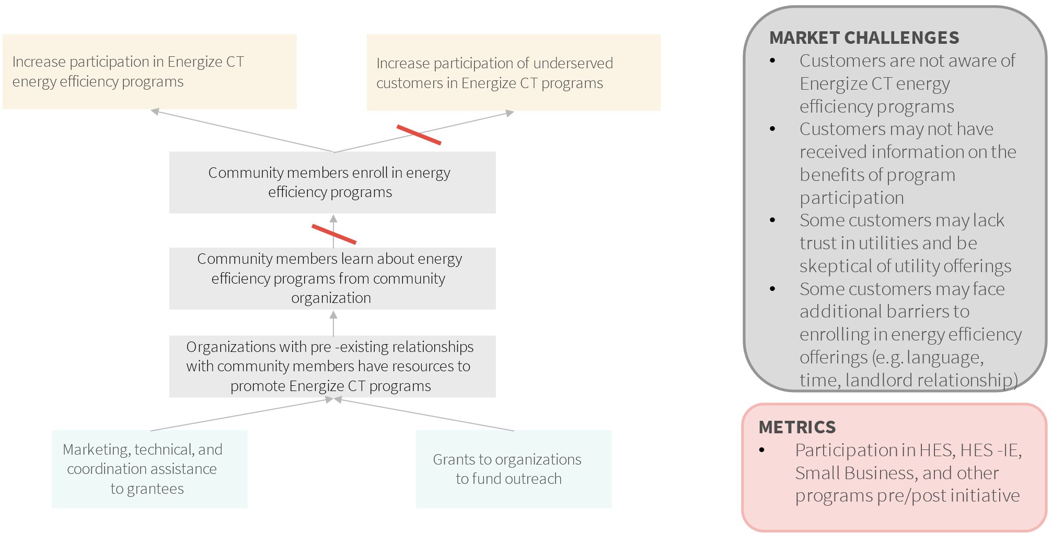

Challenges with current approach
In general, the approach planned for the community partnerships initiative is strong, however the team has identified several challenges with the approach. First, it is unclear which of the two goals is primary versus secondary. Second, the activities are geared toward increasing awareness of programs but do not contain mechanisms to track participation in programs. Finally, the evaluation team notes that other challenges may exist for customer participation and need to be identified to create effective activities and outcomes.

Potential adjustments to the initiative
In Figure 14 below, the team identifies potential adjustments to the Community Partnership initiative. These include adding an additional activity (consulting grantee organizations to assess whether the initiative is targeting the right populations and whether programs offered meet community member needs). The evaluation team recommends that grantee organizations help define what underserved communities need to be reached and the programs that will best serve them. The team also includes additional outcomes of grantees using utility consultation and support and for organizations to provide support to customers with enrollment. This will help reduce challenges to program participation beyond awareness. The team also provides an additional outcome, where interested community members may become future partners of the initiative. These outcomes support a goal of increasing participation of underserved customers in Energize CT programs. The team understands that this is not the primary goal of the initiative but recommends that the program focus on this goal in future iterations in order to better meet the needs of the Connecticut residents. Reaching underserved customers should be a key priority for the initiative as they are less likely to enroll through other modes of outreach.
Figure 14: Potential Program Revisions: Community Partnerships Initiative
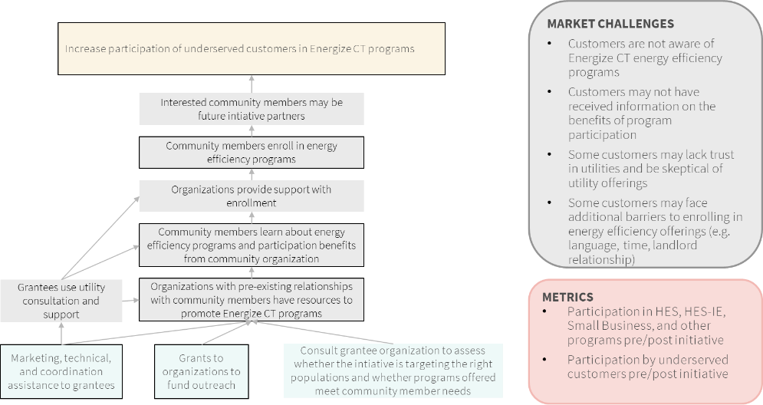

Community Partnership Best Practices
The team reviewed community partnership programs from other utilities, non-profit organizations, and broader literature on engaging community partners to reach underserved customers to understand the best practices of these programs. The evaluation team also assessed the Energize CT Community Partnerships for Energy Efficient Engagement sub-initiative’s alignment with best practices. This section presents our findings.
We identified six best practices used by effective community partnership programs:
- Develop trust
- Involve partners throughout the program lifecycle
- Pursue partnerships with agencies with a non-energy focus
- Build personal connections
- Minimize the participation burden
- Set realistic expectations
Figure 15 and the subsequent descriptions summarize each best practice, followed by a case study for the Bronx Healthy Buildings program, a program demonstrating high alignment with best practices.
Figure 15. Utility Community Partnership Best Practices
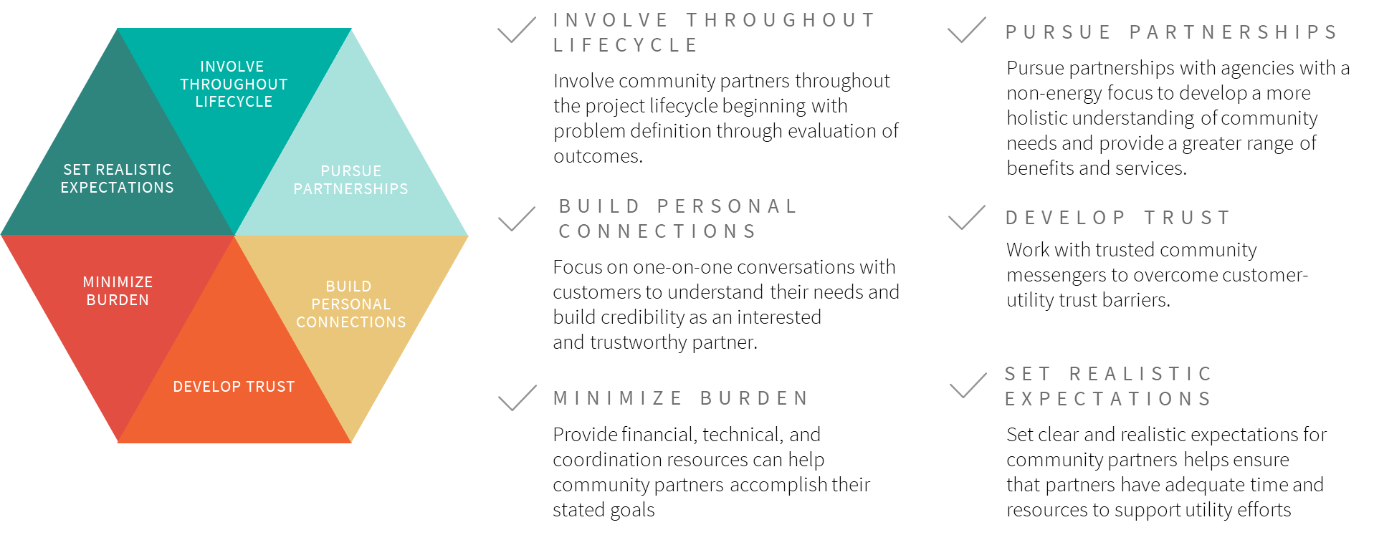
Develop Trust. Working with trusted messengers within the community may help community members overcome hesitation that may exist among underserved groups towards utilities. Research with non-participants in MA revealed that lack of trust was a significant barrier for non-participants. Some customers may not trust their utility due to a prior negative experience or negative impressions of similar institutions, and therefore may view energy efficiency offerings as “too good to be true.” Working with a trusted community leader or organization can lend legitimacy and local support to utility efforts. Additionally, utility recognition and support of partner efforts can help demonstrate that utilities are invested in partnerships with community leaders.
Draw on community expertise throughout the lifecycle. Involving community partners throughout the project lifecycle is a critical component of designing programs that meet community needs, address current community concerns, and draw on the expertise of community members. Community partners are the stakeholders most knowledgeable about exactly who needs services in their community and what the community needs are. By engaging them during the initial stages of a project – before the utility has defined the customer or market need that a program aims to address – community partners can help utilities identify where community needs, and utility interests overlap and co-create solutions that speak directly to those needs.

Likewise, community partners can offer valuable support in program implementation, whether through leveraging existing relationships to spread the word about a program, providing supplemental education or resources to community members, recruiting and training local contractors, or helping community members complete program participation steps, such as filling out application paperwork. Finally, involving community partners in the evaluation can help utilities identify ways to improve programs to better serve communities.
It is critical to differentiate between community engagement that is tokenistic or informative in nature (i.e., where stakeholders are consulted but have no real impact on program or policy design) and community engagement that is true co-creation (i.e., where communities are empowered to design solutions that meets their unique needs). There are frameworks that have been developed to identify and support community engagement and can be used as a tool to close equity gaps, create local capacity for change, and address power imbalances between communities and the institutions that serve them. However, achieving these goals requires initial investments to develop meaningful relationships between communities and institutions.
Figure 16 shows one framework differentiating between marginalization of communities to full ownership. This framework, created by Rosa Gonzáles, founder of Facilitating Power, demonstrates how various activities are aligned with different community engagement goals and how those activities send messages to the community about their voice in the decision-making process. The Ladder of Citizen Engagement, proposed by Sherry Arnstein, is another seminal framework for advancing equity in public policy and institutional decision making.
Figure 16. Spectrum of Community Engagement to Ownership (Facilitating Power)
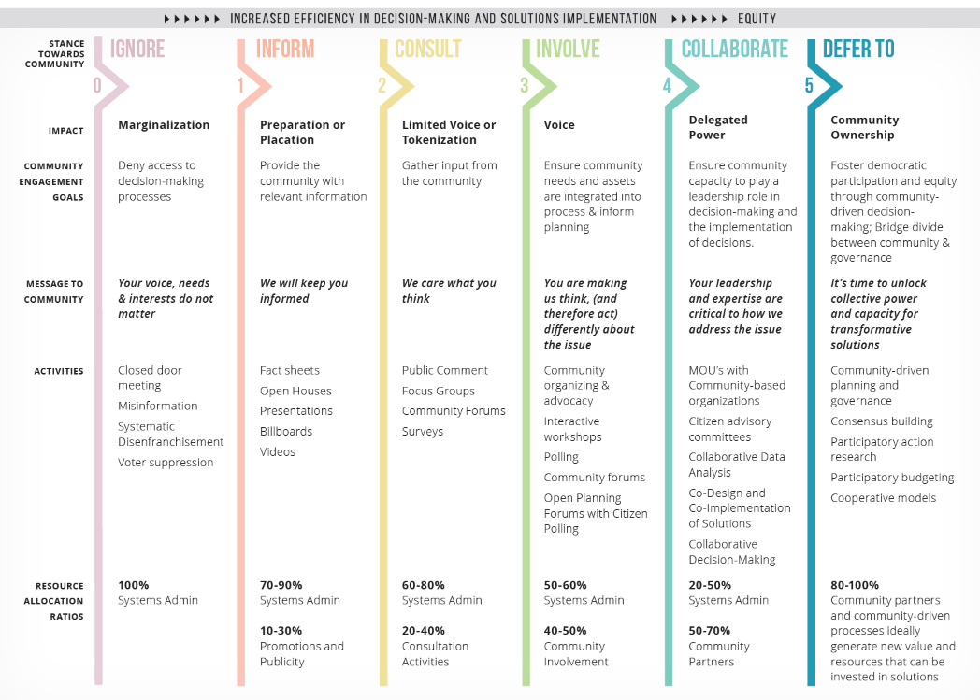
Involvement of communities as partners and collaborators is key in this process. Some utility programs recruit community organizations to provide recruitment support for their EE programs. While this model is laudable, it does not involve the community throughout the lifetime of the program. Rather, the utility EE programs have been developed and implemented independently, and the community organizations are invited to support recruitment once the program is already running. Models such as Arnstein’s Ladder of Citizen Engagement and Gonzáles’ Spectrum of Community Engagement to Ownership make clear that true integration of the community into the program offering is more comprehensive and begins well before a program has launched. In the case of utilities, this initial engagement may result in the development of new programs or services if existing offerings do not fully address community needs.

Pursue Partnerships. Creating partnerships with agencies outside the energy sector can help utilities develop a more holistic understanding of community needs and provide a greater range of benefits and services. Examples include programs at the intersection of health and energy, like the Bronx Healthy Buildings Program, which the evaluation team will cover in more detail in the case study section below. This program leverages partnerships with health and housing agencies to identify multifamily buildings most in need of energy, health, and safety upgrades. The program then works with partner agencies to provide upgrades targeted at improving both health and energy-related outcomes. Other types of partner organizations include affordable housing, social and human services, workforce development, environment and sustainability, faith communities, cultural communities, neighborhood associations, and youth groups.
Build Personal Connections. Personalized outreach strategies that speak to the concerns and values of the community members lead to greater customer engagement and participation. The DOE Better Buildings Neighborhood program (BBNP) found the most successful outreach efforts by community partners tailored program messaging to areas or populations with latent demand, such as underserved populations. Research conducted with non-participants in MA suggested that they may not be interested in energy efficiency, and bill savings, while valuable, may not be a top priority if there are other more pressing needs. This suggests that messaging and communications that is tailor ed to the needs and concerns of a community is likely to be of greater value than generic outreach. The evaluation team further explores the impact of personalizing messaging and provide additional examples of successful implementation in the Digital Customer Engagement Best Practices section of this report. Utilities and partners can further increase the impact of their outreach by pursuing one-on-one conversations that can help them better understand community member needs. Conversations with utility representatives can also help customers feel heard and help utilities build credibility as an interested and trustworthy partner.
Minimize Burden. When working with community partners, it is important to remember that they may provide a variety of services to community members, beyond those that they are working on with utility partners. Additionally, community organizations may vary widely in the number of staff, financial, and other resources available to them, depending on the type of organization they are and how established they are. Providing community partners with financial, technical, and coordination resources can help maximize the effectiveness of their partnerships with utilities. Community partners resource needs may also vary based on the amount of effort required to reach the population they serve, so it is important to customize support to an organization’s specific needs. For example, the BBNP program evaluation found that organizations without expertise in energy efficiency needed substantial support in communicating the technical details of program participation.
Community-based organizations also benefited from other technical support, including tracking leads and creating marketing materials. Other examples of potential resources that may prove beneficial, depending on the type of organization engaged, include facilitation of grants for survey research, childcare, meals, or other resources that can help organizers overcome time or financial constraints to allow them to co-create programs.
Set Realistic Expectations. Ensuring expectations for community partners and stakeholders are realistic and clearly documented (with ample time to complete) can help set community partnership programs up for success. Overly stringent fiduciary requirements or tight timelines may limit the ability for groups that are less formally organized or primarily volunteer-run to participate. The BBNP found that community partners were most successful when they used outreach strategies that were most aligned with the organization’s capacity and mission. Specifically, organizations with full-time staff or an active volunteer network were more likely to be able to provide sufficient time and financial resources to meet project goals than those without. Community partners were also more likely to succeed when their mission aligned with the goals of the BBNP, so the utilities could talk about the BBNP and their own organization simultaneously. However, the evaluation also found that organizations who were well-integrated into the community were successful partners, even when not environmentally focused. For example, the BBNP program facilitated the following successful partnerships:
- An organization with strong relationships with local contractors facilitated connections between homeowners and contractors, allowing contractors to assist homeowners in following through and completing upgrades.
- A community organizer fluent in Spanish answered questions about the program, helped community members complete paperwork, and facilitated trust between the utility and community members.
- A rural organization bundled local home upgrade projects together for contractors, making it cost-effective for contractors to upgrade homes by reducing travel and marketing costs.
- Community partners organizing events such as home and garden fairs, homeowner association meetings, hardware store events, or health and safety fairs were able to leverage participants’ existing interest in home improvement to promote EE programs.
The BBNP evaluation study noted that not all outreach efforts were successful and emphasized that program managers should closely monitor how partner activities contribute to program goals.

How does Energize CT Align with these Best Practices?
The evaluation team assessed the alignment of Energize CT’s Community Partnerships for Energy Efficient Engagement sub-initiative with the best practices identified through the literature review. Since the sub-initiative was still in the planning phase at the time of assessment, the evaluation team used preliminary documentation provided by the Companies about the sub-initiative to assess prospective alignment. Following the June 2021 presentation, the Companies submitted comments providing further context on their alignment with best practices, which have been incorporated into this report.
Overall, based on a preliminary review of program materials, the evaluation team found the Community Partnerships for Energy Efficient Engagement sub-initiative is partially aligned with four best practices and fully aligned with two best practices, as shown in Figure 17. In the following sections, the evaluation team identifies the ways in which the sub-initiative does align with best practices, and the additional steps the Companies would need to take to fully align it with best practices. The evaluation team includes our detailed review of the community partnership sub-initiative application in Appendix D. The evaluation team will reassess alignment with these best practices following community partner interviews in late summer 2022.
Figure 17. Energize CT Community Partnership Best Practices (Prospective)
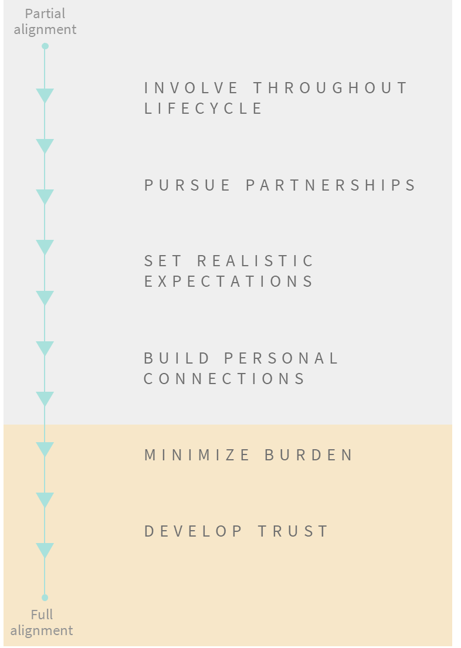
Draw on Community Expertise Throughout Lifecycle (Partial Alignment). The evaluation team understands the Companies included community stakeholders while developing the Community Partnerships for Energy Efficient Engagement sub-initiative and plan to continue meetings with stakeholders through the revision process for launching further rounds of community partnerships. Additionally, community partners will dictate how to conduct outreach for each community by detailing these plans in the sub-initiative application. Our team agrees that these engagements will create a positive foundation for the sub-initiative. The evaluation team recommends as a next step for the program development that this sub-initiative further engage community partners in identifying challenges within the community that Energize CT may be well-positioned to help address and co-create solutions to those challenges that are based on individual community resources and needs. The evaluation team recognizes that the program is not currently designed for this, but in future program terms may want to:
- Engage community partners in an interactive workshop to define what challenges a community may be facing and co-create solutions that help to address those challenges.
- Conduct a collaborative data analysis of past Energize CT participation trends to assess whether the underserved populations identified by the Companies align with community partners’ understanding of which populations are in greatest need of energy efficiency services.
- Invite community partners to participate in assessing the performance of the sub-initiative following its first application and participation cycle, co-developing and co-prioritizing recommendations to improve the sub-initiative and implementing those recommendations.
- Ensure that participating communities have an opportunity to interact by hosting regular workshops (at least twice a year) so that communities can exchange strategies that have been successful and collaborate to address challenges.
Since a primary objective of this sub-initiative is to increase participation in EE programs, the evaluation team recommends the Companies prioritize allowing communities to have greater input into which programs or solutions would serve them best. For example, during the webinar to introduce the sub-initiative to community partners, one community partner asked why the programs being promoted through the initiative were not targeted towards distressed communities. This question seemed to indicate that the community partner sees a gap between the current programs promoted through the sub-initiative and the needs of the audience (in this case, distressed communities), or a misunderstanding of the purpose of the program. On the webinar, the Companies interpreted the question as asking why there were not more income eligible programs being offered and answered the community partner by saying they are offering both income eligible and non-income eligible programs to reach a mix of customers. However, the Companies should consider follow up with this community partner to identify whether: 1) the income eligible offering (HES-IE) will meet the needs of customers living in distressed communities, and 2) if there are different or additional programs that would better serve the needs of this community.
The evaluation team recognizes that the goals of the program are to provide a marketing and outreach mechanism based on the rationale that some participants will be more likely to participate if the messenger is someone (or an organization or entity) they trust. However, in the future, the evaluation team recommends the program understand if there are other opportunities to better meet the needs of historically underserved communities. More broadly, the evaluation team recommends soliciting feedback from all community partners on how well the programs promoted through this sub-initiative meet the needs of communities and whether there are opportunities to modify or expand program offerings to better meet customer needs. As part of this engagement, the Companies can, in turn, ask community partners to help address participation barriers such as locating a qualified contractor or completing an application. The evaluation team acknowledges that implementing this recommendation may require coordination with other Energize CT programs or staff, and therefore may require a higher level of effort to implement.
Pursue Partnerships (Partial Alignment). The evaluation team understands the Companies have been pursuing partnerships with organizations that have a health and human-services focus. Given the impact of buildings on health, and the impact that EE upgrades can have on some health conditions, such as asthma, the evaluation team sees these partnerships as an excellent fit. Building on this, the evaluation team recommends expanding this type of partnerships with non-energy organizations even further to better meet community needs and enable them to receive energy- and health-related services. These could include sustainability groups, chambers of commerce, student groups, or civic associations. The evaluation team recognize that this is a challenge given regulatory restrictions, but the current health and safety barriers program that the State has put forward is a good model of the kind of creative partnerships that enable greater participation and allow the programs to serve more people.
Set Realistic Expectations (Partial Alignment). The sub-initiative clearly outlines community partner expectations and requirements in the application. Additionally, the Companies will be working with each applicant to provide guidance related to the goals and objectives they are undertaking as part of their participation with the sub-initiative. The Companies also plan to meet with each applicant to understand their approach, assess how the Companies can best support them, and identify customized data to help applicants track progress to goals, which they will be able to access via the Clean Energy Communities dashboard. These individual meetings with applicants to customize approach, support, and data tracking sets the Companies up to achieve alignment with this best practice.
To further help set realistic expectations, the sub-initiative should also solicit feedback from community partners during these meetings on whether the goals and objectives the Companies have defined are feasible from the community partner’s standpoint and whether they foresee any barriers or external factors that may impact their ability to meet goals.
The aim of this recommendation is to create a dialogue between the Companies and community partners to ensure both parties are aligned on expectations and community partners have the support they need to achieve goals.
Build Personal Connections (Partial Alignment). While community partners will be the primary group responsible for building personalized connections, the Companies can provide added support by:
- Working with community partners to create personalized marketing or informational materials for specific communities
- Prioritizing community partner applications that utilize direct outreach methods
- Soliciting community partner feedback on whether they need additional resources to overcome participation barriers for specific communities
The Companies have highlighted the importance of direct engagement of customers in the sub-initiative application. Example outreach methods identified by the Companies that facilitate direct person-to-person engagement with customers include coffee hours, open houses, and co-sponsoring events. During the webinar to introduce the sub-initiative to community partners, utility staff also highlighted they are looking for new and innovative outreach methods that go beyond sending emails or mailers. In future application cycles, the Companies should share examples of outreach methods that have been successful in previous cycles to facilitate community partner understanding of the types of proposals the Companies would like to see submitted through the sub-initiative. The Companies should also provide more information on existing utility outreach efforts, so the community partners can build on existing utility outreach and avoid duplication of efforts. Additional opportunities for partner communities to collaborate can also ensure that outreach efforts are not duplicative.
Minimize Burden. The support community partners receive through the Community Partnerships for Energy Efficient Engagement sub-initiative (funding, technical, and coordination) is substantial and aligns with best practices. The Companies also plan to meet with each applicant to ensure they have the support needed to achieve goals and objectives they are undertaking. These meetings provide an opportunity to collect information that will help the Companies customize their support to the specific needs of each community partner. The Companies may also consider offering support not directly related to outreach, including support that may remove barriers to participation for less well-resourced community partners (e.g., childcare, meals, or monetary incentives for organization representatives for their time).
Develop Trust. The Companies have emphasized empowering community organizations to be the messengers for utility programs to overcome customer-utility trust barriers. The evaluation team recommends further demonstrating utility investment in these partnerships by recognizing the efforts of community partners and seeking opportunities to further involve them in collaborative decision-making.

Community Partnership Recommendations
Based on the findings from our review of Community Partnerships for Energy Efficient Engagement materials and our best practices research, the evaluation team has identified a series of recommendations aimed at bringing this initiative into alignment with other “best in class” programs. Our recommendations are made with the assumption that Energize CT is looking for new and innovative solutions to reach historically underserved communities, including solutions that may have been applied outside the utility context.
REview Pre-and Post- intervention data and Coordinate with Evaluations of other Energy Efficiency programs To assess impact
Future evaluations of the community Partnership program should look at the pre- and post-intervention participation data of the 4 relevant resource programs (HES, HES-IE, SBEA, and Residential HVAC) to assess whether participation in the target program increased within the target geography/population after the efforts of the community partners. As a secondary means of assessing effectiveness of outreach, the evaluation team recommends including questions to assess recall of outreach efforts among participants and non-participants, as well as examining differences in participation.
track longitudinal metrics to understand progress over time
The evaluation team recommends that in addition to tracking pre- and post-participation metrics and data for specific geographic and demographic groups, the Companies should identify specific goals and outcomes they want communities to deliver. Specifically, the evaluation team suggests identifying long-term metrics to assess program success that address questions such as:
- Does the Companies want to engage community partners across multiple years? What would an ideal community parnter achieve through the sub-initiative? What benefits will community partners realize over the long-run?
- Does the Companies want to set specific goals for percentage increases in participation among hard-to-reach communities?
- Are these metrics included in the application and the application evaluation criteria?
Consider using metrics from the E3 report (Goals 2 and 3) to identify priority communities to reach
The Companies may consider incorporating additional metrics into their definition of hard-to-reach and undererved customers, including households with energy burdens greater than 6%, communities of color, and areas with high rates of arrearages and utility shutoffs as recommended in the E3 report goal 2 and/or medical and financial hardship customers as recommended in the E3 report goal 3. Community partners aiming to reach these groups could receive increased grant amounts or priority in years where the sub-initiative cannot accept all applicants. Reaching these groups would help the Community Partnerships for Energy Efficient Engagement sub-initiativeserve as a tool for the Companies to increase the number of hard-to-reach customers served through their EE programs.
Ensure that key determinants of success Are Aligned with Best PRactices
While the team understands that the purpose of the program was to drive participation in other EE programs through outreach from community organizations, the team nonetheless recommends that in the future, the program work to align with best practices. The team recommends the Companies consider the following key questions when identifying opportunities for continuous improvement, during evaluation research, and ultimately, when considering whether the sub-initiative is successful as currenty implemented. These questions are meant to serve as a long-term “north star” to guide decision-making about the sub-initiative year-over-year:
- Are there other opportunities to engage community partners to better understand community needs or to define services to meet those needs?
- How does community partner participation in this initiative benefit them and the populations they aim to serve? Are there opportunities to convey this to community partners when soliciting applications?
- What organizations are currently able to work with the Community Partnerships for Energy Efficient Engagement sub-initiative? What organizations are not?
  - How well do participating organizations help reach customers who are underserved through Energize CT’s EE programs? Are there any gaps? What specific techniques are working? Which are not? How transferrable are these across communities?
  - Can additional resources be made available to non-participating organizations to allow them to participate?
  - In what ways does the Community Partnerships for Energy Efficient Engagement sub-initiative help the Companies meet equity goals? Are there ways to increase alignment?
Application assessment and evaluability
Table 20 below summarizes the key questions the Companies should ask when reviewing community partner applications, the key information partners should be providing, and metrics important to capture for evaluability of the Community Partnerships for Energy Efficient Engagement sub-initiative.
Table 20. Recommended Application Assessment Criteria, Requested Information, and Evaluation Metrics
Key Questions for the Companies | Information for Community PARTNERS to Provide | Evaluability Data and Metrics
- Do community partners have resources that will help them succeed in meeting sub-initiative goals, such as an active volunteer network, relationships with local contractors, or experience working with hard-to-reach populations?  - Does the community partner understand population/ community needs?  - Is the community partner a trusted messenger? Do they have a history of working in the community?  - Does the community partner have a mission aligned with sub-initiative needs? Do they have recent or ongoing efforts related to this mission? | - Who will they reach and how those customers will benefit from the sub-initiative?  - What outreach methods will be effective for the population?  - What metrics are tracked for their outreach methods?  - What resources will they commit? | - Documentation of intended audience for outreach strategies and how outreach will reach that audience  - Example marketing and outreach materials (any print, online, video, or email marketing materials used)  - Outreach metrics: number of marketing materials distributed, number of people attending events, email send/open rates, number of likes/comments/ reshares on social media  - Contact information for key staff at partner organizations who were involved with outreach efforts  - Pre- and post-participation metrics  - Final community partner reports
In future program cycles, Engage with community partners to understand whether offerings meet community needs and whether any gaps exist
Overall, the Companies would be more aligned with best practices by listening to community needs to identify where utility and community interests overlap. While the Companies have engaged community partners to develop the Community Partnerships for Energy Efficient Engagement sub-initiative, true co-creation is only achieved when community partners are given real decision-making authority over the direction of programs and initiatives.
Further, since existing EE programs are being promoted through this sub-initiative, the Companies must consider whether there are opportunities for communities to provide greater input on these programs and whether they have adequate support to overcome barriers to participation in the programs. Based on community needs identified, the Companies may also consider whether forming additional partnerships with community groups or agencies with a non-energy focus would be helpful in reaching and engaging these communities.
The specifications and limits of the HES and HES-IE programs may inhibit participation of target groups. The program should determine if this is the case, and to what extent there are barriers to participation and work with community partners to develop work-arounds or alternative programs.
- Customer Engagement
This chapter details the Customer Engagement secondary research and program review efforts of the evaluation team.

Cataloguing Customer Engagement Efforts
The evaluation team reviewed a variety of sources to identify and understand activities within the Eversource Customer Engagement effort. For each sub-initiative, the evaluation team documented the implementation status, planned budget, and whether it is prioritized for evaluation. See Table 21 for a summary of our findings.
Table 21. Summary of Evaluation Focus for Educate the Public and Community Engagement Initiatives
Sub-Initiative Name | Implementation Status | 2022 Planned Budget | Prioritized for Evaluation?
Eversource Customer Engagement Software: Website Widgets | Planned launch 2021 | $370,000 for Customer Engagement Software Oracle – Delivered Energy Insights | Yes, literature review only
Eversource Customer Engagement Software: Monthly Insights Email | Planned launch 2021 | $370,000 for Customer Engagement Software Oracle – Delivered Energy Insights | Yes, literature review only
Eversource Customer Engagement Platform | Discontinued | N/A | No
The evaluation team focused our evaluation efforts on the Eversource Customer Engagement Software: Website Widgets and Monthly Insights Email sub-initiatives because it has a high budget and was identified by staff as the high priority.

Eversource Customer Engagement Software: Website Widgets and Monthly Insights Email
There are two components to the Eversource Customer Engagement Software sub-initiatives:
- Website Widgets: Eversource customers will have access to widgets on Eversource’s website when they are logged in to view their energy bill. Widgets are available to both residential and commercial customers. These widgets contain information on how the customer’s current energy bill compares to the previous month. Residential customers will receive additional information on their energy use by appliance and have access to a cooling costs calculator. Business customers will be able see their previous 13 months of usage.
- Monthly Insights Email: Select residential customers will receive monthly emails containing information on their current usage, previous month’s usage, and an energy saving tip, which is rotated each month.
The primary goals of the Eversource Customer Engagement Software sub-initiatives are to encourage customers to adopt energy-saving behaviors, participate in EE programs, and increase customer engagement. The website widgets are created and maintained by Oracle, the implementation contractor for this part of the initiative. The emails are created and maintained in-house by Eversource. To measure the success of these initiatives, Eversource will collect information on customer engagement, including email open rates, widget view rates, and click through rates for both platforms. Additionally, Eversource will claim savings from monthly emails via a randomized control trial.

Digital Customer Engagement Best Practices
The team reviewed similar utility customer engagement programs to understand best practices in digital customer engagement. Based on the materials reviewed, the evaluation team identified a set of best practices for digital customer engagement and a set of best practices for behavioral energy efficiency. This section discusses best practices for digital customer engagement. Best practices for behavioral EE are included in Appendix D. The team also assessed the Eversource Customer Engagement Software: Website Widgets and Monthly Insights Email sub-initiatives’ alignment with best practices.

The evaluation team identified six digital customer engagement best practices from the programs reviewed:
- Engage emotional decision making
- Change customer behaviors
- Look at all points of interaction
- Create a dialogue
- Personalize communications
- Maximize convenience
Figure 18 and the subsequent descriptions summarize each best practice.
Figure 18. Utility Digital Customer Engagement Best Practices
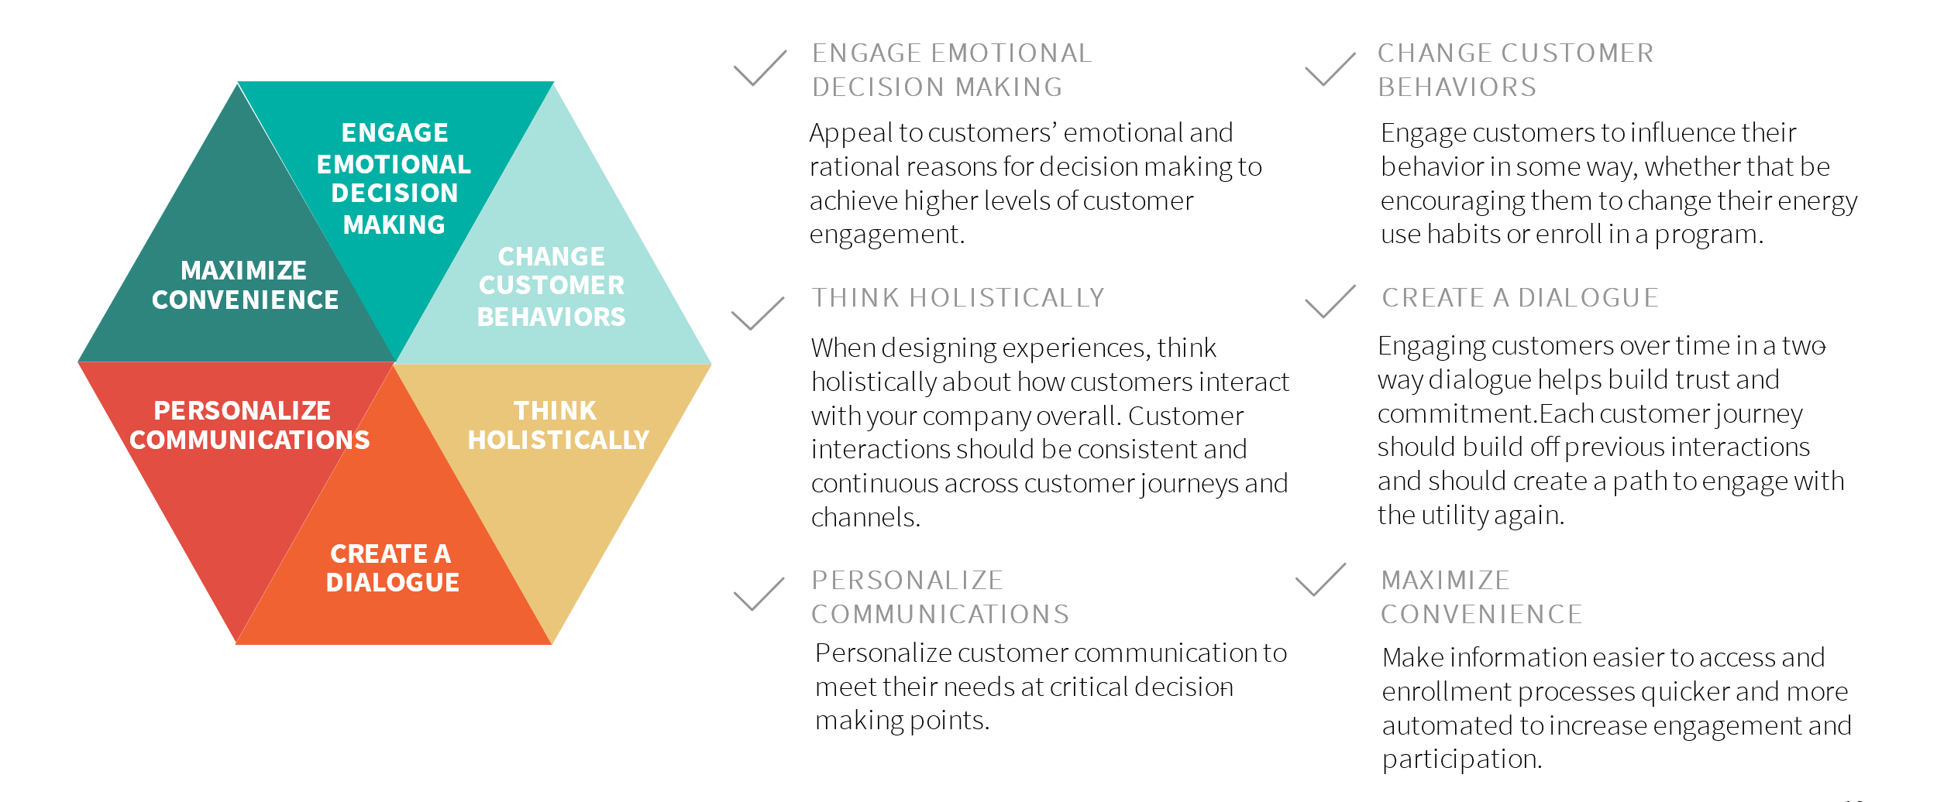
Engage Emotional Decision Making. Appeal to customers’ emotional and rational reasons for decision making to achieve higher levels of customer engagement. According to Gallup, when it comes to engagement, customers can be grouped into three categories: fully engaged customers who are rationally loyal and emotionally attached (they will choose a brand in good times and bad), indifferent customers who are emotionally and rationally neutral (they are not overly concerned one way or another what brand they chose), and actively disengaged customers who are emotionally detached (these customers will switch brands without a second thought or may leave negative reviews or comments if they have a bad experience). Gallup found that customers falling into the fully engaged category are more likely to engage with products and services across a variety of industries.
Likewise, customers who are fully engaged with their utility, including rational and emotional attachment, may be more willing to participate in EE programs.
Change Customer Behaviors. The aim of engaging customers should be to influence their behavior in some way. For many companies, this is getting a customer to purchase a product or service. For utilities, this could range from enrolling customers in paperless billing, reporting an outage, or participating in an EE program. Content that engages customers but does not result in some sort of action over time ultimately does not create any meaningful impact for the utility or the customer. Program administrators should track metrics related to the specific behaviors they are trying to influence, such as energy efficiency behaviors adopted or number of enrollments in a promoted program. Views, opens, and clicks alone should not be the only metrics tracked to measure program success.
Look at all points of interaction. When designing experiences, think holistically about how customers interact with your company overall. Customer interactions should be consistent and continuous across customer journeys and channels. Each individual journey impacts the customer's overall experience with a company or brand. In a survey of utility customers, McKinsey (2018) found that two-thirds of overall customer satisfaction with the utility related to the customer journey with billing and payment and managing energy usage.
Create a Dialogue. Engaging customers over time in a two-way dialogue helps build trust and commitment. Each customer journey should build off previous interactions and should create a path to engage with the utility again. One common example of this best practice is when utilities refer customers with high bill complaints to their EE programs as a means of addressing their complaint. Another example is to refer customers who engage with online dashboards that provide energy and bill analytics to the utility’s online store where customers can purchase energy efficient products to help them manage their energy use.
Personalize Communications. Personalize customer communications to appeal to their individual needs, values, and ensure communications are timely and reach customers at key decision-making points. Questline (2021) found that customer engagement with utility communications reached a four-year high in March and April 2020, with topics like saving energy when working from home, cybersecurity for home workers, and convenient bill pay options being the most popular content. Interest in utility communications extended to non-pandemic related communications with higher open and click through rates for promotional energy efficiency emails during April 2020 than in previous years.
Maximize Convenience. Making information easier to access and enrollment processes quicker and more automated is an effective way to increase customer engagement and participation. Customers have competing priorities in their day-to-day lives and limited time and bandwidth to address all their needs. Simplified processes are appreciated by customers and maximize the chance that they will be willing to engage. Questline (2021) found that an email campaign promoting one-click enrollment in a deferred payment arrangement program resulted in higher opens, click-through rates, and enrollments.

How is Energize CT doing?
The evaluation team assessed the alignment of the Eversource Customer Engagement Software: Website Widgets and Monthly Insights Email sub-initiatives with the best practices identified through the literature review. Since the sub-initiatives were still in the planning phase at the time of assessment, the evaluation team used preliminary documentation provided by the Companies about the initiative to assess prospective alignment.
Figure 19 identifies where the Eversource Customer Engagement Software sub-initiatives currently fall on the spectrum from non-alignment to total alignment with the best practices identified in the literature review. These findings reflect the sub-initiatives’ status in June 2021, when they were in the early stages of implementation.
Figure 19. Eversource Digital Customer Engagement Best Practices (Prospective)
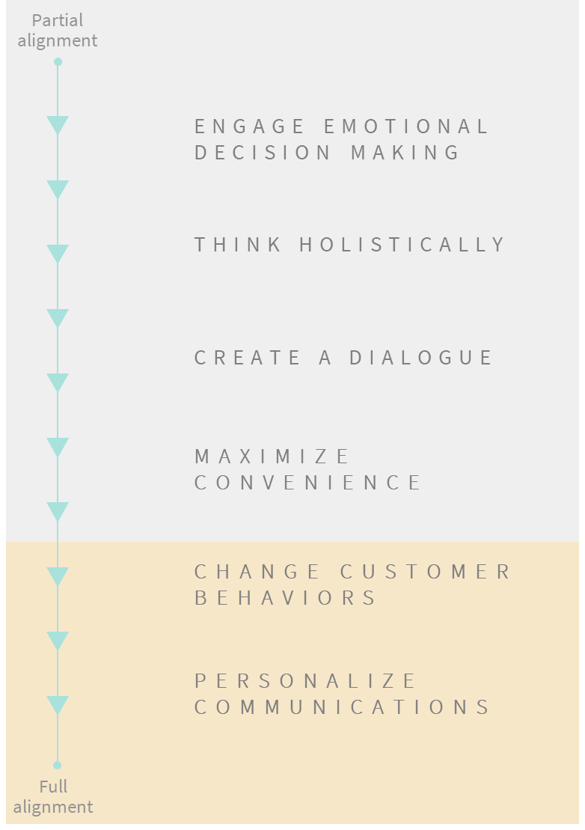
Engage Emotional Decision Making (Partial Alignment). Website widgets and monthly insights emails appeal to customers' rational decision making by providing more information about their energy usage. Eversource should also include messaging to appeal to customer values that drive energy saving behaviors, such as concern for the environment, excitement about new technologies, or wanting to keep one’s family safe and comfortable.
Think Holistically (Partial Alignment). Website widgets and monthly insights emails integrate two customer journeys that are often separated: energy management and billing. Eversource should consider opportunities to integrate additional customer journeys into the online experience or to promote the online experience through other customer journeys. Examples of potential opportunities include:
- Incorporating additional energy management tools into the website widgets, such as referral to an online marketplace, or into the monthly emails, such as referring customers to the website widgets
- Allowing customers to report and track outage status through the same portal they use for website widgets and billing
- Promoting the website widgets as a tool to understand and manage energy usage to new customers when they activate utility service or enrolling these customers in the monthly insights email
The evaluation team recommends these sub-initiatives coordinate with broader customer engagement efforts at Eversource to identify where these opportunities exist and prioritize which would best support both the energy saving and customer engagement objectives of the website widgets and monthly insights emails.
Create a Dialogue (Partial Alignment). Eversource should increase opportunities for customers to engage or interact with their energy use data by sending information between billing cycles, such as energy savings tips or articles. Eversource should also consider ways to direct customers to other energy efficiency offerings or tools utilizing the website widgets or emails. Eversource plans to include interactive tools on the website, such as the Cooling Cost Calculator widget and the Home Energy Analysis widget, to allow customers to further personalize the information they see through the website widgets and provide them with additional tools to manage their energy usage. Also, the monthly insights email invites customers to reply to the email to provide feedback, creating an opportunity for dialogue between the customer and Eversource.
Maximize Convenience (Partial Alignment). Relocating information from a separate portal to the energy billing page of Eversource’s website reduces the number of times customers need to log in to access information, thus increasing convenience. Additionally, limiting text and maximizing the use of visuals and interactive tools makes information easier for customers to understand and digest. Eversource should consider further opportunities to make information more accessible, such as making it available via mobile app or increasing the number of customers who receive the monthly insights email.
Change Customer Behaviors. By offering energy savings tips and program recommendations, the website widgets and monthly insights email are attempting to influence customer behaviors related to energy usage. Eversource should ensure they track metrics to capture customer actions and behavior change as a result of these tools.
Personalize Communications. Eversource has customized website widgets to personalize the energy savings tips and program recommendations that customers receive. For example, the Home Energy Analysis widget shows customers tips to reduce the energy use of appliances and equipment corresponding with the end-use category (e.g., electronics, appliances) that uses the most energy. Eversource also indicated they plan to increase personalization of energy savings tips and program recommendations via monthly insights emails using customer segmentation data soon. Current Customer Engagement Initiative
The evaluation team illustrated the activities, outcomes, and goal of the customer engagement effort (see Fig 20). This figure highlights that the monthly emails, have far more outcomes and stronger connections to goal of increasing awareness of energy use among customers and promoting behaviors to save energy than the website widgets. The effort currently lacks metrics to show or track changes in behavior.
Figure 20: Current Customer Engagement Initiative
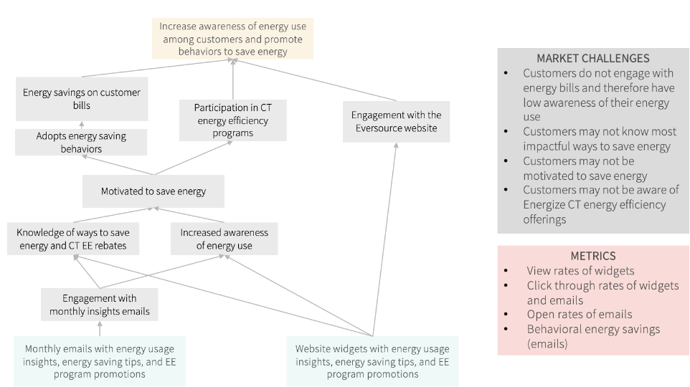

Potential adjustments to the initiative
The team recommends a few slight adjustments to the program model and outcomes of program activities, particularly engagement with the website. As currently structured, there is no way to understand the pathway from engagement with the website to any subsequent action. A revised model would begin with engagement as a starting outcome, but not the only outcome. It would also allow for metrics and monitoring for drop offs between engagement and behavior change. See Fig. 21 for an illustration.
Figure 21. Potential Adjustments to Customer Engagement Initiative
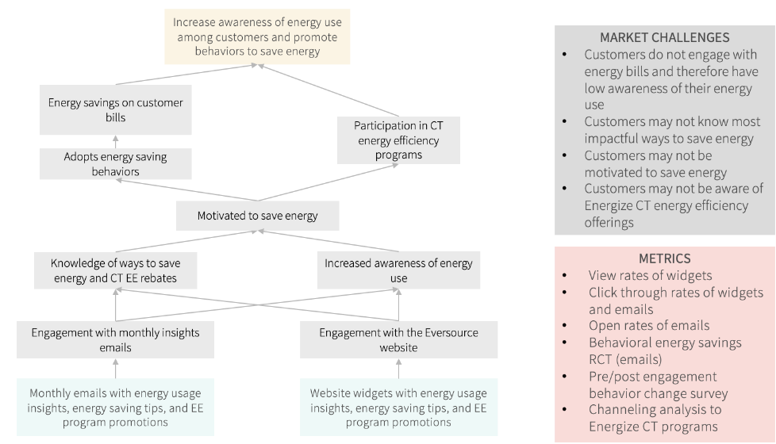

Digital Customer Engagement Recommendations
Based on the findings from our review of the Eversource Customer Engagement Software materials and our best practices research, the evaluation team has identified a series of recommendations aimed at bringing the Customer Engagement Software sub-initiatives into alignment with industry best practices.
Define the specific outcomes the Monthly Emails and Website Widgets aim to achieve and how these fit into the broader customer engagement strategy
Our team notes that while customer engagement is one of the primary objectives of these sub-initiatives, a customer engagement strategy should ideally address engagement across the entire lifecycle of a utility customer – from enrollment, to outages, moves/changes of address, bill payment, service upgrades, and engagement in EE programs. The customer engagement activities within the Customer Engagement Software: Website Widgets and Monthly Insights Email sub-initiatives are narrowly focused on interactions around energy usage.
The evaluation team recommends Eversource more clearly dilineate the elements of their overall customer engagement strategy that are addressed by these sub-initatives (and the non-resource programs overall) and the elements that are addressed by Eversource’s marketing and customer engagement efforts. Eversource should also define how these two areas integrate. Some questions to consider include:
- Who is being reached through the monthly insights email and the website? Who is not being reached?
- What customer journeys or actions lead them to the monthly insights email or website?
- Ideally, what do you want customers to do after seeing an email or website widget? Are there opportunities to reinforce this message or nudge customers to remind them to take these actions?
- Are customers engaging with the email and website widgets over time? Why or why not?
Define metrics for the Website Widgets that capture customer behavior change as well as engagement
While Eversource intends to assess energy savings resulting from customers receiving the monthly insights email using a randomized control trial design, current metrics for the website widgets include only those focused on engagement (such as views and clicks). To track outcomes related to the website widgets, the evaluation team recommends using metrics specifically designed to capture customer behavior change that will result in energy savings. Metrics may include program channeling or behavior changed as assessed through treatment/control group surveys and/or billing analysis. Engagement metrics should be actionable and allow Eversource to target specific customer behaviors.
Include emotional appeals in The Website Widgets and Monthly Insights Emails
The website widgets and monthly insights email will appeal to customers’ rational decision making by providing feedback about their energy usage. Incorporating an emotional decision-making component as well will drive deeper engagement. Other tools such as increasing convenience to access information or creating opportunities for customers to interact with or share content may also improve email and website efficacy. Eversource is already planning some personalization of website widgets and monthly insights email based on segmentation data, but could further leverage data on customer values and priorities to include emotional appeals as well.

Track Metrics To Capture Direct and Indirect Energy Savings for the Sub-Initiatives
Table 22 summarizes the key considerations related to metrics that should be tracked for the website widgets and monthly insights email. (Bold text indicates metrics are currently tracked.) Overall, the evaluation team recommends Eversource tracks metrics that are aligned with the intended outcomes of the sub-initiatives, including customer behavior change.
Table 22. Recommended Digital Customer Engagement Evaluation Metrics
 | Website Widgets | Monthly Insights Email
Current Planned Energy Savings Metrics | None | Randomized control trial
Current Planned Customer Engagement Metrics | Customer impressions and clicks | Email opens and clicks
Potential Behavior Change / Energy Metrics | - Energy savings for customers (assessed via billing analysis)  - Self-reported adoption of energy efficient behaviors  - Participation in energy efficiency programs | - Energy savings for customers (assessed via billing analysis)  - Customer information for those who opted-out of receiving emails  - Self-reported adoption of energy efficient behaviors  - Participation in EE programs
Recommendations | Both widgets and email: Eversource should also track metrics to allow targeting of specific customer behaviors, such as customer engagements over time, length of time between customer engagements, and whether customers act in response to certain content. This will let CT use interventions to improve customer engagement such as, sending re-engagement emails to customers who have not interacted with website widgets recently or personalizing calls to action.  Widgets only: Eversource should more clearly define outcomes of customers engaging with website widgets. Based on these outcomes, Eversource can define metrics for the website widgets that will allow them to track behavior change in addition to engagement, such as adoption of energy efficient behaviors and/or increases in program participation.

Kellogg Foundation. 2004. Logic Model Development Guide. https://www.naccho.org/uploads/downloadable-resources/Programs/Public-Health-Infrastructure/KelloggLogicModelGuide_161122_162808.pdf
Rand Corporation. 2006. Using Logic Models for Strategic Planning and Evaluation. https://www.rand.org/content/dam/rand/pubs/technical_reports/2006/RAND_TR370.pdf
Kellogg Foundation. 2004. Logic Model Development Guide. https://www.naccho.org/uploads/downloadable-resources/Programs/Public-Health-Infrastructure/KelloggLogicModelGuide_161122_162808.pdf
Rand Corporation. 2006. Using Logic Models for Strategic Planning and Evaluation. https://www.rand.org/content/dam/rand/pubs/technical_reports/2006/RAND_TR370.pdf
Page 10 of the 2019-2021 Plan Conservation & Load Management Plan Update
Page 201 of the 2019-2021 Plan Conservation & Load Management Plan Update
Page 28 of the 2020 Plan Update to the 2019-2021 Conservation & Load Management Plan
Page 28 of the 2020 Plan Update to the 2019-2021 Conservation & Load Management Plan
Page 146 of the 2022-2024 Conservation and Load Management Plan, submitted November 1, 2021
ComEd 2017. Workforce Development Implementation Plan. http://blogs.edf.org/energyexchange/files/2017/10/ComEd-Ex.-1.0-Workforce-Development-Plan.pdf
Logic Models for Workforce Education & Training’s “Integrated Energy Education and Training” Sub-Program Components and Linkage Explanation
US DoE. “Evaluation of the Compressed Air Challenge Training Program,” March 1, 2004. https://doi.org/10.2172/1215869.
Page 10 of the 2019-2021 Plan Conservation & Load Management Plan Update
Navigant. “Comprehensive Review of Non-Residential Training and Education Programs, with a Focus on Building Operator Certification,” 2015. http://www.theboc.info/wp-content/uploads/2015/09/Training-and-Education-Programs-Final-Report-0601915-clean.pdf.
US DoE. “Evaluation of the Compressed Air Challenge Training Program,” March 1, 2004. https://doi.org/10.2172/1215869.
Xie, Yulong, Mark Halverson, Rosemarie Bartlett, Yan Chen, Michael Rosenberg, Todd Taylor, Jeremiah Williams, and Michael Reiner. “Evaluating Building Energy Code Compliance and Savings Potential through Large-Scale Simulation with Models Inferred by Field Data.” Energies 13, no. 9 (January 2020): 2321. https://doi.org/10.3390/en13092321.
US DoE. “Evaluation of the Compressed Air Challenge Training Program,” March 1, 2004. https://doi.org/10.2172/1215869.
Energy Trust of Oregon and Btan Consulting. “ESP Training Evaluation Final Report,” 2015. https://www.energytrust.org/wp-content/uploads/2016/12/ESP_training-final_report_12may2015_w_appendices_and_SR.pdf.
Evergreen Economics. “Evaluation of the Hawaii Energy Conservation and Efficiency Programs,” 2014.
Xie, Yulong, Mark Halverson, Rosemarie Bartlett, Yan Chen, Michael Rosenberg, Todd Taylor, Jeremiah Williams, and Michael Reiner. “Evaluating Building Energy Code Compliance and Savings Potential through Large-Scale Simulation with Models Inferred by Field Data.” Energies 13, no. 9 (January 2020): 2321. https://doi.org/10.3390/en13092321.
Navigant. “Comprehensive Review of Non-Residential Training and Education Programs, with a Focus on Building Operator Certification,” 2015. http://www.theboc.info/wp-content/uploads/2015/09/Training-and-Education-Programs-Final-Report-0601915-clean.pdf.
US DoE. “Evaluation of the Compressed Air Challenge Training Program,” March 1, 2004. https://doi.org/10.2172/1215869.
http://calmac.org/publications/STE__Final_Report.pdf
ASWB Engineering and Opinion Dynamics. “Lighting Controls Training Assessment,” 2016. http://www.calmac.org/publications/Lighting_Controls_Training_Assessment_Report_2016-04-08b.pdf.
The following programs track post-training data: ComEd Workforce Training Programs, NYSERDA Clean Energy Workforce Development Program, Clean Energy Works Oregon Workforce Development Program, Energy Trust of Oregon Efficiency Sales Professional Certificate Program, Southern California Regional Energy Network Architecture Construction Engineering Students Pathway Program, Ameren Illinois Energy Efficiency Program: Market Development Initiative, California Investor-Owned Utilities’ Workforce Education and Training Program (WE&T), City of Milwaukee, Wisconsin: ReFresh Milwaukee, Tennessee Valley Authority: Building Futures Minority Contractor Training Program.
“Equitable Energy Efficiency: Proposed Phase I Actions and Recommendations,” Department of Energy and Environmental Protection Bureau of Energy and Technology Policy, May 5, 2021, https://portal.ct.gov/-/media/DEEP/energy/ConserLoadMgmt/E3-Proposed-Phase-I-Actions-and-Recommendations.pdf.
“ComEd Equity Hiring & Workforce Development Update,” ComEd Energy Efficiency Program, Accessed August 6, 2021, https://ilsag.s3.amazonaws.com/SAG-Meeting-Equity-and-Workforce-Development-ComEd-Presentation_10-1-2020.pdf.
“ComEd Equity Hiring & Workforce Development Update.”
“Expanding Opportunity Through Energy Efficiency Jobs: Strategies to Ensure a More Resilient, Diverse Workforce.”
“ComEd Equity Hiring & Workforce Development Update.”
“Expanding Opportunity Through Energy Efficiency Jobs: Strategies to Ensure a More Resilient, Diverse Workforce.”
“Workforce Development Implementation Plan,” ComEd, Accessed August 18, 2021, http://blogs.edf.org/energyexchange/files/2017/10/ComEd-Ex.-1.0-Workforce-Development-Plan.pdf.
“Expanding Opportunity Through Energy Efficiency Jobs: Strategies to Ensure a More Resilient, Diverse Workforce.”
Wirtshafter Associates, Inc. Evaluation of the 2003 Statewide Education and Training Services Program Final Report. June 3, 2005. UBC. Adult Learning Principles And Recommended Practices. https://fmf.cfpc.ca/wp-content/uploads/2016/11/F134230_What-Do-Adult-Learners-Want.pdf Palis, Ana G, and Peter A Quiros. “Adult learning principles and presentation pearls.” Middle East African journal of ophthalmology vol. 21,2 (2014): 114-22. doi:10.4103/0974-9233.129748 Lohman, L. 2016/ CSUF Faculty Development Center. 6 tips for teaching: Based on principles of adult learning theory. https://fdc.fullerton.edu/teaching/FDC%20Quick%20Start%20Teaching%20with%20Principles%20of%20Adult%20Learning%20Theory.pdf University of Wisconsin, Green Bay. Creating Trainings using Adult Learning Principles. https://www.uwgb.edu/UWGBCMS/media/Continueing-Professional-Education/files/Handout-0-Master-Handout-Adult-Learning-Principles-Participant-Handout.pdf
Trainers noted they provide curriculum and course materials to the Companies. The evaluation team did not receive any materials from the Energize CT team. As a result, we obtained curriculum information in different ways.
“QuickFacts: Connecticut,” United States Census Bureau, Accessed August 16, 2021, https://www.census.gov/quickfacts/fact/table/CT/PST045219.
Note, the survey was not designed to document energy savings. To document energy savings, surveys will need to include additional questions to gain more detail on what actions changed and how often those changes occurred.
EnergizeCT 2019 – 2021 plan; p.199. https://energizect.com/sites/default/files/FINAL%202019%202021%20Plan%20%283-1-19%29.pdf
While this study explored program activities in 2019 and early 2020 under the 2019-2021 C&LM Plan, we apply findings in the context of the 2022-2024 plan, where possible, to optimize relevancy and usefulness.
Program stakeholders we interviewed include program design and implementation staff from the Capitol Region Education Council (CREC), Green STEP workshop instructors, administrators, and teachers from the Connecticut Technical Education & Career System (CTECS) technical high schools
ACEEE report
See: https://www.smartbuildingscenter.org/education-training/controls-specialist-apprenticeship/
https://www.lni.wa.gov/licensing-permits/apprenticeship/_docs/2178.pdf
See Energize CT C&LM plan; https://energizect.com/sites/default/files/FINAL%202019%202021%20Plan%20%283-1-19%29.pdf
See: https://ctsciencefair.org/media/2021FSV4.pdf; https://energizect.com/your-town/solutions-list/eesmarts
See https://www.cttech.org/about/career-technical-education-advisory-committee/;. CTECS partners with SkillsUSA CT (a CTSO - career and technical skills organization), which also connects students to employers. Industry-informed curriculum through it. https://www.skillsusa-connecticut.com/about
https://www.aceee.org/sites/default/files/publications/researchreports/b1601.pdf
https://www.epa.gov/sites/default/files/2015-08/documents/k-12_guide.pdf.
The team created this visual by qualitatively assessing impacts and ease of implementation for different program activities based on our review of school program evaluations conducted for the best practices summary.
See p 139-140 https://energizect.com/sites/default/files/2022-03/Final%202022%202024%20Plan%20%2803-01-22%29.pdf “The primary objective of the Energy Education program is to instill an energy-efficient ethic in Connecticut’s K-12 schools and empower students and educators to be agents of change in their communities…. A secondary program objective is to engage Connecticut’s K-12 school community—educators, administrators, facilities personnel, and municipal officials—to work toward more energy efficient and sustainable schools. This includes ensuring that the buildings and systems in K-12 schools are sustainable and energy efficient, that the personnel and students who use the school building(s) practice and model energy conservation behaviors, and that the school’s curriculum promotes energy efficiency and clean energy technologies. The Energy Education program provides several offerings, including professional development workshops for educators, in-classroom outreach and support, individual class and large assembly presentations, career and technical trainings, an annual student contest, and a science-based curriculum with energy efficiency, clean energy, and climate change educational lessons and materials. During the upcoming term, the Companies will focus on expanding Energy Education program efforts to ensure that resources and initiatives are equitably distributed statewide.”
For all planned and ongoing sub-initiatives, Table 11 in Appendix E summarizes the objective and goals, activities and efforts that take place as part of the sub-initiative, who performs these activities, target audience, metrics tracked, and energy-related behaviors the sub-initiative intends to change. We also summarize this information in this section for the sub-initiatives prioritized for evaluation.
Gonzáles, Rosa. “The Spectrum of Community Engagement to Ownership” Community Commons. (2020). https://www.communitycommons.org/entities/3aec405c-6908-4bae-9230-f33bef9f40e1.
“Ladder of Citizen Participation”. Organizing Engagement. Accessed June 10, 2021. https://organizingengagement.org/models/ladder-of-citizen-participation/
Facilitating Power (https://www.communitycommons.org/entities/3aec405c-6908-4bae-9230-f33bef9f40e1 )
Research Into Action. “Spotlight on Key Program Strategies from the Better Buildings Neighborhood Program Final Evaluation Volume 6.” Research Into Action, Inc. Vol. 6 (June 2015): 1-94, https://www.energy.gov/sites/default/files/2015/08/f25/bbnp_volume_6_spotlight_072215_0.pdf.
Research Into Action. “Spotlight on Key Program Strategies from the Better Buildings Neighborhood Program Final Evaluation Volume 6.” Research Into Action, Inc. Vol. 6 (June 2015): 1-94, https://www.energy.gov/sites/default/files/2015/08/f25/bbnp_volume_6_spotlight_072215_0.pdf.
https://www.mckinsey.com/industries/electric-power-and-natural-gas/our-insights/the-revival-of-customer-loyalty#
https://cdn.questline.com/asset/get/56c186ba-40d5-405d-9c37-2c2b6171baea?rand=2042591251
https://cdn.questline.com/asset/get/56c186ba-40d5-405d-9c37-2c2b6171baea?rand=2042591251

