C1634 Energy Conscious
Blueprint Impact Evaluation
REVIEW DRAFT
July 7, 2020
Prepared for:
Connecticut Energy Efficiency Board
And Evaluation Administrator Team

Prepared by:
Ryan Hughes
Brad Jones

Table of Contents
Executive Summary 1
Key Findings 1
Recommendations 3
Introduction 6
Evaluation Goals and Research Objectives 6
Evaluation Activities 6
Impact Evaluation 17
Overall Evaluated Gross Savings Results 17
Evaluated Gross Savings Results by Strata 17
True New Construction (TNC) Results 40
Baseline Study 41
Conclusions and Recommendations 44
PSD-Related Conclusions and Recommendations. 44
General Conclusions and Recommendations 45
Appendix A. Light Logger Data A-1
Appendix B. ECB Impact Evaluation (C1634) Baseline Additional Scope of Work Memorandum B-1
Objectives B-1
Literature Review B-2
Interviews B-4
Overall Conclusions and Recommendations B-13

Tables
Table 1. 2017 and 2018 ECB Program Electric Energy Savings 2
Table 2. 2017 and 2018 ECB Program Summer Demand Savings 2
Table 3. 2017 and 2018 ECB Program Winter Demand Savings 3
Table 4. 2017 and 2018 ECB Program Natural Gas Savings 3
Table 5. Evaluation Goals 6
Table 6. Research Objectives 6
Table 7. Impact Steps to Determine Evaluated Gross Savings 7
Table 8. 2017 and 2018 Program Reported Savings 9
Table 9. 2017 and 2018 ECB Program Sampling Summary 10
Table 10. Measure Type Savings Calculation Methodology 14
Table 11. 2017 and 2018 ECB Program Reported and Evaluated Savings by Measure Category 17
Table 12. 2017 and 2018 ECB Program Reported and Evaluated Savings for Cooling, Electric Stratum 18
Table 13. Cooling, Electric Sample Detailed Findings 20
Table 14. 2017 and 2018 ECB Program Reported and Evaluated Savings by Measure Category 22
Table 15. Lighting, Electric Sample Detailed Findings 24
Table 16. 2017 and 2018 ECB Program Reported and Evaluated Savings by Stratum 24
Table 17. Heating, Electric Sample Detailed Findings 26
Table 18. 2017 and 2018 ECB Program Reported and Evaluated Savings by Stratum 27
Table 19. Custom/Other, Electric Sample Detailed Findings 29
Table 20. 2017 and 2018 ECB Program Reported and Evaluated Savings by Stratum 31
Table 21. Process, Electric Sample Detailed Findings 33
Table 22. 2017 and 2018 ECB Program Reported and Evaluated Savings by Stratum 34
Table 23. Heating, Natural Gas Sample Detailed Findings 36
Table 24. 2017 and 2018 ECB Program Reported and Evaluated Savings by Stratum 37
Table 25. Domestic Hot Water, Natural Gas Sample Detailed Findings 38
Table 26. 2017 and 2018 ECB Program Reported and Evaluated Savings by Stratum 38
Table 27. Custom/Other, Natural Gas Sample Detailed Findings 39
Table 28. True New Construction Sampled Measures Reported and Evaluated Savings 40
Table 29. True New Construction Sampled Measures Realization Rates 41
Table 30. True New Construction and All Measures Realization Rates 41
Figures
Figure 1. Cooling, Electric Sample Gross Electric Savings Results 18
Figure 2. Cooling, Electric Sample Peak Summer Demand Savings Results 19
Figure 3. Cooling, Electric Sample Peak Winter Demand Savings Results 19
Figure 4. Lighting, Electric Sample Gross Electric Savings Results 22
Figure 5. Lighting, Electric Sample Peak Summer Demand Savings Results 23
Figure 6. Lighting, Electric Sample Peak Winter Demand Savings Results 23
Figure 7. Heating, Electric Sample Gross Electric Savings Results 25
Figure 8. Heating, Electric Sample Peak Summer Demand Savings Results 25
Figure 9. Heating, Electric Sample Peak Winter Demand Savings Results 26
Figure 10. Custom/Other, Electric Sample Gross Electric Savings Results 28
Figure 11. Custom/Other, Electric Sample Peak Summer Demand Savings Results 28
Figure 12. Custom/Other, Electric Sample Peak Winter Demand Savings Results 29
Figure 13. Process, Electric Sample Gross Electric Savings Results 31
Figure 14. Process, Electric Sample Peak Summer Demand Savings Results 32
Figure 15. Process, Electric Sample Peak Winter Demand Savings Results 32
Figure 16. Heating, Natural Gas Sample Natural Gas Savings Results 35
Figure 17. Domestic Hot Water, Natural Gas Sample Natural Gas Savings Results 37
Figure 18. Custom/Other, Natural Gas Sample Natural Gas Savings Results 39
Figure 19. Installed Efficiency Level by Equipment Type 42

Executive Summary
Energize Connecticut’s Energy Conscious Blueprint (ECB) program provides incentives for new construction; major renovation; tenant fit-out measures; and new (or end of useful life) equipment measures for commercial, industrial, or municipal customers throughout Connecticut. Four utilities—Eversource, United Illuminating, Connecticut Natural Gas, and Southern Connecticut Gas Company—participate in the ECB program. The ECB program contributed 18% of annual energy savings (kWh) and 20% of natural gas savings (ccf) to Energize Connecticut’s program portfolio in 2016. During the 2017 and 2018 years, 2,813 unique measures were incentivized through the ECB program, and 103,192,682 annual energy savings (kWh) and 2,091,506 natural gas savings (therms) were reported in Connecticut.
The Connecticut Energy Efficiency Board contracted with the Evaluation Administrators and Cadmus (The Team) to conduct an impact evaluation of its ECB program for the 2017 and 2018 years. The goals for this evaluation are to assess the savings impacts of electric energy, electric demand, and natural gas through the ECB program. This report provides the results of The Team’s evaluation.

Key Findings

Key Evaluation Findings
The Team analyzed 274 measures, which contributed 27% of 2017 and 2018 program electric consumption savings and 18% of 2017 and 2018 program natural gas savings. Overall, the two program years achieved gross realization rates of 101.4% for electric savings, 98.6% for seasonal peak summer electric demand savings, 110.6% for seasonal peak winter electric demand savings, and 94.6% for natural gas savings, though variability occurred between measure categories. The Team calculated 104,605,400 kWh of evaluated electric energy savings, 16,279 kW of summer electric demand savings, 11,721 kW of winter electric demand savings, and 1,979,081 therms of natural gas savings. Table 1, Table 2, Table 3, and Table 4 provide reported and evaluated savings, realization rates, and precision for each strata. Specific details and findings per strata are described in the report’s Evaluated Gross Savings Results by Strata section.
Table 1. 2017 and 2018 ECB Program Electric Energy Savings
Strata | Total Measures | Reported Gross Savings (kWh) | Evaluated Gross Savings (kWh) | Retrospective Gross Realization Rate | Precisionª | Prospective Gross Realization Rate
Cooling, Electric | 643 | 10,906,169 | 7,612,779 | 69.8% | 12.9% | 69.8%
Lighting, Electric | 721 | 41,405,184 | 53,410,487 | 129.0% | 16.3% | 129.0%
Heating, Electric | 117 | 1,285,371 | 1,257,713 | 97.8% | 9.0% | 97.8%
Custom/Other, Electric | 222 | 12,405,684 | 12,221,278 | 98.5% | 3.9% | 98.5%
Process, Electric | 449 | 36,031,608 | 28,944,477 | 80.3% | 7.4% | 80.3%
Heating, Gas | 515 | 0 | - | N/A | N/A | N/A
Domestic Hot Water, Gas | 101 | 0 | - | N/A | N/A | N/A
Custom/Other, Gas | 45 | 1,158,666 | 1,158,666 | 100% | 0% | 100%
Total | 2,813 | 103,192,682 | 104,605,400 | 101.4% | 8.4% | 101.4%
ª Strata precision is based on 80% confidence; overall precision is based on 90% confidence.

Table 2. 2017 and 2018 ECB Program Summer Demand Savings
Strata | Total Measures | Reported Summer Demand Savings (kW) | Evaluated Summer Demand Savings (kW) | Retrospective Gross Realization Rate | Precisionª | Prospective Gross Realization Rate
Cooling, Electric | 643 | 3,808.8 | 2,774.3 | 72.8% | 21.9% | 72.8%
Lighting, Electric | 721 | 7,148.7 | 7,477.1 | 104.6% | 11.2% | 104.6%
Heating, Electric | 117 | 30.9 | 29.2 | 94.4% | 27.0% | 94.4%
Custom/Other, Electric | 222 | 1,803.2 | 1,757.1 | 97.4% | 22.7% | 97.4%
Process, Electric | 449 | 3,716.6 | 4,241.3 | 114.1% | 15.2% | 114.1%
Heating, Gas | 515 | - | - | 0% | 0.0% | 0%
Domestic Hot Water, Gas | 101 | - | - | 0% | 0.0% | 0%
Custom/Other, Gas | 45 | - | - | 0% | 0.0% | 0%
Total | 2,813 | 16,508 | 16,279 | 98.6% | 7.7% | 98.6%
ª Strata precision is based on 80% confidence; overall precision is based on 90% confidence.

Table 3. 2017 and 2018 ECB Program Winter Demand Savings
Strata | Total Measures | Reported Winter Demand Savings (kW) | Evaluated Winter Demand Savings (kW) | Retrospective Gross Realization Rate | Precisionª | Prospective Gross Realization Rate
Cooling, Electric | 643 | 410.7 | 195.5 | 47.6% | 267.1% | 47.6%
Lighting, Electric | 721 | 5,454.6 | 6,360.2 | 116.6% | 21.7% | 116.6%
Heating, Electric | 117 | 361.7 | 336.5 | 93.0% | 13.3% | 93.0%
Custom/Other, Electric | 222 | 1,343.9 | 1,429.2 | 106.3% | 12.3% | 106.3%
Process, Electric | 449 | 3,022.4 | 3,399.2 | 112.5% | 17.5% | 112.5%
Heating, Gas | 515 | - | - | N/A | N/A | N/A
Domestic Hot Water, Gas | 101 | - | - | N/A | N/A | N/A
Custom/Other, Gas | 45 | - | - | N/A | N/A | N/A
Total | 2,813 | 10,594 | 11,721 | 110.6% | 12.9% | 110.6%
ª Strata precision is based on 80% confidence; overall precision is based on 90% confidence.

Table 4. 2017 and 2018 ECB Program Natural Gas Savings
Strata | Total Measures | Reported Gross Natural Gas Savings (therms) | Evaluated Gross Natural Gas Savings (therms) | Retrospective Gross Realization Rate | Precisionª | Prospective Gross Realization Rate
Cooling, Electric | 643 | 0 | N/A | N/A | N/A | N/A
Lighting, Electric | 721 | 0 | N/A | N/A | N/A | N/A
Heating, Electric | 117 | 0 | N/A | N/A | N/A | N/A
Custom/Other, Electric | 222 | 0 | N/A | N/A | N/A | N/A
Process, Electric | 449 | 0 | N/A | N/A | N/A | N/A
Heating, Gas | 515 | 1,345,263 | 1,304,631 | 97.0% | 8.5% | 97.0%
Domestic Hot Water, Gas | 101 | 108,869 | 96,541 | 88.7% | 12.9% | 88.7%
Custom/Other, Gas | 45 | 637,374 | 577,908 | 91.1% | 19.4% | 90.7%
Total | 2,813 | 2,091,506 | 1,979,081 | 94.6% | 7.7% | 94.6%
ª Strata precision is based on 80% confidence; overall precision is based on 90% confidence.

Recommendations
Based on the evaluation findings, the Team compiled the following recommendations. (This report’s Conclusions and Recommendations section provides a more complete discussion of the findings and associated recommendations).

Savings Considerations
Recommendation 1 – Dual Enthalpy Economizers. Remove dual enthalpy economizer measures from the Connecticut Program Savings Document (PSD) and ECB-offered measures. The Team simulated energy performance in Connecticut’s climate with three building types through energy modeling and found minimal savings were realized.
Recommendation 2 – Lighting Hours of Use. Consider commissioning a lighting study for a future version of the Connecticut Program Savings Document to assess and update hours of use (HOU) by building type. The Team installed light loggers at 18 facilities. Analysis of light logger data indicated the actual HOU were typically greater than reported. Light Logger data from sampled projects are provided in Appendix A. Reported HOU were typically based on the associated facility type for each measure, per Appendix 5 in the 2017 Connecticut PSD.
Recommendation 3 – Chiller Calculations. Calculate chiller savings using an annual 8,760 hourly spreadsheet calculation method rather than the bin analysis method to account for the variable temperatures and change in average demand during the summer and winter peak periods.
Recommendation 4 – Air Compressor Load Profiles. Implement a post-implementation assessment of HOU, average load, and line pressures for air compressor measures by using trend data or power metering post-implementation. Based on site visit observations, as well as power meter data and trend data from the air compressor measures, the Team found three driving factors decreased energy savings when compared to reported documentation: HOU were lower, average compressor speeds were higher, and line pressure was lower.
Recommendation 5 – Air Compressor Calculations. Update electric demand savings calculations such that the demand savings are calculated as the difference in the average load of the efficient compressor and the average load of the baseline compressor during peak periods. The Team found the majority of measures calculated electric demand savings as the difference in maximum demand during the peak periods instead of the difference in average demand during peak period. Updating the calculations will result in increased reported demand savings.
Recommendation 6 – Chiller Load Profiles. Adopt greater scrutiny into the assessment of load profiles for all chiller measures, including post-implementation metering or trending. The Team derived a 48% realization rate average among all sampled chiller measures. Realization rates ranged from 15% to 134% for electric energy use savings and 24% to 268% for summer electric demand savings. The greatest driver for realization rate variation was due to meter data exhibiting a different load profile than assumed in the reported documentation. By including post-implementation metering, lower variability in realization rates is expected for incentivized chiller measures.

Recommendation 7 – True New Construction. Include a True New Construction (TNC) designation within the measure tracking database. Measures installed as TNC are not consistently documented in the measure tracking databases from the utilities with this designation. Consequently, the quantity of measures and associated energy savings of measures installed as TNC cannot be determined. Customers who install TNC measures often pursue energy efficiency through a different decision-making process than those who install energy efficiency measures due to equipment failure or end-of-life replacement, and the performance of TNC measures may differ as a result.
Recommendation 8 – Tracking Measure Database Detail. Improve the detail provided in the measure description data entry within the measure tracking database for each measure. The measure description data entry within the tracking databases varied in detail and quality. For custom measures, the measure description often did not provide sufficient detail to understand the incentivized measure without reviewing the specific measure documentation. Without sufficient detail in the measure description, the total population of measure types remains unknown.
Recommendation 9 – Baseline Study. Use the results of the baseline study to help prioritize quantitative investigations of standard practice baselines in a future study

Introduction
Energize Connecticut’s Energy Conscious Blueprint (ECB) program provides incentives for new construction, major renovation, tenant fit-out measures, and new (or end of useful life) equipment measures for commercial, industrial, or municipal customers throughout Connecticut. In March 2018, the Team was hired to evaluate the ECB program’s impact in Connecticut for 2017 and 2018.

Evaluation Goals and Research Objectives
The Team addressed the following evaluation, measurement, and verification goals and research objectives for the impact evaluation of the ECB program.
Table 5. Evaluation Goals
Evaluation Goals
Provide gross savings (retrospective) realization rates for information purposes for electric and natural gas energy.
Update gross savings (prospective) realization rates for electric energy and demand and natural gas energy.
Evaluate demand savings with appropriate rigor to meet the Independent System Operator New England standards.
Develop realization rates for at least five electric and two natural gas end-use groups.
Investigate developing separate realization rates for true comprehensive new construction measures.
Support future updates to the Connecticut Program Savings Document.

Table 6. Research Objectives
Research Objectives
What are the evaluated summer and winter demand (kW) and electric (kWh) and natural gas energy (therms) savings for a sample of selected electric and natural gas measures?
For measure-level realization rates less than 90% or greater than 115%, what are the primary reasons for differences between ex post and ex ante savings estimates?
What are the gross savings realization rates for each sampled measure?
What are the updated values that should be incorporated into the PSD from this evaluation?
Are the current applicable Connecticut Program Savings Document methods and values being used appropriately for each measure?
Are applicable baselines properly applied to savings estimates?

Evaluation Activities
The Team implemented several steps to achieve the evaluation goals and research objectives. This section outlines the activities and processes we used throughout the impact evaluation of the 2017 and 2018 ECB program. To determine gross savings, the Team applied the steps outlined in Table 7.
Table 7. Impact Steps to Determine Evaluated Gross Savings
Step | Action
1 | Tracking Database Review: Validate the accuracy of data in the participant database
2 | Stratification and Sampling: Develop strata from participant database and perform sampling
3 | Evaluation, Measurement, and Verification Plan Development: Review sample measure data and identify appropriate International Performance Measurement and Verification Protocol methodology to apply for each sampled measure
4 | Site Visits, Metering: Perform site visits, install power meters or light loggers, interview facility staff, collect measure data
5 | Analysis: Validate reported savings using engineering calculations, model simulations, meter data, and other forms of analysis techniques
6 | Realization Rates: Extrapolate realization rates to population and summarize findings

Step 1: The Team reviewed the program tracking database to verify the accuracy of the reported energy savings, participant counts, measure descriptions, and incentive dates. Where discrepancies were found, The Team communicated with the utilities to review and update the participant database.
Step 2: The Team stratified the population from the ECB program database into five electric strata (cooling, lighting, heating, custom/other, process) and three natural gas strata (heating, domestic hot water, custom). Within each stratum, The Team designed a sample to achieve ±10% precision at the two-tailed 90% confidence level for the ECB portfolio. The Team selected the sampled measures and requested the sample measure documentation from the utilities. Some customers implemented multiple measures as part of a single project application. In these cases, the utilities provided documentation for all measures implemented with the specific project application. The measures that were not specifically sampled but included with the project documentation were identified as convenience measures. The Team evaluated and reviewed convenience measures with the same rigor as the directly sampled measures to meet confidence and precision sample targets.
Step 3: The Team received and reviewed the sample measure documentation from the utilities to understand how savings were calculated, identify the site-specific variables that could be collected during site visits, and develop the appropriate evaluation measurement and verification (M&V) plans. The M&V plans are based on methods established by the International Performance Measurement and Verification Protocol (IPMVP).
Step 4: The Team performed site visits to verify the installation, specification, and operation of rebated measures. The Team installed light loggers and power metering equipment at 106 of the 274 customer sites within the sample. The Teame intended to install power metering equipment for all sampled measures within the Electric stratum (Cooling, Lighting, Heating, Custom/Other, Process) where energy savings varied based on independent variables such as time of day, outside air temperature, production/process schedules, or variable loads. However, in some cases, we did not install metering equipment for the following reasons: at the site contact’s request, the equipment characteristics prohibited the metering equipment to be installed safely, the metered equipment was not in service, or the historical trend data were available and we could spot test and retrieve the data on site. In the absence of meter installations and where possible, we collected equipment performance trend data on site from the customer’s monitoring and/or control system. The Team collected trend data at eight customer sites. Additionally, The Team interviewed facility staff to understand the operation, control strategy, and installation success of incentivized measures.
Step 5: The Team analyzed the collected data from site visits including interview data, spot measurements, site observations, building management trend data, power metering trend data and utility bills. The team calculated evaluated energy savings utilizing the methodologies outlined with the Program Savings Document (PSD) or the most appropriate technical reference manual (TRM). For complicated or custom measures, The Team calculated evaluated energy savings based on custom engineering spreadsheet analysis, energy modeling, or a utility bill analysis if the energy savings from the sampled measure exceeded 10% of the total facility’s electric energy consumption. For sites where light loggers or power meters were installed, The Team used logger data to determine hours of use (HOU) or power consumption for the metered equipment types. In some instances, customers provided trend data from their building management systems, which the Team used to determine equipment load profiles, HOU, and performance characteristics.
Step 6: The Team extrapolated the results from the sampled measures to each respective stratum population and identified trends and commonalities among the findings.

Database Review
The evaluation team reviewed the 2017 and 2018 program databases for missing data, unrealistic values, inconsistencies and anomalies. When discrepancies were found, the Team coordinated with the utilities to discuss the issues and collect updated data.

Sampling and Extrapolation Methodology
The Team developed a sample design intended to support analysis of measures implemented through the ECB program over the 2017 and 2018 program years. The design included the following parameters:
- Program-level estimates of electric and natural gas gross energy savings realization rates with ±10% precision at the two-tailed 90% confidence level.
Electric demand estimates that meet Independent System Operators New England (ISO-NE) requirements for bid into the forward capacity market.
The Team developed a sample design based on 2017 customer data, then updated the sample design with 2018 customer data once available in March 2019. The final sample design was based on 2017 and 2018 program-level tracking data provided by the two program sponsors: Eversource and United Illuminating (UI). The data included measure savings values, site locations, nonstandard measure categories (different classifications are used by each utility), and similar administrative data.
Table 8 summarizes the combined 2017 and 2018 data from Eversource and UI. The Team created its own measure-category schema and classified each program measure from the constituent data based on known information. The Team calculated total energy savings (in units of MMBtu) from provided electric (kWh) and natural gas (therms) data, along with a conversion factor provided by Eversource (0.1029 ccf per MMBtu).
Table 8. 2017 and 2018 Program Reported Savings
Strata | Quantity of Measures | Reported Savings (kWh) | Reported Savings (summer kW) | Reported Savings (winter kW) | Reported Savings (therms)
Cooling, Electric | 643 | 10,906,169 | 3,808.8 | 410.7 | N/A
Lighting, Electric | 721 | 41,405,184 | 7,148.7 | 5,454.6 | N/A
Heating, Electric | 117 | 1,285,371 | 30.9 | 361.7 | N/A
Custom/Other, Electric | 222 | 12,405,684 | 1,803.2 | 1,343.9 | N/A
Process, Electric | 449 | 36,031,608 | 3,716.6 | 3,022.4 | N/A
Heating, Gas | 515 | N/A | N/A |  | 1,345,263
Domestic Hot Water, Gas | 101 | N/A | N/A | N/A | 108,869
Custom/Other, Gas | 45 | 1,158,666 | N/A | N/A | 637,374
Total | 2,813 | 103,192,682 | 16,508.2 | 10,593.3 | 2,091,506

The Team developed the sample design based on the following methodology and assumptions:
- The measure category assignment was based on each utility’s unique schema, captured in the program tracking data. The utilities defined 126 measure categories in the 2017 and 2018 tracking databases. The Team mapped each of the 126 measure categories to one of the eight strata used in this evaluation. In some instances, a measure type could be defined as multiple measure categories. Because of this, identical measure types may be tracked in different strata depending on the initial measure categorization.
- The population count was based on a combination of 2017 and 2018 population counts for each measure category. The Team adjusted 2018 data to remove any customers contacted in 2017 to minimize the impact to customers who already received a site visit.
- Expected precision used finite population correction; it was based on historic coefficient of variation estimates from the 2011 impact evaluation (given the absence of better data). These estimates were considered conservative, and it was expected that the 2017–2018 program population would exhibit lower variability than historic results.
- The proposed sample count was based on a theoretical optimization (Neyman allocation). The Team then tuned the sample manually, increasing precision for electric measures while keeping reasonable precision for the natural gas portfolio. This approach met the necessary rigor level required to meet the ISO-NE requirements for electric measures. The sample counts represented independently sampled measures.
- The Team applied sample weights based on measure-level data (MMBtu) after analysis because of the unequal probability of selecting a measure within strata. The weight was calculated as the inverse of the probability of selection, as shown here:
$$π_{ih}=n_{h}*\frac{x_{ih}}{x_{1h}+x_{2h}+…+x_{Nh}}$$
Where $n_{h}$ is the sample size in stratum h, $x_{i}$ is the MMBtu for measure i, stratum h, and the denominator is the total MMBtu of all measures in stratum h. The Team also applied sample weights, based on measure counts when combining results across multiple strata as the measure counted for the measure category strata were not proportional to their natural distribution in the program population.
The Team used probability proportional to size (a stratified sampling scheme) within each measure category to select measures for site visits. This scheme used energy savings as the size factor, either electric or natural gas (depending upon the given stratum), and randomly selected measures for evaluation.
Table 9 shows the total quantity of measures sampled, the associated reported energy savings, and the percentage that this sample represented out of the population.
Table 9. 2017 and 2018 ECB Program Sampling Summary
Strata | # of Unique Measures | Population Reported Savings (kWh or therms) | Sampled Measures | Sampled Measures Reported Savings (kWh or therms) | Sampled Reported Savings (% of Population)
Cooling, Electric | 643 | 10,906,169 | 43 | 2,350,748 | 22%
Lighting, Electric | 721 | 41,405,184 | 33 | 6,915,628 | 17%
Heating, Electric | 117 | 1,285,371 | 17 | 452,331 | 35%
Custom/Other, Electric | 222 | 12,405,684 | 48 | 5,855,699 | 47%
Process, Electric | 449 | 36,031,608 | 78 | 11,996,550 | 33%
Heating, Gas | 515 | 1,345,263 | 30 | 179,697 (therms) | 13%
Domestic Hot Water, Gas | 101 | 108,869 | 11 | 14,096 (therms) | 13%
Custom/Other, Gas | 45 | 637,374 | 15 | 186,005 (therms) | 29%
Total Electric | 2,152 | 103,192,682 | 218 | 27,570,956 | 27%
Total Gas | 661 | 2,091,506 | 56 | 379,798 | 18%

Measurement and Verification Plan Development
the Team reviewed all measure documentation available from Eversource and UI, including measure applications, equipment invoices, reports published by third-party energy engineering consultants, and savings calculation spreadsheets. We calculated energy savings for 187 of the 274 sampled measures using standardized calculation spreadsheets. For each sampled measure, we applied M&V methods established by the IPMVP. A summary of IPMVP options follows, including the Team’ logic in assigning respective methods.
- IPMVP Option A, Retrofit Isolation: Key Parameter Measurement. The Team used engineering calculations and partial site/device measurements (such as fixture wattages with lighting runtimes) to verify savings resulting from specific measures where equipment energy demand would not vary over time (such as non-dimming light bulbs). Generally, the Team used Option A for lighting circuits where power metering was not feasible and where logging secondary variables (current or run time) would support accurate savings estimates. However, The Team generally favored IPMVP Option B over Option A for most measures, as it reduced uncertainty associated with proxy and secondary variables.
- IPMVP Option B, Retrofit Isolation: All Parameter Measurement. The Team used engineering calculations and time series true kilowatt measurements to verify savings resulting from the affected system’s change in energy use. Generally, the Team used Option B for distinct non-lighting measures and lighting circuits where power logging was feasible.
- IPMVP Option C, Whole Facility. The Team generally used whole-facility monthly or interval energy consumption data to evaluate savings when a given measure represented a significant portion of a metered load (such that the signal-to-noise ratio allowed The Team to detect changes between pre- and post-installation consumption). This approach was contingent upon sufficient available data, generally judged as a minimum of eight months pre- and post-install or outside air temperature data from the metered period that satisfied 90% of the entire range of outside air temperatures identified in typical meteorological year data sets for the measure installation location. Option C was limited to sites where savings were reported as at least 10% of total consumption on the affected meter.
- IPMVP Option D, Calibrated Simulation. The Team used Option D for new construction and retrofit measures where a simulation model was used as the basis for claimed savings, and where the claimed-savings modeling files were available. We updated energy simulation models based on site observations for independent variables that impacted energy use, occupancy rates or schedules, and production data. The Team paid close attention to key parameters that drove savings and to measure baselines that might vary from energy code requirements or other baseline requirements.

Site Visits and Engineering Measurements
The Team performed on-site visits and engineering analyses for 274 measures. For each sampled measure, we performed a site visit to execute the following tasks:
- Verify installation and operation of equipment receiving incentives, confirming that installed equipment met program eligibility requirements and verifying that the quantity of installed measures matched program documentation.
- Interview facility staff regarding the installation, operation and maintenance of equipment. The interviews were also intended to aid in understanding of any operational changes (planned or unplanned) that could impact the associated equipment’s energy use.
Install power metering or light logging equipment where possible to collect true power measurements.
The site activities were based on the M&V plans developed as part of the measure documentation review process. The Team identified any metering or trend logging prior to the site visit and collected true power measurements for most measures. Additionally, we installed logging equipment to collect temperature or flow data for measures where equipment performance was impacted by variables independent of outside air temperatures. Outside air temperature data were based on temperature loggers installed at four facilities and on Local Climatological Data available from the National Oceanic and Atmospheric Administration for 10 weather stations in Connecticut.
Where equipment was found to operate at a continuous constant load, with no control methodology, the Team performed spot measurements rather than installing power metering equipment. When equipment was found to be out of service, we did not install power meters. In some cases, the Team could not install power metering equipment for the following reasons:
- An electrical disconnect was too small to fit a power meter.
- Voltage taps could not be completed successfully or safely.
- An existing sensor data feed was available and known to be accurate.
A participant site would not allow temporary logging.
In addition to installing power metering equipment, the Team took spot measurements of temperature, flow, true power (kW), power factor, and amperage during installation site visits and removal site visits. The Team also collected trend data from customers’ building automation systems, when these were available.
Where an M&V plan was based on whole-building analysis and an energy model used by the project team to predict energy savings were available, the Team collected building performance information, such as glass U-values and solar heat gain coefficient ratings, equipment efficiencies, and occupancy schedules, to update the energy model variables, using whole-building energy data to calibrate the as-built model to actual building performance.

Analysis and Reporting
The Team analyzed data collected on site and calculated savings based on the IPMVP option established through the M&V plan development process. When data logging equipment was deployed or trend data were obtained from a participant’s control system, we used a variety of approaches, including bin analysis, regression analysis, utility bill analysis, energy modeling, and custom spreadsheet analysis. Advanced tools, such as Python, were utilized when data files were very large or when non-linearities in system parameter relationships made more complex analytics necessary.
In general, the Team followed the savings methodology outlined in the PSD. When sampled measure types were not identified in the PSD, we utilized savings methodologies outlined from the most relevant and recently updated TRMs within the region. These TRMs include the following:
- Massachusetts Technical Reference Manual, 2016–2018 Program Years, Plan Version
- New York Standard Approach for Estimating Energy Savings from Energy Efficiency Programs Version 6
- 2018 Mid-Atlantic Technical Reference Manual Version 8
- Wisconsin Focus on Energy 2017 Technical Reference Manual
Often, the Team collected site-specific data on-site through spot measurements, data logger data, trend data, or observations that deviated from the calculation inputs assumed in the PSD or TRMs for the associated measure type. In such cases, analysis utilizing site-specific data resulted in evaluated savings that differed from reported savings.
The utilities reported savings for measures incentivized through the ECB program based on the application date. The state of Connecticut adopted the 2012 International Energy Conservation Code (IECC) as part of the Connecticut State Building Code for commercial buildings, effective October 1, 2016. The 2012 IECC incorporates the ASHRAE 90.1-2010 Standard by reference and requires commercial building projects to comply with its commercial requirements or with the ASHRAE 90.1-2010 Standard. Approximately 31% of measures incentivized through the ECB program were initiated prior to the effective code date change of October 1, 2016. Because of this, baseline energy use, reported energy savings, and evaluated energy savings may vary between identical measures within the program, depending on the application date.
The Team sampled 274 measures, spanning eight unique strata. Among the sampled measures, 23 unique measure types were identified. Table 10 describes the sampled measure types, reported savings calculation methodology, and evaluated savings calculation methodology. In general, the prescriptive calculators used as the reported savings calculation methodology followed the associated measure type from the PSD with varying levels of rigor in terms of use of site-specific inputs and assumptions.
Table 10. Measure Type Savings Calculation Methodology
Measure Type (Qty) | Reported Savings Calculation Methodology | Evaluated Savings Calculation Methodology
Air Conditioners (16) | Prescriptive Calculators | 2017 PSD Measure 2.2.2: Unitary Air Conditioners and Heat pumps  Energy Model simulations
Air Compressors (64) | Prescriptive Calculators | Custom calculations
Appliance (10) | Custom, Prescriptive Calculators | Department of Energy’s ENERGY STAR®-Certified Commercial Kitchen Equipment Calculator
Boilers (16) | Custom, Prescriptive Calculators | 2017 PSD Measure 2.2.6: Gas Fired Boiler and Furnace
Chillers (12) | Custom, Prescriptive Calculators | 2017 PSD Measure 2.2.1: Chillers
Controls (16) | Energy Model, Custom | Custom calculations
Custom (1) | Custom | Custom calculations
Dehumidification (1) | Custom | Custom calculations
Electronically Commutated Motors (6) | Prescriptive Calculators | 2017 PSD Measure 3.4.3 Evaporator Fans Motor Replacement
Envelope (9) | Custom | Custom calculations
Energy Recovery Units (3) | Prescriptive Calculators | Custom or Focus on Energy 2019 Measure:  Energy Recovery Ventilator
Furnace (4) | Custom, Prescriptive Calculators | 2017 PSD Measure 2.2.6: Gas Fired Boiler and Furnace
Heat Pumps (7) | Prescriptive Calculators | 2017 PSD Measure 2.2.2:  Unitary ACs and Heat pumps
Heat Recovery (5) | Prescriptive Calculators | Custom calculations
Infrared/Unit Heater (2) | Custom, Prescriptive Calculators | 2017 PSD Measure 2.2.7: Gas Fired Radiant Heater
Lighting (33) | Prescriptive Calculators | 2017 PSD Measure 2.1.1: Standard Lighting  2017 PSD Measure 3.1.1: Standard Lighting
Motors (1) | Custom | Custom calculations
Process (7) | Custom | Custom calculations
Pumps (2) | Custom | Custom calculations
Refrigeration (12) | Custom, Prescriptive Calculators | Custom, 2019 Focus on Energy TRM measure Retrofit Open Multi-Deck Cases with Doors
Variable Frequency Drives (25) | Custom, Prescriptive Calculators | 2017 PSD Measure 2.4.1: HVAC Variable Frequency Drives
Variable Refrigerant Flow Systems (7) | Energy Model, Prescriptive Calculators | Energy Model, Custom calculations
Water Heating (15) | Prescriptive Calculators | 2017 PSD Measure 2.2.8: Gas Fired Domestic Hot Water Heater

Expansion Analysis
Expansion analysis is a process for aggregating sampled site-level data to develop program-level findings. The Team calculated retrospective realization rates based on measures in the evaluation sample, dividing evaluated (ex post gross) savings by claimed (ex ante) savings for all sampled measures in a given end-use category (strata). These realization rates incorporated sample weight factors. These realization rates were then multiplied by the total claimed (ex ante) savings for an end-use category to produce a program-level savings estimate. This process was applied for demand and energy savings, and these values were considered retrospective realization rates, based on conditions at the time of implementation (for example, the PSD, or the energy code at that time).
Prospective realization rates are impacted by the measure population mixture (quantities of measures and reported savings per measure type), changes in state energy codes, and updates to the PSD. The Team based the evaluation on the PSD in effect at the measure application date. We identified changes between the 2017 PSD and the 2020 PSD. The changes affecting commercial lost opportunity measures were largely due to the adoption of IECC 2016 in October of 2018. Additional changes included:
- Lighting: Change in gas interactive effects multiplier
- Boilers: Addition of a heat equivalent full load hours value for spaces occupied 24/7
- Variable Refrigeration Flow (VRF) HVAC Systems: Added a new measure section
- Foodservice Equipment: Added a new deemed savings table
- Cool Roof: Measure eliminated
Energy efficiency measures are adopted based on expected energy savings above code. It would be improper to impose a new code baseline on measures installed under an earlier version of the code as measure efficiency is expected to also change to maintain savings. Thus, the Team did not consider changes to the baselines because of the code update. Other PSD changes affecting the sampled measures were limited to foodservice equipment. We substituted the deemed savings values from the 2020 PSD for the program-reported savings and re-calculated the savings for the Custom Other/Gas stratum. The impact on the Custom Gas/Other and overall program realization rates were minimal.
The prospective realization rates by strata are expected to match the retrospective realization rates by strata, assuming minimal changes to measure classification, measure quantity, minimum efficiency qualifications, and magnitude of savings by measure type. When measure classification changes from year to year (boilers, for example, may be classified within any of the heating, process, or custom strata), the prospective realization rates may vary greatly from the retrospective realization rates by strata.
Additionally, Connecticut is expected to adopt the next state energy code update in October 2021. Changes to baseline energy use and savings by measure type are expected to have minimal effects on prospective realization rates as long as savings margins are maintained. These changes do not affect the 2020 PSD but will likely affect the 2021 or 2022 PSD.

Impact Evaluation
For the impact evaluation, the Team analyzed 274 measures that contributed 27% of the 2017 and 2018 program savings. Overall, the two program years achieved gross retrospective realization rates of 101.4% for electric energy savings, 98.6% for summer peak demand savings, 110.6% for winter peak demand savings, and 94.6% for natural gas savings.

Overall Evaluated Gross Savings Results
Table 11 shows reported and evaluated gross savings results, along with realization rates and precisions by measure type.
Table 11. 2017 and 2018 ECB Program Reported and Evaluated Savings by Measure Category
Strata | Electric Gross Savings |  | Electric Summer Peak Demand Savings |  | Electric Winter Peak Demand Savings |  | Natural Gas Savings
 | Realization Rate | Precision | Realization Rate | Precision | Realization Rate | Precision | Realization Rate | Precision
Cooling, Electric | 69.8% | 12.9% | 72.8% | 21.9% | 47.6% | 267.1% | N/A | N/A
Lighting, Electric | 129.0% | 16.3% | 104.6% | 11.2% | 116.6% | 22.1% | N/A | N/A
Heating, Electric | 97.8% | 9.0% | 94.4% | 27.0% | 93.0% | 4.0% | N/A | N/A
Custom/Other, Electric | 98.5% | 3.9% | 97.4% | 22.7% | 106.3% | 18.7% | N/A | N/A
Process, Electric | 80.3% | 7.4% | 114.1% | 15.2% | 112.5% | 17.1% | N/A | N/A
Heating, Gas | N/A | N/A | 0% | N/A | N/A | N/A | 97.0% | 8.5%
Domestic Hot Water, Gas | N/A | N/A | 0% | N/A | N/A | N/A | 88.7% | 12.9%
Custom/Other, Gas | 100% | N/A | 0% | N/A | N/A | N/A | 91.1% | 19.4%
Total | 101.4% | 8.4% | 98.6% | 7.7% | 110.6% | 12.9% | 94.6% | 7.7%

Evaluated Gross Savings Results by Strata

Cooling, Electric
The ECB program offers incentives for 23 unique measure types within the Cooling, Electric stratum. During 2017 and 2018, the ECB program provided incentives for 643 measures in this stratum. The Cooling, Electric stratum achieved 10,906,169 kWh in electric energy savings, accounting for 11% of all reported energy savings in the ECB program.

Sampled Measures
The Team evaluated 43 measures, representing eight equipment types—air conditioners, chillers, envelope measures, energy recovery units, heat pumps, heat recovery measures, variable frequency drives (VFD), and variable VRFs—and accounting for 22% of reported energy savings within the Cooling, Electric stratum. Savings were reported based on deemed savings for one measure, energy models for three measures, and prescriptive calculators for 39 measures. The Team installed power meters or collected trend data for 15 of 43 sampled measures.

Findings
Table 12 shows reported and evaluated gross savings results, along with realization rates by measure type.
Table 12. 2017 and 2018 ECB Program Reported and Evaluated Savings for Cooling, Electric Stratum
Stratum: Cooling, Electric | Electric Gross Savings (kWh) | Electric Summer Peak Demand Savings (kW) | Electric Winter Peak Demand Savings (kW) | Natural Gas Savings (therms)
Stratum Savings (% of ECB program) | 11% | 25% | 4% | N/A
Sampled Measures (% of Stratum) | 22% | 20% | 32% | N/A
Realization Rate (%) | 70% | 73% | 48% | N/A

Figure 1, Figure 2, and Figure 3 show realization rates and associated energy savings for all sampled measures within the Cooling, Electric stratum.
Figure 1. Cooling, Electric Sample Gross Electric Savings Results
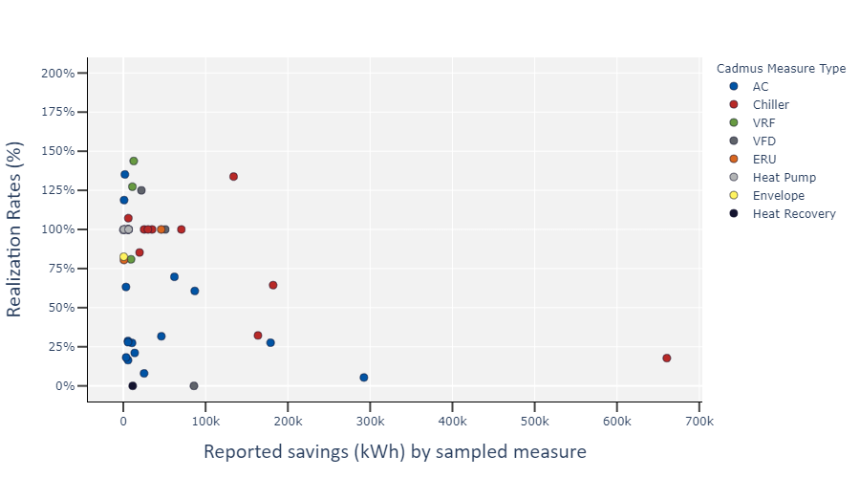

Figure 2. Cooling, Electric Sample Peak Summer Demand Savings Results
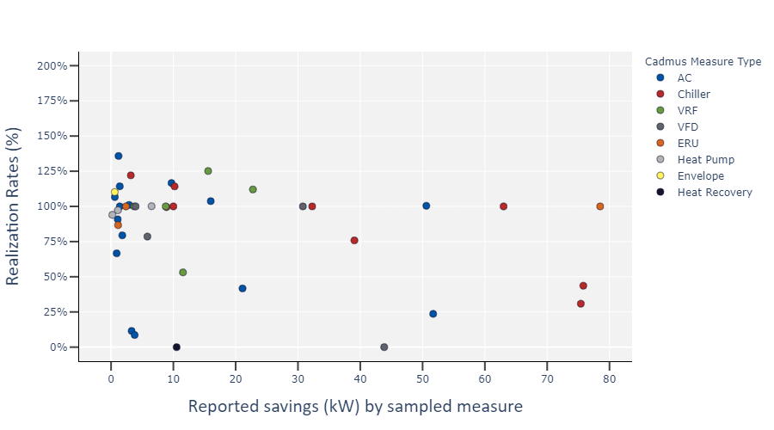

Figure 3. Cooling, Electric Sample Peak Winter Demand Savings Results
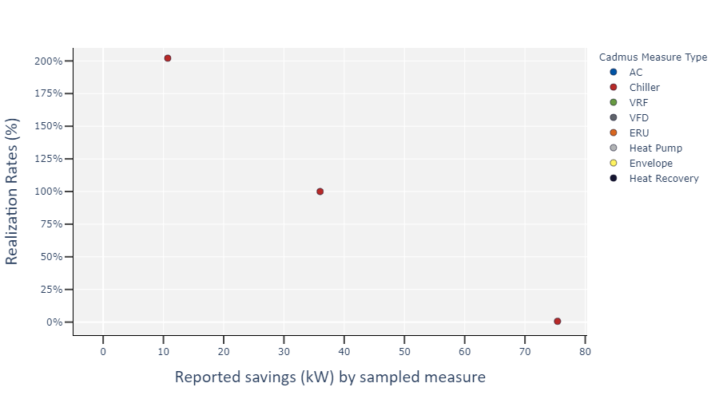

Table 13 provides the quantity of measures sampled, reported savings, evaluated savings, and common reasons for discrepancies.
Table 13. Cooling, Electric Sample Detailed Findings
Measure Type | Sampled Measures | Reported kWh | Evaluated kWh | Realization Rate (%) | Common Reasons for Discrepancy
Air Conditioners | 16 | 747,411 | 198,771 | 27% | Ten sampled Air Conditioner measures included dual enthalpy economizers, which were evaluated using eQuest energy models by facility type and location. Energy models indicate economizers save, on average, 0-2.1 kWh/ton, while reported savings utilize a deemed value of 276 kWh/ton based on the PSD.  Metered data for 10 sites indicated lower energy savings on average than estimated in the reported documentation
Chillers | 10 | 1,326,824 | 650,737 | 49% | Metered data for four sites indicated much lower chiller loads than estimated in the reported documentation, resulting in low realization rates. One sampled chiller, accounting for 50% of all sampled chiller measure kWh savings, served a data center that was minimally loaded, resulting in very low evaluated savings.
Energy Recovery Units | 3 | 47,432 | 47,279 | 100% | Minimal discrepancies found.
Envelope Upgrades | 1 | 534 | 441 | 83% | No calculations were provided with reported documentation. Evaluated savings were based on the Berkley Lab WINDOW computer program. .
Heat Pumps | 3 | 7,181 | 7,181 | 100% | No discrepancies found.
Heat Recovery | 1 | 11,379 | 0 | 0% | This measure involved the installation of ductwork to remove heat from conditioned areas produced by air compressors. The Team found the air compressors to be installed in an unconditioned space.
Variable Frequency Drives | 4 | 165,345 | 85,002 | 51% | The condensing pumps served by VFDs at one site were found to have failed, and the facility was running on rented pumps.
Variable Refrigerant Flow Systems | 5 | 44,642 | 51,378 | 115% | Metered data for two sites indicated greater evaluated energy savings due to higher average loads. Observed Energy Efficiency Ratio values were found to deviate slightly from reported Energy Efficiency Ratio values, with minimal impact on evaluated savings.

Explanations follow for a few of the more atypical measure-level realization rates:
- Incentives were provided separately for high efficiency air conditioners and dual enthalpy economizers. Among the sampled measures, most incentivized air conditioners included incentivized dual enthalpy economizers. The reported savings for dual enthalpy economizers were based on deemed savings from the 2017 PSD. The Team evaluated these dual enthalpy economizers by creating eQuest energy models of representative building types and simulated energy use of a dry bulb economizer and a dual enthalpy economizer. All sampled dual enthalpy economizer measures were installed at small office, industrial, and retail facility types. Savings were calculated as the reduction in energy use between an air conditioner with a dual enthalpy economizer and an air conditioner with a dry bulb economizer. The Team found no savings realized for two of three building types, and minimal savings (2.1 kWh/ton) for the retail building type. Most air conditioner measures sampled included both a high efficiency air conditioner unit and a dual enthalpy economizer. Reported savings for dual enthalpy economizers were, on average, much greater than reported savings for air conditioners. Consequently, the realization rate for air conditioner measures was highly impacted by the low realized savings from dual enthalpy economizers.
The Team evaluated 10 chiller measures where high efficiency variable speed chillers were installed as new construction or end-of-life replacement. The Team installed power metering equipment on three large chiller measures, where the resulting energy performance exhibited lower total energy use and the associated energy savings than assumed in the reported calculations. For one measure, the incentivized chiller served a new data center facility, where the average chiller load was significantly lower than reported. The Team observed the data center equipment inventory to be approximately 25% of maximum capacity. The low equipment inventory infers the chiller load profile in the reported calculations may have assumed a fully loaded data center. Because of the low equipment load, the total chiller energy use for both the baseline and efficient conditions is significantly lower than reported resulting in low realized energy savings. This chiller measure accounted for 50% of all sampled chiller measure electric energy savings in the Cooling, Electric stratum, and it heavily impacted the overall realization rate for measure categories containing chillers.

Lighting, Electric
The ECB program offers incentives for 21 unique measure types within the Lighting, Electric stratum. During 2017 and 2018, the ECB program provided incentives for 721 measures in this stratum. The lighting, electric stratum achieved 41,405,184 kWh in energy savings, which accounts for 40% of all reported energy savings in the ECB program.

Sampled Measures
The Team evaluated 33 lighting measures, representing interior lighting, exterior lighting, and custom lighting measures. The sampled measures accounted for 17% of reported energy savings within the Lighting, Electric stratum. Savings were reported to be based on prescriptive calculators for 20 measures, energy models for two measures, and custom calculations for one measure. The Team installed light loggers on 17 of 33 sampled measures, and evaluated lighting measures based on the savings methodology outlined in the PSD for lighting.

Findings
Table 14 shows reported and evaluated gross savings results, along with realization rates by measure type.
Table 14. 2017 and 2018 ECB Program Reported and Evaluated Savings by Measure Category
Stratum: Lighting, Electric | Electric Gross Savings (kWh) | Electric Summer Peak Demand Savings (kW) | Electric Winter Peak Demand Savings (kW) | Natural Gas Savings (therms)
Stratum Savings (% of ECB program) | 40% | 45% | 56% | N/A
Sampled Measures (% of Stratum) | 17% | 23% | 19% | N/A
Realization Rate (%) | 129% | 105% | 117% | N/A

Figure 4, Figure 5, and Figure 6 show realization rates and associated energy savings for all sampled measures within the Lighting, Electric stratum.
Figure 4. Lighting, Electric Sample Gross Electric Savings Results
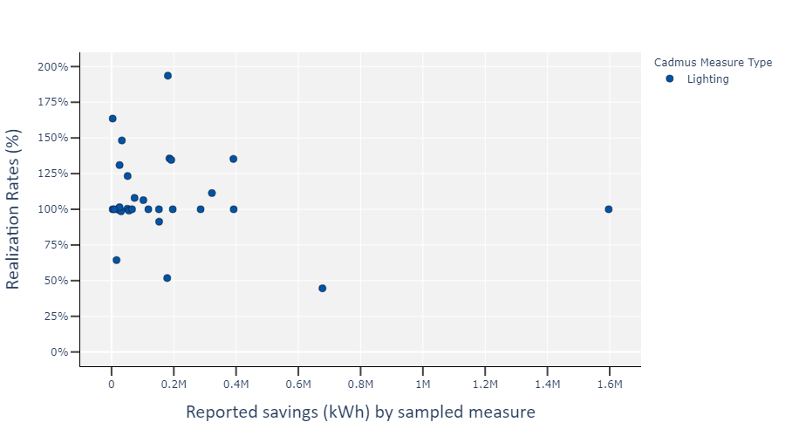

Figure 5. Lighting, Electric Sample Peak Summer Demand Savings Results
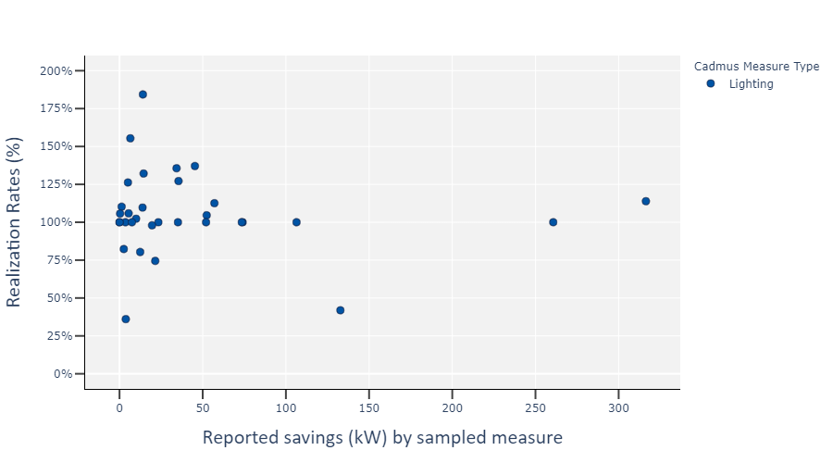

Figure 6. Lighting, Electric Sample Peak Winter Demand Savings Results
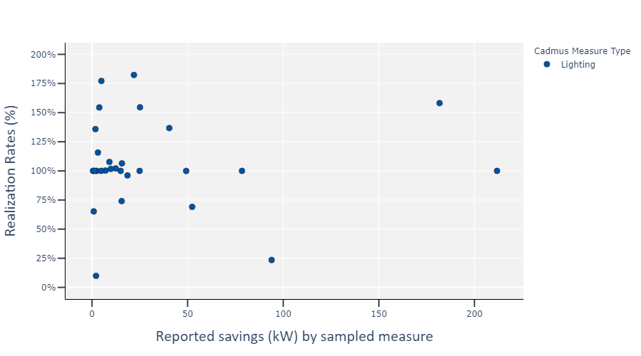

Table 15 provides the quantity of measures sampled, reported savings, evaluated savings, and common reasons for discrepancies.
Table 15. Lighting, Electric Sample Detailed Findings
Measure Type | Sampled Measures | Reported kWh | Evaluated kWh | Realization Rate (%) | Common Reasons for Discrepancy
Lighting | 33 | 6,915,628 | 9,103,207 | 132% | The Team installed light loggers at 18 facilities. The analyzed HOU from the light loggers served as the main driver behind differences in evaluated savings and reported savings.

Thirteen of the 33 sampled lighting measures exhibited realization rates greater than 110% and three sampled lighting measures exhibited realization rates lower than 90%. The Team found minimal discrepancies with observed quantities, types, and wattages of incentivized lighting measures. The Team did not find errors in reported calculations, based on prescriptive calculators created by the utilities. The Team installed light loggers at 16 facilities. Appendix A provides light Logger data from sampled projects. Analysis of the light logger data for 12 of the logged facilities indicated actual HOU greater than reported. Light logger data for four facilities indicated actual HOU were lower than reported. The reported HOU were typically self-reported or based on the associated facility type for each measure, based on Appendix 5 in the 2017 PSD.

Heating, Electric
The ECB program offers incentives for eight unique measure types within the Heating, Electric stratum. During 2017 and 2018, the ECB program provided incentives for 117 measures in this stratum. The Heating, Electric stratum achieved 1,285,371 kWh in energy savings, accounting for 1% of all reported electric energy savings in the ECB program.

Sampled Measures
The Team evaluated 17 measures, representing five equipment types—controls, envelope, heat pumps, VFDs serving hot water pumps, and VRF systems—and accounting for 35% of reported electric energy savings within the Heating, Electric stratum. Savings were reported based on prescriptive calculators for 12 measures, energy models for two measures, and custom calculations for three measures. The Team installed power meters or collected trend data for three of 17 sampled measures.

Findings
Table 16 shows reported and evaluated gross savings results, along with realization rates by measure type.
Table 16. 2017 and 2018 ECB Program Reported and Evaluated Savings by Stratum
Stratum: Heating, Electric | Electric Gross Savings (kWh) | Electric Summer Peak Demand Savings (kW) | Electric Winter Peak Demand Savings (kW) | Natural Gas Savings (therms)
Stratum Savings (% of ECB program) | 1% | 0% | 4% | N/A
Sampled Measures (% of Stratum) | 35% | 90% | 27% | N/A
Realization Rate (%) | 98% | 94% | 93% | N/A

Figure 7, Figure 8, and Figure 9 show realization rates and the associated energy savings for all sampled measures within the Heating, Electric stratum.
Figure 7. Heating, Electric Sample Gross Electric Savings Results
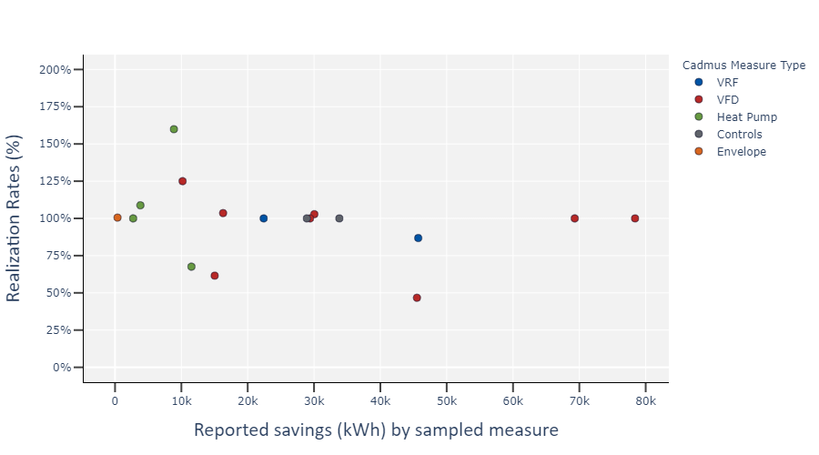

Figure 8. Heating, Electric Sample Peak Summer Demand Savings Results
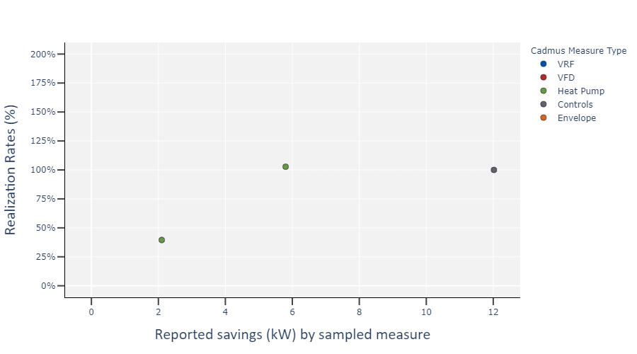

Figure 9. Heating, Electric Sample Peak Winter Demand Savings Results
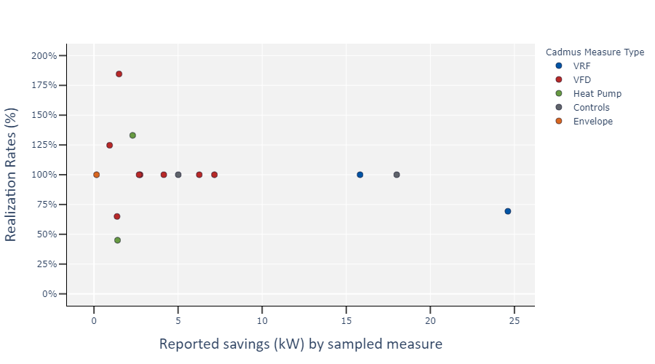

Table 17 provides the quantity of measures sampled, reported savings, evaluated savings, and common reasons for discrepancies.
Table 17. Heating, Electric Sample Detailed Findings
Measure Type | Sampled Measures | Reported kWh | Evaluated kWh | Realization Rate (%) | Common Reasons for Discrepancy
Controls | 2 | 62,736 | 62,736 | 100% | No discrepancies found.
Envelope Upgrades | 1 | 375 | 377 | 101% | Minimal discrepancies found.
Heat Pumps | 4 | 26,950 | 28,869 | 107% | The Team observed higher installed heat pump efficiencies than reported for two sampled measures.
Variable Frequency Drives | 8 | 294,154 | 268,087 | 91% | Metered performance indicated load profiles that often deviated from the reported documentation.
Variable Refrigerant Flow Systems | 2 | 68,116 | 62,091 | 91% | Metered data indicated lower energy use and load profiles for VRF systems at one of two sampled measures.

Realization rates among sampled measures in the Heating, Electric stratum exhibited low variability and were typically near 100%. Realization rates for the most sampled measure (VFDs) exhibited the greatest variability within the Heating, Electric stratum with one measure realizing electric energy savings greater than 110% and two measures realizing electric energy savings lower than 90%. The sampled incentivized VFDs in the Heating, Electric stratum served hot water pumps. Both measures with low realization rates are a result of power metering data indicating low hours of use during the meter period.

Custom/Other, Electric
The ECB program offers incentives for 29 unique measure types within the Custom/Other, Electric stratum. During 2017 and 2018, the ECB program provided incentives for 222 measures in this stratum. The Custom/Other, Electric stratum achieved 12,405,684 kWh in energy savings, accounting for 12% of all reported energy savings in the ECB program.

Sampled Measures
The Team evaluated 43 measures, representing 11 equipment types—appliances, boilers, controls, custom, electronically commutated motors, envelope, motors, pumps, refrigeration, VFDs, and water source heat pumps—and accounting for 47% of reported electric energy savings within the Custom/Other, Electric stratum. Savings were reported based on prescriptive calculators for 23 measures, energy models for two measures, and custom calculations for 18 measures. The Team installed power meters or collected trend data for five of 43 sampled measures.

Findings
Table 18 shows reported and evaluated gross savings results, along with realization rates and precisions by measure type.
Table 18. 2017 and 2018 ECB Program Reported and Evaluated Savings by Stratum
Stratum: Custom/Other, Electric | Electric Gross Savings (kWh) | Electric Summer Peak Demand Savings (kW) | Electric Winter Peak Demand Savings (kW) | Natural Gas Savings (therms)
Stratum Savings (% of ECB program) | 12% | 4% | 4% | N/A
Sampled Measures (% of Stratum) | 47% | 135%* | 198%* | N/A
Realization Rate (%) | 99% | 97% | 112% | N/A
*Multiple measures reported negative demand savings.

Figure 10, Figure 11, and Figure 12 show realization rates and associated energy savings for all sampled measures within the Custom/Other, Electric stratum.
Figure 10. Custom/Other, Electric Sample Gross Electric Savings Results
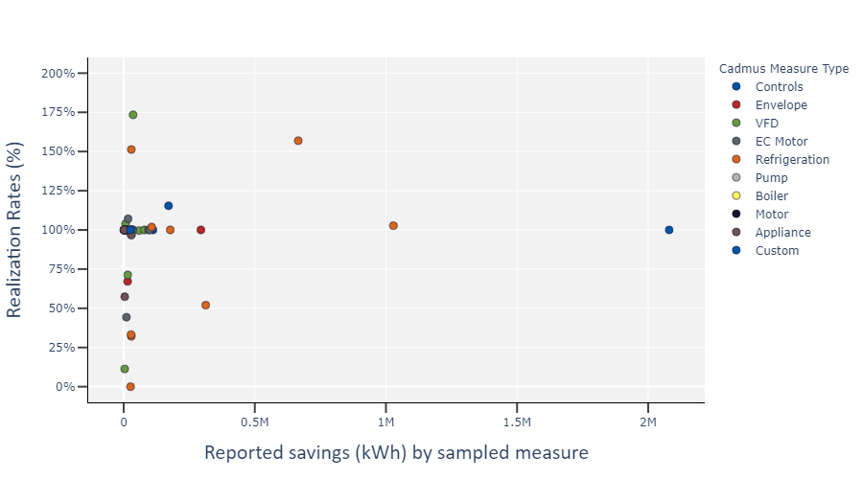

Figure 11. Custom/Other, Electric Sample Peak Summer Demand Savings Results
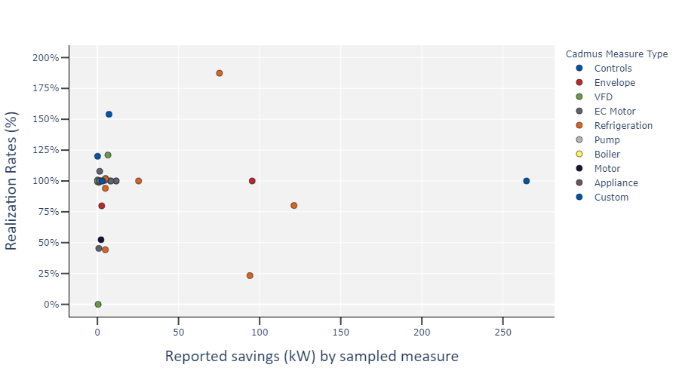

Figure 12. Custom/Other, Electric Sample Peak Winter Demand Savings Results
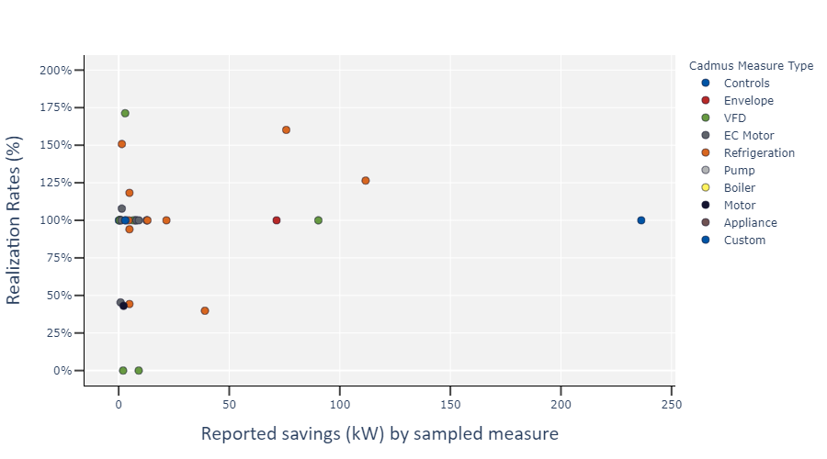

Table 19 provides the quantity of measures sampled, reported savings, evaluated savings, and common reasons for discrepancies.
Table 19. Custom/Other, Electric Sample Detailed Findings
Measure Type | Sampled Measures | Reported kWh | Evaluated kWh | Realization Rate (%) | Common Reasons for Discrepancy
Appliance | 6 | 45,386 | 42,696 | 94% | Evaluated savings for one measure involving an incentivized high-efficiency dishwasher were calculated based on site observations and staff interview data, resulting in reduced HOU and loads. Minimal discrepancies were observed at five of six evaluated measures.
Boiler | 1 | 27,800 | 27,181 | 98% | Minimal discrepancies found.
Controls | 6 | 2,415,887 | 2,442,253 | 101% | Minimal discrepancies found.
Custom | 1 | 25,942 | 25,942 | 100% | No discrepancies found.
Electronically Commutated Motor | 6 | 269,412 | 264,748 | 99% | For one measure, the Team found fan amperages utilized by the reported calculations did not match installed conditions.
Envelope Upgrades | 2 | 309,543 | 304,627 | 98% | Minimal discrepancies found.
Motor | 1 | 8,777 | 8,777 | 100% | No discrepancies found.
Pump | 2 | 55,892 | 55,892 | 100% | No discrepancies found.
Refrigeration | 12 | 2,472,252 | 2,680,390 | 108% | The Team found discrepancies at 7 of 12 sampled measures. Verified wattages for high-efficiency cool and freezer display doors were higher than reported for two measures. The Team found that control strategies and setpoints differed at two sampled measures. Metered power load profiles differed from reported assumptions for one sampled measure.
Variable Frequency Drives | 11 | 224,808 | 243,421 | 108% | Metered load profiles differed from reported assumptions.

The majority of measures sampled involved VFDs, Refrigeration, or Controls measure types, serving unique and custom processes and equipment. Due to the nontraditional nature of the measures, custom calculations were often utilized when reporting savings. While savings calculation methodologies followed traditional engineering concepts and accepted practices, inputs and assumptions were often unique to each specific application.
In general, the Team found few discrepancies for measures where custom calculations were utilized to report savings. The greatest impacts to the stratum realization rate are the result of two refrigeration and controls measures. One measure involved a large refrigeration plant upgrade including the installation of new refrigeration equipment and optimized control strategies. The Team found that one control strategy was not implemented during the site visit. Instead, facility staff controlled the refrigeration system based on a less-efficient control strategy, resulting in lower realized energy savings. Another measure involved a new refrigerated warehouse facility. Custom calculations were used to report energy savings. The Team reviewed the custom calculation workbooks and updated the inputs and load profiles based on site observations, which increased energy savings.

Process, Electric
The ECB program offered incentives for eight unique measure types within the Process, Electric stratum. During 2017 and 2018, the ECB program provided incentives for 449 measures in this stratum. The Process, Electric stratum achieved 36,031,608 kWh in energy savings, accounting for 35% of all reported energy savings in the ECB program.

Sampled Measures
The Team evaluated 78 measures, representing six equipment types—air compressors, chillers, controls, heat recovery, process, and VFDs—and accounting for 3% of reported energy savings within the Process, Electric stratum. Savings were reported based on prescriptive calculators for 64 measures and on custom calculations for 14 measures. The Team installed power meters or collected trend data for 44 of 78 sampled measures.

Findings
Table 20 shows reported and evaluated gross savings results, along with realization rates and precisions by measure type.
Table 20. 2017 and 2018 ECB Program Reported and Evaluated Savings by Stratum
Stratum: Process, Electric | Electric Gross Savings (kWh) | Electric Summer Peak Demand Savings (kW) | Electric Winter Peak Demand Savings (kW) | Natural Gas Savings (therms)
Stratum Savings (% of ECB program) | 35% | 24% | 32% | N/A
Sampled Measures (% of Stratum) | 33% | 33% | 33% | N/A
Realization Rate (%) | 80% | 114% | 112% | N/A

Figure 13, Figure 14, and Figure 15 show realization rates and associated energy savings for all sampled measures within the Process, Electric stratum.
Figure 13. Process, Electric Sample Gross Electric Savings Results
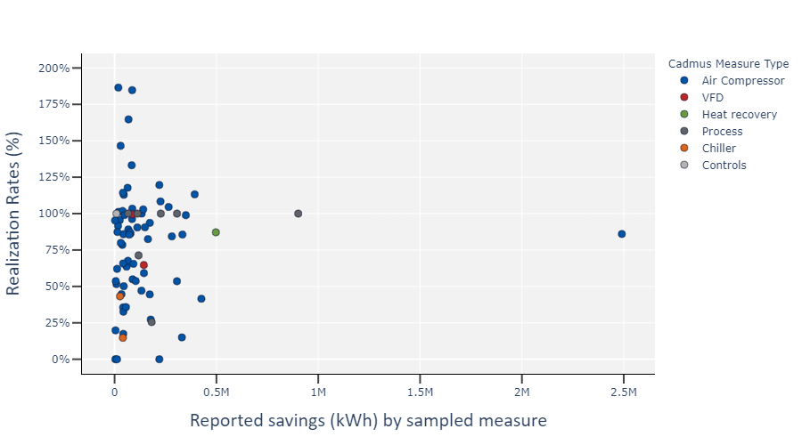

Figure 14. Process, Electric Sample Peak Summer Demand Savings Results
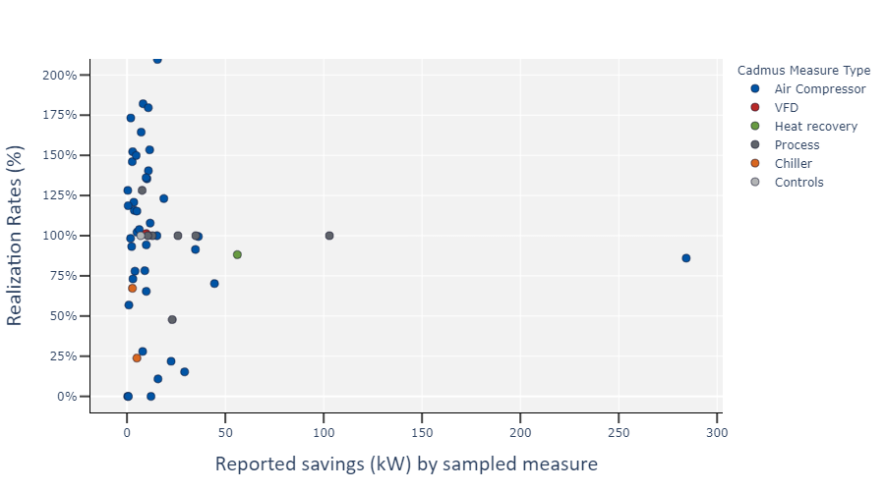

Figure 15. Process, Electric Sample Peak Winter Demand Savings Results
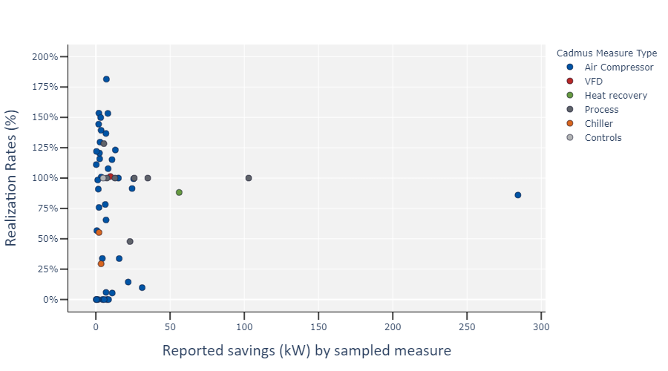

Table 21 provides the quantity of measures sampled, reported savings, evaluated savings, and common reasons for discrepancies.
Table 21. Process, Electric Sample Detailed Findings
Measure Type | Sampled Measures | Reported kWh | Evaluated kWh | Realization Rate (%) | Common Reasons for Discrepancy
Air Compressor | 64 | 9,279,238 | 7,414,299 | 80% | Metered load profiles differed from reported assumptions. Variations in load profiles were often due to lower observed line pressure than assumed and on differences in production/system use between reported and evaluated calculations.
Chillers | 2 | 67,298 | 17,468 | 26% | Metered data from the process chillers at both sampled customer sites indicated lower peak demand and lower HOU, resulting in reduced energy savings.
Controls | 1 | 9,072 | 9,072 | 100% | No discrepancies found.
Heat recovery | 1 | 497,312 | 433,378 | 87% | Reported calculations did not account for additional fan energy use from installing a VFD, resulting in lower evaluated savings compared to reported savings.
Process | 7 | 1,914,390 | 1,745,030 | 91% | The Team found the installation of incentivized process equipment had only been partially implemented, resulting in reduced energy savings.
Variable Frequency Drives | 2 | 229,240 | 178,190 | 78% | The Team found the incentivized VFD at one customer site was offline during the site visit, and the associated well pump would not be returned to service until fall. The Team interviewed the facility contact and calculated savings, based on expected HOU when the well pump is redesigned and reinstalled.

The majority of sampled measures involved high-efficiency air compressor systems. Based on site visit observations as well as on power meter data and trend data from the air compressor measures, the Team found three driving factors that decreased energy savings when compared to reported documentation:
- The Team found HOU were lower, on average. The compressed air systems sampled operated fewer hours than expected. Fewer HOU typically result in lower realized energy savings as baseline equipment was expected to provide the same production capacity and associated HOU as the installed equipment.
- Average loads or compressor speeds were higher. In general, variable speed compressed air systems save more energy than traditional compressed air systems when operating in part-load conditions. As the average speed approaches 100%, the energy savings decrease. Customers typically provided an estimated load profile, based on four expected speed positions and on the total hours the compressors are expected to operate at the associated speeds. The Team found the average load was typically higher than expected in the reported documentation, resulting in lower energy savings.
Line pressure was lower. Lower line pressure reduces total energy required by a compressor to maintain system pressures. The Team found the line pressure setpoints at many sampled measures were lower than indicated in the reported documentation. This reduction in line pressure resulted in lower energy use by the baseline and installed compressors, ultimately resulting in total energy savings.
Besides a reduction in total energy savings for compressed air measures, the Team found demand savings calculations were typically not representative of actual operations. The majority of measures reported demand savings to be the difference in the maximum demand of installed and baseline compressed air systems. Based on site visit observations and meter data from 44 compressed air measures, the Team found average demand during peak periods to be lower than maximum demand expected by the system. As demand savings were calculated as average demand reduction during peak periods, compressed air measures realized more savings than reported for most sampled measures.
The Team sampled and metered two-process chiller measures and found the average load significantly below the expected load. For one measure, the process chiller served a newly constructed data center. The Team observed that the data center was partially filled, and meter data proved that the chiller operated at very low load. As the reported documentation assumed a nearly fully loaded data center, lower first-year energy savings were realized.

Heating, Natural Gas
The ECB program offered incentives for 19 unique measure types within the Heating, Natural Gas stratum. During 2017 and 2018, the ECB program provided incentives for 515 measures in this stratum. The Heating, Natural Gas stratum achieved 1,345,263 therms in natural gas savings, accounting for 63% of all reported natural gas savings in the ECB program.

Sampled Measures
The Team evaluated 30 measures, representing six equipment types—boilers, controls, envelope, furnaces, heat recovery, infrared/unit heaters—and accounting for 63% of reported energy savings within the Heating, Natural Gas stratum. Savings were reported based on prescriptive calculators for 21 measures, custom calculations for seven measures, and energy models for two measures. The Team installed power meters or collected trend data for two of 30 sampled measures.

Findings
Table 22 shows reported and evaluated gross savings results, along with realization rates by measure type.
Table 22. 2017 and 2018 ECB Program Reported and Evaluated Savings by Stratum
Stratum: Heating, Natural Gas | Electric Gross Savings (kWh) | Electric Summer Peak Demand Savings (kW) | Electric Winter Peak Demand Savings (kW) | Natural Gas Savings (therms)
Stratum Savings (% of ECB program) | N/A | N/A | N/A | 64%
Sampled Measures (% of Stratum) | N/A | N/A | N/A | 13%
Realization Rate (%) | N/A | N/A | N/A | 97%

Figure 16 shows realization rates and associated energy savings for all sampled measures within the Heating, Natural Gas stratum.
Figure 16. Heating, Natural Gas Sample Natural Gas Savings Results
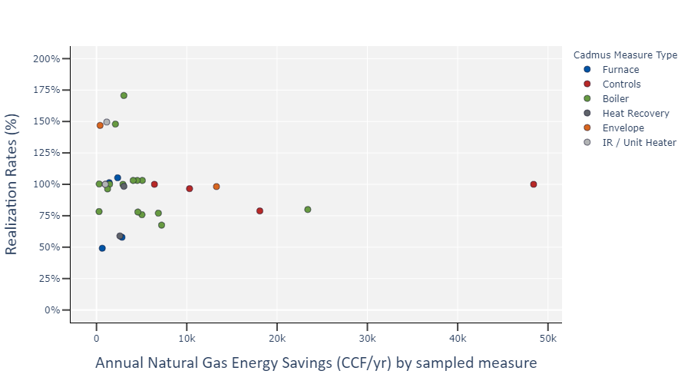

Table 23 provides the quantity of measures sampled, reported savings, evaluated savings, and common reasons for discrepancies.
Table 23. Heating, Natural Gas Sample Detailed Findings
Measure Type | Sampled Measures | Reported Therms | Evaluated Therms | Realization Rate (%) | Common Reasons for Discrepancy
Boiler | 15 | 72,040 | 64,676 | 90% | The Team performed combustion tests for most sampled measures and found installed efficiency consistently lower than reported.
Controls | 5 | 84,216 | 80,034 | 95% | Metered data from one measure involving a dust collection system indicated fewer HOU than reported, resulting in lower evaluated savings.
Envelope Upgrades | 2 | 13,684 | 13,632 | 100% | Minimal discrepancies found.
Furnace | 4 | 7,228 | 5,852 | 81% | Installed capacities for furnaces for one sampled measure were 48% lower than reported. Installed efficiencies varied slightly from the reported documentation for three sampled measures.
Heat Recovery | 2 | 5,628 | 4,514 | 80% | Metered data from one measure indicated lower air compressor loads than assumed, resulting in lower heat recovery and lower evaluated savings.
Infrared Heater | 2 | 2,112 | 2,675 | 127% | Installed capacity for infrared heaters at one facility were 43% greater than indicated in the reported documentation.

In general, the majority of reductions in realized energy savings resulted from lower installed efficiencies, lower operating output, and lower HOU. Explanations for these discrepancies follow in more detail:
- The Team performed combustion tests for the majority of sampled measures, finding that boilers and furnaces operated below the associated advertised efficiency. For one measure, the Team collected trend data on the entering water temperature (EWT) for a condensing boiler and calculated boiler efficiency, based on EWT and supply water temperatures. Because EWT directly impacts condensing boilers’ efficiency, and trend data exhibited consistently high EWTs, the condensing boiler operated at a lower efficiency than expected.
Meter data for a sampled heat-recovery measure and controls measure indicated lower HOU and average operating loads than reported. The heat-recovery measure reported savings based on recovery of compressed air heat. As the compressed air operated at a lower average speed, less heat was recovered, resulting in lower realized savings. Similarly, a sampled measure involving a dust collection system operated at fewer hours than expected, resulting in reduced realized energy savings.

Domestic Hot Water, Natural Gas
The ECB program offered incentives for four unique measure types within the Domestic Hot Water, Natural Gas stratum. During 2017 and 2018, the ECB program provided incentives for 101 measures in this stratum. The Domestic Hot Water, Natural Gas stratum achieved 108,869 therms in natural gas savings, accounting for 5% of all reported natural gas savings in the ECB program.

Sampled Measures
The Team evaluated 11 measures—all represented natural gas water heaters and accounted for 13% of reported energy savings within the Domestic Hot Water, Natural Gas stratum. Savings reported were based on prescriptive calculators for all measures. The Team installed power meters or collected trend data for four of 11 sampled measures.

Findings
Table 24 shows reported and evaluated gross savings results, along with realization rates and precisions by measure type.
Table 24. 2017 and 2018 ECB Program Reported and Evaluated Savings by Stratum
Stratum: Domestic Hot Water, Natural Gas | Electric Gross Savings (kWh) | Electric Summer Peak Demand Savings (kW) | Electric Winter Peak Demand Savings (kW) | Natural Gas Savings (therms)
Stratum Savings (% of ECB program) | N/A | N/A | N/A | 5%
Sampled Measures (% of Stratum) | N/A | N/A | N/A | 13%
Realization Rate (%) | N/A | N/A | N/A | 89%

Figure 17 lists realization rates and associated energy savings for all sampled measures within the Domestic Hot Water, Natural Gas stratum.
Figure 17. Domestic Hot Water, Natural Gas Sample Natural Gas Savings Results
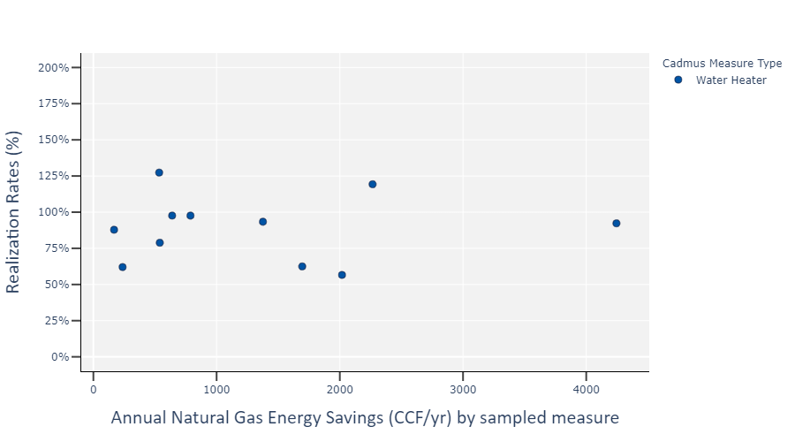

Table 25 provides the quantity of measures sampled, reported savings, evaluated savings, and common reasons for discrepancies.
Table 25. Domestic Hot Water, Natural Gas Sample Detailed Findings
Measure Type | Sampled Measures | Reported Therms | Evaluated Therms | Realization Rate (%) | Common Reasons for Discrepancy
Water Heater | 11 | 14,505 | 12,901 | 89% | The Team found differences in installed efficiency based on combustion test results and nameplate efficiencies. Additionally, the Team installed meters at two customer sites and found reduced hot water use when compared to the expected hot water use in the PSD.

Custom/Other, Natural Gas
The ECB program offered incentives for 13 unique measure types within the Custom/Other, Natural Gas stratum. During 2017 and 2018, the ECB program provided incentives for 45 measures in this stratum. The Custom/Other, Natural Gas stratum achieved 637,374 therms in natural gas savings, accounting for 30% of all reported natural gas savings in the ECB program.

Sampled Measures
The Team evaluated 15 measures, representing six measure types—appliances, water heaters, controls, dehumidification, envelope upgrades, and heat recovery, accounting for 29% of reported energy savings within the Custom/Other, Natural Gas stratum. Savings reported were based on prescriptive calculation workbooks, custom calculations, or energy models. The Team installed power meters or collected trend data for one of 15 sampled measures.

Findings
Table 26 shows reported and evaluated gross savings results, along with realization rates by measure type.
Table 26. 2017 and 2018 ECB Program Reported and Evaluated Savings by Stratum
Stratum: Custom/Other, Natural Gas | Electric Gross Savings (kWh) | Electric Summer Peak Demand Savings (kW) | Electric Winter Peak Demand Savings (kW) | Natural Gas Savings (therms)
Stratum Savings (% of ECB program) | N/A | N/A | N/A | 30%
Sampled Measures (% of Stratum) | N/A | N/A | N/A | 29%
Realization Rate (%) | N/A | N/A | N/A | 91%

Figure 18 lists realization rates and associated energy savings for all sampled measures within the Custom/Other, Natural Gas stratum.
Figure 18. Custom/Other, Natural Gas Sample Natural Gas Savings Results
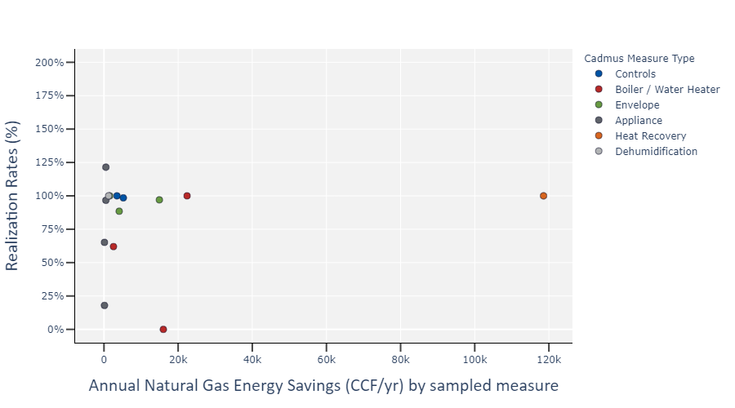

Table 27 provides the quantity of measures sampled, reported savings, evaluated savings, and common reasons for discrepancies.
Table 27. Custom/Other, Natural Gas Sample Detailed Findings
Measure Type | Sampled Measures | Reported Therms | Evaluated Therms | Realization Rate (%) | Common Reasons for Discrepancy
Appliance | 4 | 1,274 | 1,215 | 95% | Operation HOU and production capacity differed from reported documentation, based on site observations and staff interviews.
Boiler/ Water Heater | 4 | 41,014 | 24,212 | 59% | The Team found an incentivized kettle cooker was not installed at one facility due to construction installation limitations. The cooker was found on site, but will not be installed until 2020.
Controls | 2 | 8,724 | 8,645 | 99% | Minimal discrepancies found.
Dehumidification | 1 | 1,245 | 1,245 | 100% | No discrepancies found.
Envelope Upgrades | 3 | 20,588 | 19,671 | 96% | Minimal discrepancies found.
Heat Recovery | 1 | 118,554 | 118,554 | 100% | No discrepancies found.

The Team found few discrepancies when evaluating sampled measures in the Custom/Other, Natural Gas stratum. One sampled measure drove the majority of reduced realized energy savings for this stratum. The Team found incentivized equipment was not installed at one facility due to construction limitations. During the site visit, the Team located the equipment, but the facility could not install the equipment without modifying the facility’s structure to install the equipment and to realize energy savings.

True New Construction (TNC) Results
TNC measures are defined as energy measures that are part of construction for an entirely new space, or as part of a major renovation where energy codes are applicable. The ECB participant database did not track TNC measures consistently across the two utilities or each program year. As such, the total population count and associated savings for TNC measures remain unknown.

Sampled Measures
The Team reviewed all sampled measure documentation when determining if each measure qualified as a TNC measure. Of 274 measures sampled for the evaluation, 127 measures were determined to be part of TNC measures. The Team installed power meters or collected trend data for 59 of 127 sampled TNC measures. Sampled measures that were not included in the TNC category are for end-of-life equipment replacement or for incentivized equipment that does not have an energy code mandated baseline energy efficiency. Air compressors are an example of these measures. Additionally, the applications do not always indicate if the incentivized equipment replaces existing equipment or not. For situations where we could not determine if the measure was TNC or not, we did not include them in the TNC category. Non-TNC measures are included in the Normal Replacement (NR) category in Table 29.

Findings
Table 28 shows reported and evaluated gross savings results, along with realization rates. The Team weighted the realization rates to account for the sampling strategy employed on the entire population.
Table 28. True New Construction Sampled Measures Reported and Evaluated Savings
Stratum: True New Construction | Electric Gross Savings (kWh) | Electric Summer Peak Demand Savings (kW) | Electric Winter Peak Demand Savings (kW) | Natural Gas Savings (therms)
Reported Savings | 27,570,956 | 2,216 | 1,281 | 136,111
Realization Rate (%) | 110% | 98% | 113% | 98%

Table 29 shows TNC realization rates and precision by strata.
Table 29. True New Construction Sampled Measures Realization Rates
Strata | Quantity of Measures | Electric Gross Savings (kWh) Realization Rate |  | Electric Summer Peak (kW) Demand Savings Realization Rate |  | Electric Winter Peak (kW) Demand Savings Realization Rate |  | Natural Gas (therms) Savings Realization Rate
 |  | TNC | Precision | TNC | Precision | TNC | Precision | TNC | Precision
Cooling, Electric | 34 | 80% | 11.7% | 81% | 18.8% | 100% | N/A | N/A | N/A
Lighting, Electric | 32 | 119% | 11.3% | 104% | 11.3% | 115% | 22.0% | N/A | N/A
Heating, Electric | 16 | 98% | 9.7% | 86% | 181.3% | 93% | 14.1% | N/A | N/A
Custom/Other, Electric | 19 | 89% | 12.3% | 105% | 12.1% | 97% | 16.3% | N/A | N/A
Process, Electric | 1 | 86% | N/A | 237% | N/A | 257% | N/A | N/A | N/A
Heating, Gas | 16 | N/A | N/A | N/A | N/A | N/A | N/A | 99% | 12.1%
Domestic Hot Water, Gas | 6 | N/A | N/A | N/A | N/A | N/A | N/A | 89% | 24.7%
Custom/Other, Gas | 3 | N/A | N/A | N/A | N/A | N/A | N/A | 97% | 1.8%
Total | 127 | 110% | 8.9% | 98% | 8.6% | 113% | 18.1% | 98% | 9.5%

Table 29 shows TNC and all measures realization rates by strata.
Table 30. True New Construction and All Measures Realization Rates
Strata | Electric Gross Savings (kWh) Realization Rate |  | Electric Summer Peak (kW) Demand Savings Realization Rate |  | Electric Winter Peak (kW) Demand Savings Realization Rate |  | Natural Gas (therms) Savings Realization Rate
 | TNC | NR | TNC | NR | TNC | NR | TNC | NR
Cooling, Electric | 80% | 36% | 81% | 48% | 100% | 26% | N/A | N/A
Lighting, Electric | 119% | 447% | 104% | 64% | 115% | 248% | N/A | N/A
Heating, Electric | 98% | 100% | 86% | 42% | 93% | 100% | N/A | N/A
Custom/Other, Electric | 89% | 105% | 105% | 98% | 97% | 109% | N/A | N/A
Process, Electric | 86% | 82% | 237% | 86% | 257% | 110% | N/A | N/A
Heating, Gas | N/A | N/A | N/A | N/A | N/A | N/A | 99% | 89%
Domestic Hot Water, Gas | N/A | N/A | N/A | N/A | N/A | N/A | 89% | 93%
Custom/Other, Gas | N/A | N/A | N/A | N/A | N/A | N/A | 97% | 90%
total | 110% | 87% | 98% | 86% | 113% | 106% | 98% | 90%

Baseline Study
The team conducted research into commercial new construction building standards in the general Connecticut market. This research included a literature review of applicable commercial new construction baseline studies, building codes and standards whitepapers, ASHRAE technical guidelines, and independent research reports. We also conducted in-depth interviews with key market actors holding various roles within Connecticut’s commercial new construction industry.
The literature review and interviews focused on true new construction projects and standards in Connecticut.
With this research, the team sought to address these objectives:
- Investigate recommended baselines for the following equipment:
  - Lighting and lighting power density
  - HVAC equipment efficiency
  - Boiler equipment efficiency and replace-upon-failure projects
- Understand market actor practices and perspectives on new construction baselines
- Identify factors that influence the new construction market in Connecticut
- Determine influences on the ECB program and implications for measuring energy saving impacts

Findings
Based on our market actor interviews, respondents estimated the average installed efficiency level of lighting, HVAC, and boiler equipment types. Respondents more reliably provided estimates for lighting and new construction boilers, which were most likely to be installed above code. Most respondents were unable to provide the installed efficiency levels for chillers, gas radiant heaters, and end-of-life (EOL) replacement gas fired boilers. Figure 19 shows the combined responses of installed efficiency levels by equipment type.
Figure 19. Installed Efficiency Level by Equipment Type
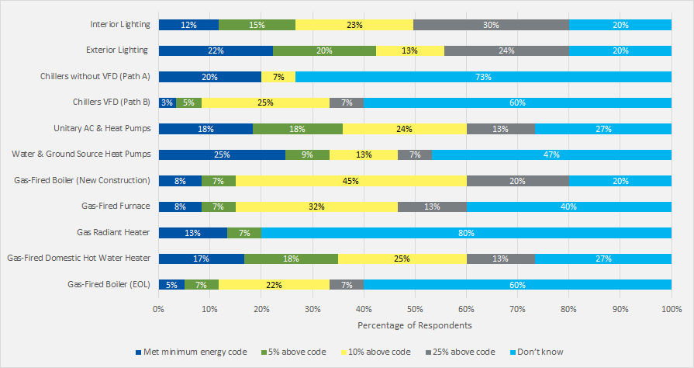
Source: Estimate the average installed efficiency level of lighting,
HVAC, and boiler equipment types. (n=15)
The resources we reviewed indicated that raising the baselines for certain lighting, HVAC, and boiler equipment is justified. Market actors indicated that interior and exterior lighting, unitary air conditioner and heat pumps, water and ground-source heat pumps, gas-fired boilers (new construction), gas-fired furnaces, and gas-fired domestic hot water heaters were already being installed at least 10% above code, and as high as 25% above code for lighting. The results of the market actor interviews were not appropriate for making quantitative baseline changes for this study but indicate the need for further research in this area. Additional details regarding the baseline study can be found in Appendix B.

Conclusions and Recommendations
The 2017 and 2018 program evaluation yielded overall retrospective realization rates of 101.4% for electric energy savings, 98.6% for summer seasonal peak demand savings, 110.6% for winter seasonal peak demand savings, and 94.6% for natural gas savings. Varying degrees of realization rates and precision fell within each of the nine measure categories. The Team calculated prospective realization rates of 101.4% for electric energy savings, 98.6% for summer seasonal peak demand savings, 110.6% for winter seasonal peak demand savings, and 94.6% for natural gas savings. This section provides the Team’s conclusions and recommendations, based on findings presented in this report.

PSD-Related Conclusions and Recommendations.

Conclusion—Dual Enthalpy Economizers
The utilities provided incentives for dual enthalpy economizers, which were included in most of the air conditioners sampled. Reported savings were based on deemed savings from the 2017 PSD. Deemed savings in the PSD were based on a study performed in 1999. The Team evaluated these measures by creating three eQuest energy models of the industrial, office, and retail building types based on sampled measures and simulating energy use of a minimally code-compliant single setpoint dry bulb economizer and a dual enthalpy economizer. No savings were realized for two of three building types, and minimal savings (2.1 kWh/ton) were realized for the retail building type. Most sampled air conditioners included dual enthalpy economizers, and reported savings for dual enthalpy economizers were, on average, much greater than reported savings for air conditioners. Consequently, the realization rate for air conditioners was highly impacted by realized savings from dual enthalpy economizers.

Recommendation—Dual Enthalpy Economizers
Remove the dual enthalpy economizer measure from PSD- and ECB-offered measures. The evaluation found that dual enthalpy economizer measures exhibit minimal energy savings in Connecticut’s climate.

Conclusion—Lighting Hours of Use
The Team installed light loggers at 16 facilities. Analysis of light logger data indicated the actual HOU were typically greater than reported. Reported HOU were typically self-reported or based on the associated facility type for each measure, per Appendix 5 in the 2017 PSD.

Recommendation—Lighting Hours of Use
Incorporate the light logger data from this study with other lighting studies to support a PSD update to revised HOU by building types. For lighting measures where HOU were based on the associated facility type, improving the accuracy of HOU by facility type is expected to improve the accuracy of reported energy savings.

Conclusion—Chiller Calculations
Chiller calculations often were reported based on a weather-bin calculator that projects chiller load as a function of outside air temperature and economizer setpoint. Using a weather-bin analysis approach may be appropriate for calculating annual energy use if the chiller load correlates well to outside air temperatures, but it may not be appropriate for calculating demand savings. The hourly average temperatures during the ISO-NE seasonal summer and winter peak periods typically will not align with maximum-weather temperature bins assumed in a bin analysis. Using a bin analysis may underestimate demand savings during the summer peak period and may inaccurately estimate savings during the winter peak period.

Recommendation—Chiller Calculations
Calculate chiller savings using an annual 8,760 hourly spreadsheet calculation method instead of the bin analysis method. Using an 8,760 hourly spreadsheet calculation method will account for variable temperatures and change in average demand during the summer and winter peak periods resulting in more accurate savings calculations.

General Conclusions and Recommendations

Conclusion—Air Compressor Load Profiles
Based on site visit observations, as well as power meter data and trend data from the air compressor measures, The Team found three driving factors decreased energy savings when compared to reported documentation: HOU were lower, average loads or compressor speeds were higher, and line pressure was lower.

Recommendation—Air Compressor Load Profiles
Conduct an additional post-implementation assessment of HOU, average loads, and line pressures by utilizing trend data or power metering pre-implementation or post-implementation. Implementing these changes will result in greater accuracy of energy savings calculations.

Conclusion—Air Compressor Calculations
Besides a reduction in total energy savings for compressed air measures, the Team found reported demand savings calculations typically were not representative of actual operations. The majority of measures reported demand savings as the difference in the maximum demand of installed and baseline compressed air systems multiplied by the summer or winter peak coincidence factors identified in Appendix A of the PSD. Based on site visit observations and meter data from 44 compressed air measures, the Team found average demand during peak periods was consistently lower than the reported peak demand expected by the system. As demand savings were calculated as average demand reduction during peak periods, compressed air measures realized more savings than reported for most sampled measures.

Recommendation—Air Compressor Calculations
Update the demand savings calculation methodology for compressed air measures. Savings calculation inputs should be revised, such that the customer provides the expected compressor load for each hour of every weekday and weekend of a typical week. If seasonal or monthly changes are expected to increase or decrease the load, the calculation inputs should provide customers with the ability to provide these seasonal changes. The compressor calculations should be updated so that the average load of the efficient compressor is reduced from the average load of the baseline compressor during the peak period. The average load should be based on trend data, historical observations, or customer judgement. Making these changes will allow for greater accuracy of annual energy savings, seasonal summer savings, and seasonal winter savings.

Conclusion—Chiller Load Profiles
The Team installed power metering equipment on five chiller measures, where the resulting energy performance exhibited lower total energy use and associated energy savings than assumed in the reported calculations. For one measure, the chiller served a new data center facility, where average chiller loads were observed to be significantly lower than reported. This chiller accounted for 50% of all electric energy savings from chiller measures sampled in the Cooling, Electric stratum and heavily impacted the overall realization rate for the chiller sample. Within the Process, Electric stratum, the realization rate from the two chiller measures exhibited a 26% realization rate due to low hours of use and average loads. Average demand levels during peak periods also were lower than expected, resulting in lower peak demand savings.

Recommendation—Chiller Load Profiles
Adopt greater scrutiny in review of load profiles for all chiller measures, including post-implementation metering or trending. Improving the accuracy of the load profiles for incentivized chillers will minimize the possibility of over- or under-calculating reported energy savings.

Conclusion—True New Construction
Measures installed as TNC are not consistently documented in the measure tracking databases from the utilities with this designation. Consequently, the quantity of measures and associated energy savings of measures installed as TNC cannot be determined. Customers who install TNC measures often pursue energy efficiency through a different decision-making process than those who install energy efficiency measures due to equipment failure or end-of-life replacement, and the performance of TNC measures may differ as a result.

Recommendation—True New Construction
Include a TNC designation within the measure tracking databases. By tracking TNC by application, utilities and evaluators may assess the impact of TNC measures throughout the ECB program.

Conclusion—Tracking Measure Database Detail
The Team received measure tracking databases from both utilities. The data entry values for each measure within the measure tracking databases varied by utility and program year. The measure description data entry within the tracking databases varied in detail and quality. For custom measures, the measure description often did not provide sufficient detail to understand the incentivized measure without reviewing the specific measure documentation. Without sufficient detail in the measure description, the total population of measure types remains unknown.

Recommendation—Tracking Measure Database Detail
Improve the detail provided in the measure description data entry within the measure tracking database for each measure. By including detailed measure descriptions, assigned measure types and measure categories may be improved and the reliability of measure type stratification for evaluation purposes may be improved.

Conclusion—Baseline Study
Market actors indicated that standard practice exceeds baseline for several measures included in the baseline study, notable interior and exterior lighting, unitary air conditioner and heat pumps, water and ground-source heat pumps, gas-fired boilers (new construction), gas-fired furnaces, and gas-fired domestic hot water heaters.

Recommendation—Baseline Study
Use the results of the baseline study to help prioritize quantitative investigations of standard practice baselines in a future study.

Light Logger Data

Project ID | Quantity of Light Loggers Installed | Facility Type | Reported Hours of Use | Calculated Hours of Use | Measured Summer Peak coincident factor | Measured Winter Peak coincident factor
1 | 5 | Retail | 4057 | 6170 | 0.96 | 0.94
2 | 6 | Gymnasium | 2586 | 3664 | 0.77 | 0.90
3 | 11 | Warehouse | 2602 | 7149 | 0.91 | 0.84
4 | 5 | Retail | 4057 | 5314 | 0.80 | 0.65
5 | 7 | Retail | 4057 | 7908 | 1.00 | 1.00
6 | 7 | Retail | 4057 | 4806 | 0.98 | 0.98
7 | 9 | Warehouse | 2602 | 8757 | 1.00 | 1.00
8 | 5 | Workshop | 3750 | 3696 | 0.71 | 0.44
9 | 5 | Dining: Cafeteria / Fast Food | 6456 | 3081 | 0.57 | 0.43
10 | 9 | Warehouse | 2602 | 8760 | 1.00 | 1.00
11 | 7 | Retail | 4057 | 1810 | 0.80 | 0.65
12 | 4 | Office | 2132 | 3130 | 0.80 | 0.40
13 | 6 | School | 2187 | 2773 | 0.68 | 0.68
14 | 12 | Court House | 2500 | 2571 | 0.96 | 0.46
15 | 22 | Auto Related | 2634 | 2847 | 0.61 | 0.27
16 | 11 | Warehouse | 2857 | 1839 | 0.24 | 0.04

ECB Impact Evaluation (C1634) Baseline Additional Scope of Work Memorandum

To: Peter Jacobs, Ralph Prahl, Study Lead, Evaluation Administrator
From: Ryan Hughes, Kaitlyn Teppert, Kean Amidi-Abraham, Cadmus
Subject: ECB Impact Evaluation (C1634) Baseline Additional Scope of Work
Date: April 24, 2020
As part of Energize Connecticut’s Energy Conscious Blueprint (ECB) 2017-2018 program evaluation, the Connecticut Energy Efficiency Board (EEB) requested Cadmus conduct research into commercial new construction building standards in the general Connecticut market. This research will inform the ECB impact evaluation and bridge any gaps created by not conducting a baseline study (C1662). This memo summarizes the findings and conclusions from this investigation but is not intended as a formal baseline study that provides recommended baseline efficiency values for identified measures.
This research included a literature review of applicable commercial new construction baseline studies, building codes and standards whitepapers, ASHRAE technical guidelines, and independent research reports. We also conducted in-depth interviews with key market actors holding various roles within Connecticut’s commercial new construction industry.
The literature review and interviews focused on true new construction projects and standards in Connecticut. Based on conversations with the EA, true new construction projects are defined as energy projects that are part of the construction of an entirely new space or part of a major renovation (excluding all other types of retrofit or equipment replacement projects) where an energy code is applicable.

Objectives
With this research, Cadmus sought to address these objectives:
- Investigate recommended baselines for the following equipment:
  - Lighting and lighting power density
  - HVAC equipment efficiency
  - Boiler equipment efficiency and replace-upon-failure projects
- Understand market actor practices and perspectives on new construction baselines
- Identify factors that influence the new construction market in Connecticut
- Determine influences on the ECB program and implications for measuring energy saving impacts

Literature Review
As the first step in this research, Cadmus worked with the EA to determine a list of resources—such as baseline and compliance studies from neighboring Northeastern states, technical resource manuals, and past evaluations—to guide our initial understandings of the research objectives and design an informed market-actor interview guide.

Method
Cadmus prepared an Excel spreadsheet with preliminary, proposed resources to conduct a full literature review and submitted it to the EEB for review. Once the EEB approved and appended the list, Cadmus moved forward with the complete literature review. The detailed literature review notes can be found in this memo’s companion document, CT Baseline Secondary Research.xlsx.
When pulling together the resources, Cadmus and the EEB first prioritized studies and documents focused on Connecticut. Next, we concentrated on Massachusetts, a neighboring state that is well-known for its aggressive energy-efficiency policies, projects, and research. Other secondary states of interest included New York, New Hampshire, Rhode Island, and Vermont due to their regional proximity to Connecticut.
Cadmus conducted a preliminary review of regional code adoption in 2017, Connecticut code for measures of interest, and some high-level research about other states’ codes. We then examined studies that had very similar scopes to understand how and why baseline codes may have increased because of existing market activity (particularly within new construction projects, where possible). In supplemental research, we also examined related studies to further understand baseline activity, what market actors may be of interest for subsequent interviews, and potential methodologies to use in the interview guide.
A full list of resources used for this literature review can be found in CT Baseline Secondary Research.xlsx.

Literature Review Overall Findings
Though much of the literature review helped to inform the interview guide, there were two unique aspects of the review that also helped to contextualize our research. First, the status of regional code adoption in 2017. Second, what previous studies had found regarding baseline equipment assumptions used in evaluations versus what the market was installing, and if those findings justified an upward shift in baselines.

Regional Code Adoption
Since the C1634 Energy Conscious Blueprint Impact Evaluation covered projects completed in 2017 and 2018, Cadmus reviewed Connecticut’s energy code adoption and compared it to neighboring states. In 2017, Connecticut had adopted the ASHRAE Standard 90.1-2010, which put Connecticut behind every neighboring state except New Hampshire and Rhode Island (Figure 1). However, in 2018, Connecticut adopted ASHRAE Standard 90.1-2013, which was on par with neighboring states.
Figure 1. 2017 ASHRAE Commercial Code Adoption Across the United States
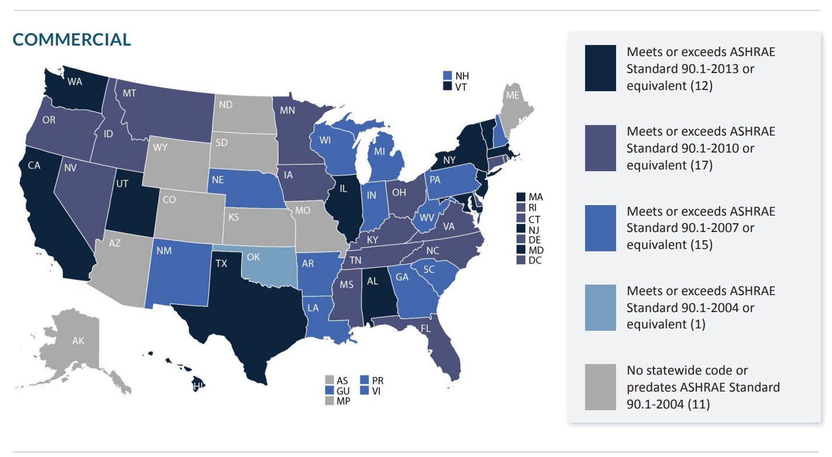
Source: Building Codes Assistance Project. Code Adoption Status: April 2017. http://bcapcodes.org/wp-content/uploads/2015/11/code-status-april-2017.pdf

Standard New Construction Practice versus Minimum Code Compliance
In the past five years, rigorous baseline and code compliance studies have found that many measures installed within new commercial and industrial construction projects exceeded code requirements at the time of construction. For example, in 2015, the Commercial New Construction Baseline and Code Compliance Study found that the efficiency of installations of equipment like lighting, air conditioners, heat pumps, and water heaters all exceeded prevailing code requirements and instead adhered to the most current ASHRAE requirements or beyond. Similarly, the Massachusetts Commercial Energy Code Compliance and Baseline Study for the International Energy Conservation Code (IECC) 2012 (2018), which focused on lighting, found that the code requirement at the time was not reflective of then-standard practices, with higher-efficiency equipment regularly installed.
Beyond standard practices for commercial and industrial projects, the Massachusetts Commercial and Industrial Impact Evaluation of 2014 Custom CDA (Comprehensive Design Approach) Installations (2018) explored how participation in an energy efficiency program could impact the baseline assumptions of installed equipment within projects and how those installations affected realization rates and adjusted gross savings. The Custom CDA program in Massachusetts was an energy efficiency program offered within the custom commercial and industrial new construction portfolio intended to encourage a comprehensive, whole-building approach to designing new construction projects. Similarly, this 2018 study found that Custom CDA projects often installed equipment that exceeded code requirements at the time.
All three of these studies recommended increasing baseline efficiencies to reflect standard practices, rather than baselines defined in state codes. These studies asserted that not adjusting evaluation baselines would jeopardize the accuracy of claimed savings. As evaluations of net and gross savings values involve a rigorous and variable measurement process to account for freeridership, some of the inherent “noise” in these measurements could be reduced by adjusting baselines to reflect current practices. Additionally, the fact that these markets typically adopted more efficient equipment than required could impact future program design. For example, the Commercial New Construction Baseline and Code Compliance Study (2015) recommended that future energy efficiency programs should either lower the incentives for installing at-code efficient equipment and/or raise the efficiency threshold for program-eligible equipment.
In addition to installed equipment becoming more efficient, the Massachusetts Gas Boiler Market Characterization Study Phase II – Final Report (2017) found that manufacturers were keeping pace with the demand; most boiler manufacturers, large and small, were produced more high-efficiency models (81%, n=42) than standard and lower-efficiency models.

Literature Review Outputs
Throughout the literature review, it became clear that the scope of baseline and compliance studies needed to be extremely rigorous to justify adjusting the savings baselines. The three baseline studies cited in the Literature Review Overall Findings section all included site visits and a much larger scope compared to this study to look at many different data points of completed projects, as well as gathering feedback from industry officials. And even then, recommendations within those studies indicated that further research was needed to determine exactly what new baselines should be. Therefore, Cadmus determined that the outcomes of this study could not on their own inform or justify changing the baselines within the C1634 Energy Conscious Blueprint Impact Evaluation.
Cadmus found the literature review findings useful when developing the interview guide for the second half of this research. First, since the reviewed studies confirmed that builders had installed equipment above minimum standards in recent years, this provided justification for moving forward with the interviews. Additionally, since the studies found that manufacturers were keeping pace with the market by providing high-efficiency models, we were motivated to include manufacturers in the interviews. Finally, since the Massachusetts’ Custom CDA program experienced similar patterns in the general market—where equipment was installed above code and above requirements for the program—we expanded on the research objectives and added questions to the interview guide about the efficiency levels of the equipment installed within ECB projects versus non-ECB projects.

Interviews
Cadmus conducted 15 market actor interviews (targeting respondents for each end use: lighting, HVAC, and boilers). Our team worked with the EA to identify a representative and knowledgeable cohort of manufacturers, contractors, distributors, engineers, designers, and developers with an understanding of Connecticut (or nearby) market conditions, and a willingness to share their insights.

Method
Cadmus identified eligible market actors through the EA, trade associations, and online searches. We scheduled interviews through email and phone outreach, and we conducted phone interviews between December 2019 and February 2020. Cadmus used Qualtrics to capture interview responses in digital format. We scheduled half of the interviews in advance and recorded these interviews with market actor approval.
Although we were unable to fulfill the original quotas planned for respondent type due to low response rates, we were able to complete 15 interviews. Overall, the respondents were well distributed across types and highly experienced within their roles. Table 1 shows the count of respondent type and average career length.
Table 1. Respondent Types
Respondent Types | Target Number of Respondents | Actual Number of Respondents | Average Career Length (years)
Code Official | 2 | 2 | 25
Commissioning Agent | 2 | 2 | 21
Contractor | 5 | 0 | N/A
Engineer | 5 | 4 | 18
Developer | 2 | 2 | 15
Lighting Designer | 2 | 2 | 18
Local Distributor | 6 | 3 | 36

We analyzed responses using frequency bins, which we then developed into bar and column charts for visualization. We used text matching on verbatim responses to develop choices for frequency charts.

Key Findings from Interviews
In this section, we summarize key findings from the interviews based on our analysis of responses provided.

ECB
Cadmus asked market actors about their familiarity with the ECB program, to which over half (53%) responded that they were at least somewhat familiar with the program. On average, commissioning agents and developers were more familiar with the program, while code officials and local distributors were not as familiar. Figure 2 represents the familiarity of the different respondents with the ECB program.
Figure 2. ECB Familiarity
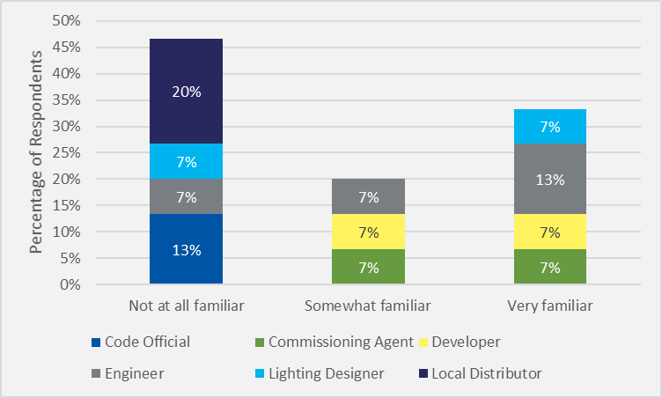
Source: How familiar are you with the Energy Conscious Blueprint program? (n=15)

Of the respondents that were at least somewhat familiar with the program, 88% said that ECB projects installed higher-efficiency equipment than non-ECB projects. Figure 3 shows the effectiveness of the ECB program at increasing efficient measure installation.
Figure 3. ECB Increased Efficiency Effectiveness
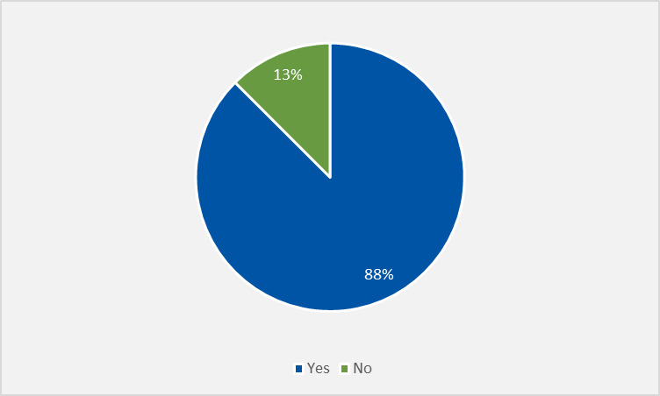
Source: From your experience, have you noticed if projects that participate in the ECB tend to install more energy efficient measures than those that do not participate in the ECB? (n=8)

Installed Efficiency Levels
We asked respondents to estimate the average installed efficiency level of lighting, HVAC, and boiler equipment types. Respondents more reliably provided estimates for lighting and new construction boilers, which were most likely to be installed above code. Most respondents were unable to provide the installed efficiency levels for chillers, gas radiant heaters, and end-of-life (EOL) replacement gas fired boilers. One respondent very familiar with interior lighting mentioned that half of the “25% above code” projects are 50% above code or better, healthcare/research facility projects are 25 to 30% above code, university/school projects are 30% to 50% above code, and corporate office projects are 50% above code. Another respondent mentioned that “water-source heat pumps are mostly in residential, although New York has some commercial applications.” Figure 4 shows the combined responses of installed efficiency levels by equipment type.
Figure 4. Installed Efficiency Level by Equipment Type
Source: Estimate the average installed efficiency level of lighting,
HVAC, and boiler equipment types. (n=15)

Equipment Features
We asked respondents if they plan, install, or sell certain equipment features, such as variable frequency drives (VFD), dual enthalpy controls, and ventilation CO₂ controls. More than half of respondents (53%) said air-handling VFD, pump VFD, and ventilation CO₂ controls were planned when not otherwise required by code. Conversely, primary-hot water VFD were not often planned. In the verbatim section, 43% of respondents mentioned “variable-primary” pumps as more common than “primary-secondary” systems. Figure 5 shows the combined responses of installed equipment features.
Figure 5. Installed Equipment Features

Source: In situations where not required by code in 2017 and 2018, did you typically plan for…? (n=15)

Building Types
We asked respondents about specific building types and their relation to energy-efficient installation measures. Schools, offices, universities, and labs were mentioned as more likely to have efficient measures. Some verbatim answers mentioned that these buildings have high-transiency occupancy and large lighting and equipment loads. Transiency occupancy refers to buildings or structures intended to be occupied at different times for different purposes, with relatively high levels of turnover. One response mentioned “courthouses, schools, universities, places with high-transiency occupancy.” Another mentioned “new design thinking has resulted in less obtrusive equipment. Private-sector buildings have higher efficiency than public-sector (municipal, state, county, federal) buildings. Lowest-bid procurement policies result in lower efficiency.” The building keywords were extracted from the verbatim responses and combined into Figure 6.
Figure 6. Building Types for Efficient Measures
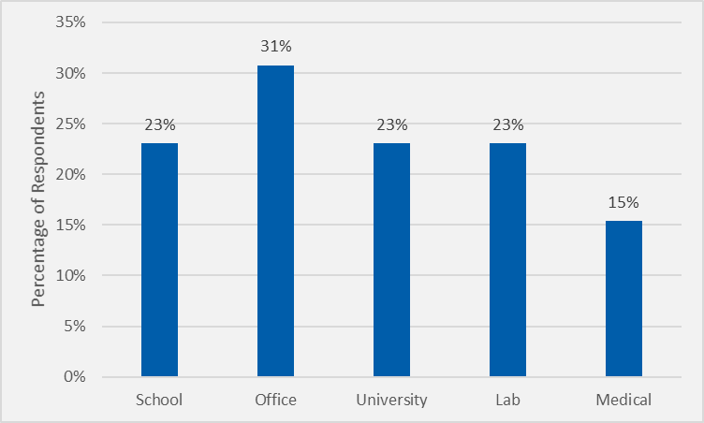
Source: Are there specific building types for which efficient measures are more likely? If so, what kind of buildings, and what type of equipment is typically “above” the minimum code or more efficient relative to other building types? (n=13)

Factors for Exceeding Code
Respondents were asked to list several factors that influence the extent to which new construction projects exceed building and energy codes and standards and then rank the factors from 1 (least influential) to 10 (most influential). Some common factors that were influential were energy code requirements, energy cost savings, owner preference, and marketing of energy efficient buildings.
Some verbatim answers elaborated on the context for the responses. One of these responses mentioned that for projects like schools and hospitals, individual financing entities usually want higher-efficiency measures while a board-run project will want a secure return on investment. Another response mentioned that ownership and responsibility for energy costs is an important challenge for office buildings and other shared buildings. More respondents think that the owner’s preference is more important than the cost of the upgrades, although the cost comes in as the second most important factor. Cadmus analyzed the average importance rating for each factor, shown in Figure 7.
Figure 7. Average Importance of Factors for Exceeding Code

Source: What factors influence the extent to which new construction projects exceed
building energy codes and standards? (n=15)

Compliance Strategies
Respondents were asked about their experience with chillers and, if applicable, what chiller types were most common. Most respondents who were familiar with chillers responded that centrifugal chillers were more common. They also mentioned that chillers with VFD (Path B) compliance were more common than non-VFD (Path A) compliance. Figure 8 shows commonly installed chiller types and their compliance distribution.
For respondents who were familiar with overall prescriptive and performance compliance strategies, there was not a consensus on what was more common, although performance was slightly more common. Figure 9 shows the distribution of compliance strategies.
Figure 8. Installed Chiller Types
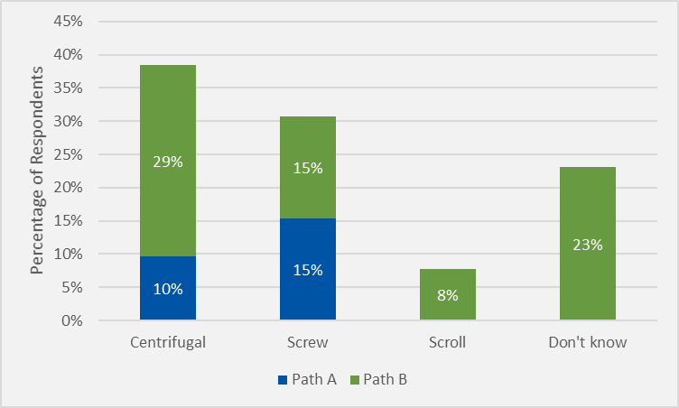
Source: Which chiller types were the most common? Which chiller compliance paths were the most common? (n=9)
Figure 9. Building Compliance Strategies

Source: What compliance strategy is most commonly used? (n=12)

Challenges
Respondents were asked about any challenges they face when new energy codes take effect. Comprehension and educating others of the new code were mentioned as the main challenges to remain competitive in a market that quickly adheres to code changes. One respondent mentioned “getting employers, builders, and buyers to understand that it’s harder to meet higher energy codes.” Another mentioned “learning new rules, educating architects and builders, overlaying new rules with above-code programs.” Decommissioning old equipment was also mentioned as a challenge. The most common keywords from these responses are outlined in Figure 10.
Figure 10. Challenges for New Energy Codes
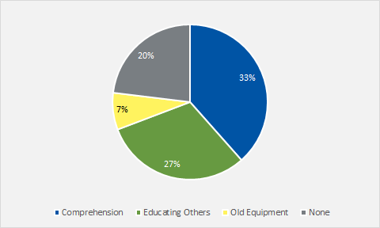
Source: What challenges, if any, does your organization face when new energy codes take effect? (n=15)

State Comparison
Respondents with work experience in states other than Connecticut were asked to compare the efficiency of Connecticut to those other states. Seventy-eight percent of respondents said that Massachusetts was at least as efficient or more efficient than Connecticut, and an equal percentage said New York was less efficient than Connecticut. One respondent mentioned utility programs as more important for installing above-code equipment than state regulations. Another respondent mentioned that electricity rates contribute to the frequency of above-code equipment installations. Figure 11 compares efficiency in Connecticut with various states.
Figure11. State Efficiency Comparison
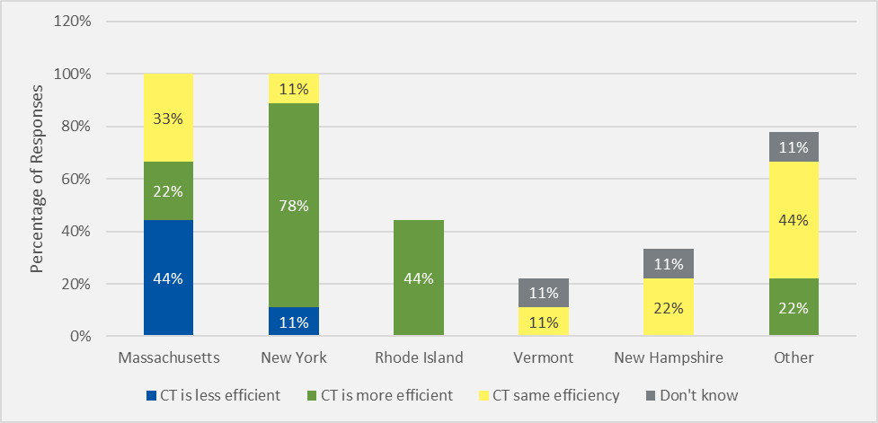
Source: Overall, when thinking about your new construction work in Connecticut compared to your work in other states how would you say the standard efficiency levels (for new construction designs and equipment) in Connecticut compares to that in other states? (n=15)

Additional Comments
At the conclusion of the interview, respondents were asked for any additional comments that were not covered earlier in the interview. One respondent said that it is more difficult to convince owners of the value-add of efficiency measures that are out of sight to customers. These include projects that are not public-facing and do not have an added benefit of marketing appeal. Another respondent said that educating contractors in new technologies is key to ensuring that work is properly done. Installed efficiency levels have improved through technology but more tech-savvy contractors are required for proper implementation. Another said that “One of the roadblocks to efficient measures is electric and gas pricing in Connecticut. Gas should be more expensive and electricity cheaper to incentivize electrification. All-electric buildings should be rewarded with cheaper electricity rates.” This sentiment indicates that other policy options can be pursued to encourage the adoption of efficient electric and gas measures.

Overall Conclusions and Recommendations
Objective #1: Investigate baselines for lighting, lighting power density, HVAC equipment efficiency, boiler equipment efficiency, and replace-upon-failure projects.

Conclusions
The resources we reviewed indicated that raising the baselines for certain lighting, HVAC, and boiler equipment is justified. Market actors indicated that interior and exterior lighting, unitary air conditioner and heat pumps, water and ground-source heat pumps, gas-fired boilers (new construction), gas-fired furnaces, and gas-fired domestic hot water heaters were already being installed at least 10% above code, and as high as 25% above code for lighting as shown in Figure 2.

Recommendation
Consider conducting a baseline code compliance study to determine actual baseline efficiency levels for each equipment type.
Objective #2: Understand market actor perspectives and practices on new construction baselines.

Conclusions
The variety of market actor experiences provided a diverse overview of the state of new construction in Connecticut and neighboring states. Many of the respondents reported that office buildings, schools, labs, universities, and medical facilities were more likely to install higher-efficient measures due to their more ambitious goals and high-transiency occupancy. The biggest challenge the market actors faced for complying with new energy codes was understanding them and educating staff.
Objective #3: Understand factors that influence new construction market in Connecticut.

Conclusions
Market actors indicated that owner preference is the most influential driver of efficient measure installation in projects like schools and hospitals, with individual owners being more inclined to install higher-efficient measures than facilities where decisions are made through a group of stakeholders such as a board of trustees. As owners are the primary project decision-makers, information and marketing messages about efficient equipment benefits need to resonate with building owners as the key audience. Equipment/project cost and resulting building marketing appeal are rated as the second highest factors but are inherently linked to the preference of the owner.

Recommendation
Consider targeting building owners for marketing approaches that recognize their concerns and interests associated with installing above-code measures.
Objective #4: Determine influences on the ECB program and implications for measuring energy-saving impacts.

Conclusions
Over half of the respondents were at least somewhat familiar with the ECB program. Of these respondents, a large majority said that ECB projects installed more efficient measures than projects that did not participate in the program. In addition to encouraging the installation of more efficient measures, the program helps design and engineering teams communicate with the owner. Raising minimum baselines for equipment that qualify for the ECB program will result in lower energy savings for existing equipment replacements but will encourage the adoption of higher-efficient equipment into the program. As manufacturers raise efficiencies to meet the demand of energy codes, utility incentives can further drive efficiency levels from baseline adjustments by raising the minimum efficiency criteria.

Recommendation
Consider encouraging utilities to raise minimum efficiency program eligibility criteria to account for a more efficient baseline.

Energize Connecticut. 2016. Connecticut Program Savings Document. 12th Edition for 2017 Program Year. https://www.puc.nh.gov/EESE%20Board/EERS_WG/ct_trm.pdf
Electric demand savings (winter and summer) are defined as the average peak reduction for a measure during the ISO-NE definition for a Seasonal Peak Demand Resource – when the real-time system hourly load is equal or greater than 90% of the most recent “50/50” season peak load forecast for the applicable summer or winter season. The summer season is defined as the non-holiday weekdays during the months of June, July, and August. The winter season is defined as the non-holiday weekdays during December and January.
Retrospective realization rates indicate the realized energy savings when compared to the reported energy savings for the evaluated time period.
Prospective realization rates indicate the predicted realized energy savings when compared to the reported energy savings for a future time period.
The ISO-NE requirements specify electric demand savings as the average peak demand reduction for a Seasonal Peak Demand Resource—when the real-time system’s hourly load is equal or greater than 90% of the most recent “50/50” season peak load forecast for the applicable summer or winter season. The summer season is defined as the non-holiday weekdays during the months of June, July, and August. The winter season is defined as the non-holiday weekdays during December and January. For weather-dependent measures, the Team installed power meters on incentivized measures during each applicable season to measure and calculate peak demand savings. Specific requirements for the forward capacity market are defined in the ISO New England Manual for the Forward Capacity Market (FCM) Manual M-20. https://www.iso-ne.com/static-assets/documents/2018/10/manual_20_forward_capacity_market_rev25_20181004.pdf
Massachusetts Electric and Gas Energy Efficiency Program Administrators. 2015. Massachusetts Technical Reference Manual for Estimating Savings from Energy Efficiency Measures. http://ma-eeac.org/wordpress/wp-content/uploads/2016-2018-Plan-1.pdf
New York Standard Approach for Estimating Energy Savings from Energy Efficiency Programs – Residential, Multi-Family, and Commercial/Industrial Measures Version 6. http://www3.dps.ny.gov/W/PSCWeb.nsf/96f0fec0b45a3c6485257688006a701a/72c23decff52920a85257f1100671bdd/$FILE/TRM%20Version%206%20-%20January%202019.pdf
Northeast Energy Efficiency Partnership. 2018. Mid-Atlantic Technical Reference Manual Version 8. https://neep.org/sites/default/files/resources/Mid_Atlantic_TRM_V8_0.pdf
Public Service Commission of Wisconsin. 2017. Wisconsin Focus on Energy 2017 Technical Reference Manual. https://focusonenergy.com/sites/default/files/Focus%20on%20Energy%20TRM%20-%20PY2017_1%28Archive%29.pdf
Berkeley Lab WINDOW is a publicly available computer program for calculating total window thermal performance indices. https://windows.lbl.gov/software/window
All of the studies mentioned in this memo are fully cited in the companion document, Eventual Title of Final Excel document.
The “Other” category includes states such as PA, NJ, MD, VA, and others around the U.S.

