MEMORANDUM
To: Lisa Skumatz, Bob Wirtshafter, and Ralph Prahl, Connecticut Energy Efficiency Board Evaluation Contractors, Evaluation Committee
From: NMR Group and Cadeo (Evaluation Team)
Date: July 1, 2022
Re: Air Sealing and Insulation Gross Realization Rate Recommendation for PSD

This memo provides Eversource and UI (the companies) with insights from the ongoing Home Energy Solutions (HES) and Home Energy Solutions Income Eligible (HES-IE) evaluation (R1983) to inform impending updates to the Connecticut Program Savings Document (PSD).
The high-level results of the evaluation team’s natural gas billing analysis of air sealing and insulation measures delivered through HES and HES-IE indicate that the study’s final evaluated savings are considerably lower than both the previous impact evaluation (R1603) and the companies reported savings (provided in the program tracking data).
The evaluation team recommends that the companies use the high-level results in this memo to make proactive updates to the PSD in advance of the final R1983 report. Making updates now will limit the level of disparity between the PSD and evaluation at the conclusion of R1983. Updating the PSD now will also ensure the prospective application of the PSD more accurately represents the overall energy consumption and air sealing and insulation savings that the evaluation team has observed for more recent HES and HES-IE participant cohorts.
The evaluation team recommends the companies apply a placeholder gross realization rate of at least 50% (relative to the reported savings for 2019 participants) for air sealing and insulation for both programs pending the completion of R1983.
This memo focuses exclusively on natural gas air sealing and insulation in recognition of the key role these measures play for residential retrofit programs. The evaluation team will provide evaluated savings for the complete set of HES & HES-IE measures, including air sealing and insulation, at the conclusion of R1983 in Q3 2022.

High Level Savings Results
As with the previous HES and HES-IE evaluation, the evaluation team is using billing analysis to estimate the natural gas savings associated with air sealing and insulation. Described in the R1983 work plan, billing analysis is industry best practice when model results are sufficiently precise (i.e., at least 20% precision threshold at 90% confidence). This is because billing analysis implicitly accounts for myriad factors (e.g., preconditions, installation quality, and customer behavioral change) that impact savings and because the approach uses a control group (made up of future program participants) to account for nonprogrammatic factors. See Section 5 for a brief overview of the team’s billing analysis methodology.
The evaluation team’s estimated savings for HES and HES-IE participants who only received air sealing during their assessment (referred to as “Core” participants) separately from those who, following their assessment, installed one or more types of insulation (“Rebated” participants).
Table 1 provides a range of the average per-participant savings we observed in our initial modeling efforts for both programs and participant types (i.e., Core and Rebated). The evaluation team’s final reported savings could fall outside the identified ranges, but this is unlikely. As presented in the next section, these savings ranges are much lower than the previous evaluation and reported savings in the tracking data, which is the basis for our team’s early recommendation that the PAs update the PSD now.
Table 1: Preliminary Statewide Savings Ranges for 2019 Participants (CCF/year)
Program | Core (Air Sealing Only) | Rebated (Air Sealing & Insulation)
HES | 10-20 | 40-90
HES-IE | 10-20 | 110-140

Savings Comparison
In this section, the evaluation team provides three comparisons for the values in Table 1:
- The previous HES and HES-IE impact evaluation (R1603)
- Reported savings in the provided program tracking data
- Evaluation results of similar programs in neighboring states
The evaluation team has also provided additional information regarding the possible cause of the decline in average savings per participant (relative to these points of comparison) in Section 3.

Comparison to previous evaluation
R1603, completed in 2019, evaluated savings for the 2015 and 2016 HES and HES-IE program years. For HES, R1603 found an average statewide evaluated savings of 64 CCF for air sealing and 154 CCF for insulation. For HES-IE, the comparable evaluated values were 59 and 158 CCFs.
The evaluated R1603 savings for air sealing and insulation are mutually exclusive and additive. In other words, HES participants who had their home air sealed during the assessment and then installed insulation saved an estimated 218 therms on average. The combined savings from R1603 (Table 2) is comparable to the “Rebated” savings ranges in Table 1.
Table 2: Comparison #1: 1603 Evaluated Savings (CCF/year)
 | Core (Air Sealing Only) |  | Rebated (Air Sealing & Insulation)
 | R1983  Savings Ranges  (2019 Participants) | R1603  Evaluated Savings  (2014 & 2015 Participants) | R1983  Savings Ranges  (2019 Participants) | R1603  Evaluated Savings*  (2014 & 2015 Participants)
HES | 10-20 | 64 | 40-90 | 218
HES-IE | 10-20 | 59 | 110-140 | 217
*Combination of evaluated air sealing and insulation savings, which were assessed separately as part of R1603.

Comparison to reported savings
The HES and HES-IE program tracked data provided Eversource and UI included reported savings by measure and participant. Table 3 summarizes average reported savings for Core and Rebated participants.
The evaluation team’s savings ranges above do not facilitate an exact gross savings realization rate calculation. However, a simple comparison of those ranges with the average reported savings from the program tracking data underscores the significant disparity and suggests a low gross realization rate will result from R1983.
Table 3: Comparison #2: Program Tracking Data – Average Reported Savings (CCF/year) for 2019 Participants
 | Core (Air Sealing Only) |  | Rebated (Air Sealing & Insulation)
 | R1983  Savings Ranges | Program  Tracking Data | R1983  Savings Ranges | Program  Tracking Data *
HES | 10-20 | 109 | 40-90 | 264
HES-IE | 10-20 | 130 | 110-140 | 360
*Combination of reported air sealing and insulation savings, which the evaluation team calculated (using the PSD algorithm) and reported separately in HES and HES-IE program tracking data.

Comparison to similar evaluations in nearby states
The evaluation team has completed several evaluations of similar market-rate and income-eligible programs in Rhode Island and Massachusetts. Table 4 summarizes the findings of these studies, which all yield lower savings than R1603 values and 2019 reported savings, but closer to the savings ranges for R1983 in Table 1. It is important to consider the participation cohort (i.e., the year participants installed measures) when comparing across studies. As discussed in the next section, the evaluation team has seen a decline in preprogram consumption for participating HES customers, which reduces the opportunity for program savings.
Table 4: Comparison #3: Evaluations of Similar Programs –
Average Reported Savings (therms/year)
Program (Completion Year) | State | Participant Cohort | Air Sealing & Insulation**
EnergyWise Single Family | Rhode Island | 2017–2018 | 96
Income Eligible Single Family | Rhode Island | 2015–2016 | 124
Home Energy Services* | Massachusetts | 2015–2016 | 130
*Now the Residential Coordinated Delivery program
**The billing analysis results from all three studies produced a combined air sealing and insulation savings estimate, referred to as “weatherization savings.”

Preprogram Consumption Trends
To create a control group for the billing analysis, the evaluation team assessed preprogram consumption for five years of HES and HES-IE cohorts (2017–2020). Figure 1 provides the average consumption in a given calendar year (indicated at the bottom of the figure) for a given HES participant cohort (indicated at the top of the figure). The arrows compare the pre-program consumption of subsequent cohorts as they entered HES.
What is most notable about Figure 1 is the decline in pre-program consumption for each subsequent cohort. For example, the 2018 participant cohort consumed, on average, approximately 1,000 therms in 2017. When we look at the 2019 cohort for the same year (2017), we see the average consumption is closer to 800 therms – a 20% decrease. The trend continues for the 2020 cohort, which averaged even less consumption in 2017 (less than 700 therms).
The clear year-over-year decline in average preprogram natural gas energy consumption has a direct impact on program savings: lower preprogram consumption means less opportunity for post-program energy savings. The average decline in consumption could be the result of numerous, concurrent factors:
- Customers with least efficient homes and highest bills have already participated (i.e., there less “low hanging fruit”)
- Increasing saturation of condensing natural gas furnaces
- Increasing saturation of smart thermostats
- Repeat program participation
Momentarily setting aside the issue of causation, as well as the complicated nuances of billing analysis regression models, the simple pattern of declining total consumption in Figure 1 intuitively suggests much lower average savings over time. Specifically, the average savings for the 2020 HES cohorts would be 30 to 40% lower than the 2018 cohort based on total pre-program usage alone. If the trend extends backwards (to the 2015 and 2016 cohorts participants included in R1603), the large disparity between the R1603 and R1983 results is expected. Further, if the trend continues forward to future HES participants, for which the updated PSD would be relevant, the companies should expect steadily lower savings over time – although perhaps at a decelerated rate.
Figure 1. Annual Natural Gas Consumption by HES Participant Cohort
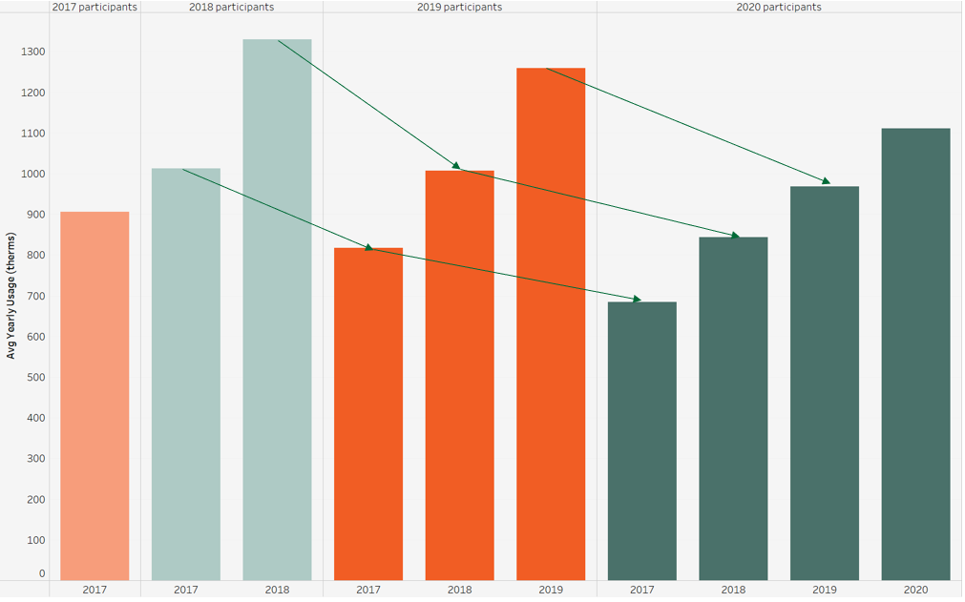

Guidance for PSD Updates
The range of savings associated with the evaluation team’s analysis clearly indicates that R1983 will yield lower-than-anticipated savings (relative to the previous evaluation and reported savings) for HES and HES-IE participants who heat with natural gas and who have air sealed and/or insulated their homes. The savings estimated as part of our recent evaluations of similar programs in other states, as well as the year-over-year decline in preprogram consumption, suggest the relatively lower savings have both a theoretical basis and empirical support.
The evaluation team recommends that the companies use the findings in this memo to make interim and proactive updates to the PSD in advance of the final R1983 report. Making updates now will limit the ultimate disparity between the PSD and evaluation at the conclusion of R1983 and better reflect the overall energy consumption of more recent and future HES and HES-IE participant cohorts.
The evaluation team recommends the companies apply a placeholder gross realization rate of at least 50% (relative to the reported savings for 2019 participants) for air sealing and insulation for both programs pending the completion of R1983.
These high-level results are part of the full set of gross savings all HES and HES-IE measures that the evaluation team will provide in the full R1983, due in late summer 2022. As part of that process, we will work closely with the Energy Efficiency Board and companies to communicate findings and offer formal, actionable, and accurate recommendations for PSD updates.

Appendix A: Billing Analysis Methodology Overview
The bullets below provide brief overview of the billing analysis methodology the evaluation team used to generate the initial, high-level results presented in this memo approach for the R1983 billing analysis:
- Combined customer-specific billing records with weather data and measure installation data to understand each customer’s energy consumption drivers.
- Conducted a structured screening process to ensure that the model uses only those customers with sufficient billing data and without spurious billing records.
- Matched each treatment group customer to a control group (consisting of future HES and HES-IE participants) customer with a similar monthly preprogram energy consumption pattern.
- Disaggregated billing data into specific end uses (heating, water heating, and baseload) to inform concurrent engineering algorithms and building simulation activities.
- Specified and refined a monthly post-program regression (PPR) model.
- Estimated separate participant-specific “difference of differences” savings (using matched control) to corroborate pooled PPR model results and provide greater insight into differences in savings by contractor.
- Generated results, which were weather-normalized (where applicable) using 30-year historical weather data from National Oceanic and Atmospheric Administration weather stations across Connecticut; each participant was mapped to the closest weather station.

West Hill Energy and Computing, CT Home Energy Services-Income Eligible and Home Energy Solutions Impact Evaluation: Program Years 2015-2016, prepared for the CT EEB Evaluation Team, October 2019, https://acrobat.adobe.com/link/review?uri=urn%3Aaaid%3Ascds%3AUS%3A6ad1a31e-b53f-43aa-81bc-d5646e8c7d45#pageNum=1.
The evaluation team analyzed of HES and HES-IE participants who installed air sealing and/or insulation in 2019 using a control group comprising “future” participants (that participated in 2020) with similar preprogram consumption.
For simplicity, the evaluation team uses “rebated” for both HES and HES-IE participants. The term is most appropriate for HES participants, who paid a copay toward their insulation, while HES-IE participated received insulation at no cost.
Combines Eversource and UI participants in both programs to increase sample sizes and statistical significance. The evaluation team is also assessing the viability of reporting saving by company.
Table ES-6.
Table ES-7.
The evaluation team will confirm the participant-specific reported savings for the relevant customers and measures with each company’s program staff prior to finalizing the R1983 gross realization rates
We will ensure the recommendations account for temporal differences (e.g., the method used to report savings for the 2019 cohort of participants has changed as part of subsequent PSD updates).
The evaluation team is also using two complementary methodologies (engineering algorithms and building simulation) to evaluate other HES and HES-IE measures.

