Final Evaluation Report for:  
**X2001: Connecticut Measure Life/EUL Update Study-Residential & Commercial**

Connecticut Energy Efficiency Board

10 Franklin Square

New Britain, CT 06051

**Prepared by:**

Jake Millette, Michaels Energy

Ted Helvoigt, Evergreen Economics

4/20/2023

In partnership with:

Contents

Abstract 1

1 Executive Summary 3

1.1 Key Findings 3

1.2 Additional Findings 6

2 Introduction 7

2.1 Study Objectives 7

2.2 Methodology 7

2.2.1 Estimating Lifetime 7

2.2.2 Data Gathered 8

3 Residential Results 10

3.1 Effective Useful Life (EUL) 10

3.1.1 Estimated EULs 10

3.2 Comparison to the Program Savings Document 13

3.3 Remaining Useful Life (RUL) 14

3.3.1 RUL Results 14

3.3.2 Using the RULs / Dual Baseline 16

3.4 Repairs 17

4 Commercial HVAC Results 19

4.1 Effective Useful Life 19

4.2 Repairs 20

5 Comparison of EUL Values 21

6 Conclusions and Recommendations 25

7 References 28

Appendix A | Detailed Methodology 29

A.1.1 Measure Selection 29

A.1.1.1 Residential Measures 29

A.1.1.2 Commercial & Industrial Measures 30

A.1.2 Sampling Approach 31

A.1.3 Residential Survey Fielding 32

A.1.3.1 EUL Survey 32

A.1.3.2 Heat Pump Survey 32

A.1.3.3 Response Rate 32

A.1.4 Commercial HVAC Survey Fielding 33

A.1.4.1 Commercial HVAC Survey 33

A.1.4.2 Response Rate 34

A.1.5 Residential Survey Verification 35

A.1.5.1 Equipment Photographs 35

A.1.5.2 Verification Interviews 36

A.1.6 Analysis 37

Appendix B | Remaining Useful Life Table 42

# Abstract

The X2001 Measure Life/EUL Update Study involves the update of the effective useful life (EUL) and remaining useful life (RUL) values for key measures offered through Connecticut’s energy efficiency programs. The objectives of this study were to identify high priority EULs to update, apply an efficient, quick, and cost-effective approach, and to update the EUL and RUL values for those key measures.

This report presents the results for six prioritized residential measures and one commercial measure. Using a survey-based methodology, the Evaluation Team gathered information about survival of these measures installed through Connecticut’s energy efficiency programs from 2011-2019. In line with industry standard practice, the team used a parametric survival analysis approach to estimate the “survival” function of each equipment type to develop estimates of its effective useful life (EUL) and remaining useful life (RUL).

Based on the primary research conducted in this study, the Evaluation Team made the following recommendations:

| **Recommendation Category** | **Recommendation** |
| --- | --- |
| Effective Useful Life (EUL) | 1. Update the EUL values in the Program Savings Document (PSD) for the measure types with adequate precision levels. Use recommended values of 20 years for air source heat pumps, 17 years for ductless heat pumps, 15 years for heat pump water heaters, and 25 years for central air conditioners. We recommend continuing to use the values in the PSD for natural gas furnaces and insulation, as the estimates for these measures did not meet the study’s precision threshold. Also continue to use the PSD value of 15 years for commercial high-efficiency unitary equipment due to the lack of equipment failures in the survey data preventing the Evaluation Team from developing an EUL estimate 2. Conduct additional research on natural gas furnaces and insulation to develop EUL estimates with better precision that can be used to update the PSD in the future. |
| Remaining Useful Life (RUL) | 1. Where practical, programs should document the age of the replaced equipment at a site-specific level and use the RUL values in Appendix B for air source heat pumps, ductless heat pumps, heat pump water heaters, and central air conditioners when calculating retirement savings. 2. Where the age of the existing equipment cannot be determined, programs should use the recommended values in this study. 3. For natural gas furnaces and other measures without an RUL specified in the PSD, continue to use the industry standard practice of 1/3 of the EUL. |
| EUL Study Methodology | 1. Consider conducting future EUL research similar to this for measures that meet the criteria of high levels of participation, large contributions to Connecticut’s energy efficiency portfolio, and are able to be easily observed and self-reported by participants. 2. Conduct future research on the measures included in this study, as new cohorts of participants can be added to this data to bolster these results. 3. Consider using the combination of respondent-provided photographs and follow-up interviews for other evaluations and studies where additional verification may be desired but site visits are too costly. 4. Consider a mixed mode approach, using both mailed and emailed invitations, for commercial recruitment. Mailed invitations may result in a lower response rate than emailed invitations, but are recommended because the person with the email address or the business may no longer be at the address where the equipment was installed. |

# Executive Summary

This report presents the results of the primary research to update the effective useful life (EUL) and remaining useful life (RUL) values for key residential and commercial measures offered through Connecticut’s energy efficiency programs. The Connecticut Energy Efficiency Board (EEB) Evaluation Administrators (EA) commissioned the team of Michaels Energy and Evergreen Economics (the Evaluation Team) to conduct this research. The objectives of this study were to identify high priority EULs to update, apply an efficient, quick, and cost-effective approach, and to update the EUL and RUL values for those measures.

This report presents the results for six selected residential measures and one commercial measure:

* Air Source Heat Pump (ASHP)
* Ductless Heat Pump (DHP)
* Heat Pump Water Heater (HPWH)
* Central Air Conditioner
* Natural Gas Furnace
* Attic/Wall Insulation
* High-efficiency Unitary Equipment (Commercial HVAC)

## Key Findings

Using a survey-based methodology, the Evaluation Team gathered information about survival of six residential measures and one commercial measure installed through Connecticut’s energy efficiency programs from 2011-2019. In line with very long-standing industry standard practice, we used a parametric survival analysis approach to estimate the “survival” function of each equipment type to develop estimates of its effective useful life (EUL) and remaining useful life (RUL).

* **Effective Useful Life (EUL)** – the median number of years between installation of a piece of equipment and its failure or removal
* **Remaining Useful Life (RUL)** – the difference between the current age of operating equipment and its expected age at failure or removal

Table 3 shows the estimated EULs for each measure developed through this research as well as the current value in the Program Savings Document (PSD). The Evaluation Team recommends updating the PSD for four of the residential measures but keeping the current PSD value for natural gas furnaces and insulation due to the lack of statistical significance of the results for those measures resulting from limited sample sizes. The Evaluation Team was also unable to estimate the EUL for commercial HVAC equipment due to a low response rate and lack of equipment reported as failed or removed.

Table : Estimated EULs (in Years) and PSD Recommendations

| **Measure** | **Estimated EUL (years)** | **2021 PSD Value** | **Recommendation** |
| --- | --- | --- | --- |
| Air Source Heat Pump | 20 | 18 | Update PSD to 20 years |
| Ductless Heat Pump | 17 | 18 | Update PSD to 17 years |
| Heat Pump Water Heater | 15 | 13 | Update PSD to 15 years |
| Central Air Conditioner | 25 | 18 | Update PSD to 25 years |
| Gas Furnace | 28 | 20 | Continue using PSD value of 20 years |
| Insulation | 38 | 25 | Continue using PSD value of 25 years |
| Commercial HVAC | n/a | 15 | Continue using PSD value of 15 years |

Using the estimated survival functions, the Evaluation Team also developed estimates of the RUL of each equipment type, which represents the length of time we would expect equipment to continue to operate. RUL values are important for measures with dual baselines, like early replacement measures. To calculate lifetime savings of a measure with a dual baseline, we need both as estimate of the expected remaining life of the existing equipment to calculate the retirement savings and the EUL to calculate lost opportunity savings.

* **Recommended / Preferred Approach for Early Removal**: Where practical, programs should document the age of the replaced equipment as a site-specific level and use the RUL values from Appendix B when calculating retirement savings. Figure 1 below shows the remaining useful life curves for four residential measures under study.[1]
* **Back-up Approach for Early Removal RULs**: Where the age of the existing equipment cannot be determined, programs should use the recommended values from the table below, which are based on the EUL estimates from this study. For natural gas furnaces and other measures without an RUL specified in the PSD, we recommend continuing to use the rule of thumb of 1/3 of the EUL.

Figure 1. Remaining Useful Life Curves for Select Residential Measures

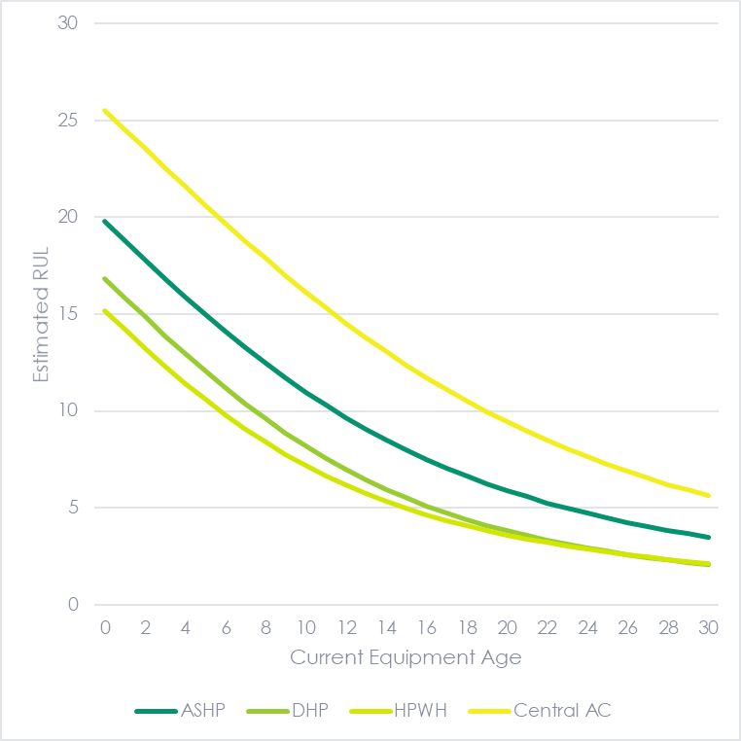

Table : Back-up Approach for Early-Removal RUL (if Equipment Age is Unknown)

|  |  |  |
| --- | --- | --- |
|  | **Recommended EUL** | **Recommended RUL if Unknown Age** |
| Air Source Heat Pump | 20 | 6 |
| Ductless Heat Pump | 17 | 5 |
| Heat Pump Water Heater | 15 | 5 |
| Central Air Conditioner | 25 | 7 |
| Gas Furnace | 20 | 7* |
| Insulation | 25 | N/A |

*Denotes 1/3 of Existing PSD EUL

## Additional Findings

* Many of the reviewed EUL values in the PSD and other TRMs are based on dated literature reviews of even older studies. Some sources also apply the same EUL value to several equipment types that may have different lifetimes (e.g., a single EUL value for all heating and cooling equipment).
* The EUL point estimates resulting from this study appear reasonable and tend to be similar to those in the PSD and used in other jurisdictions. However, unlike other studies, these estimates are based on new primary research in Connecticut and are therefore very applicable.
* The EUL analysis in this study also allowed the Evaluation Team to develop RUL curves for each equipment type, which were not generally available.
* The study’s survey-based methodology resulted in much lower fielding costs than if we conducted in-person site visits to verify the operation and age of equipment of the same number of respondents. Comparing the responses to two types of verification approaches (respondent-provided photographs of equipment and follow-up interviews), the study found very little error in the self-reported information, indicating that the information provided by respondents is reasonably accurate *for the measures included in the study*.
* The study’s unusual[2] methodology also resulted in cost savings by analyzing multiple years of installations (2011-2019) instead of multiple studies of single years of installations.
* The response rate for the commercial HVAC survey differed by survey mode. The response rate for mailed invitations was 1.8% while the response rate for emailed invitations was 5.8%.
* Eighteen percent of respondents reported having their residential equipment repaired since it was installed. The shares ranged from 11% for natural gas furnaces to 22% for ASHPs and central air conditioners. Equipment that ultimately failed had a slightly higher repair rate (27%) than equipment that was still operating at the time of the survey (18%). Only 2% of the commercial HVAC equipment had been repaired and 81% indicated that the equipment works well.

# Introduction

## Study Objectives

The primary objectives of this study were to:

* Identify the highest priority EULs to address[3]
* Implement an efficient, quick turn-around, and cost-effective approach and templates[4] to use in future EUL studies in Connecticut
* Update EUL and RUL values for key measures

## Methodology

After prioritizing the measures to investigate, the study focused on estimating the effective useful life (EUL) of ASHPs, DHPs, HPWHs, CACs, and gas furnaces used in residential applications, wall and ceiling insulation installed in residences, and commercial HVAC equipment. Following industry standard practice, we define EUL as the median length of time (in years) that equipment is in operation. The EUL, therefore, represents the length of time in which we would expect half of all installed measures to be still operating and the other half to have been replaced due to equipment failure or for any other reason.[5]

In this study, the term “failure” is used broadly to mean that the equipment stopped working or was replaced for any reason. A non-surviving piece of equipment could have stopped working because of electrical or mechanical failure or could have been replaced because of renovation, storm damage, or preference of the owner.[6]

### Estimating Lifetime

The estimation of the survival of the equipment and associated measure lifetimes derives from similar concepts related in the health field related to life expectancy. The estimates can be derived from two main pieces of information: information from equipment that failed with its age at failure, and the age of equipment that is still functioning.

Statistically, and in line with industry standard practice, this translates to using a parametric survival analysis approach to estimate the “survival” function of each equipment type.[7] The survival function represents the expected distribution of lifetimes of equipment based on a sample of residents who installed the measures through an energy efficiency program operated by UI or Eversource. The data necessary to estimate the survival functions, referred to as time-to-event (TTE) data, consist of only two variables:

1. **The Event**: A binary variable that equals 1 if the event has occurred (i.e., the unit of equipment failed), else 0.
2. **The Time**: Time in years between equipment installation and ***the event.***
   1. *If event = 1 →* ***the time*** *is the difference in years between equipment installation and equipment failure.*
   2. *If event = 0 →* ***the time*** *is the difference in years between equipment installation and when the equipment was checked (2021).*

### Data Gathered

The Evaluation Team surveyed homes with equipment installed through Connecticut utility programs from 2011 to 2019 and businesses with commercial HVAC equipment installed through programs from 2001 to 2019.[8] The survey included questions to determine if the equipment was still installed and operating and, if not, the year in which the equipment was removed and/or failed. Based on the responses to these questions, we created the two TTE variables (the event indicator and the time variable).

For the residential measures, the Evaluation Team utilized a mail push-to-web survey approach because the original program participant may no longer be living at the address in which the energy efficient equipment was installed. Residents of sampled addresses received a letter invitation to complete a short online survey about the equipment. We provided respondents a $25 gift card to Dunkin’ to generate a sufficient response rate. Overall, the Evaluation Team sampled 25,104 residences and received 3,007 responses, resulting in a response rate of 11.0%. For the commercial measures, we used both a mail push-to-web approach as well as an email invitation. Overall, we contacted 910 commercial facilities and received 42 responses, resulting in a response rate of 4.6%.

The study’s survey-based methodology resulted in much lower fielding costs than if we conducted in-person site visits to verify the operation and age of equipment of the same number of respondents. However, relying on self-reported information exposes the study to the risk of respondent error. To mitigate this risk, the Evaluation Team conducted two types of verification to ensure the accuracy of the self-reported data: photographs of installed equipment and follow-up verification interviews. For both verification activities, we found very little error in the self-reported information, indicating that the information provided by respondents is accurate.

A more detailed methodology can be found in Appendix A.

# Residential Results

## Effective Useful Life (EUL)

### Estimated EULs

It is traditional for EUL studies to test several statistical distributions to determine best fit for the lifetime model.[9] After testing multiple distributions, the Evaluation Team used the Weibull parametric survival model to estimate the expected distribution of lifetimes for each of the six residential measures. For each of the measures analyzed, most of the installed units are still installed and operating. For these units, the age at failure is unknown (“censored”) and, while we lack complete information on the lifetime of these units, these records provide vital information that is used by the Weibull model to estimate the survival function.

Figure 2 shows the estimated probability density functions (PDFs) for the six residential measures. This represents the expected share of units that will fail in a given year. Each of these PDFs is defined by its two estimated parameters: λ (shape parameter) and ρ (scale parameter). The shape parameter (also referred to as the slope parameter) represents the failure rate behavior of the equipment type, and the scale parameter represents the spread in the lifetimes of the equipment. While there are differences in the PDFs shown in Figure 2, they are similar in that the estimated shape parameter for each equipment type is greater than 1.0, indicating that the failure rate increases over time. The estimated shape parameter is greatest for the compressor-driven measures (HPWH, DHP, ASHP, and Central AC) and lowest for insulation. Conversely, the scale parameter is greatest for insulation and lowest for HPWH.

Figure : Probability Density Functions for the Six Residential Measures

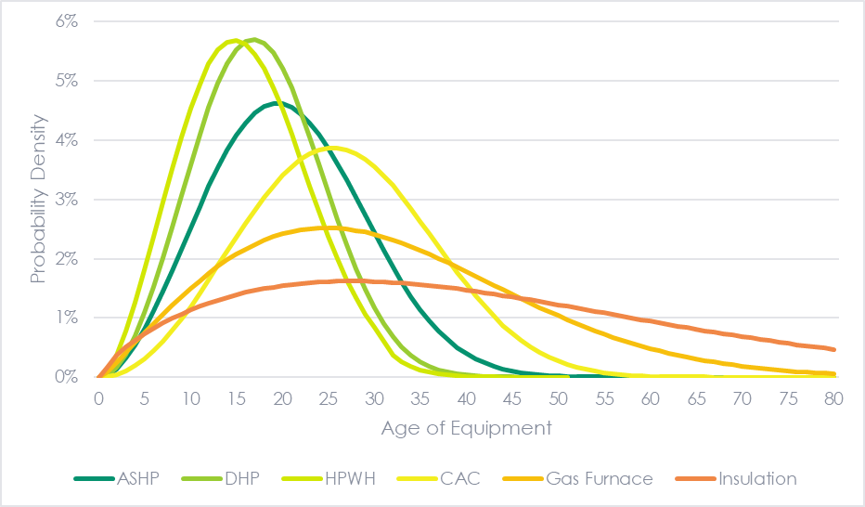

Figure 3 shows the estimated survival functions for the six residential measures, which correspond, respectively, to the PDFs shown in Figure 2. The survival functions provide a clearer view of how different values of the shape parameter (i.e., the slope parameter) describes the rate at which the respective residential measures fail. The EUL of each measure is the age at which the curve intersects with the 50% value of the y-axis (i.e., the median).

Figure : Estimated Survival Functions of the Six Residential Measures

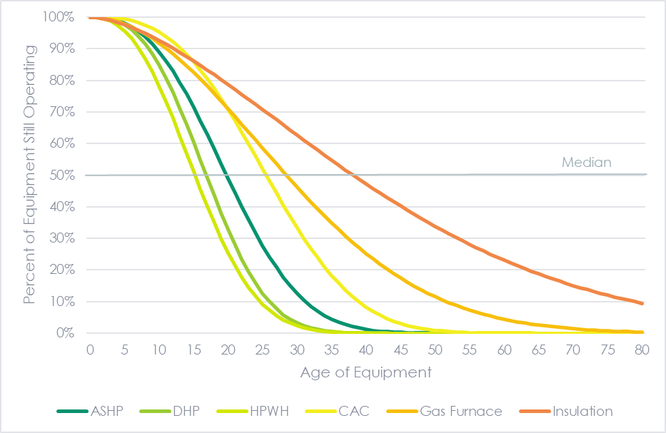

At the one extreme, the residential measure with the highest estimated shape parameter (i.e., steepest slope) is HPWHs, while at the other extreme, insulation has a far gentler slope. For both measures, the shape parameter is greater than 1.0—signifying that the failure rate increases over time—but the rate of increase in the failure rate is greater for HPWHs.

Using the estimated survival model for each residential measure, we estimated the EUL, which is defined as the median expected lifetime in years of that equipment type.[10] Table 3 shows the estimated EUL for each of the six residential measures, along with standard error of the estimate and the lower and upper bounds of the 90% confidence interval for the true EUL. The table also includes the EUL value from the Connecticut PSD for context.

Table : Estimated EULs (in Years) for the Six Residential Measures

| **Installed Measure** | **Study EUL Estimate** | **Relative Precision**  **(90% CI)** | **Lower Bound  (90% CI)** | **Upper Bound  (90% CI)** | **Existing 2021 PSD Value** | **Recommended Value** |
| --- | --- | --- | --- | --- | --- | --- |
| Air Source Heat Pump | 19.8 | 30% | 13.8 | 25.7 | 18 | 20 |
| Ductless Heat Pump | 16.8 | 20% | 13.5 | 20.1 | 18 | 17 |
| Heat Pump Water Heater | 15.2 | 20% | 12.1 | 18.3 | 13 | 15 |
| Central Air Conditioner | 25.5 | 39% | 15.5 | 35.6 | 18 | 25 |
| Gas Furnace | 28.4 | 87% | 3.7 | 53.1 | 20 | 20 |
| Insulation | 38.1 | 89% | 4.2 | 72.0 | 25 | 25 |

The estimated EULs range from a low of 15 years for HPWHs to a high of 38 years for insulation. Overall, the estimated EULs appear reasonable as do the relative differences between EULs (e.g., the EUL for HPWHs is less than the EUL for gas furnaces, which is less than the EUL for insulation). Notably, the EUL values for DHP and HPWH have a relative precision of 20% at the 90% confidence level, while the relative precision for ASHP and CACs is 30% and 39%, respectively. The relative precision is based on the sample size as well as the number of observed failures and the years in which the failures occurred.

Although many small businesses use residential equipment, the Evaluation Team currently does not recommend using the EUL values from this study in commercial applications. Although the equipment lifespans are likely similar in residential and small commercial applications, the results from this study do not account for the removal or replacement of equipment due to business turnover.

Table 4 shows the sample size for each residential measure studied, along with the count of unit failures, the average unit age at failure and the average age of units still installed and operating. While the sample sizes for each measure are large—ranging from 305 to 768 observations—the number of observed failures is far smaller, ranging from just 11 for CACs and 14 for gas furnaces to 37 for DHPs. As shown in Table 3, even with large overall sample sizes, the small number of failures results in a low level of precision for some of measures.

Table : Sample Size and Disposition of Sampled Units by Equipment Type

|  |  |  |  |  |  |
| --- | --- | --- | --- | --- | --- |
| **Installed Measure** | **Sample Size (units)** | **Unit Failures** | **Proportion Failed** | **Average Age at Failure** | **Average Age  of Units Still Operating** |
| Air Source Heat Pump | 305 | 19 | 6.2% | 6.6 | 7.8 |
| Ductless Heat Pump | 710 | 37 | 5.2% | 6.2 | 6.1 |
| Heat Pump Water Heater | 335 | 33 | 9.9% | 6.3 | 6.3 |
| Central Air Conditioner | 749 | 11 | 1.5% | 6.6 | 6.3 |
| Gas Furnace | 575 | 14 | 2.4% | 4.4 | 5.5 |
| Insulation | 768 | 23 | 3.0% | 4.4 | 6.3 |

## Comparison to the Program Savings Document

In comparing the EUL estimates from this study to the EULs reported in the Program Savings Document (PSD), we find that the EULs we estimated with the greatest precision (ASHP, DHPs, and HPWHs) are very similar to the EULs reported in the PSD and that the EULs we estimated with much lower precision (CAC, gas furnaces, and insulation) are substantially higher than the EULs reported in the PSD.

Table : Comparing Estimated EULs From This Study to EULs from PSD

|  |  |  |  |  |  |
| --- | --- | --- | --- | --- | --- |
|  | **Estimated EUL** | **Relative Precision**  **(90% CI)** | **PSD EUL** | **Difference** | **Recommended Value** |
| Air Source Heat Pump | 19.8 | 30% | 18.0 | 1.8 | 20 |
| Ductless Heat Pump | 16.8 | 20% | 18.0 | -1.2 | 17 |
| Heat Pump Water Heater | 15.2 | 20% | 13.0 | 2.2 | 15 |
| Central Air Conditioner | 25.5 | 39% | 18.0 | 7.5 | 25 |
| Gas Furnace | 28.4 | 87% | 20.0 | 8.4 | 20 |
| Insulation | 38.1 | 89% | 25.0 | 13.1 | 25 |

It is important to note that our goal was not to attempt to match the EULs reported in the PSD. The values in the PSD were generally not statistically or empirically derived. The intention of the study was 1) to estimate EULs based on the performance of the measures installed through the programs operated by the respective Connecticut utilities, and 2) provide empirically derived RULs, which are not currently available in the PSD. Nevertheless, given the large number of censored records for all measure types, but especially for gas furnaces, and insulation, the EUL point estimates should be considered with caution as these measures have fairly wide confidence intervals .

The Evaluation Team recommends updating the PSD for four of the measures but keeping the current PSD value for natural gas furnaces and insulation because the results for those measures were not statistically significant. In light of the limited data underlying the current EUL values in the PSD, the Evaluation Team has used the liberal criterion of statistical significance of 40% relative precision at the 90% confidence level.

## Remaining Useful Life (RUL)

Using the estimated survival functions, we also developed estimates of the RUL of each equipment type, which represents the length of time we would expect an installed HVAC unit to continue to operate (or insulation to remain installed). The EUL is an estimate of the expected service life of a piece of equipment at the time of installation, and the RUL is an estimate of the remaining service life of an already-installed piece of equipment. The RUL accounts for the fact that the equipment has already survived up to a specific point. These RUL results are drawn directly from the work estimating EULs.

### RUL Results

Figure 4 shows the remaining useful life curves for four residential measures under study.[11] For example, the RUL for an ASHP that is five years old is 15 years, which is about the same as the EUL for an ASHP. However, the RUL for an ASHP that is 15 years old is eight (additional) years, which is three years more than the EUL for an ASHP.

Figure : Remaining Useful Life Curves for Select Residential Measures



Table 6 provides estimated RUL values for four residential measures under study by the length of time already installed in five-year increments. Appendix B includes a larger table for all years that can be referenced in the PSD.

Table : Estimated RULs by Length of Time Already Installed

|  |  |  |  |  |  |
| --- | --- | --- | --- | --- | --- |
| **Installed Measure** | **Length of Time Measure Has Been Installed** | | | | |
| **5 Years** | **10 Years** | **15 Years** | **20 Years** | **25 Years** |
| Air Source Heat Pump | 15 | 11 | 8 | 6 | 4 |
| Ductless Heat Pump | 12 | 8 | 6 | 4 | 3 |
| Heat Pump Water Heater | 11 | 7 | 5 | 4 | 3 |
| Central Air Conditioner | 21 | 16 | 12 | 9 | 7 |

### Using the RULs / Dual Baseline

For non-retrofit installations, the lifetime savings of the measure are equal to its annual savings multiplied by the EUL. However, for early retirement/replacement measures or retrofit measures that use existing conditions as a baseline, lifetime savings are calculated through a dual baseline approach, for which RULs estimates are a crucial input. Per the PSD and industry best practices, in a dual baseline approach, lifetime savings are calculated using two baseline periods. The first period (the retirement savings) uses the existing equipment as the baseline and lasts until the end of the remaining useful life of the existing equipment. The second period (the lost opportunity savings) assumes a code or industry standard practice as the baseline and continues until the last year of the measure’s EUL. The total lifetime savings is the sum of the savings from these two periods, as illustrated in Figure 5 below.

Figure : Illustration of Retrofit, Retirement, and Lost Opportunity Savings

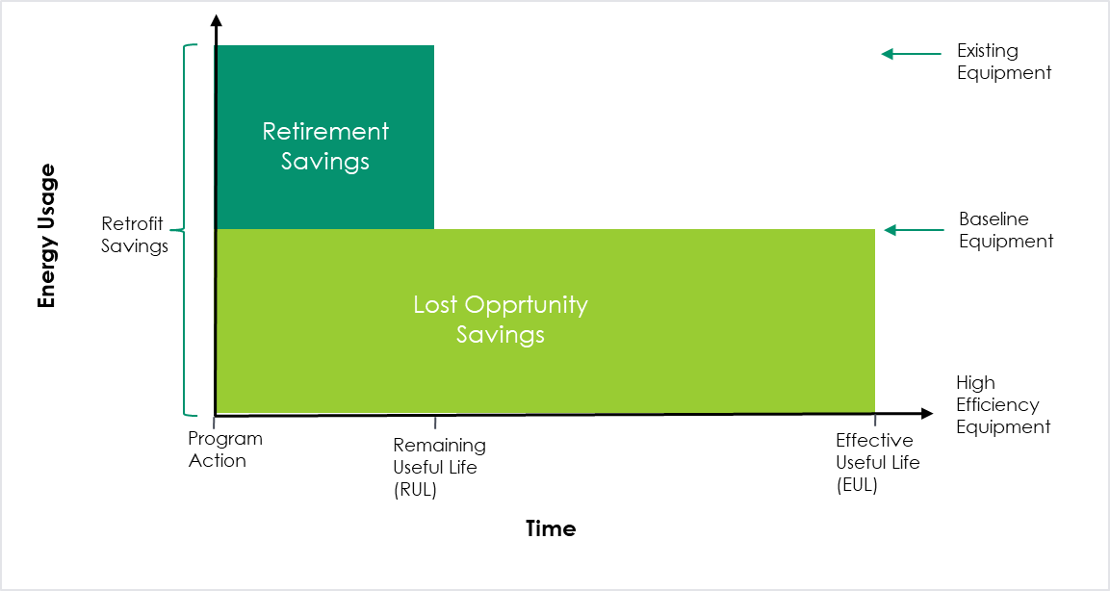

*Adapted from Connecticut’s 2022 Program Savings Document, Chart A4-1*

**Preferred Values for RUL**: Where practical, programs should document the age of the replaced equipment as a site-specific level and use the researched RUL values in Appendix B when calculating retirement savings.

**Fallback Option for RUL Values**: Where the age of the existing equipment cannot be determined, programs should use the recommended values from Table 7 below. With the exception of gas furnaces, these RUL values are based on the EUL estimates from this study.

Table : Back-up Approach for Early-Removal RUL if Equipment Age is Unknown

|  |  |  |
| --- | --- | --- |
|  | **Recommended EUL** | **Recommended RUL if Unknown Age** |
| Air Source Heat Pump | 20 | 6 |
| Ductless Heat Pump | 17 | 5 |
| Heat Pump Water Heater | 15 | 5 |
| Central Air Conditioner | 25 | 7 |
| Gas Furnace | 20 | 7* |

*Denotes 1/3 of Existing PSD EUL

Many jurisdictions, including Connecticut, use the common fallback practice of assigning the RUL of a measure as 1/3 of its EUL when 1) RUL curves are not available or 2) when the age of the removed equipment is not collected through the program or cannot be determined. While assigning a measure’s RUL as 1/3 of its EUL is a common practice, this approach has not been rigorourly studied and should be considered a “rule of thumb.” However, as can be seen in lookup table in Appendix B, for most measures covered in this study, the RUL at the EUL year is within one year of the 1/3 EUL estimate. This suggests that when site-specific information about the measure’s age is not available or cannot be obtained, the 1/3 EUL assumption can be a reasonable proxy for these measures.

## Repairs

For additional context, the Evaluation Team asked respondents about the repair history of their residential equipment. Eighteen percent of respondents reported having their equipment repaired since it was installed. As shown in Table 8, the shares ranged from 11% for natural gas furnaces to 22% for ASHPs and central air conditioners. Equipment that ultimately failed had a slightly higher repair rate (27%) than equipment that was still operating at the time of the survey (18%).

Table 8: Repair Rate by Residential Equipment Type

|  |  |  |
| --- | --- | --- |
|  | **Share of Respondents Reporting Repair** | **Mean Age of Equipment When Repaired** |
| Air Source Heat Pump (n=274) | 22% | 2.5 |
| Ductless Heat Pump (n=401) | 21% | 3.5 |
| Heat Pump Water Heater (n=244) | 16% | 4.4 |
| Central Air Conditioner (n=637) | 22% | 1.7 |
| Gas Furnace (n=487) | 11% | 1.8 |
| Total (n=2,043) | 18% | 1.9 |

Interestingly, the measures with the shortest measure life, ductless heat pumps and HPWHs, had the highest average age of when the equipment was repaired.[12] Respondents report that approximately half (49%) of repairs cost under $500, 23% cost between $500 and $1000, and 28% cost more than $1,000.

# Commercial HVAC Results

## Effective Useful Life

Based on results from the commercial HVAC survey, the Evaluation Team determined that all of the 42 commercial HVAC systems for which we have data were in place and operational at the time of the survey. In other words, there were no failed commercial HVAC systems among the surveyed facilities even though the study reached out to program participants from as long ago as 2000.

Figure 6 illustrates the estimated survival function of commercial HVAC equipment assuming a 15-year EUL, which is the current value in the 2022 PSD.

Figure 6: Estimated Survival Function of Commercial HVAC Equipment with a 15-Year EUL

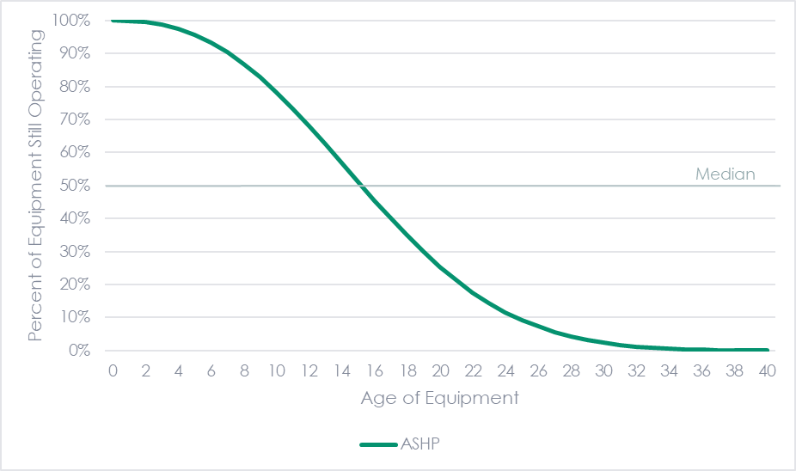

Applying this survival function to the respondents in the study results in an expected number of failures of 2.1 out of 42.[13] Figure 7 shows the expected number of failures per year based on the number of survey respondents and assuming a 15-year EUL. Although the survey did not identify any failures when a small number were expected, we cannot determine whether this was due to sampling error from a small sample size with no observations beyond nine years or if the 15-year EUL assumption is too low. To confirm (or perhaps refute) the existing EUL value, the study would have needed to find at least two failures from among the relatively small number of responses. A larger sample size, including some instances of failed equipment, would be needed to provide an EUL estimate for this measure.

Figure 7: Expected Number of Failures in Survey Data Given an EUL of 15 Years

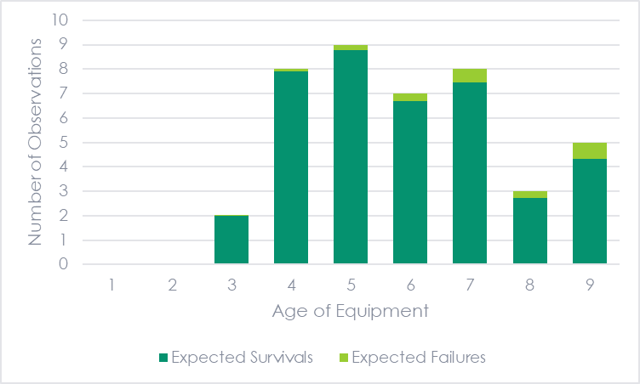

Overall, while the analysis of the survey results is inconclusive, the Evaluation Team did not see sufficient evidence that the current 15-year EUL used in the PSD should be updated at this time.[14] Given the relatively small population of installed equipment and low response rate, the Evaluation Team recommends maintaining the list of respondents to this study with known functional systems for follow-up in future measure life studies.

## Repairs

For additional context, the Evaluation Team asked respondents about the condition of the commercial HVAC equipment. The large majority of respondents (81%) indicated that the equipment works well with no need of repair. Another 14% stated that the equipment works but needs a minor repair and one respondent (2%) reported that the equipment works but needs a major repair. Only one respondent answered that the equipment had been repaired since it was installed – three years after installation.

# Comparison of EUL Values

The following tables provide a comparison between the EUL values estimated in this study, the current Connecticut PSD values, and the values from comparable jurisdictions. In many cases jurisdictions use the same source (e.g., the 2007 GDS measure life study) and rely on studies more than a decade old. Additionally, nearly all sources are literature reviews and do not contain primary data collection. Finally, some sources apply the same EUL values to several equipment types that may have different lifetimes (e.g., the 2007 GDS study provides a single EUL value for all residential heating and cooling equipment).

Table : Comparison of Air Source Heat Pump EUL Values

| **Source** | **EUL** | **Source** | **Year** | **Notes** |
| --- | --- | --- | --- | --- |
| X2001 Study Estimate | 20 | Michaels Energy | 2022 | Primary data |
| 2021 CT PSD | 18 | GDS Associates | 2007 | Literature review |
| New York TRM v9 | 15 | CPUC DEER | 2014 | -- |
| Massachusetts TRM 2022-2024 Plan | 18 | Guidehouse | 2020 | EUL is not sourced in Guidehouse report |
| Efficiency Vermont TRM | 18 | GDS Associates | 2007 | Literature review |
| Rhode Island TRM PY2020 | 14 | GDS Associates | 2007 | Literature review; note that TRM says 14 years, not 18 |
| Efficiency Maine v2022.3 | 25 | GDS Associates | 2007 | Literature review; TRM uses New Construction value for retrofits |
| Illinois TRM v10.0 | 16 | DOE Rulemaking Technical Support | 2016 | -- |

Table : Comparison of Ductless Heat Pump EUL Values

| **Source** | **EUL** | **Source** | **Year** | **Notes** |
| --- | --- | --- | --- | --- |
| X2001 Study Estimate | 17 | Michaels Energy | 2022 | Primary data |
| 2021 CT PSD | 18 | GDS Associates | 2007 | Literature review |
| Massachusetts TRM 2022-2024 Plan | 18 | GDS Associates | 2007 | Literature review |
| Efficiency Vermont TRM | 15 | DEER | 2008 | -- |
| Rhode Island TRM PY2020 | 18 | GDS Associates | 2007 | Literature review |
| Efficiency Maine v2022.3 | 18 | GDS Associates | 2007 | Literature review |
| Illinois TRM v10.0 | 18 | DOE Rulemaking Technical Support | 2016 | -- |

Table : Comparison of Heat Pump Water Heater EUL Values

| **Source** | **EUL** | **Source** | **Year** | **Notes** |
| --- | --- | --- | --- | --- |
| X2001 Study Estimate | 15 | Michaels Energy | 2022 | Primary data |
| 2021 CT PSD | 13 | LBNL | 2010 | -- |
| New York TRM v9 | 10 | CPUC DEER | 2014 | -- |
| Massachusetts TRM 2022-2024 Plan | 13 | Guidehouse | 2021 | -- |
| Efficiency Vermont TRM | 13 | Unknown | -- | -- |
| Rhode Island TRM PY2020 | 13 | Utility BCR Model | -- | -- |
| Efficiency Maine v2022.3 | 13 | NREL | Unknown | -- |
| Illinois TRM v10.0 | 15 | Guidehouse | 2018 | Literature review |

Table : Comparison of Central Air Conditioner EUL Values

| **Source** | **EUL** | **Source** | **Year** | **Notes** |
| --- | --- | --- | --- | --- |
| X2001 Study Estimate | 25 | Michaels Energy | 2022 | Primary data |
| 2021 CT PSD | 18 | GDS Associates | 2007 | Literature review |
| New York TRM v9 | 15 | CPUC DEER | 2014 | -- |
| Massachusetts TRM 2022-2024 Plan | 18 | GDS Associates | 2007 | Literature review |
| Rhode Island TRM PY2020 | 16 | Utility BCR Model | Unknown | -- |
| Illinois TRM v10.0 | 18 | GDS Associates | 2007 | Literature review |

Table : Comparison of Natural Gas Furnace EUL Values

| **Source** | **EUL** | **Source** | **Year** | **Notes** |
| --- | --- | --- | --- | --- |
| X2001 Study Estimate | 28 | Michaels Energy | 2022 | Primary data |
| 2021 CT PSD | 20 | CPUC DEER | 2014 | Unknown |
| New York TRM v9 | 22 | DOE | 2015, 2016 | -- |
| Massachusetts TRM 2022-2024 Plan | 17 | Guidehouse | 2021 | -- |
| Efficiency Vermont TRM | 15 | CEE | 2015 | -- |
| Rhode Island TRM PY2020 | 18 | EPA | 2009 | -- |
| Efficiency Maine v2022.3 | 25 | GDS Associates | 2007 | Literature review; TRM uses New Construction value for retrofits |
| Illinois TRM v10.0 | 20 | DOE Rulemaking Technical Support | 2016 |  |

Table : Comparison of Insulation EUL Values

| **Source** | **EUL** | **Source** | **Year** | **Notes** |
| --- | --- | --- | --- | --- |
| X2001 Study Estimate | 38 | Primary data collection | 2022 | -- |
| 2021 CT PSD | 25 | GDS Associates | 2007 | Literature review |
| New York TRM v9 | 25 | GDS Associates | 2007 | Literature review |
| Massachusetts TRM 2022-2024 Plan | 25 | GDS Associates | 2007 | Literature review |
| Efficiency Vermont TRM | 25 | Unknown | -- | -- |
| Rhode Island TRM PY2020 | 20 | GDS Associates | 2007 | Literature review; note that TRM measure is for weatherization, including insulation |
| Efficiency Maine v2022.3 | 25 | GDS Associates | 2007 | Literature review |
| Illinois TRM v10.0 | 20 | Guidehouse | 2018 | Literature review |

Table 15: Comparison of Commercial HVAC Values*

| **Source** | **EUL** | **Source** | **Year** | **Notes** |
| --- | --- | --- | --- | --- |
| 2021 CT PSD | 15 | GDS Associates | 2007 | Literature review |
| New York TRM v9 | 15 | CPUC DEER | 2014 | -- |
| Massachusetts TRM 2022-2024 Plan | 12 | DNV GL | 2018 | Observed age data from market characterization studies |
| Rhode Island TRM PY2020 | 20 | ERS | 2005 | Literature review |
| Efficiency Maine v2022.3 | 15 | GDS Associates, ERS | 2007, 2005 | Literature review |
| Illinois TRM v10.0 | 15 | GDS Associates | 2007 | Literature review |

* High-efficiency unitary equipment (A/C and heat pumps)

# Conclusions and Recommendations

This section summarizes the conclusion and recommendations of this study based on the results presented above.

**Conclusion 1:** Many of the reviewed EUL values in the PSD and other TRMs are based on dated literature reviews of even older studies. Some sources also apply the same EUL value to several equipment types that may have different lifetimes (e.g., a single EUL value for all heating and cooling equipment).

***Recommendation 1:*** Consider conducting future EUL research similar to this for measures that meet the criteria of high levels of participation, large contributions to Connecticut’s energy efficiency portfolio, and are able to be easily observed and self-reported by participants. Any future research should include confidence intervals around estimates. We also recommend additional future research on the measures included in this study, as new cohorts of participants can be added to this data to bolster these results.

**Conclusion 2:** The EUL point estimates resulting from this study appear reasonable and tend to be similar to those in the PSD and used in other jurisdictions. However, unlike other studies, these estimates are based on new primary research in Connecticut and are therefore very applicable.

***Recommendation 2:*** Update the EUL values in the PSD for the measure types with adequate precision levels. We recommend including an EUL value of 20 years for air source heat pumps, 17 years for ductless heat pumps, 15 years for heat pump water heaters, and 25 years for central air conditioners. We recommend continuing to use the values in the PSD for natural gas furnaces and insulation, as the estimates for these measures did not meet our threshold of 90%/40% confidence/precision. We also recommend continuing to use the values in the PSD for commercial HVAC (High-efficiency unitary equipment) due to the lack of data preventing the Evaluation Team from developing an EUL estimate.

***Recommendation 3:*** Conduct additional research on natural gas furnaces and insulation to develop EUL estimates with better precision that can be used to update the PSD in the future.

***Recommendation 4:*** Although many small businesses use residential equipment, the Evaluation Team currently does not recommend using the EUL values for residential equipment in commercial applications. Although the equipment lifespans are likely similar in residential and small commercial applications, the results from this study do not account for the removal or replacement of equipment due to business turnover.

**Conclusion 3:** Remaining useful life (RUL) values are important for measures with two-part baselines, like early replacement measures.

***Recommendation 5:*** Where practical, programs should document the age of the replaced equipment at a site-specific level and use the RUL curves in the figure below and the values in Appendix B for air source heat pumps, ductless heat pumps, heat pump water heaters, and central air conditioners when calculating retirement savings. Where the age of the existing equipment cannot be determined, programs should use the recommended values from the table below, which is based on the EUL research in this study. For natural gas furnaces and other measures without an RUL specified in the PSD, we recommend continuing to use the common practice of 1/3 of the EUL.

Figure 8. Remaining Useful Life Curves for Select Residential Measures



Table : Recommended RUL if Equipment Age is Unknown

|  |  |  |
| --- | --- | --- |
|  | **Recommended EUL** | **Recommended RUL if Unknown Age** |
| Air Source Heat Pump | 20 | 6 |
| Ductless Heat Pump | 17 | 5 |
| Heat Pump Water Heater | 15 | 5 |
| Central Air Conditioner | 25 | 7 |
| Gas Furnace | 20 | 7* |

*Denotes 1/3 of Existing PSD EUL

**Conclusion 4:** The study’s survey-based methodology used a modified approach from the normal single-study-year method. This approach, which used 1) multiple cohorts of program years in one study (as far back as 2000), and 2) used survey responses, which were then verified. This approach resulted in much lower fielding costs than if we conducted in-person site visits to verify the operation and age of equipment of the same number of respondents. Using two types of verification (respondent-provided photographs of equipment and follow-up interviews), we found very little error in the self-reported information, indicating that the information provided by respondents is accurate.

***Recommendation 6:*** Consider using this survey-based methodology, across many cohorts of participants, for future EUL studies of easily identifiable measures like those selected for this study. Also consider using the combination of respondent-provided photographs and follow-up interviews for other evaluations and studies where additional verification may be desired but site visits are too costly.

***Recommendation 7:*** The response rate for the commercial HVAC survey differed by survey mode, with the response rate for emailed invitations being much higher than the response rate for mailed letter invitations. Despite this, future studies should consider using a mixed mode approach that includes both emailed and mailed invitations because the person with the email address or the business may no longer be at the address where the equipment was installed.

# References

DNV (2021). *X1939 Phase 1 Best Practices Research.*

GDS Associates Inc. (2007). *Measure Life Report, Residential and Commercial Industrial Lighting and HVAC Measures*.

Gibbs, Ann, and Lisa A. Skumatz, “Time to Update Those EULs! An Affordable Way Forward”, Proceedings of the ACEEE Summer Study on Buildings, 2022, Asilomar, CA.

California Public Utilities Commission (2014). *Database for Energy-Efficient Resources, Feb. 4, 2014*. <http://www.deeresources.com/files/DEER2013codeUpdate/download/DEER2014-EUL-tableupdate_2014-02-05.xlsx>.

Franco, F., Bennani, Y., Ke, J., Cubero, E., Lekov, A. (2018). *Estimating Residential Appliance Lifetime for Energy Efficient Policy Analysis*. Energy Analysis and Environmental Impacts Division, Lawrence Berkeley National Laboratory

Guidehouse (2020). *Massachusetts Residential Baseline Study.* https://ma-eeac.org/wp-content/uploads/RES-1-Residential-Baseline-Study-Ph4-Comprehensive-Report-2020-04-02.pdf

Lawrence Berkeley National Laboratory (2010). *Heat Pump Water Heaters and American Homes: A Good Fit?*, pp. 9-74.

Lutz, J.D., Hopkins, A., Letschert, V., Franco, V.H, and Sturges, A. (2011). *Using National Survey Data to Estimate Lifetimes of Residential Appliances.*, Energy Analysis Department Environmental Energy Technologies Division Lawrence Berkeley National Laboratory.

Navigant (2018). *ComEd Effective Useful Life Research Report.* https://www.icc.illinois.gov/docket/P2017-0312/documents/287811/files/501915.pdf

Prinja, S., Gupta, N., & Verma, R. (2010). *Censoring in clinical trials: review of survival analysis techniques.* Indian journal of community medicine: official publication of Indian Association of Preventive & Social Medicine, 35(2), 217–221. <https://doi.org/10.4103/0970-0218.66859>

Skumatz Economic Research Associates (2014). *Estimated Annual Outflow of Mercury-Containing Thermostats in the State of Rhode Island*. Available from: https://www.nrdc.org/sites/default/files/hea_14021901a.pdf

U.S. DOE (2016) “Technical Support Document: Energy Efficiency Program for Consumer Products and Commercial and Industrial Equipment: Residential Furnaces” and “Technical Support Document: Energy Efficiency Program for Consumer Products and Commercial and Industrial Equipment: Commercial Warm Air Furnaces.” [https://www.regulations.gov/document?D=EERE-2014-BT-STD-0031-0217](https://www.regulations.gov/document?D=EERE-2014-BT-STD-0031-0217%20)

Appendix A | Detailed Methodology

* 1. Measure Selection

The Evaluation Team initially targeted four measure types of this study: three residential measures and one commercial. However, in the course of the study as the costs of studying each measure became more clear, the EA Team looked to increase the number of measure types covered, resulting in a total of six residential measure types and one commercial type.

We identified the measure types for the study by analyzing the utilities’ program tracking data, reviewing the PSD and technical reference manuals (TRMs) from other jurisdictions, and gathering feedback from utility staff and other stakeholders. Specifically, we used the following criteria to select the measure types to include in the study:

* Number of units installed across years
* Availability of contact information
* Availability, rigor, and age of past EUL research
* Future trends of measures in programs
* Recent and anticipated changes in technology
* Limitations of self-reported data collection
  + 1. Residential Measures

Using these criteria, the Evaluation Team selected three residential heat pump measures for the initial wave: air source heat pumps (ASHPs), ductless minisplit heat pumps (DHPs), and heat pump water heaters (HPWHs). Following the successful fielding of the first wave, we selected three additional residential measure types to research: central air conditioners (CACs), natural gas furnaces, and attic/wall insulation. Table 17 below shows the number of installed units for each residential equipment type by year for Eversource and UI. For both utilities, 2011 was the earliest year for which residential program tracking data was available.

Table : Number of Installed Units by Residential Equipment Type by Year

|  |  |  |  |  |  |  |
| --- | --- | --- | --- | --- | --- | --- |
| Program (installation) Year | Air Source Heat Pump | Ductless Heat Pump | Central  AC | Furnace (Natural Gas) | Heat Pump Water Heater | Insulationa |
| 2011 | 547 | 431 | 2,655 | 15 | 93 | 1,146 |
| 2012 | 325 | 482 | 2,008 | 249 | 175 | 1,225 |
| 2013 | 264 | 575 | 2,081 | 642 | 378 | 1,511 |
| 2014 | 343 | 2,735 | 2,404 | 1,252 | 1,205 | 2,253 |
| 2015 | 337 | 1,332 | 1,704 | 1,905 | 1,015 | 2,281 |
| 2016 | 115 | 823 | 1,023 | 2,188 | 1,404 | 1,769 |
| 2017 | 182 | 4,768 | 1,600 | 3,222 | 1,657 | 1,600 |
| 2018 | 146 | 6,197 | 1,532 | 5,185 | 4,203 | 948 |
| 2019 | 88 | 7,810 | 1,350 | 7,069 | 4,666 | 1,346 |
| Total | 2,347 | 25,153 | 16,357 | 21,727 | 14,796 | 14,079 |
| Operating Yearsb | 7.2 | 3.9 | 6.5 | 3.7 | 3.8 | 6.0 |

a: Number of homes installing attic/wall insulation

b: Weighted average years of operation, computed as differences between 2021 and installation year.

Across the six residential measures, there was substantial variation in the count of installation—ranging from 2,347 for ASHPs to over 25,000 for ductless heat pumps. The measures also differed with respect to the trend in the number of installations by year. For ASHPs, about one-in-four measures were installed in 2011, and more than three-quarters were installed by 2015. In sharp contrast, less than 1% of furnaces and HPWHs were installed in 2011, and only about 20% of each were installed by 2015.

The number of installed units and the number of years the units have been installed are critical factors for the EUL analysis. To estimate the EUL of an HVAC measure, one needs information on the date of installation and the date of failure for a sufficiently large sample of HVAC units (or insulation projects).[15] For each of the equipment types shown in Table 17, the count of installed units *appears* sufficiently large for estimating the EUL with a conservative response rate.[16] However, complicating the analysis is the relatively short duration in which most of the HVAC units and insulation installed through the utility programs have been in place. The weighted average years of operation of the equipment analyzed by the Evaluation Team ranges from 3.7 and 3.8 years for furnaces and HPWHs, respectively, to 7.2 years for ASHPs. Across all measures, the maximum years of operation was 10 (corresponding to a unit installed in 2011).

* + 1. Commercial & Industrial Measures

The Evaluation Team selected commercial HVAC as the measure type on which to focus in the commercial and industrial sector. We defined this as high efficiency unitary equipment, including both air conditioning equipment and heat pumps. The table below shows the number of installed units by year. UI’s C&I program tracking data went back to 2000, while 2010 was the earliest year for which C&I program tracking data was available for Eversource.

Table 18: Number of Installed Commercial HVAC Units by Residential Equipment Type by Year

|  |  |  |  |
| --- | --- | --- | --- |
| Program (installation) Year | Number of Units | Program (installation) Year | Number of Units |
| 2000 | 141 | 2011 | 197 |
| 2001 | 59 | 2012 | 169 |
| 2002 | 31 | 2013 | 134 |
| 2003 | 85 | 2014 | 485 |
| 2004 | 507 | 2015 | 488 |
| 2005 | 145 | 2016 | 416 |
| 2006 | 189 | 2017 | 647 |
| 2007 | 186 | 2018 | 418 |
| 2008 | 170 | 2019 | 466 |
| 2009 | 172 | Total | 5,253 |
| 2010 | 148 |  |  |

* 1. Sampling Approach

The Evaluation Team developed a stratified random sample approach for the residential survey. Our sampling unit was the premise in order to capture as many measures as possible with each survey. To maximize the precision of our estimates, the Evaluation Team targeted at least 400 completes for each measure type where possible given the population size. We stratified the population by year of installation to ensure sufficient coverage by equipment age. Additionally, we oversampled older equipment for a greater chance of information on failed units. Because of the potentially large incentive total, we also set quotas for each year, resulting in a total quota of 600 per measure type.

Once the sample frame was established, we drew a random sample of participants from each stratum to achieve our target completes, assuming a 5% response rate. In many cases, however, the Evaluation Team conducted a census attempt due to low numbers of participants in that stratum.

For the commercial HVAC survey, the limited number of unique premises necessitated a modified census attempt. The initial survey effort targeted unique premises with one commercial HVAC unit installed through a utility program (n=615). This allowed the respondent to know which unit was covered in the survey. A second survey effort targeted unique premises with participant email addresses, regardless of the quantity of units. The sample size for this wave was 515. Overall, we sent surveys to 910 unique facilities out of 1,621 in the program tracking data.[17]

* 1. Residential Survey Fielding
     1. EUL Survey

The Evaluation Team surveyed homes with equipment installed through Connecticut utility programs from 2011 to 2019. The survey included questions to determine if the equipment was still installed and operating and, if not, the year in which the equipment was removed and/or failed. Based on the responses to these questions, we created the two TTE variables (the event indicator and the time variable).

We utilized a mail push-to-web survey approach because the original program participant may no longer be living at the address in which the energy efficient equipment was installed. Residents of sampled addresses received a letter invitation to complete a short online survey about the equipment. We provided respondents a $25 gift card to Dunkin’ to generate a sufficient response rate.

Invitations for the first wave (targeting ASHP, DHP, and HPWH) were sent on May 27, 2021. To increase response rates, we sent a reminder postcard in early August. Invitations for the second wave (targeting central AC, furnaces, and insulation) were sent on July 27, 2021. Due to the high response rate for the second wave, no follow up reminder mailings were necessary.

* + 1. Heat Pump Survey

The Evaluation Team was able to leverage data collection from a concurrent heat pump study (R2027) to reduce the number of invitations sent and to minimize the burden on respondents. This study focused on heat pumps installed from 2017 to 2019. We worked with the evaluation contractor for that study to add three questions to gather information on whether the heat pump was still installed and working and, if not, when it stopped working.

* + 1. Response Rate

Overall, the Evaluation Team sent survey invitations to 25,104 residences and received 2,846 responses, resulting in a response rate of 11.0%.[18] Table 19 shows, for each year of the study, the number of invitations sent, the number of surveys completed, and the response rate.

Table : Sample Size, Survey Completes, and Response Rate for EUL Survey

|  |  |  |  |  |  |  |  |  |  |  |
| --- | --- | --- | --- | --- | --- | --- | --- | --- | --- | --- |
| **Measure Type** | **Sample** | | | | | | | | | |
| **2011** | **2012** | **2013** | **2014** | **2015** | **2016** | **2017\*** | **2018\*** | **2019\*** | **Total** | |
| Air Source Heat Pump | 466 | 277 | 225 | 200 | 286 | 102 | -- | -- | -- | 1,556 | |
| Ductless Heat Pump | 405 | 402 | 447 | 784 | 780 | 755 | -- | -- | -- | 3,573 | |
| Heat Pump Water Heater | 87 | 162 | 338 | 226 | 35 | 434 | -- | -- | -- | 1,282 | |
| Central Air Conditioner | 881 | 824 | 800 | 772 | 821 | 771 | 826 | 544 | 555 | 6,794 | |
| Natural Gas Furnace | 9 | 128 | 427 | 807 | 790 | 777 | 772 | 507 | 512 | 4,729 | |
| Insulation | 792 | 842 | 865 | 882 | 864 | 868 | 895 | 585 | 577 | 7,170 | |
| **Measure Type** | **Survey Completes** | | | | | | | | | |
| **2011** | **2012** | **2013** | **2014** | **2015** | **2016** | **2017\*** | **2018\*** | **2019\*** | **Total** | |
| Air Source Heat Pump | 69 | 50 | 47 | 42 | 46 | 16 | 0 | 6 | 4 | 280 | |
| Ductless Heat Pump | 75 | 78 | 96 | 62 | 60 | 62 | 2 | 105 | 63 | 603 | |
| Heat Pump Water Heater | 26 | 45 | 80 | 42 | 3 | 58 | 21 | 14 | 37 | 326 | |
| Central Air Conditioner | 77 | 89 | 92 | 90 | 82 | 80 | 79 | 50 | 49 | 688 | |
| Natural Gas Furnace | 3 | 28 | 85 | 78 | 76 | 73 | 68 | 48 | 51 | 510 | |
| Insulation | 71 | 72 | 72 | 72 | 72 | 72 | 72 | 49 | 48 | 600 | |
| **Measure Type** | **Response Rate** | | | | | | | | | |
| **2011** | **2012** | **2013** | **2014** | **2015** | **2016** | **2017\*** | **2018\*** | **2019\*** | **Total** | |
| Air Source Heat Pump | 15% | 18% | 21% | 21% | 16% | 16% | -- | -- | -- | 18% | |
| Ductless Heat Pump | 19% | 19% | 21% | 8% | 8% | 8% | -- | -- | -- | 17% | |
| Heat Pump Water Heater | 30% | 28% | 24% | 19% | 9% | 13% | -- | -- | -- | 25% | |
| Central Air Conditioner | 9% | 11% | 12% | 12% | 10% | 10% | 10% | 9% | 9% | 10% | |
| Natural Gas Furnace | 33% | 22% | 20% | 10% | 10% | 9% | 8% | 8% | 10% | 11% | |
| Insulation | 9% | 9% | 8% | 8% | 8% | 8% | 8% | 8% | 8% | 8% | |

*Includes survey completes from concurrent heat pump study (R2027)

As shown in the table above, we achieved response rates of between 8% and 25%. The measures with the lowest response rates were those with the largest samples. For most years, we met the quota set for these measures, artificially limiting the response rate.

* 1. Commercial HVAC Survey Fielding
     1. Commercial HVAC Survey

The Evaluation Team surveyed commercial facilities with commercial HVAC equipment installed through Connecticut utility programs from 2000 to 2019. As with the residential equipment survey, the commercial HVAC survey included questions to determine if the equipment was still installed and operating and, if not, the year in which the equipment was removed and/or failed.

The commercial HVAC survey was fielded in two waves. In the first wave, the Evaluation Team use a mail push-to-web approach like the residential survey because the original participating business may no longer occupy the space in which the energy efficient equipment was installed. Businesses located at the sampled addresses received a letter invitation to complete a short online survey about the equipment. In an attempt to increase the response rate as well as to gather observations of failed equipment, the Evaluation Team fielded a second survey, using an email invitation. This survey was sent to past participants of unique premises with email addresses. For both survey waves, we provided respondents a $25 gift card to Dunkin’ to generate a sufficient response rate.

Invitations for the first wave (mailed letter invitations) were sent on March 23, 2022. To increase response rates, we sent a reminder letter on April 12, 2022. Emails invitations for the second wave were sent on February 1, 2023. We sent three reminder emails in approximately weekly intervals.

* + 1. Response Rate

Overall, the Evaluation Team sent survey invitations to 910 unique commercial facilities residences and received 42 responses, resulting in a response rate of 4.6%.[19] Table 20 shows, for each year of the study, the number of invitations sent, the number of surveys completed, and the response rate, by mode.

Table 20: Sample Size, Survey Completes, and Response Rate for EUL Survey

| **Year** | **Sample** | | | **Completes** | | | **Response Rate** | | |
| --- | --- | --- | --- | --- | --- | --- | --- | --- | --- |
| **Total** | **Mail** | **Email** | **Total** | **Mail** | **Email** | **Total** | **Mail** | **Email** |
| 2000 | 0 | 0 | 0 | 0 | 0 | 0 | -- | -- | -- |
| 2001 | 1 | 1 | 0 | 0 | 0 | 0 | 0.0% | 0.0% | -- |
| 2002 | 0 | 1 | 0 | 0 | 0 | 0 | -- | 0.0% | -- |
| 2003 | 0 | 0 | 0 | 0 | 0 | 0 | -- | -- | -- |
| 2004 | 1 | 1 | 0 | 0 | 0 | 0 | 0.0% | 0.0% | -- |
| 2005 | 6 | 6 | 0 | 0 | 0 | 0 | 0.0% | 0.0% | -- |
| 2006 | 3 | 3 | 0 | 0 | 0 | 0 | 0.0% | 0.0% | -- |
| 2007 | 2 | 2 | 0 | 0 | 0 | 0 | 0.0% | 0.0% | -- |
| 2008 | 2 | 2 | 0 | 0 | 0 | 0 | 0.0% | 0.0% | -- |
| 2009 | 4 | 4 | 0 | 0 | 0 | 0 | 0.0% | 0.0% | -- |
| 2010 | 8 | 2 | 7 | 0 | 0 | 0 | 0.0% | 0.0% | 0.0% |
| 2011 | 16 | 6 | 12 | 0 | 0 | 0 | 0.0% | 0.0% | 0.0% |
| 2012 | 21 | 9 | 16 | 0 | 0 | 0 | 0.0% | 0.0% | 0.0% |
| 2013 | 24 | 7 | 22 | 0 | 0 | 0 | 0.0% | 0.0% | 0.0% |
| 2014 | 151 | 125 | 58 | 7 | 2 | 5 | 4.6% | 1.6% | 8.6% |
| 2015 | 116 | 90 | 48 | 2 | 1 | 1 | 1.7% | 1.1% | 2.1% |
| 2016 | 164 | 130 | 85 | 8 | 1 | 7 | 4.9% | 0.8% | 8.2% |
| 2017 | 153 | 100 | 105 | 11 | 5 | 6 | 7.2% | 5.0% | 5.7% |
| 2018 | 117 | 85 | 85 | 5 | 1 | 4 | 4.3% | 1.2% | 4.7% |
| 2019 | 121 | 87 | 77 | 9 | 2 | 7 | 7.4% | 2.3% | 9.1% |
| **Total** | **910** | **661** | **515** | **42** | **12** | **30** | **4.6%** | **1.8%** | **5.8%** |

As shown in the table above, the response rate differed by survey mode. The response rate for mailed invitations was 1.8% while the response rate for emailed invitations was 5.8%. Despite the lower response rate for mailed invitations, future studies should consider continuing to use a mailed letter invitation because the person with the email address or the business may no longer be at the address where the equipment was installed.

* 1. Residential Survey Verification

The study’s survey-based methodology resulted in much lower fielding costs than if we conducted in-person site visits to verify the operation and age of equipment of the same number of respondents. However, relying on self-reported information exposes the study to the risk of respondent error. To mitigate this risk, the evaluation team conducted two types of verification to ensure the accuracy of the self-reported data: photographs of installed equipment and follow-up verification interviews. For both verification activities, we found very little error in the self-reported information, indicating that the information provided by respondents is accurate.

The Evaluation Team primarily chose these verification approaches because they were cost-effective and replicable. However, the study’s timing also coincided with the COVID-19 pandemic which limited the ability for in-person site visits.

* + 1. Equipment Photographs

As part of the survey, respondents were asked to take a picture of the sampled piece of equipment. The Evaluation Team asked the respondents to take two pictures: the first of the equipment as a whole and the second of the equipment’s nameplate. Figure 9 shows an example of the pictures provided.

Figure : Example of Verification Picture Provided by Respondent



These pictures allowed us to verify three things. First, we verified that the equipment was the same type of equipment as what was sampled. This confirmed that 1) the utility tracking data was correct, and 2) that the respondent was answering questions about the correct type of equipment.[20] Second, the picture of the nameplate often included the manufacture date, which allowed us to verify the age of the equipment. Finally, the picture allowed us to see if the equipment was in obviously poor condition or inoperable (e.g., severe rust or damage, pipes not hooked up).

The survey did not require respondents to provide pictures of the equipment. Overall, 22% of respondents provided pictures. The Evaluation Team’s engineers reviewed all submitted pictures. We were able to verify the sampled equipment in nearly all cases, with only 3% not able to be verified.

Note that we did not ask for pictures of insulation because it is often not accessible in homes and it would be very difficult for an engineer to verify through pictures.

* + 1. Verification Interviews

The Evaluation Team also conducted follow-up phone interviews with a random sample of survey respondents to verify survey responses. For each equipment type, we randomly selected 10% of survey respondents in each equipment/year stratum.[21] Overall, we selected 259 of 2,563 respondents who provided their contact information for potential follow up and completed 50 interviews (19% response rate). Of the 50 interviews completed, we identified very few survey errors: no respondents changed the state of their equipment (e.g., from failed to surviving) and only two revised the year of when their equipment failed.

* 1. Analysis

The primary objective of this study was to estimate the effective useful life (EUL) of the targeted measures. The Evaluation Team could only conduct this analysis for the residential measures under study because our survey of past commercial HVAC participants did not uncover any failed equipment. Specifically, we estimated the EUL of ASHPs, DHPS, HPWHs, CACs, and gas furnaces used in residential applications, as well as wall and ceiling insulation installed in residences.

We define EUL as the median length of time (in years) that equipment is in operation.[22] In addition, we estimated the residual useful life (RUL) of these same equipment types (and insulation). We define RUL as the difference between the current age of a piece of equipment and the expected age of the equipment at replacement, also measured in years.

We used a parametric survival analysis approach to estimate the “survival” function of each equipment type. The survival function represents the expected distribution of lifetimes of equipment based on a sample of residents who installed HVAC equipment or insulation through an energy efficiency program operated by UI or Eversource. The data necessary to estimate the survival functions for HVAC equipment, referred to as time-to-event (TTE) data, consist of only two variables:

1. **The Event**: A binary variable that equals 1 if the event has occurred (i.e., the unit of equipment failed), else 0.
2. **The Time**: Time in years between equipment installation and ***the event.***
   1. *If event = 1 →* ***the time*** *is the difference in years between equipment installation and equipment failure.*
   2. *If event = 0 →* ***the time*** *is the difference in years between equipment installation and when the equipment was checked (2021).*

The Connecticut utilities provided the Evaluation Team with contact information for program participants and the year in which equipment or insulation was installed in the participant’s home. In the online survey completed by program participants, we asked whether the equipment or insulation is still installed and is still operating, and if not, the year in which the equipment was removed and/or failed. Based on the responses to these questions, the Evaluation Team created the two TTE variables (the event indicator and the time variable).

Survival analysis techniques are designed to account for the unique characteristic that many (or even most) observations of TTE data are censored. *Censoring* refers to the circumstance in which the value or outcome of an observation is only partially known. For HP equipment, the time to event (failure and/or replacement) is censored for all units that are still operating as of the date the participant completed the online survey. In this case, we know the unit is still operating, but do not know when it will fail. To avoid the potential bias associated with censoring, survival analysis methods account for this “incomplete” information on units that are still operating, thus allowing information on all units to be used—those for which the event has occurred and those for which the event is yet to occur.[23]

The survival function defines the probability of survival at time *t*:

$$S\left(t\right)=Pr\left\{T≥t\right\}=1-F\left(t\right)=\int_{t}^{∞}{f\left(x\right)dx,}$$

Alternatively, the hazard function characterizes the instantaneous rate of failure (i.e., the probability the event will occur) at each point along the survival function:[24]

The survival function and the hazard function are related, and if one is known, the other can be computed. Figure 10 shows an example of a survival function and corresponding hazard function.

Figure 10: Example of a Survival Function (upper) and Hazard Function (lower)



The survival function (upper figure) shows the proportion of a population (e.g., gas furnaces) expected to survive over a 50-year time period. The lower figure shows the proportion of the population expected to fail (i.e., experience the event) each year. In this example, the hazard (or failure) rate grows through age 10 and then begins to decline. For any given point in time, the value of the hazard function defines the failure rate and slope of the survival function.

There are three general approaches to estimating the survival function from TTE data: parametric, semi-parametric, and non-parametric. The choice of which approach to use should be based on the available data and the research question(s) of interest.

**Non-Parametric Approach**

Non-parametric approaches are completely data driven, not relying on any assumptions about the shape of the survival function of the underlying distribution. The Kaplan-Meier estimator is the most common non-parametric approach for estimating survival functions. In addition to estimating the survival function, the Kaplan-Meier approach estimates the median and quartiles of survival time—statistics that cannot be accurately estimated from the underlying data because of censoring.

Our *a priori* assumption when beginning this study was that we would use the Kaplan-Meier approach to estimate EULs for two related reasons: a) the Kaplan-Meier estimator is extremely flexible resulting in estimated survival curves that are solely dependent on the data, and b) the Kaplan-Meier approach would not require us to impose a parametric functional form to the data.

There are, however, two limitations associated with the Kaplan-Meier approach that make it unsuitable for this project. First, the estimated EULs are biased toward longer life expectancies when a large proportion of observations are censored.[25] Given that the residential customers included in this study had HVAC equipment or wall/ceiling insulation installed in their home in 2011 or later, most of these installations are still in place—i.e., are censored with respect to age at failure.[26] Across the nearly 2,900 residential customers surveyed for this analysis, only approximately 5 percent reported that the HVAC equipment (or insulation) had failed and/or been replaced. This means that the *age at failure* for 95 percent of the HVAC equipment or insulation examined in this study is unknown. This is a remarkedly high level of (right) censoring.

Second, the Kaplan-Meier approach is most suitable when no assumption about the distribution of failures over time is made and the period of study is sufficiently long to capture all or nearly all failures. However, since the Kaplan-Meier approach makes no assumption about the distribution of failures and most of the installations have not yet failed, it is not possible to reasonably extrapolate the results of the study beyond the relatively short operating life we have studied (Gupta and Verma, 2010).

For these reasons, the Kaplan-Meier approach is not an appropriate choice for this study.

**Semi-Parametric Approach**

The semi-parametric approach combines a non-parametric component with a parametric component that allows for the comparison of groups within the population of interest. The non-parametric component is similar to the Kaplan-Meier estimator in that it is a purely data driven approach to estimating the shape of the survival function; it does not rely on any underlying distributional assumptions. The parametric component is comprised of a vector of covariant that describes the specific groups within the population of interest. The most used semi-parametric model for estimating survival functions is the Cox proportional estimator.

Similar to the non-parametric approach, the semi-parametric model would result in estimated EULs that are biased toward a longer expected life, and for this reason, we determined that the semi-parametric approach was not appropriate for this project.

**Parametric Approach**

In a parametric approach to survival analysis, the survival and hazard functions are estimated based on an assumed distribution of the underlying population. Commonly used distributions include the Weibull, exponential, normal, log-normal, and gamma distributions. Using the data collected from survey respondents, we tested the performance of the different distributions and found that the Weibull distribution best fit the data (see discussion below). This result was not unexpected, as the Weibull distribution has been used to represent a wide variety of survival models to fit almost all survival data—including for estimated EULs for residential appliances (Franco et. al 2018, Lutz et. al 2011, Young 2008).

The probability density function for the Weibull distribution is as follows:[27]

and the survival (or “reliability”) function is:

$$S\left(t\right)=e^{-{\left(λt\right)}^{ρ}}$$

Where:

*t* = age of the equipment at failure or, if still operating, age of the equipment in 2021

*S(t)* = probability appliance will survive beyond age *t* (i.e., its reliability)

λ = the shape parameter estimated in the regression model

ρ = the scale parameter estimated in the regression model

**Choosing Between Alternative Distributions for the Parametric Survival Model**

We estimated parametric survival models for each of the six residential measures under the assumption of five alternative distributions: Weibull, exponential, normal, log-normal, and gamma. For each residential measure, we compared the **Akaike information criterion** (**AIC**) computed for each model estimated assuming an alternative survival distribution. The AIC is an estimator of a model’s prediction error, which can be compared to the AIC computed from other models estimated using the same data, but with different distributional assumptions. The AIC serves as a measure of the quality of a model, relative to the alternative models estimated with the same data. As a measure of prediction error, the model with the lower AIC would be the preferred model.

Table 21 shows the AIC values from each model. For all four heat pump measures, the Weibull distribution produced the lowest AIC—indicating the preferred model. However, for the gas furnace and insulation models, the normal distribution produced the lowest AIC (but an EUL estimate of 55 years that was not statistically significantly different from zero) and for insulation, both the normal and log-normal distribution produced lower AIC values (but EULs of 75 years and 87 years, respectively).

Table : Estimated AIC by Residential Measure for Alternative Survival Distributions*

|  |  |  |  |  |  |
| --- | --- | --- | --- | --- | --- |
| **Installed Measure** | **Akaike Information Criterion** | | | | |
| **Weibull** | **Exponential** | **Normal** | **Log-normal** | **Inverse Gaussian** |
| Air Source Heat Pump | 139.3 | 152.5 | 142.0 | 139.7 | 215.1 |
| Ductless Heat Pump | 251.0 | 287.0 | 254.9 | 251.4 | 390.6 |
| Heat Pump Water Heater | 206.4 | 230.6 | 211.8 | 207.3 | 330.6 |
| Central Air Conditioner | 104.4 | 114.1 | 106.9 | 104.5 | 155.8 |
| Gas Furnace | 132.3 | 137.2 | 131.3 | 132.3 | 175.1 |
| Insulation | 214.4 | 218.2 | 211.9 | 214.0 | 288.4 |

The evaluation team attempted, but ultimately did not estimate, a two-parameter gamma survival model. For the gamma model to converge at a solution, the analyst is required to assign a fixed value for the scale parameter (theta); without any knowledge of what that value should be, the evaluation team did not further pursue estimation of the gamma model.

Appendix B | Remaining Useful Life Table

Table : Remaining Useful Life Values for Select Residential Measures

| **Equipment Age (Years)** | **Estimated Remaining Useful Life** | | | |
| --- | --- | --- | --- | --- |
| **Air Source Heat Pump** | **Ductless Heat Pump** | **Heat Pump Water Heater** | **Central Air Conditioner** |
| 0 | 20 | 17 | 15 | 26 |
| 1 | 19 | 16 | 14 | 25 |
| 2 | 18 | 15 | 13 | 24 |
| 3 | 17 | 14 | 12 | 23 |
| 4 | 16 | 13 | 11 | 22 |
| 5 | 15 | 12 | 11 | 21 |
| 6 | 14 | 11 | 10 | 20 |
| 7 | 13 | 10 | 9 | 19 |
| 8 | 12 | 10 | 8 | 18 |
| 9 | 12 | 9 | 8 | 17 |
| 10 | 11 | 8 | 7 | 16 |
| 11 | 10 | 8 | 7 | 15 |
| 12 | 10 | 7 | 6 | 15 |
| 13 | 9 | 6 | 6 | 14 |
| 14 | 8 | 6 | 5 | 13 |
| 15 | 8 | 6 | 5 | 12 |
| 16 | 7 | 5 | 5 | 12 |
| 17 | 7 | 5 | 4 | 11 |
| 18 | 7 | 4 | 4 | 11 |
| 19 | 6 | 4 | 4 | 10 |
| 20 | 6 | 4 | 4 | 9 |
| 21 | 6 | 4 | 3 | 9 |
| 22 | 5 | 3 | 3 | 8 |
| 23 | 5 | 3 | 3 | 8 |
| 24 | 5 | 3 | 3 | 8 |
| 25 | 4 | 3 | 3 | 7 |
| 26 | 4 | 3 | 3 | 7 |
| 27 | 4 | 2 | 2 | 7 |
| 28 | 4 | 2 | 2 | 6 |
| 29 | 4 | 2 | 2 | 6 |
| 30 | 3 | 2 | 2 | 6 |

1. The RUL for natural gas furnaces and insulation are not included in this figure because of the poor precision of the results for those measures.
2. Suggested from the literature, see Skumatz Economic Research Associates 2014.
3. The selection criteria consisted of: the number of units installed across years; availability of contact information; availability, rigor, and age of past research; future trends of measures in programs; recent and anticipated changes in technology; and limitations of self-reported data collection.
4. This approach was developed as part of thermostat research conducted in RI, CA, IL , and NY. (For example: SERA. Estimated Annual Outflow of Mercury-Containing Thermostats in the State of Rhode Island. February 2014.)
5. Alternatively, EUL could be defined as the average length of time (in years) that equipment is in operation. In practice, the two approaches generally do not differ greatly, however a mean-based EUL is typically at least a little higher than the median-based EUL. This is due to the lifetime of equipment being right-skewed—meaning the upward tail of the distribution is considerably longer than the lower tail (which cannot be less than 0). In comparison, the median of a distribution is fixed by its position within the distribution, not by its individual value. As such, the median lifetime is less impacted by extreme values.
6. Because it has no moving parts, insulation typically “fails” when it is damaged by a storm or leak, if it is disturbed, or if it is removed in a home renovation.
7. In a parametric approach to survival analysis, the survival and hazard functions are estimated based on an assumed distribution of the underlying population. Commonly used distributions include the Weibull, exponential, normal, log-normal, and gamma distributions. We compared the survival models for each of these distributions and found the Weibull models fit the data best, resulting in the least amount of information loss. The Weibull distribution is commonly used in other EUL studies due to its ability to represent a wide variety of survival models to fit almost all survival data, including for estimated EULs for residential appliances.
8. The residential and commercial sample frame differed in the range of participation years due to differences in utility program tracking for the two sectors.
9. Commonly used distributions include the Weibull, exponential, normal, log-normal, and gamma distributions. In this study, the Weibull was the best fitting distribution for all measures and is the focus of the remaining discussions.
10. While our a priori assumption was that the Weibull distribution was the appropriate choice for estimating EULs for the six residential measures, we nevertheless compared the Akaike information criterion (AIC) from the Weibull survival models to the AIC from survival models using other distributions—exponential, normal, lognormal, loglogistic, and gamma. The AIC is a statistical measure of the “information loss” associated with using a particular distribution. The AIC criterion is to choose the distribution with the minimum AIC value—representing the least amount of information loss—which was the Weibull distribution.
11. The RUL for natural gas furnaces and insulation are not included in this figure because of the poor precision of the results for those measures.
12. The Evaluation Team notes that these results may suggest some recall bias and that respondents may be more likely to recall those repairs that presaged the failure of the equipment. If so, this would suggest that the repair frequencies may be understated.
13. Based on the data gathered, observing no failures among the 42 respondents suggests that the EUL may be closer to 24 years than it is to 15.
14. Although this study found some indication that the 15-year EUL for commercial HVAC equipment may be too low, a recent Massachusetts market characterization study resulted in a recommendation that the EUL be revised to 12 years.
15. Information on the installation date of units still operating is also used in the analysis; such observations are referred to as “censored,” as the date of failure for units is unknown.
16. Our *a priori* assumption was that we would achieve a survey response rate of between 5 percent and 10 percent.
17. Approximately 20% of sites had service addresses that did not match with a US Postal Service mailing address, limiting the number of surveyable sites.
18. The response rate of 11.0% does not include the 252 responses from the heat pump survey.
19. The Evaluation Team received a total of 79 responses, but many respondents indicated that no one at the facility was knowledgeable about the equipment or they did not want to provide additional information.
20. This only allowed us to verify that the equipment in the picture was the same type, not the same piece of equipment. For example, if a respondent had multiple ductless heat pumps and only one was sampled, we may not be able to tell which specific unit was in the picture.
21. Higher percentages of respondents were selected for some equipment/year strata that had either very low numbers of responses or questionable results.
22. As such, the median-based EUL represent the age at which half of the equipment would still be in operation and half would have already failed. Alternatively, EUL could be defined as the average length of time (in years) that equipment is in operation. In general, the two approaches do not differ greatly, however a mean-based EUL is typically a little higher than the median-based EUL. This is due to the lifetime of equipment being right-skewed—meaning the upward tail of the distribution is considerably longer than the lower tail (which cannot be less than 0). In comparison, the median of a distribution is fixed by its position within the distribution, not by its individual value. As such, the median lifetime is less impacted by extreme values.
23. Neither ordinary least squares (OLS) nor logistic regression is an appropriate modeling approach when censoring is present in the data such as the TTE data for HVAC equipment, which are restricted to be positive. Even without censoring, due to the unique character of TTE data in which the outcome of interest includes both the event and the time of the event, standard regression methods (e.g., OLS and logistic regression) are not well suited for model estimation.
24. The numerator of the hazard function is the conditional probability that the event will occur given that it has not occurred before; the denominator is the width of time interval (e.g., day, month, year).
25. For the purposes of this study, censoring (or more precisely, “right censoring”) simply means that the event of interest has not yet occurred –- i.e., the HVAC equipment is still operating or the insulation is still in place.
26. Across the nearly 2,900 residential customers surveyed for this analysis, only about 5 percent reported that the HVAC equipment (or insulation) had failed and/or been replaced.
27. This formula is for the two-parameter Weibull distribution; an alternative three-parameter specification would include a location or “delay” parameter, which would correspond to a shift to the right (away from time zero) and represent a survival function with zero probability of failure before the time value of the delay.