**MEMORANDOM**

To: Lisa Skumatz, Ralph Prahl, Bob Wirtino, Connecticut Energy Efficiency Board Evaluation Administrator Team

From: Seth Craigo-Snell, Ph.D.; Founder and Owner, SCS ANALYTICS

Date: 7/13/20

RE: Preliminary Results from R1963B: Short Term Residential Lighting Analysis

**EXECUTIVE SUMMARY**

As part of R1963B: Short Term Residential Lighting Analysis, SCS ANALYTICS completed shelf inventory data collection at 30 retailers across the state of Connecticut from June 22-26, 2020. Six of the locations were hard-to-reach discount retailers as identified by the Energize CT program and the sample was nearly evenly divided between rural and urban locations. The goals of the shelf inventory work are to establish the availability and pricing of key lighting products for residential lighting promotion within the state of Connecticut. SCS ANALYTICS has prepared this memo of preliminary results to inform future program planning that is currently underway. This data collection had originally been scheduled for mid-March but was delayed due to the Covid-19 response in the state.

Data were collected from retailer shelves on an individual SKU from within 25 key product types (see Table 3). In each product category (e.g. general purpose A-Line, Candelabra, G25 Globe, Directional), information was collected on LED models of varying brightness and corresponding baseline incandescent/halogen products.

Some key findings in each key product type follow.

**Product Availability – All Product Types** (see Table 4 for more information)

* Baseline incandescent and halogen products are widely available in Food Markets, Hardware/Lumber, and National Retailers, especially for general purpose A-Line bulbs.
* Discount stores primarily only carry products that are “brought in” by Energize CT program. The one exception to this is Dollar stores which tend to carry some amount of baseline products.
* Walmart does not stock baseline incandescent products for: Globe, Candelabra, and Directional products, but does still carry baseline A-Line halogen bulbs.
* Among specialty products (G25 Globes and Candelabra), 25W equivalent bulbs are less commonly available across all retailers than brighter bulbs (esp. 40W equivalent).
* In the Directional category, dimmable LED BR30 products and their corresponding baseline incandescent bulbs are widely available.

**Pricing - General Purpose (A-Line) Products** (see Figures in Section 5 for more information)

* Across all brightness levels, efficient A-Line products are significantly more expensive than their baseline halogen counterparts.
* These price differences range from just over $1 per bulb for 60W equivalent bulbs in Hardware/Lumber and National Retailers to over $4 per bulb for brighter bulbs in those same retail channels. The maximum difference (≈$7) is likely to be found in the Food Market channel.
* The price variation for the baseline halogen products is notably smaller than efficient products across all product brightness levels and retail channels.
* There is a notable range in average retail pricing across the retail channels for bulbs at each brightness level.

**Pricing - Candelabra Products** (see Figures in Section 6 for more information)

* Across all brightness levels and retail channels, efficient candelabra products are more expensive than their baseline halogen counterparts.
* As with A-Line products, there is notable price variation for efficient products at each brightness level across the different retail channels. This price variation is notably less for baseline incandescent bulbs than their efficient counterparts.

**Pricing - G25 Globe Products** (see Figures in Section 7 for more information)

* Across nearly all brightness levels and retail channels, efficient G25 Globe products are more expensive than their baseline incandescent/halogen counterparts.
* For G25 Globe products there is notable price variation for efficient and baseline products at each brightness level across the different retail channels.

**Pricing - Directional Products** (see Figures in Section 8 for more information)

* There is a strong variation in the pricing of both efficient and baseline BR30 products across retail channels.
* Efficient BR30 products (within channel) cost significantly more than baseline products with the exception being the Hardware/Lumber channel.
* However, the cost difference is notably less (especially on a percentage of the total cost basis) than the other key product categories.
* The price differences between 5/6” retrofit kits and baseline BR30 incandescent products is significant and ranges from ≈$6 per bulb in National Retailers to well over $8 per bulb in the Hardware/Lumber channel.

**Progression of Federal Standards**

Two major developments in the DOE rulemaking process have significant implications for the kinds of light bulbs that will continue to be available for purchase in the U.S. market. First, the withdrawal of January 2017 revised definitions of General Service Lamps (GSLs) and General Service Incandescent Lamps (GSILs). Second, the determination late in December 2019 that new standards for GSILs were not “economically justified.” Challenges to these actions are the subjects of two petitions making their way through the U.S. Court of Appeals for the Second Circuit. As of June 15, 2020, arguments for the first petition (regarding definitions) have been filed with the court. The second petition is being held in abeyance while the first petition is decided. A decision in the first case is not expected until Q3 or Q4 2020.

For the foreseeable future, baseline product availability will remain unchanged in the U.S. market due to federal standards.

**1. SAMPLE SELECTION**

SCS ANALYTICS used 2019 YTD program sales data for sample selection (See Table 1 below). Given that Techniart event promotions and pop-up retail efforts represent non-traditional retail sales, those sales are removed from consideration when developing this sample.

**Table 1. YTD 2019 Eversource Program Participation Data**

|  |  |  |  |  |  |
| --- | --- | --- | --- | --- | --- |
| **Retailer Type** | **# of Locations** | **TOTAL** | **% of Total** | **Bulbs/Location** | **% Total (w/o Techniart)** |
| Club Store | 15 | **405,261** | 14.2% | **27,017** | 14.5% |
| Discount | 166 | **336,127** | 11.8% | **2,025** | 12.0% |
| Drug Store | 188 | **38,848** | 1.4% | **207** | 1.4% |
| Food Market | 135 | **74,810** | 2.6% | **554** | 2.7% |
| Hardware/Lumber | 81 | **80,997** | 2.8% | **1,000** | 2.9% |
| Lighting Showroom | 3 | **68,107** | 2.4% | **22,702** | 2.4% |
| Miscellaneous | 28 | **40,802** | 1.4% | **1,457** | 1.5% |
| National Retailers | 73 | **1,744,746** | 61.2% | **23,901** | 62.5% |
| Techniart | 1 | **63,059** | 2.2% | **63,059** |  |
| **TOTAL** | **690** | **2,852,757** | 100.0% |  | 100.0% |

The sample design leveraged the homogeneity within each of the big box retailers (e.g. Costco, Home Depot, Lowe’s, Target, Walmart) representing over 75% of program activity with approximately 50% of the sample. To ensure representation within both Eversource and UI service territories, 1 location for each club store and each national retailer (Home Depot, Lowe’s, Target, Wal-Mart) were selected within UI’s territory and 2 each within Eversource’s territory. Given the similarities between food stores and drug stores, these two categories were combined. In all cases, sample store locations were selected randomly with probability proportional to size (YTD 2019 Eversource bulb sales). The final sample design is shown in Table 2 below. Figure 1 shows a map of the sample locations across the state. See Appendix A for full listing of sample locations.

**Table 2. On-Site Shelf Inventory Sample Design**

|  |  |  |
| --- | --- | --- |
| **Retailer Type** | **Sample** | **Notes** |
| Club Store | 3 | 2 from Eversource; 1 UI [sample units selected randomly with probability proportional to size (YTD 2019 Bulb sales)] |
| Discount (program Hard-to-Reach) | 6 | [sample units selected randomly with probability proportional to size (YTD 2019 Bulb sales)] |
| Drug Store/ Food Market | 5 | [sample units selected randomly with probability proportional to size (YTD 2019 Bulb sales)] |
| Hardware/Lumber | 5 | [sample units selected randomly with probability proportional to size (YTD 2019 Bulb sales)] |
| Lighting Showroom | 2 | [sample units selected randomly with probability proportional to size (YTD 2019 Bulb sales)] |
| National Retailers | 12 | 2 from Eversource; 1 UI - for each retail chain [sample units selected randomly with probability proportional to size (YTD 2019 Bulb sales)] |
| **Total** | **33** |  |

**Figure 1. Map of Sample Locations**

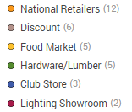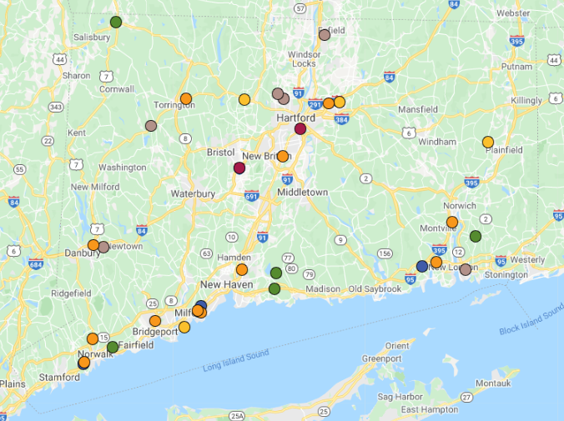

**2. DATA COLLECTION METHODOLOGY**

This research was designed to generate product availability and pricing information for key product types to inform market conditions and program planning. This is not an exhaustive shelf inventory. For each of 25 key product types (see Table 3), a single model/SKU is selected to inventory at each location. The individual SKUs at each brightness level for LEDs and corresponding baseline incandescent/halogen products are selected based on: a) high sales volume and b) market representation of the product type.

For each SKU inventoried, the additional product characteristics: bulbs per package, wattage, light output, and color temperature were captured. Retailer specific information: shelf area, regular retail price, and program adjusted retail price were captured (where available). Additionally, we captured whether the SKU was ENERGY STAR labeled and labeled by the Energize CT program. The data collection instrument is included in Appendix B for specific detail on what information was collected.

**Table 3. Key Product Types**



Both the regular retail price and the program adjusted retail price were not available for some LED SKUs in some locations. In nearly all these cases these are situations where the program adjusted price is posted at the retailer but not along with the regular retail price. We utilized both cross-location comparisons and MOU data to verify that the program adjusted price was posted and updated the collected data with the regular retail price. For example, the Manchester Home Depot location did not list the regular retail price for the general purpose dimmable A-Line LED bulbs that were inventoried. At each brightness level (60W eq.: $5.48, 4-pack; 75W eq.: $4.65, 2-pack; 100W eq.: $5.23, 2-pack), the same EcoSmart products were inventoried at both the Uncasville and Bridgeport locations with the same program adjusted pricing AND the regular retail prices (60W eq.: $9.48; 75W eq.: $7.85; 100W eq.: $8.43). We used this cross-location comparison to update the regular retail price data for the Manchester location. We also utilized the SKU level product information listed program MOUs to identify regular retail prices where none was listed at retail locations.

In three locations in our sample it was not possible to complete the data collection because of Covid-19 guidelines. The Connecticut Lighting Center locations participate in the program through a two-party MOU and promote LED bulbs (mostly Satco and Bulbrite). Both locations exclusively carry LED bulbs. The displays of these products are near the registers/computers where sales associates are working with customers. It was not possible to complete the data collection while maintaining physical distance and without interfering with the sales process. The third location where data collection had to be abandoned was a Westport True Value Hardware. This is a small store with a wide selection of Satco bulbs. Again, it was not possible to collect data while maintaining physical distance and not interfering with sales.

**3. PRODUCT AVAILABILTY**

Table 4 provides a breakdown of where key product types are available in each retail channel.

**Table 4. Availability of Key Product Types by Retail Channel**

|  |  |  |  |  |  |  |  |  |  |  |  |  |  |
| --- | --- | --- | --- | --- | --- | --- | --- | --- | --- | --- | --- | --- | --- |
| **Shape** | **Technology** | **Dim** | **Equiv.Watts** | **Club Store** | | **Discount**  **Store** | | **Food Market** | | **Hardware/ Lumber** | | **National Retailers** | |
| **TOTAL LOCATIONS:** | | | | | **3** | | **6** | | **5** | | **4** | | **12** | |
| A-Line | LED | Yes | 60 | 3 | | 6 | | 5 | | 4 | | 12 | |
| A-Line | LED | Yes | 75 |  | | 2 | | 3 | | 4 | | 12 | |
| A-Line | LED | Yes | 100 | 3 | | 5 | | 4 | | 4 | | 12 | |
| A-Line | LED | No | 60 |  | | 2 | | 3 | | 4 | | 10 | |
| A-Line | LED | No | 75 |  | |  | | 3 | | 4 | | 4 | |
| A-Line | LED | No | 100 |  | |  | | 3 | | 4 | | 10 | |
| A-Line | Halogen | Yes | 60 |  | | 2 | | 4 | | 4 | | 12 | |
| A-Line | Halogen | Yes | 75 |  | |  | | 4 | | 4 | | 12 | |
| A-Line | Halogen | Yes | 100 |  | | 2 | | 4 | | 4 | | 12 | |
| Globe | LED | Yes | 25 |  | |  | | 2 | | 2 | | 3 | |
| Globe | LED | Yes | 40 |  | | 2 | | 3 | | 4 | | 12 | |
| Globe | LED | Yes | 60 |  | |  | | 2 | | 4 | | 12 | |
| Globe | Incand | Yes | 25 |  | |  | | 2 | | 3 | | 8 | |
| Globe | Incand | Yes | 40 |  | | 2 | | 3 | | 3 | | 9 | |
| Globe | Halogen | Yes | 60 |  | | 1 | | 2 | | 3 | | 6 | |
| Candelabra | LED | Yes | 25 |  | |  | | 1 | | 4 | | 9 | |
| Candelabra | LED | Yes | 40 | 3 | | 1 | | 4 | | 4 | | 12 | |
| Candelabra | LED | Yes | 60 |  | | 1 | | 3 | | 3 | | 12 | |
| Candelabra | Incand | Yes | 25 |  | |  | | 3 | | 4 | | 7 | |
| Candelabra | Incand | Yes | 40 |  | | 2 | | 3 | | 4 | | 9 | |
| Candelabra | Incand | Yes | 60 |  | | 2 | | 3 | | 4 | | 9 | |
| BR30 Reflector | LED | Yes | 65 | 3 | | 4 | | 3 | | 4 | | 12 | |
| BR30 Reflector | LED | No | 65 |  | |  | |  | | 3 | | 1 | |
| 5/6 Retrofit Kit | LED | Yes | 75 | 3 | | 1 | |  | | 4 | | 7 | |
| BR30 Reflector | Incand | Yes | 65 |  | | 2 | | 4 | | 4 | | 9 | |

**Some Key Findings:**

* Baseline incandescent and halogen products are widely available in Food Markets, Hardware/Lumber, and National Retailers, especially for general purpose A-Line bulbs.
* Discount stores primarily only carry products that are “brought in” by Energize CT program. The one exception to this is dollar stores which tend to carry some amount of baseline products.
* Walmart does not stock baseline incandescent products for: Globe, Candelabra, and Directional products, but does still carry baseline A-Line halogen bulbs.
* In the G25 Globe shaped product category, 25W equivalent LED bulbs are rarely available across all retailers and 60W equivalent G25s are somewhat less common, as well. 40W equivalent G25 products are more commonly available across retailer types.
* As with G25 Globes, 25W equivalent LED Candelabra bulbs are less commonly found than 40W and 60W equivalent bulbs.
* In the Directional category, non-dimmable BR30 LED products are rarely found (mostly only in Hardware stores). However, dimmable LED BR30 products and their corresponding baseline incandescent bulbs are widely available.

**4. BULB PRICING**

In the next 4 sections, we present pricing information for 11 key efficient product types and their corresponding baseline products. In all figures, the error bars reflect the 80% confidence intervals for the observations. In all cases, we are presenting the average **regular** retail price per bulb from varying package configurations based on what was inventoried for the key product type in each location. In all cases, care was taken to make sure the pricing **does not include program incentives**.

A reminder that this pricing information *does NOT* represent an average of *all* SKUs and *all* package configurations within each key product type. The pricing information is the average of the individual SKUs chosen to represent the key product type in each sample location. As such, this pricing information does not represent the full range of pricing in the market. Rather, it aims to show a clear representation of the difference between key efficient and baseline products in the market for planning purposes.

It should also be noted that some product-retail channel combinations (e.g. 75W Equiv. A-Line bulbs in Discount retailers) have extremely small sample sizes and correspondingly large confidence intervals. In some other instances (e.g. Club Stores, all products; Discount stores, baseline products) pricing across this market varies extremely little (or none). Confidence intervals are very small or non-existent in those cases. We refer readers back to Table 4 to note the sample sizes for each product and retailer combination.

**5. PRICING – General Purpose (A-Line) Products**

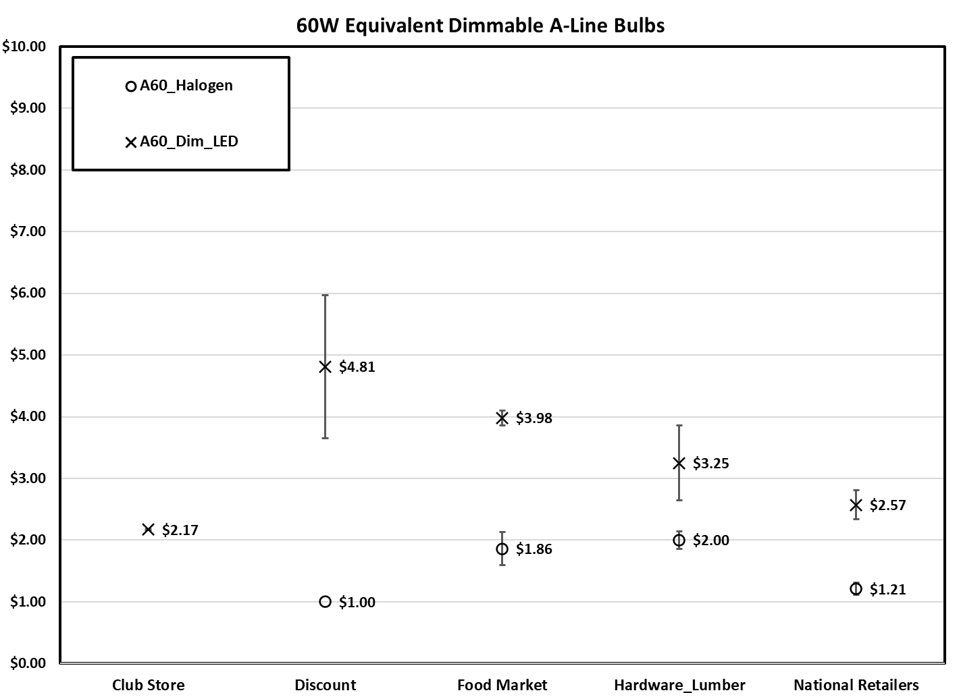

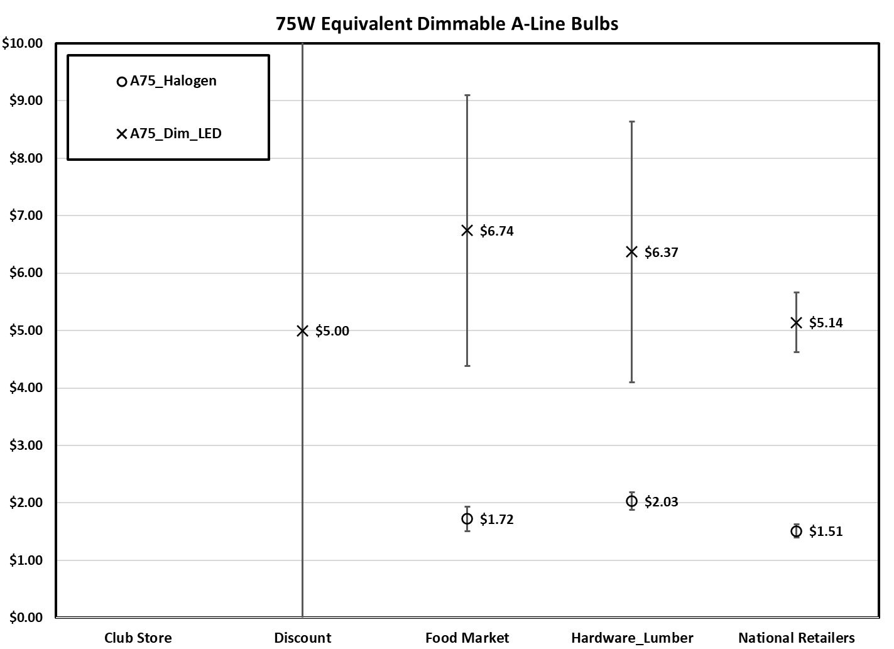

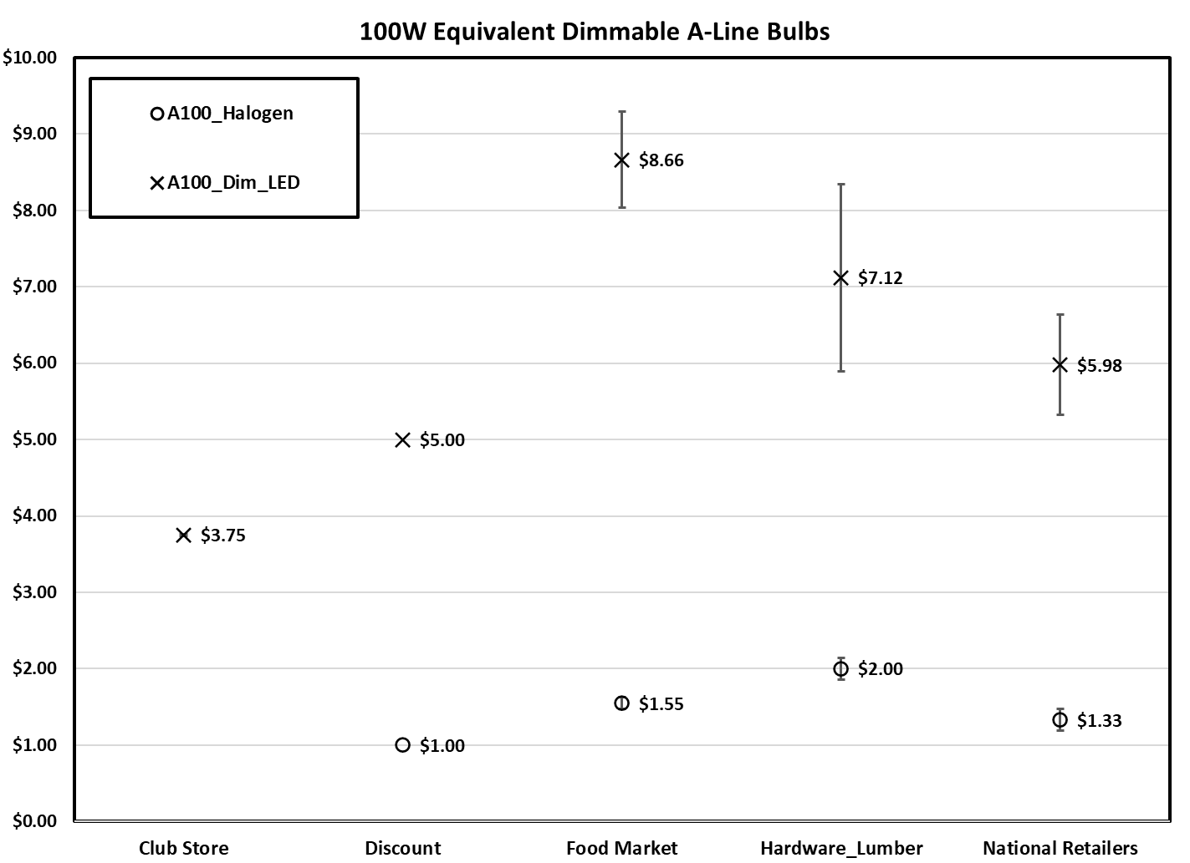

In addition to the pricing information for dimmable A-Line products in the previous three figures, we compared pricing for dimmable vs. non-dimmable 60W equivalent A-Line bulbs (see Figure below).

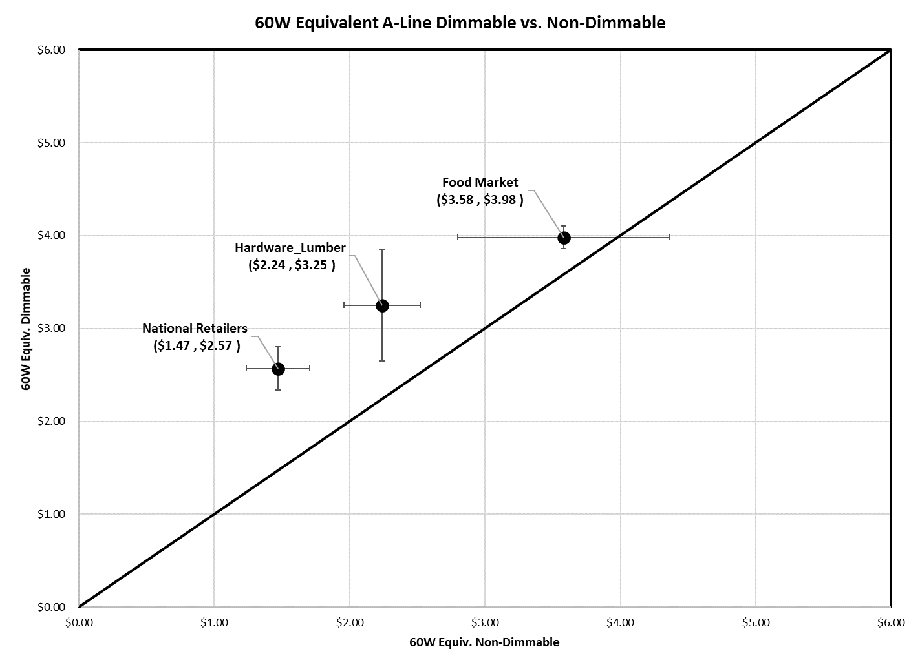

**Some Key Findings:**

* Across all brightness levels, efficient A-Line products are more expensive than their baseline halogen counterparts.
* These differences range from just over $1 per bulb for 60W equivalent bulbs in Hardware/Lumber and National Retailers to over $4 per bulb for brighter bulbs in those same retail channels. The maximum difference (≈$7) is likely to be found in the Food Market channel for brighter bulbs (e.g. 100W equivalent).
* The price variation for the baseline halogen products is notably smaller than efficient products across all product brightness levels and retail channels.
* There is notable range in average retail pricing across the retail channels for bulbs at each brightness level. Club Stores and National Retailers tend to have lower pricing than Hardware/Lumber and Food Stores. There is notably less variation in baseline halogen products across retail channels.
* In two of the three retail channels where non-dimmable LED bulbs were available, the pricing is significantly lower than their dimmable counterparts.

**6. PRICING – Candelabra Products**

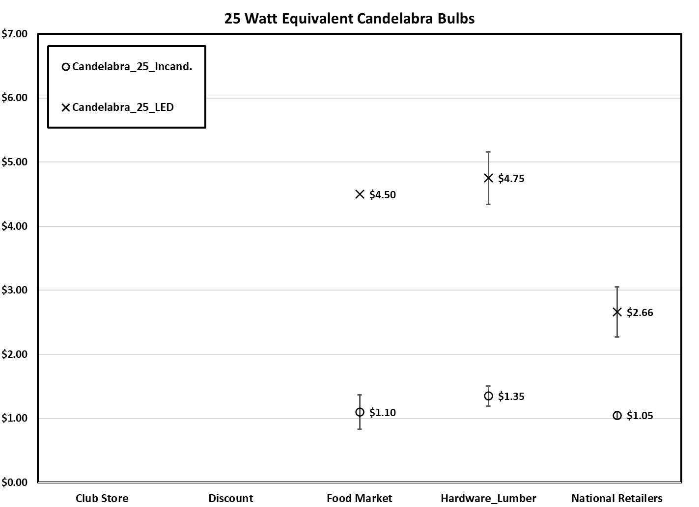

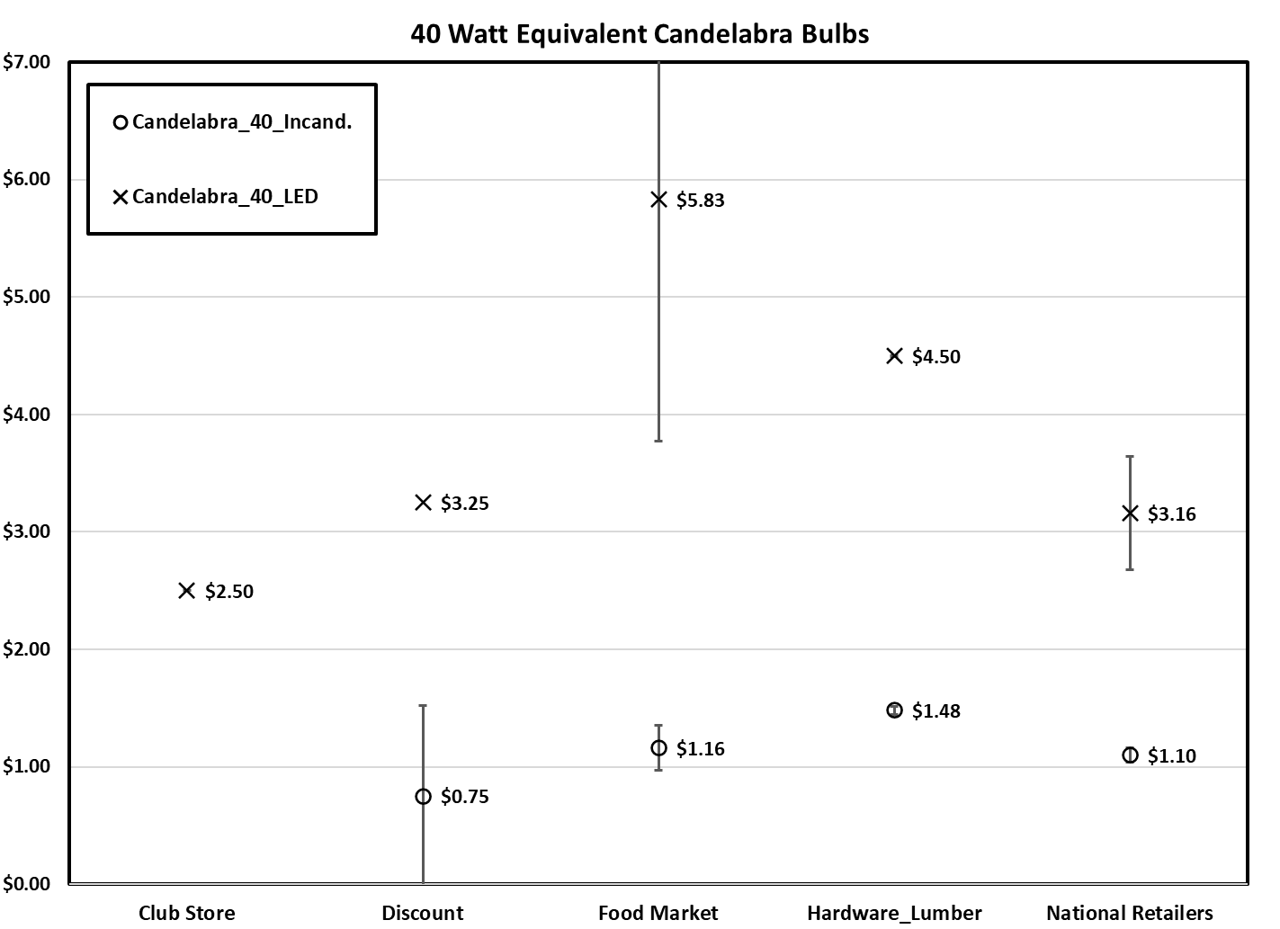

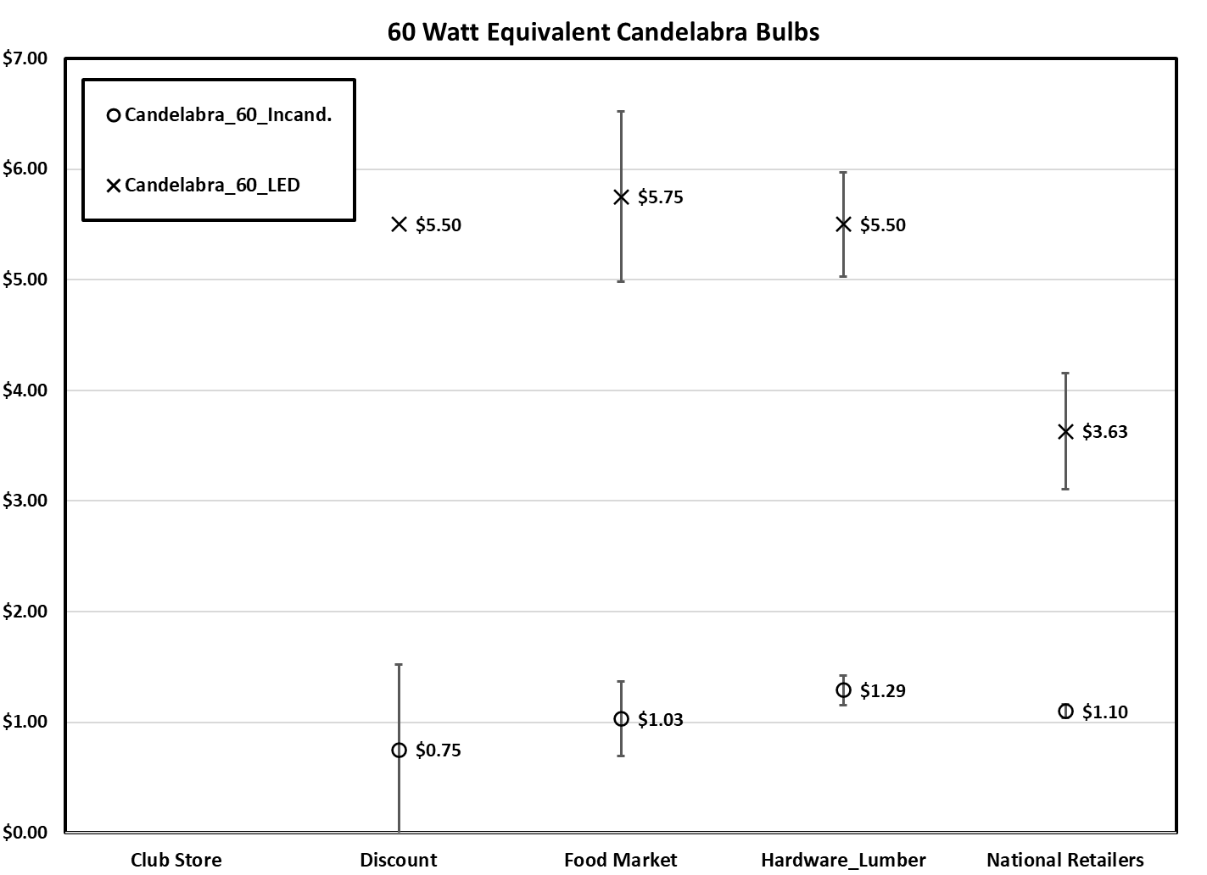

**Some Key Findings:**

* Across all brightness levels and retail channels, efficient Candelabra products are more expensive than their baseline halogen counterparts.
* As with A-Line products, there is notable price variation for efficient products at each brightness level across the different retail channels. This price variation is notably less for baseline incandescent bulbs than their efficient counterparts.
* Highlighting the 40W equivalent category since it is most widely available for both efficient and baseline products, the price differential (within channel) is between ≈$2 per bulb in National Retailers and well over $4 per bulb in Food Stores.

**7. PRICING – G25 Globe Products**

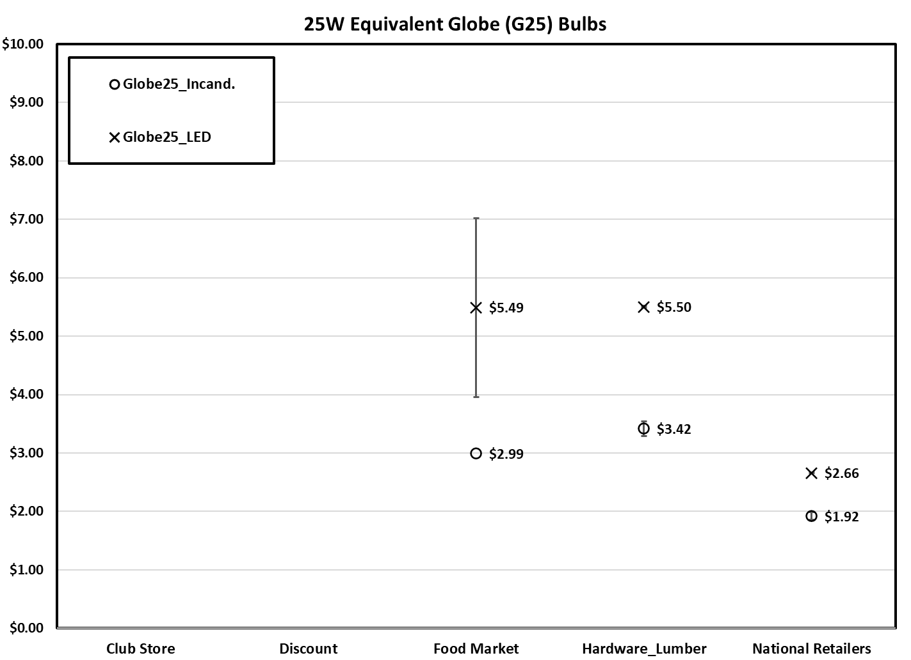

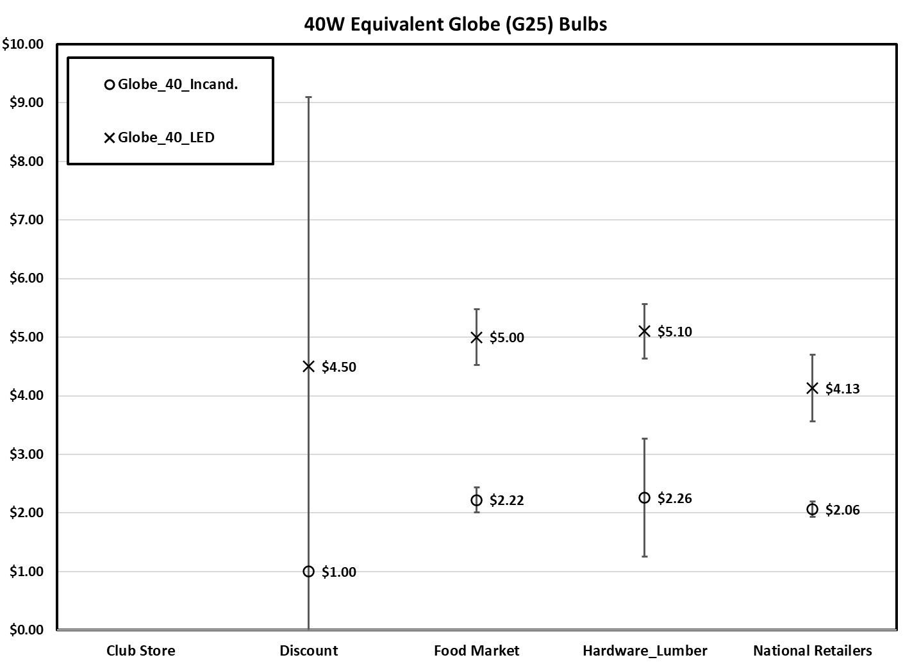

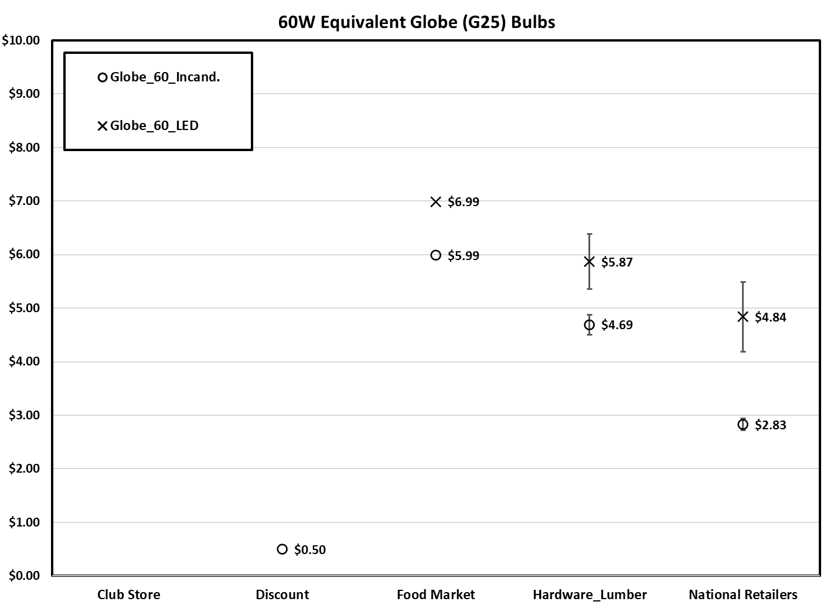

**Some Key Findings:**

* Across nearly all brightness levels and retail channels, efficient G25 Globe products are more expensive than their baseline incandescent/halogen counterparts.
* For these G25 Globe products there is notable price variation for efficient and baseline products at each brightness level across the different retail channels.
* As with Candelabra bulbs, highlighting the 40W equivalent category since it is most widely available in both efficient and baseline products, the price differential (within channel) is more consistent across retailer types between ≈$2 and $3 per bulb.

**8. PRICING – Directional Products**

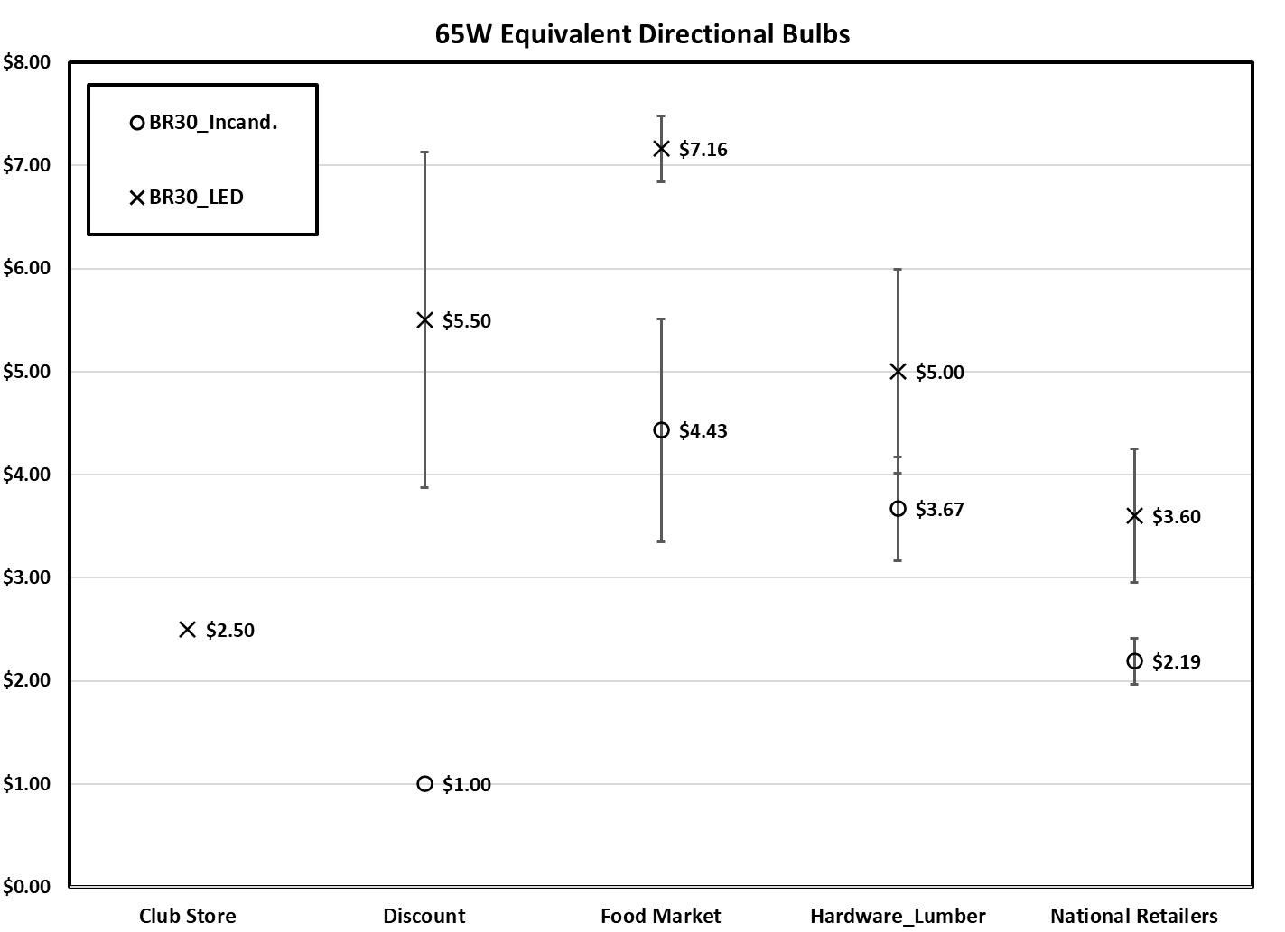

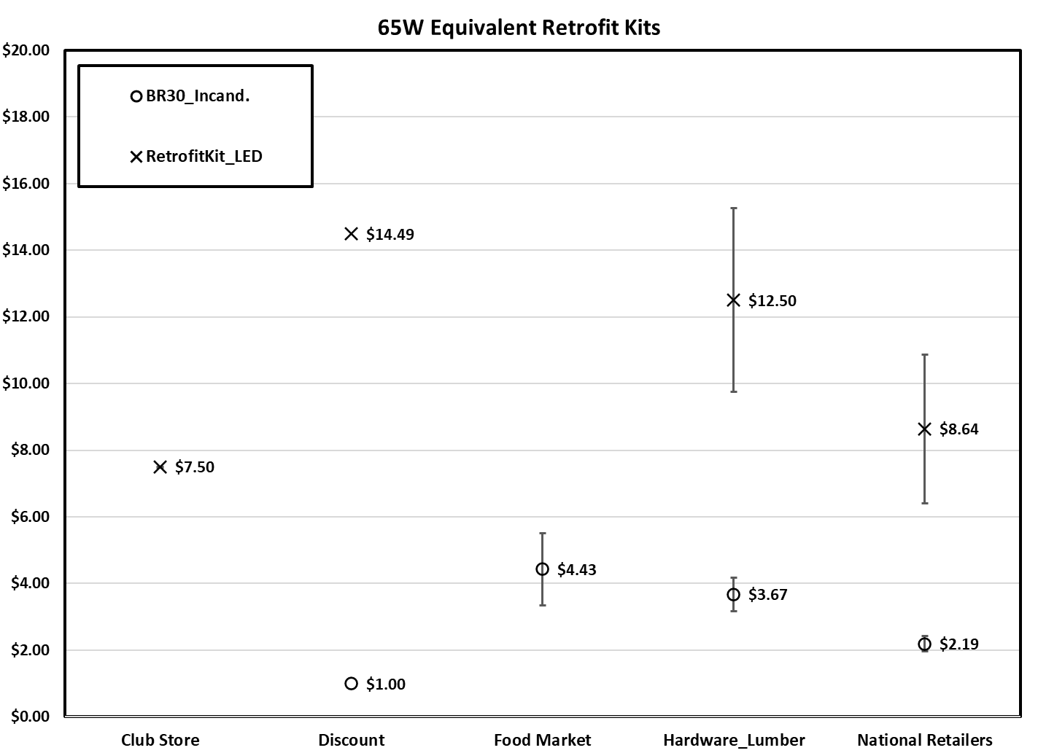

**Some Key Findings:**

* There is a strong variation in the pricing of both efficient and baseline BR30 products across retail channels.
* Efficient BR30 products (within channel) cost significantly more than baseline products with the exception being the Hardware/Lumber channel.
* However, the cost difference is notably less (especially on a percentage of the total cost basis) than the other key product categories.
* The price differences between 5/6” retrofit kits and baseline BR30 incandescent products is significant and ranges from ≈$6 per bulb in National Retailers to well over $8 per bulb in the Hardware/Lumber channel.

**9. Progression of Federal Standards**

Over the past two years, there have been two major developments in the DOE rulemaking process that have significant implication for the kinds of light bulbs that will continue to be available for purchase in the U.S. market.

First, in February 2019, DOE published a Notice of Proposed Rulemaking (NOPR) “proposing to withdraw the revised definitions of general service lamp (GSL), general service incandescent lamp (GSIL) and other supplemental definitions, that were to go into effect on January 1, 2020. DOE received comments and held public hearings on this issue and finalized the rule on September 5, 2019. The effect of the ruling was to revert back to the definitions for GSL and GSIL in place prior to January 19, 2017.

Second, effective December 27, 2019, DOE determined that standards for GSIL were not “economically justified”, and therefore, would not be updated. This allows the continued sale of all baseline incandescent/halogen products that were inventoried in this research.

Two reactionary petitions have been filed in the U.S. Court of Appeals for the Second Circuit in response to these DOE rules. The first petition (which itself is the combination of two petitions – one from a group of U.S. states and another from a group of environmental organizations) challenges DOE’s withdraw of the revised definitions of GSL and GSIL put into place in January 2017. The second petition, also filed in the U.S. Court of Appeals for the Second Circuit, involves the NRDC along with several other public interest environmental groups and challenges DOE’s determination not to update GSIL standards. This second petition is being held in abeyance by the court while it decides the first petition. As of June 15, 2020, arguments have been filed by both parties in the first petition. Although there is no deadline set for a ruling in the petition, it is not expected to be resolved until Q3 or Q4 2020. It seems likely that the progression of these court petitions has the effect of maintaining *status quo* in the market for the foreseeable future.

**APPENDIX A – Listing of Sample Locations**



**APPENDIX B – DATA COLLECTION INSTRUMENT**

