Northeast Residential Lighting Hours-of-Use Study

DRAFT

1/17/2014

Submitted to:
Connecticut Energy Efficiency Board
Cape Light Compact
Massachusetts Energy Efficiency Advisory Council
National Grid Massachusetts
National Grid Rhode Island
New York State Energy Research and Development Authority
Northeast Utilities
Unitil

Submitted by:
NMR Group, Inc.
DNV GL

Contents
Executive Summary I
Methodology I
Sample Design, Recruitment and Onsite Visits I
Sample Attrition, Data Cleaning, and Treatment of Outliers II
Coefficient of Variation II
Weighting III
HOU Modeling III
Derivation of Load Curves IV
Solar Shading IV
HOU Analysis Results V
HOU Analysis Results – Hierarchical Models: All Bulbs V
HOU Analysis Results – Standalone Models: All Bulbs VI
Inefficient versus Efficient Bulbs HOU VII
Load Shape Analysis VIII
Solar Shading Analysis X
Considerations XI
Consider Adopting the Overall model for CT, MA, RI, and Upstate New York XI
Consider Adopting Two Models for NYSERDA Area XI
Consider Higher HOU Estimates for Retrospective Studies XI
Consider Higher HOU Estimates for LED Promotions Moving Forward XII
1 Introduction 1
2 Methodology 2
2.1 Sample Design and Recruitment 2
2.2 Onsite Visits 4
2.2.1 Data Collection – Initial Visit 4
2.2.2 Data Collection – Logger Retrieval 6
2.2.3 Quality Assurance and Control 6
2.3 Sample Attrition, Data Cleaning, and Outlier Detection 7
2.4 Sample and Coefficient of Variation 9
2.5 Weighting 12
2.6 HOU Modeling 13
2.6.1 Annualized HOU Estimates 13
2.6.2 Adjusted HOU 15
2.6.3 Hierarchical Model 16
2.6.4 Overall Regression Model Coefficients 17
2.7 Derivation of Load Curves 18
2.8 Solar Shading Methodology 19
2.8.1 Glazing 19
2.8.2 Solar Shading 20
3 HOU Analysis Results 23
3.1 Analysis Organization 23
3.2 Overall HOU Estimates 25
3.2.1 Overall HOU Estimates – Room-by-Room 27
3.3 HOU Estimates by Home Type and Income Level 29
3.4 Efficient and Inefficient Bulb Types 33
3.4.1 Efficient and Inefficient Bulb Types – Room by Room 34
3.4.2 Efficient and Inefficient Bulb Types – Unweighted Analyses 38
4 Load Shape Analysis 41
4.1 Summer and Winter Load Shapes 41
4.3 Calculating Coincide Factors for Peak Periods 46
4.3.1 ISO-NE Seasonal Peak Hours 47
4.3.2 NYISO Seasonal Peak Hours 48
5 Solar Shading Analysis 50
5.1.1 Glazing 50
5.1.2 Solar Exposure 51
5.1.3 Regression Model 52

Tables
Table ES-1: Original and Updated Coefficient of Variation – All Home Types III
Table ES-2: HOU Estimates by Area and Room VI
Table ES-3: HOU Estimates by Area and Room VII
Table ES-4: HOU by Area for Efficient Bulbs VIII
Table ES-5: HOU by Area for Efficient Bulbs VIII
Table ES-6: Peak Period Coincidence Factors and Confidence Intervals X
Table ES-7: Marginal Effects of Solar Predictors from Regression Analysis XI
Table 2-1: Recruitment Method 3
Table 2-2: Data Collected for Installed Bulbs by Area 5
Table 2-3: Estimated Usage vs. Average HOU Recorded 8
Table 2-4: Logger Counts with Attrition 9
Table 2-8: Original and Updated Coefficient of Variation 10
Table 2-9: Updated Coefficient of Variation by Sub-sample 11
Table 2-5: Variables Used as Predictors in HOU Regression Models 15
Table 2-6: Overall Estimated HOU from Preliminary Models 16
Table 2-7: Overall Regression Coefficients from Hierarchical Model 19
Table 3-1: Overall HOU Estimates by Area and Room 29
Table 3-2: Sample Sizes, Overall HOU Estimates by Area and Room 29
Table 3-4: Sample Sizes, Inefficient Bulbs 37
Table 3-5: HOU by Area for Efficient Bulbs 38
Table 3-6: Sample Sizes, Efficient Bulbs 38
Table 3-7: Daily Average HOU Overall by Type of Bulb (Unweighted) 39
Table 4-1: Peak Period Coincidence Factors and Confidence Intervals 47
Table 4-2: Peak Period Coincidence Factors and Confidence Intervals 48
Table 4-3: ISO New England Seasonal Peak Period Coincidence Factor 48
Table 4-4: Peak Period Coincidence Factors and Confidence Intervals 50
Table 5-2: Glazing Classes 51
Table 5-3: Southerly Glazing Classes 51
Table 5-4: Solar Exposure Classes 52
Table 5-5: Binned Sum of Class Values 53
Table 5-6: Variables Used in Solar Shading Regression Analysis 55
Table 5-7: Marginal Effects of Solar Predictors from Regression Analysis 55

Figures
Figure ES-1: Site Locations with Population Density II
Figure ES-2: Overall Load Curve for Summer and Winter (Weekday) X
Figure 2-1: Site Locations with Population Density 4
Figure 2-2: Overview of Hierarchical Model 17
Figure 2-3: Solar Pathfinder 21
Figure 2-4: View Out SE-facing Window 22
Figure 2-5: Solar Pathfinder Assistant Report 23
Figure 3-1: Overall HOU Estimates by Area 27
Figure 3-2: HOU Estimates by Home Type and Income Level – Hierarchical Models 32
Figure 3-3: HOU Estimates by Home Type and Income Level – Standalone Models 33
Figure 3-4: HOU Estimates by Bulb Type and Area 35
Figure 3-5: HOU Estimates by Bulb Type and Fixture Type (unweighted) 40
Figure 3-6: HOU Estimates by Bulb Type and Fixture Type (unweighted) 41
Figure 4-1: Connecticut Load Curve for Summer and Winter (Weekday) 42
Figure 4-2: Massachusetts Load Curve for Summer and Winter (Weekday) 43
Figure 4-3: Rhode Island Load Curve for Summer and Winter (Weekday) 43
Figure 4-4: Upstate New York Load Curve for Summer and Winter (Weekday) 44
Figure 4-5: Overall Load Curve for Summer and Winter (Weekday) 44
Figure 4-6: Manhattan Load Curve for Summer and Winter (Weekday) 45
Figure 4-7: Downstate New York Load Curve for Summer and Winter (Weekday) 45
Figure 4-8: NYSERDA Load Curve for Summer and Winter (Weekday) 46
Figure 4-9: ISO New England Seasonal Peak Period – HOU Load Shape (Winter) 49
Figure 4-10: ISO New England Seasonal Peak Period – HOU Load Shape (Summer) 49
Figure 4-11: NY ISO Peak Hour – HOU Load Shape 50

Executive Summary
The purpose of this study was to provide updated information to the Connecticut Energy Efficiency Board, the Massachusetts Program Administrators (Cape Light Compact, National Grid Massachusetts, Northeast Utilities, and Unitil), National Grid Rhode Island, and the New York State Energy Research and Development Authority (hereafter “the Sponsors”) to assist in the calculations of demand and energy savings for lighting programs. Specifically, this report presents load shapes, coincidence factors (CFs), and daily hours of use (HOU), and also presents a separate analysis of the effects of “urban canyons” on the lighting use of high-rise apartment dwellers in Manhattan.
Following are the principal tasks completed as part of this project:
- Sample design
- Recruitment
- Onsite data collection
- Analysis and reporting
In addition, this study leveraged data collected as part of two additional concurrent studies: the Massachusetts Low-Income HOU Study (conducted by Cadmus) and the National Grid New York EnergyWise Study (conducted by DNV GL). NMR, Cadmus, and DNV GL coordinated the development of protocols and methods to ensure comparable data.

Methodology
We provide a brief overview of the methodology here in the Executive Summary; for complete details, please refer to Section 2.

Sample Design, Recruitment and Onsite Visits
For this evaluation, the Team collected data through onsite visits to 848 homes located throughout Connecticut, Massachusetts, New York, and Rhode Island. All sites required two visits. During the first visit, the Team collected detailed lighting inventory data and installed time-of-use light meters (loggers). The second visit consisted of removing loggers installed during the first visit. In New York, NYSERDA funded the inclusion of an additional oversample of high-rise homes located in Manhattan. The second sampling approach involved an oversample of high-rise apartments. This high-rise oversample was designed to focus on households whose lighting use would most likely be affected by their locations in “urban canyons.”
The team offered all potential study participants incentives that varied by area and study (that is, the region-wide study in all four states, and a separate study of high-rise apartments in Manhattan). Sections 2.1 and 2.2 provide additional detail on sample design, recruitment methods, and onsite visit protocols. Figure ES-1 provides an overview of the sample included in the final analysis, along with population density.
Figure ES-1: Site Locations with Population Density
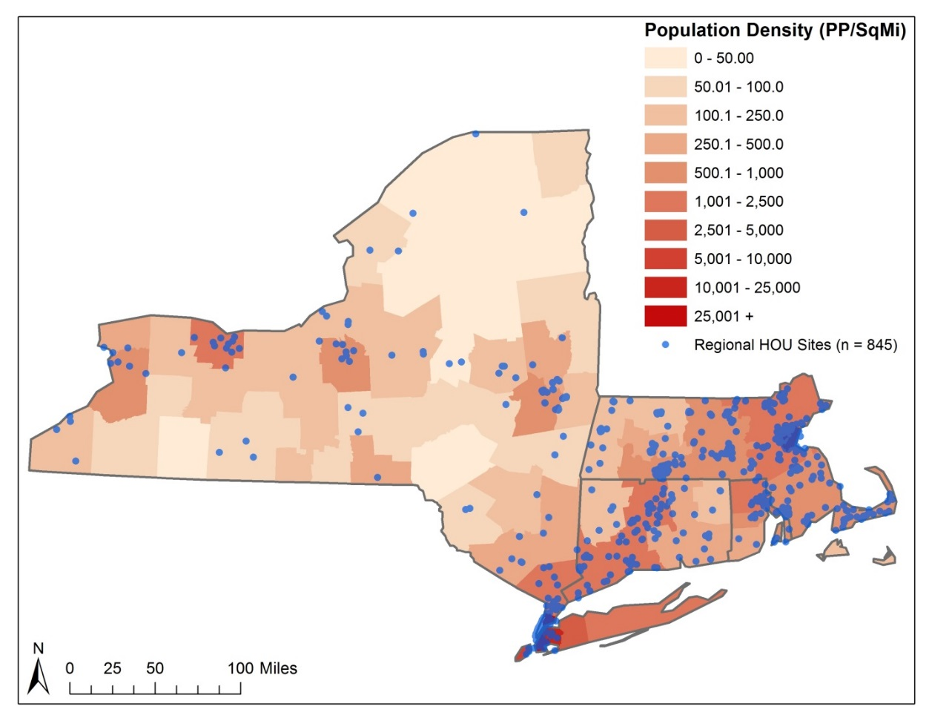

Sample Attrition, Data Cleaning, and Treatment of Outliers
Altogether, over 5,730 loggers were installed between December 2012 and March 2013. Logger installations were timed to be as close to the winter solstice as practical, given project constraints and the impact of winter storms. All of the loggers in Rhode Island were installed prior to December 21, 2012. Logger installation in the other areas began in January 2013 and was completed by the end of March 2013. Logger retrieval began in June 2013 and continued through August 2013. Attrition due to customers moving, damage to loggers, and lost loggers reduced the sample about 4%.
The team was very careful in identifying and removing loggers with HOU values that might be considered outliers. While some loggers recorded very high usage over the study period, the percentage of these loggers was small. In addition, the Team implemented quality assurance and control procedures during logger installation and removal that reduced errors associated with loggers recording incorrect data (described in Section 2.2). Removing outliers and data cleaning (see Section 2.3) reduced the number of loggers included in the final analysis to 4,642.

Coefficient of Variation
Table ES-1 provides a summary of the coefficients of variation (CV) assumed when calculating the original onsite sample sizes, final sample sizes used in the analysis, the updated CV found by this study, and the sample size required by the updated CV to achieve 90/10 precision. Further discussion of the CVs can be found in Section 2.4.
Table ES-1: Original and Updated Coefficient of Variation – All Home Types
Room | Original CV | Final Sample Size utilized in Analysis | Updated CV | Sample Size using Updated CV
Bathroom | 0.7 | 700 | 1.38 | 515
Bedroom | 0.7 | 913 | 1.15 | 358
Dining Room | 0.7 | 401 | 1.10 | 327
Exterior | 0.7 | 184 | 0.89 | 214
Kitchen | 0.7 | 751 | 0.93 | 233
Living Space | 0.7 | 742 | 1.04 | 293
Other | 1.0 | 951 | 1.60 | 693

Weighting
To account for differences in demographics and lighting inventory in the final sample and the population, the Team applied a complex weighting scheme. For each logger, we applied a premise weight that controlled for home type (single-family or multifamily) and income (low-income or not-low-income). Also at the logger level, we applied room weights that adjusted for the total number of bulbs in a given room type as well as the total number of logged bulbs in each room type. Room-level weights were further broken out by efficient and inefficient bulb types. For a complete overview of weights, please see Section 2.5.

HOU Modeling
Developing HOU estimates consisted of three modeling steps:
- Creating annual datasets (Section 2.6.1)
- Adjusting HOU estimates (Section 2.6.2)
- Applying a hierarchical model (Section 2.6.3)
A summary of each modeling steps is included here in the Executive Summary. Detailed descriptions of each of the steps in the modeling are included in Section 2).
Creating Annual Datasets. Since each logger was installed for only a portion of the year—between five and nine months—we had to annualize the data, and we did this by fitting a sinusoid model to each logger. We drew upon the methods outlined in the KEMA/Cadmus California Upstream Lighting Program Evaluation. The Team fitted separate weekend and weekday models for each logger. For any loggers not conforming well to the sinusoid model, the analysts took additional steps to prepare annualized estimates based on average daily usage over the period logged (described in Section 2.6.1).
Adjusting HOU Estimates. Using the annualized estimates, we performed a weighted regression analysis to estimate the adjusted HOU for each room in each area of the study. In this step, only loggers for each individual area were used to develop area-specific estimates, and all loggers were used to develop estimates for the overall region. Based on outputs from this model, it was clear that Connecticut, Massachusetts, Rhode Island, and Upstate New York all had comparable usage patterns and that usage patterns for Downstate New York (including Manhattan) households were different compared to the other areas.
Applying a Hierarchical Model. Due to the similar use patterns in four of the areas (CT, MA, Upstate NY, and RI), we sought a way to leverage data from each of these areas to refine area-specific estimates. To accomplish this, we fit a multi-level hierarchical model. The advantage of this type of modeling approach is the ability to use information from all four areas to help inform area-specific estimates. In a hierarchical model, the observations specific to an area form the basis of the estimates for that area, while observations from outside that area also inform and help refine the area-specific estimates., The hierarchal model is particularly beneficial for areas where fewer loggers were installed, thereby providing more refined (tighter precision and adjusted means) HOU estimates compared to individual models fit to each area separately.

Derivation of Load Curves
As with the HOU modeling, since each logger was installed for only a portion of the year—between five and nine months—we had to annualize the data to generate a full year of monthly load curves for the eight geographies included in the study. In general, adequate load data was available for February through July for all areas. For any months lacking sufficient data, we applied two techniques to estimate additional load data: an equivalent-dates technique and modeling lighting usage as a function of average hours of daylight. Both methods rely on the relationship between lighting and average daylight hours. Additional discussion of these methods is included in Section 2.7.

Solar Shading
To explore the effects of shading on lighting HOU, the Team collected glazing and solar shading data for 130 sites in high-rise apartment units in Manhattan to determine if the availability of direct sunlight, and ambient light generally, has an effect on residential lighting use in high-rise apartments. The Team developed a regression model to quantify the relationship. For additional details, see Section 2.8.

HOU Analysis Results
When we began to analyze HOU across areas, it became apparent that the HOU estimates for Connecticut, Massachusetts, Rhode Island, and Upstate New York were all very similar and that the estimates for Manhattan, Downstate New York, and NYSERDA diverged from the other areas. The HOU estimates for Manhattan and Downstate New York are significantly higher compared to those for all five of the hierarchical models, and the NYSERDA combined model is higher compared to each of the hierarchical models except for the Connecticut model. It is important to note that the estimates from the hierarchical Upstate New York model are significantly different from the estimates from the Downstate New York model and the NYSERDA standalone model that is informed by the Upstate New York model.
To simplify the analysis presented in the Executive Summary, we will focus on comparing the four similar areas informed by the hierarchical model (plus the Overall model that collapses results of the other four) and then discuss the NYSERDA area standalone models.

HOU Analysis Results – Hierarchical Models: All Bulbs
Across the four areas included in the hierarchical model, we found no significant differences in HOU estimates at the household level between any of the areas. Even at the room level, only three significant differences exist:
- Bedroom: HOU in Upstate New York (1.7) are significantly lower compared to those in Connecticut (2.6)
- Exterior: HOU in Rhode Island (6.6) are significantly higher compared to those in both Massachusetts (1.7) and Upstate New York (1.7)
Further, when we examined HOU estimates in these four areas by eight categories of home type and income levels, within areas across the eight categories there were only four significant differences:
- Massachusetts: HOU estimates for non-low-income multifamily households are significantly lower compared to those for single-family, low-income, and low-income single-family households.
- Rhode Island: HOU estimates for low-income households are significantly higher compared to those for non-low-income households.
Across the areas, there were only three significant differences among the four areas:
- Low-income: Household HOU in Connecticut (3.2) are higher compared those for to Massachusetts (2.7)
- Low-income single-family: Household HOU in Rhode Island (1.9) are lower compared to those for Connecticut (3.2) and Massachusetts (2.7).
With such minor differences in HOU estimates across Connecticut, Massachusetts, Rhode Island, and Upstate New York and with relatively few differences at the home type and income level, the Team recommends that the Sponsors consider adopting the HOU room-by-room estimates from the Overall hierarchical model for all households. Table ES-2 provides the room-by-room estimates by area.
Table ES-2: HOU Estimates by Area and Room – All Bulbs
Room | CT | MA | RI | UNY | Overall
Bedroom | 2.6 (2.2, 3.1) | 2.0 (1.8, 2.3) | 2.6 (2.0, 3.3) | 1.7 (1.3, 2.1) | 2.1 (1.9, 2.3)
Bathroom | 1.5 (1.1, 2.0) | 1.8 (1.5, 2.0) | 1.2 (0.6, 1.8) | 1.9 (1.5, 2.4) | 1.7 (1.5, 1.9)
Kitchen | 4.6 (4.0, 5.1) | 4.0 (3.7, 4.3) | 3.8 (3.0, 4.5) | 4.1 (3.7, 4.6) | 4.1 (3.9, 4.3)
Living Space | 3.8 (3.3, 4.3) | 3.3 (3.0, 3.6) | 3.4 (2.7, 4.2) | 3.1 (2.6, 3.5) | 3.3 (3.1, 3.6)
Dining Room | 3.2 (2.6, 3.9) | 2.7 (2.3, 3.1) | 3.5 (2.6, 4.6) | 2.5 (1.9, 3.1) | 2.8 (2.5, 3.1)
Exterior | 6.0 (5.6, 6.5) | 5.5 (5.2, 5.8) | 6.6 (6.0, 7.1) | 5.5 (5.1, 5.8) | 5.6 (5.3, 5.9)
Other | 1.7 (1.4, 2.0) | 1.7 (1.5, 1.9) | 1.6 (1.2, 2.0) | 1.7 (1.4, 2.0) | 1.7 (1.6, 1.9)
Overall | 2.8 (2.7, 3.0) | 2.7 (2.6, 2.8) | 2.6 (2.3, 2.9) | 2.6 (2.4, 2.8) | 2.7 (2.6, 2.8)

HOU Analysis Results – Standalone Models: All Bulbs
Comparing Manhattan, Downstate New York, and NYSERDA to each other, there are no statistically significant differences at the household level, the room level, or even among the eight home type and income categories. However, there were several statistically significant differences:
- Downstate: HOU estimates for low-income households are significantly higher compared to those for single-family overall, non-low-income overall, non-low-income single-family, and non-low-income multifamily households.
- NYSERDA:
  - HOU estimates for single-family households are significant lower compared to those for multifamily, low-income, and low-income multifamily households.
  - HOU estimates for non-low-income households are significantly lower compared to those for low-income and low-income multifamily households.
The divergence of Upstate New York and Downstate New York estimates and the relative proportion of single-family and multifamily homes in each area help to explain the difference in the NYSERDA service area model. Given this divergence, NYSERDA should consider adopting separate HOU estimates for Upstate New York and Downstate New York. We recommend that NYSERDA consider adopting the Overall model room-by-room estimates and the Downstate New York model presented in Table ES-3.
Table ES-3: HOU Estimates by Area and Room – All Bulbs
Room | MHT | DNY | NYSERDA
Bedroom | 3.4 (2.9, 4.0) | 3.6 (3.1, 4.1) | 2.8 (2.4, 3.2)
Bathroom | 2.7 (2.2, 3.3) | 3.2 (2.4, 4.1) | 2.8 (2.2, 3.5)
Kitchen | 6.3 (5.6, 7.1) | 7.0 (5.8, 8.2) | 5.8 (5.0, 6.6)
Living Space | 3.9 (3.3, 4.6) | 4.5 (3.5, 5.4) | 4.0 (3.3, 4.6)
Dining Room | 4.5 (3.6, 5.3) | 4.0 (2.9, 5.0) | 3.2 (2.5, 3.9)
Exterior | -- | 3.6 (2.2, 5.1) | 4.7 (3.7, 5.7)
Other | 3.4 (2.4, 4.5) | 3.2 (2.3, 4.1) | 2.4 (1.9, 2.9)
Overall | 3.9 (3.4, 4.4) | 4.1 (3.5, 4.7) | 3.3 (2.9, 3.7)

Inefficient versus Efficient Bulbs HOU
While the Team did not find many significant differences between areas, home types, and income types, we did find significant differences when we compared HOU by bulb efficiency. HOU estimates for efficient bulbs are significantly higher than HOU estimates for inefficient bulbs within each of the eight individual models. Estimates for inefficient and efficient bulbs, respectively, across each of the five hierarchical models are all statistically similar, meaning that use of inefficient bulbs does not vary much across the areas, and neither does use of efficient bulbs.
Because the team found no evidence of takeback (i.e., people increasing use of bulbs when switching from an inefficient to efficient model), we believe the difference in use reflects a long-standing assumption among lighting programs that households install efficient bulbs in high-use areas, but as saturation of efficient bulbs increases, hours of use will start to drop.
This means that for retrospective HOU studies, the Team recommends that the Sponsors consider using the HOU for efficient bulbs. Moving forward, the sponsors should consider using HOU for all bulb types for prospective savings estimates, as it is likely that EISA will lead to more rapid conversion to efficient bulb types.
However, the Sponsors should consider carefully whether or not LED users will (as this study shows CFL users have) first install LEDs in higher use locations. If so, the Sponsors may be able to justify using the higher efficiency HOU estimates for the evaluation of LED promotions, at least for a few years. Table ES-4 and Table ES-5 present the HOU estimates by room for the five hierarchical models and the three standalone models, respectively. As with the all-bulb HOU estimates, the Team recommends that the Sponsors consider using the Overall model for Connecticut, Massachusetts, Rhode Island, and Upstate New York. NYSERDA should consider using two estimates: one for Upstate New York and one for Downstate New York.
Table ES-4: HOU by Area for Efficient Bulbs
Room | CT | MA | RI | UNY | Overall
Bedroom | 2.8 (2.4, 3.3) | 2.3 (2.0, 2.6) | 3.1 (2.4, 3.7) | 2.2 (1.7, 2.6) | 2.4 (2.2, 2.6)
Bathroom | 1.8 (1.3, 2.2) | 2.2 (1.9, 2.5) | 1.7 (1.0, 2.4) | 2.1 (1.7, 2.6) | 2.1 (1.8, 2.3)
Kitchen | 4.7 (4.2, 5.3) | 4.2 (3.9, 4.5) | 4.2 (3.4, 5.0) | 4.3 (3.9, 4.8) | 4.3 (4.1, 4.6)
Living Space | 4.0 (3.5, 4.5) | 3.6 (3.3, 3.9) | 3.7 (2.9, 4.5) | 3.3 (2.8, 3.8) | 3.6 (3.4, 3.9)
Dining Room | 3.5 (2.9, 4.2) | 3.1 (2.6, 3.5) | 3.9 (2.8, 5.0) | 2.9 (2.3, 3.5) | 3.1 (2.8, 3.5)
Exterior | 6.7 (6.1, 7.3) | 5.8 (5.5, 6.2) | 6.7 (6.1, 7.4) | 5.7 (5.2, 6.2) | 6.0 (5.6, 6.3)
Other | 2.0 (1.7, 2.3) | 2.0 (1.7, 2.2) | 1.7 (1.3, 2.1) | 2.0 (1.7, 2.3) | 2.0 (1.8, 2.1)
Overall | 3.1 (2.9, 3.3) | 3.0 (2.9, 3.1) | 3.0 (2.7, 3.3) | 3.0 (2.8, 3.2) | 3.0 (2.9, 3.1)

Table ES-5: HOU by Area for Efficient Bulbs
Room | MHT | DNY | NYSERDA
Bedroom | 4.2 (3.3, 5.0) | 4.4 (3.6, 5.2) | 3.3 (2.8, 3.8)
Bathroom | 3.5 (2.8, 4.3) | 4.6 (3.4, 5.8) | 3.6 (2.8, 4.5)
Kitchen | 6.7 (5.8, 7.6) | 7.7 (6.4, 9.0) | 6.3 (5.4, 7.1)
Living Space | 4.7 (3.9, 5.5) | 5.1 (4.1, 6.2) | 4.3 (3.5, 5.0)
Dining Room | 5.4 (4.3, 6.4) | 5.4 (4.1, 6.6) | 4.1 (3.3, 4.9)
Exterior | -- | 4.8 (3.0, 6.6) | 5.4 (4.3, 6.5)
Other | 4.1 (2.9, 5.3) | 3.9 (2.8, 5.0) | 2.9 (2.2, 3.6)
Overall | 4.7 (4.1, 5.4) | 5.2 (4.4, 6.0) | 4.0 (3.4, 4.5)

Load Shape Analysis
The Team calculated monthly hourly load shapes for each area based on logger data collected for the study. For each area, we calculated coincidence factors (CFs) in two ways:
- Using the data that informed the monthly load shapes for the three New England states included in the study, the Team calculated CFs during the New England Independent System Operator (ISO-NE) summer and winter on-peak and Seasonal Peak hours. According to ISO-NE, the winter on-peak hours are during non-holiday weekdays from 5 P.M. to 7 P.M. The summer on-peak hours are during non-holiday weekdays from 1 P.M. to 5 P.M.
- In addition to calculating average coincidence factors based on the ISO-NE peak periods, the Team prepared estimates based on peak data from the two Independent System Operators covering the area of the Sponsors.
  - The Team prepared estimates based on ISO-NE’s 2013 Seasonal Peak Data for Connecticut, Massachusetts, and Rhode Island. According to the ISO-NE Seasonal Peak Data Summary, in 2013 the winter peak period occurred on January 24, 2013 at the hour ending 19 and the summer peak hour occurred on July 19, 2013 at the hour ending 17.
  - The Team prepared estimates based on the NYISO’s peak hour. Based on NYISO actual load data for 2013, the peak occurred on July 7, 2013 at the hour ending 19.
We include one load curve here (Figure ES-2) in the Executive Summary as a visual accompaniment to the data presented in Table ES-6. Additional load curves for each area are included in Section 4. In each load curve, we have shaded the relevant summer and winter peak periods (1 P.M. to 5 P.M. in the summer and 5 P.M. to 7 P.M. in the winter, based on the hour ending). Average percent on during summer and winter peak periods is shown in the upper left, and the calculated confidence interval is displayed for each hour. All of the load curves for each of the areas show a similar pattern of low usage starting around midnight, ramping up beginning in the hour ending at 6 P.M., building until around noon, and then flattening off. In each area there is also a slight ramp-up in usage entering the evening hours at around hour ending at 6 P.M. or 7 P.M. (near the end of the winter peak period).
Figure ES-2: Overall Load Curve for Summer and Winter (Weekday)
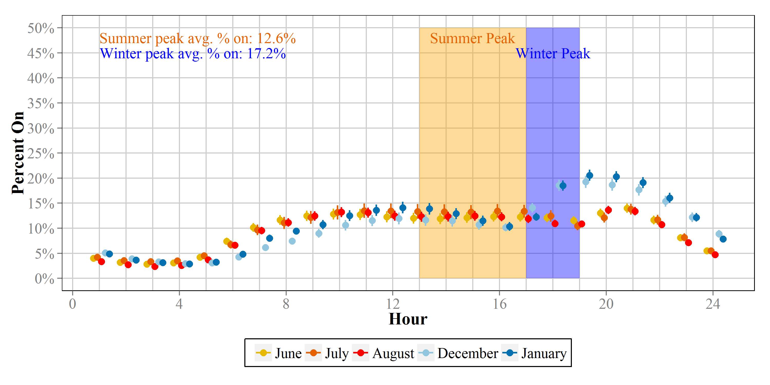
Table ES-6: Peak Period Coincidence Factors and Confidence Intervals
Month | Winter Peak Period  Dec. & Jan.  (5 PM – 7PM) | Summer Peak Period  Dec. & Jan.  (1 PM – 5PM | ISO-NE Seasonal Peak Hour (Winter)  January 24, 2013  Hour Ending 19 | ISO-NE Seasonal Peak Hour (Summer)  July 19, 2013  Hour Ending 17 | NYSO Peak Hour  July 7, 2013  Hour Ending 19
CT | 18% (16%, 21%) | 16% (13%, 19%) | 29% (22%, 35%) | 19% (7%, 31%) | n/a
MA | 17% (16%, 18%) | 11% (10%, 13%) | 20% (19%, 22%) | 15% (11%, 19%) | n/a
RI | 17% (13%, 20%) | 19% (15%, 24%) | 15% (11%, 19%) | 22% (16%, 28%) | n/a
UNY | 14% (11%, 16%) | 11% (9%, 13%) | 21% (17%, 25%) | 19% (11%, 26%) | n/a
Overall | 17% (16%, 18%) | 13% (11%, 14%) | n/a | n/a | 10% (7%, 13%)
MHT | 27% (24%, 30%) | 16% (13%, 18%) | n/a | n/a | 16% (11%, 20%)
DNY | 28% (25%, 31%) | 15% (13%, 18%) | n/a | n/a | 13% (10%, 16%)
NYSERDA | 24% (20%, 28%) | 13% (11%, 14%) | n/a | n/a | 12% (10%, 14%)

Solar Shading Analysis
To determine which solar shading variables were important predictors of HOU, the Team performed variable selection using a stepwise linear regression analysis. The goal of the variable selection procedure, therefore, was to determine which, if any, of the solar shading variables were also important predictors of HOU. Ultimately, five solar shading variables were determined to affect HOU. These five factors are included in Table ES-7 along with a summary of the marginal effects of each of the variables. Given the relatively small sample size and exploratory nature of this solar shading analysis, the Team advises a more qualitative interpretation of the numbers in Table ES-7. The values should be interpreted as follows: holding all other variables in the model constant, for every 10% increase in %NW glazing there is an expected increase in HOU of 0.31 hours (or about 19 minutes per day). Similarly, holding all other variables in the model constant, for a 10% increase in %SE glazing there is an expected decrease in HOU of 0.14 hours (or about 8 minutes per day).
Table ES-7: Marginal Effects of Solar Predictors from Regression Analysis
Variable | Level | Coefficient | Std Error | p-value
%NW Glazing |  | 0.031 | 0.011 | 0.006
%NE Glazing |  | -0.018 | 0.015 | 0.232
%SW Glazing |  | 0.018 | 0.012 | 0.135
%SE Glazing |  | -0.014 | 0.010 | 0.180
Total of Glazing Class Values | 1 | -- | -- | --
 | 2 | -0.569 | 0.819 | 0.488
 | 3 | -2.285 | 1.054 | 0.030

Considerations

Consider Adopting the Overall model for CT, MA, RI, and Upstate New York
With such minor differences in HOU estimates across Connecticut, Massachusetts, Rhode Island, and Upstate New York and with relatively few differences at the home type and income level, the Team recommends that the Sponsors consider adopting the HOU room-by-room estimates from the Overall hierarchical model for all households. The Overall model has the greatest level of precision owing to the larger sample sizes and is statistically similar to each of the individual area models on a room-by-room basis and by each of the eight categories of home type and income.

Consider Adopting Two Models for NYSERDA Area
Given the divergence of the Upstate New York model from both the Downstate and perhaps more importantly the NYSERDA overall model, NYSERDA should consider using separate estimates for Upstate and Downstate New York instead of using one service-area wide estimate. NYSERDA may also want to consider programmatic differences for Upstate and Downstate, such as higher incentives in the latter.

Consider Higher HOU Estimates for Retrospective Studies
HOU estimates for efficient bulbs are significantly higher than HOU estimates for inefficient bulbs within each of the eight individual models. As we explain in Inefficient versus Efficient Bulbs HOU, this implies that the Sponsors should considering assuming higher retrospective HOU for efficient bulbs, but, moving forward, they should use the overall HOU, as it is likely that EISA will lead to more rapid conversion to efficient bulb types. Future HOU studies should be on the lookout, however for evidence of take back; one would find this by determining if HOU for efficient bulbs continues to hover around 3.0 even as saturation continues

Consider Higher HOU Estimates for LED Promotions Moving Forward
While we recommend the Sponsors consider using higher efficient bulbs HOU estimates for retrospective studies and lower HOU estimates moving forward for general CFL programs, we think that future LED promotions may justify higher efficient HOU estimates for the next few years. Based on this study, it appears that households have historically selected higher-use locations for their high-efficiency light bulbs. If this behavior continues we would expect to see households replacing CFLs or other efficient bulbs with LEDs. Therefore, the Sponsors may be able to justify higher LED HOU estimates until LED saturations begin to reach significantly higher levels.

Introduction
The purpose of this study was to provide updated information to the Connecticut Energy Efficiency Board, the Massachusetts Program Administrators (Cape Light Compact, National Grid Massachusetts, Northeast Utilities, and Unitil), National Grid Rhode Island, and the New York State Energy Research and Development Authority (hereafter “the Sponsors”) to assist in the calculations of demand and energy savings for lighting programs. Specifically, this report presents load shapes, coincidence factors (CFs), and daily hours of use (HOU), and also presents a separate analysis of the effects of “urban canyons” on the lighting use of high-rise apartment dwellers in Manhattan.
The implementation of the Energy Independence and Security Act of 2007 (EISA) and the introduction of new technologies to the market—specifically, light-emitting diode bulbs (LEDs) and EISA-compliant halogens—are two indicators that residential lighting saturation is likely to change rapidly over the coming years. At the same time, changes in the composition of residential lighting means that HOU estimates based on individual bulb types are likely to become obsolete very quickly.
Unlike previous HOU studies, this study provides estimates not for a single technology or bulb type (e.g., compact fluorescent lamps [CFLs]), but by room type. This is based on the assumption that people are likely to use their lights in a given room the same way regardless of the types of bulbs in the room.
The following are the principal tasks completed as part of this project:
- Sample design
- Recruitment
- Onsite data collection
- Analysis and reporting
In addition to the data collected as part of the current study, referred to as the Base Study, in the report the researchers also leveraged data collected as part of two concurrent studies: the Massachusetts Low-Income HOU Study (conducted by Cadmus) and the National Grid New York EnergyWise Study (conducted by DNV GL). NMR, Cadmus, and DNV GL coordinated the development of protocols and methods to ensure comparable data.

Methodology
This section describes the sample design, recruitment, onsite data collection, data preparation, the coefficient of variation, weighting, HOU modeling, derivation of load curves, and solar shading methodology.

Sample Design and Recruitment
This study included data collected in four separate states: Connecticut, Massachusetts, Rhode Island, and New York. While we attempted to keep the sample similar in each area, the strategies differed somewhat both within and across areas. The evaluation team identified households for the onsites in three different ways: random-digit dial (RDD) telephone surveys, customer lists, and an address lookup. The reasons for these differences were primarily due to lack of customer lists for NYSERDA households and the need to maintain comparability to prior efforts in Massachusetts. For all areas except that covered by the Massachusetts Low-Income Study, households were recruited by telephone using Computer Assisted Telephone Interviewing (CATI). The Massachusetts Low-Income Study obtained customer names and addresses from a list of customers on the low-income rate and did not have reliable phone numbers. For the Massachusetts Low-Income Study, recruitment was carried out using postcards that explained the study and encouraged customers to call to arrange an appointment. Massachusetts and New York Base Study households were recruited in conjunction with consumer telephone surveys (analysis presented under separate cover).
In New York, NYSERDA funded the inclusion of an additional oversample of high-rise homes located in Manhattan. The second sampling approach involved an oversample of high-rise apartments. This high-rise oversample was designed to focus on households whose lighting use would most likely be affected by their locations in “urban canyons.” For this reason, the evaluation team decided to limit the sample to Manhattan to more readily capture the possible effects of building shading since, among New York City households, Manhattan has the greatest number and concentration of high-rise buildings and therefore is most likely to demonstrate “urban canyon” effects. To recruit the high-rise oversample, the evaluation team developed a list of high-rise buildings in Manhattan using the Primary Land Use Tax Lot Output (PLUTOTM) database maintained by the City of New York Department of City Planning. The PLUTO data files contained information for 859,324 building locations across five boroughs in New York City (NYC). Focusing on Manhattan, the evaluators identified 31,092 residential high-rise buildings with 868,942 units in Manhattan. Based on the data contained within the PLUTO database, the evaluation team developed an initial sample stratified by age of building (vintage) and height, with a goal of completing visits to low-income households in proportion to their share of total units. Abt SRBI, NYSERDA’s survey contractor, sent samples of addresses from the PLUTO database to Telematch. The Team used matched telephone numbers to conduct a CATI survey to recruit high-rise respondents.
Regardless of identification or recruitment method, the team offered all potential study participants incentives that varied by area and study.
Table 2-1 provides an overview of the incentive levels and method of identification, and Figure 2-1 shows the locations of the sites included in the analysis overlaid on a population density map of the Northeast. Additional maps showing sites by income, housing type, and logger location are provided in Appendix B.
Table 2-1: Recruitment Method
Bulb Type | Incentive | RDD | Customer List | Address Reverse Lookup
Connecticut | $150 | ✔
Massachusetts
Base Study | $250 |  | ✔
Low-Income Study | $150 |  | ✔
New York
Base Study | $250 | ✔
High-Rise Study | $200 |  |  | ✔
EnergyWise Study | $150 |  | ✔
Rhode Island | $150 | ✔
Figure 2-1: Site Locations with Population Density

Onsite Visits
For this evaluation, the Team collected data through onsite visits to 848 homes located throughout Connecticut, Massachusetts, New York, and Rhode Island. All sites visited required two visits. During the first visit, the Team collected detailed lighting inventory data and installed time-of-use light meters (loggers). The second visit consisted of removing the loggers installed during the first visit.
Altogether, over 5,730 loggers were installed between December 2012 and March 2013. Logger installations were timed to be as close to the winter solstice as was practical given project constraints and the impact of winter storms. All of the loggers in Rhode Island were installed prior to December 21, 2012. Logger installation in the other areas began in January 2013 and was completed by the end of March 2013.

Data Collection – Initial Visit
During the initial onsite visits, a trained technician gathered detailed information on each socket in the home. This information differed slightly by area and included the following factors listed in Table 2-2.
Table 2-2: Data Collected for Installed Bulbs by Area
 | NYSERDA Base Study | MA Base Study | MA  Low-Income Study | RI | CT | NY High-Rise Study
Room Location | ✔ | ✔ | ✔ | ✔ | ✔ | ✔
Primary Room | ✔ | ✔ |  | ✔ | ✔ | ✔
Control Type/Specialty Features | ✔ | ✔ | ✔ | ✔ | ✔ | ✔
Wall Mounted Control | ✔ | ✔ |  | ✔ | ✔ | ✔
Multi Switch | ✔ |  |  |  | ✔
Fixture Type | ✔ | ✔ | ✔ | ✔ | ✔ | ✔
Bulb Type | ✔ | ✔ | ✔ | ✔ | ✔ | ✔
Bulb Shape | ✔ | ✔ | ✔ | ✔ | ✔ | ✔
Socket Type | ✔ | ✔ | ✔ | ✔ | ✔ | ✔
Wattage | ✔ | ✔ |  |  |  | ✔
Manufacturer and model number (CFLs and LEDs only) | ✔ | ✔ |  |  |  | ✔
Where and When Purchased (CFLs and LEDs only) | ✔ | ✔ |  |  |  | ✔
What type of bulb was replaced (CFLs and LEDs purchased in past year) | ✔ | ✔ |  |  |  | ✔

A typical onsite visit proceeded as follows: A trained technician arrived at the home at a pre-scheduled time, introduced him- or herself, and asked for the contact person who had been identified when scheduling the visit. To ensure uniformity in data collection and facilitate quality control checks, the technician walked around the outside of the home in a clockwise direction, recording all information on exterior lighting sockets. Next, the technician proceeded through the inside of the home in a clockwise direction, beginning with the foyer (entryway) and going through each room and part of the home systematically. If the product was a CFL or LED, the technician noted its manufacturer and model number and any specialty features. The technician also asked the respondent to estimate when he or she had purchased that particular CFL or screw-base LED. The technician and householder also examined all light bulbs in storage, again noting similar detailed information on stored LEDs and CFLs and asking the householder the specific reason why he or she had bought the stored bulbs. Lastly, the technician installed lighting loggers on fixtures in targeted room types using a predetermined random selection methodology. The lighting inventory portion of the visits typically took less than two hours.
The Team installed an average of seven loggers per home—eight for single-family homes and six for multifamily homes. Loggers were placed on unique circuits (a circuit is a set of bulbs or fixtures operated by the same switch) throughout each home with a goal of installing one logger in each of the following room types for single-family homes: dining rooms, exteriors, living spaces, bedrooms, bathrooms, and kitchens, and two loggers in other room types. Protocols for multifamily homes were similar except for dining rooms and exteriors, which were included in other room types.

Data Collection – Logger Retrieval
During the onsite visits to remove the loggers, the technician was provided with pre-filled forms containing the logger ID number, room, fixture type, bulb type, bulb shape, and socket type for each logger expected to be installed at each site. The technician confirmed the characteristics for each bulb and performed a state test to determine whether or not the logger had accurately recorded event data during the time it was installed. Additional information recorded upon retrieval included:
- Total time shown on the logger
- Any changes to the bulb, logger, or fixture during the time the logger was installed as reported by the homeowner
- The homeowner’s estimated typical usage for each monitored fixture
Altogether, over 5,500 loggers were installed between December 2012 and March 2013. Logger installations were timed to coincide with the winter solstice, and all of the loggers in Rhode Island were installed prior to December 21, 2012. Logger installation in the other areas began in January 2013 and was completed by the end of March 2013. In total, 5,730 loggers were installed. Logger retrieval began in June 2013 and continued through August 2013. Attrition due to customers moving, damage to loggers, and lost loggers reduced the sample by about 4%.

Quality Assurance and Control
In all of our work, NMR endeavors to maintain a high quality work product. The sensitive nature of onsite work means that we take special precautions to ensure the quality of data collected and avoid jeopardizing the relationship our clients have with their customers. To that end, we employed a number of steps to ensure that onsite technicians performed quality work that reflected well on NMR and our clients.
Our quality control and standard operating procedures began well before a field technician ever set foot in a customer’s home. All of our field technicians received rigorous project-specific training. Training topics included project background, project-specific data collection protocols, and customer service and interaction training. We also provided our scheduling staff with an overview of this training so that they knew what customers would expect when they agreed to participate and were able to answer any questions the customers had. We made every effort to ensure that customers were fully informed and that unnecessary surprises were avoided.
Below, we outline some of the specific quality control and training measures we utilized for the Northeast Residential Lighting HOU Study.
Quality Control and Training Measures
- All field staff received training directly from NMR staff using training materials successfully implemented in similar onsite lighting saturation studies but tailored to the unique needs of the Northeast Residential Lighting HOU Study. Training included instruction on how to do the following:
  - Identify various types and shapes of sockets, light bulbs, and controls
  - Examine light bulbs in a safe manner, including instructions on what equipment to bring to a home, working with covered fixtures, and clean-up of (especially for CFLs and fluorescents) and compensation for bulbs and fixtures accidentally damaged during the visit
  - Ensure that they have located and inventoried all light bulbs (including stored bulbs) in the home through such procedures as creating a home schematic, mapping their route through the home, and documenting difficult-to-characterize lighting with pictures.
  - Correctly set up, install, and remove lighting loggers
- Training also included some background on EISA and its requirements so that the field technician could answer questions he or she might receive on this topic while performing the inventory.
- The NMR project manager or a designated staff member accompanied each part-time field technician on his or her first day of site visits.
- The NMR project manager or a designated staff member recruited participants and scheduled appointments, assigning them to field staff based on location and work load.
- Each field staff member was required to report his or her progress at the end of each day and input the completed onsite data into a shared document site for the NMR project manager for review.
In addition to reviewing the onsite forms, NMR staff called 20% of participants to ensure that their experience with the field technician was satisfactory. We also revisited approximately 5% of the homes, where we repeated the data collection and observed logger installation to make sure the technician had performed all tasks in a satisfactory manner.

Sample Attrition, Data Cleaning, and Outlier Detection
When planning the study, the Team assumed that some attrition would take place due to loggers being damaged, stolen, or being otherwise unrecoverable. As Table 2-4 shows, the Team installed 5,730 loggers and obtained data for 5,494 loggers—2,627 from the base study and 2,867 from the following three studies combined: the Massachusetts Low-Income Study, the National Grid NY EnergyWise Study, and the NYSERDA High-Rise Study. For each logger, we calculated the HOU for each day of the study period. NMR performed quality assurance and quality control on the daily logger data. Loggers with extremely frequent on/off records (flickering) or loggers that were on for over three consecutive weeks were removed, as were loggers with unusable read data (e.g., dates outside of the study period or corrupt logger IDs). We cross-checked loggers with extremely high or extremely low usage with participant self-reported use data as collected by field technicians while onsite.
Self-reported usage data were collected in the Rhode Island, Connecticut, NYSERDA, and Massachusetts Low-Income Study sites. Homeowners responded with estimated hours of use per day or a general estimation, such as frequent or infrequent use. As Table 2-3 shows, while respondents were not completely accurate with their estimations, for the most part they were able to describe the relative magnitude of lighting usage by bulb.
Table 2-3: Estimated Usage vs. Average HOU Recorded
Self-Reported Estimate | # of Loggers | Avg HOU Recorded
Total # of Loggers | 3,506 | 3.06
Less than 1 hour per day | 191 | 1.03
1-2 hours per day | 392 | 2.30
3-4 hours per day | 274 | 4.06
5-6 hours per day | 333 | 4.12
7-9 hours per day | 59 | 7.85
10-14 hours per day | 63 | 10.45
15-20 hours per day | 29 | 10.33
24 hours per day/always | 45 | 9.24
Never/Almost never | 90 | 1.23
Infrequent Use | 1,294 | 1.86
Frequent Use | 504 | 4.13
Don't know | 232 | 3.06

The Team was very careful in identifying and removing loggers with HOU values that might be considered outliers. While some loggers did indeed record very high usage over the study period, the percentage of these loggers was small. Using a relatively standard, albeit conservative, cutoff of 3.0 times the interquartile range of HOU (broken out by room type), roughly 2% of all loggers would have been deemed outliers. However, it is also true that different people/households can exhibit very different usage patterns for any number of reasons, and it is not unlikely that the loggers exhibiting higher than ordinary usage represent some small portion of the actual population. Therefore, the Team adopted a very conservative approach, and the only “outliers” removed were those for which it was not reasonable to assume the recorded data were correct—namely, those that exhibited obvious flickering or that were on continuously for over three consecutive weeks and whose unexpectedly high observed usage did not agree with self-reported usage, as discussed above. Ultimately, all preliminary data cleaning resulted in the removal of 364 loggers, leaving 5,130 loggers across all areas.
The Team then created a dataset for analysis by merging logger data with household demographic data that included the following: education, income, home type (single-family and multifamily), tenure, and presence of children under the age of 18 in the home. Loggers that were missing all demographic data or had corrupt IDs were dropped. Of the 5,130 loggers included after Step 1 (cleaning), an additional 488 loggers (most from the Massachusetts Low-Income Study) had to be dropped because they were missing one or more of the variables that contributed to the regression analysis, or because they had corrupt IDs. This left us with a total of 4,642 loggers for analysis.
Table 2-4: Logger Counts with Attrition
Bulb Type | Homes | Loggers Installed | Loggers Retrieved | Modeled Loggers
Connecticut | 90 | 613 | 579 | 549
Massachusetts
Base Study | 137 | 941 | 941 | 837
Low-Income Study | 261 | 2,000 | 1,975 | 1,338
New York
Base Study | 138 | 964 | 849 | 843
High-Rise Study¹ | 121 | 615 | 593 | 544
EnergyWise Study | 60 | 320 | 299 | 299
Rhode Island | 41 | 277 | 258 | 232
Total | 848 | 5,730 | 5,494 | 4,642
¹ Eleven of the homes included as part of the New York Base Study were located in Manhattan. After attrition nine of these eleven homes remained bringing the total number of Manhattan households to 130.

Sample and Coefficient of Variation
The Team employed two different coefficients of variation (CVs) when designing the sample for single-family, multifamily, and high-rise homes. Because we did not know the CVs for lighting ahead of time, the team turned to the Independent Service Operators of New England (ISO-NE) for guidance. The ISO-NE suggests using a CV of 0.5 for homogeneous populations (i.e., ones that exhibit similar behavior) and 1.0 for heterogeneous population (i.e., ones that behave differently). After some discussion, the Sponsors and the evaluation team decided to employ a CV of 0.7 to calculate onsite sample size for specific rooms (bedroom, bathroom, kitchen, living room, dining room, and exterior) in which we hypothesized lighting use to be fairly similar across the sample. For the “other” category of rooms, which included a number of miscellaneous rooms with various uses, we used a CV of 1.0 because we could not be confident that lighting usage would be consistent across the sample. Utilizing the two CVs, the Team calculated a specific room sample size of 133 and “other” room sample size of 271 based on a 90% confidence level and a 10% acceptable margin of error.
After completing the study and estimating HOU, the Team recalculated the CVs for each room type. As shown in Table 2-5, lighting use within each room type was more variable than the Sponsors and Team members anticipated, with CVs hovering around 1.0 but reaching as high as 1.38 for bathrooms and 1.6 for the “other” room type. Overall, the CV is 1.20. We also calculated updated CVs for the sub-groups utilized in the analysis, and they also exhibit a fair amount of heterogeneity in use by room type (Table 2-6). Therefore, moving forward, the Team recommends that evaluators utilize a CV of at least 1.2 for each are of interest (e.g., each room type or each sub-group in the population) and possibly as high as 1.5 to ensure an adequate sample size. In fact, if sampling very specific room types or sub-groups, the CV may need to be even greater.
Table 2-5: Original and Updated Coefficient of Variation
 | Original CV | Final Sample Size utilized in Analysis | Standard Deviation of Average HOU | Mean HOU | Updated CV | Sample Size using Updated CV
Bathroom | 0.7 | 700 | 2.98 | 2.16 | 1.38 | 515
Bedroom | 0.7 | 913 | 2.78 | 2.42 | 1.15 | 358
Dining Room | 0.7 | 401 | 3.43 | 3.13 | 1.10 | 327
Exterior | 0.7 | 184 | 4.52 | 5.08 | 0.89 | 214
Kitchen | 0.7 | 751 | 4.26 | 4.59 | 0.93 | 233
Living Space | 0.7 | 742 | 3.59 | 3.45 | 1.04 | 293
Other | 1.0 | 951 | 2.96 | 1.85 | 1.60 | 693

Table 2-6: Updated Coefficient of Variation by Sub-sample
 | SF | MF | Low Income | Non-low Income | SF Low Income | SF Non-low Income | MF Low Income | MF Non-low Income | Efficient Lighting | Non-efficient Lighting
Bathroom | 1.36 | 1.36 | 1.32 | 1.45 | 1.28 | 1.40 | 1.35 | 1.36 | 1.34 | 1.36
Bedroom | 1.23 | 1.05 | 1.15 | 1.15 | 1.18 | 1.33 | 1.10 | 1.01 | 1.15 | 1.12
Dining Room | 1.16 | 1.00 | 1.12 | 1.08 | 1.13 | 1.19 | 1.12 | 0.92 | 1.02 | 1.14
Exterior | 0.87 | 1.31 | 0.95 | 0.80 | 0.93 | 0.80 | 1.82 | 0.39 | 0.87 | 0.91
Kitchen | 0.95 | 0.90 | 1.01 | 0.84 | 1.01 | 0.85 | 0.99 | 0.82 | 0.91 | 0.96
Living Space | 1.06 | 1.01 | 1.03 | 1.05 | 1.03 | 1.07 | 1.00 | 1.02 | 0.97 | 1.10
Other | 1.63 | 1.52 | 1.63 | 1.55 | 1.63 | 1.62 | 1.60 | 1.44 | 1.59 | 1.58

Weighting
We applied a fairly complex weighting scheme to accommodate the four states and to control for home type and income level. We developed the following weighting factors:
Premise weights are based on four demographic characteristics collected during recruitment:
- Home type: single-family or multifamily
- Income: low-income or not-low-income
Room weights are based on the total number of bulbs in each room as well as the total number of logged bulbs in each room type. The weights include breakdowns for the following room types and are further broken out by room type and whether the bulb is an LED, CFL, or fluorescent tube versus whether the bulb is an incandescent or halogen:
- Single-family homes: bathroom, bedroom, dining room, exterior, kitchen, living room, and all other rooms.
- Multifamily homes: bathroom, bedroom, kitchen, living room, and all other rooms.
We created separate weights for Connecticut, Massachusetts, and Rhode Island. For New York, we created a set of weights for upstate New York, Downstate New York, and Manhattan, as well as an overall NYSERDA weight that does not include Manhattan.
For single-family homes, we based HOU estimates on only those loggers installed in single-family homes, and we did the same for multifamily homes. Because the evaluators made a point of ensuring adequate representation from multifamily and low-income households when creating the sample, it was also necessary to develop a premise weight that incorporates home type as well as income status. The premise weight is based on demographic data specific to each individual state or area.
In addition to the individual state weights described above, we prepared a combined overall Northeast weight that incorporates the combined demographic characteristics of all states included in the study.
Below, we provide an example to illustrate the various components of the weighting scheme.
Example: In New York we visited 138 homes—70 single-family and 68 multifamily. In the 68 multifamily homes, there were:
- 5,201 light bulbs in all rooms, of which 912 were metered
  - 1,749 Efficient bulbs, of which 461 were metered (TB)
  - 3,452 Inefficient bulbs, of which 451 were metered (TB)
- 849 light bulbs in bathrooms, of which 177 were metered
  - 252 Efficient bulbs, of which 79 were metered (TRB)
  - 597 Inefficient bulbs, of which 98 were metered (TRB)
In the entire multifamily sample, there were:
- 1,705 light bulbs in all rooms
  - 880 Efficient bulbs (TM)
  - 825 Inefficient bulbs (TM)
- 304 light bulbs in bathrooms
  - 140 Efficient bulbs (TRM)
  - 164 Inefficient bulbs (TRM)
To calculate the bathroom weight for multifamily homes in New York, we used the following formula:
Efficient bulb weight: $\frac{TRB/TB}{TRM/TM}$ = $\frac{252/1749}{140/880}=0.90566$
Inefficient bulb weight: $\frac{TRB/TB}{TRM/TM}$ = $\frac{597/3452}{164/825}=0.869989$
Where:
TRB = total bulbs in a given room type (specific to a given state)
TB = total bulbs in all rooms (specific to a given state)
TRM = total bulbs metered in a room (based on all homes across four states)
TM = total metered bulbs in all rooms (based on all homes across four states)
This process was repeated for each room type among multifamily homes and then again among single-family homes. To combine single-family and multifamily HOU estimates, we prepared premise weights based on the Census data specific to each individual state or area included in the study.
During the course of the analysis it became apparent to the evaluators that the Manhattan High-Rise sample behaved differently than the rest of the sample; for this reason, the Manhattan weights were consistently treated differently than the rest of the areas. The Manhattan sample is not included in other areas’ premise or room weight calculations and the Manhattan room weights are not leveraged against the entire sample and only refer to Manhattan in the weighting formula. The detailed weighting tables are included in Appendix D.

HOU Modeling

Annualized HOU Estimates
Since each logger was installed for only a portion of the year—between five and nine months—we had to annualize the data, and we did this by fitting a sinusoid model to each logger. We drew upon the methods outlined in the KEMA/Cadmus California Upstream Lighting Program Evaluation, which we summarize here. Separate weekend and weekday models were fitted for each logger. For any loggers not conforming well to the sinusoid model, the analysts took additional steps to prepare annualized estimates based on average daily usage over the period logged (described below). The sinusoid model for each logger took the following form:
h_{d} = α + βsin(θ_{d}) + ε_{d}
Where
h_{d} = hours of use on day d,
θ_{d} = angle for day d, where θ_{d} is 0 and the spring and fall equinox, π/2 for d = December
21, and -π/2 for d = June 21,
α and β are regression coefficients,
ε_{d} is the residual from the regression.
In each model, α represents the average use for the year. Because a weekday model and a weekend model were fitted for each logger, we calculated the overall average usage for the year for each logger as a weighted average of the α from the weekday model and the α from the weekend model (see below for more detail).
As in the KEMA/Cadmus CA Upstream Lighting report,¹² model fits with an estimated β coefficient having absolute value greater than 10 and those whose standard error for β was greater than one were classified as “poor.” Additionally, the team classified as “poor” any fits yielding an annual average (α) less than or equal to zero or greater than 24. In both the weekday and weekend models, the intercept for each poor-fitting logger was set to the average daily usage over the period for which the logger had data. We then calculated the average annual daily hours of use for each logger by averaging the weekend and weekday intercepts in proportion to the number of weekend/weekday days over the course of the year. Specifically:
$${avg.hou}_{i}=\frac{(n_{wd}α_{wd,i}+n_{we}α_{we,i})}{n_{wd}+n_{we}}$$
Where i indexes each logger, n_{wd} is the number of weekdays over the year, n_{we} is the number of weekend days over the year, α_{wd,I} is the average weekday usage for logger i, and α_{we,I} is the average weekend usage for logger i.
After annualizing the data for each logger, NMR merged logger data with household demographic data. Household demographic data included information on education level, income, single- or multifamily status, own/rent status, and whether there was anyone under 18 years of age in the household.

Adjusted HOU
Next, we used the annualized estimates in a weighted regression analysis to estimate the adjusted average HOU for each room in each area of the study. Table 2-7 describes the variables that contributed to the regression analysis as predictors.
Table 2-7: Variables Used as Predictors in HOU Regression Models
Variable | Description | Levels
Room Type | Room/location the bulb was located. | Bedroom
 |  | Bathroom
 |  | Kitchen
 |  | Living Space
 |  | Dining Room
 |  | Exterior
 |  | Other
Efficient Bulb | Whether the bulb was efficient or non-efficient. | Yes
 |  | No
Income | Household income. | Low Income
 |  | Non-Low Income
Education | Education level of the respondent. | Less than High School
 |  | High School or GED
 |  | Some College
 |  | Bachelor’s Degree
 |  | Advanced or Graduate Degree
Rent/Own | Whether household is owned or rented | Rent
 |  | Own
Under 18 | Anyone under 18 years of age in the household | Yes
 |  | No
Home Type | Single or multi-family residence | Multi Family
 |  | Single Family

In this first step, the model used only loggers for each individual area to develop area-specific estimates, and all loggers were used to develop estimates for the overall region. Based on outputs from this model, the results are clear that Connecticut, Massachusetts, Rhode Island, and Upstate New York all had comparable usage patterns, while usage patterns for Downstate New York (including Manhattan) households differed from the other areas. Table 2-8 presents the HOU estimates from these separate area-specific regressions.
Table 2-8: Overall Estimated HOU from Preliminary Models
Area | Estimated Overall HOU | 90% Confidence Interval
Connecticut | 2.9 | (2.5, 3.2)
Massachusetts | 2.6 | (2.4, 2.8)
Rhode Island | 2.9 | (2.2, 3.5)
Upstate New York | 2.4 | (2.1, 2.8)
Downstate New York | 4.1 | (3.5, 4.7)
Manhattan | 3.9 | (3.4, 4.4)

Hierarchical Model
Due to the similar use patterns in four of the areas (CT, MA, Upstate NY, and RI), we sought a way to leverage data from all of these areas to refine area-specific estimates. The structure of the data—loggers nested in homes, nested in areas—is well suited for a multi-level hierarchical model. The advantage of this type of modeling approach is the ability to use information from all four areas to help inform area-specific estimates. In a hierarchical model, the observations specific to an area form the basis of the estimates for that area, while observations from outside that area also inform and help refine the area-specific estimates., For example, Figure 2-2 below provides a visual representation of how the estimate for Rhode Island is informed by loggers in Connecticut, Massachusetts, and Upstate New York. The hierarchal model is particularly beneficial for areas where fewer loggers were installed, thus providing more refined (tighter precision and adjusted means) HOU estimates compared to individual models fit to each area separately.
Figure 2-2: Overview of Hierarchical Model
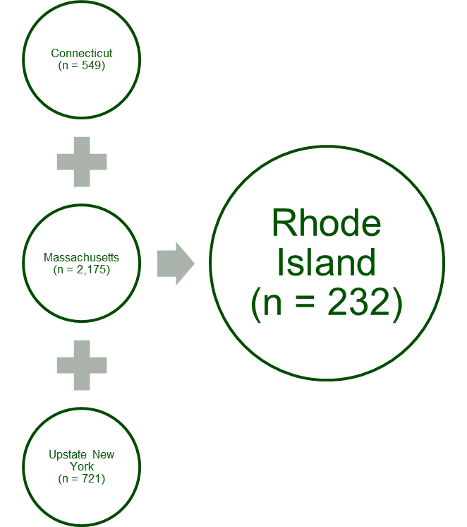
To account for potential correlation among loggers in the same household/area, the model included a random intercept term at the side ID level, which is dependent on the area that site ID is nested in. This dependence is established at another level in the modeling framework. Additionally, to estimate area-specific HOU estimates for all rooms, the model included random area-specific regression coefficients for the room type variable, allowing for information from other areas to help inform the area-specific HOU estimate of each room. The exact form of the hierarchical model is presented below:
$${E(hou}_{ijk})=(β_{0}+b_{0,j})+{(β}_{1}+b_{1,k})×I\left({Room}_{ijk}=Bathroom\right)+{(β}_{2}+b_{2,k})×I\left({Room}_{ijk}=Bedroom\right)+{(β}_{3}+b_{3,k})×I\left({Room}_{ijk}=Dining\right)+{(β}_{4}+b_{4,k})×I\left({Room}_{ijk}=Kitchen\right)+{(β}_{5}+b_{5,k})×I\left({Room}_{ijk}=Living\right)+{(β}_{6}+b_{6,k})×I\left({Room}_{ijk}=Other\right)+I\left({Bulb.type}_{ijk}=Efficient\right)+β_{8}I\left({Income}_{ijk}=LI\right)+β_{9}I\left({Education}_{ijk}=HS\right)+β_{10}I\left({Education}_{ijk}=Some college\right)+β_{11}I\left({Education}_{ijk}=Bach.\right)+β_{12}I\left({Education}_{ijk}=Adv/Grad Deg.\right)+β_{13}I\left({Own/Rent}_{ijk}=Rent\right)+β_{14}I\left({Under18}_{ijk}=yes\right)+β_{15}I\left({Home.type}_{ijk}=MF\right)$$
where i indexes the loggers, j indexes the homes, k indexes the areas, and:
$$b_{0,j} \sim N\left(b_{k},σ_{b_{k}}^{2}\right), ∀{site}_{j}∈{region}_{k} ∀k,$$
$$b_{k} \sim N\left(0,σ_{reg}^{2}\right), for k=1,…,n_{regions},$$
$b_{l,k} \sim N\left(0,σ_{l}^{2}\right), for l=1,…,6 and ∀k$,
Note that n_{regions} = 4, as the hierarchical model includes only loggers from Connecticut, Massachusetts, Rhode Island, and Upstate New York.
Table 2-8 shows that Downstate New York (including Manhattan) and Manhattan by itself had different usage patterns—specifically, higher HOU—than the other four areas in the study. Thus, we fit separate robust linear regression models for Downstate New York, for the subset of Downstate New York in Manhattan, and for all of the NYSERDA area (all of Upstate and Downstate combined). Downstate regression models incorporated the same variables listed in Section 2.6.2. After fitting the regression models, the team used the fitted values of the appropriate regression to calculate adjusted HOU estimates by area and room.

Overall Regression Model Coefficients
Table 2-9 shows the overall regression coefficients from the hierarchical model fitted to all loggers in Connecticut, Massachusetts, Rhode Island, and Upstate New York. These coefficients were relatively consistent across models, so we have presented them only for the overall hierarchical model. Table 2-9 excludes the room-by-room estimates, as those are presented in Section 2.6.3 as adjusted means rather than to the regression coefficients. Blank cells in this table represent the baseline level of each variable in the model, and all coefficients should be interpreted as relative to the corresponding baseline level for each variable. For example, this model estimates that, holding all other variables constant, households in which the respondent had a bachelor’s degree use about 0.6 hours of light less than those where the respondent had less than a high school degree.
Table 2-9: Overall Regression Coefficients from Hierarchical Model
Variable | Level | Coefficient | p-value | 90% Confidence Interval
Efficient Bulb | Yes | 0.631 | < 0.001 | (0.455, 0.806)
 | No
Income | Low Income | 0.007 | 0.482 | (-0.261, 0.273)
 | Non-Low Income
Education | Grad/Adv. Degree | -0.635 | 0.048 | (-1.288, -0.082)
 | Bachelor’s Degree | -0.587 | 0.059 | (-1.253, -0.019)
 | Some College | -0.778 | 0.017 | (-1.420, -0.248)
 | HS or GED | -0.728 | 0.026 | (-1.362, -0.176)
 | Less than HS
Own/Rent | Rent | 0.532 | 0.001 | (0.249, 0.821)
 | Own
Under 18 | Yes | 0.598 | < 0.001 | (0.362, 0.824)
 | No
Home Type | Multi Family | -0.157 | 0.204 | (-0.470, 0.154)
 | Single Family

Derivation of Load Curves
The Team generated load curves that describe the weekday lighting usage by hour of the day for each of the eight geographic categories (Connecticut, Massachusetts, Rhode Island, Upstate New York, Overall, Manhattan, Downstate New York, and NYSERDA service area) included in the study. Besides the area-specific curves that describe the each of the different areas at the overall household level, we also generated load curves for multiple sub-samples of the data including single-family, multifamily, low-income, non-low-income, single-family low-income, single-family non-low-income, multifamily low-income, and multifamily non-low-income. The majority of the data collected for this analysis was gathered in the first half of 2013, with most of the logger installations occurring in mid-to-late January; because a full year’s worth of data was not available, we utilized three separate methods for generating load curves.
For the months with adequate data (February through July), we generated the average amount of lighting usage for each hour of the study period along with a 90% confidence interval for each hour of the study period.
However, due to the timing of metering, the loggers yielded sparse lighting usage data for August, December, and January, and no data for September, October, or November. To overcome this, we utilized an “equivalent dates” technique by matching months with missing lighting usage to months with equivalent hours of daylight for which we had data. Specifically, August has equivalent daylight hours to April 11 through May 10, September daylight is equivalent to March 12 through April 10, and October is equivalent to February 10 through March 11. After assigning equivalent dates to the missing months, we calculated the average amount of lighting usage for each hour along with a corresponding 90% confidence interval.
The matching process described, however, could not be adequately applied to those dates nearest the summer and winter solstices due to lack of data and the nature of daylight hours at those times. For example, January’s equivalent dates are November 10 through December 10, and November’s are January 11 through February 8. In order to address the fact that the team had sparse or non-existent data for winter months and their equivalent late fall dates, to generate load shapes for the months of November, December, and January, we modeled lighting usage as a function of average hours of daylight (daylight hours from United States Naval Observatory for the Northeast region) by hour of the day clustered by logger. Predicted lighting usage generated by the model was then used to generate load shapes and confidence intervals for the months of November, December, and January.

Solar Shading Methodology
For a recent article in the New York Times, Cara Buckley explored how shadows affect New Yorkers, concluding that “in a city forever sprouting new buildings, the quest to reach higher often comes at the cost of stealing somebody else’s light.” The conditions described in Buckley’s article are often attributed to the “urban canyon effect.” The urban canyon effect is caused by streets cutting through dense blocks of structures that form human-made canyons. Urban canyons affect various conditions, including radio reception, wind speed, temperature, air quality, and ambient light. The design of typical high-rise apartments also tends to limit glazing (i.e., windows) to one or two sides of a unit. To explore the effects of shading on lighting HOU, the Team collected glazing and solar shading data for 130 high-rise apartment units in Manhattan to determine if the availability of direct sunlight, and of ambient light generally, has an effect on residential lighting use in high-rise apartments. The Team developed a regression model to quantify the relationship.

Glazing
The number, size, and direction of windows are important factors that determine how much of the available ambient light enters a home. Project technicians sketched the layout of apartments, identified the orientation of the walls, measured the exterior walls and windows, and recorded the presence of light obstructions like blinds, curtains, and window air conditioners.

Solar Shading
The other factor that determines available ambient light is exterior shading. Solar exposure was measured using the Pathfinder Solar PathfinderTM, a simple mechanical device used primarily in the solar energy industry for the purpose of shade analysis (Figure 2-3). The Pathfinder provides a method for measuring a full year of solar availability or shading based on a reflected image overlaid on a sun path diagram. Instead of relying on shadows, the Pathfinder uses a highly reflective convex dome that provides a panoramic view of the entire site. This makes it possible to use the Pathfinder at any time of the day or year. Details on the operation of the Pathfinder device and the principles behind it can be found here.
Technicians placed the Pathfinder on the sill of the window where solar exposure was to be measured and photographed the Pathfinder, as well as the view out the subject window (Figure 2-4). Technicians generally did not take Pathfinder photos at north-facing windows, which have no direct sun exposure. Using these photos and the Solar Pathfinder Assistant software, the Team calculated the percentage of available direct sunlight reaching the window (Figure 2-5).
It was not always possible to obtain a photo from every window, and values from windows on the same exterior wall or facing the same cardinal direction were very similar. Therefore, if multiple Pathfinder photos were available from a particular site, the Team calculated solar exposure for the site using the photo from the window with the greatest solar exposure.
Figure 2-3: Solar Pathfinder
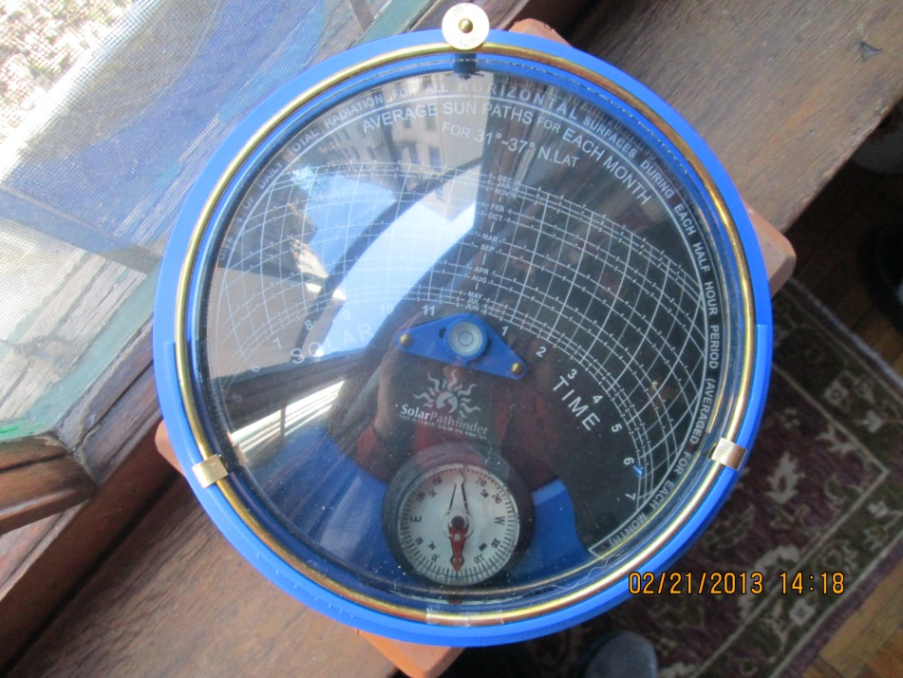
A photo of the Solar Pathfinder on the sill of a southeast-facing window. The curved lines on the Pathfinder template indicate the position of the sun at all hours of the day and all months of the year. Any point on the diagram that shows open sky indicates that there is direct sun at the Pathfinder’s location at that date and time.
Figure 2-4: View Out SE-facing Window
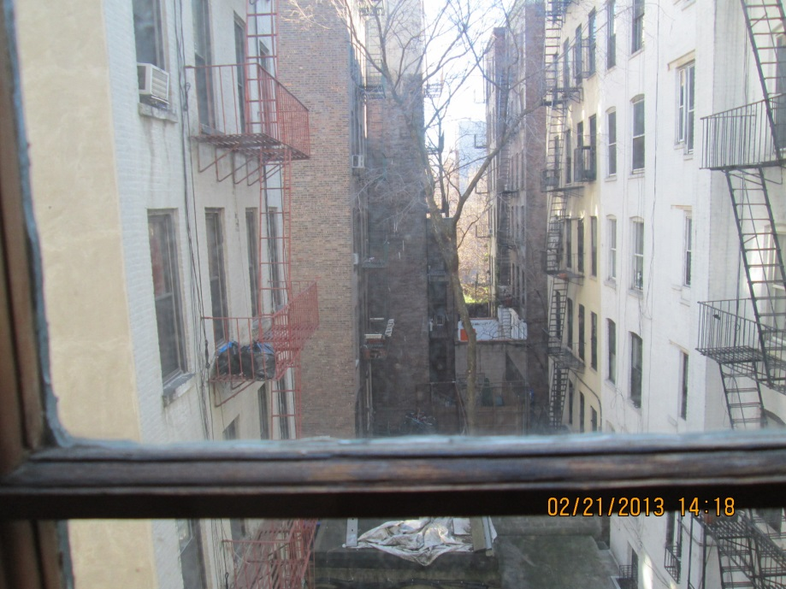
The view out the window from the Solar Pathfinder photo in Figure 2-3: Solar Pathfinder. One can see how the gap of sun in the "canyon" of buildings along the street is represented in the reflection on the Pathfinder's dome.
Figure 2-5: Solar Pathfinder Assistant Report
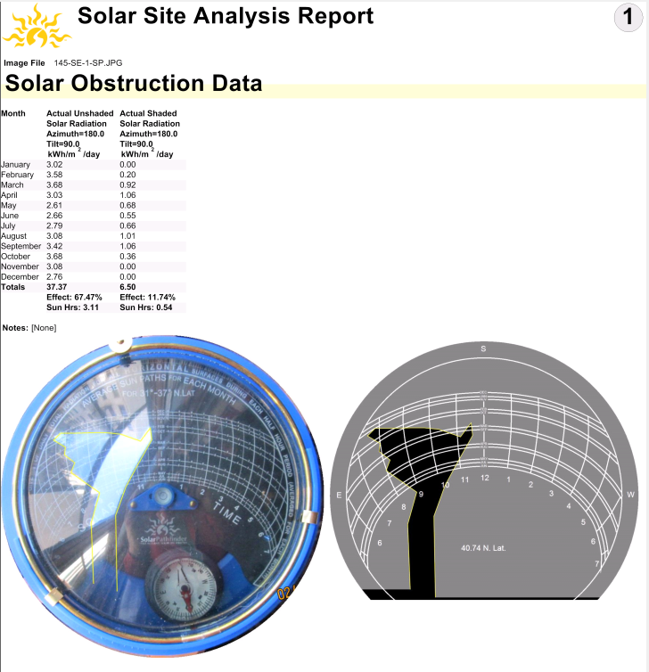
By tracing the area of sky present in the Solar Pathfinder photo, the Solar Pathfinder Assistant software calculates the amount of direct sunlight reaching the measured location.

HOU Analysis Results
Throughout this section and in the appendices, we present the five estimates from the hierarchical model first, in the leftmost portion of each table, followed by the estimates for Manhattan, Downstate New York, and NYSERDA Overall. Unless otherwise specified, all data presented are weighted as described in Section 2.4 and all sample sizes (n) reflect logger counts. Significant differences across areas are denoted with a letter a through h:
- Statistically different at the 90% confidence level from Connecticut
- Statistically different at the 90% confidence level from Massachusetts
- Statistically different at the 90% confidence level from Rhode Island
- Statistically different at the 90% confidence level from Upstate New York
- Statistically different at the 90% confidence level from Overall
- Statistically different at the 90% confidence level from Manhattan
- Statistically different at the 90% confidence level from Downstate New York
- Statistically different at the 90% confidence level from NYSERDA

Analysis Organization
Throughout this report, we refer to eight separate area estimates—five produced by the hierarchical model and three produced by separate standalone models—as described in Section 2.6.3. For the sake of clarity, before presenting the estimates we include a brief overview of the data informing each of the estimates.
Hierarchical Models
Connecticut (CT): A product of the hierarchical model described in Section 2.6.3. The 549 loggers from Connecticut inform the core of Connecticut estimates. The core estimates were then refined through a hierarchical model that drew upon all loggers installed in Massachusetts, Rhode Island, and Upstate New York.
Massachusetts (MA): A product of the hierarchical model described in Section 2.6.3. The 2,175 loggers from Massachusetts inform the core of Massachusetts estimates. The core estimates were then refined through a hierarchical model that draws upon all loggers installed in Connecticut, Rhode Island, and Upstate New York.
Rhode Island (RI): A product of the hierarchical model described in Section 2.6.3. The 232 loggers from Rhode Island inform the core of Rhode Island estimates. The core estimates were then refined through a hierarchical model that drew upon all loggers installed in Connecticut, Massachusetts, and Upstate New York.
Upstate New York (UNY): A product of the hierarchical model described in Section 2.6.3. The 721 loggers from Upstate New York inform the core of Upstate New York estimates. The core estimates were then refined through a hierarchical model that drew upon all loggers installed in Connecticut, Massachusetts, and Rhode Island.
Overall Northeast (Overall): A product of the hierarchical model described in Section 2.6.3, the Overall estimates collapse the modeled data from the four areas described above. The 3,677 loggers from Connecticut, Massachusetts, Rhode Island, and Upstate New York make up the core of Overall estimate. As with the other estimates above, the Overall estimate excludes all loggers from Downstate New York (including Manhattan).

Standalone Models
Manhattan (MHT): A product of a standalone model (as described in Section 2.6.3), the 544 loggers from Manhattan inform the Manhattan estimates.
Downstate New York (DNY): A product of a standalone model (as described in Section 2.6.3), the 965 loggers from Downstate New York, including the 544 loggers from Manhattan, inform the Downstate New York estimates.
NYSERDA Service Area (NYSERDA): A product of a standalone model (as described in Section 2.6.3), the 1,686 loggers from New York—the 721 loggers from Upstate New York and the 965 loggers from Downstate New York (including the 544 loggers from Manhattan)— inform the NYSERDA Overall estimates.

Overall HOU Estimates
Figure 3-1 below shows the overall daily HOU estimates for each of the eight models as well as the confidence intervals around the point estimates. Each of the five estimates from the hierarchical model is statistically similar to the others. The confidence interval around the Overall estimate is the narrowest (2.6 to 2.8 HOU); each tenth represents just six minutes. Therefore, we can say that we are 90% confident that actual HOU fall within a twelve-minute range. The Rhode Island estimate has the widest confidence interval (2.4 to 2.8 HOU, a 24-minute range) because Rhode Island had the fewest loggers. Compared to each of the hierarchical models, the Manhattan and Downstate New York HOU estimates are significantly higher (3.9 and 4.1, respectively). Further, we see that these estimates have much wider confidence intervals than those from the hierarchical model; this is true across all models for Downstate New York, Manhattan, and NYSERDA Overall. As discussed in Section 2.6.3, the higher level of precision in the estimates for CT, MA, RI, and Upstate NY is one of the main benefits of the hierarchical modeling approach. The standalone models for Downstate NY, Manhattan, and NYSERDA Overall do not benefit from the ability to borrow information from other areas, thus yielding less precision and wider confidence intervals. The NYSERDA Overall model HOU estimate is significantly higher than the Massachusetts, Rhode Island, Upstate New York, and Overall model estimates, but is statistically similar to the Connecticut model estimate. It is important to note that the estimates from the hierarchical Upstate New York model are significantly different from the estimates from the Downstate New York model and the NYSERDA standalone model that includes Upstate New York. Given the divergence of the Upstate New York model from both the Downstate and, perhaps more importantly, the NYSERDA Overall model, NYSERDA should consider using separate estimates for Upstate and Downstate New York instead of using one NYSERDA-wide estimate.
Figure 3-1: Overall HOU Estimates by Area
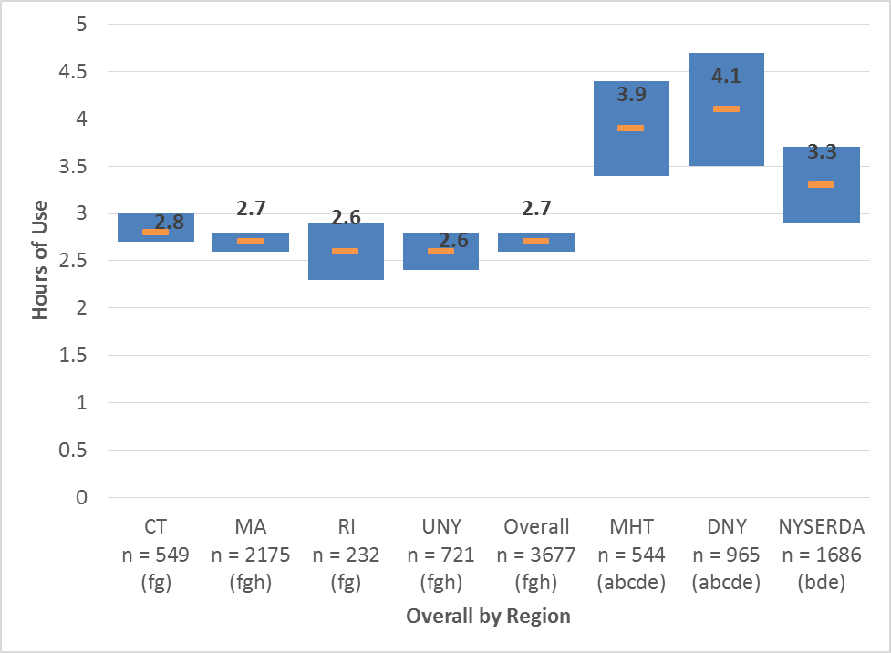
Statistically different at the 90% confidence level from:
a – Connecticut | ^{e} – Overall
^{b} – Massachusetts | ^{f} – Manhattan
^{c} – Rhode Island | ^{g} – Downstate NY
^{d} – Upstate NY | ^{h} – NYSERDA Overall

Overall HOU Estimates – Room-by-Room
Turning to the room-by-room analysis presented in Table 3-1, we note only a few statistically significant differences among the five estimates from the hierarchical model:
- Bedroom: HOU estimates for Upstate New York are significantly lower compared to those for Connecticut.
- Exterior: HOU estimates are significantly lower in Massachusetts and Upstate New York compared to those for Rhode Island.
In contrast, the five estimates from the hierarchical model exhibit a great number of statistical differences at the room level when compared to Manhattan, Downstate New York, and NYSERDA Overall.
- Bedroom: HOU estimates for Manhattan and Downstate New York are significantly higher compared to those for Massachusetts, Upstate New York, and Overall.
- Bedroom: HOU estimates for NYSERDA are significantly higher compared to those for Upstate New York.
- Bathroom: HOU estimates for Manhattan are significantly higher compared to those for Rhode Island and Overall.
- Kitchen: HOU estimates for Manhattan and Downstate New York are significantly higher compared to all five hierarchical model estimates.
- Kitchen: HOU estimates for NYSERDA are significantly higher compared to all of the hierarchical model estimates except that from Connecticut.
- Dining Room: HOU Estimates for Manhattan are significantly higher compared to those for Massachusetts, Upstate New York, and Overall.
- Exterior: HOU estimates for Rhode Island are statistically higher compared to those for Downstate New York and NYSERDA.
- Exterior: HOU estimates for Connecticut are statistically lower compared to those for NYSERDA.
- Other: HOU Estimates for Manhattan and Downstate New York are significantly higher compared to all five hierarchical model estimates.
Comparing Manhattan, Downstate New York, and NYSERDA to each other, there are no statistically significant differences at the room level. Table 3-2 provides the sample sizes (number of loggers) for each area and room type presented in Table 3-1.
.

Table 3-1: Overall HOU Estimates by Area and Room
Room | CT | MA | RI | UNY | Overall | MHT | DNY | NYSERDA
Bedroom | 2.6 (2.2, 3.1)  ^{d} | 2.0 (1.8, 2.3)  ^{fgh} | 2.6 (2.0, 3.3) | 1.7 (1.3, 2.1)  ^{afgh} | 2.1 (1.9, 2.3)  ^{fgh} | 3.4 (2.9, 4.0)  ^{bde} | 3.6 (3.1, 4.1)  ^{bde} | 2.8 (2.4, 3.2)  ^{bde}
Bathroom | 1.5 (1.1, 2.0)  ^{fgh} | 1.8 (1.5, 2.0)  ^{fgh} | 1.2 (0.6, 1.8)  ^{fgh} | 1.9 (1.5, 2.4) | 1.7 (1.5, 1.9)  ^{fgh} | 2.7 (2.2, 3.3)  ^{abce} | 3.2 (2.4, 4.1)  ^{abce} | 2.8 (2.2, 3.5)  ^{abce}
Kitchen | 4.6 (4.0, 5.1)  ^{fg} | 4.0 (3.7, 4.3)  ^{fgh} | 3.8 (3.0, 4.5)  ^{fgh} | 4.1 (3.7, 4.6)  ^{fgh} | 4.1 (3.9, 4.3)  ^{fgh} | 6.3 (5.6, 7.1)  ^{abcde} | 7.0 (5.8, 8.2)  ^{abcde} | 5.8 (5.0, 6.6)  ^{bcde}
Living Space | 3.8 (3.3, 4.3) | 3.3 (3.0, 3.6) | 3.4 (2.7, 4.2) | 3.1 (2.6, 3.5) | 3.3 (3.1, 3.6) | 3.9 (3.3, 4.6) | 4.5 (3.5, 5.4) | 4.0 (3.3, 4.6)
Dining Room | 3.2 (2.6, 3.9) | 2.7 (2.3, 3.1)  ^{f} | 3.5 (2.6, 4.6) | 2.5 (1.9, 3.1)  ^{f} | 2.8 (2.5, 3.1)  ^{f} | 4.5 (3.6, 5.3)  ^{bde} | 4.0 (2.9, 5.0) | 3.2 (2.5, 3.9)
Exterior | 6.0 (5.6, 6.5)  ^{g} | 5.5 (5.2, 5.8)  ^{c} | 6.6 (6.0, 7.1)  ^{bdgh} | 5.5 (5.1, 5.8)  ^{c} | 5.6 (5.3, 5.9) | -- | 3.6 (2.2, 5.1)  ^{ac} | 4.7 (3.7, 5.7)  ^{c}
Other | 1.7 (1.4, 2.0)  ^{fg} | 1.7 (1.5, 1.9)  ^{fg} | 1.6 (1.2, 2.0)  ^{fg} | 1.7 (1.4, 2.0)  ^{fg} | 1.7 (1.6, 1.9)  ^{fg} | 3.4 (2.4, 4.5)  ^{abcde} | 3.2 (2.3, 4.1)  ^{abcde} | 2.4 (1.9, 2.9)
Overall | 2.8 (2.7, 3.0)  ^{fg} | 2.7 (2.6, 2.8)  ^{fgh} | 2.6 (2.3, 2.9)  ^{fg} | 2.6 (2.4, 2.8)  ^{fgh} | 2.7 (2.6, 2.8)  ^{fgh} | 3.9 (3.4, 4.4)  ^{abcde} | 4.1 (3.5, 4.7)  ^{abcde} | 3.3 (2.9, 3.7)  ^{bde}
ª – Statistically different at the 90% confidence level from Connecticut | ^{e} – Statistically different at the 90% confidence level from Overall
^{b} – Statistically different at the 90% confidence level from Massachusetts | ^{f} – Statistically different at the 90% confidence level from Manhattan
^{c} – Statistically different at the 90% confidence level from Rhode Island | ^{g} – Statistically different at the 90% confidence level from Downstate NY
^{d} – Statistically different at the 90% confidence level from Upstate NY | ^{h} – Statistically different at the 90% confidence level from NYSERDA Overall
Table 3-2: Sample Sizes, Overall HOU Estimates by Area and Room
Room | CT | MA | RI | UNY | Overall | MHT | DNY | NYSERDA
Bedroom | 100 | 451 | 47 | 127 | 725 | 108 | 188 | 315
Bathroom | 79 | 292 | 37 | 107 | 515 | 119 | 185 | 292
Kitchen | 79 | 351 | 33 | 120 | 583 | 104 | 168 | 288
Living Space | 85 | 349 | 35 | 113 | 582 | 102 | 160 | 273
Dining Room | 52 | 171 | 16 | 72 | 311 | 51 | 90 | 162
Exterior | 14 | 114 | 7 | 33 | 168 | 1 | 16 | 49
Other | 140 | 447 | 57 | 149 | 793 | 59 | 158 | 307
Overall | 549 | 2175 | 232 | 721 | 3677 | 544 | 965 | 1686

HOU Estimates by Home Type and Income Level
To further identify any differences by area, we looked at a breakdown of household HOU by different factors. In this section we compare HOU at the household level across eight categories for each area:
- Single-Family Households (SF)
- Multifamily Households (MF)
- Low-Income Households (LI)
- Non-Low-Income Households (NLI)
- Low-Income Single-Family Households (LI SF)
- Low-Income Multifamily Households (LI MF)
- Non-Low-Income Single-Family Households (NLI SF)
- Non-Low-Income Multifamily Households (NLI MF)
Figure 3-2 and Figure 3-3 show the overall daily HOU estimates by category in each area as well as the confidence intervals. In the figures, confidence intervals that do not overlap indicate significant differences. We also follow our convention of denoting significant differences across areas with a letter designation a through h, found in the legend along with sample sizes (n).
Figure 3-2 presents a comparison of the five hierarchical model estimates for each category, and Figure 3-3 presents a comparison of the Overall model and the three standalone New York models (Manhattan, Downstate New York, and NYSERDA). Additional detailed room-by-room tables using the same eight categories can be found in Appendix A.
First, we examine Figure 3-2, comparing the estimates from the hierarchical models for each of the eight categories. Among individual areas there are relatively few significant differences:
- Massachusetts: HOU estimates for non-low-income multifamily households are significantly lower compared to those for single-family, low-income, and low-income single-family households.
- Rhode Island: HOU estimates for low-income households are significantly higher compared to those for non-low-income households.
- Overall: HOU estimates for low-income households are significantly higher compared to those for non-low-income multifamily households.
Across the five area groupings corresponding to each hierarchical model, there are only three significant differences:
- Connecticut: HOU estimates for low-income households are significantly higher compared to those for Massachusetts.
- Rhode Island: HOU estimates for low-income single-family households are significantly lower compared to those for Connecticut, Massachusetts, and Overall.
Turning to Figure 3-3, it is apparent that the Overall model estimates are significantly lower for several categories compared to those from each of the standalone models:
- Overall:
  - HOU estimates for multifamily households, low-income households, and low-income multifamily households are significantly lower compared to those for Manhattan, Downstate, and NYSERDA.
  - HOU estimates for non-low-income households and non-low-income multifamily households are significantly lower compared to those for Manhattan and Downstate.
It is worth noting that the Overall estimate for single-family homes is statistically similar to the estimates for single-family homes from the Downstate and NYSERDA models. Combined with the significant differences among multifamily households, we can conclude that the differences between the multifamily households in the Downstate New York and NYSERDA models account for the differences between the Overall models.
Across the three standalone models, there are no significant differences, although it is worth noting that the confidence intervals for these models are wider compared to the hierarchical models. As mentioned in Section 3.2, this is mainly a product of these standalone models not being able to benefit from the increased precision the other areas gained through their ability to borrow information across areas in the hierarchical modeling framework.
Among individual standalone models, we note several statistical differences:
- Downstate: HOU estimates for low-income households are significantly higher compared to those for single-family, non-low-income, non-low-income single-family, and non-low-income multifamily households.
- NYSERDA:
  - HOU estimates for single-family households are significant lower compared to those for multifamily, low-income, and low-income multifamily households.
  - HOU estimates for non-low-income households are significantly lower compared to those for low-income and low-income multifamily.

Figure 3-2: HOU Estimates by Home Type and Income Level – Hierarchical Models
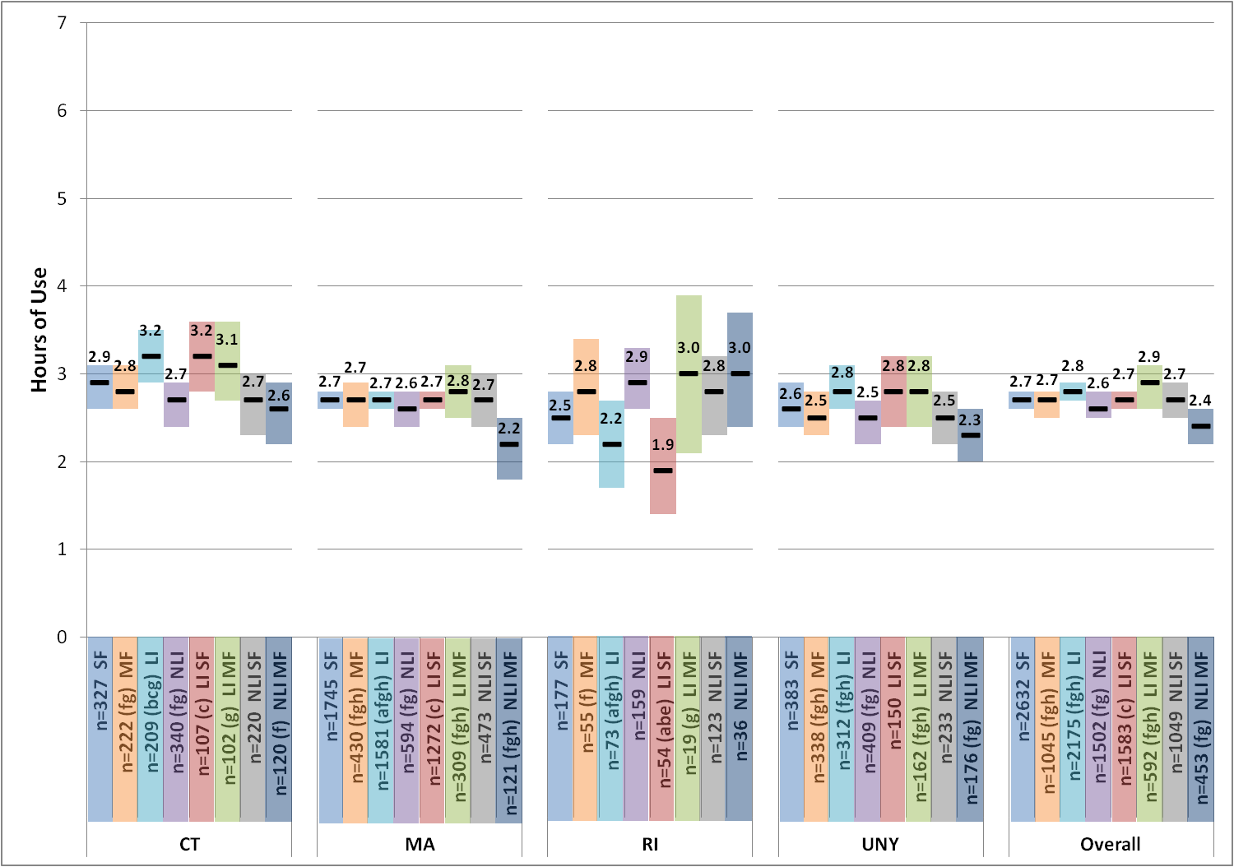
Figure 3-3: HOU Estimates by Home Type and Income Level – Standalone Models
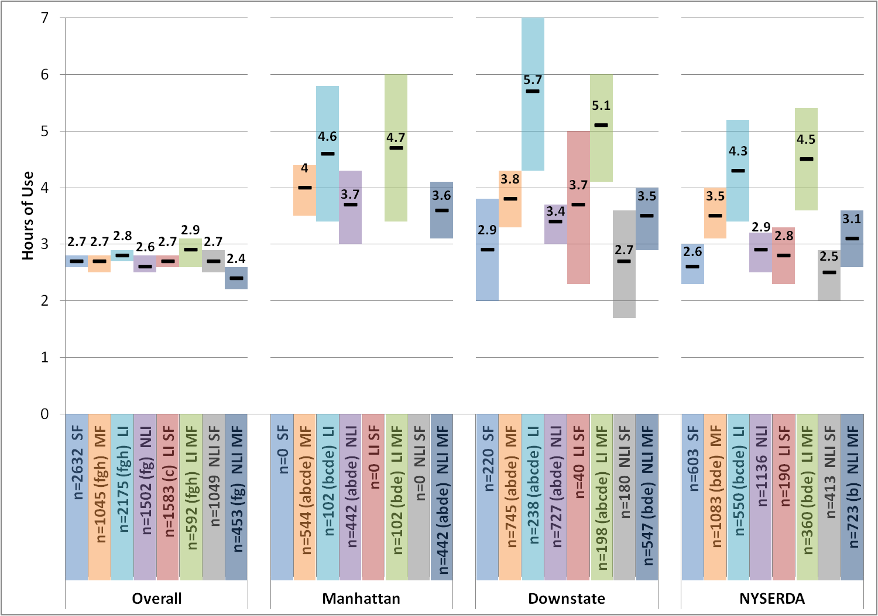

Efficient and Inefficient Bulb Types
Figure 3-4 shows the HOU estimates by area broken out by the type of bulb (inefficient vs. efficient). Inefficient bulbs include halogens and incandescent bulbs, and efficient bulbs include CFLs, LEDs, and fluorescent bulbs. For each bulb type, the figure provides the mean as well as the confidence interval; confidence intervals that do not overlap are considered significantly different. We indicate significant differences within an area with an asterisk (*) and follow our convention of denoting significant differences across areas with a letter a through h, found in the legend along with sample size (n).
HOU estimates for efficient bulbs are significantly higher than HOU estimates for inefficient bulbs within each model. Estimates for inefficient and efficient bulbs, respectively, across each of the five hierarchical models are all statistically similar. In contrast, when compared to the Manhattan, Downstate New York, and the NYSERDA model estimates, there are a number of significant differences. HOU estimates for efficient bulbs are universally lower among the five hierarchical models compared to the three standalone model estimates, and HOU estimates for inefficient bulbs are significantly lower for four out of the five hierarchical models compared to those for Manhattan. (Those for Connecticut are statistically similar.) Estimates for inefficient and efficient bulbs, respectively, across Manhattan, Downstate New York, and NYSERDA are statistically similar.

Figure 3-4: HOU Estimates by Bulb Type and Area
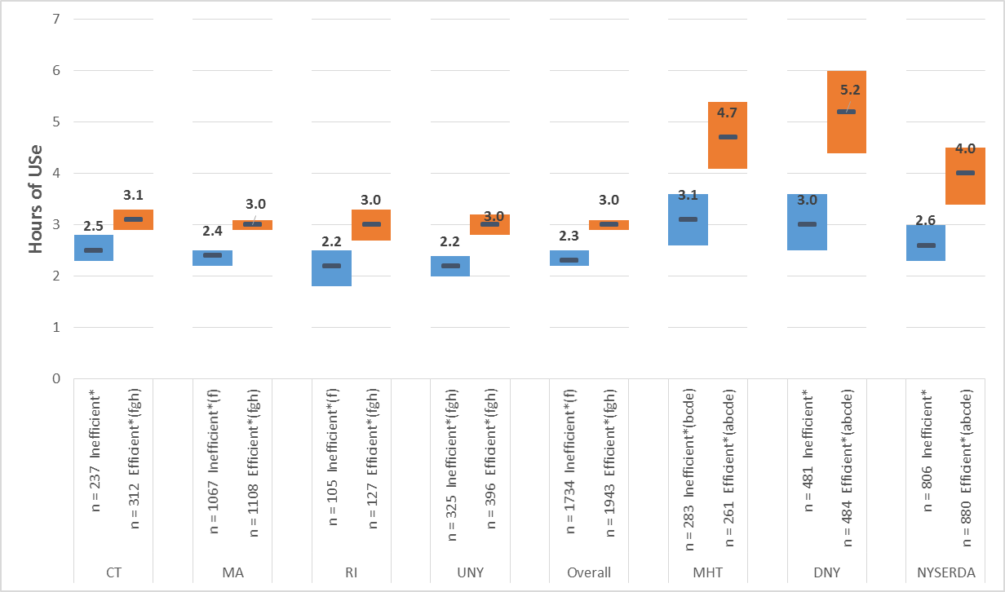
Statistically different at the 90% confidence level from:
a – Connecticut | ^{e} – Overall
^{b} – Massachusetts | ^{f} – Manhattan
^{c} – Rhode Island | ^{g} – Downstate NY
^{d} – Upstate NY | ^{h} – NYSERDA Overall

Efficient and Inefficient Bulb Types – Room by Room
The trend seen at the household level continues when room-by-room estimates are examined. Table 3-3 provides the inefficient bulb estimates room by room, and Table 3-5 contains the efficient bulb estimates room by room. Table 3-4 and Table 3-6 provide the sample sizes (number of loggers) for each area and room type.
Inefficient Bulbs:
- Bedroom: Upstate New York estimates are significantly lower compared to those for Connecticut, Manhattan, Downstate New York, and NYSERDA.
- Bedroom: Manhattan and Downstate New York estimates are significantly higher compared to those for Massachusetts, Upstate New York, and Overall.
- Kitchen: Manhattan estimates are significantly higher compared to those for Massachusetts, Rhode Island, Upstate New York, and Overall.
- Kitchen: Downstate New York estimates are significantly higher compared to those for Rhode Island.
- Dining Room: Manhattan estimates are significantly higher compared to those for Upstate New York and Overall.
- Exterior: Downstate New York estimates are significantly lower compared to those from all five hierarchical models.
- Exterior: NYSERDA estimates are significantly lower compared to those for Rhode Island.
- Other: Manhattan estimates are significantly higher compared to those for Massachusetts, Rhode Island, Upstate New York, and Overall.
Efficient Bulbs:
- Bedroom: Manhattan, Downstate New York, and NYSERDA estimates are significantly higher compared to those for Massachusetts, Upstate New York, and Overall.
- Bedroom: Downstate New York estimates are also significantly higher compared to those for Connecticut.
- Kitchen: Manhattan, Downstate New York, and NYSERDA estimates are significantly higher compared to those from all five hierarchical models.
- Living space: Manhattan and Downstate New York estimates are significantly higher compared to those for Upstate New York.
- Living space: Downstate New York estimates are also significantly higher compared to those for Massachusetts and Overall.
- Dining Room: Manhattan and Downstate New York estimates are significantly higher compared to those for Massachusetts, Upstate New York, and Overall.
- Dining Room: Manhattan estimates are also significantly higher compared to those for Connecticut.
- Other: Manhattan and Downstate New York estimates are significantly higher compared to those from all five hierarchical models.
- Other: NYSERDA estimates are significantly higher compared to those for Rhode Island and Overall.

Table 3-3: HOU by Area for Inefficient Bulbs
Room | CT | MA | RI | UNY | Overall | MHT | DNY | NYSERDA
Bedroom | 2.4 (1.9, 2.9)  ^{d} | 1.8 (1.5, 2.0)  ^{fg} | 2.2 (1.5, 2.9) | 1.4 (0.9, 1.8)  ^{afgh} | 1.8 (1.6, 2.0)  ^{fg} | 2.8 (2.2, 3.3)  ^{bde} | 3.1 (2.4, 3.7)  ^{bde} | 2.5 (2.0, 3.0)  ^{d}
Bathroom | 1.2 (0.7, 1.7) | 1.5 (1.2, 1.8) | 0.8 (0.2, 1.5)  ^{f} | 1.4 (0.9, 1.9) | 1.4 (1.1, 1.6)  ^{f} | 2.3 (1.7, 2.8)  ^{ce} | 2.0 (1.3, 2.7) | 1.9 (1.3, 2.4)
Kitchen | 4.3 (3.7, 4.9) | 3.7 (3.4, 4.0)  ^{f} | 3.0 (2.2, 3.8)  ^{fg} | 3.5 (3.0, 4.0)  ^{f} | 3.7 (3.4, 4.0)  ^{f} | 5.6 (4.8, 6.4)  ^{bcde} | 5.3 (4.0, 6.6)  ^{c} | 4.6 (3.8, 5.4)
Living Space | 3.5 (3.0, 4.1) | 3.0 (2.6, 3.3) | 2.9 (2.1, 3.7) | 2.8 (2.3, 3.2) | 3.0 (2.8, 3.2) | 3.3 (2.5, 4.0) | 4.0 (2.9, 5.0) | 3.7 (2.9, 4.5)
Dining Room | 3.0 (2.4, 3.7) | 2.5 (2.1, 2.9) | 3.3 (2.3, 4.4) | 2.1 (1.5, 2.7)  ^{f} | 2.5 (2.2, 2.8)  ^{f} | 3.7 (2.9, 4.5)  ^{de} | 2.9 (1.9, 3.9) | 2.5 (1.9, 3.1)
Exterior | 5.4 (4.8, 5.9)  ^{g} | 5.3 (4.9, 5.6)  ^{g} | 6.3 (5.6, 7.0)  ^{gh} | 5.3 (4.9, 5.7)  ^{g} | 5.3 (5.0, 5.6)  ^{g} | -- | 3.1 (1.7, 4.6)  ^{abcde} | 4.4 (3.4, 5.3)  ^{c}
Other | 1.3 (1.0, 1.7) | 1.4 (1.2, 1.7) | 1.5 (1.1, 2.0) | 1.4 (1.1, 1.7) | 1.4 (1.2, 1.6)  ^{f} | 2.7 (1.7, 3.7)  ^{e} | 2.4 (1.4, 3.4) | 1.9 (1.3, 2.4)
Overall | 2.5 (2.3, 2.8) | 2.4 (2.2, 2.5)  ^{f} | 2.2 (1.8, 2.5)  ^{f} | 2.2 (2.0, 2.4)  ^{f} | 2.3 (2.2, 2.5)  ^{f} | 3.1 (2.6, 3.6)  ^{bcde} | 3.0 (2.5, 3.6) | 2.6 (2.3, 3.0)
ª – Statistically different at the 90% confidence level from Connecticut | ^{e} – Statistically different at the 90% confidence level from Overall
^{b} – Statistically different at the 90% confidence level from Massachusetts | ^{f} – Statistically different at the 90% confidence level from Manhattan
^{c} – Statistically different at the 90% confidence level from Rhode Island | ^{g} – Statistically different at the 90% confidence level from Downstate NY
^{d} – Statistically different at the 90% confidence level from Upstate NY | ^{h} – Statistically different at the 90% confidence level from NYSERDA Overall

Table 3-4: Sample Sizes, Inefficient Bulbs
Room | CT | MA | RI | UNY | Overall | MHT | DNY | NYSERDA
Bedroom | 47 | 228 | 24 | 75 | 374 | 60 | 103 | 178
Bathroom | 35 | 171 | 21 | 33 | 260 | 77 | 107 | 140
Kitchen | 25 | 132 | 12 | 29 | 198 | 33 | 53 | 82
Living Space | 40 | 174 | 11 | 56 | 281 | 54 | 85 | 141
Dining Room | 30 | 101 | 10 | 37 | 178 | 30 | 49 | 86
Exterior | 7 | 66 | 3 | 21 | 97 | 1 | 11 | 32
Other | 53 | 195 | 24 | 74 | 346 | 28 | 73 | 147
Overall | 237 | 1067 | 105 | 325 | 1734 | 283 | 481 | 806

Table 3-5: HOU by Area for Efficient Bulbs
Room | CT | MA | RI | UNY | Overall | MHT | DNY | NYSERDA
Bedroom | 2.8 (2.4, 3.3)  ^{g} | 2.3 (2.0, 2.6)  ^{fgh} | 3.1 (2.4, 3.7) | 2.2 (1.7, 2.6)  ^{fgh} | 2.4 (2.2, 2.6)  ^{fgh} | 4.2 (3.3, 5.0)  ^{bde} | 4.4 (3.6, 5.2)  ^{abde} | 3.3 (2.8, 3.8)  ^{bde}
Bathroom | 1.8 (1.3, 2.2)  ^{fgh} | 2.2 (1.9, 2.5)  ^{fgh} | 1.7 (1.0, 2.4)  ^{fgh} | 2.1 (1.7, 2.6)  ^{fgh} | 2.1 (1.8, 2.3)  ^{fgh} | 3.5 (2.8, 4.3)  ^{abcde} | 4.6 (3.4, 5.8)  ^{abcde} | 3.6 (2.8, 4.5)  ^{abcde}
Kitchen | 4.7 (4.2, 5.3)  ^{fgh} | 4.2 (3.9, 4.5)  ^{fgh} | 4.2 (3.4, 5.0)  ^{fgh} | 4.3 (3.9, 4.8)  ^{fgh} | 4.3 (4.1, 4.6)  ^{fgh} | 6.7 (5.8, 7.6)  ^{abcde} | 7.7 (6.4, 9.0)  ^{abcde} | 6.3 (5.4, 7.1)  ^{abcde}
Living Space | 4.0 (3.5, 4.5) | 3.6 (3.3, 3.9)  ^{g} | 3.7 (2.9, 4.5) | 3.3 (2.8, 3.8)  ^{fg} | 3.6 (3.4, 3.9)  ^{g} | 4.7 (3.9, 5.5)  ^{d} | 5.1 (4.1, 6.2)  ^{bde} | 4.3 (3.5, 5.0)
Dining Room | 3.5 (2.9, 4.2)  ^{f} | 3.1 (2.6, 3.5)  ^{fg} | 3.9 (2.8, 5.0) | 2.9 (2.3, 3.5)  ^{fg} | 3.1 (2.8, 3.5)  ^{fg} | 5.4 (4.3, 6.4)  ^{abde} | 5.4 (4.1, 6.6)  ^{bde} | 4.1 (3.3, 4.9)
Exterior | 6.7 (6.1, 7.3) | 5.8 (5.5, 6.2) | 6.7 (6.1, 7.4) | 5.7 (5.2, 6.2) | 6.0 (5.6, 6.3) | -- | 4.8 (3.0, 6.6) | 5.4 (4.3, 6.5)
Other | 2.0 (1.7, 2.3)  ^{fg} | 2.0 (1.7, 2.2)  ^{fg} | 1.7 (1.3, 2.1)  ^{fgh} | 2.0 (1.7, 2.3)  ^{fg} | 2.0 (1.8, 2.1)  ^{fgh} | 4.1 (2.9, 5.3)  ^{abcde} | 3.9 (2.8, 5.0)  ^{abcde} | 2.9 (2.2, 3.6)  ^{ce}
Overall | 3.1 (2.9, 3.3)  ^{fgh} | 3.0 (2.9, 3.1)  ^{fgh} | 3.0 (2.7, 3.3)  ^{fgh} | 3.0 (2.8, 3.2)  ^{fgh} | 3.0 (2.9, 3.1)  ^{fgh} | 4.7 (4.1, 5.4)  ^{abcde} | 5.2 (4.4, 6.0)  ^{abcde} | 4.0 (3.4, 4.5)  ^{abcde}
ª – Statistically different at the 90% confidence level from Connecticut | ^{e} – Statistically different at the 90% confidence level from Overall
^{b} – Statistically different at the 90% confidence level from Massachusetts | ^{f} – Statistically different at the 90% confidence level from Manhattan
^{c} – Statistically different at the 90% confidence level from Rhode Island | ^{g} – Statistically different at the 90% confidence level from Downstate NY
^{d} – Statistically different at the 90% confidence level from Upstate NY | ^{h} – Statistically different at the 90% confidence level from NYSERDA Overall

Table 3-6: Sample Sizes, Efficient Bulbs
Room | CT | MA | RI | UNY | Overall | MHT | DNY | NYSERDA
Bedroom | 47 | 228 | 24 | 75 | 374 | 60 | 103 | 178
Bathroom | 35 | 171 | 21 | 33 | 260 | 77 | 107 | 140
Kitchen | 25 | 132 | 12 | 29 | 198 | 33 | 53 | 82
Living Space | 40 | 174 | 11 | 56 | 281 | 54 | 85 | 141
Dining Room | 30 | 101 | 10 | 37 | 178 | 30 | 49 | 86
Exterior | 7 | 66 | 3 | 21 | 97 | 1 | 11 | 32
Other | 53 | 195 | 24 | 74 | 346 | 28 | 73 | 147
Overall | 237 | 1067 | 105 | 325 | 1734 | 283 | 481 | 806

Efficient and Inefficient Bulb Types – Unweighted Analyses
To further explore the root causes of differences in HOU estimates for inefficient and efficient bulbs, the Team turned to unweighted and unadjusted analyses of HOU estimates. First, we examined the unweighted average HOU by bulb type. As Table 3-7 shows, CFLs and fluorescent HOU estimates are significantly higher compared to both incandescent and halogen estimates. Unfortunately, LEDs have not yet been adopted in high enough quantities to comprise a significant amount of our sample, and the resulting confidence interval surrounding LED HOU estimates is quite wide.
Table 3-7: Daily Average HOU Overall by Type of Bulb (Unweighted)
Bulb Type | n | Overall – Northeast | 90% Confidence Interval
All | 4,642 | 2.95 | ± 0.12
Efficient¹ | 2,427 | 3.35 | ± 0.17
Inefficient² | 2,215 | 2.51 | ± 0.14
Incandescent | 2,109 | 2.49 | ± 0.14
CFL | 1,922 | 3.16 | ± 0.17
Fluorescent | 475 | 4.04 | ± 0.40
Halogen | 106 | 2.86 | ± 0.52
LED | 30 | 4.30 | ± 1.74
¹ Includes CFL, fluorescent, and LED bulbs.
² Includes incandescent and halogen bulbs.
Next, the Team evaluated usage by fixture, room, and number of bulbs unweighted. Within each chart, an asterisk (*) denotes a statistically significant difference at the 90% confidence level within a category (inefficient vs. efficient).
Figure 3-5 illustrates significant differences between inefficient and efficient bulbs in seven room types: bathrooms, bedrooms, closets, dining rooms, hallways, kitchens, and living spaces. Five of these room types (bathrooms, bedrooms, kitchens, living spaces, and dining rooms) comprise the top five room types by socket count among Northeast homes, accounting for over three-fifths of household sockets.
Figure 3-6 shows the HOU estimates by bulb type and fixture type for all households in the study. Four fixture categories demonstrate significant differences between inefficient and efficient bulbs: floor lamps, flush mounts, table lamps, and wall mounts.

Figure 3-5: HOU Estimates by Bulb Type and Fixture Type (unweighted)
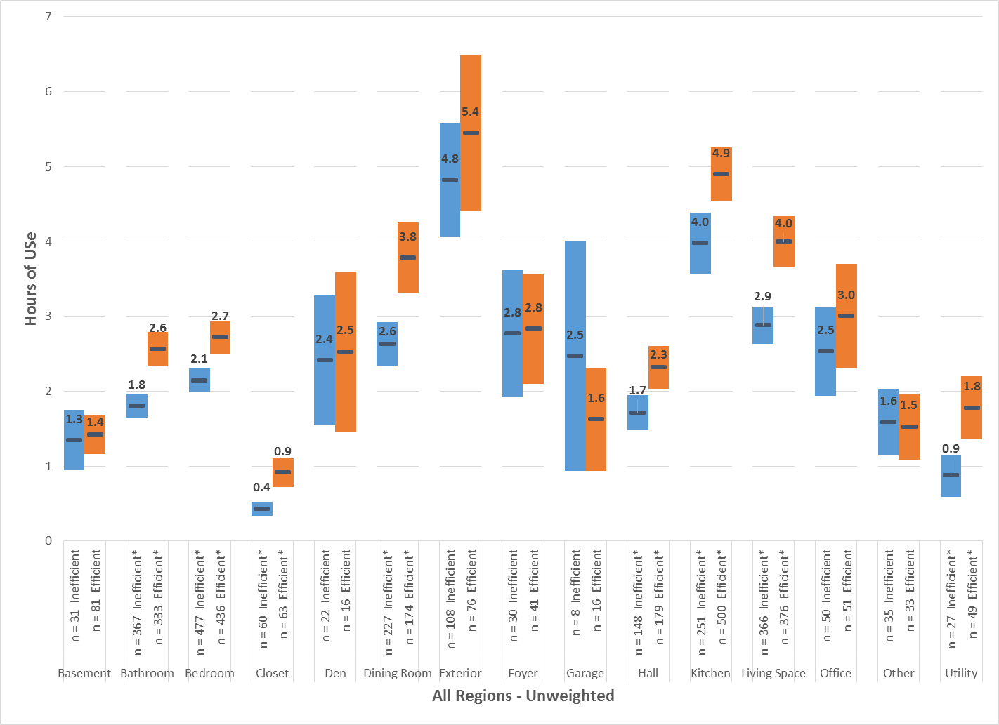
Figure 3-6: HOU Estimates by Bulb Type and Fixture Type (unweighted)
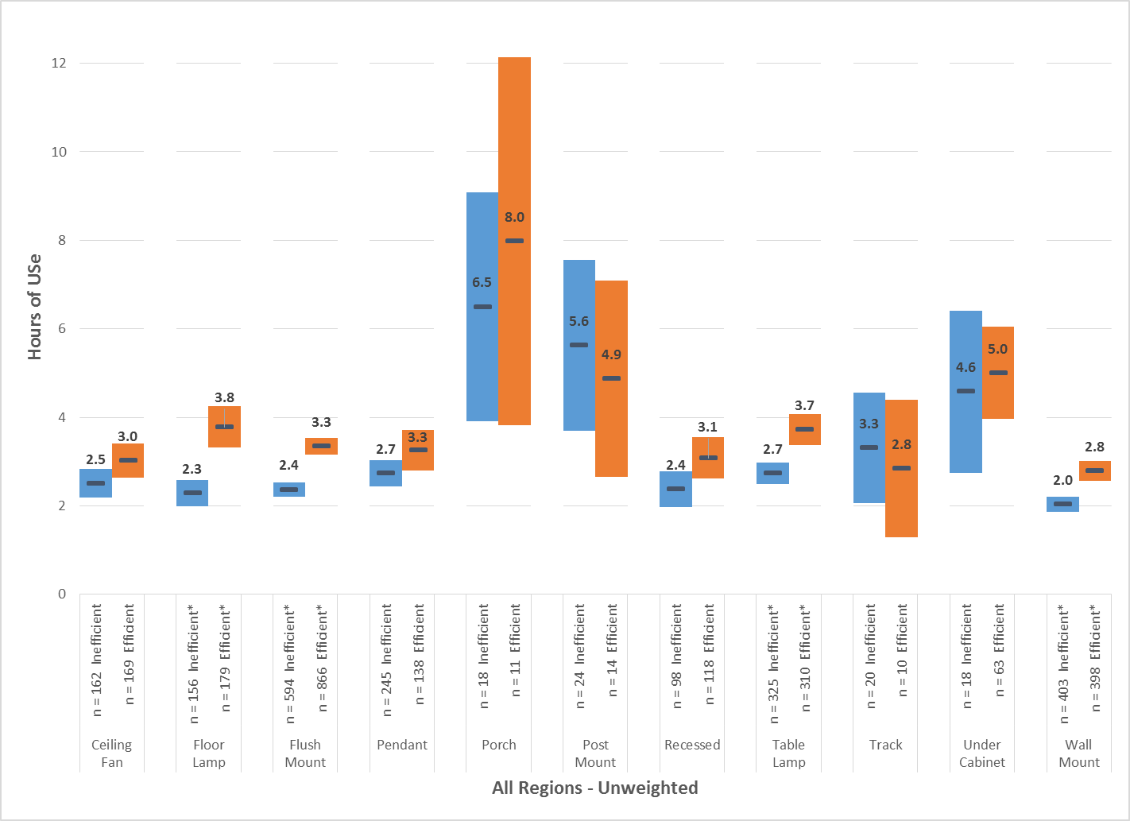

Load Shape Analysis
This chapter describes the analysis of the monthly load shapes for December and January (winter peak period) and for June, July, and August (summer peak period) as well as the calculation of coincidence factors. The development of monthly load shapes is discussed in Section 2.7.

Summer and Winter Load Shapes
Figure 4-1 through Figure 4-8 present the summer and winter weekday load shapes for the eight area models (Connecticut, Massachusetts, Rhode Island, Upstate New York, Overall, Manhattan, Downstate New York, and NYSERDA). Additional load curves broken down by home type and income as well as load curves with weekend data can be found in Appendix C. In each load curve, we have shaded the relevant summer and winter peak periods (1 P.M. to 5 P.M. in the summer and 5 P.M. to 7 P.M. in the winter, based on the hour ending). Average percent on during summer and winter peak periods is shown in the upper left, and the calculated confidence interval is displayed for each hour. All of the load curves for each of the areas show a similar pattern of low usage starting around midnight, ramping up beginning in the hour ending at 6 P.M., building until around noon, and then flattening off. In each area there is also a slight ramp up in usage entering the evening hours around the hour ending at 6 P.M. or 7 P.M. (near the end of the winter peak period).
Figure 4-1: Connecticut Load Curve for Summer and Winter (Weekday)
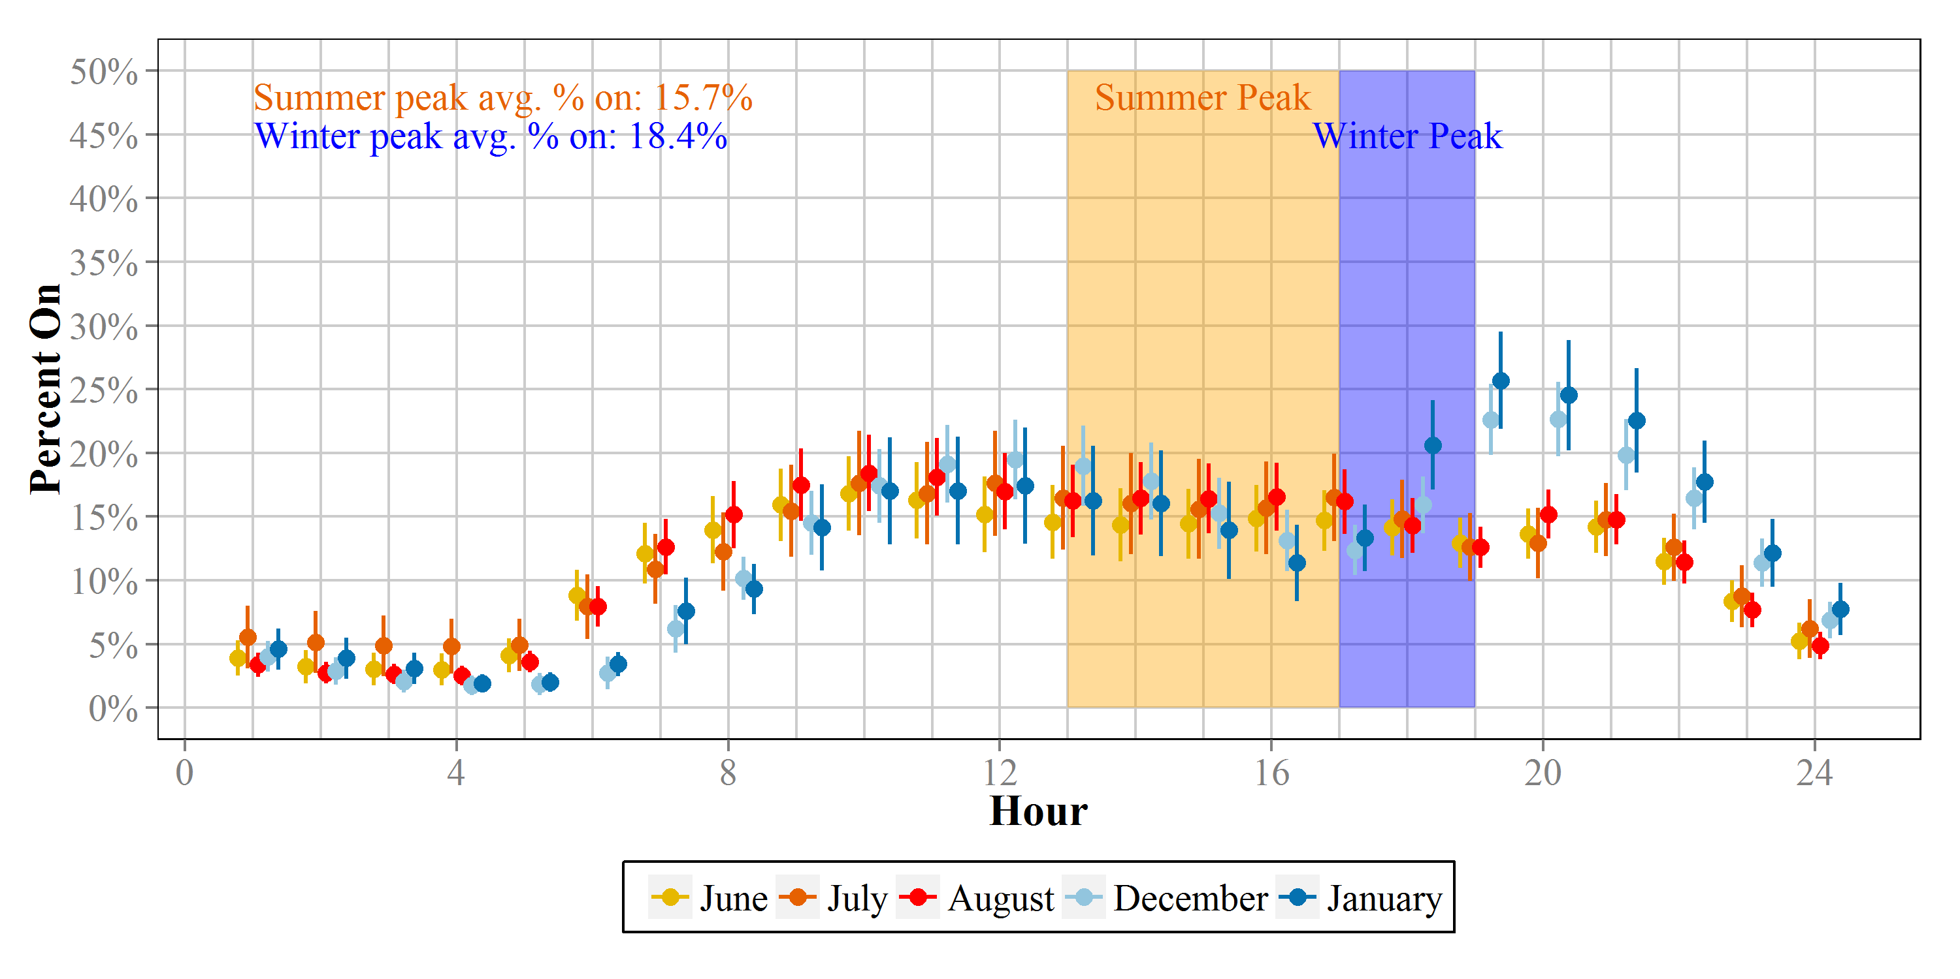
Figure 4-2: Massachusetts Load Curve for Summer and Winter (Weekday)
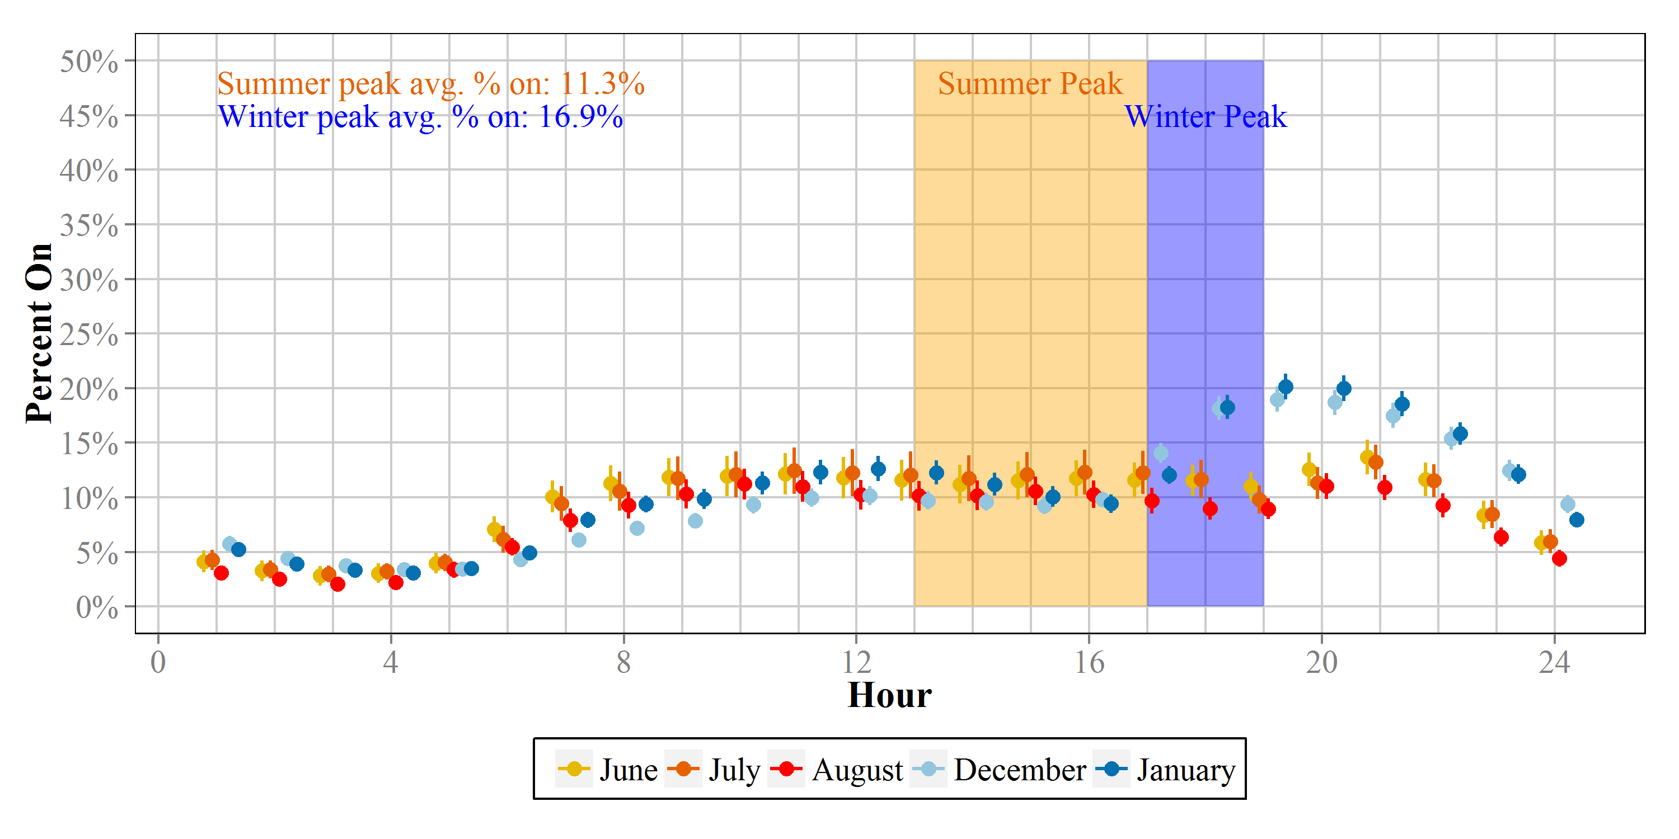
Figure 4-3: Rhode Island Load Curve for Summer and Winter (Weekday)
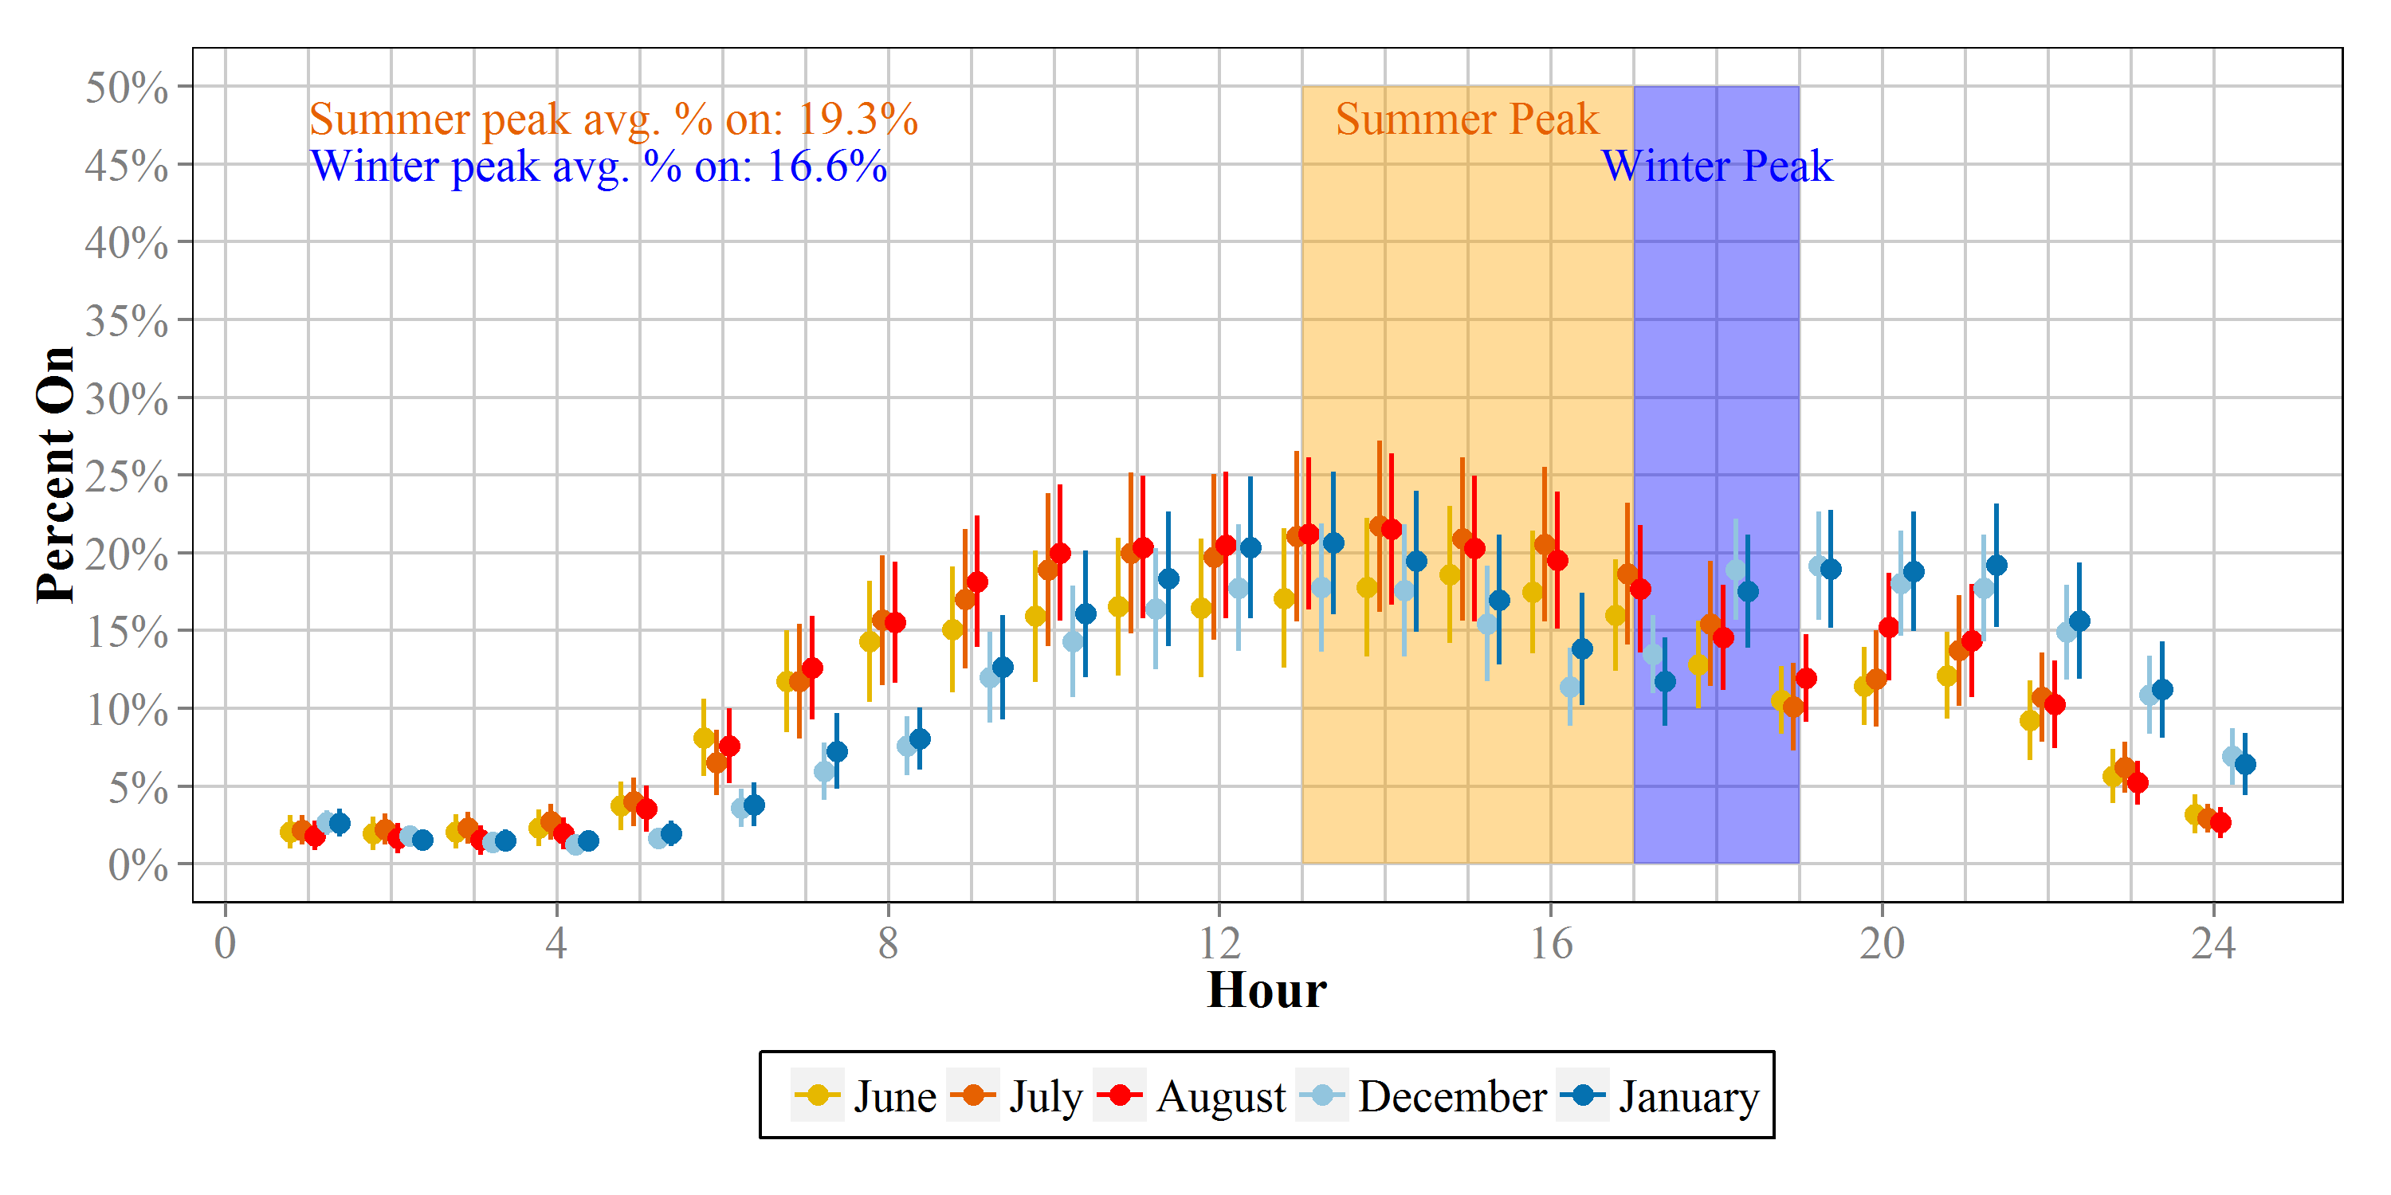
Figure 4-4: Upstate New York Load Curve for Summer and Winter (Weekday)
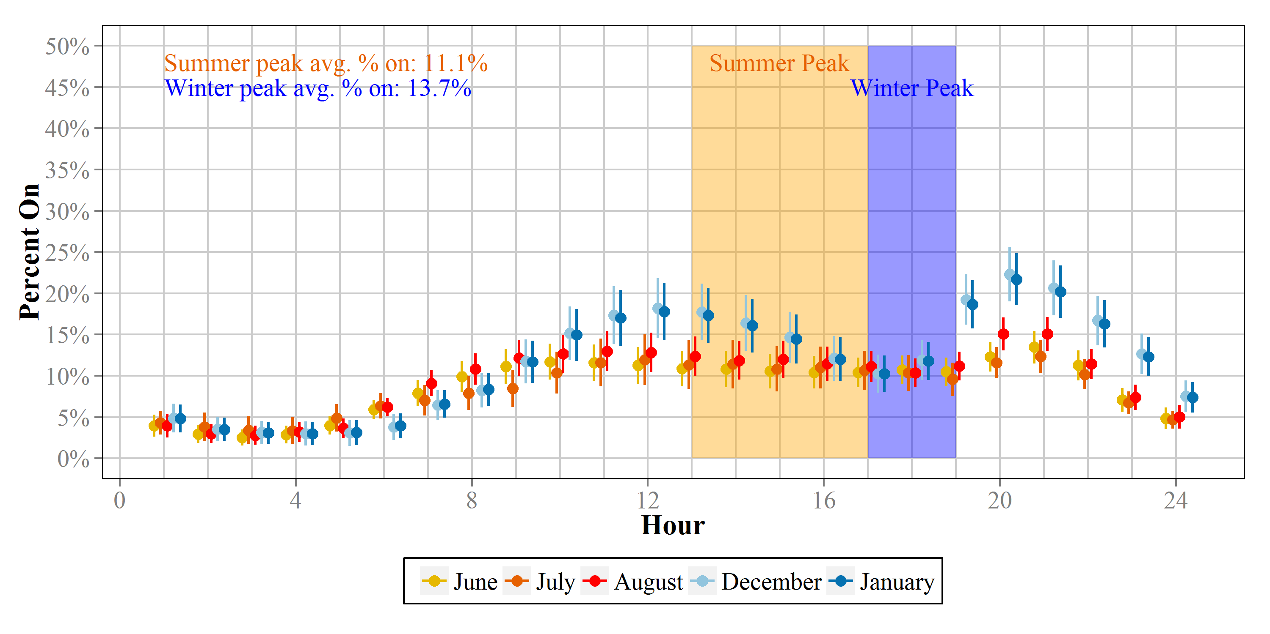
Figure 4-5: Overall Load Curve for Summer and Winter (Weekday)
Figure 4-6: Manhattan Load Curve for Summer and Winter (Weekday)
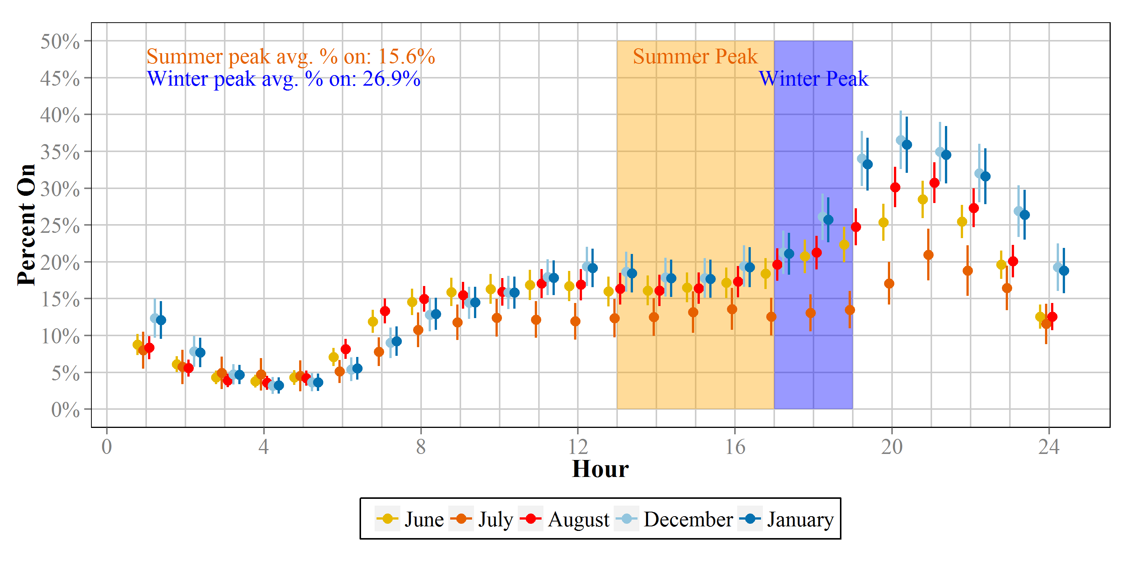
Figure 4-7: Downstate New York Load Curve for Summer and Winter (Weekday)
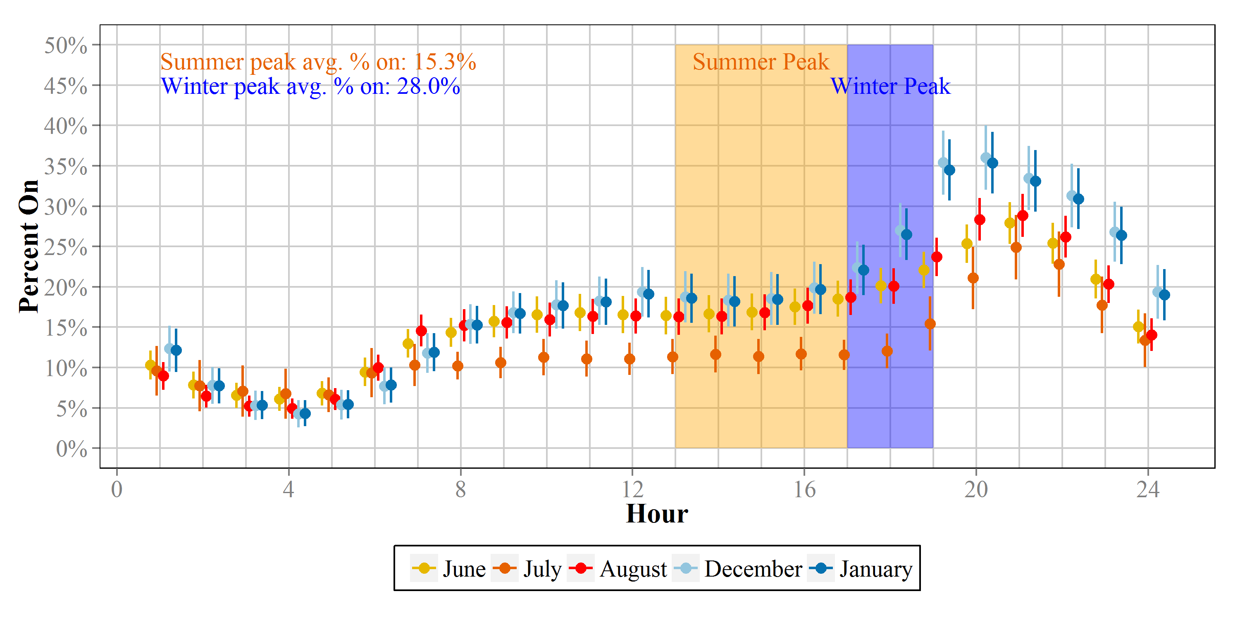
Figure 4-8: NYSERDA Load Curve for Summer and Winter (Weekday)
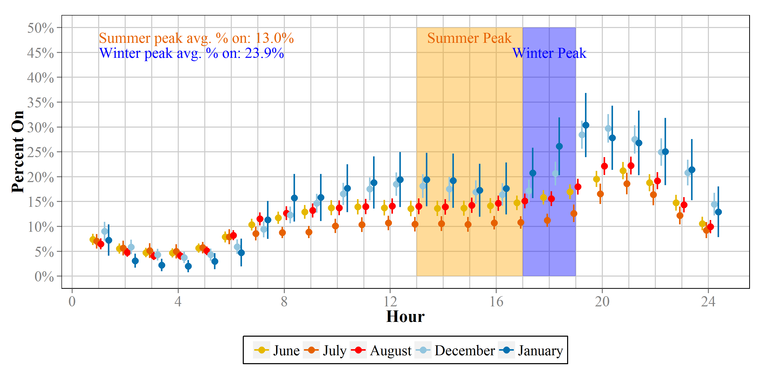

Calculating Coincide Factors for Peak Periods
Using the data that informed the monthly load shapes for the three New England states included in the study, the Team calculated coincidence factors (CFs) during the New England Independent System Operator (ISO-NE) summer and winter on-peak and Seasonal Peak hours. CFs are ratios that represent the percentage of light bulbs in operation during a period of interest and are used in calculating demand reductions. According to ISO-NE, the winter on-peak hours are during non-holiday weekdays from 5 P.M. to 7 P.M. The summer on-peak hours are during non-holiday weekdays from 1 P.M. to 5 P.M.
While NYSERDA does not fall within the ISO-NE area and is instead included at the New York Independent System Operator (NYISO), the New York technical manual published by the New York Department of Public Service (DPS) currently provides summer CFs based on the ISO-NE peak period. Therefore, we provide updated CFs for NYSERDA areas during the same summer and winter peak periods.
Table 4-1: Peak Period Coincidence Factors and Confidence Intervals
Month | CT  Percent On | MA  Percent On | RI  Percent On | UNY  Percent On | Overall  Percent On
December | 17% (15%, 19%) | 17% (16%, 18%) | 17% (14%, 20%) | 14% (11%, 16%) | 17% (16%, 18%)
January | 20% (17%, 23%) | 17% (16%, 18%) | 16% (13%, 19%) | 14% (11%, 16%) | 17% (16%, 18%)
Average Winter | 18% (16%, 21%) | 17% (16%, 18%) | 17% (13%, 20%) | 14% (11%, 16%) | 17% (16%, 18%)
June | 15% (12%, 17%) | 12% (10%, 13%) | 17% (13%, 22%) | 11% (9%, 13%) | 12% (11%, 13%)
July | 16% (12%, 20%) | 12% (10%, 14%) | 21% (15%, 26%) | 11% (8%, 14%) | 13% (12%, 15%)
August | 16% (14%, 19%) | 10% (9%, 11%) | 20% (15%, 25%) | 12% (10%, 14%) | 12% (11%, 13%)
Average Summer | 16% (13%, 19%) | 11% (10%, 13%) | 19% (15%, 24%) | 11% (9%, 13%) | 13% (11%, 14%)

Table 4-2: Peak Period Coincidence Factors and Confidence Intervals
Month | MHT  Percent On | DNY  Percent On | NYSERDA  Percent On
December | 27% (24%, 30%) | 28% (25%, 32%) | 22% (20%, 25%)
January | 27% (24%, 30%) | 28% (24%, 31%) | 26% (20%, 32%)
Average Winter | 27% (24%, 30%) | 28% (25%, 31%) | 24% (20%, 28%)
June | 17% (15%, 19%) | 17% (15%, 19%) | 14% (12%, 15%)
July | 13% (10%, 16%) | 12% (9%, 14%) | 11% (9%, 12%)
August | 17% (15%, 19%) | 17% (15%, 19%) | 14% (13%, 16%)
Average Summer | 16% (13%, 18%) | 15% (13%, 18%) | 13% (11%, 14%)

ISO-NE Seasonal Peak Hours
In addition to calculating average coincidence factors based on the ISO-NE peak periods, the Team prepared estimates based on ISO-NE’s 2013 Seasonal Peak Data for Connecticut, Massachusetts, and Rhode Island. According to the ISO NE Seasonal Peak Data Summary, in 2013 the winter peak period occurred on January 24, 2013 at the hour ending 19, and the summer peak hour occurred on July 19, 2013 at the hour ending 17. Figure 4-9 and Figure 4-10 provide a visual depiction of the peak days for winter and summer, respectively.
Table 4-3: ISO New England Seasonal Peak Period Coincidence Factor
Month | CT  Percent On | MA  Percent On | RI  Percent On
1/24/2013 Hour Ending 19 | 29% (22%, 35%) | 20% (19%, 22%) | 15% (11%, 19%)
6/19/2013 Hour Ending 17 | 19% (7%, 31%) | 15% (11%, 19%) | 22% (16%, 28%)

Figure 4-9: ISO New England Seasonal Peak Period – HOU Load Shape (Winter)
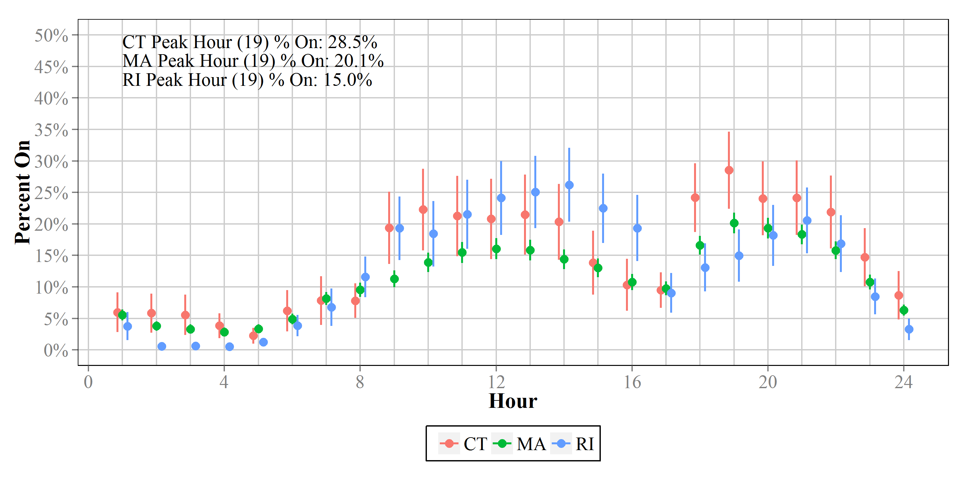
Figure 4-10: ISO New England Seasonal Peak Period – HOU Load Shape (Summer)
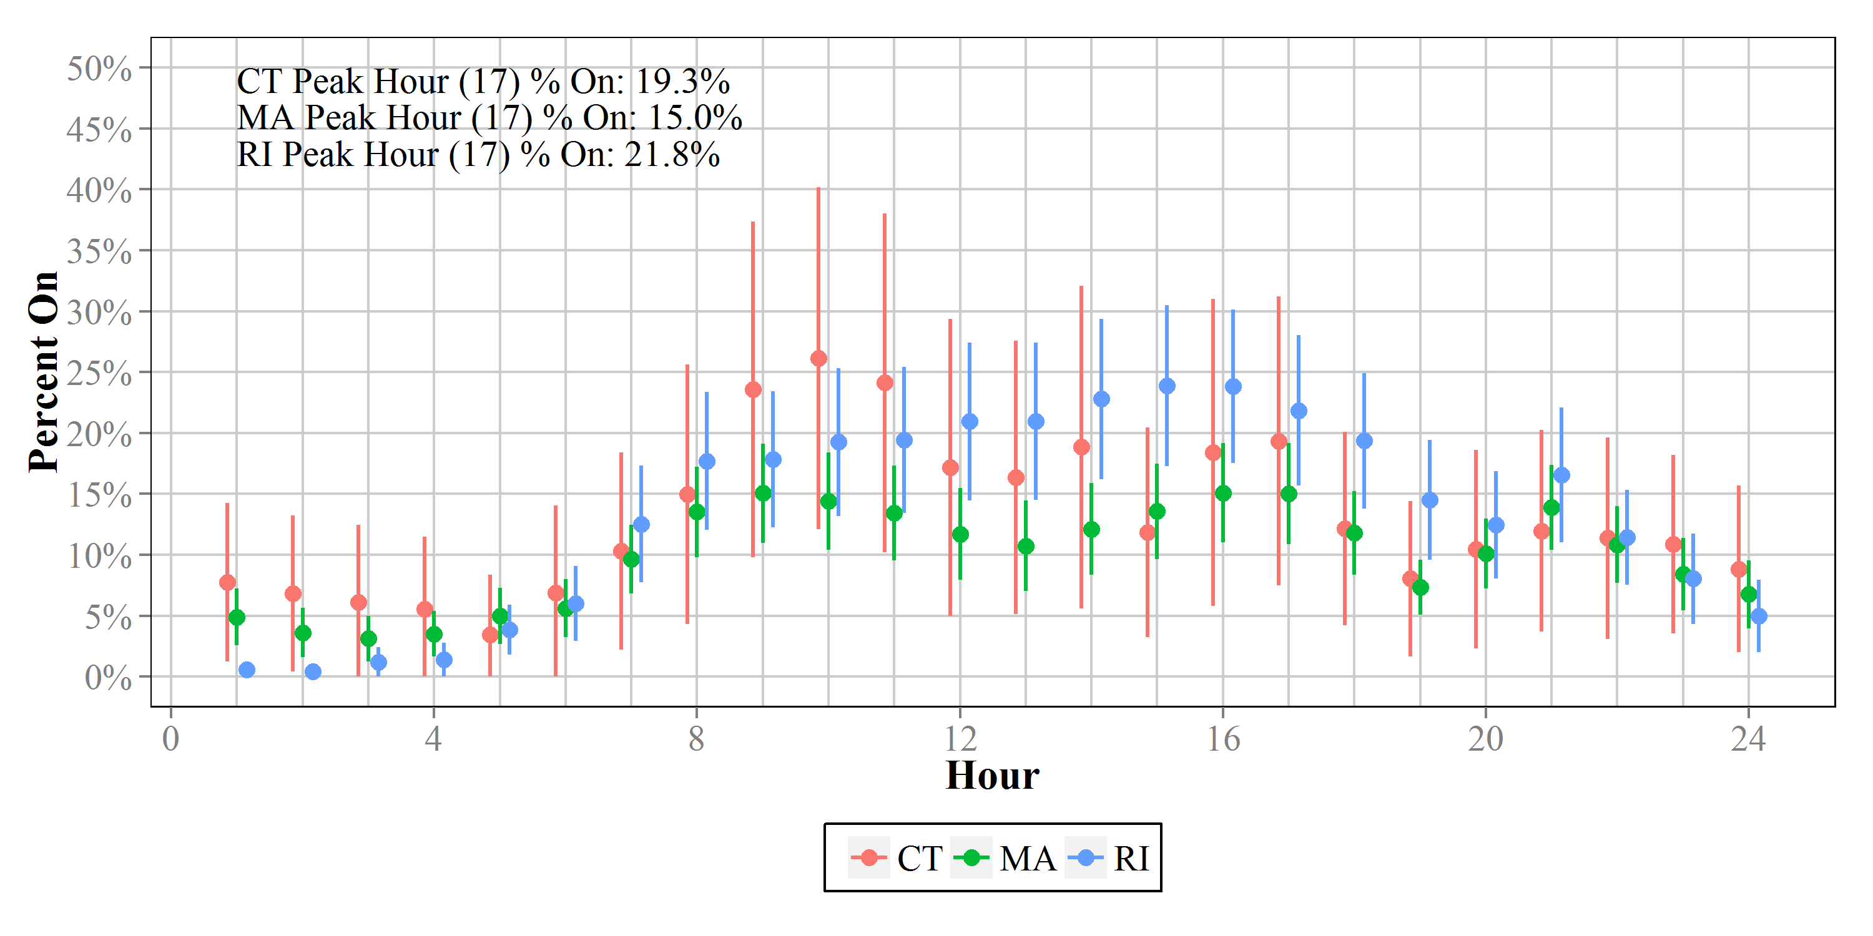

NYISO Seasonal Peak Hours
Finally, the Team prepared estimates based on the NYSIO’s peak hour. Based on NYISO actual load data for 2013, the peak occurred on July 7, 2013 at the hour ending 19. Table 4-4 provides the percent on during this hour for each of the four NYSERDA-area models. Figure 4-11 provides a visual depiction of the peak day of July 7.
Table 4-4: Peak Period Coincidence Factors and Confidence Intervals
Month | UNY  Percent On | MHT  Percent On | DNY  Percent On | NYSERDA  Percent On
6/7/2013 Hour Ending 19 | 10% (7%, 13%) | 16% (11%, 20%) | 13% (10%, 16%) | 12% (10%, 14%)

Figure 4-11: NY ISO Peak Hour – HOU Load Shape
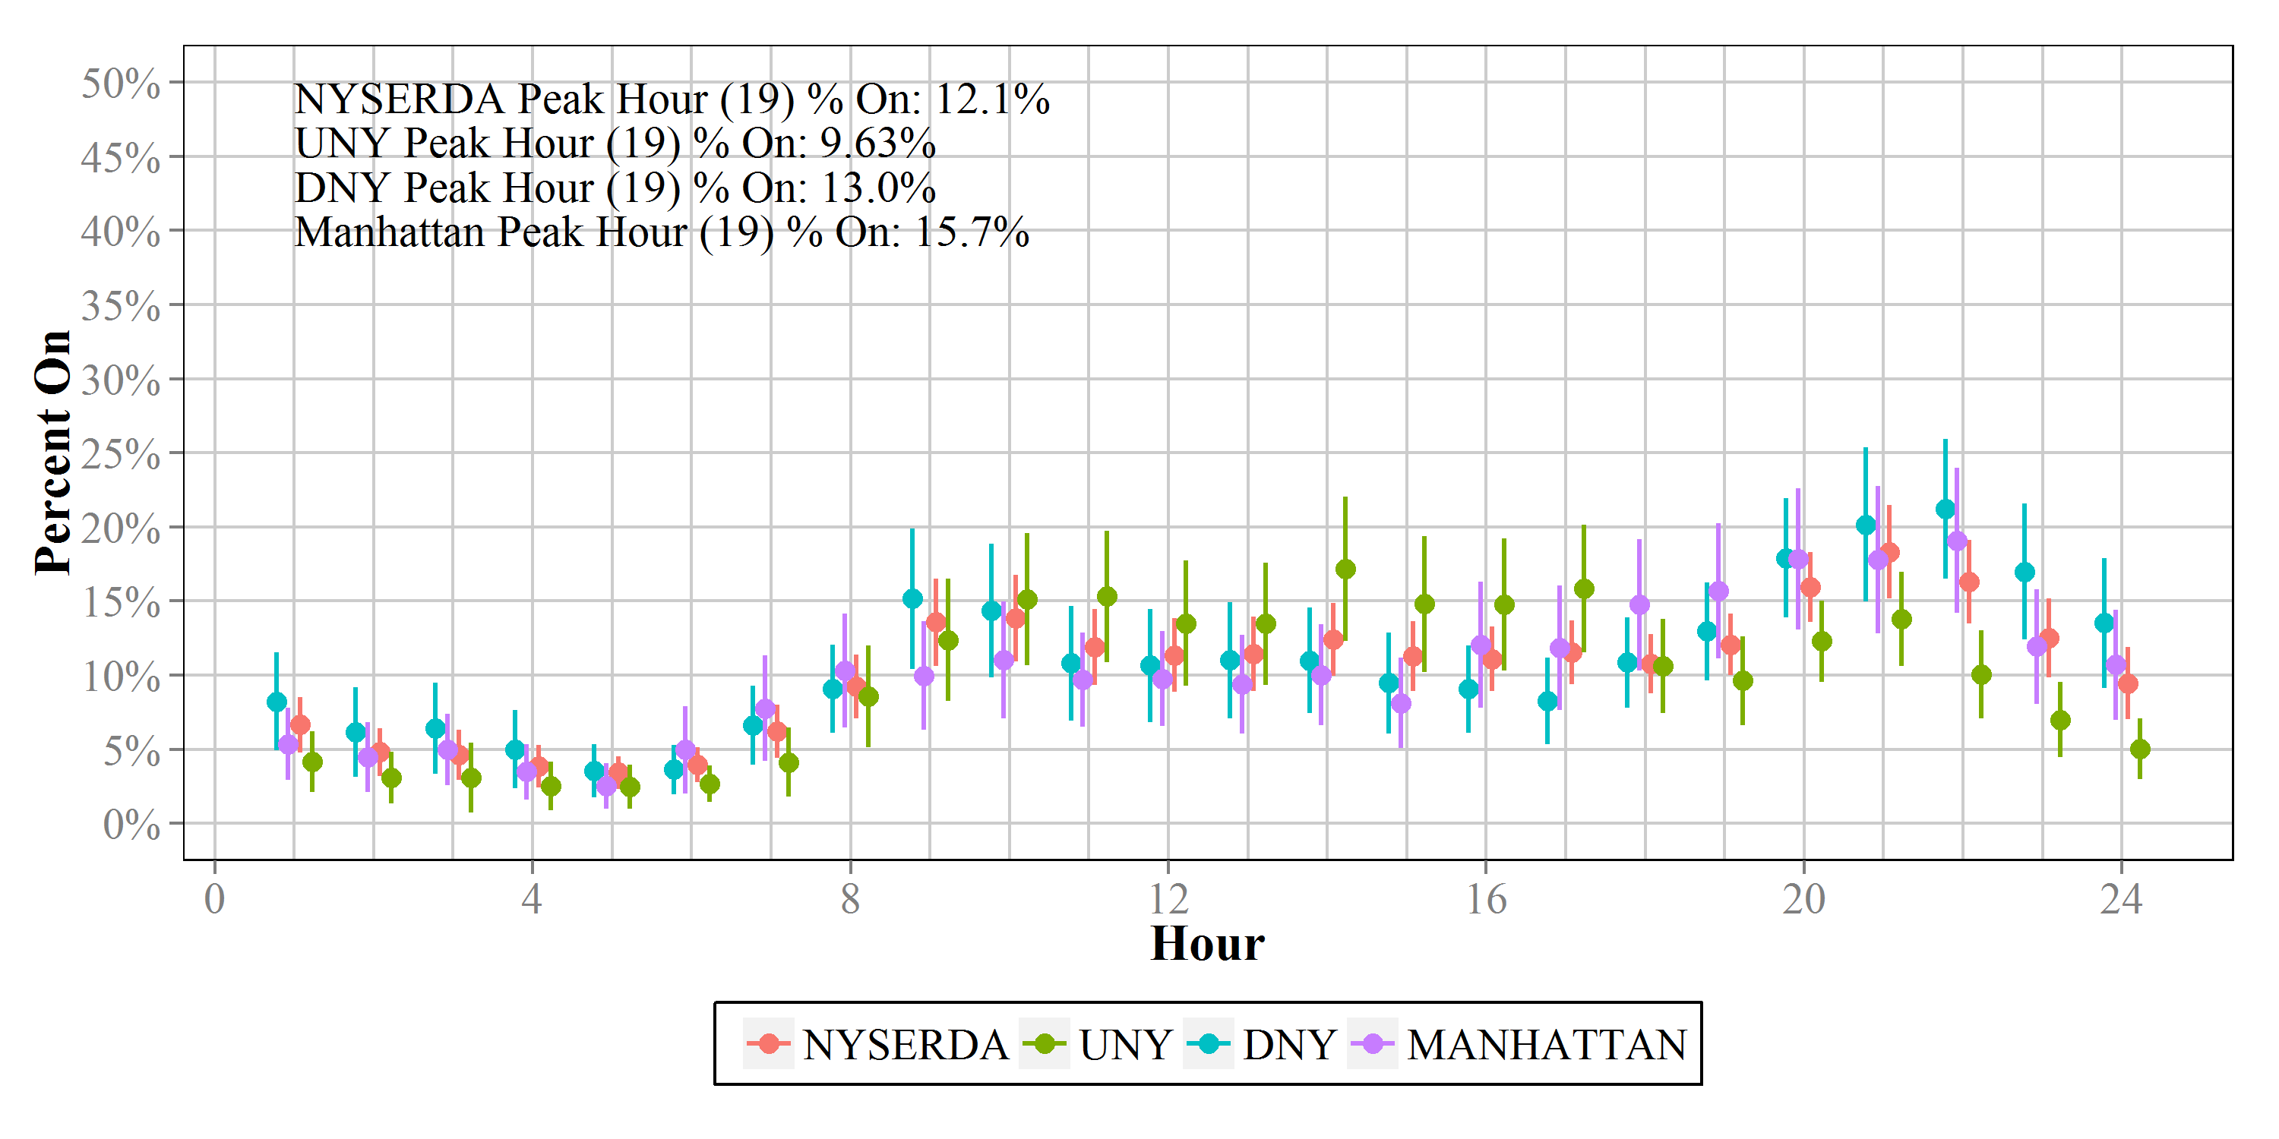

Solar Shading Analysis

Glazing
The mean value for the glazing area of the 130 sites was 10% of the total wall area. Wall area includes all boundary walls of the unit, not just exterior walls. Manhattan’s characteristic grid is aligned roughly on the NE-SW axis. Most buildings north of Houston Street are aligned to the street grid, leading to a prevalence of glazing on the NE-SE-SW-NW sides (Table 5-1). The design of typical high-rise apartments in Manhattan also tends to limit glazing to one or two sides of a unit.
Table 5-1: Window Orientation
(n = 130)
Orientation | Percent of total window area
North | 3%
Northeast | 26%
East | 3%
Southeast | 15%
South | 2%
Southwest | 30%
West | 2%
Northwest | 19%

To facilitate regression modelling, glazing values were divided into classes for both overall and southerly glazing (Table 5-2 and Table 5-3).
Table 5-2: Glazing Classes
(n = 130)
Glazing % of wall area | Glazing Class | Count
0 – 10% | 1 | 81
11% - 20% | 2 | 40
21% - 30% | 3 | 6
> 30% | 4 | 3

Table 5-3: Southerly Glazing Classes
(n = 130)
Glazing % of wall area | Glazing Class | Count
0 – 10% | 1 | 110
11% - 20% | 2 | 17
21% - 30% | 3 | 3

Solar Exposure
Solar exposure is measured relative to the maximum solar insolation at a given location and tilt angle. As calculated with the Solar Pathfinder Assistant software, the maximum solar insolation in Manhattan is 3.11 kWh/m² per day for an object perpendicular to the ground, such as a window. This can also be expressed as the effective solar radiation percentage, or the average percentage of the day during which there is no shade. The maximum effective percentage for Manhattan is 67.5%. The Team was able to collect reliable solar exposure measurements at 101 sites. The average insolation was 0.97 kWh/ m² per day, or 21%. Solar exposure data were also divided into classes (Table 5-4). Classes were divided on a scale of 0-100% as a percentage of the theoretical maximum insolation.
Table 5-4: Solar Exposure Classes
(n = 101)
Percent of maximum insolation | Class | Count
0 – 25% | 1 | 48
26-50% | 2 | 30
51-75% | 3 | 20
76-100% | 4 | 3

In further anticipation of regression modeling, the Team created a variable defined as the sum of all classes. The variable was equal to the sum of the glazing class, south-facing glazing class, and solar exposure class for each site. Values ranged from 3 to 10; therefore, a simplified variable called the binned sum of class values was created taking only the values 1, 2, or 3. See Table 5-5 for more details. The motivation for creating this variable is that it combines the different glazing variables and amount of solar exposure into one variable as opposed to three. This is desirable because a combination of glazing and solar exposure dictate useable ambient light. For example, a site with a large amount of glazing that is mostly shaded by a big tree and a large building will not receive much ambient light in the home; similarly, a site with a high amount of solar exposure but very low glazing will also not receive much ambient light. However, a site with a large amount of glazing and high solar exposure should receive a good amount of ambient light in the home.
Table 5-5: Binned Sum of Class Values
Sum of Class Values | Count | Binned Sum of Class Values | Count
3 | 31 | 1 | 31
4 | 25 | 2 | 49
5 | 24
6 | 10 | 3 | 21
7 | 4
8 | 5
9 | 1
10 | 1

Regression Model
To determine which solar shading variables were important predictors of HOU, the Team performed variable selection using a stepwise linear regression analysis, accepting or rejecting variables based on the Akaike information criterion (AIC). Prior to the variable selection procedure, four variables were dropped in a preliminary phase: %North, %South, %East, and %West-facing glazing. These variables were excluded due to the NE-SW axis on which the Manhattan grid is aligned, which translates to very few sites that have windows facing north, south, east, or west.
In the stepwise regression, the model was forced to contain the same household and logger explanatory variables as the HOU models in the previous section (except the home type variable, as all sites in this subsample were multifamily); specifically, the base solar shading model had the following variables:
- Room type
- Efficient bulb indicator
- Low-income indicator
- Household education
- Rent/own indicator
- Anyone under 18 years of age indicator
- Home type (SF or MF)
The goal of the variable selection procedure, therefore, was to determine which, if any, of the solar shading variables were also important predictors of HOU in addition to the base variables listed above. The variables selected into the model via the stepwise procedure were:
- %Northwest-facing glazing
- %Northeast-facing glazing
- %Southwest-facing glazing
- %Southeast-facing glazing
- Binned sum of class values
The final model also included an interaction term between the binned sum of class values variable and each of the directional variables (see Table 5-6). Table 5-7 summarizes the marginal effects of each of the solar shading variables selected into the model. Given the relatively small sample size and exploratory nature of this solar shading analysis, the Team advises a more qualitative interpretation of the numbers in Table 5-7. For the sake of clarity, however, the values in Table 5-7 should be interpreted as follows: Holding all other variables in the model constant, for every 10% increase in %NW glazing there is an expected increase in HOU of 0.31 hours (or about 19 minutes per day). Similarly, holding all other variables in the model constant, for a 10% increase in %SE glazing there is an expected decrease in HOU of 0.14 hours (or about 8 minutes per day). More qualitatively, however, the general trend seen in Table 5-7 is that sites with a high proportion of their glazing facing the NE and SE have slightly lower HOU, while sites with a high proportion of glazing facing the NW and SW appear to have a slightly higher HOU.
As expected, the binned sum of class values variable also proved to be quite informative. Consider a site with a binned sum of class values equal to one. As described briefly above, that means that particular site has a small percentage of glazing wall area, a small percentage of southerly glazing wall area, and a small amount of solar exposure. Unsurprisingly, the model suggests that such a home would have a higher HOU than a site with a binned sum of class values equal to two or three. On the other end of the spectrum, a residence with a binned sum of class values equal to 3 would have a large percentage of glazing wall area, a large percentage of southerly glazing wall area, and a large amount of solar exposure; the model suggests that these homes have a significantly lower HOU than homes with a value of one or two for this variable. Formally, the results in Table 5-7 say that holding all other variables in the model constant, sites in “Level 2” of the binned sum of glazing class variable would have 0.6 HOU less than sites in “Level 1,” while sites in “Level 3” would use 2.3 HOU less than those in “Level 1.” Again, while these are the formal interpretations of the values below, the Team advises the more qualitative interpretation, given the nature of the study.
Table 5-6: Variables Used in Solar Shading Regression Analysis
Variable | Description | Levels
Room Type | Room/location the bulb was located. | Bedroom
 |  | Bathroom
 |  | Kitchen
 |  | Living Space
 |  | Dining Room
 |  | Exterior
 |  | Other
Efficient Bulb | Whether the bulb was efficient or non-efficient. | Yes
 |  | No
Income | Household income. | Low Income
 |  | Non-Low Income
Education | Education level of the respondent. | Less than High School
 |  | High School or GED
 |  | Some College
 |  | Bachelor’s Degree
 |  | Advanced or Graduate Degree
Rent/Own | Whether household is owned or rented | Rent
 |  | Own
Under 18 | Anyone under 18 years of age in the household | Yes
 |  | No
Home Type | Single or Multi Family Residence | Multi Family (5+)
 |  | Single Family
%NW Glazing | % of total glazing facing NW | Continuous
%NE Glazing | % of total glazing facing NE | Continuous
%SW Glazing | % of total glazing facing SW | Continuous
%SE Glazing | % of total glazing facing SE | Continuous
Total of Glazing Class Values | Binned variable summarizing the sum of all glazing class values (See Table 5-5) | 1
 |  | 2
 |  | 3
Interactions
%NW Glazing × Total of Glazing Class Values
%NE Glazing × Total of Glazing Class Values
%SW Glazing × Total of Glazing Class Values
%SE Glazing × Total of Glazing Class Values

Table 5-7: Marginal Effects of Solar Predictors from Regression Analysis
Variable | Level | Coefficient | Std Error | p-value
%NW Glazing |  | 0.031 | 0.011 | 0.006
%NE Glazing |  | -0.018 | 0.015 | 0.232
%SW Glazing |  | 0.018 | 0.012 | 0.135
%SE Glazing |  | -0.014 | 0.010 | 0.180
Total of Glazing Class Values | 1 | -- | -- | --
 | 2 | -0.569 | 0.819 | 0.488
 | 3 | -2.285 | 1.054 | 0.030

The evaluators will provide an image of this model type in the final report, but a quick Google image search for “sinusoidal model” will show the shape.
KEMA, Inc. and the Cadmus Group, Inc. Final Evaluation Report: Upstream Lighting Program Volume 1. Prepared for California Public Utilities Commission, Energy Division. February 8, 2010.
Cnaan, A., Laird, N.M., & Slasor, P. “Tutorial in Biostatistics: Using the Generalized Linear Mixed Model to Analyze Unbalanced Repeated Measure and Longitudinal Data.” Statistics in Medicine 16 (1997): 2349-2380.
Fitzmaurice, G.M., Laird, N.M., & Ware, J.H. Applied Longitudinal Analysis, 2nd Ed. New York: Wiley, 2011.
While NYSERDA does not fall within the ISO-NE area and is instead included at the New York Independent System Operator (NYISO), the New York technical manual published by the New York Department of Public Service (DPS) currently provides summer CFs based on the ISO-NE peak period. Therefore, we provide updated CFs for NYSERDA areas during the same summer and winter peak periods
Each location may have multiple buildings.
For the purposes of this study, high-rise buildings were defined as four stories or higher.
The Team completed quality control revisits on 5% of the sample homes to ensure the reliability and validity of all procedures and data collection.
The CV is equal to the standard deviation divided by the mean.
ISO New England Inc. 2012. Measurement and Verification of Demand Reduction Value from Demand Resources: Manual M-MVDR. Revision 4, effective June 1, 2012.
The evaluators will provide an image of this model type in the final report, but a quick Google image search for “sinusoidal model” will show the shape.
KEMA, Inc. and the Cadmus Group, Inc. Final Evaluation Report: Upstream Lighting Program Volume 1. Prepared for California Public Utilities Commission, Energy Division. February 8, 2010.
Cnaan, A., Laird, N.M., & Slasor, P. “Tutorial in Biostatistics: Using the Generalized Linear Mixed Model to Analyze Unbalanced Repeated Measure and Longitudinal Data.” Statistics in Medicine 16 (1997): 2349-2380. Fitzmaurice, G.M., Laird, N.M., & Ware, J.H. Applied Longitudinal Analysis, 2nd Ed. New York: Wiley, 2011.
More technically, the estimate from each area is a weighted average of the adjusted population-averaged mean HOU (across all areas in the model) and that particular area’s adjusted HOU profile.
The team does not present Downstate New York minus Manhattan due to the NYSERDA program structure. They treat Downstate—comprising all of New York City, most of Westchester County, and a few towns in other counties—as one unit in their program planning and implementation.
See http://www.usno.navy.mil/USNO
Buckley, Cara. “In the Shadow of Rising Towers, Laments of Lost Sunlight in New York.” The New York Times. Nytimes.com 19 Dec. 2013. Web. 20 Dec. 2013.
http://www.solarpathfinder.com/PF
http://www.solarpathfinder.com/pdf/pathfinder-manual.pdf
New York Evaluation Advisory Contractor Team. New York Standard Approach for Estimating Energy Savings from Energy Efficiency Programs: Residential, Multi-family, and Commercial/Industrial Measures. Submitted October 15, 2010 Current Technical Manual).
Solar insolation is a measure of solar radiation energy received during a given period of time on a given surface area.
Only 20% of the sample had glazing facing any of the four cardinal directions.

