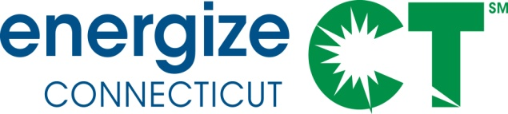

Energy Efficiency Board Monthly Meeting

Wednesday, August 12, 2020, 1:00 – 3:30 PM
Webinar Only

Meeting Materials in Box.com: https://app.box.com/s/wv7mv3o8yyae82yzz6t4l0sf370v6nid
Call-in number: +1 (646) 749-3122 / Call-in passcode: 586-192-293
Web conference: https://global.gotomeeting.com/join/586192293

Agenda

1. Process (20 minutes)
- Roll call of Board Members, Consultants, Company Staff and DEEP Staff
- Minutes - approve minutes from July 8, 2020 Board meeting
- Process Guidelines for EEB Webinar Meetings
- Public Comments - 3 minutes per organization

2. Programs and Planning (125 minutes)

- 2021 Plan Update Status– Companies (15 minutes)
- Serving Underserved Communities/Customers – Consultants and Companies (20 minutes)
- Heat Pumps and Electrification Focus Area Presentation/Discussion – Consultants (30 minutes)
- COVID-19 Updates – Companies (20 minutes)
- Energize CT Center Alternatives Update – Companies (10 minutes)
  - Updated Monthly C&LM Revenue, Spending and Savings (10 minutes)
- Operation Fuel Overview – Brenda Watson (20 minutes)

3. Other (5 minutes)

4. Closing Public Comments – (3 minutes per organization)

Adjourn

