Commissioner Katie Scharf Dykes

Connecticut Department of Energy and Environmental Protection

79 Elm Street

Hartford, CT 06106

August 28, 2023

Dear Commissioner Dykes:

As the undersigned Legislative members, we are expressing our strong support for the NuPower Bridgeport FC LLC qualification for CLM funding under Conn. Gen. Stat. 16-258d(a)(1) and the Legislature’s intent in establishing this Statute.

Important City, public and private Bridgeport customers in the South End have signed thermal supply contracts and are depending on the NuPower Project to provide essential heating services as quickly as possible. These customers are our constituents and they have been vocal supporters of the NuPower Project in numerous PURA proceedings. They recognize the economic and environmental benefits in replacing their legacy fossil-based heating systems with clean heating sources derived from thermal energy that would otherwise go to waste, and in participating in Connecticut’s aggressive goals for emission reductions.

The Legislative intent of the Statute is to provide incentives for thermal loop systems that have historically not received the financial support common to other renewable energy technologies. The Statute included qualifying language for District Heating Systems with which we intended to encourage both developers and customers to participate in thermal loop projects. Therefore, it is important to avoid alternative interpretations of the Statute’s plain language that will severely limit its application.

To qualify as a District Heating System under the Statute, a system must meet four criteria which the NuPower Project satisfies. These are the location of the project in a Designated Area such as Bridgeport, the reduction of the customer’s natural gas demand which is accomplished by displacing legacy fossil-based heating systems, a minimum waste heat thermal capacity requirement of 30 MMBTU which is far surpassed by the project and a minimum distribution of 75% of that captured waste heat to the end customers which is also far surpassed by the project.

The NuPower Project meets all four of these criteria. There is no ambiguity on these criteria including the last criteria which was intended to be agnostic as to the source of the thermal system’s waste heat. The Statute’s plain language indicates that the percentage of waste heat pertains not to the source of the waste heat but to the waste heat used in the thermal loop. This criteria insures that the thermal loop efficiently distributes the waste heat to its customers. The application of the minimum requirement to the waste heat source is not only contrary to the Statute’s plain language but defeats the purpose of the statute which is to encourage the capture of waste heat from any source and efficiently (i.e., minimum distribution of 75%) distribute it for a useful purpose.

While both DEEP and the Energy Efficiency Board (EEB) have the ability to approve each gas company’s incentive program for district heating under the Statute, it is the General Assembly’s intent to clearly establish the qualifications of a district heating system for this incentive program.

We understand that UI has already conducted an extensive review confirming the NuPower Project’s ability to reduce their existing customers’ natural gas usage and has established a proposed incentive amount under the incentive program.

We encourage DEEP to not only to approve UI’s district heating incentive program submission as proposed in the upcoming CL&M Plan but to actively support such efforts for both the benefit of the City of Bridgeport and the State of Connecticut.

Sincerely

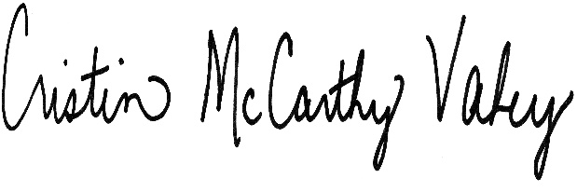

Representative Steve Stafstrom Representative Cristin McCarthy Vahey

129th District 133rd District

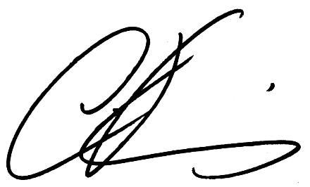 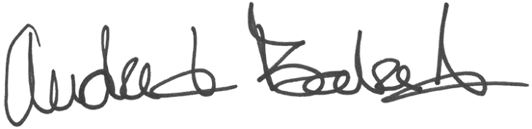

Representative Christopher Rosario Representative Andre Baker Jr

128th District 124th District

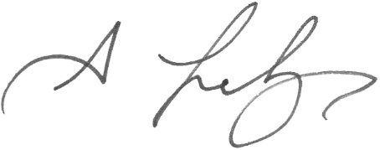 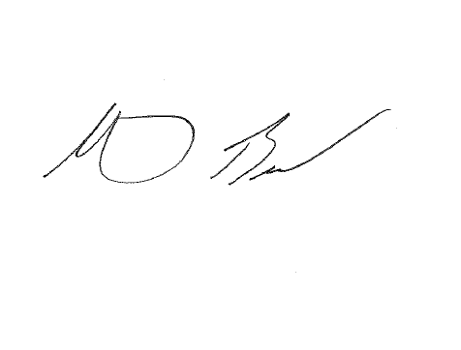

Representative Antonio Felipe Representative Marcus Brown

130th District 127th District

Representative Fred Gee Representative Joe Gresko

126th District 121st District

Representative Jonathan Steinberg

136th District

Cc: Governor’s Chief of Staff