Single-Family Potential Study (R15)

Review Draft

9/5/2014

Submitted to:
The Connecticut Energy Efficiency Fund
Connecticut Light and Power
The United Illuminating Company

Submitted by:
NMR Group, Inc.
Project Oversight: EEB Evaluation Committee and EEB Evaluation Consultants: Lisa Skumatz (Skumatz Economic Research Associates / SERA) with assistance from Scott Dimetrosky (Apex Analytics) and Lori Lewis (AEC)

Abstract
This report contains findings of a residential Potential Savings Study, for single-family homes, which NMR (from here on referred to as “the Team”) conducted on behalf of the Connecticut Energy Efficiency Board (EEB). The following descriptions detail each of the four critical study components. See Section 2 for details on the methodology, which vary for each study component.
- Technical Potential Savings: The total amount of energy savings that are technically feasible over a ten-year period from 2013 to 2022. These estimates do not take into account the cost-effectiveness of home energy upgrades. These estimates assume all measure upgrades are applied immediately.
- Cost-Effective Potential Savings: The amount of energy savings that are technically feasible and cost-effective to achieve over a ten-year period from 2013 to 2022.
- Achievable Potential Savings: The amount of energy savings that are technically feasible, cost-effective, and achievable through over a ten-year period from 2013 to 2022. These estimates also take into account the likelihood of energy upgrade adoption and the evolution of codes and standards.
- Fuel Switching Potential Savings: The potential impacts that result from converting the heating and water heating equipment in single-family homes currently using oil, propane, biomass, or electric heating to either (a) natural gas space heating and water heating equipment, or (b) electric heat pump space heating and water heating equipment.

Figure AB-1 presents a summary of the savings associated with technical, cost-effective, and achievable potential. As shown, fuel oil is responsible for the majority of savings (using the fuel neutral metric of MMBtu) in each of the potential analyses. This is primarily due to the fact that fuel oil is the most prevalent heating fuel among single-family homes in Connecticut.
Figure AB-1: Ten-Year (2013-2022) Aggregate Savings by Fuel Type
(Base: All SF homes, weighted to the population)
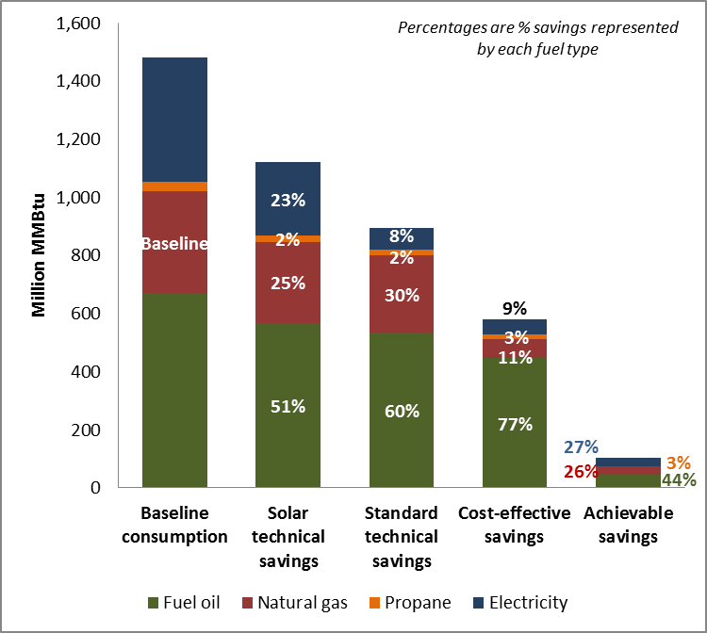

The following conclusions and recommendations were identified as part of this evaluation. Conclusions and recommendations are presented for the potential study (i.e., technical, cost-effective, and achievable) and fuel switching analyses separately as these results should be considered independent of one another.

Technical, Cost-Effective, and Achievable Potential
Conclusions
- Of the 43 measures considered in this study, ductless mini-split heat pumps have the largest technical potential for energy savings (in terms of MMBtu, see Table 4-10). This is due to the high efficiency of the units, the fact that they can displace a high percentage of a home’s heating load, and the versatility of the technology to be installed in any home.
- Fifteen out of the 43 measures considered have an average benefit/cost ratio that is greater than one when using the Total Resource Cost (TRC) test (Table 5-1 and Table 5-2). Of these 15 measures, all but foundation wall insulation and water heater tank wrap insulation are currently incentivized through the HES and HES-IE programs. These results indicate that the HES and HES-IE programs are already targeting the majority of cost-effective measures through their incentive efforts.
  - Air sealing, duct sealing, ceiling insulation, and wall insulation are all key measures that are incentivized by HES and HES-IE with mean benefit/cost ratios that are greater than one.
- Ductless mini-split heat pumps and heat pump water heaters are two emerging technologies that have an average benefit/cost ratio that is greater than one when using the TRC test (Table 5-1). Current market penetration for these measures is extremely low (see Section 2.3.3), indicating there are significant cost-effective savings opportunities associated with these technologies moving forward.
- Achievable potential, which accounts for the likelihood of energy upgrade adoption as well as codes and standards, shows that fuel oil (7%), natural gas (8%), propane (10%), and electricity (7%) all have a savings potential between 7% and 10% of baseline consumption over the ten-year period assessed in the analysis.

Recommendations
- The Companies should consider adding foundation wall insulation and hot water heater tank wrap insulation to their list of incentivized retrofit measures.
- The Companies should continue to provide incentives for ductless mini-splits and heat pump water heaters; the Companies may want to consider increasing current incentive levels to increase the market penetration as the potential savings from these measures are substantial (see Section 4.1.2).
- The Companies should review their savings calculations and cost-effectiveness screening processes to ensure that known changes to codes and standards are incorporated.

Fuel Switching
Conclusion
- Under the upgrade case, assuming program incentives are available for high efficiency equipment, fuel switching has the potential to decrease fuel oil consumption by 21% and propane consumption by 18% if conversions take place at 25% of potential single-family homes. These percentages are only slightly higher than the 19% of savings for fuel oil and 15% of savings for propane under the base case scenario with 25% uptake in fuel switching. Similar increases are reflected at the 50%, 75%, and 100% conversion levels.
Recommendations
- Potential fuel oil and propane savings from fuel switching are significant. The Companies should consider the best ways to promote fuel switching among single-family homes in Connecticut.
- Incentives designed to influence homeowners to fuel switch, thereby increasing the overall rate of fuel conversions, will have a more significant impact than incentives for high efficiency equipment once a fuel switch has already taken place. The Companies should consider offering an incentive for fuel switching if reducing fuel oil and propane consumption is a goal moving forward.

Contents
Executive Summary I
Technical, Cost-Effective, and Achievable Potential II
Energy Savings II
Peak Demand Savings VI
Fuel Switching Potential VII
Base Case Scenario VIII
Upgrade Case Scenario IX
Conclusions XI
1 Introduction 1
2 Methodology 1
2.1 Technical Potential Methodology 1
2.2 Cost-Effective Potential Methodology 4
2.2.1 Total Resource Cost Test vs. Utility Cost Test 5
2.2.2 Screening at the Measure Level 6
2.2.3 Data Sources for Cost-Effectiveness Screening 6
2.3 Achievable Potential Methodology 9
2.3.1 Baseline Shift 9
2.3.2 Adoption of Upgrade Measures 10
2.3.3 Emerging Technologies Market Penetration 10
2.3.4 Lighting 12
2.4 Peak Demand and Coincidence Factors 12
2.5 Fuel Switching Methodology 13
3 Sampling and Weighting 18
3.1 Weighting 20
4 Technical Potential 21
4.1 Results 21
4.1.1 Comprehensive Model Results (All Applicable Upgrades) 22
4.1.2 Individual Measures 30
5 Cost-Effective Potential 37
5.1 Results of Cost-Effectiveness Screening 38
5.2 Cost-Effective Potential Savings 39
6 Achievable Potential 45
7 Fuel Switching Potential 53
7.1 Results 53
7.1.1 MMBtu Summary 54
7.1.2 Results by Fuel 57
7.1.3 Base Case Scenario (No Utility Incentive) 61
7.1.4 Upgrade Case Scenario (Program Incentive Impact) 66
7.1.5 Fuel Switching Impact by End Use 72
Appendix A Potential Upgrade Measures A1
A.1 Maximum R-value Achievable by Framing A3
Appendix B Potential Modeling Assumptions and Other Details B1
B.1 Technical Feasibility for Advanced Measures B1
B.2 Baseline Assessment for Measures Not Inventoried During Site Visits B2
Appendix C Detailed Fuel Switching Impact Tables C1
Appendix D Sources of Growth Rates D1
Appendix E Federal Standards Accounted for In Achievable Potential E1

Tables
Table ES-1: Savings from All Applicable Measures for All Homes—Ten-Year Aggregate Savings (2013-2022)* IV
Table ES-2: Achievable Savings Potential by End Use-Ten-Year Aggregate Savings (2013-2022)* V
Table 2-1: Measures Included in Comprehensive Technical Potential Model Run—Most Common* 3
Table 2-2: Measures Included in Comprehensive Technical Potential Model Run—Less Common* 4
Table 2-3: Benefits Included in Cost-Effectiveness Screening 8
Table 2-4: Coincidence Factors 13
Table 2-5: Upgrade Efficiencies 14
Table 2-6: Features of Fuel Switching Groups 16
Table 2-7: Fuel Switching Conversion Scenarios 17
Table 2-8: Growth Rates and Annual Consumption Change 17
Table 3-1: Sample Design Planned and Actual, with Sampling Error 19
Table 3-2: Potential Study Population Weights 20
Table 4-1: Savings from All Applicable Measures— Ten-Year Aggregate Savings (2013-2022)* 24
Table 4-2: Total Technical Savings Potential by End Use—First-Year* 25
Table 4-3: Total Technical Savings Potential by End Use—First-Year (Percentage of Overall MMBtu Savings)* 26
Table 4-4: Fuel Type Share of Baseline Consumption and Savings Potential 28
Table 4-5: Technical Peak Electric Demand Savings Estimates (MW)* 30
Table 4-6: Building Shell Savings Potential—First-Year 31
Table 4-7: HVAC Savings Potential—First-Year 32
Table 4-8: Water Heating Savings Potential—First-Year^{i} 33
Table 4-9: Appliance Savings Potential—First-Year 34
Table 4-10: Heat Pumps and Solar Technologies Savings Potential—First-Year 35
Table 4-11: Savings from Non-REM Measures—First-Year 36
Table 5-1: Cost-Effectiveness Screening Results: Measures with a Mean TRC B/C Ratio Greater than 1.0 38
Table 5-2: Cost-Effectiveness Screening Results: Measures with a Mean TRC B/C Ratio Less than 1.0 39
Table 5-3: Cost-Effective Potential Savings— Ten-Year Aggregate Savings (2013-2022)* 41
Table 5-4: Cost-Effective Potential Savings by End Use—First Year 42
Table 5-5: Cost-Effective Savings Potential by End Use As A Percentage of Overall Savings in MMBtu —First Year 42
Table 5-6: Fuel Type Share of Baseline Consumption and Cost-Effective Savings Potential 43
Table 5-7: Cost-Effective Peak Electric Demand Savings Estimates (MW)* (Base: All homes, weighted to the population) 44
Table 6-1: Achievable Potential Savings— Ten-Year Aggregate Savings (2013-2022)* 46
Table 6-2: Achievable Savings As A Percent of Baseline in Year Ten 47
Table 6-3: Achievable Potential Savings by End Use—Year One & Year Ten* 47
Table 6-4: Achievable Potential Savings by End Use as a Percentage of Overall Savings in MMBtu—Year One and Year Ten 48
Table 6-5: Fuel Type Share of Baseline Consumption and Savings Potential 50
Table 6-6: Achievable Peak Electric Demand Savings Estimates (MW)* 52
Table 7-1: Overall Summary in MMBtu 55
Table 7-2: Change in Annual Consumption by Fuel At Year Ten 57
Table 7-3: Annual Consumption Trajectories – Base Case Scenario 62
Table 7-4: Annual Consumption Trajectories – Upgrade Case Scenario 67
Table 7-5: Maximum Impacts of Program Incentive by End Use (100% Conversion Rate) 73
Table A-1: Building Shell Measure Upgrades A1
Table A-2: HVAC Measure Upgrades A1
Table A-3: Water Heating Measure Upgrades A2
Table A-4: Lights & Appliances Measure Upgrades A2
Table A-5: Heat Pumps & Solar Technologies Measure Upgrades A2
Table C-1: Consumption Growth Trajectories Under the Maximum (100%) Uptake Rate C1
Table C-2: Estimated Savings Due to Program Incentive Over Ten Years C2
Table C-3: Maximum Impacts of Fuel Switching by End Use Under the 100% Conversion Rate^{i} C3
Table E-1: Federal Standards for Heating & Cooling Equipment E1
Table E-2: Federal Standards for Water Heating Equipment E2
Table E-3: Federal Standards for Appliances E2

Figures
Figure ES-1: Ten-Year (2013-2022) Aggregate Savings for All Homes (MMBtu) II
Figure ES-2: Ten-Year (2013-2022) Aggregate Savings by Fuel Type III
Figure ES-3: Potential Savings from 2013-2022 (MMBtu) V
Figure ES-4: Peak Demand Savings for All Homes VII
Figure ES-5: Change in Overall Consumption Under the Base Case Scenario (MMBtu) VIII
Figure ES-6: Percent Change in Energy Consumption by Fuel Type Under the 100% Conversion Rate IX
Figure ES-7: Incentive Impact on Overall Consumption (MMBtu) X
Figure ES-8: Percent Change From Base Case, in Energy Consumption, by Fuel Type Under the 100% Conversion Rate XI
Figure 4-1: Baseline MMBtu Consumption (156.6 MMBtu) by Fuel Type and End Use (Base: All homes, weighted to the population) 23
Figure 4-2: Total Technical Potential Savings by End Use—% MMBtu Savings 27
Figure 4-3: Total Technical Potential Savings by Fuel Type—% MMBtu Savings 29
Figure 5-1: Ten-Year (2013-2022) Aggregate Savings for Technical and Cost-Effective Potential (MMBtu) 40
Figure 5-2: Fuel Type Percent of Cost-Effective Savings Measured in MMBtu 41
Figure 5-3: Cost-Effective Potential Savings by End Use 43
Figure 5-4: Fuel Type Share of Cost-Effective Potential Savings Measured in MMBtu 44
Figure 6-1: Ten-Year (2013-2022) Aggregate Savings for Cost-Effective and Achievable Potential (MMBtu) 45
Figure 6-2: Achievable Potential Savings Growth Measured in MMBtu 46
Figure 6-3: Achievable Potential Savings by End Use 49
Figure 6-4: Fuel Type Share of Achievable Potential Savings Measured in MMBtu 51
Figure 7-1: Change in Total Consumption in MMBtu, Base Case Scenario 56
Figure 7-2: Change in Total Consumption in MMBtu, Upgrade Case Scenario 56
Figure 7-3: Impact on Fuel Oil Consumption (100% Conversion Rate) 58
Figure 7-4: Impact on Propane Consumption (100% Conversion Rate) 59
Figure 7-5: Impact on Natural Gas Consumption (100% Conversion Rate) 59
Figure 7-6: Impact on Electricity Consumption (100% Conversion Rate) 60
Figure 7-7: Impact on Overall Consumption in MMBtu (100% Conversion Rate) 60
Figure 7-8: Change in Fuel Oil Consumption Under the Base Case Scenario 63
Figure 7-9: Change in Propane Consumption Under the Base Case Scenario 64
Figure 7-10: Change in Natural Gas Consumption Under the Base Case Scenario 65
Figure 7-11: Change in Electricity Consumption Under the Base Case Scenario 66
Figure 7-12: Change in Total Consumption in MMBtu, Base to Upgrade Comparison* 68
Figure 7-13: Change in Fuel Oil Consumption, Base to Upgrade Comparison* 69
Figure 7-14: Change in Propane Consumption, Base to Upgrade Comparison* 70
Figure 7-15: Change in Natural Gas Consumption, Base to Upgrade Comparison* 71
Figure 7-16: Change in Electricity Consumption, Base to Upgrade Comparison* 72
Figure 7-17: Base Case Annual Savings in MMBtu at Year Ten, by End Use* (100% Conversion Rate) 74
Figure 7-18: Upgrade Case Annual Savings from Base Case in MMBtu at Year Ten, by End Use (100% Conversion Rate) 75

Executive Summary
This report contains findings of a residential Potential Savings Study which NMR (from here on referred to as “the Team”) conducted on behalf of the Connecticut Energy Efficiency Board (EEB). The study estimates the potential heating oil, natural gas, propane, and electricity savings from upgrading the efficiency of existing single-family homes in Connecticut, making use of home energy data gathered over the course of 180 on-site assessments. The assessments were conducted at existing single-family homes in the state between September 2012 and January 2013 for the Connecticut Weatherization Baseline Assessment.
The results presented in this document describe technical potential savings, cost-effective potential savings, achievable potential savings, and fuel switching potential savings results. The technical potential savings, cost-effective savings, and achievable savings should be considered as various steps in the same analysis. The fuel switching results should be viewed and considered independently. The savings presented in the fuel switching potential section are not meant to be additive to the savings presented in any of the other sections, as some of the measure upgrades overlap.
The following descriptions detail each of the four critical study components. See Section 2 for details on the methodology, which vary for each study component.
- Technical Potential Savings: The total amount of energy savings that are technically feasible over a ten year period from 2013 to 2022. These estimates assume all measure upgrades are applied immediately.
- Cost-Effective Potential Savings: The amount of energy savings that are technically feasible and cost-effective to achieve over a ten year period from 2013 to 2022. These estimates assume all measure upgrades are applied immediately.
- Achievable Potential Savings: The amount of energy savings that are technically feasible, cost-effective, and achievable over a ten year period from 2013 to 2022. These estimates also take into account the likelihood of energy upgrade adoption and the evolution of codes and standards.
- Fuel Switching Potential Savings: The potential impacts that result from converting the heating and water heating equipment in single-family homes currently using oil, propane, biomass, or electric heating to either (a) natural gas space heating and water heating equipment, or (b) electric heat pump space heating and water heating equipment.
In order to calculate the savings associated with each of these components the Team used REM/Rate™ home energy modeling software. The Team began with 180 REM/Rate models that are representative of the existing single-family housing stock in Connecticut. These models were adjusted to reflect the energy consumption that would result from potential energy efficiency retrofits and fuel switching opportunities. The energy consumption from the original REM/Rate models was compared to the adjusted models to calculate potential energy savings. More detail on the methodology can be found in Section 2.

Technical, Cost-Effective, and Achievable Potential
This section presents high-level results of the technical, cost-effective, and achievable potential analyses.

Energy Savings
Figure ES-1 shows ten-year aggregate savings for technical potential (with and without solar technologies), cost-effective potential, and achievable potential.
Figure ES-1: Ten-Year (2013-2022) Aggregate Savings for All Homes (MMBtu)
(Base: All SF homes, weighted to the population)
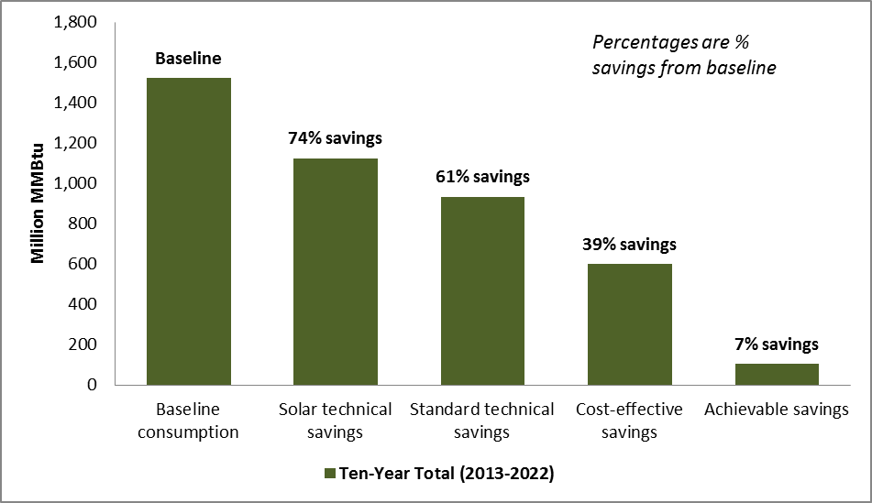

Figure ES-2 presents ten-year aggregate savings by fuel type. As shown, fuel oil is responsible for the majority of savings (using the fuel neutral metric of MMBtu) in each of the potential analyses. This is primarily due to the fact that fuel oil is the most prevalent heating fuel among single-family homes in Connecticut.
Figure ES-2: Ten-Year (2013-2022) Aggregate Savings by Fuel Type
(Base: All SF homes, weighted to the population)

Table ES-1 shows the following detailed findings from the technical, cost-effective, and achievable potential analyses:
- Accounting for all applicable energy efficiency upgrades including solar technologies (photovoltaics and solar hot water), single-family homes in Connecticut have the technical potential to save approximately 4 billion gallons of oil, 2.7 billion ccf of natural gas, and 74,000 Gigawatt-hours (GWh) of electricity from 2013 through 2022.
  - These savings represent 84% of baseline consumption for fuel oil, 80% of baseline consumption for natural gas, and 59% of baseline electric consumption over that same period.
- After accounting for the cost-effectiveness of measures, fuel oil (68%) and propane (52%) both represent significant savings over the baseline. Natural gas (19%) and electricity (12%) show lower savings relative to baseline consumption than the other fuels.
  - The primary reason for lower electric savings is the fact that photovoltaics were not cost-effective at any of the applicable sites, and ductless mini-split continued to be cost-effective at 62% of applicable sites (Table 5-1). Installing ductless mini-splits to displace fossil fuel heating sources results in an increase in electric consumption.
  - One explanation for natural gas (19%) having a lower portion of savings than fuel oil (68%), relative to their respective baseline consumptions, is that fewer homes heated with natural gas pass cost-effectiveness screening for ductless mini-splits (55% of applicable homes) and air leakage (71% of applicable homes) than oil-heated homes (68% and 92%, respectively).
- Achievable potential, which accounts for the likelihood of energy upgrade adoption as well as codes and standards, shows that fuel oil (7%), natural gas (8%), propane (10%), and electricity (7%) all have a savings potential between 7% and 10% of baseline consumption over the ten-year period assessed in the analysis.
Table ES-1: Savings from All Applicable Measures for All Homes—Ten-Year Aggregate Savings (2013-2022)*
(Base: All SF homes, weighted to population)
 | Fuel Oil (Gallons) | Natural Gas (ccf) | Propane (Gallons) | Electricity (kWh) | MMBtu
Ten-Year Aggregate Savings (2013-2022)
Technical Potential Including Solar | 4,081.7 | 2,729.2 | 234.5 | 74,022.4 | 1,120.9
Technical Potential Excluding Solar | 3,847.7 | 2,590.9 | 200.9 | 21,843.2 | 934.5
Cost-Effective Potential | 3,266.8 | 630.4 | 184.3 | 15,349.9 | 587.1
Achievable Potential | 361.0 | 278.6 | 35.2 | 8,587.1 | 110.9
Percent Savings Over Baseline (2013-2022)
Technical Potential Including Solar | 84% | 80% | 66% | 59% | 74%
Technical Potential Excluding Solar | 80% | 76% | 57% | 17% | 61%
Cost-Effective Potential | 68% | 19% | 52% | 12% | 39%
Achievable Potential | 7% | 8% | 10% | 7% | 7%
*Savings are in millions of units.

Figure ES-3 presents baseline consumption, technical potential savings (with and without solar technologies), cost-effective potential savings, and achievable potential savings over the ten year period assessed by this study. The left y-axis of the figure shows the baseline consumption and savings for technical potential and cost-effective potential in million MMBtu’s. The right y-axis shows the savings for achievable potential in million MMBtu’s. The achievable potential savings display a gradual increase over the ten year period as this analysis accounted for federal codes and standards, market penetration of emerging technologies, and the likelihood of measure adoption by 2022. For more details on the achievable potential methodology please see Section 2.3.
Figure ES-3: Potential Savings from 2013-2022 (MMBtu)
(Base: All SF homes, weighted to the population)
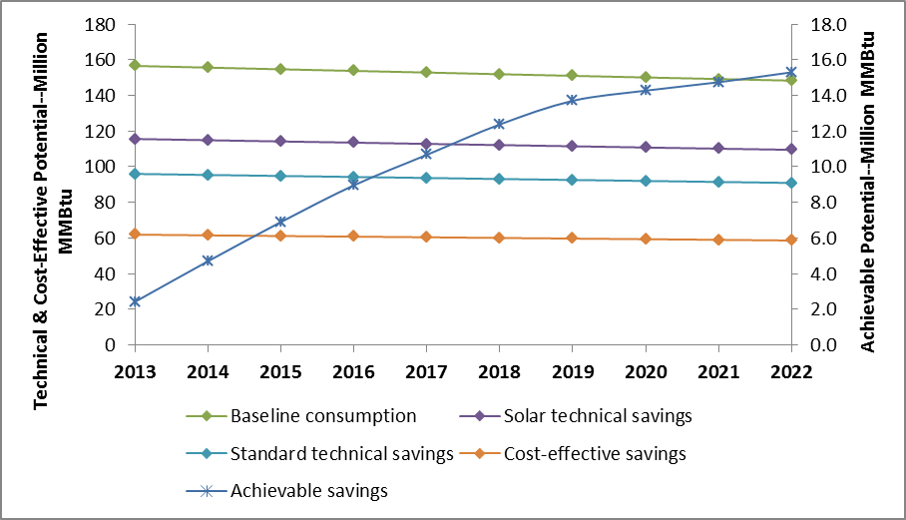

Table ES-2 displays the aggregate ten-year achievable savings by fuel type and end use. Most of the achievable savings attributable to fuel oil and natural gas take place at the heating end use. Electricity shows negative savings at the heating end use; this is a function of ductless mini-split heat pumps displacing a portion of the heating load previously served by fossil fuel fired heating systems. Most of the achievable savings for electricity take place at the lighting and appliance end use.

Table ES-2: Achievable Savings Potential by End Use-Ten-Year Aggregate Savings
(2013-2022)*
(Base: All SF homes, weighted to the population)
End Use | Fuel Oil (gal.) | Nat. Gas (ccf) | Propane (gal.) | Electricity (kWh)
Heating | 258.9 | 248.8 | 11.1 | -737.2
Cooling | -- | -- | -- | 382.3
Water Heating | 102.1 | 29.89 | 24.1 | 1,663.0
Lights & Appliances | -- | -- | -- | 7,279.0
Total | 361.0 | 278.6 | 35.2 | 8,587.1
* Savings are in millions of units.

Peak Demand Savings
Figure ES-4 (on the next page) presents peak demand savings estimates for each of the scenarios assessed as part of the potential study. Below is a summary of the findings:
Summer Peak
- Summer peak demand savings for technical potential range from approximately 2,000 MW to 2,200 MW from 2013-2022.
- Cost-effective summer peak demand savings range from 1,346 MW to 1,472 MW from 2013-2022.
- Achievable summer peak demand savings range from 116 MW to 409 MW from 2013-2022.
Winter Peak
- Winter peak demand savings are negative for technical potential (approximately -1,250 MW to 1,400 MW from 2013-2022) and cost-effective potential (-900 MW to -984 MW from 2013-2022) due to the fact that ductless mini-split heat pumps were modeled at a large number of homes.
- Achievable winter peak demand savings range from 109 MW to 303 MW from 2013-2022.
Achievable demand savings show a fluctuating growth curve as the achievable analysis accounts for upcoming federal codes and standards, likely market penetration of emerging technologies, and the gradual implementation of measures over the ten year period assessed in this study—technical potential and cost-effective potential do not account for these factors.
Figure ES-4: Peak Demand Savings for All Homes
(Base: All SF homes, weighted to the population)
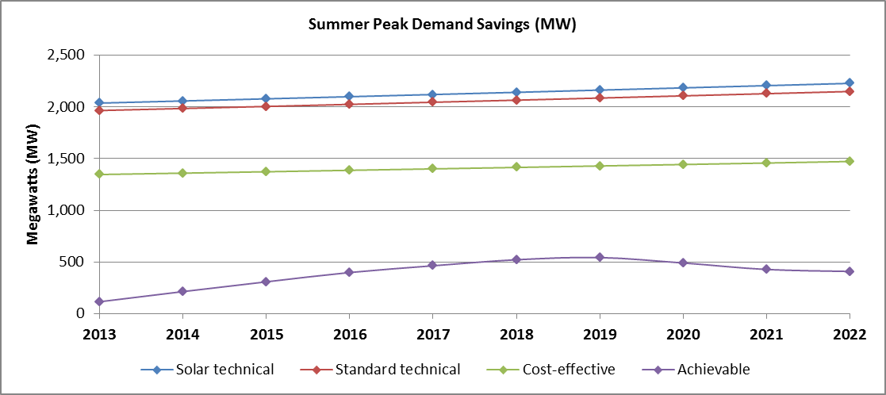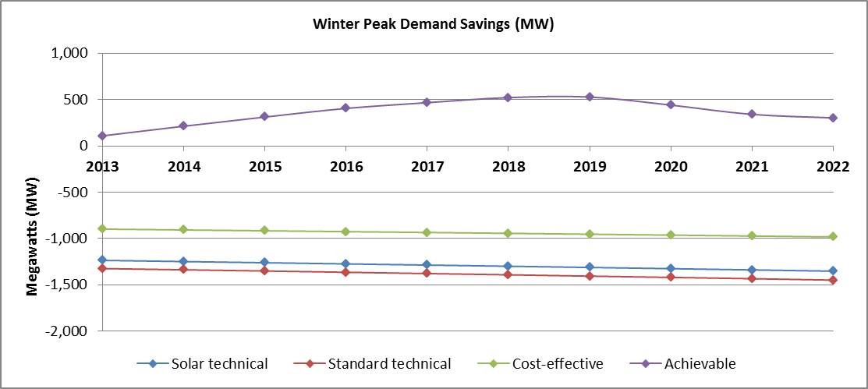

Fuel Switching Potential
The Team modeled conversions of heating and water heating equipment from oil or propane to natural gas or electricity (heat pumps) in two ways:
- A base case, where all new gas and electric equipment were modeled at baseline efficiency levels, assuming no involvement of an energy efficiency program.
- An upgrade case, where all new gas and electric equipment was modeled at the higher efficiency levels utilized in the technical potential analysis. This case describes a scenario wherein the programs incentivize efficient equipment during the fuel switching process.
The fuel switch modeling was applied—using REM/Rate™ energy modeling software—to all homes not currently heating with natural gas. This constitutes 134 (74%) of the 180 homes that were audited during the onsite assessments. The Team modeled a fuel switch to natural gas for 19% of the sampled homes not currently fueled by natural gas. The remaining 47% of homes were modeled with a fuel switch to electricity for heating (and water heating in the upgrade scenario).
The results of fuel switching are presented over a ten year conversion period with conversions increasing to the maximum 100% rate of uptake over that time as well as 25%, 50%, and 75% uptake rates.
More detail on the fuel switching methodology can be found in Section 2.5.
As previously mentioned, the fuel switching results should be viewed and considered independently from the technical, cost-effective, and achievable potential findings. The fuel switching analysis results in a number of key findings.

Base Case Scenario
As Figure ES-5 demonstrates, total annual fuel consumption in the state will decrease by 5% in the next decade (from 155.9 million MMBtu to 147.7 million MMBtu) if left on its current trajectory. Fuel switching could potentially lead to an additional 4% (base case scenario with 25% conversion rate) to 17% (base case scenario with 100% conversion rate) decrease in annual fuel consumption in MMBtu in that same time period. These savings are primarily due to the fact that naturally-occurring replacement equipment (equipment that would be installed without any program intervention) is more efficient than the equipment currently present in homes.

Figure ES-5: Change in Overall Consumption Under the Base Case Scenario (MMBtu)
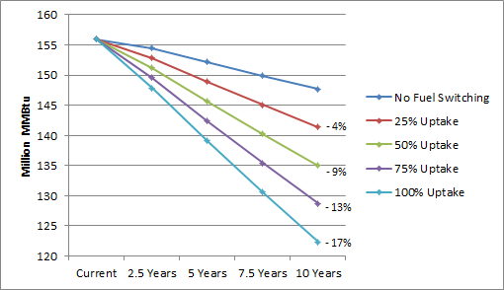

Potential maximum changes in fuel use due to base case fuel switching include a 77% decrease in annual fuel oil consumption, a 59% decrease in annual propane consumption, an 89% increase in annual consumption of natural gas, and a 13% increase in annual electric usage ten years from now (Figure ES-6). The Team assumed a gradual increase in fuel switch conversions over the ten year period. For this reason, the percent change in energy consumption in year ten is greater than the same change measured in aggregate over ten years.
Figure ES-6: Percent Change in Energy Consumption by Fuel Type Under the 100% Conversion Rate
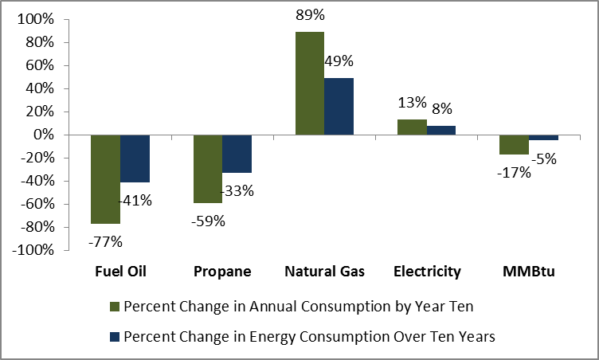

Upgrade Case Scenario
The energy savings from possible program incentives for higher-efficiency equipment (the upgrade case scenario) are substantially smaller than the energy savings from the base case scenario (fuel switching without incentives).
The analysis showed that the maximum impact of program incentives for higher-efficiency equipment would decrease overall annual consumption by about 6% relative to the expected annual consumption ten years from now under the base case fuel switching scenario (Figure ES-7).
Figure ES-7: Incentive Impact on Overall Consumption (MMBtu)
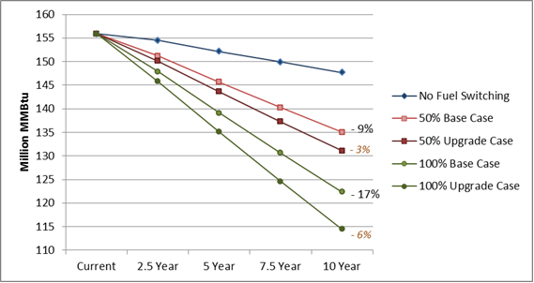
* Base case data labels show percent difference from a scenario without fuel switching at year ten. Upgrade case labels (in orange) show percent difference from the base case.

The maximum potential impacts (under the 100% conversion rate) due to program incentives include annual decreases of 30.1 million gallons of oil (30% decrease from the base case), 4.8 million gallons of propane (33% decrease), 24.3 million ccf of natural gas (4% decrease), and 188.7 million kWh (1% decrease) (Figure ES-8).
The percent decreases for oil and propane are higher because base case fuel switching captures most savings associated with those fuels and these numbers are presented relative to base case consumption. Fuel oil and propane savings occur entirely at the water heating end use as heating consumption for these fuels was eliminated in the base case.
Figure ES-8: Percent Change From Base Case,
in Energy Consumption, by Fuel Type Under the 100% Conversion Rate
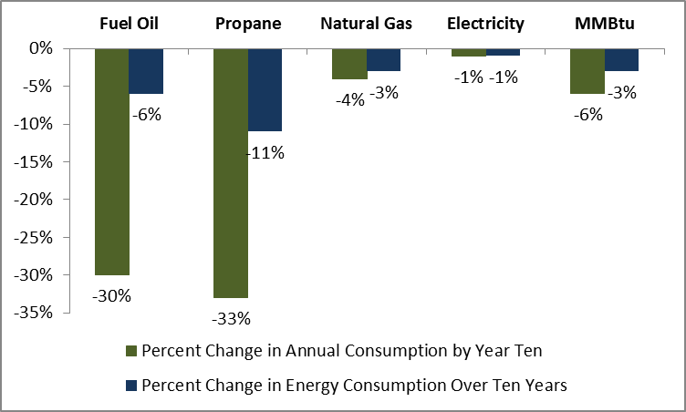

Conclusions and Recommendations
The following conclusions and associated recommendations were identified as part of this evaluation. The Team makes only limited recommendations regarding the HES and HES-IE programs as this study does not include an impact or process evaluation of those programs. However, the HES and HES-IE programs are the most likely to change based on the findings of this study and as a result the Team does propose potential changes to said programs for the Companies and the EEB to consider. The Team presents conclusions and recommendations from the potential study (i.e., technical, cost-effective, and achievable) and fuel switching analyses separately as these results should be considered independent of one another.

Technical, Cost-Effective, and Achievable Potential
Conclusions
- Of the 43 measures considered in this study, ductless mini-split heat pumps have the largest technical potential for energy savings (in terms of MMBtu, see Table 4-10). This is due to the high efficiency of the units, the fact that they can displace a high percentage of a home’s heating load, and the versatility of the technology to be installed in any home.
- Fifteen out of the 43 measures considered have an average benefit/cost ratio that is greater than one when using the Total Resource Cost (TRC) test (Table 5-1 and Table 5-2). Of these 15 measures, all but foundation wall insulation and water heater tank wrap insulation are currently incentivized through the HES and HES-IE programs. These results indicate that the HES and HES-IE programs are already targeting the majority of cost-effective measures through their incentive efforts.
  - Air sealing, duct sealing, ceiling insulation, and wall insulation are all key measures that are incentivized by HES and HES-IE with mean benefit/cost ratios that are greater than one.
- Ductless mini-split heat pumps and heat pump water heaters are two emerging technologies that have an average benefit/cost ratio that is greater than one when using the TRC test (Table 5-1). Current market penetration for these measures is extremely low (see Section 2.3.3), indicating there are significant cost-effective savings opportunities associated with these technologies moving forward.
- Achievable potential, which accounts for the likelihood of energy upgrade adoption as well as codes and standards, shows that fuel oil (7%), natural gas (8%), propane (10%), and electricity (7%) all have a savings potential between 7% and 10% of baseline consumption over the ten-year period assessed in the analysis.

Recommendations
- The Companies should consider adding foundation wall insulation and hot water heater tank wrap insulation to their list of incentivized retrofit measures.
- The Companies should continue to provide incentives for ductless mini-splits and heat pump water heaters; the Companies may want to consider increasing current incentive levels to increase the market penetration as the potential savings from these measures are substantial (see Section 4.1.2).
- The Companies should review their savings calculations and cost-effectiveness screening processes to ensure that known changes to codes and standards are incorporated.

Fuel Switching
Conclusion
- Under the upgrade case, assuming program incentives are available for high efficiency equipment, fuel switching has the potential to decrease fuel oil consumption by 21% and propane consumption by 18% if conversions take place at 25% of potential single-family homes. These percentages are only slightly higher than the 19% of savings for fuel oil and 15% of savings for propane under the base case scenario with 25% uptake in fuel switching. Similar increases are reflected at the 50%, 75%, and 100% conversion levels.
Recommendations
- Potential fuel oil and propane savings from fuel switching are significant. The Companies should consider the best ways to promote fuel switching among single-family homes in Connecticut.
- Incentives designed to influence homeowners to fuel switch, thereby increasing the overall rate of fuel conversions, will have a more significant impact than incentives for high efficiency equipment once a fuel switch has already taken place. The Companies should consider offering an incentive for fuel switching if reducing fuel oil and propane consumption is a goal moving forward.

Introduction
This report contains findings of a residential Potential Savings Study which NMR conducted on behalf of the Connecticut Energy Efficiency Board (EEB). The study estimates the potential heating oil, natural gas, propane, and electricity savings from upgrading the efficiency of existing single-family homes in Connecticut, making use of home energy data gathered over the course of 180 on-site assessments. The assessments were conducted at existing single-family homes in the state between September 2012 and January 2013 for the Connecticut Weatherization Baseline Assessment.
The following information was collected as part of the onsite inspections:
- General information, including house type and year of construction, conditioned floor area, conditioned volume, foundation type, primary heating fuel, number of stories, number of bedrooms, thermostat type, and ownership status;
- Basement information, detailing a basement’s characteristics to aid in categorizing a space as within or outside the buildings conditioned space;
- Building shell measures that fall into two types:
  - Insulation location, area, type, R-value, and installation grade for walls, floors, ceilings, joists, foundation walls, and slabs,
  - Framing description where applicable;
- Window type, location, area, U-value, and SHGC values;
- Door type, location, area, and insulation;
- Mechanical equipment, including make, model, type, age, location, efficiency, and capacity of heating, cooling, and water heating units;
- Appliances, including make, model, age, location, energy usage in kWh/yr., and Energy Factor where applicable;
- Lighting, including number of fixtures by type and location;
- Diagnostic testing, including building envelope air leakage in cubic feet per minute at 50 Pascals (CFM50) and duct leakage, both total and to the outside of the envelope, in cubic feet per minute at 25 Pascals (CFM25);
- Duct information, including type of duct, location in the home, location on the supply or return portion of the system, insulating material, and R-value;
- Ventilation, including attic ventilation; Energy Recovery and Heat Recovery Ventilation Systems (ERV/HRV) make, model, rate, and recovery efficiency; and bathroom fan control type;
- Renewable technologies, including the size, type, and efficiency of solar thermal, photovoltaic, and wind technologies; and
- Auditor rankings, wherein auditors record the level of opportunity for improving energy efficiency in the home on a scale of one (low) to five (high) and rank the energy features of the home by greatest savings opportunity.
The results presented in this document describe technical potential savings, cost-effective potential savings, achievable potential savings, and fuel switching potential savings results. The technical potential savings, cost-effective savings, and achievable savings should be considered as various steps in the same analysis. The fuel switching results should be viewed and considered independently. The savings presented in the fuel switching potential section are not meant to be additive to the savings presented in any of the other sections, as some of the measure upgrades overlap.
The following descriptions detail each of the four critical study components:
- Technical Potential Savings. The total amount of energy savings technically feasible over a ten year period from 2013 to 2022. These estimates assume all measure upgrades are applied immediately.
- Cost-Effective Potential Savings. The amount of energy savings technically feasible and cost-effective to achieve over a ten year period from 2013 to 2022. These estimates assume all measure upgrades are applied immediately.
- Achievable Potential Savings. The amount of energy savings technically feasible, cost-effective, and achievable over a ten year period from 2013 to 2022. These estimates also take into account the likelihood of energy upgrade adoption and the evolution of codes and standards.
- Fuel Switching Potential Savings. The potential impacts resulting from converting the heating and water heating equipment in single-family homes currently using oil, propane, biomass, or electric heating to either (a) natural gas space heating and water heating equipment, or (b) electric heat pump space heating and water heating equipment.

In order to calculate the savings associated with each of these components the Team used REM/Rate™ home energy modeling software. The Team began with 180 REM/Rate models that are representative of the existing single-family housing stock in Connecticut. These models were adjusted to reflect the energy consumption that would result from potential energy efficiency retrofits and fuel switching opportunities. The energy consumption from the original REM/Rate models was compared to the adjusted models to calculate potential energy savings.

Methodology
This section explains the methodology which NMR used in assessing technical potential, cost-effective potential, achievable potential, and fuel switching potential savings.

Technical Potential Methodology
To determine the intensity of energy use in Connecticut single-family homes, the 180 homes audited for the Weatherization Baseline Study were first modeled using REM/Rate™ home energy modeling software. REM/Rate is a residential energy analysis software that is commonly used to model the performance of residential buildings—the software is most notably used by the ENERGY STAR® Homes program. REM/Rate accounts for interactive energy effects between the various facets of a house, and thereby provides a highly accurate picture of a homes’ projected annual energy use irrespective of occupant behavior. For example, a house with inefficient lighting will normally use slightly less heating fuel than it otherwise would because incandescent light bulbs produce more heat than more efficient lighting technologies.
Because this report presents estimates of technical potential for an early replacement or retrofit scenario, the analysis presumes that all of the upgrades would be installed immediately, which is consistent with the EPA definition of technical potential. In addition, this analysis assumes that all measures, once installed, remain installed for the 10-year window for which savings are projected; the analysis assumes that if equipment were to fail then they would be replaced by equipment with the same efficiencies. The Team considered 43 possible home energy upgrades related to the building envelope, HVAC (heating, ventilation, and air conditioning) systems, water heating equipment, lighting, appliances, and solar technologies. Most upgrades were applied to homes that have a given feature but do not meet the efficiency level specified for the upgrade; for instance, a home featuring a gas boiler with an AFUE less than the upgrade value of 95% would qualify for a gas boiler upgrade, while the same home with a 97% efficient gas boiler would not receive that upgrade. In determining insulation upgrade eligibility, consideration was given to the maximum R-value achievable by framing depth. For example, the upgrade value for above-grade wall insulation is R-20, but homes built with 2x4 framing can only realistically accommodate R-12 blown-in cellulose insulation. These insulation upgrade values are presented in detail in Appendix A.1.
Additionally, upgrades to features not commonly found in homes—photovoltaics, solar hot water systems, heat pumps, and dehumidifiers—were applied to a sample of homes, and savings from three upgrades for which there are no inputs in REM/Rate—low-flow showerheads, faucet aerators, and pipe insulation—were calculated using equations found in the 2013 Connecticut Program Savings Document., Excluding measures for which there is no REM/Rate input (savings for these measures were calculated using the alternative method described in Section 4.1.2.6 of this report), an average of 19 upgrades were applicable to any one site. A full list of upgrades is provided in Appendix A.
For each of the 180 homes, the following REM/Rate models were created to assess potential savings:
- A baseline model that includes all of the characteristics and efficiencies identified during the site visits. This model represents the baseline or “as-is” condition of the home.
- A unique upgrade model for each applicable measure upgrade where all other features are held the same as the baseline model. For example, if a home was deemed eligible for a gas furnace upgrade then the only item upgraded in the model was the gas furnace—all other items remained the same. These models assume the immediate installation of the upgrade in question.
- A comprehensive upgrade model in which all applicable measure upgrades were modeled together to account for interactive effects and to estimate the total technical potential savings. In the few cases where upgrades conflicted (e.g., instantaneous gas water heaters vs. condensing gas storage water heaters), the upgrade which resulted in the greatest savings in the individual measure runs was applied. These models assume the immediate installation of all applicable upgrades.
This process resulted in 3,579 REM/Rate models for which the consumption data were exported to Microsoft Access for querying and analysis.
Table 2-1 and Table 2-2 present each of the measures that were considered for this study and the percentage of homes for which the measure was applied to the comprehensive model run. As shown, ductless mini-splits were included in the comprehensive model run for every home; this is due to the fact that ductless mini-splits yielded the greatest overall energy savings when compared to other conflicting measures (e.g., conventional air source heat pumps, high efficiency furnaces, high efficiency central air conditioning systems, etc.).
Table 2-1: Measures Included in Comprehensive Technical Potential Model Run—Most Common*
Measure | Sample Size | % of Sites
Upgrade windows | 180 | 100%
Install ductless mini-split | 180 | 100%
Increase socket saturation of efficient lighting | 180 | 100%
Upgrade refrigerator | 180 | 100%
Install low-flow showerheads | 180 | 100%
Install faucet aerators | 180 | 100%
Upgrade clothes washer | 177 | 98%
Add flat attic insulation | 167 | 93%
Add above grade wall insulation | 166 | 92%
Upgrade dishwasher | 164 | 91%
Add frame floor insulation | 161 | 89%
Reduce air infiltration | 143 | 79%
Increase water heater tank wrap R-value | 134 | 74%
Add rim joist insulation | 109 | 61%
Add solar hot water system | 109 | 61%
Add photovoltaic array | 108 | 60%
Add foundation wall insulation | 91 | 51%
Increase oil boiler AFUE | 83 | 46%
Add vaulted ceiling insulation | 78 | 43%
Add duct insulation | 78 | 43%
Reduce duct leakage | 74 | 41%
*Note that central heating systems were upgraded for a portion of the sample. While ductless mini-splits were included in every model they were sized to meet the cooling load of each home, not the heating load. As a result, the existing heating equipment was modeled to fulfill the remainder of the heating load and was upgraded where applicable.

Table 2-2: Measures Included in Comprehensive Technical Potential Model Run—Less Common*
Measure | Sample Size | % of Sites
Upgrade freezer | 60 | 33%
Install ECM fan motor | 53 | 29%
Upgrade dehumidifier | 49 | 27%
Replace gas storage water heater with instantaneous | 43 | 24%
Replace tankless coil with indirect water heater | 43 | 24%
Replace electric DHW with heat pump DHW | 42 | 23%
Add DHW pipe insulation | 39 | 22%
Increase oil furnace AFUE | 29 | 16%
Increase gas furnace AFUE | 26 | 14%
Increase gas boiler AFUE | 24 | 13%
Replace oil storage DHW with more efficient oil storage | 9 | 5%
Replace LP storage water heater with instantaneous | 6 | 3%
Install air source heat pump | 4 | 2%
Increase propane furnace AFUE | 2 | 1%
Increase propane boiler AFUE | 2 | 1%
Replace gas storage DHW with more efficient gas storage | 0 | 0%
Replace gas storage DHW with gas condensing | 0 | 0%
Replace LP storage DHW with more efficient LP storage | 0 | 0%
Replace LP storage water heater with LP condensing | 0 | 0%
Upgrade central air conditioner | 0 | 0%
Upgrade room air conditioners | 0 | 0%
Install ground source heat pump | 0 | 0%
*Note that central heating systems were upgraded for a portion of the sample. While ductless mini-splits were included in every model they were sized to meet the cooling load of each home, not the heating load. As a result, the existing heating equipment was modeled to fulfill the remainder of the heating load and was upgraded where applicable.

Cost-Effective Potential Methodology
Each of the 43 measures considered for the potential study were screened for cost-effectiveness. The Team screened each measure using the Total Resources Cost (TRC) test and the Utility Cost Test (UCT) applied at the individual measure level. These screening methods, as defined in Connecticut’s 2013-2015 Electric and Natural Gas Conservation and Load Management Plan, are detailed below:
Total Resource Cost Test: Compares the present value of future utility system and other customer savings to the total of the conservation expenditures plus customer costs necessary to implement the programs.
Utility Cost Test: Compares the present value of utility-specific program benefits to the “utility cost”, or program cost, of the program.
These screening methods were applied at the measure level for this study, not the program level that is described above. Many of the measures considered for the potential study are not currently incentivized by the Companies and as a result they cannot be screened using the UCT method. For this reason, the TRC test was used to determine whether or not measures were cost-effective.
Measures that were determined to be cost-effective were modeled simultaneously to estimate cost-effective potential savings. The results of the cost-effectiveness screening can be found in Section 5.1.
As discussed below, the cost-effectiveness methodology utilized in this study was consistent with the Connecticut Light and Power (CL&P) reference cost-effectiveness model. In a number of cases these assumptions were based solely on current codes and standards, and did not incorporate future, known changes in codes and standards. To prevent overstating the potential, the evaluation team adjusted the achievable potential estimates for codes and standards. This adjustment – along with the adjustment for naturally occurring adoption – contributes to the reduction in savings in going from technical and cost-effective potential to technical potential.

Total Resource Cost Test vs. Utility Cost Test
Benefit/cost ratios were developed using both the TRC test and the UCT. Prior to screening measures for cost-effectiveness the Team was provided with a reference cost-effectiveness model from Connecticut Light and Power (CL&P) for the 2014 program year. The Team followed the methodology laid out in the reference model so that the evaluation results are consistent with current program planning practices. All of the benefits from the 2013 Avoided Energy Supply Costs study (see Section 2.2.3, Avoided Energy Costs) were included in the benefits for the TRC test. The utility benefits for the UCT included all of the same benefits as the TRC test except emissions, water, and non-resource benefits. The following algorithms were used for each test:
Total Resource Cost Test
$${BC}_{TRC}=\frac{Sum of Utility and Customer Benefits}{Total Resource Cost}$$
Where:
- $Total Resource Cost=Program Cost+Particpant Cost$
- $Program Cost=Incentive Cost+Administrative Cost$

Utility Cost Test
$${BC}_{UCT}=\frac{Sum of Utility Benefits}{Program Cost}$$

At the time the cost-effective analysis was taking place it was unclear which benefits from the 2013 Avoided Energy Supply Costs study would be approved by the state’s regulatory body for inclusion in TRC and UCT calculations. As a result, each of the benefits included in the cost-effectiveness screening were assessed individually so that the results of the screening can be later modified to reflect the state regulatory body’s final decision on which benefits can be included in TRC and UCT analyses.

Screening at the Measure Level
As noted earlier, this study made use of REM/Rate models for 180 existing single-family homes in Connecticut. As part of the technical potential assessment each of the 43 measures reviewed by the Team was modeled individually to show the potential savings of individual measures. The savings associated with these individual model runs were used as the savings inputs for cost-effectiveness screening. Given that the savings for each measure varied by household the cost-effectiveness of each measure was screened at the measure level for each of the 180 sites in the sample. For example, an R-13 wall insulation upgrade may pass cost-effectiveness screening at a home that previously had uninsulated walls, while the same upgrade may not pass cost-effectiveness screening at a home that previously had R-11 insulation.

Data Sources for Cost-Effectiveness Screening
The Team used a variety of data sources to define the inputs of the cost-effectiveness screening model.
Program Incentives
Connecticut Light & Power and The United Illuminating Company (UI) provided a list of the current incentive levels for the measures currently incentivized through the HES and HES-IE programs. The Companies do not currently incentivize all of the measures included in the study. Measures that are not currently incentivized by the Companies were only screened for cost-effectiveness using the TRC test.

Cost of Measure Upgrades
Full installation costs as opposed to incremental costs were used to calculate cost-effectiveness for this study. The Team chose to use full costs for the analysis because the measures being replaced in the models were fully functioning during the onsite inspections and as a result it was appropriate to use full costs (and early replacement savings) as opposed to incremental costs (and lost opportunity savings).
Most of the cost data for the cost-effectiveness screening came from two incremental cost studies recently conducted by the Northeast Energy Efficiency Partnerships (NEEP).
- Navigant, “Incremental Cost Study Report, Final” Submitted to NEEP, September 23, 2011
- Navigant, “Incremental Cost Study Phase Two, Final Report” Submitted to NEEP, January 16, 2013
Specifically, these studies were used to assess costs for the majority of shell measures and mechanical equipment. NEEP provides the raw data for these studies along with final published reports. The Team was able to leverage the raw data from these studies to develop CT specific cost estimates.
In addition to the NEEP studies the following sources were used to assess the costs associated with various measure upgrades:
- NMR, “MA RNC Program, Incremental Cost Report” Submitted to Berkshire Gas, Cape Light Compact, Columbia Gas of Massachusetts, National Grid, New England Gas Company, NSTAR Electric & Gas, Unitil, and the Western Massachusetts Electric Company, June 11, 2013
- NMR, “Connecticut Ground Source Heat Pump Impact Evaluation & Market Assessment-Final, Study R7” Submitted to the Connecticut Energy Efficiency Board and the Connecticut Clean Energy Finance and Investment Authority, June 3, 2014
- Database for Energy Efficient Resources (DEER)
- Standards and supporting documentation from the Department of Energy’s Energy Efficiency and Renewable Energy Office
- Internet-based market research
Energy Savings
The energy savings for cost-effectiveness screening came from the individual model runs used in the technical potential assessment. These model runs reflected the as-built home with only one measure upgraded. The difference between the as-built model and the revised model represent the savings for each measure. These models were created for each measure and for each of the 180 homes.
The full savings (i.e., early retirement savings) were used in conjunction with full installation costs to screen each measure for cost-effectiveness. As previously mentioned the Team elected to use full costs because all of the measures being replaced in the revised models were fully functioning at the time of the onsite inspections.

Avoided Energy Costs
Data from the following report and its supporting documentation were used to calculate avoided energy costs for the cost-effectiveness screening:
- Synapse, “Avoided Energy Supply Costs in New England”, Prepared for the Avoided-Energy-Supply-Component (AESC) Study Group, July 12, 2013
Table 2-3 displays the benefits that were included in the cost-effectiveness screening. Each of these benefits was calculated independently so that the benefit/cost ratios can be easily re-calculated to include any combination of benefits. For more detail on the benefit definitions and values please refer to the Synapse study.
Table 2-3: Benefits Included in Cost-Effectiveness Screening
Electric Benefits | Gas Benefits
Electric Energy | Gas Energy
Transmission | Gas DRIPE
Distribution | Gas Cross-fuel DRIPE
Capacity | Fossil Fuel Energy
Intrastate Demand Reduction Induced Price Effects (DRIPE) | Water
Rest of Pool DRIPE | Non-Resource Benefits
Capacity DRIPE
Cross-fuel DRIPE
Emissions
Fossil Fuel Energy
Water
Non-Resource Benefits

Achievable Potential Methodology
Measure-level savings which screened as cost-effective were adjusted to account for increases in federal minimum efficiencies, gradual adoption of upgrade measures, and the changing market penetration of emerging technologies. The results of these adjustments constitute achievable potential savings.

Baseline Shift
New federal efficiency standards will go into effect for a variety of products during the ten-year span from 2013 to 2022. In the technical and cost-effective sections of this study, all savings are early retirement savings. Some existing equipment will reach the end of its useful life during the ten years from 2013 to 2022 and be replaced with new equipment, however. The baseline against which savings are measured after the equipment is replaced is not the existing consumption, but the consumption of a hypothetical replacement unit that meets federal minimum efficiency at the time of its installation.
To account for this baseline shift, the Team used data on the age of the equipment found on-site and effective useful lives (EUL) taken from Connecticut’s Program Savings Documentation. The early retirement savings and lost opportunity savings attributable to each individual cost-effective upgrade were extrapolated across the ten-year window using growth rates for each fuel type, which are detailed in Appendix E. Lost opportunity savings were calculated using the current federal minimum standard as well as each amended federal standard that will go into effect during the ten-year window. The full early retirement savings were applied to a given site for each year until the end of the equipment’s EUL, and the lost opportunity savings appropriate to the year of equipment failure were applied for each year thereafter. These calculations were performed independently for each equipment type and then aggregated.
These adjustments were applied to savings from equipment types for which the upgrade passed cost-effectiveness screening and for which a federal minimum efficiency standard exists. These measures include:
- Boilers and furnaces
- Water heaters
- Refrigerators and freezers
- Clothes washers
- Room air conditioners
- Lighting
Standards and effective dates were taken from the websites of the Department of Energy and the Appliance Standards Awareness Project (ASAP). In cases where the effective date of a second amended standard was known but the standard itself has not yet been determined by the Department of Energy, the percent change between the current standard and the first amended standard was applied.

Adoption of Upgrade Measures
Achievable potential savings were adjusted to reflect the gradual adoption of upgrade measures over the course of ten years. With the exception of the three emerging technologies described in Section 2.3.3, the Team assumed that all upgrades would reach 100% of cost-effective market penetration by 2022, such that they reach 10% penetration in year one, 20% in year two, and gradually increase to 100% in year ten.

Emerging Technologies Market Penetration
Three of the upgrade measures that screened as cost-effective are emerging technologies for which market penetration is expected to gradually increase over time. These include:
- Ductless mini-splits. Cost-effective at 109 sites (61%) out of the 180 modeled in technical potential.
- Heat pump water heaters. Cost-effective at 39 sites (93%) out of the 42 modeled in technical potential.
- Solar hot water systems. Cost-effective at 52 sites (48%) out of the 109 modeled in technical potential.
The Team conducted secondary research to determine a reasonable level of market penetration for these technologies in 2022. The details of that research are described below.
Ductless Mini-Splits
A NEEP paper published in January 2014 offers some details as to the number of ductless mini-splits sold per year in the Northeast, estimating current sales to be between 150,000 and 200,000 systems annually. Connecticut accounts for about 10% of the population of the Northeast (New England and New York). Additionally, it is likely that a substantial proportion of ductless mini-splits are installed in multi-family or small commercial spaces, rather than at the single-family homes that are the focus of this study.
Mini-splits were present at 10 (5.6%) of the 180 sites audited for the Weatherization Baseline Assessment; as a result, a 5.6% existing rate of market penetration was assumed for this type of equipment. The Team estimates that over the course of ten years, about 20% of all ductless mini-splits sold will be installed at single-family homes. Using the NEEP sales estimate, this translates to slightly less than a 5% increase in market penetration among single-family homes over that same ten years, or about 10% overall penetration by 2022 when taking into account the existing penetration.
Fossil-fuel savings and increased electric consumption due to ductless mini-split upgrades in the models were therefore adjusted to reflect an increase to 10% overall market penetration over time, rather than the increase to 100% of cost-effective penetration that was applied to more common upgrades.
Heat Pump Water Heaters
NEEP’s 2012 Market Strategies Report for heat pump water heaters posits a potential market trajectory for 50-gallon electric water heaters, forecasting that given the implementation of certain market transformation strategies, heat pump water heaters could constitute up to 20% of electric water heaters in the Northeast by 2016. Connecticut currently offers a substantial $400 heat pump water heater rebate, addressing one of the key market barriers identified by NEEP in that report—namely, the high incremental cost of heat pump water heaters in relation to electric resistance heaters.
Forty-one of the 180 homes in the sample (23%) have an existing electric water heater. Using the NEEP market trajectory, the Team estimates that the increase in heat pump water heater market penetration could reach 4.5% of all single-family homes in Connecticut by 2016, or 9% by 2022. An existing heat pump water heater was found on-site at one out of the 180 sites in the sample (1%). Savings due to the heat pump water heater upgrade in the models were therefore adjusted to reflect an increase to 10% overall market penetration by 2022—a 9% increase added to the 1% existing penetration.
Solar Hot Water
A report on solar water heating published by the National Renewable Energy Laboratory in 2012 includes a figure forecasting residential solar hot water system installations under four market penetration scenarios. According to the report, installations of these systems will range from five million to 16 million nationally by 2022, with an average of about 10 million among all market penetration scenarios. The American Community Survey indicates that there are approximately 132 million housing units in the United States; using the NREL forecast, this translates to approximately 7.5% solar hot water market penetration by 2022.
Assuming that warmer climates drive up that national average, the Team estimates that the market penetration of solar hot water systems could reach 5% in Connecticut by 2022. Four homes out of 180 in the sample (2%) have existing solar hot water systems. Solar hot water savings were therefore adjusted to reflect a 3% increase in market penetration between 2013 and 2022.

Lighting
The Team modeled lighting for the Potential Study using data from the Connecticut Efficient Lighting Saturation and Market Assessment, rather than the lighting data obtained during on-site inspections for the Weatherization Baseline Assessment, as the former study included more details on lighting, thereby improving the estimates of achievable potential (see Appendix B for details). The wattages, bulb counts, and hours of use per day featured in the models are statewide averages that were assigned to each model on the basis of home size. Lighting upgrades passed the cost-effectiveness test at all 180 sites in the sample.
In order to de-rate these savings to account for higher baseline market penetration of efficient lighting, the Team used bulb sales forecasts from the Market Adoption Model included in NMR’s 2013 Massachusetts Residential Retail Products Evaluation. The forecasts include the percentage of total bulb sales taken up by a given bulb type in each year between 2012 and 2023. These sales percentages were used to calculate new baseline electric consumption for lighting for each year in the ten-year window. Lighting savings were then adjusted in each year to reflect the new baseline.

Peak Demand and Coincidence Factors
In order to assess peak demand savings, the Team used REM/Rate demand estimates as a starting point. After reaching out to Architectural Energy Corporation (AEC), the developers of REM/Rate, the Team was able to determine that REM/Rate assumes coincidence factors when assessing peak demand. The Team removed these pre-existing coincidence factors and applied Connecticut-specific coincidence factors to provide a more accurate estimate of the peak demand for single-family homes in Connecticut.
Table 2-4 displays the coincidence factors that were applied for this study. All of these factors, with the exception of those used for lighting, appliances, and plug loads, are from the 2013 Connecticut Program Savings Documentation. The coincidence factors for lighting are based on the recent Northeast Residential Lighting Hours-of-Use Study. The coincidence factors for appliances and plug loads are based on load profiles for these measures as estimated by the Department of Energy in their Building American Research Benchmark Definition.
Table 2-4: Coincidence Factors
End Use | Summer Coincidence Factor | Winter Coincidence Factor
Heating | 0.00 | 0.50
Cooling | 0.59 | 0.00
Water heating | 0.10 | 0.15
Lights | 0.13 | 0.20
Appliances & Plug Loads | 0.05 | 0.06
Refrigerators/Freezers | 0.30 | 0.21

REM/Rate does not include photovaltaics, one of the upgrades in the potential study, in estimates of demand savings. However, it is unlikely that photovoltaics would influence winter peak demand savings as the winter peak in New England is from 5-7 PM during the months of December and January. It should also be noted that photovoltatics were not cost-effective at any of the 180 sites and as a result the exclusion of photovoltaics from demand estimates does not impact cost-effective or achievable demand savings estimates.

Fuel Switching Methodology
This section details the methodology NMR used to assess potential savings from fuel switching.
The Team modeled conversions of heating and water heating equipment from oil or propane to natural gas or heat pumps in two ways:
- In the base case, all new gas and electric equipment was modeled at the efficiency levels specified in the User Defined Reference Home (UDRH) currently utilized by the Connecticut Residential New Construction (RNC) Program. The Team chose to use the UDRH values rather than federal minimum efficiencies because they are more representative of typical replacement equipment efficiencies. This case provides a baseline scenario, with no involvement of an energy efficiency program.
- In the upgrade case, all new gas and electric equipment was modeled at the higher efficiency levels utilized in the technical potential study. This case describes a scenario wherein the programs incentivize efficient equipment during the fuel switching process.

Table 2-5 details the upgrade efficiencies approved by the EEB for use in this study.
Table 2-5: Upgrade Efficiencies
Equipment | Base Case^{i} | Upgrade Case^{ii}
Gas Boiler | 92.4% AFUE | 95% AFUE
Gas Furnace | 92.4% AFUE | 97% AFUE
Conventional Gas Storage Water Heater | 0.62 EF, 0.79 RE | N/A^{iv}
On-demand Tankless Water Heater | N/A^{iii} | 0.93 EF
Heat Pump Water Heater | N/A^{iii} | 2.3 EF
Ductless Mini-Split^{v} | 13.4 SEER, 8.9 HSPF | 19.2 SEER, 10.3 HSPF
^{i} Connecticut Residential New Construction Program User Defined Reference Home values
^{ii} Technical potential efficiency levels
_{iii} Not applicable because these measures are only modeled in the upgrade case.
^{iv} Not applicable because this measure is only modeled in the base case.
^{v} Modeled in the same manner for both the technical potential and fuel switching analyses. See Appendix B for details.

The differences in natural gas, electricity, fuel oil, and propane consumption between the two scenarios provide an estimate of potential savings attributable to the programs incentivizing of high-efficiency equipment. In addition to potential savings from utility incentives, the following impacts are assessed in this study:
- Reduced oil and propane consumption from fuel switching, in both cases;
- Increased natural gas consumption from fuel switching, in both cases;
- Increased electric consumption from fuel switching, in both cases.
The monetary savings associated with switching from fuel oil or propane to natural gas or electricity as the primary heating fuel are not assessed in this report. It should be noted that such a fuel switch often results in significant upfront costs to homeowners, but is likely to result in substantial monetary savings from reduced fuel costs for homeowners.
The fuel switch modeling was applied—using REM/Rate™ energy modeling software—to all homes not currently heating with natural gas. This constitutes 134 (74%) of the 180 homes that were audited during the Weatherization Baseline Study. Connecticut’s Comprehensive Energy Strategy (CES) posits that 34% of residential buildings in the state currently heat with gas, and an additional 19% might be expected to convert under various conditions. In all, the CES indicates that the proportion of Connecticut residences for which natural gas is either currently in use for heating or could feasibly be in the near-term is 53%. Therefore, the 134 homes not currently heating with natural gas were grouped in the following manner for modeling:
- Group A (non-gas homes in gas-served towns, switched to gas) consisted of a randomly-selected 49 of the 97 homes in the Weatherization Baseline sample which are located in a town served by a natural gas pipeline but are currently heating with either oil or propane. These homes were modeled with gas space heating and water heating equipment. These 49 homes represent 27.2% of the 180 sites in the Weatherization Baseline sample. When added to the 46 sites (25.6% of the 180 sites) in the sample that already heat with gas, these sites represent 53% of the Weatherization sample, which is consistent with the forecast information in the CES.
- Group B (non-gas homes in gas-served towns, switched to heat pump) consisted of the remaining 48 of the 97 homes described above, as well as 17 homes in towns with natural gas service that heat with electricity, wood pellets, or cord wood—65 in all. These homes were modeled with ductless mini-splits, which is the heat pump technology that resulted in the greatest energy savings in the technical potential savings analysis. In these models, existing space heating equipment remained in a backup capacity. Existing water heating equipment remained the same in the base case and was upgraded to a heat pump water heater in the upgrade case.
- Group C (non-gas homes in non-gas towns, switched to heat pump) consisted of the 20 homes in the Weatherization Baseline sample that are located in a town not currently served by any of Connecticut’s three natural gas companies. These homes were modeled with ductless mini-splits and heat pump water heaters in the same manner as those in Group B.
Table 2-6, on the next page, details the features of each fuel switching group.

Table 2-6: Features of Fuel Switching Groups
Group | n | % | Location | Heating Fuel |  | Heating Equipment |  | Water Heating
 |  |  |  | Existing | After Switch | Existing | After Switch | Base Case | Upgrade Case
Group A | 49 | 27% | Towns with gas service | Oil or propane | Gas | Oil or propane boiler | Gas boiler | Conventional gas storage water heater | On-demand gas water heater
 |  |  |  |  |  | Oil or propane furnace | Gas furnace
Group B | 65 | 36% | Towns with gas service | Oil, propane, electricity, or biomass | Electric with Existing Backup | Oil, propane, or biomass boiler | DHP* with existing boiler backup | Existing water heater | Heat pump water heater
 |  |  |  |  |  | Oil, propane, or biomass furnace | DHP* with existing furnace backup
 |  |  |  |  |  | Electric resistance | DHP* with electric resistance backup
Group C | 20 | 11% | Towns with no gas service | Oil, propane, electricity, or biomass | Electric with Existing Backup | Oil, propane, or biomass boiler | DHP* with existing boiler backup | Existing water heater | Heat pump water heater
 |  |  |  |  |  | Oil, propane, or biomass furnace | DHP* with existing furnace backup
 |  |  |  |  |  | Electric resistance | DHP* with electric resistance backup
Gas Sites | 46 | 26% | Towns with gas service | No switch |  | No switch |  | No switch
* “DHP” stands for “ductless heat pump,” or ductless mini-split.

Additionally, this report presents the results of the fuel switching analysis over a ten year conversion period, with conversions increasing to the maximum 100% rate of uptake over that time as well as 25%, 50%, and 75% uptake rates. Table 2-7 details the four conversion rates.
Table 2-7: Fuel Switching Conversion Scenarios
Overall Conversion Rate | Rates of Uptake |  |  |  | Percent of Homes with Primary Heating Fuel in Year 10
 | Year 2.5 | Year 5 | Year 7.5 | Year 10 | Natural Gas^{i} | Electricity^{ii} | Other Fuels
25% | 6.25% | 12.5% | 18.75% | 25% | 32% | 18% | 50%
50% | 12.5% | 25% | 37.5% | 50% | 39% | 28% | 33%
75% | 18.75% | 37.5% | 56.25% | 75% | 46% | 37% | 17%
100% | 25% | 50% | 75% | 100% | 53% | 47% | 0%
^{i} These values include the 25.6% of homes that already use gas as their primary heating fuel.
^{ii} These values include the 8.8% of homes that already use electricity as their primary heating fuel.

All of the impacts detailed in this report are presented relative to what the annual consumption of a given fuel is expected to be ten years from now. The growth rates for these projections along with current fuel consumption and expected fuel consumption ten years from now are detailed in Table 2-8.
Table 2-8: Growth Rates and Annual Consumption Change
Fuel type | Annual Growth Rate | Current Annual Consumption | Annual Consumption at Year Ten, No Fuel Switching
Fuel oil (million gallons) | - 2.1% | 527.6 | 435.9
Propane (million gallons) | 0.4% | 34.4 | 35.7
Natural gas (million ccf) | 0.7% | 326.8 | 348.0
Electricity (million kWh) | 1.0% | 12,048.2 | 13,177.0

Sampling and Weighting
The same 180 single-family homes which the Team audited for the Connecticut Weatherization Baseline Assessment were used to model savings potential for the Potential Study. The study focused exclusively on single-family homes, both detached (stand-alone homes) and attached (side-by-side duplexes and townhouses that have a wall dividing them from attic to basement and that pay utilities separately). Multifamily units—even smaller ones with two to four units—were excluded from the study due to the complexity and concomitant added costs of including them in the evaluation. Specifically, multifamily units would be difficult to recruit for this study as these units have a higher proportion of renters; the need to secure landlord permission—and the difficulties in doing so—reduced the likelihood that the team would have permission to enter such buildings to perform a weatherization assessment. Additionally, it can be challenging to assess the efficiency of the buildings without having access to all of the units. From a logistics perspective, it would be quite difficult to coordinate participation of multiple tenants (renters or condominium owners) within the same building in order to achieve the most reliable study results. All of these factors lend themselves to a more expensive study, and the EEB and DEEP directed the Team to exclude them for this reason. The evaluators relied on a disproportionately stratified design that aimed to achieve 10% sampling error or better at the 90% confidence level across all of Connecticut and also for several subgroups of interest (Table 3-1, shaded cells). This level of precision means that one can be 90% confident that the results are a reasonably (±10% or less) accurate description of all the single-family homes in Connecticut. All precisions are based on a coefficient of variation of 0.5.
Table 3-1: Sample Design Planned and Actual, with Sampling Error
Single-family Segment | Planned Sample Size | Actual Sample Size | Precision
Overall | 180 | 180 | 6%
Low-income | 68 | 34 | 14%
Non-low-income | 76 | 146 | 7%
Income eligibility not identified | 36* | 0* | n/a
Fuel oil heat | 109 | 111 | 8%
All other heating fuels | 71** | 69** | 10%
Own | 159 | 177 | 6%
Rent | 21 | 3 | 47%
*The survey approach for identifying household income asked respondents if their income was above or below a certain amount based on their family size. This unobtrusive approach meant that the evaluators were able to identify the income status for all participants in the onsite study.
**The evaluators planned for 47 of these homes to heat with natural gas, and 46 of the homes in the final sample actually did so.

The final sample, however, did not achieve 90/10 precision for low-income households—although the sampling error of 14% is close to the desired 10%—and sampled fewer than expected renters (although the evaluators had not expected to achieve 90/10 precision for renters). These are traditionally difficult groups to sample, but three factors directly related to this study further limited the evaluators’ ability to achieve 90/10 precision for the low-income households and to visit the expected number of rental households. Two of these factors stem from the HES requirement that renters receive permission from their landlords before receiving HES services. First, when recruiting for the study, the evaluators informed possible participants that they would have to get landlord approval before taking part in the study; at that point, many renters indicated they did not want to take part in the study. Second, renters that did originally express interest in the study were ultimately unable or unwilling to secure landlord permission prior to the onsite visit. Because a disproportionately high number of households that rent single-family homes also qualify as low-income, the difficulty in securing participants who rent also limited the evaluators’ ability to sample as many low-income households as designed. A third reason for the lower than expected renter and low-income participation relates to the structure of buildings: When scheduling onsite visits, the evaluators discovered that many interested survey respondents who had originally indicated that they lived in single-family attached homes actually lived in multifamily homes or attached homes that were not completely separate units (i.e., they were not separated from attic to basement or they shared utilities).
The Team achieved 90/10 precision for oil-heated households and for households of all other fuel types combined. This reflects the fact that about 62% of single-family homes in Connecticut are heated with oil, and the Team could not promise—and did not achieve—90/10 precision for any other single heating fuel type with a sample size of 180 (the size chosen by the EEB and DEEP from a list of options provided by the evaluators).

Weighting
The weighting scheme utilized in this study is consistent with that of the Weatherization Baseline study. The consumption data exported from REM/rate were weighted to the population based on each homes primary heating fuel type and income status. A count of Connecticut single-family households gathered from the American Community Survey 2008-2010 three-year estimates was used to determine the count within each weighting stratum. Two primary heating fuel type categories—one for gas and electricity and one for oil, propane, and other—were combined with income categories in order to establish the following four weighting categories:
- Low-income with oil, propane, or other heating fuel;
- Low-income with gas or electric heating fuel;
- Not low-income with oil, propane, or other heating fuel;
- Not low-income with gas or electric heating fuel.
Table 3-2 presents the population weights for these four categories.
Table 3-2: Potential Study Population Weights
Weighting Category  (Income Level: Primary Heating Fuel) | Connecticut Population from ACS | Sample | Population Weight
Low Income: Oil, Propane, or Miscellaneous | 128,495 | 20 | 6,425
Low Income: Gas or Electric | 72,766 | 14 | 5,198
Not Low Income: Oil, Propane, or Miscellaneous | 475,295 | 98 | 4,850
Not Low Income: Gas or Electric | 216,042 | 48 | 4,501

Technical Potential
Technical potential, as defined by the United States Environmental Protection Agency, is an estimate of what energy and capacity savings would be achieved if all technically feasible measures were implemented immediately for all customers. The term “all customers” is limited to single-family homes in Connecticut in this study.
The upgrade measures included as part of the technical potential study component were reviewed by the EEB consultants prior to the analysis. These upgrades consist of the following measure categories:
- Building shell upgrades
- Heating, cooling, and water heating upgrades
- Solar technology upgrades
- Heat pump upgrades
- Lighting upgrades
- Appliances upgrades
This study excludes plug load measure upgrades.

Results
This section first details the results derived from analyses of the comprehensive models that include all applicable upgrades, then provides context by examining potential savings from individual measure upgrades. Overall, the analyses reveal that there is substantial technical potential for energy savings among single-family homes in Connecticut.
To put the results of this section into perspective the Team assessed the share of overall energy consumption, by fuel type, that is attributable to single-family homes in the residential sector of Connecticut. According to the 2009 Residential Energy Consumption Survey (RECS) data, single-family homes in the northeast represent the following shares of residential energy consumption:
- 75% of electric consumption
- 67% of natural gas consumption
- 79% of fuel oil consumption
Additionally, according to Energy Information Administration (EIA), in 2011 the residential sector was responsible for the following shares of energy consumption in Connecticut:
- 43% of all electric consumption statewide
- 20% of all natural gas consumption statewide
- 51% of all distillate fuel oil consumption
Combining these two sets of data, the Team estimates that the study captures the following portion of baseline energy consumption in Connecticut:
- 32% of all electric consumption statewide
- 13% of natural gas consumption statewide
- 43% of all distillate fuel oil consumption statewide
Throughout this section some tables indicate negative savings. Some measures may offer savings opportunities for one fuel type, but actually increase consumption of another fuel. For example, a ductless heat pump that is used for heating may decrease fossil fuel consumption, but it will simultaneously increase electric consumption; however, it will result in a net decrease in energy consumption.
Unless a table indicates otherwise, all of the results in this section present first-year savings opportunities, not accounting for growth rates.

Comprehensive Model Results (All Applicable Upgrades)
The consumption figures in this section were calculated by subtracting the consumption of the home when modeled with all applicable energy upgrades (the comprehensive model) from the consumption of the home as it was found on-site (the baseline model). These results provide an estimate of total technical potential savings in MMBtus, as well as by fuel type. For reference, Figure 4-1 shows overall baseline consumption, in MMBtus, by fuel type and end use.
Figure 4-1: Baseline MMBtu Consumption (156.6 MMBtu) by Fuel Type and End Use
(Base: All SF homes, weighted to the population)
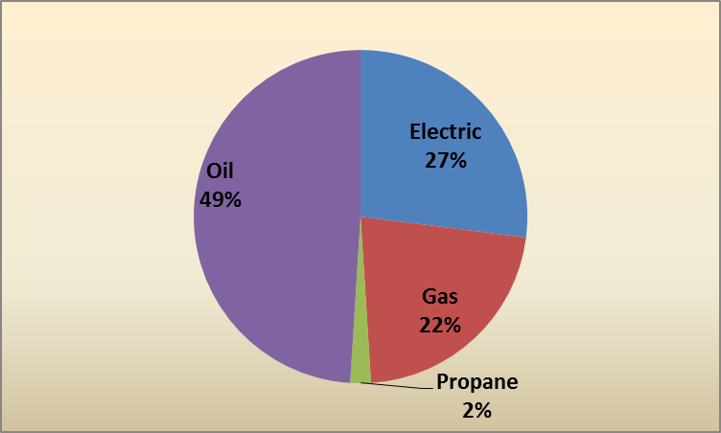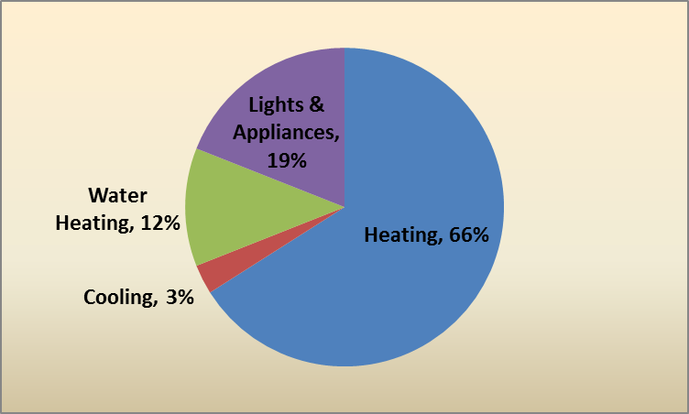

A substantial portion of the overall technical potential savings can be attributed to photovoltaics and solar hot water, which were each modeled at 60% of the sites in the sample. Specifically, these technologies account for 13% of overall savings in MMBtus and 42% of the overall savings for electricity over the ten year period (2013-2022) assessed in this report. Table 4-1 provides aggregate technical potential savings, from 2013-2022, both with and without the inclusion of solar technologies (photovoltaics and solar hot water) in the models. As shown:
- Technical potential savings in fuel oil exceed 4 billion gallons of fuel oil when including solar technologies.
- Savings in natural gas exceed 2.7 billion ccf of natural gas when including solar technologies.
- Removing the photovoltaics upgrade decreases the technical potential for electric savings considerably.
Table 4-1: Savings from All Applicable Measures— Ten-Year Aggregate Savings
(2013-2022)*
(Base: All SF homes, weighted to population)
 | Fuel Oil (Gallons) | Natural Gas (ccf) | Propane (Gallons) | Electricity (kWh) | MMBtu
Technical Potential Including Solar Technologies
Baseline Aggregate Consumption (2013-2022) | 4,835.3 | 3,394.6 | 353.3 | 125,904.4 | 1,524.4
Ten-Year Aggregate Savings (2013-2022) | 4,081.7 | 2,729.2 | 234.5 | 74,022.4 | 1,120.9
Percent Savings Over Baseline | 84% | 80% | 66% | 59% | 74%
Technical Potential Excluding Solar Technologies
Baseline Aggregate Consumption (2013-2022) | 4,835.3 | 3,394.6 | 353.3 | 125,904.4 | 1,524.4
Ten-Year Aggregate Savings (2013-2022) | 3,847.7 | 2,590.9 | 200.9 | 21,843.2 | 934.5
Percent Savings Over Baseline | 80% | 76% | 57% | 17% | 61%
*Savings are in millions of units.

All of the technical potential savings in fossil fuel consumption occur at the home heating and water heating end uses, while the bulk of total technical potential savings in electricity consumption occur in lighting and appliances. The presence of ductless mini-splits in each comprehensive model run results in a substantial increase in electric usage for heating.
Table 4-2: Total Technical Savings Potential by End Use—First-Year*
(Base: All SF homes, weighted to population)
End Use | Fuel Oil (gal.) | Nat. Gas (ccf) | Propane (gal.) | Electricity (kWh)
Model Runs Including Solar Technologies
Heating | 409.8 | 243.3 | 18.4 | - 1,492.6
Cooling | -- | -- | -- | 849.3
Water heating | 38.4 | 21.1 | 4.6 | 646.3
Lights & appliances | -- | -- | -- | 2,439.3
Photovoltaics | -- | -- | -- | 4,632.9
Total | 448.2 | 264.4 | 23.0 | 7,075.2
Model Runs Excluding Solar Technologies
Heating | 409.8 | 243.3 | 18.4 | - 1,495.7
Cooling | -- | -- | -- | 849.4
Water heating | 12.8 | 7.7 | 1.4 | 431.1
Lights & appliances | -- | -- | -- | 2,303.0
Total | 422.6 | 251.0 | 19.8 | 2,087.8
* In millions. Negative savings indicate a consumption increase.

Table 4-3 is based off of the same information that is presented in Table 4-2 and displays the percentage of overall saving potential (in MMBtu) by end use.
Table 4-3: Total Technical Savings Potential by End Use—First-Year (Percentage of Overall MMBtu Savings)*
(Base: All SF homes, weighted to population)
End Use | Fuel Oil | Nat. Gas | Propane | Electricity
Model Runs Including Solar Technologies
Heating | 49% | 22% | 1% | - 4%
Cooling | -- | -- | -- | 3%
Water heating | 5% | 2% | 0% | 2%
Lights & appliances | -- | -- | -- | 7%
Photovoltaics | -- | -- | -- | 14%
Total | 54% | 24% | 2% | 21%
Model Runs Excluding Solar Technologies
Heating | 61% | 27% | 2% | - 5%
Cooling | -- | -- | -- | 3%
Water heating | 2% | 1% | 0% | 2%
Lights & appliances | -- | -- | -- | 8%
Total | 63% | 28% | 2% | 8%
* Negative savings indicate a consumption increase.

Figure 4-2 presents the percentage of first-year savings (in MMBtus) associated with key end uses. Heating accounts for the majority of potential savings among all end uses.
Figure 4-2: Total Technical Potential Savings by End Use—% MMBtu Savings
(Base: All SF homes, weighted to the population)
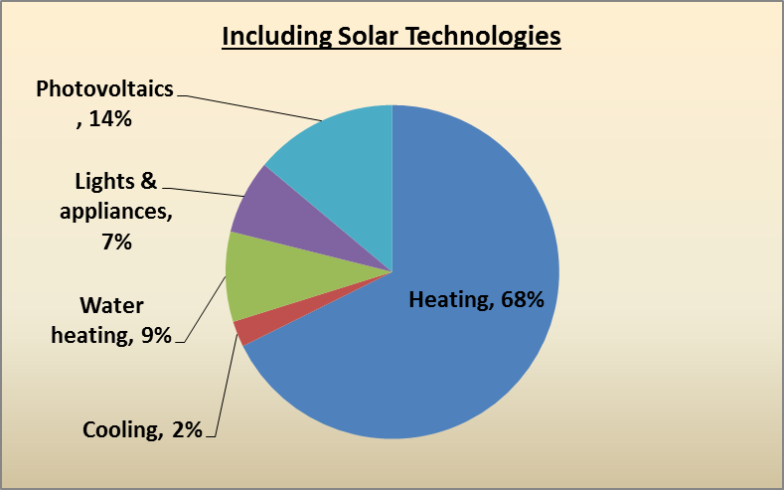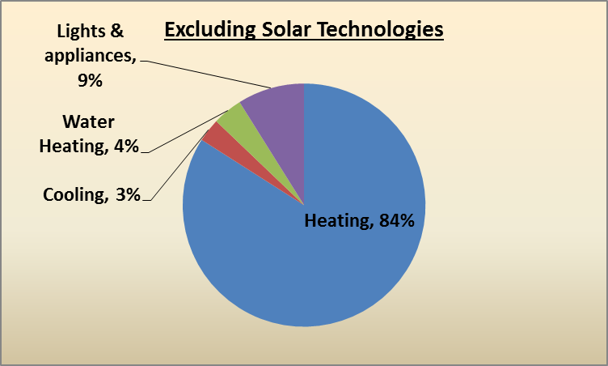

There is a larger relative savings opportunity for fuel oil and natural gas as they have greater shares of potential savings than they do of baseline consumption, while the opposite is true for electricity and propane (Table 4-4). This is because consumption in MMBtus is greatest for the heating end use and nearly 90% of homes in the sample heat with either oil or gas. Individual measure upgrades serve to shed some light on where the greatest technical potential for heat loss reduction lies.
Table 4-4: Fuel Type Share of Baseline Consumption and Savings Potential
(Base: All SF homes, weighted to the population)
 | Share of Baseline Consumption in MMBtu | Share of Savings Potential*
 |  | Including Solar Technologies | Excluding Solar Technologies
Fuel oil | 48.5% | 53.8% | 62.8%
Natural gas | 22.3% | 23.5% | 27.7%
Propane | 2.1% | 1.8% | 1.9%
Electricity | 27.1% | 20.9% | 7.6%
* Excluding ductless mini-splits raises the electric share of savings potential from
20.9% to roughly 29.5% when solar technologies are included, and from 7.6%
to roughly 19.8% when solar technologies are excluded.

Figure 4-3 shows the same information presented in Table 4-4, but in pie charts.
Figure 4-3: Total Technical Potential Savings by Fuel Type—% MMBtu Savings
(Base: All SF homes, weighted to the population)
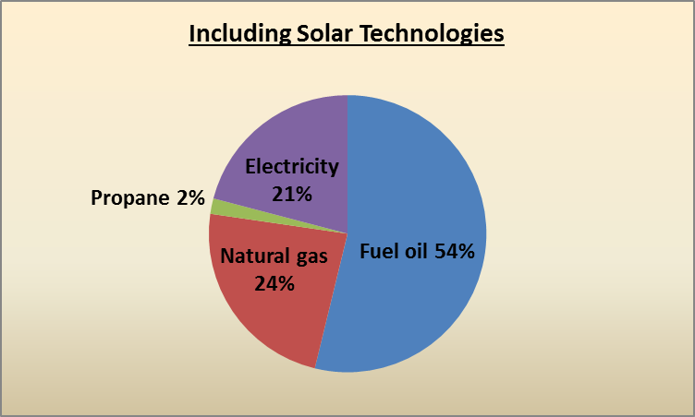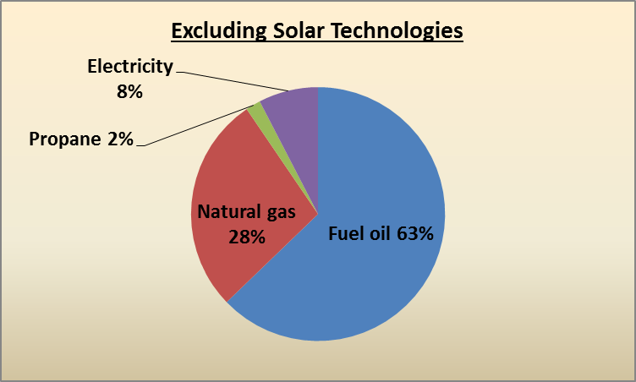

Table 4-5, shows the peak demand savings estimates associated with technical potential efficiency upgrades for 2013 and 2022. These estimates do not account for the impact of photovaltatics as REM/Rate does not include phtovoltaics in demand calculations. It is unlikely that photovoltaics would influence winter peak demand savings as the winter peak in New England is from 5-7 PM during the months of December and January. Table 4-5 shows the following:
- The technical potential summer peak demand savings (including solar technologies) are 2,038 MW in 2013 and 2,229 MW in 2022.
- Savings associated with winter peak demand are negative (i.e., winter peak demand increases, by 23%-25%) because ductless mini-split heat pumps were modeled at all homes.
The estimated baseline summer and winter peak demand levels are similar. Connecticut, as a whole, is a summer peaking state where the maximum demand for electricity occurs during the summer peak hours. Both the commercial and industrial sectors are significant contributors to the summer peak demand. Because this study only analyzes single-family homes, it is not surprising to see similar baseline summer and winter peak demand estimates. While cooling is typically the primary driver of summer peak demand, some homeowners will be at work during summer peak hours with their air-conditioning turned off.
Table 4-5: Technical Peak Electric Demand Savings Estimates (MW)*
(Base: All SF homes, weighted to the population)
 | Baseline | 2013 Savings | 2022 Savings
Summer Peak Demand
Technical Potential Including Solar | 4,229 | 2,038 | 2,229
Technical Potential Excluding Solar |  | 1,966 | 2,150
Winter Peak Demand
Technical Potential Including Solar | 3,655 | -1,238 | -1,354
Technical Potential Excluding Solar |  | -1,326 | -1,450
*See Section 2.4 for details on the methodology and coincidence factors.

Individual Measures
The individually-modeled upgrade measures provide some context to the overall technical savings potential figures. All savings figures presented in this section are first-year savings, not accounting for growth rates. The savings from these figures are not additive as the measures in this section were modeled individually, not accounting for interactive effects with other measure upgrades, and some measures overlap for the same end use.
Throughout this section of the report, the sample sizes for individual measure upgrades represent the number of homes (out of a 180 home sample) where a particular upgrade applied. For example, Table 4-6 (on the next page) shows that reduced air infiltration has a sample size of 143 homes. This means that 143 out of the 180 homes in the sample had air leakage levels that required reduction to achieve the technical potential efficiency level.

Building Shell
Reducing air infiltration in the models saves 7.1% of baseline MMBtu consumption; the only other upgrades which resulted in greater savings were the three varieties of heat pumps and photovoltaics (Table 4-6). Other building shell upgrades also led to substantial savings, notably windows and above-grade wall, flat attic, and frame floor insulation. The absence of a similar level of savings from HVAC upgrades suggests that potential savings in heating and cooling are attributable mostly to upgrades in the building shell.
Table 4-6: Building Shell Savings Potential—First-Year
(Base: All SF homes, weighted to population)
 | Sample Size | Percent Savings^{i} | Fuel Oil (gal.)^{ii} | Nat. Gas (ccf)^{ii} | Propane (gal.)^{ii} | Electric (kWh)^{ii} | Total MMBtu^{ii}
Baseline consumption | 180 | - | 531.0 | 328.9 | 34.7 | 12,034.2 | 156.6
Reduce air infiltration | 142 | 7.1% | 51.8 | 29.7 | 1.4 | 142.0 | 11.1
Upgrade windows | 180 | 6.0% | 35.0 | 21.1 | 2.1 | 535.0 | 9.4
Add above grade wall insulation | 165 | 4.9% | 32.1 | 26.0 | 1.0 | 68.7 | 7.7
Add flat attic insulation | 166 | 4.0% | 29.5 | 15.6 | 1.0 | 70.8 | 6.3
Add frame floor insulation | 161 | 3.6% | 24.0 | 17.9 | 0.8 | 17.5 | 5.7
Add foundation wall insulation | 91 | 2.4% | 18.6 | 7.4 | 0.3 | 36.9 | 3.7
Reduce duct leakage | 50 | 1.9% | 10.5 | 10.5 | 0.4 | 125.4 | 3.0
Add vaulted ceiling insulation | 75 | 1.1% | 6.7 | 5.7 | 0.1 | 30.2 | 1.7
Add rim joist insulation | 109 | 0.4% | 2.4 | 1.7 | 0.1 | 1.9 | 0.6
Add duct insulation | 78 | 0.3% | 1.5 | 2.0 | 0.2 | 12.6 | 0.5
^{i} Percent savings over baseline consumption in MMBtus.
^{ii} In millions.

HVAC
Oil boilers are the most common heating equipment type in the sample, and also lead to the greatest potential savings among HVAC measures; gas furnaces are the second most common heating equipment, and lead to the second most savings (Table 4-7). As a percentage of baseline MMBtu consumption, however, no HVAC system upgrade resulted in as much savings in the models as any of the top five building shell measure upgrades.
Table 4-7: HVAC Savings Potential—First-Year
(Base: All SF homes, weighted to population)
 | Sample Size | Percent Savings^{i} | Fuel Oil (gal.)^{ii} | Nat. Gas (ccf)^{ii} | Propane (gal.)^{ii} | Electric (kWh)^{ii} | Total MMBtu^{ii}
Baseline consumption | 180 | -- | 531.0 | 328.9 | 34.7 | 12,034.2 | 156.6
Increase oil boiler AFUE | 81 | 2.5% | 29.1 | -- | - 0.1 | 12.2 | 3.9
Increase gas furnace AFUE | 25 | 1.3% | -- | 19.6 | -- | 32.6 | 2.1
Increase gas boiler AFUE | 24 | 1.2% | -- | 18.9 | -- | - 0.3 | 1.9
Increase oil furnace AFUE | 31 | 1.2% | 12.1 | -- | - <0.1 | 5.4 | 1.8
Upgrade central air conditioner | 76 | 0.5% | - <0.1 | 0.6 | -- | 203.0 | 0.7
Upgrade room air conditioners | 66 | 0.1% | - <0.1 | -- | -- | 62.4 | 0.2
Install ECM fan motor | 54 | 0.1% | -- | 1.7 | -- | 16.5 | 0.2
Increase propane boiler AFUE | 2 | 0.1% | - 0.02 | -- | 1.0 | - <0.1 | 0.1
Increase propane furnace AFUE | 2 | <0.1% | -- | -- | 0.4 | 0.35 | <0.1
^{i} Percent savings over baseline consumption in MMBtus.
^{ii} In millions

Water Heating
Technical potential savings attributable to water heater upgrades are comparatively modest. No single domestic hot water system upgrade exceeds savings of 1% MMBtu (Table 4-8). Nonetheless, technical potential savings of 11.2 million gallons of oil are available by replacing tankless coil water heating with an indirect (or integrated) system off of the boiler.

Table 4-8: Water Heating Savings Potential—First-Year^{i}
(Base: All SF homes, weighted to population)
 | Sample Size | Percent Savings^{ii} | Fuel Oil (gal.)^{iii} | Nat. Gas (ccf)^{iii} | Propane (gal.)^{iii} | Electric (kWh)^{iii} | Total MMBtu^{iii}
Baseline consumption | 180 | - | 531.0 | 328.9 | 34.7 | 12,034.2 | 156.6
Replace tankless coil on oil boiler with indirect water heater | 42 | 0.9% | 11.2 | - 0.9 | - 0.2 | 8.2 | 1.4
Replace gas storage water heater with instantaneous | 43 | 0.9% | -- | 13.5 | -- | 3.8 | 1.4
Replace electric water heater with heat pump water heater | 42 | 0.9% | - 1.4 | - 0.4 | -- | 490.0 | 1.4
Replace gas storage water heater with condensing gas water heater | 39 | 0.9% | -- | 14.6 | -- | 2.9 | 1.5
Replace gas storage water heater with more efficient gas storage heater | 39 | 0.6% | -- | 10.1 | -- | 1.2 | 1.0
Increase water heater tank wrap R-value | 102 | 0.2% | 0.3 | 1.3 | 0.1 | 41.5 | 0.3
Replace oil storage water heater with more efficient oil storage water heater | 9 | 0.1% | 1.3 | -- | 0.03 | - 0.2 | 0.2
Replace propane storage water heater with instantaneous | 6 | 0.1% | -- | -- | 1.6 | 0.3 | 0.1
Replace propane storage water heater with more efficient propane storage heater | 4 | 0.1% | <0.1 | -- | 1.0 | - <0.1 | 0.1
Replace propane storage water heater with condensing propane water heater | 4 | 0.1% | -- | -- | 1.3 | 0.3 | 0.1
^{i} Negative savings indicate a consumption increase.
^{ii} Percent savings over baseline consumption in MMBtus.
^{iii} In millions.

Appliances and Lighting
The potential for electric savings achievable by increasing homes’ saturation of efficient lighting is considerable (Table 4-9). However, lighting upgrades—along with refrigerator and freezer upgrades, to a lesser degree—also result in more fossil fuel consumption due to reduced internal heat gains.
Table 4-9: Appliance Savings Potential—First-Year
(Base: All SF homes, weighted to population)
 | Sample Size | Percent Savings^{i} | Fuel Oil (gal.)^{ii} | Nat. Gas (ccf)^{ii} | Propane (gal.)^{ii} | Electric (kWh)^{ii} | Total MMBtu^{ii}
Baseline consumption | 180 | -- | 531.0 | 328.9 | 34.7 | 12,034.2 | 156.6
Increase socket saturation of efficient lighting^{iii} | 180 | 2.6% | - 11.0 | - 5.9 | - 0.7 | 1,900.0 | 4.1
Upgrade clothes washer | 177 | 1.2% | 3.8 | 3.3 | 0.5 | 323.6 | 2.0
Upgrade refrigerator | 180 | 0.6% | - 2.9 | - 1.6 | - 0.2 | 439.0 | 0.9
Upgrade dishwasher | 164 | 0.4% | 1.9 | 0.9 | 0.3 | 69.7 | 0.6
Upgrade freezer | 60 | 0.3% | - 0.6 | - 0.1 | -- | 174.0 | 0.5
Upgrade dehumidifier^{iv} | 49 | 0.1% | - <0.1 | - <0.1 | - <0.1 | 39.3 | 0.1
^{i} Percent savings over baseline consumption in MMBtus.
^{ii} In millions. Negative savings indicate a consumption increase.
^{iii} See Appendix B for details on the baseline assumptions that were used for lighting.
^{iv} See Appendix B for details on the baseline assumptions that were used for dehumidifiers.

Heat Pumps and Solar Technologies
By far the most substantial savings among all the individual measures occur with heat pumps and solar technologies (Table 4-10). While each of the three heat pump upgrades—ground source, air source, and ductless—by themselves result in a great deal more electric consumption because of the change in heating fuel, each leads to a sizable net reduction in total MMBtu consumption. Ductless mini-splits exhibit the greatest potential savings as a result of their high efficiency, the high percentage of a home’s heating load displaced, and being applied at all 180 homes.
Table 4-10: Heat Pumps and Solar Technologies Savings Potential—First-Year
(Base: All SF homes, weighted to population)
 | Sample Size | Percent Savings^{i} | Fuel Oil (gal.)^{ii} | Nat. Gas (ccf)^{ii} | Propane (gal.)^{ii} | Electric (kWh)^{ii} | Total MMBtu^{ii}
Baseline consumption | 180 | - | 531.0 | 328.9 | 34.7 | 12,034.2 | 156.6
Install ductless mini-split^{iii} | 180 | 32.8% | 310.0 | 178.0 | 14.1 | - 4,140.0 | 51.3
Install air source heat pump | 104 | 14.7% | 165.0 | 107.0 | 8.4 | - 3,660.0 | 23.1
Add photovoltaic array | 108 | 11.8% | - 0.1 | <0.1 | -- | 5,430.0 | 18.5
Install ground source heat pump | 103 | 9.2% | 111.0 | 74.0 | 5.8 | - 2,750.0 | 14.5
Add solar hot water system | 109 | 5.7% | 36.7 | 19.6 | 4.0 | 466.0 | 9.0
^{i} Percent savings over baseline consumption in MMBtus.
^{ii} In millions. Negative savings indicate a consumption increase.
^{iii} See Appendix B for the details on the modeling assumptions applied to ductless mini-splits.

Similarly, the addition of photovoltaic arrays to 108 of the 180 models (60%) leads to over five Gigawatt hours (GWh) in first-year technical potential electric savings. Adding solar hot water systems to the same number of homes results in 9 MMBtus in technical savings potential, spread relatively evenly across fuel types.

Measures Assessed Outside of REM/Rate
Four of the upgrade measures could not be modeled using REM/Rate. Savings from low-flow showerheads, faucet aerators, and pipe insulation were calculated using equations found in the 2013 Connecticut HES Program Savings Document (PSD). Clothes washer upgrade calculations were also performed outside of REM/Rate because the software’s model for clothes washers requires complete data on the machine from the Energy Guide label, which was not available for all models. Savings attributable to all four non-REM/Rate upgrade measures are integrated into the comprehensive model savings in Table 4-1 and Table 4-2. The comprehensive savings values are de-rated to account for the interactive effects of water heater upgrades and water savings measures.
Auditors did not gather information regarding the presence or absence of low-flow showerheads and faucet aerators during the Connecticut Weatherization Baseline on-site inspections. Instead, data from a residential baseline study which NMR Group conducted in 2011 and 2012 on behalf of the Vermont Department of Public Service were used to estimate the number of low-flow showerheads and faucet aerators per home, which then provided context for calculations. For example, the Vermont data revealed that the mean number of low-flow showerheads in homes with one bathroom is 0.45. Similar “opportunity levels” were calculated for low-flow showerheads and faucet aerators based on number of bathrooms and subsequently used to calculate savings.
Potential savings attributable to the installation of low-flow showerheads and faucet aerators are substantial in both fossil fuels and kWh, according to equations provided in the PSD (Table 4-11).
Table 4-11: Savings from Non-REM Measures—First-Year
(Base: All SF homes, weighted to population)
 | Sample Size | Percent Savings | Fuel Oil (gal.)^{ii} | Nat. Gas (ccf)^{ii} | Propane (gal.)^{ii} | Electric (kWh)^{ii} | Total MMBtu^{ii}
Baseline DHW Energy Factors
DHW Pipe insulation | 138 | 0.3% | 1.4 | 1.4 | 0.3 | 24.2 | 0.5
Low-flow showerheads | 180 | 0.4% | 2.6 | 1.5 | 0.3 | 24.7 | 0.6
Faucet aerators | 180 | 0.3% | 2.0 | 1.2 | 0.2 | 20.0 | 0.5
Upgrade DHW Energy Factors
DHW Pipe insulation | 138 | 0.2% | 1.1 | 0.8 | 0.3 | 10.0 | 0.3
Low-flow showerheads | 180 | 0.3% | 2.0 | 0.9 | 0.2 | 10.2 | 0.4
Faucet aerators | 180 | 0.2% | 1.6 | 0.7 | 0.2 | 8.3 | 0.3
^{i} The 2013 Program Savings Document provides no equations which could be
used to de-rate pipe insulation savings consistent with the increased mechanical
efficiencies in the comprehensive model runs.
^{ii} In millions.

Cost-Effective Potential
This section presents the potential savings from cost-effective measures. Each measure, where applicable, was screened based on the savings and upgrades used in the individual model runs from the technical potential analysis. This means that each measure was screened based on the unique characteristics found in each of the 180 homes in the sample. As a result, the savings and costs associated with any given measure vary by site because of the unique characteristics and preexisting conditions of each site in the sample. Measures that passed cost-effectiveness screening (i.e., had a benefit/cost ratio greater than or equal to 1.0 using the TRC test) were all modeled simultaneously for each of the 180 sites. See Section 2.2 for details on how measures were screened for cost-effectiveness.

Results of Cost-Effectiveness Screening
Table 5-1 presents the results of the cost-effectiveness screening. The efficiency levels associated with each of these measures can be found in Appendix A. As shown, 15 out of the 43 measures (highlighted in gray in the table) considered have a TRC benefit/cost ratio that is greater than one. All of these measures, with the exception of foundation wall insulation and water heater tank wrap insulation, are currently incentivized by the HES and HES-IE programs. These results indicate that the HES and HES-IE programs are already targeting the majority of cost-effective measures through their incentive efforts.
A number of measures (e.g., windows, oil furnaces, air source heat pumps, etc.) show high benefit/cost ratios using the UCT screening results, while the same measures show benefit/cost ratios of less than one when using the TRC screening results. This is driven by the fact that the program incentives for these measures are only a small portion of the overall cost, leading to high participant costs. These measures offer substantial savings, so the benefits when compared to program costs alone, are significant. The same savings, when compared to the total resource cost, are not as significant (due to high participant costs) and as a result the average TRC benefit/cost ratios are less than one.
Table 5-1: Cost-Effectiveness Screening Results: Measures with a Mean TRC B/C Ratio Greater than 1.0
Measure | # of Sites Measure Applied | % Pass UCT | UCT Mean B/C Ratio | % Pass TRC | TRC Mean B/C Ratio
Faucet Aerators | 180 | 98% | 7.41 | 100% | 18.29
DHW Pipe Insulation | 138 | 100% | 27.97 | 100% | 15.84
Water Heater Tank Wrap Insulation | 102 | -- | -- | 92% | 6.93
Increase socket saturation of efficient lighting | 180 | 100% | 2.5 | 100% | 3.76
Low Flow Showerheads | 180 | 98% | 3.57 | 82% | 3.09
Duct Sealing | 50 | 92% | 3.17 | 74% | 2.63
Air Sealing | 142 | 86% | 2.45 | 86% | 2.57
Freezer | 60 | 95% | 19.27 | 82% | 2.41
Heat Pump Water Heater | 42 | 90% | 3.18 | 93% | 1.66
Foundation Wall Insulation | 91 | -- | -- | 49% | 1.56
Flat Ceiling Insulation | 166 | 67% | 2.45 | 46% | 1.51
Ductless Mini-Split Heat Pump* | 176 | 89% | 30.68 | 62% | 1.46
Above Grade Walls Insulation | 165 | 40% | 2.15 | 27% | 1.36
Vaulted Ceiling Insulation | 75 | 45% | 1.88 | 32% | 1.07
Frame Floor Insulation | 161 | 66% | 3.03 | 34% | 1.03
* Ductless mini-splits were not screened for cost-effectiveness at four sites as the technology was already present.

Table 5-2: Cost-Effectiveness Screening Results: Measures with a Mean TRC B/C Ratio Less than 1.0
Measure | # of Sites Measure Applied | % Pass UCT | UCT Mean B/C Ratio | % Pass TRC | TRC Mean B/C Ratio
Clothes Washers | 177 | 47% | 0.97 | 47% | 0.97
Room Air Conditioner | 66 | -- | -- | 41% | 0.94
Oil Furnace | 31 | 100% | 14.23 | 23% | 0.88
Solar Assisted Hot Water | 109 | -- | -- | 48% | 0.85
Refrigerator | 180 | 87% | 6.56 | 26% | 0.82
Indirect Water Heater | 42 | 86% | 8.55 | 5% | 0.58
Propane Condensing Hot Water Heater | 4 | -- | -- | 0% | 0.56
Propane Storage Hot Water Heater | 4 | -- | -- | 0% | 0.55
Gas Furnace | 25 | 52% | 2.44 | 16% | 0.5
Oil Boiler | 81 | -- | -- | 9% | 0.5
ECM Fan Motor | 54 | -- | -- | 4% | 0.43
Oil Storage Hot Water Heater | 9 | -- | -- | 0% | 0.39
Propane Boiler | 2 | -- | -- | 0% | 0.34
Propane Furnace | 2 | 100% | 4.31 | 0% | 0.32
Propane Instantaneous Water Heater | 6 | -- | -- | 0% | 0.31
Rim Joist Insulation | 109 | -- | -- | 5% | 0.28
Air Source Heat Pump (Ducted) | 104 | 72% | 13.04 | 4% | 0.27
Windows | 180 | 98% | 64.61 | 0% | 0.27
Gas Boiler | 24 | 71% | 1.51 | 0% | 0.25
Duct Insulation | 78 | -- | -- | 8% | 0.21
Gas Condensing Hot Water Heater | 39 | 62% | 1.13 | 3% | 0.21
Gas Storage Hot Water Heater | 39 | 95% | 2.18 | 0% | 0.19
Dehumidifier | 49 | 100% | 3.35 | 0% | 0.15
Central Air Conditioner | 76 | 74% | 2.04 | 0% | 0.13
Gas Instantaneous Hot Water Heater | 43 | 33% | 0.99 | 0% | 0.12
Dishwasher | 164 | -- | -- | 1% | 0.1
Ground Source Heat Pump | 103 | 56% | 2.01 | 0% | 0.04
Photovaltaics | 108 | -- | -- | 0% | 0

Cost-Effective Potential Savings
Figure 5-1 compares potential cost-effective savings to technical potential savings. As shown, cost-effective potential savings are about one-half of the technical potential savings when solar technologies are included. The proportion of overall savings attributable to fuel oil increase when comparing cost-effective potential saving to technical potential savings, while the proportion of overall gas savings decreases.
Figure 5-1: Ten-Year (2013-2022) Aggregate Savings for Technical and Cost-Effective Potential (MMBtu)
(Base: All SF homes, weighted to the population)
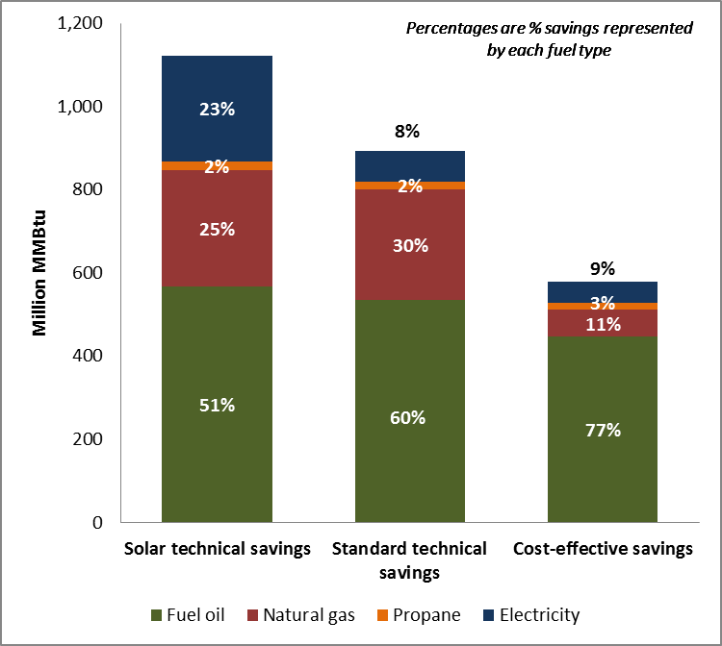

Table 5-3 presents cost-effective potential savings by fuel type. Upgrades that screened as cost-effective, applied in their totality over the ten year period of 2013-2022, result in savings of 39% of overall baseline consumption, measured in MMBtu. Savings of 68% relative to baseline fuel oil consumption screened as cost-effective, as did 52% of baseline propane consumption.
Cost-effective natural gas savings represent only 19% of baseline consumption. This is, in part, due to the high cost of upgrades to gas space heating and water heating systems.
Cost-effective electric savings represent only 12% of baseline consumption. This is because much of the savings due to cost-effective heat pump water heater, room air conditioner, lighting, and appliance upgrades are negated by a fuel switch from fossil fuel to electric heating in ductless mini-split upgrades.

Table 5-3: Cost-Effective Potential Savings— Ten-Year Aggregate Savings (2013-2022)*
(Base: All SF homes, weighted to population)
 | Fuel Oil (Gallons) | Natural Gas (ccf) | Propane (Gallons) | Electricity (kWh) | MMBtu
Baseline Aggregate Consumption (2013-2022) | 4,835.3 | 3,394.6 | 353.3 | 125,904.4 | 1,524.4
Ten-Year Aggregate Savings (2013-2022) | 3,266.8 | 630.4 | 184.3 | 15,349.9 | 587.1
Percent Savings Over Baseline | 68% | 19% | 52% | 12% | 39%
*Savings are in millions of units.
The results in this section provide an estimate of the potential savings that screen as cost-effective at the measure level. Results are presented by fuel type and end use.
Figure 5-2 shows the change in the proportion of cost-effective potential savings accounted for by each fuel type over the ten-year span from 2013 to 2022. While the share of cost-effective savings taken up by fuel oil declines during that period due to a negative growth rate, it remains above 75% in all years but 2022. The rates of natural gas, propane, and electricity consumption are expected to increase to varying degrees between 2013 and 2022, but the relative savings opportunity for all these fuels combined will nonetheless only reach about one-quarter of the total cost-effective savings opportunity during that window.
Figure 5-2: Fuel Type Percent of Cost-Effective Savings Measured in MMBtu
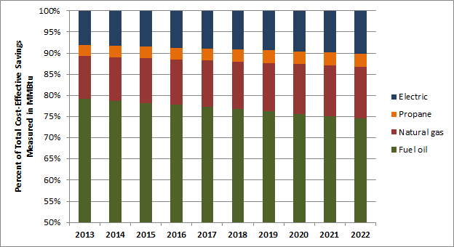

Most cost-effective fossil-fuel savings occur in space heating, which is the end use responsible for most energy consumption overall in Connecticut and the primary way in which consumers use fossil fuels (Table 5-4). A substantial amount of cost-effective electric savings occur in lights and appliances due to lighting, refrigerator, freezer, and clothes washer upgrades; however, additional electric usage for heating negates almost three-quarters of those savings.
Table 5-4: Cost-Effective Potential Savings by End Use—First Year
(Base: All SF homes, weighted to population)
End Use | Fuel Oil (gal.) | Nat. Gas (ccf) | Propane (gal.) | Electricity (kWh)
Heating | 341.7 | 58.3 | 16.9 | - 1,521.1
Cooling | -- | -- | -- | 476.8
Water heating | 11.6 | 2.2 | 1.0 | 303.8
Lights & appliances | -- | -- | -- | 2,207.2
Total | 353.3 | 60.5 | 17.9 | 1,466.7

As a percentage of overall cost-effective savings measured in MMBtu, fuel oil is the most substantial contributor to savings—almost 80% of all cost-effective savings are attributed to fuel oil (Table 5-5). More than three-quarters (77%) of all cost-effective savings are attributable to fuel oil at the heating end use alone.
Table 5-5: Cost-Effective Savings Potential by End Use As A Percentage of Overall Savings in MMBtu —First Year
(Base: All SF homes, weighted to population)
End Use | Fuel Oil | Nat. Gas | Propane | Electricity
Heating | 76.6% | 9.7% | 2.5% | - 8.4%
Cooling | -- | -- | -- | 2.6%
Water heating | 2.6% | 0.4% | 0.1% | 2.4%
Lights & appliances | -- | -- | -- | 11.5%
Total | 79.2% | 10.1% | 2.6% | 8.1%

Figure 5-3 presents the information from Table 5-5 in a pie chart.
Figure 5-3: Cost-Effective Potential Savings by End Use
(Base: All SF homes, weighted to the population)
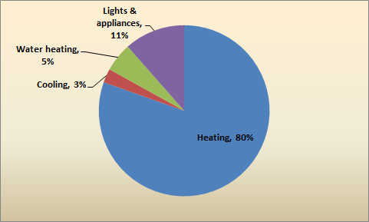

Table 5-6 details the share of cost-effective savings potential accounted for by each fuel type and compares it to its share of baseline consumption. The relative savings opportunity in fuel oil is substantial—while fuel oil only accounts for about 49% of baseline consumption measured in MMBtu, it accounts for 79% of cost-effective potential savings. Both natural gas and electricity have much less relative cost-effective savings opportunity than oil.
Table 5-6: Fuel Type Share of Baseline Consumption and Cost-Effective Savings Potential
(Base: All SF homes, weighted to the population)
Fuel Type | Share of Baseline Consumption | Share of Cost-Effective Savings Potential
Fuel oil | 48.5% | 79.2%
Natural gas | 22.3% | 10.1%
Propane | 2.1% | 2.6%
Electricity | 27.1% | 8.1%

Figure 5-4 presents the information from Table 5-6 in a pie chart.
Figure 5-4: Fuel Type Share of Cost-Effective Potential Savings Measured in MMBtu
(Base: All SF homes, weighted to the population)
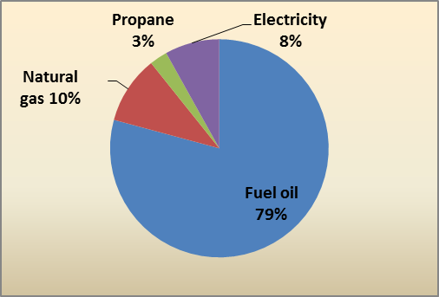

Table 5-7 presents the cost-effective peak electric demand savings. As shown, cost-effective summer peak demand savings range from 1,346 MW to 1,473 MW from 2013-2022. Cost-effective winter peak demand savings range from -900 MW to -984 MW from 2013-2022.
Table 5-7: Cost-Effective Peak Electric Demand Savings Estimates (MW)*
(Base: All SF homes, weighted to the population)
 | Baseline | 2013 Savings | 2022 Savings
Summer Peak Demand | 4,229 | 1,346 | 1,473
Winter Peak Demand | 3,655 | -900 | -984
*See Section 2.4 for details on the methodology and coincidence factors.

Achievable Potential
The results in this section provide an estimate of the cost-effective savings that are achievable when taking into account changes in codes and standards, gradual adoption of upgrade measures, and the growing market penetration of emerging technologies. Results are presented by fuel type and end use.
Figure 6-1 shows that achievable savings, in terms of MMBtu, are about one-sixth of cost-effective potential savings. The share of savings attributable to fuel oil decreases when comparing cost-effective savings to achievable savings, but the share of savings attributable to natural gas and electricity increase.
Figure 6-1: Ten-Year (2013-2022) Aggregate Savings for Cost-Effective and Achievable Potential (MMBtu)
(Base: All SF homes, weighted to the population)
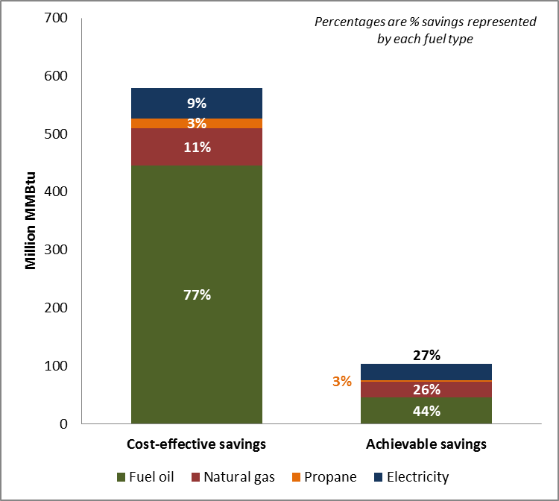
Table 6-1 details total achievable potential savings by fuel type. Achievable savings represent anywhere from 7% to 10% of baseline consumption, depending on the fuel type, over the ten year period of 2013-2022.
Table 6-1: Achievable Potential Savings— Ten-Year Aggregate Savings (2013-2022)*
(Base: All SF homes, weighted to population)
 | Fuel Oil (Gallons) | Natural Gas (ccf) | Propane (Gallons) | Electricity (kWh) | MMBtu
Baseline Aggregate Consumption (2013-2022) | 4,835.3 | 3,394.6 | 353.3 | 125,904.4 | 1,524.4
Ten-Year Aggregate Savings (2013-2022) | 361.0 | 278.6 | 35.2 | 8,587.1 | 110.9
Percent Savings Over Baseline | 7% | 8% | 10% | 7% | 7%
*Savings are in millions of units.

Figure 6-2 shows the growth in achievable potential savings over time, measured in MMBtu in the interest of making savings across fuel types comparable to one another. The analysis shows that due to the gradual adoption of upgrades and increasing market penetration of new technologies, achievable potential savings overall increase substantially between 2013 and 2019, after which point their growth slows due to a downturn in achievable electric savings. Electric savings decrease while fossil-fuel savings increase for two reasons: first, increases in federal minimum efficiency standards for lights and appliances will raise the baseline against which savings are measured over time, and second, the growing adoption of ductless mini-splits for heating results in increased electric consumption even as it saves fossil fuel.
Figure 6-2: Achievable Potential Savings Growth Measured in MMBtu
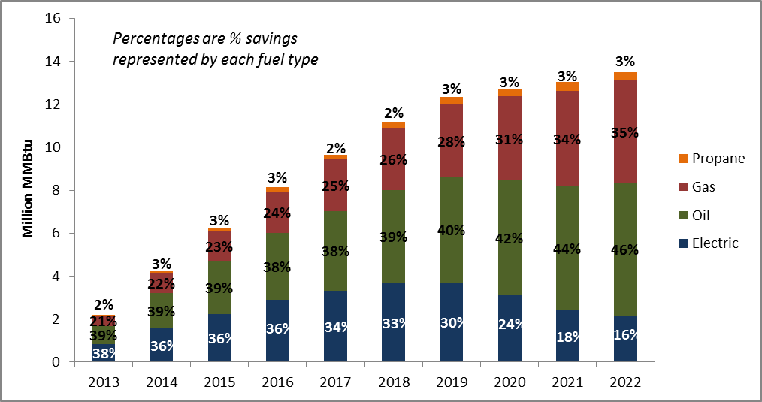

First-year achievable savings estimates are low in comparison to baseline consumption because the analysis assumes gradual adoption of upgrade measures. In year ten (2022), achievable potential savings constitute about 10% of total baseline consumption, measured in MMBtu (Table 6-2). This ranges from about 6% electric savings to over 13% savings in natural gas and propane. Achievable electric savings are lower as a percentage of the baseline than other fuels because the ductless mini-split upgrade results in both fossil-fuel savings and increased electric consumption.
Table 6-2: Achievable Savings As A Percent of Baseline in Year Ten
(Base: All SF homes, weighted to population)
Fuel Type | Year Ten Savings (2022) | Percent of Baseline
Fuel oil (million gallons) | 54.0 | 12.3%
Natural gas (million ccf) | 46.4 | 13.2%
Propane (million gallons) | 4.9 | 13.6%
Electricity (million kWh) | 761.4 | 5.8%
Total million MMBtus | 15.3 | 10.3%

As in technical and cost-effective potential, all achievable fossil-fuel savings occur at the home heating and water heating end uses, while the majority of electric savings occur in lighting and appliances. Due to gradual adoption of upgrade measures, savings in year ten are likely to be much greater than in the first year, particularly at the home heating end use.
Table 6-3: Achievable Potential Savings by End Use—Year One & Year Ten*
(Base: All SF homes, weighted to population)
End Use | Fuel Oil (gal.) | Nat. Gas (ccf) | Propane (gal.) | Electricity (kWh)
Year One (2013) Achievable Savings
Heating | 5.5 | 4.4 | 0.2 | - 12.6
Cooling | -- | -- | -- | 24.1
Water heating | 2.4 | 0.5 | 0.5 | 29.5
Lights & appliances | -- | -- | -- | 219.7
Total | 7.9 | 4.9 | 0.7 | 260.8
Year Ten (2022) Achievable Savings
Heating | 43.1 | 44.5 | 2.0 | - 138.1
Cooling | -- | -- | -- | 43.0
Water heating | 10.9 | 1.9 | 2.8 | 248.0
Lights & appliances | -- | -- | -- | 608.4
Total | 54.0 | 46.4 | 4.9 | 761.4
* In millions. Negative savings indicate a consumption increase.

Table 6-4 presents achievable potential savings in year one and year ten as a percentage of overall savings in MMBtu. In year one (2013), fuel oil accounts for a higher percentage of overall savings than any other fuel; by year ten (2022), the proportion of savings accounted for by fuel oil grows to nearly half of all achievable savings measured in MMBtu. The proportion of savings accounted for by natural gas also grows substantially from year one to year ten, from about 20% to more than 30%.
Table 6-4: Achievable Potential Savings by End Use as a Percentage of Overall Savings in MMBtu—Year One and Year Ten
(Base: All SF homes, weighted to population)
End Use | Fuel Oil (gal.) | Nat. Gas (ccf) | Propane (gal.) | Electricity (kWh)
Year One (2013) Achievable Savings
Heating | 29.6% | 17.7% | 0.7% | - 1.7%
Cooling | -- | -- | -- | 3.2%
Water heating | 13.2% | 2.2% | 1.9% | 3.9%
Lights & appliances | -- | -- | -- | 29.3%
Total | 42.8% | 19.9% | 2.6% | 34.8%
Year Ten (2022) Achievable Savings
Heating | 39.1% | 29.9% | 1.2% | - 3.1%
Cooling | -- | -- | -- | 1.0%
Water heating | 9.9% | 1.3% | 1.7% | 5.5%
Lights & appliances | -- | -- | -- | 13.6%
Total | 48.9% | 31.2% | 2.9% | 17.0%

Figure 6-3 presents the percentage of first-year savings, measured in MMBtu, associated with key end uses. Heating accounts for a plurality of achievable potential savings in the first year and a majority in year ten. In the near-term, annual savings due to lights and appliances are much more substantial than they will be in year ten. This is due primarily to several imminent increases in federal minimum efficiency standards.
Figure 6-3: Achievable Potential Savings by End Use
(Base: All SF homes, weighted to the population)
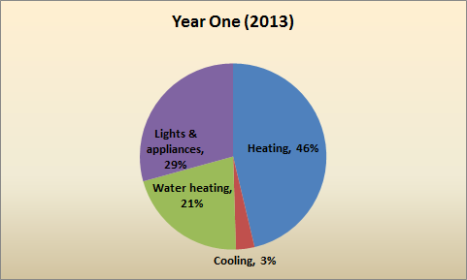
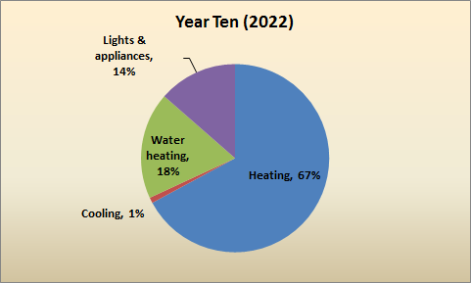

In the technical and cost-effective components of the analysis, the largest relative savings opportunity is in fuel oil, which has a larger share of technical and cost-effective potential savings than it does of baseline consumption. Among achievable savings, electricity has the highest relative savings opportunity in year one (Table 6-5). However, this opportunity decreases dramatically by year ten as the baseline efficiency for lighting and appliances shifts upward and the market penetration of ductless mini-splits, a fuel switch measure, grows.
Natural gas has low relative savings opportunity in year one, but by year ten its share of achievable potential savings is substantially higher than its share of baseline consumption, indicating high relative savings opportunity. In year ten, the share of achievable potential savings taken up by fuel oil is about equal to the fuel oil share of baseline consumption.
Table 6-5: Fuel Type Share of Baseline Consumption and Savings Potential
(Base: All SF homes, weighted to the population)
 | Share of Baseline Consumption in MMBtu | Share of Achievable Potential Savings
 |  | Year One | Year Ten
Fuel oil | 48.5% | 41.8% | 48.9%
Natural gas | 22.3% | 19.6% | 31.2%
Propane | 2.1% | 2.4% | 2.9%
Electricity | 27.1% | 36.2% | 17.0%

Figure 6-4 presents the information from Table 6-5 in pie charts.
Figure 6-4: Fuel Type Share of Achievable Potential Savings Measured in MMBtu
(Base: All SF homes, weighted to the population)
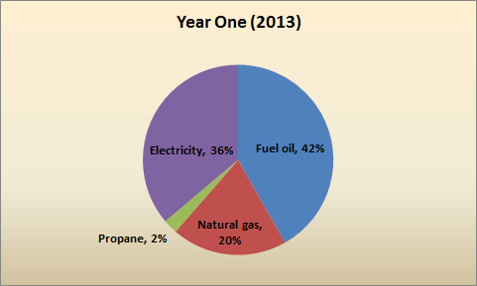
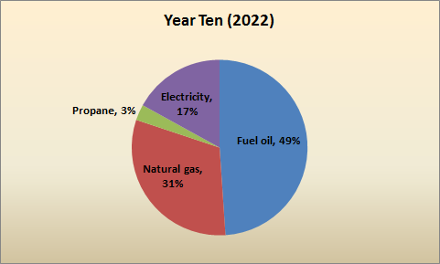

Table 6-6 presents the achievable peak electric demand savings. As shown, achievable summer peak demand savings range from 116 MW to 409 MW from 2013-2022. Achievable winter peak demand savings range from 109 MW to 303 MW from 2013-2022.
Table 6-6: Achievable Peak Electric Demand Savings Estimates (MW)*
(Base: All SF homes, weighted to the population)
 | Baseline | 2013 Savings | 2022 Savings
Summer Peak Demand | 4,229 | 116 | 409
Winter Peak Demand | 3,655 | 109 | 303
*See Section 2.4 for details on the methodology and coincidence factors.

Fuel Switching Potential
The results presented here detail the potential impacts from converting the heating and water heating equipment in single-family homes currently using oil, propane, biomass, or electric heating to either (a) natural gas space heating and water heating equipment, or (b) electric heat pump space heating and water heating equipment.
Three potential impacts from fuel switching are assessed in this study:
- Reduced oil and propane consumption.
- Increased natural gas consumption and electric consumption.
- Potential gas and electric savings from utility incentives.
Impacts are assessed in two ways: a base case scenario and an upgrade case scenario. The base case assesses the potential impacts of fuel switching without any utility intervention aside from that which would be necessary to persuade homeowners to switch fuels. The upgrade case assesses the potential effects of program incentives for higher-efficiency heating and water heating equipment for homes that undergo a fuel switch (see Section 2.5 for more details on the base case and upgrade case scenarios). All of the impacts detailed in this report are presented relative to what the annual consumption of a given fuel is expected to be in 2022; these trajectories were extrapolated using growth rates from various sources. For more detail on the sources for growth rates see Appendix D.
The Team presents study results over a ten-year conversion period, with conversions increasing, under different scenarios, to 100%, 75%, 50%, and 25% over that period. All of the results presented in this report reflect the impacts of fuel switching on Connecticut’s single-family housing stock only.

Results
This section details the results of the fuel switching analysis. It includes the following subsections:
MMBtu Summary
Presents overall savings across all four of the fuel types included in the analysis, in order to provide an overview of the total potential savings due to fuel switching.
Results by Fuel
Presents the results of fuel switching for each of the four fuel types included in the analysis.
Base Case Scenario
Details the results of base case scenario fuel switching (fuel switching group features are described in detail in Table 2-6).

Upgrade Case Scenario
Details the results of upgrade case scenario fuel switching (fuel switching group features are described in detail in Table 2-6).
Fuel Switching Impact by End Use
Further details base case and upgrade case fuel switching impact by the heating, cooling, and water heating end uses.

MMBtu Summary
Table 7-1 shows the overall impact of fuel switching across all fuel types. Fuel switching, of course, results in more consumption of some fuels and less consumption of others. Nonetheless, because of the comparatively greater efficiency of replacement equipment, it would result in an overall decrease in total annual consumption in MMBtu (Table 7-1).The following impacts were identified during the fuel switching analysis:
- Over the next decade, single-family homes in Connecticut can be expected to consume about 1.5 billion MMBtu of energy.
- Base case fuel switching could, under the 100% conversion rate, potentially save 5.5% of that amount in total over the course of ten years.
- By year ten, annual fuel consumption in MMBtu would decline by 17.2% of the expected annual consumption level.
- Program incentives for higher-efficiency equipment can be expected to save a maximum of 43.8 million MMBtu over the course of ten years, or 7.8 million MMBtu annually by year ten.
  - This amount represents 3.1% of base case consumption over ten years and 6.4% of year-ten annual consumption.
Table 7-1: Overall Summary in MMBtu
(Base: All SF homes, weighted to population)
Conversion Rate | Annual Consumption |  |  |  |  | Total Over Ten Years
 | Current | Year 2.5 | Year 5 | Year 7.5 | Year 10
No fuel switching | 155.9 | 154.5 | 152.2 | 149.9 | 147.7 | 1,475.5
Base Case
25% conversion rate (million MMBtu) | 155.9 | 152.8 | 148.9 | 145.1 | 141.3 | 1,455.3
Percent change from existing |  | 1.1% | 2.2% | 3.2% | 4.3% | 1.4%
50% conversion rate (million MMBtu) | 155.9 | 151.2 | 145.7 | 140.3 | 135.0 | 1,435.1
Percent change from existing |  | 2.1% | 4.3% | 6.4% | 8.6% | 2.7%
75% conversion rate (million MMBtu) | 155.9 | 149.5 | 142.4 | 135.4 | 128.7 | 1,414.9
Percent change from existing |  | 3.2% | 6.4% | 9.7% | 12.9% | 4.1%
100% conversion rate (million MMBtu) | 155.9 | 147.9 | 139.1 | 130.6 | 122.3 | 1,394.7
Percent change from existing |  | 4.3% | 8.6% | 12.9% | 17.2% | 5.5%
Upgrade Case
25% conversion rate (million MMBtu) | 155.9 | 152.3 | 147.9 | 143.6 | 139.4 | 1,444.4
Percent change from base |  | 0.3% | 0.7% | 1.0% | 1.3% | 0.8%
50% conversion rate (million MMBtu) | 155.9 | 150.1 | 143.6 | 137.3 | 131.1 | 1,413.2
Percent change from base |  | 0.7% | 1.4% | 2.1% | 2.9% | 1.5%
75% conversion rate (million MMBtu) | 155.9 | 148.0 | 139.4 | 130.9 | 122.8 | 1,382.1
Percent change from base |  | 1.0% | 2.1% | 3.3% | 3.5% | 2.3%
100% conversion rate (million MMBtu) | 155.9 | 145.8 | 135.1 | 124.6 | 114.5 | 1,350.9
Percent change from base |  | 1.4% | 2.9% | 4.6% | 6.4% | 3.1%
Incentive Impact in Million MMBtu
25% conversion rate (million MMBtu) |  | 0.5 | 1.0 | 1.5 | 1.9 | 10.9
50% conversion rate (million MMBtu) |  | 1.1 | 2.1 | 3.0 | 3.9 | 21.9
75% conversion rate (million MMBtu) |  | 1.5 | 3.0 | 4.5 | 5.9 | 32.8
100% conversion rate (million MMBtu) |  | 2.1 | 4.0 | 6.0 | 7.8 | 43.8

As Figure 7-1 and Figure 7-2 demonstrate, total annual fuel consumption in the state will decrease by 5% in the next decade (from 155.9 million MMBtu to 147.7 million MMBtu) if left on its current trajectory. Fuel switching could potentially lead to an additional 4% (base case scenario with 25% conversion rate) to 22% (upgrade case scenario with 100% conversion rate) decrease in annual fuel consumption in MMBtu in that same time period.
Figure 7-1: Change in Total Consumption in MMBtu, Base Case Scenario
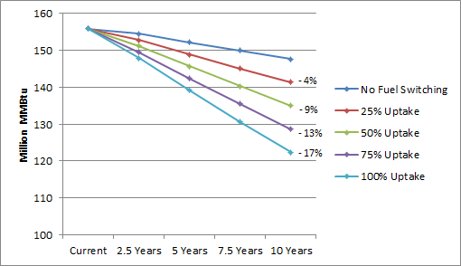
Figure 7-2: Change in Total Consumption in MMBtu, Upgrade Case Scenario
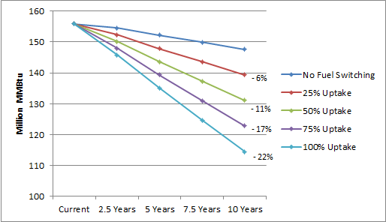

Results by Fuel
This section presents the results of fuel switching for each of the four fuel types included in the analysis.
Table 7-2 demonstrates the following:
- Fuel switching has the potential to decrease single-family home oil use in Connecticut by up to 77% of the year-ten expected annual consumption, in the absence of program incentives for efficient equipment.
  - With incentives for higher efficiency equipment fuel switching has the potential decrease single-family home oil use in Connecticut by up to 84% of the year-ten expected annual consumption.
- Fuel switching has the potential to decrease single-family home propane use in Connecticut by up to 59% of the year-ten expected annual consumption, in the absence of program incentives.
  - With incentives for higher efficiency equipment fuel switching has the potential decrease single-family home propane use in Connecticut by up to 73% of the year-ten expected annual consumption.
- Switching the state’s heating and water heating equipment to gas-fired models or heat pumps could result in up to an 89% increase in annual natural gas consumption and up to a 13% increase in annual electricity consumption by year ten in the base case.
  - In the upgrade case these fuel switches could result in up to an 82% increase in annual natural gas consumption and up to a 12% increase in annual electricity consumption by year ten.
Table 7-2: Change in Annual Consumption by Fuel At Year Ten
(Base: All SF homes, weighted to population)
Fuel | Current Annual | Percent Change from Expected Level*
 |  | 25% Uptake | 50% Uptake | 75% Uptake | 100% Uptake
Base Case
Fuel oil (million gallons) | 527.6 | - 19% | - 39% | - 58% | - 77%
Propane (million gallons) | 34.4 | - 15% | - 30% | - 44% | - 59%
Natural gas (million ccf) | 326.8 | + 22% | + 44% | + 66% | + 89%
Electricity (million kWh) | 12,048.2 | + 3% | + 7% | + 10% | + 13%
Upgrade Case
Fuel oil (million gallons) | 527.6 | - 21% | - 42% | - 63% | - 84%
Propane (million gallons) | 34.4 | - 18% | - 36% | - 55% | - 73%
Natural gas (million ccf) | 326.8 | + 20% | + 41% | + 61% | + 82%
Electricity (million kWh) | 12,048.2 | + 3% | + 6% | + 9% | + 12%
* Expected consumption is the current annual consumption extrapolated over ten years using growth rates.

Consumers in the state of Connecticut could potentially avoid burning nearly 2 billion gallons of oil and over 100 million gallons of propane over the ten-year period from 2013 to 2022 as a result of fuel switching, assuming a 100% conversion rate and no utility intervention. The same switch would result in approximately a 1.7 billion ccf increase in natural gas consumption and about a 9.5 billion kilowatt-hour increase in electric consumption over a ten-year period, in aggregate. See Table C in Appendix C for detailed consumption growth trajectories under the maximum (100%) conversion rate.
The analysis also estimates that program incentives for energy efficient natural gas and heat pump heating and water heating equipment could potentially save 8% of the total increase in natural gas consumption (130.8 million ccf) and 11% of the total increase in electric consumption (1 billion kilowatt-hours) over the course of the next decade (Table C).
Figure 7-3 demonstrates the maximum impact of the two fuel switching scenarios on oil consumption over ten years.
Figure 7-3: Impact on Fuel Oil Consumption (100% Conversion Rate)
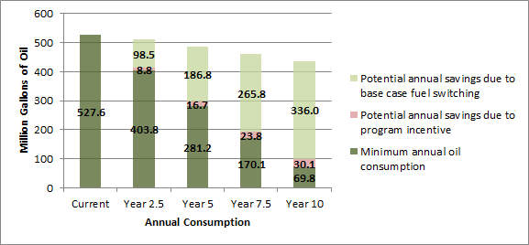

Figure 7-4 demonstrates the maximum impact of the two fuel switching scenarios on propane consumption over ten years.
Figure 7-4: Impact on Propane Consumption (100% Conversion Rate)
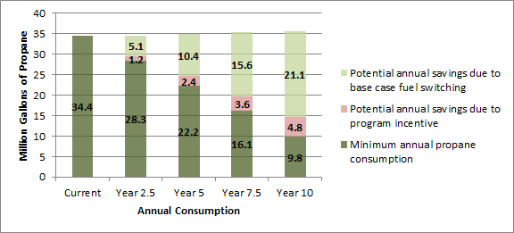

Likewise, Figure 7-5 demonstrates the maximum impact of fuel switching on natural gas consumption over ten years.
Figure 7-5: Impact on Natural Gas Consumption (100% Conversion Rate)
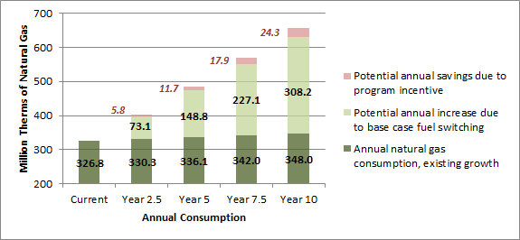

Figure 7-6 shows the maximum impact fuel switching could have on electricity consumption over the next ten years.
Figure 7-6: Impact on Electricity Consumption (100% Conversion Rate)
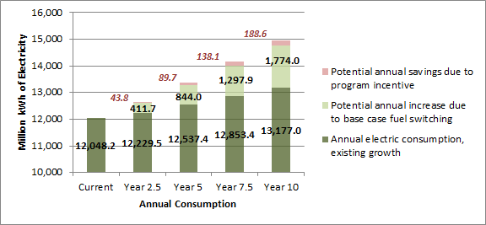

Lastly, Figure 7-7 demonstrates the maximum potential impact of fuel switching on overall fuel consumption, measured in MMBtu.
Figure 7-7: Impact on Overall Consumption in MMBtu (100% Conversion Rate)
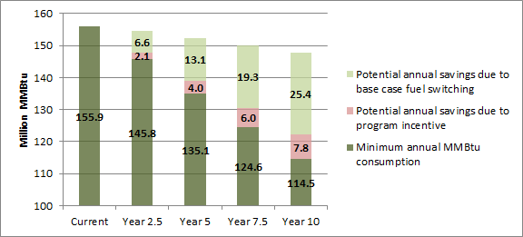

Base Case Scenario (No Utility Incentive)
This section details the results of base case scenario fuel switching. Fuel switching group features are described in detail in Table 2-6.
Table 7-3 details the impact of fuel switching under the base case scenario for various conversion rates. As shown:
Natural Gas
- Even with a 25% conversion rate, natural gas consumption in the state would exceed in 2.5 years a level (348 million ccf) which would otherwise not be reached for a decade under the no fuel switching scenario.
- Overall, fuel switching can be expected to increase natural gas consumption to between 130% and 201% of current annual consumption in the next decade.
Electricity
- A 25% conversion rate in the base case scenario would lead to an increased consumption of more than 2.3 billion kilowatt-hours of electricity in total over the next decade.
- A 50% conversion rate would result in more than 4.7 billion kilowatt-hours in increased usage, and a 100% conversion rate would lead to nearly 9.5 billion more kilowatt-hours over the next ten years than would be the case without fuel switching.
Fuel Oil and Propane
- Fuel switching could potentially reduce the state’s annual consumption of fuel oil for heating from the expected 435.9 million gallons per year in year ten to less than 100 million gallons.
  - This would represent a 77% decrease from the expected year-ten consumption level.
- Annual propane consumption could be reduced to 14.6 million gallons per year, which is a 59% decrease related to expected year-ten annual consumption.
Table 7-3: Annual Consumption Trajectories – Base Case Scenario
(Base: All SF homes, weighted to population)
Conversion Rate | Annual Consumption by Fuel |  |  |  |  |  | Difference in 10-Year Totals*
 | Current | Growth Rate | 2.5 Years | 5.0 Years | 7.5 Years | 10 Years
Fuel Oil Consumption Trajectory (million gallons)
No fuel switching | 527.6 | -2.1% | 511.1 | 484.7 | 459.7 | 435.9 | -
25% Uptake |  |  | 486.5 | 438.0 | 393.2 | 351.9 | - 493.1
50% Uptake |  |  | 461.9 | 391.3 | 326.8 | 267.9 | - 986.1
75% Uptake |  |  | 437.2 | 344.6 | 260.3 | 183.9 | - 1,479.2
100% Uptake |  |  | 412.6 | 297.9 | 193.9 | 99.9 | - 1,972.2
Propane Consumption Trajectory (million gallons)
No fuel switching | 34.4 | 0.4% | 34.6 | 35.0 | 35.3 | 35.7 | -
25% Uptake |  |  | 33.3 | 32.4 | 31.4 | 30.4 | - 28.6
50% Uptake |  |  | 32.1 | 29.8 | 27.5 | 25.1 | - 57.3
75% Uptake |  |  | 30.8 | 27.2 | 23.6 | 19.9 | - 85.9
100% Uptake |  |  | 29.5 | 24.6 | 19.7 | 14.6 | - 114.6
Natural Gas Consumption Trajectory (million ccf)
No fuel switching | 326.8 | 0.7% | 330.3 | 336.1 | 342.0 | 348.0 | -
25% Uptake |  |  | 348.6 | 373.3 | 398.8 | 425.1 | + 415.0
50% Uptake |  |  | 366.8 | 410.5 | 455.6 | 502.1 | + 829.9
75% Uptake |  |  | 385.1 | 447.7 | 512.3 | 579.1 | + 1,244.9
100% Uptake |  |  | 403.4 | 484.9 | 569.1 | 656.2 | + 1,659.9
Electricity Consumption Trajectory (million kWh)
No fuel switching | 12,048.2 | 1.0% | 12,229.5 | 12,537.4 | 12,853.4 | 13,177.0 | -
25% Uptake |  |  | 12,332.5 | 12,748.4 | 13,177.8 | 13,620.5 | + 2,368.3
50% Uptake |  |  | 12,435.4 | 12,959.4 | 13,502.3 | 14,064.0 | + 4,736.6
75% Uptake |  |  | 12,538.3 | 13,170.4 | 13,826.8 | 14,507.5 | + 7,104.9
100% Uptake |  |  | 12,641.2 | 13,381.4 | 14,151.3 | 14,951.0 | + 9,473.2
* Total aggregate difference over ten years.

Oil and Propane Savings
The current growth rate for fuel oil consumption in Connecticut is -2.1% per year. Therefore, as Figure 7-8 demonstrates, oil consumption is expected to decrease even in the absence of an effort to convert oil-fired heating equipment to gas. The analysis shows that a fuel switching effort would substantially accelerate the decrease in oil consumption. In the base case scenario—wherein some oil-fired heating equipment is converted to gas and others to heat pumps with an oil-fired backup, and water heating equipment is left as-is—oil consumption could decrease to as little as 23% of the expected annual consumption level by 2022 (if a 100% conversion rate is reached).
Figure 7-8: Change in Fuel Oil Consumption Under the Base Case Scenario
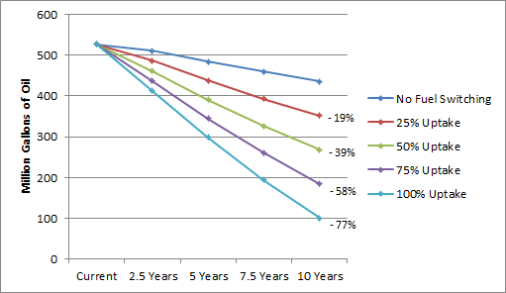

Currently, propane use in Connecticut is expected to increase by 0.4% per year. The analysis shows that fuel switching would reverse this trend even with a 25% conversion rate. In the next decade, annual propane consumption could potentially decline to 41% of the expected annual consumption level if a 100% conversion rate is reached. If the conversion rate only reaches 25%, then annual consumption would decrease by 15% relative to the expected annual consumption at year ten (Figure 7-9).
Figure 7-9: Change in Propane Consumption Under the Base Case Scenario
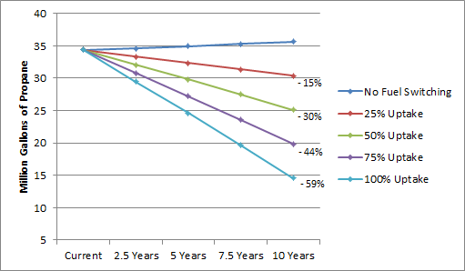

Increased Natural Gas and Electricity Consumption
Natural gas use could potentially increase 89% relative to expected annual consumption ten years from now if a 100% conversion rate is reached (Figure 7-10). At a 25% conversion rate, natural gas use would increase 22% relative to expected annual consumption ten years from now.
Figure 7-10: Change in Natural Gas Consumption Under the Base Case Scenario
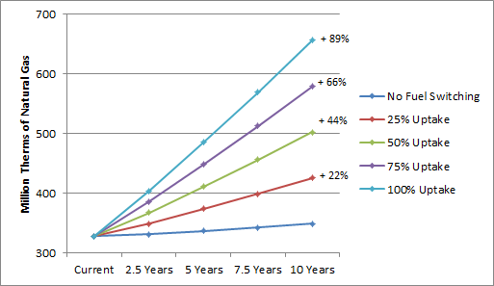

Under the base case scenario, increases in electric consumption are a result of the addition of ductless mini-splits in the place of oil- or propane-fired heating equipment, and thus occur primarily at the space heating end use. There are also small decreases in electricity use for water heating (due to the conversion of some water heaters at Group A sites from electric resistance to gas) and cooling (due to more efficient ductless mini-splits replacing existing cooling equipment) in the base case scenario.
At a 100% conversion rate, annual consumption of electricity could increase 13% relative to expected consumption ten years from now. If the conversion rate only reaches 25%, electric consumption would increase 3% relative to expected consumption ten years from now (Figure 7-11).
Figure 7-11: Change in Electricity Consumption Under the Base Case Scenario
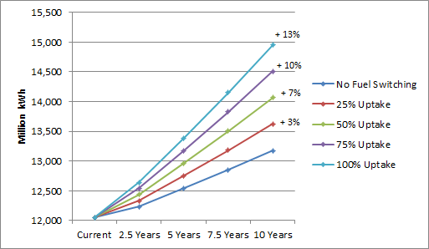

Upgrade Case Scenario (Program Incentive Impact)
This section details the results of upgrade case scenario fuel switching. Fuel switching group features are described in detail in Table 2-6.
Table 7-4 details the impact of fuel switching under the upgrade case scenario for the various conversion rates. Under this scenario, consumers in the state could potentially (i.e. with a 100% conversion rate) save more than 2 billion gallons of oil, more than 140 million gallons of propane, more than 1.5 billion ccf of natural gas, and nearly 8.5 billion kilowatt-hours of electricity in total over the next decade, relative to a scenario where fuel switching does not occur.
Table 7-4: Annual Consumption Trajectories – Upgrade Case Scenario
(Base: All SF homes, weighted to population)
Conversion Rate | Annual Consumption |  |  |  |  |  | Difference in 10-Year Totals*
 | Current | Growth Rate | 2.5 Years | 5.0 Years | 7.5 Years | 10 Years
Fuel Oil Consumption (million gallons)
No fuel switching | 527.6 | -2.1% | 511.1 | 484.7 | 459.7 | 435.9 | -
25% Uptake |  |  | 484.3 | 433.8 | 387.3 | 344.4 | - 537.2
50% Uptake |  |  | 457.5 | 382.9 | 314.9 | 252.8 | - 1,074.3
75% Uptake |  |  | 430.6 | 332.0 | 242.5 | 161.3 | - 1,611.5
100% Uptake |  |  | 403.8 | 281.2 | 170.1 | 69.8 | - 2,148.6
Propane Consumption (million gallons)
No fuel switching | 34.4 | 0.4% | 34.6 | 35.0 | 35.3 | 35.7 | -
25% Uptake |  |  | 33.0 | 31.8 | 30.5 | 29.2 | - 35.2
50% Uptake |  |  | 31.5 | 28.6 | 25.7 | 22.7 | - 70.4
75% Uptake |  |  | 29.9 | 25.2 | 20.9 | 16.2 | - 105.6
100% Uptake |  |  | 28.3 | 22.3 | 16.1 | 9.8 | - 140.8
Natural Gas Consumption (million ccf)
No fuel switching | 326.8 | 0.7% | 330.3 | 336.1 | 342.0 | 348.0 | -
25% Uptake |  |  | 347.1 | 370.4 | 394.3 | 419.0 | + 382.3
50% Uptake |  |  | 364.0 | 404.6 | 446.6 | 490.0 | + 764.5
75% Uptake |  |  | 380.8 | 438.9 | 498.9 | 560.9 | + 1,146.8
100% Uptake |  |  | 397.6 | 473.2 | 551.2 | 631.9 | + 1,529.1
Electricity Consumption (million kWh)
No fuel switching | 12,048.2 | 1.0% | 12,229.5 | 12,537.4 | 12,853.4 | 13,177.0 | -
25% Uptake |  |  | 12,321.5 | 12,726.0 | 13,143.3 | 13,573.3 | + 2,116.5
50% Uptake |  |  | 12,413.5 | 12,914.5 | 13,433.3 | 13,969.7 | + 4,232.9
75% Uptake |  |  | 12,505.4 | 13,103.1 | 13,723.3 | 14,366.0 | + 6,349.4
100% Uptake |  |  | 12,597.4 | 13,291.7 | 14,013.2 | 14,762.4 | + 8,465.9
* Total aggregate difference from current trajectory over 10-year period.

Savings Due to Program Incentives
In this analysis, the base case describes a scenario wherein fuel switching occurs, but a customer incentive to purchase higher-efficiency equipment is not offered. The upgrade case, conversely, describes a scenario wherein a program incentive is offered. The equipment efficiencies used in the REM/Rate modeling for each case are included in Table 2-5.
A program incentive for higher-efficiency equipment could potentially save between 0.9% and 2.6% of what the analysis estimates would be the total consumption of natural gas over the next decade under the base case scenario. For electric consumption that range is 0.2% to 0.7% of the total usage over ten years. See Table C-2 in Appendix C for detailed estimates of potential savings from program incentives for higher efficiency heating and water heating equipment (i.e. the difference between base case and upgrade case consumption).
As Figure 7-12 shows, a potential program incentive for higher-efficiency equipment would have less of an impact relative to the base case scenario than base case fuel switching would have relative to the existing consumption trajectory. Furthermore, some of the difference between the impacts of the base and upgrade cases can be attributed to the fact that, for 85 out of the 134 homes in the sample that were converted during the modeling (63%), water heating conversions were only modeled in the upgrade case.
Figure 7-12: Change in Total Consumption in MMBtu, Base to Upgrade Comparison*
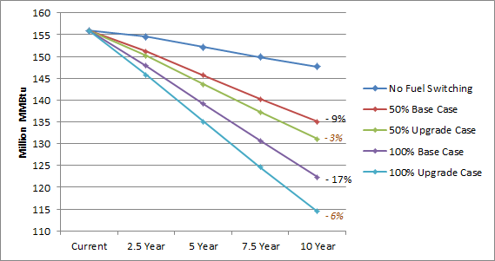
* Base case data labels show percent difference from a scenario without fuel switching at year ten. Upgrade case labels (in orange) show difference from base case.

Oil and Propane Savings
As Figure 7-13 demonstrates, the impact of a program incentive on the trajectory of annual consumption of fuel oil over the next decade is minimal, at least compared with the impact of base case fuel switching. This is because the difference between the base and upgrade cases is entirely attributable to oil consumption at the water heating end use—NMR’s presumption is that program incentives will be necessary to spur conversion to heat pump water heaters. Therefore, oil-fired water heating equipment in Groups B and C were left as-is in the base case and switched to heat pump water heaters in the upgrade case (see Section 2.5 of this report).
Since the models assume that oil space heating equipment is switched to gas or electric at the same rate for both the base and upgrade cases, the impact of a utility company incentive with reference to oil consumption is limited to switching oil-fired water heating equipment to heat pump water heaters.
Figure 7-13: Change in Fuel Oil Consumption, Base to Upgrade Comparison*
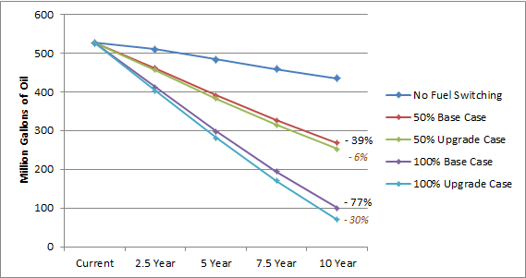
* Base case data labels show percent difference from a scenario without fuel switching at year ten. Upgrade case labels (in orange) show difference from base case.

The difference between propane consumption trajectories in the base and upgrade case scenarios is also due entirely to water heating, for the same reasons as oil: propane space heating equipment was switched to gas or heat pump in the base case, and thus a program incentive would only apply to propane insofar as it would convert propane-fired water heating equipment to a heat pump water heater.
Figure 7-14: Change in Propane Consumption, Base to Upgrade Comparison*
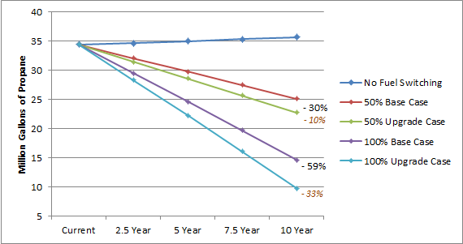
* Base case data labels show percent difference from a scenario without fuel switching at year ten. Upgrade case labels (in orange) show difference from base case.

Increased Natural Gas and Electricity Consumption
Figure 7-15 shows the change in natural gas consumption over the next decade in the base case scenario, the upgrade case scenario, and without fuel switching. More of the difference in gas consumption between the base case and upgrade case scenarios can be attributed to the water heating end use (58%) than space heating (42%) (see Section 7.1.5 for results by end use). As this figure shows, the maximum estimated impact of a program incentive for higher-efficiency natural gas equipment is 24.3 million ccf annually by year ten, or 4% of the annual consumption estimated by the base case models.
Figure 7-15: Change in Natural Gas Consumption, Base to Upgrade Comparison*
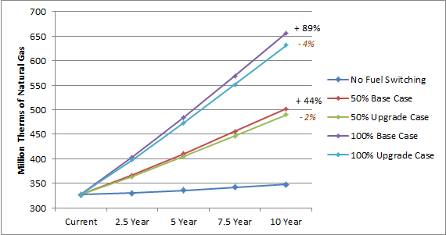
* Base case data labels show percent difference from a scenario without fuel switching at year ten. Upgrade case labels (in orange) show difference from base case.

The maximum impact of a program incentive for higher-efficiency electric heating and water heating equipment is about 1 billion kilowatt-hours over the next decade, or 0.7% of the ten-year total consumption estimated by the base case models (Figure 7-16). This impact is less substantial than it is for natural gas, predominantly because 69% of existing electric consumption occurs at the lights & appliances end use, which is unaffected by fuel switching. Most of the difference occurs at the heating end use while a small amount occurs at the cooling end use as well, since the ductless mini-splits which replaced oil- and propane-fired heating equipment also provide cooling.
Although electricity consumption would increase as a result of a possible program incentive for heat pump water heaters, this potential increase is substantially smaller than the potential savings which would be associated with an incentive for more efficient ductless mini-splits (see Section 7.1.5). It is also smaller than the amount of electricity which the analysis estimates could be saved by converting electric resistance water heaters to gas water heaters in homes that switch to gas.
Figure 7-16: Change in Electricity Consumption, Base to Upgrade Comparison*
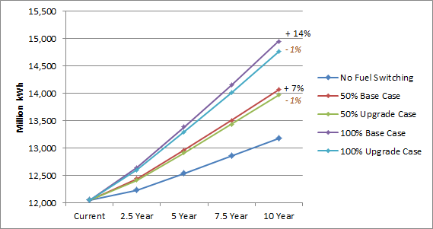
* Base case data labels show percent difference from a scenario without fuel switching at year ten. Upgrade case labels (in orange) show difference from base case.

Fuel Switching Impact by End Use
This section further details base case and upgrade case fuel switching impact by the heating, cooling, and water heating end uses.
Table 7-5 demonstrates the proportion of program incentive impacts taken up by each applicable end use. Because lights, appliances, and photovoltaics are not affected by fuel switching, those end uses are not included in the table. As shown:
- Most of the potential natural gas savings which an incentive could achieve (58%) would occur at the water heating end use, while the vast majority of electric savings (86%) would occur at the heating end use.
- Potential program incentives for more efficient natural gas equipment lead to more savings at the water heating end use than at the space heating end use, according to the models.
- There are also some modest increases in consumption from potential program incentives. Heat pump water heaters, which are present in 63% of upgrade case models but none of the base case models, account for 100% of the increase in electric consumption from possible program incentives.
  - These water heaters also account for small increases in oil and propane consumption in the upgrade case.
Table 7-5: Maximum Impacts of Program Incentive by End Use (100% Conversion Rate)
(Base: All SF homes, weighted to population)
Fuel | End Use
 | Heating | Cooling | Water Heating | Difference Over 10 Years
Percent of Consumption Decrease From Base Case to Upgrade Case
Fuel oil (million gallons) | - | - | 100% | - 182.6
Propane (million gallons) | - | - | 100% | - 26.8
Natural gas (million ccf) | 42% | - | 58% | - 130.8
Electricity (million kWh) | 86% | 14% | - | - 1,564.1
Percent of Consumption Increase From Base Case to Upgrade Case
Fuel oil (million gallons) | 100% | - | - | + 6.2
Propane (million gallons) | 100% | - | - | + 0.5
Natural gas (million ccf) | - | - | - | -
Electricity (million kWh) | - | - | 100% | + 556.7

Impacts from base case fuel switching occur mostly at the heating end use, regardless of fuel (Figure 7-17). This is unsurprising—most existing consumption occurs at the heating end use, and 85 (63%) of the 134 sites in the sample for which a fuel switch was modeled did not receive a water heater upgrade in the base case (see Table 2-6).
Figure 7-17: Base Case Annual Savings in MMBtu at Year Ten, by End Use* (100% Conversion Rate)
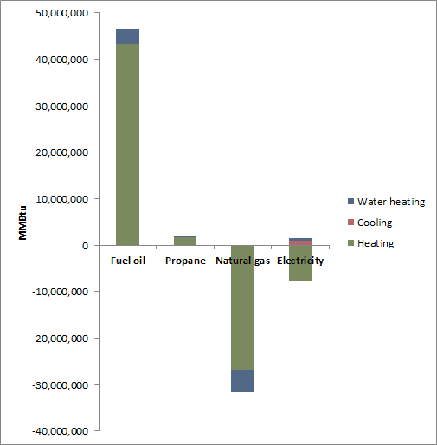
* Negative savings indicate a consumption increase.

Additionally, there is a negative impact on electricity consumption at the cooling end use in the base case. This shows that, while the models result in some extra electric consumption for cooling in homes where a ductless mini-split was modeled and no cooling equipment currently exists, that extra consumption is offset by savings from more efficient cooling in homes where ductless mini-splits were modeled and cooling equipment does currently exist. See Table C-3 in Appendix C for more details regarding fuel switching impacts by end use.
Added impact attributable to a possible incentive for higher-efficiency equipment takes place primarily at the heating end use for electric consumption, but at the water heating end use for all other fuels (Table 7-5, Figure 7-18). For oil and propane, this is because most consumption of those fuels was eliminated in the base case models, limiting the impact of the upgrade case models to water heating.
Figure 7-18: Upgrade Case Annual Savings from Base Case in MMBtu at Year Ten, by End Use (100% Conversion Rate)
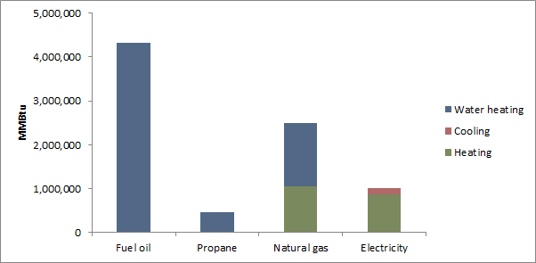

The models also show a nominal increase in oil and propane use between the base case and upgrade case (Table 7-5 and Table C-2). This is because of interactive effects in the models. All the sites showing an increase in oil or propane use from the base case to the upgrade case are in Groups B or C, which were modeled with existing water heating in the base case and heat pump water heaters in the upgrade case. In these models, existing heating equipment remained in a backup capacity to supplement heat provided by ductless mini-splits. Since heat pump water heaters draw heat from the air around them in a manner that other water heaters do not, more backup heating fuel is consumed to make up for the difference.

- Potential Upgrade Measures
Below are tables detailing the 43 measure upgrades which NMR considered in quantifying technical potential for energy savings in Connecticut single-family homes.
Table A-1: Building Shell Measure Upgrades
(Base: All applicable homes)
Measure | Sample Size | Upgrade Value
Add flat attic insulation | 166 | R-38, grade I
Add vaulted ceiling insulation | 75 | R-38, grade II or maximum achievable by framing
Add above grade wall insulation | 165 | R-20, grade II or maximum achievable by framing
Add foundation wall insulation | 91 | R-13, grade II cavity insulation
Add rim joist insulation | 109 | R-20, grade II
Add frame floor insulation | 161 | R-30, grade II or maximum achievable by framing
Reduce air infiltration | 142 | 7.0 ACH@50Pa
Reduce duct leakage | 50 | 8.0 CFM@25Pa/100 s.f.
Add duct insulation | 78 | R-8 on supplies in attics, R-6 on supplies in other u.c. space
Upgrade windows | 180 | U-value 0.2, SHGC 0.25

Table A-2: HVAC Measure Upgrades
(Base: All applicable homes)
Measure | Sample Size | Upgrade Value
Increase oil furnace AFUE | 31 | 90% AFUE (capacity same as rated home)
Increase oil boiler AFUE | 81 | 90% AFUE (capacity same as rated home)
Increase propane furnace AFUE | 2 | 97% AFUE (capacity same as rated home)
Increase propane boiler AFUE | 2 | 95% AFUE (capacity same as rated home)
Increase gas furnace AFUE | 25 | 97% AFUE (capacity same as rated home)
Increase gas boiler AFUE | 24 | 95% AFUE (capacity same as rated home)
Install ECM fan motor | 54 | 6% savings compared to PSC motor
Upgrade central air conditioner | 76 | 16 SEER, 13 EER (capacity same as rated home)
Upgrade room air conditioners | 66 | 11.5 EER (capacity same as rated home)

Table A-3: Water Heating Measure Upgrades
(Base: All applicable homes)
Measure | Sample Size | Upgrade Value
Replace tankless coil with indirect water heater | 42 | 50 gallon tank, EF 92% of boiler efficiency
Replace oil storage DHW with more efficient oil storage | 9 | 0.63 EF
Replace electric DHW with heat pump DHW | 42 | 2.3 EF
Replace gas storage water heater with instantaneous | 43 | 0.93 EF
Replace gas storage DHW with more efficient gas storage | 39 | 0.8 EF
Replace gas storage DHW with gas condensing | 39 | 0.9 EF
Replace LP storage water heater with instantaneous | 6 | 0.93 EF
Replace LP storage DHW with more efficient LP storage | 4 | 0.8 EF
Replace LP storage water heater with LP condensing | 4 | 0.9 EF
Increase water heater tank wrap R-value | 102 | R-10 tank wrap
Install low-flow showerheads | 180 | Calculated using 2013 HES Program Savings Documentation
Install faucet aerators | 180
Add DHW pipe insulation | 138

Table A-4: Lights & Appliances Measure Upgrades
(Base: All applicable homes)
Measure | Sample Size | Upgrade Value
Upgrade refrigerator | 180 | 319 kWh/year
Upgrade freezer | 60 | 188 kWh/year
Upgrade dishwasher | 164 | 1.28 EF, 170 kWh/year
Upgrade clothes washer | 177 | Calculated using 2013 HES Program Savings Documentation
Upgrade dehumidifier | 49 | 2.6 EF
Increase socket saturation of efficient lighting | 180 | Increase saturation to 100%

Table A-5: Heat Pumps & Solar Technologies Measure Upgrades
(Base: All applicable homes)
Measure | Sample Size | Upgrade Value
Install ground source heat pump | 103 | 17.1 EER, 3.6 COP
Install air source heat pump | 104 | 22.1 SEER, 11.3 HSPF
Install ductless mini-split | 180 | 12.1 EER (19.2 SEER), 3.0 COP (10.3 HSPF) (modeled as GSHP. See Appendix B for details)
Add photovoltaic array | 108 | South-facing 7.1 kW system, 35º tilt with 95% inverter
Add solar hot water system | 109 | 66 s.f., south-facing, double-glazed, liquid indirect system

  - Maximum R-value Achievable by Framing
Insulation upgrade values were assigned by determining the maximum R-value achievable with blown-in insulation in the framing found on site. Table A-6 details the insulation upgrade values by framing depth.
Table A-6: Insulation Upgrade Values by Framing Type
(Base: All applicable homes)
Measure | Sample Size | Upgrade Level by Framing Type
 |  | 2x4 | 2x6 | 2x8 | 2x10 | 2x12
Attic insulation | 166 | R-38
Vaulted ceiling insulation | 75 | n/a | R-19 | R-25 | R-32 | R-38
Wall insulation | 165 | R-12 | R-19 | n/a | n/a | n/a
Foundation wall insulation | 91 | R-10 or R-13
Frame floor insulation | 161 | n/a | R-21 | R-30

- Potential Modeling Assumptions and Other Details
This appendix provides additional information regarding the assumptions and details that were used to calculate potential savings.
  - Technical Feasibility for Advanced Measures
The following measures required special consideration when assessing technical feasibility.
Ground and Conventional Air Source Heat Pumps: These heat pump upgrades were applied to all homes with duct work and also all homes where the primary heating fuel was electricity. When modeling these upgrades, the capacity of these heat pumps was based on the cooling design load of the baseline REM/Rate models. Back-up heating equipment was also upgraded to technical potential levels and any remaining heating load was applied to said equipment.
Photovoltaics and Solar Hot Water: These upgrades were applied to 60% (108 homes) of the sample. This figure is based on informal interviews the Team conducted with a handful of Connecticut based residential solar contractors.
Ductless Mini-Split Heat Pumps: These units consist of two components—an outdoor condensing unit and an indoor air handler—linked by a conduit that contains refrigerant tubing and the power cable. Depending on capacity, an outdoor component can have up to six indoor components, which deliver heating or cooling directly to a room. Like other heat pumps, ductless mini-splits are capable of both heating and cooling. These upgrades were assumed to be technically feasible at all 180 homes. When modeling these upgrades, the capacity of the ductless mini-split was based on the cooling design load of the baseline REM/Rate models. Back-up heating equipment was also upgraded to technical potential levels and any remaining heating load was applied to said equipment.
These heat pumps were modeled using REM/Rate’s ground source heat pump library in order to account for the fact that REM/Rate does not adequately estimate the efficiencies of ductless mini-split heat pumps.
  - Baseline Assessment for Measures Not Inventoried During Site Visits
Data was not collected for the following measures during the site visits for this study, and as a result, assumptions were made regarding their baseline condition.
Lighting: As part of the Weatherization Baseline Study data collection efforts, information was collected on light fixtures but not on light bulbs. For this reason, results from a recent Connecticut lighting evaluation were leveraged to estimate the baseline saturation of energy efficient light bulbs. The number of sockets and number of efficient vs. inefficient bulbs was estimated for various single-family home sizes using the onsite data from the aforementioned study. The study results included a combination of CFLs, LEDs, and other efficient light bulbs that were all categorized together as “efficient”. The wattages that were modeled for this study were the average wattages of all efficient bulbs found in the Connecticut lighting evaluation. On average, the study found that CFL saturation in Connecticut homes was 27%.
Dehumidifier: Dehumidifiers were not part of the Weatherization Baseline Study `data collection efforts. In order to develop a baseline estimate for dehumidifiers, the Team utilized onsite data from a recent existing homes baseline study that was conducted in Vermont. After reviewing the data, the Team determined that dehumidifiers should apply to 27% of the sample (49 homes).
Low-Flow Showerheads and Faucet Aerators: Low-flow showerheads and faucet aerators were not part of the Weatherization Baseline Study data collection efforts. Similar to dehumidifiers, the Team utilized onsite data from a recent existing homes baseline study in Vermont to estimate the baseline saturation of these technologies.
The Vermont data revealed that the mean number of faucet aerators per home in that state is 1.23, while the mean number of low-flow showerheads per home is 0.55. The level of opportunity for faucet aerator and low-flow showerhead installation was therefore judged as follows:
- Faucet aerator opportunity = (# Baths + 1) – 1.23
- Low-flow showerhead opportunity for homes with one bathroom = (# Baths – 0.55)
Low-flow showerhead opportunity for homes with more than one bathroom = (# Baths – 1) – 0.55

- Detailed Fuel Switching Impact Tables
Table C-1 describes the trajectory of annual consumption by fuel type for both the base case and upgrade case scenarios. These data were used to make the figures in Section 7.1.2 of this report (Figure 7-3 through Figure 7-7).
Table C-1: Consumption Growth Trajectories Under the Maximum (100%) Uptake Rate
(Base: All SF homes, weighted to population)
Impact | Annual Consumption |  |  |  |  |  | Difference in 10-Year Totals
 | Current | Growth Rate | Year 2.5 | Year 5 | Year 7.5 | Year 10
Base Case
Oil consumption, existing trajectory (million gallons) | 527.6 | - 2.1% | 511.1 | 484.7 | 459.7 | 435.9 | -
Oil consumption trajectory with fuel switching |  |  | 412.6 | 297.9 | 193.9 | 99.9 | - 1,972.2
Propane consumption, existing trajectory (million gallons) | 34.4 | 0.4% | 34.6 | 35.0 | 35.3 | 35.7 | -
Propane consumption trajectory with fuel switching |  |  | 29.5 | 24.6 | 19.7 | 14.6 | - 114.6
Natural gas consumption, existing trajectory (million ccf) | 326.8 | 0.7% | 330.3 | 336.1 | 342.0 | 348.0 | -
Natural gas consumption trajectory with fuel switching |  |  | 403.4 | 484.9 | 569.1 | 656.2 | + 1,659.9
Electricity consumption, existing trajectory (million kWh) | 12,048.2 | 1.0% | 12,229.5 | 12,537.4 | 12,853.4 | 13,177.0 | -
Electric consumption trajectory with fuel switching |  |  | 12,641.2 | 13,381.4 | 14,151.3 | 14,951.0 | + 9,473.2
Upgrade Case
Oil consumption, existing trajectory (million gallons) | 527.6 | - 2.1% | 511.1 | 484.7 | 459.7 | 435.9 | -
Oil consumption trajectory with fuel switching |  |  | 403.8 | 281.2 | 170.1 | 69.8 | - 2,148.6
Potential oil savings due to program incentives |  |  | 8.8 | 16.7 | 23.8 | 30.1 | - 176.4
Propane consumption, existing trajectory (million gallons) | 34.4 | 0.4% | 34.6 | 35.0 | 35.3 | 35.7 | -
Propane consumption trajectory with fuel switching |  |  | 28.3 | 22.3 | 16.1 | 9.8 | - 140.8
Potential propane savings due to program incentives |  |  | 1.2 | 2.4 | 3.6 | 4.8 | - 26.2
Natural gas consumption, existing trajectory (million ccf) | 326.8 | 0.7% | 330.3 | 336.1 | 342.0 | 348.0 | -
Natural gas consumption trajectory with fuel switching |  |  | 397.6 | 473.2 | 551.2 | 631.9 | + 1,529.1
Potential gas savings due to program incentives |  |  | 5.8 | 11.7 | 17.9 | 24.3 | - 130.8
Electricity consumption, existing trajectory (million kWh) | 12,048.2 | 1.0% | 12,229.5 | 12,537.4 | 12,853.4 | 13,177.0 | -
Electric consumption trajectory with fuel switching |  |  | 12,597.4 | 13,291.7 | 14,013.2 | 14,762.4 | + 8,465.9
Potential electric savings due to program incentives |  |  | 43.8 | 89.7 | 138.1 | 188.6 | - 1,007.4

Table C-2 details estimated savings attributable to a potential program incentive for higher efficiency heating and water heating equipment (i.e. the difference between base case and upgrade case consumption) in total over the course of a ten year span from 2013 to 2022.
Table C-2: Estimated Savings Due to Program Incentive Over Ten Years
(Base: All SF homes, weighted to population)
Fuel | Scenario | Conversion Rate
 |  | 25% | 50% | 75% | 100%
Natural gas (million ccf)
Total natural gas consumption over 10 years* | No fuel switching | 3,373.4
 | Base case scenario | 3,788.3 | 4,203.3 | 4,618.3 | 5,033.3
 | Upgrade case scenario | 3,755.6 | 4,137.9 | 4,520.2 | 4,902.5
Ten-year natural gas savings due to incentive* | n/a | 32.7 | 65.4 | 98.1 | 130.8
Savings percent of base case |  | 0.9% | 1.6% | 2.1% | 2.6%
Electricity (million kWh)
Total electricity consumption over 10 years* | No fuel switching | 126,051.1
 | Base case scenario | 128,419.4 | 130,787.7 | 133,156.0 | 135,524.3
 | Upgrade case scenario | 128,167.6 | 130,284.0 | 132,400.5 | 134,516.9
Ten-year electricity savings due to incentive* | n/a | 251.8 | 503.7 | 755.5 | 1,007.4
Savings percent of base case |  | 0.2% | 0.4% | 0.6% | 0.7%
Fuel oil (million gallons)
Total fuel oil consumption over 10 years* | No fuel switching | 4,804.5
 | Base case scenario | 4,311.5 | 3,818.4 | 3,325.4 | 2,832.3
 | Upgrade case scenario | 4,267.4 | 3,730.2 | 3,193.1 | 2,655.9
Ten-year fuel oil savings due to incentive* | n/a | 44.1 | 88.2 | 132.3 | 176.4
Savings percent of base case |  | 1.0% | 2.3% | 4.0% | 6.2%
Propane (million gallons)
Total propane consumption over 10 years* | No fuel switching | 350.3
 | Base case scenario | 321.7 | 293.1 | 264.4 | 235.8
 | Upgrade case scenario | 315.1 | 279.9 | 244.7 | 209.5
Ten-year propane savings due to incentive* | n/a | 6.6 | 13.1 | 19.7 | 26.2
Savings percent of base case |  | 2.0% | 4.5% | 7.4% | 11.1%
* In millions.

Table C-3 details the impact of fuel switching by end use for the 100% conversion rate. Columns under the heading “base case difference from no fuel switching” demonstrate the impact of fuel switching without an incentive for higher-efficiency equipment, while columns under the heading “upgrade case difference from base case” describe the potential added impact of such an incentive. These data were used to make the figures in Section 7.1.5 of this report (Figure 7-17 and Figure 7-18).
Table C-3: Maximum Impacts of Fuel Switching by End Use Under the 100% Conversion Rate^{i}
(Base: All SF homes, weighted to population)
End Use^{ii} | Current Annual^{iv} | Base Case Difference from No Fuel Switching |  |  |  |  | Upgrade Case Difference from Base Case
 |  | Annual Consumption |  |  |  | Ten-Year Total^{iii} | Annual Consumption |  |  |  | Ten-Year Total^{iii}
 |  | Year 2.5 | Year 5 | Year 7.5 | Year 10 |  | Year 2.5 | Year 5 | Year 7.5 | Year 10
Total | 527.6 | - 394.0 | - 373.6 | - 354.3 | - 336.0 | - 1,972.2 | - 8.8 | - 16.7 | - 23.8 | - 30.1 | - 176.4
Heating | 460.7 | - 365.7 | - 346.7 | - 328.8 | - 311.8 | - 1,830.3 | + 0.3 | + 0.6 | + 0.8 | + 1.1 | + 6.2
Water heating | 66.9 | - 28.3 | - 26.9 | - 25.5 | - 24.2 | - 141.9 | - 9.1 | - 17.3 | - 24.6 | - 31.1 | - 182.6
Total | 34.4 | - 20.5 | - 20.7 | - 20.9 | - 21.1 | - 114.6 | - 1.2 | - 2.4 | - 3.6 | - 4.8 | - 26.2
Heating | 24.3 | - 18.3 | - 18.5 | - 18.7 | - 18.9 | - 102.6 | + < 0.1 | + < 0.1 | + < 0.1 | + 0.1 | + 0.5
Water heating | 6.9 | - 2.1 | - 2.2 | - 2.2 | - 2.2 | - 11.9 | - 1.2 | - 2.4 | - 3.7 | - 4.9 | - 26.8
Total | 326.8 | + 292.4 | + 297.6 | + 302.8 | + 308.1 | + 1,659.9 | - 5.8 | - 11.7 | - 17.9 | - 24.3 | - 130.8
Heating | 276.3 | + 247.1 | + 251.5 | + 255.9 | + 260.4 | + 1,402.6 | - 2.4 | - 4.9 | - 7.5 | - 10.2 | - 54.8
Water heating | 41.9 | + 45.3 | + 46.1 | + 46.9 | + 47.8 | + 257.3 | - 3.3 | - 6.8 | - 10.4 | - 14.1 | - 76.0
Total | 12,048.2 | + 1,646.5 | + 1,688.0 | + 1,730.5 | + 1,774.1 | + 9,473.2 | - 43.8 | - 89.7 | - 138.0 | - 188.7 | - 1,007.4
Heating | 1,868.3 | + 2,049.6 | + 2,101.2 | + 2,154.1 | + 2,208.3 | + 11,792.1 | - 58.4 | - 119.7 | - 184.1 | - 251.6 | - 1,343.5
Cooling | 1,288.9 | - 243.4 | - 249.5 | - 255.8 | - 262.2 | - 1,400.3 | - 9.6 | - 19.7 | - 30.2 | - 41.3 | - 220.6
Water heating | 798.4 | - 159.7 | - 163.7 | - 167.8 | - 172.0 | - 918.6 | + 24.2 | + 49.6 | + 76.3 | + 104.3 | + 556.7
^{i} Numbers in table assume a 100% conversion rate, and therefore describe maximum impacts.
^{ii} Fuel switching did not affect the lights & appliances end use.
^{iii} Total impact over the course of ten years.
^{iv} End uses may not add up to total because they do not include lights, appliances, or photovoltaics, which are unaffected by fuel switching.

- Sources of Growth Rates
In order to project potential savings out over time, the Team first had to identify growth rates for the various fuel types that are assessed in this report.
Electricity: The growth rates for electricity consumption and peak demand were estimated based on the Connecticut-specific forecasting details of the Capacity, Energy, Loads, and Transmission (CELT) report that is published by ISO-New England. Here is a link to the CELT forecasting details documents: http://iso-ne.com/trans/celt/fsct_detail/index.html
Natural Gas: The growth rates for natural gas consumption are based on the biennial forecast of natural gas demand and supply submitted by Yankee Gas to the State of Connecticut on October 1, 2012. Here is a link to those documents: http://www.dpuc.state.ct.us/dockcurr.nsf/8e6fc37a54110e3e852576190052b64d/9a0971f21cbf5a3e85257a8d004be07c?OpenDocument
Fuel Oil and Propane: The growth rates for fuel oil and propane are based on the U.S. Energy Information Administration’s Annual Energy Outlook for 2013. Specifically, these growth rates were derived from projected energy consumption estimates for the residential sector in New England. Here is a link to the website where this information can be found: http://www.eia.gov/forecasts/aeo/sector_residential.cfm

- Federal Standards Accounted for In Achievable Potential
The tables below present the federal standards that were accounted for in the achievable potential analysis. Standards and effective dates were taken from the websites of the Department of Energy and the Appliance Standards Awareness Project (ASAP).
Table E-1: Federal Standards for Heating & Cooling Equipment
Equipment | Type | Current Standard | Amended Standard | Amended Standard Effective | Upcoming Standard | Upcoming Standard Effective
Hydronic boiler (AFUE) | Gas | 82.0% | 84.5% | 2020
 | Oil | 84.0% | 89.0%
Steam boiler (AFUE) | Gas | 80.0% | 86.7%
 | Oil | 82.0% | 84.5%
Furnace (AFUE) | Gas | 80.0% | 90.0% | 2015
 | Oil | 80.0% | 90.0%
Room air conditioners (EER) | < 6 kBTU/h | 9.7 | 11.0 | 2014 | 12.5 | 2020
 | 6 to 7.9 kBTU/h | 9.7 | 11.0 |  | 12.5
 | 8 to 13.9 kBTU/h | 9.8 | 10.9 |  | 12.1
 | 14 to 19.9 kBTU/h | 9.7 | 10.7 |  | 11.8
 | 20 to 24.9 kBTU/h | 8.5 | 9.4 |  | 10.4
 | 25+ kBTU/h | 8.5 | 9.0 |  | 9.5

Table E-2: Federal Standards for Water Heating Equipment
Equipment | Type | Storage Volume (V) | Current Standard | Amended Standard (2015) | Upcoming Standard (2021)
Conventional storage | Gas | ≥ 20 gal & ≤ 100 gal | 0.67 - 0.0019V | 0.675 - 0.0015V | 1.0354 * (0.675 - 0.0015V)
 |  | > 55 gal & ≤ 100 gal | 0.67 - 0.0019V | 0.8012 - 0.00078V | 0.9
 | Oil | ≤ 50 gal | 0.59 - 0.0019V | 0.68 - 0.0019V | 1.1818 * (0.68 - 0.0019V)
 | Electric | ≥ 20 gal & ≤ 120 gal | 0.97 - 0.00132V | 0.96 - 0.0003V | 1.0336 * (0.96 - 0.0003V)
 |  | > 55 gal & ≤ 120 gal | 0.97 - 0.00132V | 2.057 - 0.00113V | 2.3
Instantaneous | Gas | < 2 gal | 0.62 - 0.0019V | 0.82 - 0.0019V | 0.93
 | Electric | < 2 gal | 0.93 - 0.00132V | 0.93 - 0.00132V | 0.93

Table E-3: Federal Standards for Appliances
Equipment | Type | Current Standard | Amended Standard | Amended Standard Effective | Upcoming Standard | Upcoming Standard Effective
Refrigerator (kWh/year) | Top freezer | 9.8V + 276.0 | 8.07V + 233.7 | 2014 | 0.838 * (8.07V + 233.7) | 2021
 | Side-by-side | 4.91V + 507.5 | 8.51V + 297.8 |  | 0.757 * (8.51V + 297.8)
 | Bottom freezer | 4.6V + 459.0 | 8.85V + 317.0 |  | 0.879 * (8.85V + 317.0)
Freezer (kWh/year) | Upright | 12.43V + 326.1 | 8.62V + 228.3 |  | 0.698 * (8.62V + 228.3)
 | Chest | 9.88V + 143.7 | 7.29V + 107.8 |  | 0.745 * (7.29V + 107.8)
Clothes washer (MEF) | Top-loading | 1.26 | 1.29 | 2015 | 1.57 | 2018
 | Front-loading | 1.26 | 1.84 |  | 1.84 | 2021

Many of the measures considered for the potential study are not currently incentivized by the Companies and as a result they cannot be screened for cost-effectiveness using the Utility Cost Test. For this reason, the Total Resource Cost test was used to determine whether or not measures were cost-effective.
Of the 180 homes audited for this study, 111 were primarily heated by fuel oil.
NMR Group, Inc. “Single-Family Weatherization Baseline Assessment (R5), Final Report” Submitted to The Connecticut Energy Efficiency Fund, Connecticut Light and Power, and The United Illuminating Company, June 3rd, 2014.
For example, a home with an oil boiler that is upgraded to a higher efficiency oil boiler in the core potential study may have the same boiler replaced by a high efficiency gas boiler in the fuel switching analysis; the savings from these two measure upgrades are duplicative.
Many of the measures considered for the potential study are not currently incentivized by the Companies and as a result they cannot be screened for cost-effectiveness using the Utility Cost Test. For this reason, the Total Resource Cost test was used to determine whether or not measures were cost-effective.
REM/Rate is a residential energy analysis software that is commonly used to model the performance of residential buildings—the software is most notably used by the ENERGY STAR® Homes program.
Of the 180 homes audited for this study, 111 were primarily heated by fuel oil.
A list of the measures and their upgrade efficiency levels can be found in Table A-6 through Table A-10.
Ductless mini-split heat pumps are a form of air source heat pump that, as the name suggests, do not require duct work. This is significant as it makes ductless mini-splits an easier add-on technology to existing homes than other heating and cooling technologies. Ductless mini-split heat pumps also offer the benefit of providing both heating and cooling. These heat pumps have become increasingly popular over time as the technology has improved to the point where heat pumps are a viable option for heating needs in cold climates.
Ductless mini-splits and air sealing ranked 1st and 5th, respectively, in terms of overall energy savings in the individual model runs for technical potential (see Section 4.1.2).
REM/Rate does not include photovoltaics, one of the upgrades in the potential study, in estimates of demand savings. However, it is unlikely that photovoltaics would influence winter peak demand savings as the winter peak in New England is from 5-7 PM during the months of December and January. It should also be noted that photovoltaics were not cost-effective at any of the 180 sites and as a result the exclusion of photovoltaics from demand estimates does not impact cost-effective or achievable demand savings estimates.
While ductless mini-splits reduce overall heating energy consumption, they increase electricity consumption, in particular during the winter.
This is based on annual growth projections (see Appendix D).
NMR Group, Inc. “Single-Family Weatherization Baseline Assessment (R5), Final Report” Submitted to The Connecticut Energy Efficiency Fund, Connecticut Light and Power, and The United Illuminating Company, June 3rd, 2014.
For example, a home with an oil boiler that is upgraded to a higher efficiency oil boiler in the core potential study may have the same boiler replaced by a high efficiency gas boiler in the fuel switching analysis; the savings from these two measure upgrades are duplicative.
REM/Rate is a residential energy analysis software that is commonly used to model the performance of residential buildings—the software is most notably used by the ENERGY STAR® Homes program.
Single-family homes included detached (i.e., standalone) homes and attached (e.g., duplex or townhouse) homes.
http://www.epa.gov/cleanenergy/documents/suca/potential_guide.pdf
Clothes washers, which are an input into the REM/Rate software, were also modeled outside of REM/Rate because the software’s model for clothes washers requires complete data on the machine from the Energy Guide label, which was not always available.
http://www.ctenergyinfo.com/2013%20Program%20Savings%20Documentation%20-%20Final.pdf
NMR believes this is appropriate for assessing technical potential given the versatility of the ductless mini-split technology.
http://energizect.com/sites/default/files/2013_2015_CLM%20PLAN_11_01_12_FINAL.pdf
http://www.synapse-energy.com/Downloads/SynapseReport.2013-07.AESC.AESC-2013.13-029-Report.pdf
The Team identified an incentive-to-program cost ratio of 0.67 using Connecticut’s 2013-2015 Electric and Natural Gas Conservation and Load Management Plan for residential programs. This factor, in conjunction with the incentive levels provided by the Companies, was used to calculate administrative costs for cost-effectiveness screening.
While the cost-effectiveness screening results can be easily modified, the modeling of cost-effective savings is not repeatable without additional budget.
http://neep.org/Assets/uploads/files/emv/emv-products/Incremental%20Cost_study_FINAL_REPORT_2011Sep23.pdf
http://neep.org/Assets/uploads/files/emv/emv-products/NEEP%20ICS2%20FINAL%20REPORT%202013Feb11-Website.pdf
http://neep.org/emv/forum-products-guidelines/index#incrementalcost
http://www.ma-eeac.org/Docs/8.1_EMV%20Page/2013/Residential%20Program%20Studies/Residential%20New%20Construction%20Program%20Incremental%20Cost%20Final%20Report%206-11-13.pdf
http://www.energizect.com/sites/default/files/CT%20GSHP%20Impact%20Eval%20and%20Market%20Assessment%20%28R7%29%20-%20final%20report.pdf
http://www.deeresources.com/
These savings, because they are the result of a model run in which only one measure was upgraded, do not reflect interactive effects among the measures considered for this study.
http://www.synapse-energy.com/Downloads/SynapseReport.2013-07.AESC.AESC-2013.13-029-Report.pdf
Early retirement savings are calculated as the difference between the consumption of an existing unit and that of a high-efficiency replacement.
Connecticut Program Savings Document: 8th Edition for 2013 Program Year. February 21, 2013. Pages 264-266.
Lost opportunity savings are calculated as the difference between the consumption of a federal minimum efficiency unit and that of a high-efficiency replacement.
U.S. Department of Energy, Office of Energy Efficiency & Renewable Energy. Standards and Test Procedures. http://energy.gov/eere/buildings/standards-and-test-procedures
Appliance Standards Awareness Project. National Standards. http://www.appliance-standards.org/national
Northeast Energy Efficiency Partnerships (NEEP). Northeast/Mid-Atlantic Air-Source Heat Pump Market Strategies Report. January 2014.
Northeast Energy Efficiency Partnerships (NEEP). Northeast and Mid-Atlantic Heat Pump Water Heater Market Strategies Report. December 2012.
Heat Pump Water Heater Market Strategies Report, p. 4.
Hudon, Merrigan, Burch, & Maguire, National Renewable Energy Laboratory. Low-Cost Solar Water Heating Research and Development Roadmap. August 2012. Page 26.
https://www.census.gov/acs/www/
NMR Group, Inc. Connecticut Efficient Lighting Saturation and Market Assessment. October 2, 2012.
NMR Group, Inc., Market Adoption Model found in MA Res Product Evaluation. November 2013.
http://www.ctenergyinfo.com/2013%20Program%20Savings%20Documentation%20-%20Final.pdf
https://app.box.com/s/o1f3bhbunib2av2wiblu
http://www.nrel.gov/docs/fy09osti/44816.pdf
http://iso-ne.com/regulatory/tariff/sect_1/sect_i.pdf
Lisa Skumatz, email message to author, September 26th, 2013.
NMR Group, Inc. “Technical Savings Potential for Single-Family Homes in Connecticut.” Submitted to the Connecticut Energy Efficiency Board (EEB), September 13th, 2013.
2013 Comprehensive Energy Strategy for Connecticut. The Connecticut Department of Energy and Environmental Protection. Hartford, CT. February 19, 2013. Page 132, Table 5.
The list of towns served by gas lines was determined using a map found on the Yankee Gas website. Available here: http://www.yankeegas.com/downloads/servicemap.pdf?id=4294988935&dl=t
Ductless mini-splits are also often easier to retrofit into a home than conventional air source heat pumps or ground source heat pumps, particularly for homes that do not have existing duct work.
NMR assumes that it would be unlikely for these homeowners to switch to heat pump water heaters if an incentive is not offered, and impractical for them to switch to an electric storage water heater given the high cost of electricity and the fact that oil/propane heating equipment remains as a backup to the ductless mini-splits.
The sources used to calculate growth rates can be found in Appendix D.
NMR Group, Inc. “Weatherization Baseline Assessment-Revised Draft Report” Submitted to The Connecticut Energy Efficiency Fund, Connecticut Light and Power, and The United Illuminating Company, September 11th, 2013.
The coefficient of variation measures the dispersion of data in a series of data points; it is commonly used to estimate sampling error when measuring the efficiency of measures installed in weatherization efforts.
Underrepresentation of renters and low-income respondents is common in telephone surveys. For example, see Galesic, M., R. Tourangeau, M.P. Couper (2006), “Complementing Random-Digit-Dial Telephone Surveys with Other Approaches to Collecting Sensitive Data,” American Journal of Preventive Medicine, Volume 35, Number 5.
NMR Group, Inc. “Weatherization Baseline Assessment-Revised Draft Report” Submitted to The Connecticut Energy Efficiency Fund, Connecticut Light and Power, and The United Illuminating Company, September 11th, 2013.
http://www.epa.gov/cleanenergy/documents/suca/resource_planning.pdf
The EIA does not present information on propane consumption by end use and as a result propane was excluded from this analysis.
http://www.eia.gov/consumption/residential/index.cfm
Million Btus (British thermal units).
The Team arrived at this 60% figure after interviews with several solar contractors in Connecticut suggested that about that proportion of single-family homes in the state could feasibly support the installation of a solar array without incurring the substantial extra costs associated with roof reinforcement, electrical system upgrade, or trimming or removing trees.
In the individual measure model runs, the savings due to the ductless mini-split upgrade exceeded the combined savings from upgrading existing heating and cooling equipment for every site. Because the individual measure upgrade resulting in the most savings was applied in the comprehensive model, ductless mini-splits were modeled for every site in the comprehensive model runs.
http://iso-ne.com/regulatory/tariff/sect_1/sect_i.pdf
While ductless mini-splits reduce overall heating energy consumption, they increase electricity consumption, in particular during the winter.
ISO-New England defines the summer on-peak period as non-holiday weekdays in June, July, and August between 1:00pm and 5:00pm.
The 2013 Connecticut Program Savings Documentation assumes a summer peak coincident factor of 59% for central air conditioning and 30% for room air-conditioners.
http://www.ctenergyinfo.com/2013%20Program%20Savings%20Documentation%20-%20Final.pdf
http://publicservice.vermont.gov/sites/psd/files/Topics/Energy_Efficiency/EVT_Performance_Eval/VT%20SF%20Existing%20Homes%20Onsite%20Report%20-%20final%20021513.pdf.
Converting consumption figures to MMBtu makes them directly comparable across fuel types and makes it possible to discern the overall impact of fuel switching.
Specifically, these values assume that the number of homes with gas heating and water heating equipment would increase from 34% to 53%, which is the number of residences that the Connecticut Comprehensive Energy Strategy suggests is technically feasible in the near term. Additionally, these values assume that the remaining 47% of homes convert to heat pumps.
These are homes in Groups B and C, which were switched from oil or propane to ductless mini-splits in the models. NMR assumes that it would be unlikely for these homeowners to switch to heat pump water heaters if an incentive is not offered, and impractical for them to switch to an electric storage water heater given the high cost of electricity and the fact that oil/propane heating equipment remains as a backup to the ductless mini-splits.
This is because the increase in water heating efficiency from an Energy Factor of 0.62 to 0.93 saves more fuel than the increase in space heating AFUE from 92.4% to 95% (for boilers) or 97% (for furnaces).
Heat pump water heaters draw heat from the air around them, so oil and propane heating equipment used in a backup capacity to ductless mini-splits must produce more heat to make up the difference.
Ductless mini splits were modeled with the same efficiency levels as they would be normally (though converted to EER and COP), but they were modeled using the ground source heat pump library with no fan and no pump-based energy consumption.
This study was an add-on task that utilized data from the Weatherization Baseline Assessment site visits. As a result, the data collection was not designed for this study and therefore baseline information was not available for all measures.
REM/Rate requires information on light fixtures not light bulbs.
Connecticut Efficient Lighting Saturation and Market Assessment, Submitted to the Connecticut Energy Efficiency Fund, Connecticut Light and Power, and The United Illuminating Company by NMR Group, Inc. October 2012.
http://publicservice.vermont.gov/sites/psd/files/Topics/Energy_Efficiency/EVT_Performance_Eval/VT%20SF%20Existing%20Homes%20Onsite%20Report%20-%20final%20021513.pdf.
Ibid.
Because he table assumes a 100% conversion rate, the numbers contained in it should be considered maximum impacts.
U.S. Department of Energy, Office of Energy Efficiency & Renewable Energy. Standards and Test Procedures. http://energy.gov/eere/buildings/standards-and-test-procedures
Appliance Standards Awareness Project. National Standards. http://www.appliance-standards.org/national

