Residential HVAC/DHW Performance Potential Assessment
R1982A – PSD Updates

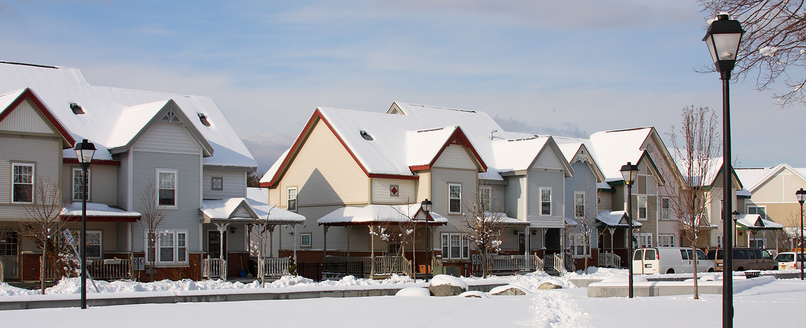

x
A Report to the Connecticut Energy Efficiency Board
Submitted by Evergreen Economics, Driftless Energy, and Michaels Energy
Kevin Price, John Flotterud, Hans Lehndorff
REVIEW DRAFT REPORT - April 18, 2023

Table of Contents
1 Abstract 1
2 Executive Summary 2
2.1 Overview of Approach 2
2.2 Heat Pump Water Heater Savings (kWh) 3
2.3 Ductless Air Source Heat Pump Effective Full Load Hours 3
2.4 Extreme Cold Day Usage Analysis 4
3 Introduction 6
3.1 Study Approach and Objectives 6
3.2 Sample Design and Final Dispositions 7
3.3 Analysis Methods 9
3.3.1 Heat Pump Water Heater Savings Estimation 9
3.3.2 Air Source Heat Pump Effective Full Load Hour Analysis 13
3.3.3 Extreme Cold Day Usage Analysis 17
3.3.4 Calculation of Confidence Intervals—Bootstrapping 18
4 Heat Pump Water Heater Savings 19
5 Ductless Air Source Heat Pump EFLH 22
6 Extreme Cold Day Usage Analysis 25
6.1 Heat Pump Water Heater Usage Does Not Change Much on Very Cold Days 25
6.2 Ductless Heat Pump Usage Increases Significantly on Very Cold Days 26
6.3 Ducted Air Source Heat Pump Usage Increases in the Afternoon on Very Cold Days 28
7 Conclusions and Potential Next Steps 29
7.1 PSD Assumption Updates 29
7.2 Heat Pump Operation on Extreme Cold Days 29
7.3 Next Steps 30
Appendix A: Energy Monitoring Approach 31
Protocol Development 31
Equipment Configuration and Technical Infrastructure Development 31
Recruitment 31
On-site Meter Installations 31
Appendix B: Ductless Heat Pumps by Capacity 33
Appendix C: Sample Points 34

Abstract

Connecticut’s 2022 Program Savings Document (PSD) requires continuous updating and relies on research and evaluation studies to provide updated inputs and methodologies to ensure utility energy efficiency program savings are estimated accurately.
This study, the Residential DHW/HVAC Performance and Potential Study, was designed to support PSD updates for heat pump-based DHW and HVAC equipment, only.
This study is based on monitoring the energy usage of key heat-pump based DHW and HVAC equipment at 149 homes across Connecticut. The study team installed energy monitoring equipment in homes from Fall 2021 into Spring 2022 and the equipment will remain installed and collecting data through Winter 2024. This study provides updates to heat pump water heater (HPWH) annual kWh savings estimates (for two measure tiers) and effective full load hour estimates for ductless air source heat pump heating and cooling savings calculations suitable for the PSD update.
Beyond providing direct updates to the PSD, this study provides insight about various drivers of usage and savings, and provides information on how these important electric energy efficiency measures are used during extreme winter weather conditions (i.e., when outdoor temperatures are very cold). The study will release a final report in Spring 2024 that will address next steps identified in this report as well as additional PSD assumption updates.
Table 1: Summary of PSD Assumption Updates
Objective | Parameter | Updated Estimate | Existing PSD Estimate
Estimate HPWH energy savings (kWh) | kWh Savings for 55 Gal + HPWHs (n=10) | 731 kWh | 197 kWh
 | kWh Savings for Below 55 Gal (n=64) | 1,723 kWh | 1,818 kWh
Estimate ductless air source heat pump heating effective full load hours (EFLH_{h}) in full displacement scenarios. | Ductless Heat Pump Heating EFLH (n=20) | 1,099 | 535

Executive Summary

The Connecticut Energy Efficiency Board (CTEEB) commissioned this DWH and HVAC Performance and Potential Study to provide engineering parameters to update existing assumptions in Connecticut’s 2022 Program Savings Document (PSD). These parameters are specific to the residential sector programs’ heat pump water heater (HPWH) and heat pump-based HVAC measures.
The objectives related to updating the Connecticut PSD were intended to be limited to incremental changes to specific parameter values given the existing savings calculation methodologies. During the study there have been significant changes in the policy context regarding the heat pump-based HVAC measures and the savings estimation methods in the PSD do not yet reflect these policy changes and new technological considerations (i.e., performance at very cold temperatures).
As such, a second study is already underway (the R2246 Residential Heat Pump Study) to help address the more fundamental savings methodology and heat pump performance characteristics that are not able to be addressed as part of this study.

Overview of Approach
The study involves the ongoing collection of electricity use at one-minute intervals for DHW and HVAC equipment across Connecticut. Participants were recruited from households that participated in a rebate program in 2019, 2020, or 2021 program years and received a rebate for a qualifying HPWH or heat pump-based HVAC measure (such as a ductless or ducted air source heat pump). The energy monitoring data itself is a project deliverable, as well as various analytical outputs. For this report, the focus is PSD update parameters for HPWHs and for ductless air source heat pumps (mini-splits). The study team aims to incorporate central ducted heat pump systems in a second report in 2024.
The program’s measure eligibility requirements during the 2018-2020 program years were different than for the current program. Heat pump water heater UEF requirements and heat pump efficiencies are lower in 2020 than they now are in 2023, and program requirements for heat pumps rebated in this study do not always meet the more rigorous ones instituted on January 1, 2023, that give enhanced rebates for systems that units provide the majority (or all) heating load in a residence or are installed in a partial-displacement scenario with integrated controls. In this study, participants were not screened out if their ductless heat pumps provided partial heating displacement only, with or without controls. Therefore, in presenting the results, it is necessary to make some adjustments in the sampled results to adjust for differences in efficiencies between the sampled units and current efficiencies, and to exclude sample points that would not be eligible for current enhanced incentives.

Heat Pump Water Heater Savings (kWh)
The HPWH PSD value the study evaluated as part of this study is the annual retrofit gross energy savings. HPWH savings estimates from this study and from the existing PSD are provided in Table 2, by measure tier. Compared to the existing PSD estimates, the currently available larger volume HPWHs save considerably more energy (731 kWh versus 197 kWh). This is due in part to the program requiring more efficient HPWHs in 2020 and presently than in the past. The average UEF of the water heaters in this study is 3.28 whereas the average UEF from the 2017 PSD is 2.68. The smaller volume HPWHs are estimated to save slightly less energy than the existing PSD assumption.
Table 2: Heat Pump Water Heater Savings by Tier
HPWH Tier | Updated Estimate | Existing PSD Estimate
55 Gal + (n=10) | 731 kWh | 197 kWh
Below 55 Gal (n=64) | 1,723 kWh | 1,818 kWh

Ductless Air Source Heat Pump Effective Full Load Hours
The study included metering of 87 ductless air source heat pumps (mini-splits), 56 of which are included in this analysis report. As noted, many of these units were not intended for full displacement and many of the partial displacement units did not have integrated controls. The existing PSD has only one heating and one cooling value for Effective Full Load Hours (EFLH) that does not distinguish by full or partial displacement. An adjustment to the PSD is needed that differentiates these intended uses of the equipment.
There is sufficient data to recommend the creation of a new PSD value for full displacement ductless mini split units. Our observed overall weather normalized heating EFLH of 1,099 full load hours in full-displacement scenarios is more than double the current PSD value of 535 full load hours. The study cannot make recommendations on what values to use for units with partial displacement and integrated controls, or units that only receive an upstream rebate. The study team recommends at this time that the 1,099 hours be used and that the PSD continue to use 218 hours for cooling savings for ductless air source heat pumps (mini-splits).
Table 3: Ductless Air Source Heat Pump EFLH Values
PSD Parameter | Updated Estimate | Existing PSD Estimate
Heating EFLH (n=20) | 1,099 | 535

This is the first report from the DWH and HVAC Performance and Potential Study; subsequent reports based on additional data will aim to both update this parameter and provide PSD parameter update recommendations for other measures where the sample sizes are currently too small to have meaningful results after one year of data collection. These additional measures include ducted air source heat pumps and ducted geothermal and water source heat pumps.

Extreme Cold Day Usage Analysis
The study team was asked to assess HPWH, ductless air source heat pump, and ducted air source heat pump usage on very cold days that resemble conditions when the grid might reach a system peak. The study compared usage during two cold days in February 2023, February 3 and February 4, to the month of February 2023 as a whole. Figure 1 shows the range of temperatures for each day in February 2023 at the Hartford, CT, weather station. The days identified as having peak like conditions had lower low temperatures than the other days in the month.
Figure 1: Daily Temperature Range in Hartford
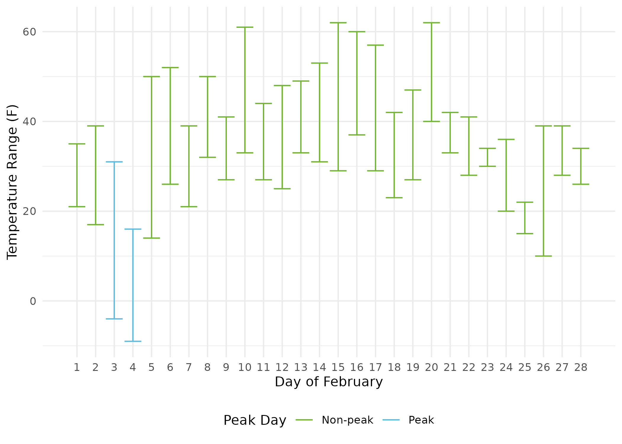
For HPWHs, we observed moderate increases in electricity usage during the morning and evening hot water peaks, but it remains unclear if this is due to HPWH performance during cold weather or due to human behaviors (e.g., longer, warming showering).
With respect to heating equipment frequency and duration of use, the study team observed a direct correlation between extreme outdoor air temperatures and increased usage of electricity. The study team found that depending on the hour, ductless heat pumps used between 150 percent and 216 percent more electricity on the extremely cold days relative to typical winter days. Because the study team are only tracking electricity, these electricity curves cannot tell us about the use of back-up sources, nor at what effectiveness heat pumps performed.
For ducted systems, the study team also found that these systems did not use more electricity on these two cold nights than they did on the average winter night or in the early morning hours but did use considerably more electricity in the middle of the day and evenings on the coldest days than they did on typical winter days (for only the compressor electricity use). This indicates that these homes may have been using some form of backup energy during these cold periods.

Introduction

The Connecticut Energy Efficiency Board (CTEEB) commissioned this Residential DHW/HVAC Performance and Potential Study (R1982) to provide engineering parameters to update existing assumptions in Connecticut’s Program Savings Document (PSD). These parameters are specific to the residential sector programs’ heat pump water heater (HPWH) and heat pump-based HVAC measures.
The R1982 study was originally envisioned as a study representative of all residential DHW and HVAC equipment in Connecticut but was later refined to focus primarily on PSD updates for heat pump-based DHW and HVAC equipment. The study plans were further updated due to the COVID-19 pandemic which reduced the overall on-site data collection effort so that the site assessment and monitoring equipment installation could be achieved by a single electrician on-site (instead of an electrician and an energy efficiency engineer).
The objectives related to updating the Connecticut PSD were intended to be limited to incremental changes to specific parameter values given the existing savings calculation methodologies. During the study there have been significant changes in the policy context regarding the heat pump-based HVAC measures and the savings estimation methods in the PSD do not yet reflect these policy changes and new technological considerations (i.e., performance at very cold temperatures).
As such, a second study is already underway (the R2246 Residential Heat Pump Study) to help address the more fundamental savings methodology and heat pump performance characteristics that are not able to be addressed as part of this study.

Study Approach and Objectives
To assess existing PSD measure savings parameters, the study team collected extensive energy usage data from recent program participant homes.
This study is based on monitoring the energy usage of key heat-pump based DHW and HVAC equipment at 149 homes across Connecticut. The study team installed energy monitoring equipment in homes from Fall 2021 into Spring 2022 and the equipment will remain installed and collecting data through Winter 2024. The collected data include one minute-level interval electricity usage (wattage) for targeted equipment types such as HPWHs and ductless air source heat pumps. Evergreen compiled the usage data in a database, along with descriptive measure and household parameters for analysis.
Through numerous discussions and iteration with members of the Connecticut Energy Efficiency Board (EEB), the R1982 study’s objectives were refined into the following list.
Objective 1: Estimate HPWH energy savings (a direct PSD input).
Objective 2: Estimate ductless air source heat pump heating and cooling effective full load hours for ductless heat pumps installed as the only or primary heating source in a home (direct PSD inputs).
Objective 3: Estimate ducted air source heat pump, and ground source heat pump heating effective full load hours (direct PSD inputs); assess whether and how to integrate cooling effective full load hours into a future PSD measure and provide relevant assumptions.
Objective 4: Assess to what degree the studied equipment types are used differently during very cold winter peak conditions.
Importantly, this study is not tasked with developing full new PSD measures for any of the studied equipment types, but rather intended to either increase confidence in existing assumptions or provide new estimates for these assumptions.
The study will release a final report in Spring 2024 that will address next steps identified in this report as well as additional PSD assumption updates. The study will also provide input regarding the measure savings calculations themselves as well as additional information for future evaluation work (e.g., measure parameters by climate zone).

Sample Design and Final Dispositions
Table 4 provides initial study targets by end use and climate zone, allocating the total sample points proportional to the population from the R1706 Connecticut Residential Appliance Saturation Survey (RASS) completed in October 2019. The intent was to make sure both climate zones are represented in the sample for each end use category.
Table 4: Initial Targets by Climate Zone
End Use | Coastal | Inland | Overall
Ducted Heat Pumps (ASHP and GSHP) | 22 | 38 | 60
Ductless Air Source Heat Pumps | 21 | 29 | 50
Heat Pump Water Heaters | 12 | 28 | 40
Total | 55 | 95 | 150

The study team identified that the total of 65 viable contacts with ducted heat pumps from the 2018-2020 program period would be insufficient to achieve our original target. The study team attempted to recruit 2020 program participant contacts first, with 2019 and earlier program participants as a fallback.
The program’s measure eligibility requirements during the 2018-2020 program years were different than for the current program. Heat pump water heater UEF requirements and heat pump efficiencies are lower in 2020 than they now are in 2023, and program requirements for heat pumps rebated in this study do not always meet the more rigorous ones instituted on January 1, 2023, that give enhanced rebates for systems that units provide the majority (or all) heating load in a residence or are installed in a partial-displacement scenario with integrated controls. In this study, participants were not screened out if their ductless heat pumps provided partial heating displacement only, with or without controls. Therefore, in presenting the results, it is necessary to make some adjustments in the sampled results to adjust for differences in efficiencies between the sampled units and current efficiencies, and to exclude sample points that would not be eligible for current enhanced incentives.
Ultimately the study team exhausted the viable sample frame for the ducted heat pumps and allocated more points to ductless heat pumps and heat pump water heaters. Table 5 provides details regarding the achieved sample of monitored end uses by climate zone and overall. The study team have included the measure tiers for HPWHs and a breakout of ductless heat pumps by heating displacement and provide both the overall achieved sample and the sample with sufficient data to include in this analysis. The second report is expected to use most of the sample frame as all sites and end uses are expected to have more than one year of data. The study team may, however, determine that the ductless heat pumps installed as supplemental sources of heating are no longer relevant in the current program context (although the study team will consider using the data to inform updated baseline assumptions).
Table 5: Monitored End Uses by Climate Zone
End Use | Total |  |  | Included in Current Analysis
 | Coastal | Inland | Overall | Coastal | Inland | Overall
HPWHs 55 Gal + | 3 | 10 | 13 | 2 | 8 | 10
HPWHs Below 55 Gal | 27 | 53 | 80 | 19 | 45 | 64
Ductless Air Source Heat Pumps (only/primary heat source) | 17 | 23 | 40 | 8 | 12 | 20
Ductless Air Source Heat Pumps (supplemental heat source) | 24 | 23 | 47 | 16 | 20 | 36
Ducted Heat Pumps (ASHP and GSHP) | 9 | 24 | 33 | 0 | 0 | 0

Analysis Methods
This section describes the analysis methodology used in for the R1982 Residential DHW/HVAC Performance and Potential Study. Analysis outputs for both HPWH and heat pumps start with the full metering data which has undergone rigorous QC. The data collection effort utilized the eGauge platform and captured true RMS power (kW) data averaged to minute data. The eGauge relies on wired current transducers installed on dedicated circuits within a home’s electrical panel.

Heat Pump Water Heater Savings Estimation
The primary deliverable for HPWHs is the estimated savings for each of the two HPWH sizes as outlined in the CT PSD based on the study participants.

HPWH Savings Methodology
The study captured the energy consumption of HPWHs and the nameplate data including the efficiency of each unit as Uniform Energy Factor (UEF). The baseline energy usage was calculated using an adaptation of the methodology contained in the Energy Star HPWH savings calculator (available as an Excel file for download). The baseline efficiency for the less than 55 gallons is also defined by Energy Star as electric resistance with an UEF of 0.945. For units larger than 55 gallons a Federal Standard sets the baseline as a minimum compliant HPWH with an UEF of approximately 2.0, depending on the tank volume and draw pattern. An overview of the process for calculating HPWH savings is shown in Figure 2. The first two steps are described in the HPWH Data Preparation and Cleaning section and the other steps in the HPWH Savings Calculations section.
Figure 2: Overview of HPWH Data Preparation and Savings Calculation Method
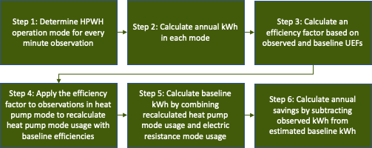

HPWH Data Preparation and Cleaning
The first step in our savings calculation process is to determine the usage mode (electric resistance, heat pump, standby) of every minute-level observation for every HPWH in the study.
As a starting point, the study team used change point analysis to determine the major transition points in energy usage for each unit. The study team then manually reviewed the outputs to ensure they aligned with observed energy usage and expected usage patterns. Figure 3 shows the result of this process for a single HPWH from March of 2022. Our process identified that usage above 4,550 W (1.32% of observations) was indicative of electric resistance mode (green), while usage between 100 W and 458 W (19.67% of observations) was indicative of heat pump mode (dark blue). The rare usage between 458 W and 4,550 W (0.04% of observations) is indicative of partial minutes where the electric resistance element is active (gray). For analysis purposes, these observations were categorized as electric resistance usage. Finally, usage below 100 W (78.97% of observations) was deemed to be representative of the HPWH being in standby/off mode (light blue).
Figure 3: Energy Usage by Mode for a Single HPWH
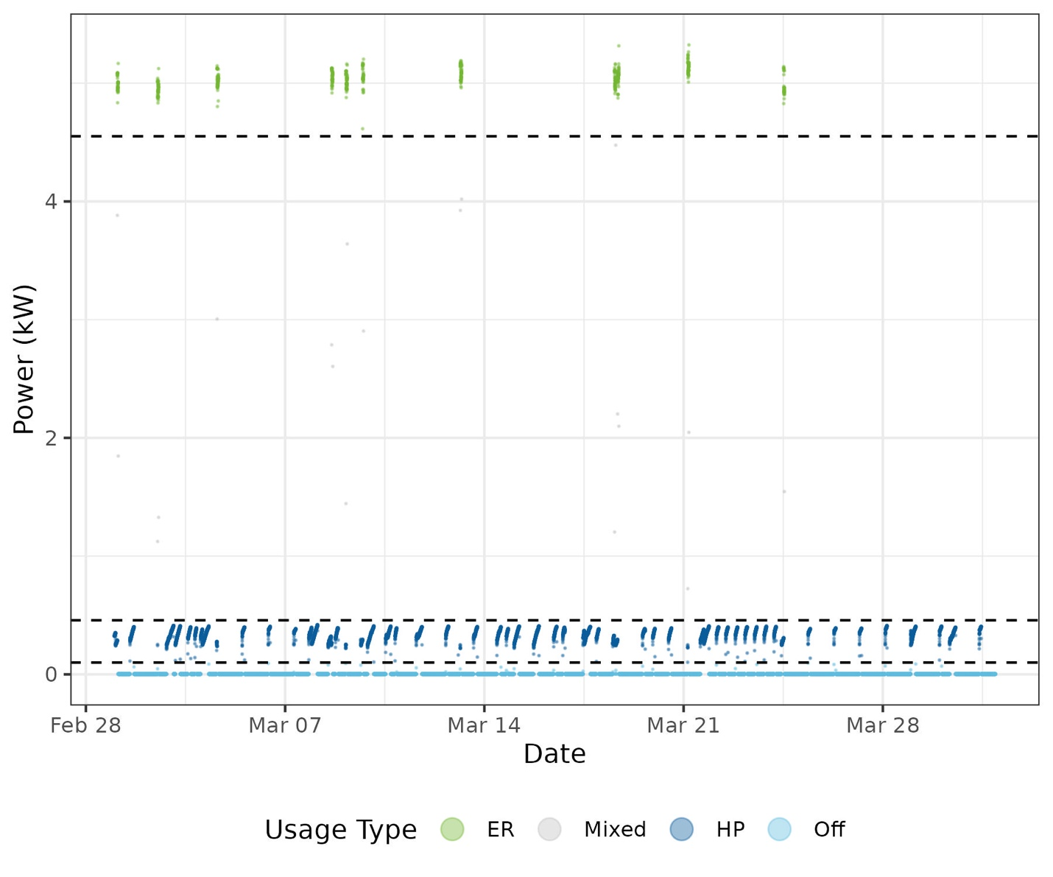
After calculating the usage mode for each minute in the analysis dataset, the study team then aggregated the dataset to calculate the number of observations and average power for each type of usage for each season for each HPWH. Only HPWHs with data for at least 30 percent of each season (winter, spring, summer, and fall) were retained for analysis.

HPWH Savings Calculations
To calculate savings, the study team first isolated observed heat pump kWh (from electric resistance kWh) and calculated annualized heat pump kWh estimates for each HPWH in the study. The study team then develop an efficiency factor using Equation 1 where the efficiency factor serves as a percent improvement over baseline. Importantly, the UEF_{installed} value is the actual UEF of the monitored HPWH. The UEF_{baseline} is the assumed UEF of the baseline measure, which is 2.0 for large HPWHs and 0.945 for small HPWHs; the result is that the efficiency factor is greater for the smaller tanks because the baseline is a much less efficient electric resistance storage water heater.
Equation 1: HPWH Heat Pump Efficiency Factor Calculation
$$HPWH Efficiency Factor=\frac{({UEF}_{installed}-{UEF}_{baseline})}{{UEF}_{baseline}}$$
The study team next calculate the energy consumption of the baseline equipment, holding constant the amount of heat delivered to the water heater, only adjusting for the lower efficiency of the baseline equipment. As Equation 2 shows, the observed heat pump kWh (HP kWh_{observed}) is multiplied by the efficiency factor and then add the observed electric resistance kWh (ER kWh_{observed}) to estimate baseline kWh for each HPWH.
Equation 2: HPWH Baseline Energy Use Calculation
$$Baseline kWh=({HP kWh}_{observed}×HPWH Efficiency Factor)+{ER kWh}_{observed}$$
To calculate HPWH savings, shown in Equation 3, the Installed kWh (from the summarized energy monitoring data) is subtracted from the Baseline kWh estimated in Equation 2.
Equation 3: HPWH Savings Calculation
$$HPWH Savings kWh=Baseline kWh-({HP kWh}_{observed}+{ER kWh}_{observed})$$
The study team then analyzed unit-by-unit savings results based on a variety of factors including climate zone (coastal/inland), tier (less than 55 gallons, 55 gallons and above), and household occupancy.

HPWH Savings Methodology Limitations
This is how efficiently the water heater converts electricity into hot water and is not reported by manufacturers. Federal UEF ratings are somewhat imperfect in this regard because some HPWHs approach uses the rated UEF of each water heater as a proxy for coefficient of performance, (COP), which may operate in electric resistance mode during certain portions of the federal test procedure, leading to a UEF that is partly electric-resistance based. It is not known how often this occurs. To the extent that it does, however, it would tend to understate savings here.

Air Source Heat Pump Effective Full Load Hour Analysis
The primary deliverable for ducted and ductless air source heat pumps are weather normalized heating EFLH and cooling EFLH to update the existing PSD values. For this report, due to a small sample size of ducted air source heat pumps with sufficient data for analysis, the study team are only providing the methodology and results for the ductless air source heat pumps (although the methods are very similar).

Ductless Air Source Heat Pump EFLH Methodology
The study team directly monitored the electricity usage of the ductless air source heat pumps and captured each heat pump’s performance specifications (i.e., the rated heating and cooling capacities and seasonal efficiencies SEER and HSPF). The effective full load hours of each heat pump are calculated using the same methodology as outlined in the PSD. This methodology defines ductless heat pump annual heating and cooling energy usage as the following:
Equation 4: Ductless Air Source Heat Pump Energy Usage Calculations
$${kWh Heating}_{observed}={Heating Capacity}_{BTUs} ×\left(\frac{1}{HSPF}\right) ×{EFLH}_{h} × \frac{1 kW}{1,000 W}$$
$${kWh Cooling}_{observed}=C{ooling Capacity}_{BTUs} ×\left(\frac{1}{SEER}\right) ×{EFLH}_{c} × \frac{1 kW}{1,000 W}$$
The EFLHs were calculated by reordering the equations and inputting the metered energy usage of each heat pump while in either heating or cooling mode along with the heat pump specifications in their appropriate locations in the equation (see Equation 5). This approach results in EFLHs developed based on the PSD methodology and the heat pump specification information readily available to the program.

Ductless Air Source Heat Pump Data Preparation and Cleaning
Our first step in calculating EFLH was to determine whether observed usage of each unit was indicative of heating or cooling. The study team first aggregated the metering data to the hourly level and added in hourly temperature data from a nearby weather station. Figure 4 shows energy usage by temperature for a single heat pump, colored by season.
Figure 4: Ductless Air Source Heat Pump Usage by Temperature
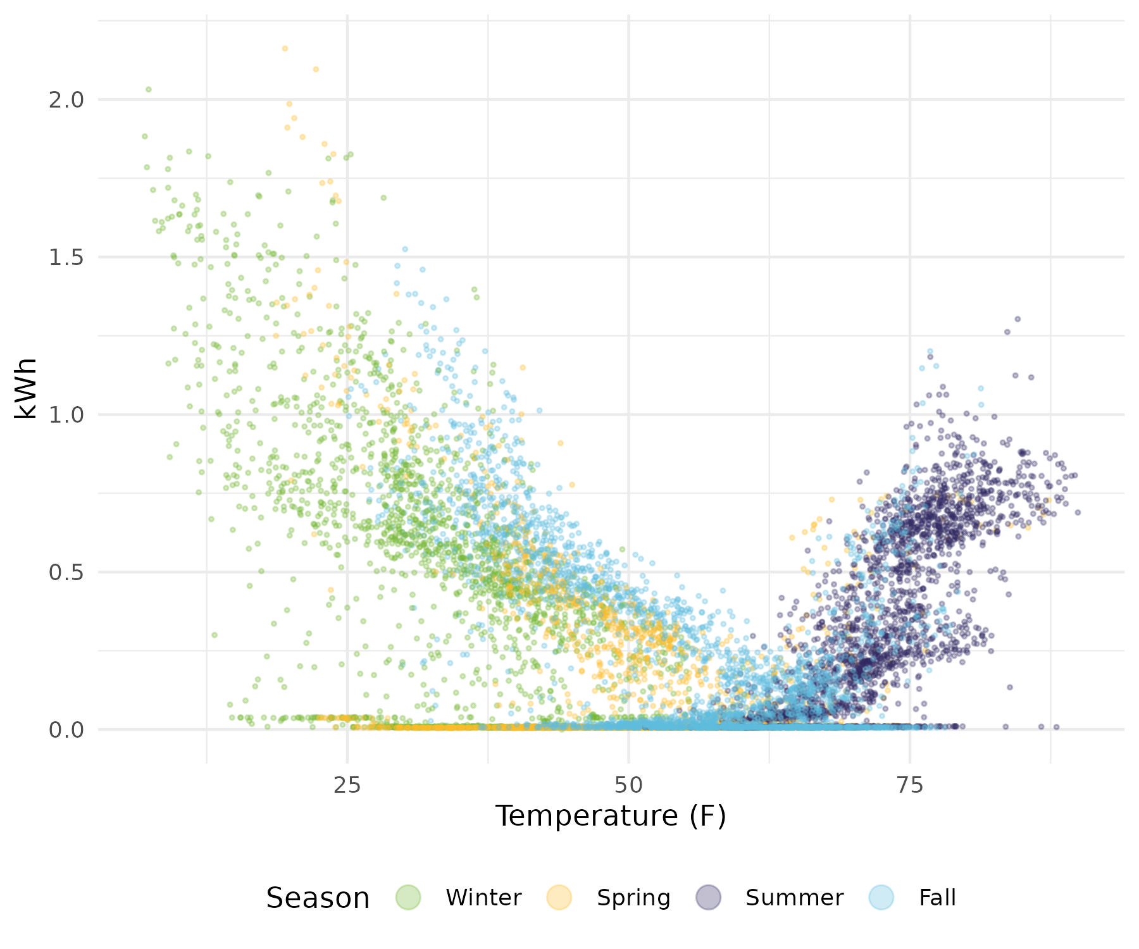

Next, the study team charted average hourly usage by temperature for each season for each heat pump and determined the temperature at which usage is the lowest. This low point is then assumed as the switchover temperature for that home. Usage in hours above these temperatures was determined to be cooling while usage in hours below these temperatures was determined to be heating.
Figure 5 shows the average usage at a given temperature. In this example, spring usage is the lowest when it is 61.59°F outside. Therefore, usage observed in the spring when the temperature is above 61.59°F is considered cooling, while usage observed below this temperature is considered heating. While this is a reasonable approach it does leave the possibility for some classification inaccuracy.

Figure 5: Determination of Ductless Air Source Heat Pump Heating/Cooling Temperature Threshold
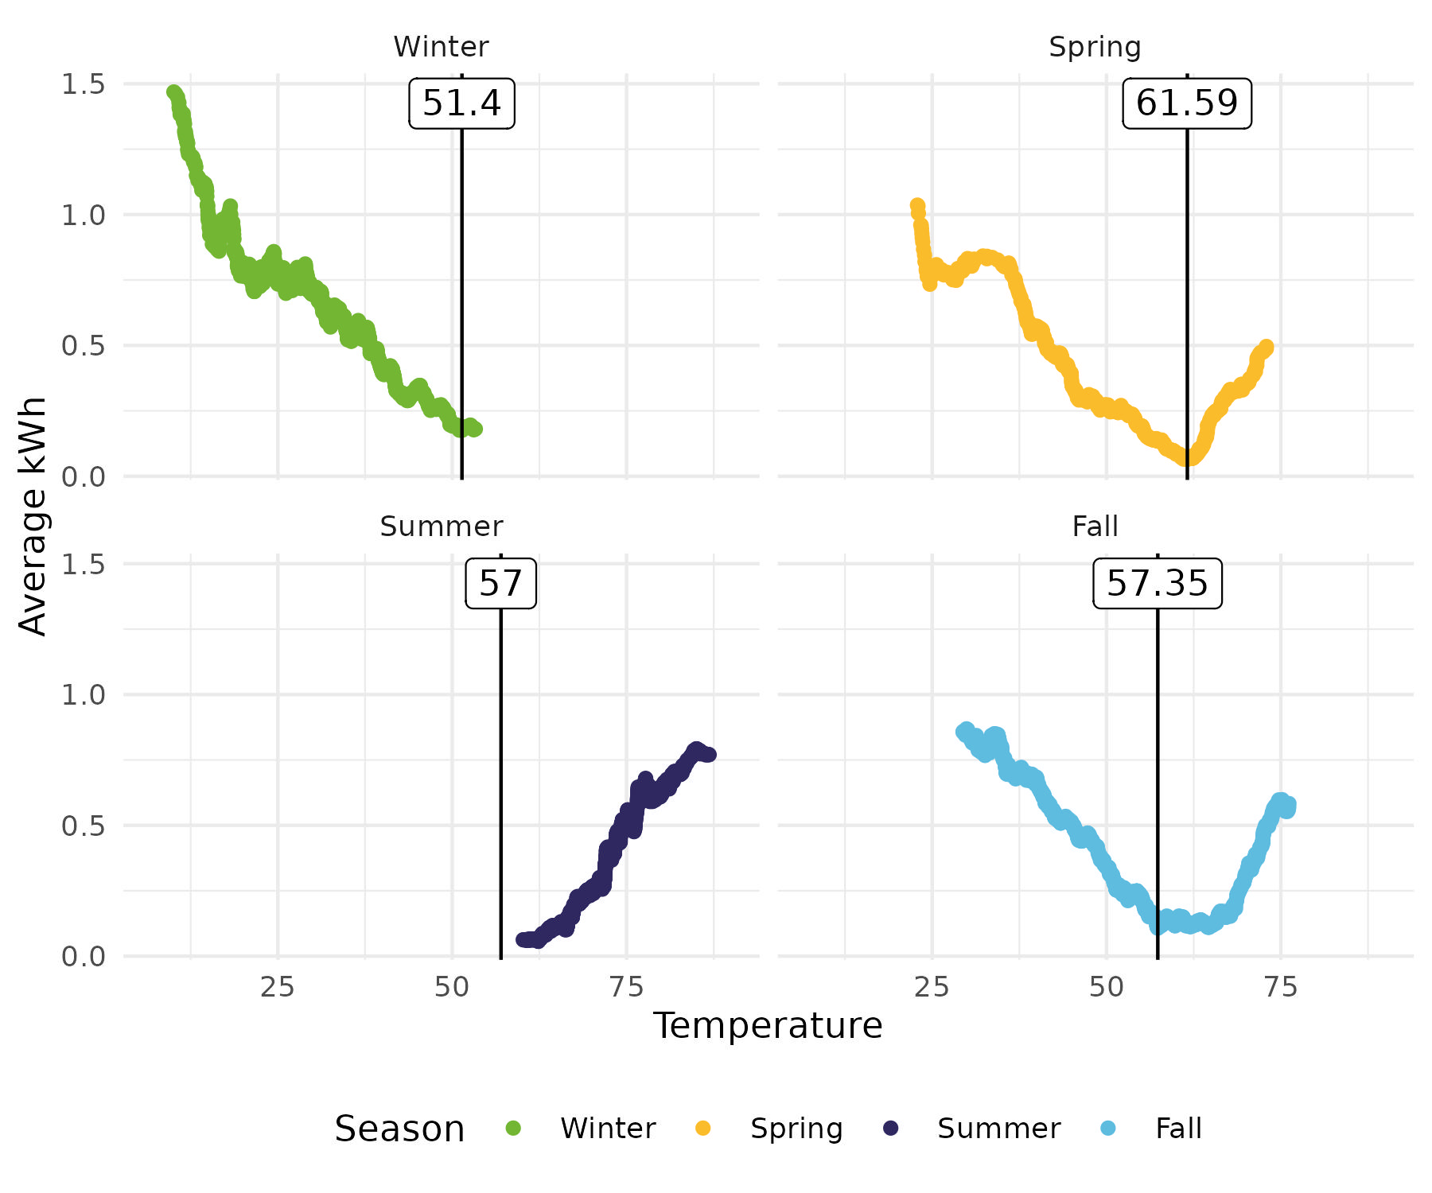

Ductless Air Source Heat Pump EFLH Calculations
To calculate EFLH, the study team first calculated kWh associated with heating and with cooling for each season for each ductless air source heat pump in the study. Only ductless heat pumps with data for at least 30 percent of each season were retained for analysis. Next, the study team did a careful review of the specification for each heat pump in the analysis based on model number to ensure the accuracy of capacity values, HSPF values, SEER values and equipment type.
Ductless air source heat pump heat pump electricity usage (kWh) was weather normalized to represent the typical weather year (TMY3). To do this, the study team took the actual, daily observed kWh used for heating and cooling and modeled it as a function of heating degree days (HDD), cooling degree days (CDD), and day of the week, for each ductless air source heat pump for each season in the analysis. The study team then used that model to predict the electricity usage (kWh) for heating and cooling for each day of the TMY3 conditions and then aggregated to seasonal totals.
The study team then calculated weather normalized heating EFLH and cooling EFLH for each unit. Equation 5 shows how these values were calculated for each unit.
Equation 5: Calculation of Heating EFLH and Cooling EFLH
$${EFLH}_{h}=\left({kWh Heating}_{observed}×1,000\frac{W}{kW}×HSPF\right)÷{Heating Capacity}_{BTUs}$$
$${EFLH}_{c}=\left({kWh Cooling}_{observed}×1,000\frac{W}{kW}×SEER\right)÷{Cooling Capacity}_{BTUs}$$
Unit-by-unit EFLH values were then analyzed based on a variety of factors including region (coastal/inland), and capacity (heating and cooling respectively). The study team also analyzed ductless heat pumps based on whether they were the only heating system, primary heating systems, or secondary heating system in a home.

Air Source Heat Pump EFLH Methodology Limitations
The approach outlined above is based on the PSD methodology and the program design at the time of the study design in 2020. The PSD methodology has not changed but the program and federal changes have had significant changes starting January 1, 2023. Federal standards have changed to a SEER2 and HSPF2 rating as well as a 5°F capacity and efficiency rating in addition to the existing 47°F and 17°F rating conditions. The program has changed to require the heat pumps to be offsetting an existing heat source and if the existing heat source remains it must have integrated controls. The heat pumps must also meet the cold-climate designation as defined by Energy Star 6.1.
The sample design from 2020 was not designed to account for all these changes; however, data was collected on the heat pumps used as the only source of heating, primary heating, and for supplemental heating. It is presumed that the new program rules would require all the heat pumps to be the only or primary source of heating. The findings of this study have been adjusted to reflect these heat pump use cases to allow the data to be meaningful for the program going forward.
During this study, it has become apparent that the PSD approach outlined above is going to be inadequate to define heat pump savings for the program in the future. The program is looking to compare heat pumps to alternative baselines such as fossil fuel furnaces or electric resistance. The newest cold-climate heat pumps also have improved capacity ratings at the lowest temperatures compared to historical heat pumps, meaning the study team would expect different operating hours at lower temperatures for cold climate heat pumps as they continue to operate efficiently at these lower temperatures (compared to historical heat pumps). This is important because the average capacity of a historical heat pump at 17°F is on average about 60 percent of its rated capacity at 47°F. This means that a historical heat pump would have to run 1.67 hours to achieve the same heating output as it does in one hour at 47°F. The newer cold-climate heat pump capacities do not decline as much with outdoor temperatures, and thus their run times to produce the same heat output during particularly cold days would be lower than their historical counterparts.
What this means is the current PSD methodology and EFLHs are not appropriate for comparison between other heating technologies and potentially the newest cold-climate heat pumps. Additional research is needed to identify an adequate approach for the program to compare cold climate heat pumps to non-heat pump baseline heating sources.

Extreme Cold Day Usage Analysis
The study team was tasked with assessing heat pump usage on very cold days to develop a better understanding of their operation during potential grid peak events. To accomplish this, the study team sought to isolate a small number of particularly cold days and compare heat pump usage on those days to more normal winter conditions.
The study team identified Friday February 3, 2023, and Saturday February 4, 2023, as especially cold days across Connecticut relative to other days during Winter 2022-23. Figure 1 shows the range of temperatures for each day in February 2023 at the Hartford, CT, weather station. The days identified as having peak like conditions had lower low temperatures than the other days in the month.
Figure 6: Daily Temperature Range in Hartford
Observations from February 3 were weighted to represent all weekdays (a weight of 20 for the number of weekdays in February 2023), while observations from February 4 were weighted to represent all weekends (a weight of 8 for the number of weekend days in the February 2023).
Next, the study team calculated the weighted average load shape based on average hourly kWh for each end use during the cold days. Then the study team calculated the average load shapes (unweighted) for the month of February. The analysis compares load shapes on a representative cold day in February to the usage observed on the average day in February for each end use.

Calculation of Confidence Intervals—Bootstrapping
Throughout this report, the study team have provided 95 percent confidence intervals around key metrics. The study team used a bootstrapping method to calculate the confidence intervals. For this report, the study team took 10,000 random samples of population size for each relevant dataset and calculated the key metric (either average savings or average EFLH). Our confidence intervals reflect the middle 95 percent of the replication means.

Heat Pump Water Heater Savings

The heat pump water heater (HPWH) PSD value the study team evaluated as part of this study is the annual retrofit gross energy savings. The PSD currently bases savings on the R1614/R1613 HVAC and Water Heater Evaluation, but HPWH options since 2020 are more efficient than they were at the time of that evaluation (2017) and updating savings estimates with data that reflects the efficiencies of today’s HPWH rebate program is important for ensuring the programs account for all gross savings. Heat pump water heater energy usage and savings are driven largely by hot water usage (and thus household size) and how much of the water heating load is derived from the water heater’s heat pump versus its resistance heating element.
HPWHs are split into two measure categories based on tank size. This split is appropriate because existing federal water heating standards impact the available alternatives for larger electric storage water heaters such that traditional electric resistance storage water heaters are generally unavailable for purchase and installation in most residential settings.
As a result, the savings analysis is conducted against different baseline assumptions. Smaller tank HPWHs (below 55 gallons) have an electric resistance water heater baseline with a UEF of 0.945, while larger HPWHs 55 gallons and above have a baseline of a code-compliant HPWH with a UEF of 2.0. Since the baseline for the larger tanks is more efficient than the baseline for the smaller tanks, the study team expected to observe greater savings for the smaller HPWHs.
HPWH savings by measure tier and by climate zone are provided in Table 6. Compared to the existing PSD estimates, the currently available larger volume HPWHs save considerably more energy (731 kWh versus 197 kWh). This is due in part to the program requiring more efficient HPWHs in 2020 and presently than in the past. The average UEF of the water heaters in this study is 3.28 whereas the average UEF from the 2017 PSD is 2.68. Importantly, the study team is unable to assess the validity of the existing PSD estimate of 197 kWh savings because there is no source for this value. The study team reviewed the value in Massachusetts’ eTRM and found that the measure assumptions are nearly identical to the existing PSD measure and baseline assumptions, but that savings are estimated at 360 kWh for large HPWHs. This compares more favorably to our estimate, which assumes a significantly higher UEF of approximately 3.30 compared to the historical UEF of approximately 2.70.
Despite the increase in UEF requirements for all HPWHs, the smaller volume HPWHs are estimated to save slightly less energy than the existing PSD assumptions. Table 7 provides the 95 percent confidence intervals around the average values in Table 6.
Table 6: Heat Pump Water Heater Savings by Tier and Climate Zone
HPWH Tier | Coastal (n=21) | Inland (n=53) | Average | Current PSD Estimate
55 Gal + (n=10) | 594 kWh | 766 kWh | 731 kWh | 197 kWh
Below 55 Gal (n=64) | 1,619 kWh | 1,767 kWh | 1,723 kWh | 1,818 kWh

Table 7: Heat Pump Water Heater Savings 95% Confidence Intervals by Tier and Climate Zone
HPWH Tier | Coastal (n=21) | Inland (n=53) | Average
55 Gal + (n=10) | 338-850 | 489-1,044 | 503-968
Below 55 Gal (n=64) | 1,351-1,870 | 1,553-1,988 | 1,554-1,901

The study team estimate coastal and inland savings by tier so that future program evaluations may be able to re-weight the program average savings based on the actual distribution of HPWHs installed with program support.
Figure 7 provides the same information as in Table 6, while also showing our estimated baseline energy usage and the installed energy use of the monitored HPWHs. As shown, the baseline energy usage is similar across the two measure tiers because of the different baseline assumptions; larger tanks do use more energy than smaller tanks of the same type, but the baseline assumptions are responsible for a significant difference in savings potential for the two tiers. Observed usage (in blue) is approximately double for larger HPWHs than smaller HPWHs, and given the similar baseline usage, the smaller tanks save considerably more energy over baseline than the larger HPWHs.
Figure 7: Heat Pump Water Heater Savings Derivation by Tier and Climate Zone
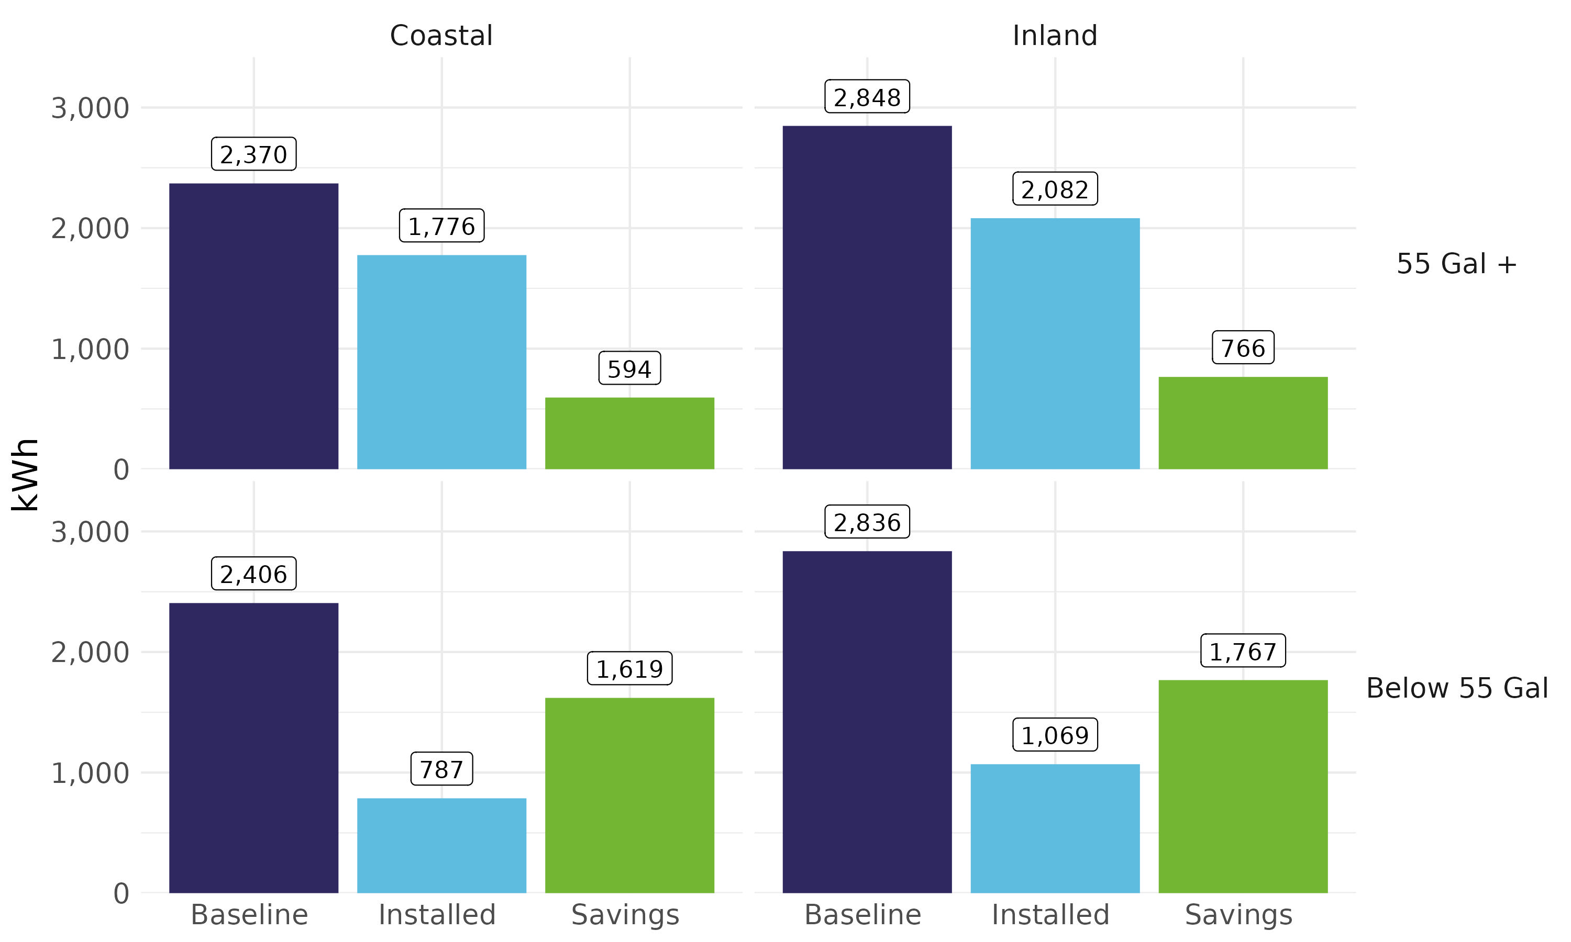

The HPWH measures supported by the program all deliver savings. However, as the baseline measures continue to increase in efficiency due to external factors (in this case, due to Federal appliance standards especially), the program can continue to push the program minimum qualifying UEF to drive savings over baseline.

Ductless Air Source Heat Pump EFLH

The ductless air source heat pump PSD values the study team evaluated include both the heating and cooling effective full load hours (EFLH). Ductless air source heat pumps provide both heating and cooling and can be used as the only or primary heating/cooling source in a home or to provide supplemental heating/cooling for specific spaces.
The PSD bases savings on findings from the Ductless Mini-split Heat Pump Impact Evaluation from 2016 and retrofit savings are estimated using an assumed EFLH and input parameters specific to the installed ductless air source heat pump. Since the input parameters are specific to the actual installed measure and are known to the program, the PSD assumption that the study team evaluated is the EFLH for heating and for cooling.
Table 8 provides the observed overall weather normalized heating and cooling EFLH values for ductless air source heat pumps from the entire study sample. The heating EFLH of 683 full load hours is 28 percent higher than the assumed PSD value of 535 full load hours. The overall average cooling EFLH is estimated to be 457 full load hours. This is more than double the current PSD estimate of 218 full load hours. Table 9 provides the confidence intervals for the values in Table 8.
Table 8: Ductless Air Source Heat Pump EFLH Values
Parameter | R1982 Estimate | Existing PSD Estimate
Heating EFLH (n=62) | 817 | 535
Cooling EFLH (n=62) | 410 | 218

Table 9: Ductless Air Source Heat Pump EFLH 95% Confidence Intervals
Parameter | R1982 Estimate
Heating EFLH (n=62) | 648-993
Cooling EFLH (n=62) | 317-513
However, due to the changing nature of the program requirements, the most relevant updated value this study can provide for the PSD for ductless air source heat pumps is for the measures installed to fully displace existing heating systems. The study breaks out only/primary heating systems from supplemental heating systems as the current program offering is focused on the full-displacement scenarios, or scenarios of partial displacement with advanced control strategies (which this study is unable to address). Table 10 provides weather normalized heating EFLH values for ductless air source heat pumps in these only/primary heating system applications by climate zone and overall (in bold in the first row), as well as weather normalized EFLH values for supplemental heating scenarios. Table 11 provides the 95 percent confidence intervals around the average values in Table 10.
Table 10: Ductless Air Source Heat Pump Heating EFLH by Displacement and Climate Zone
Displacement | Coastal (n=24) | Inland (n=32) | Average | Existing PSD Estimate
Only/Primary Heating System (n=20) | 1,124 | 1,081 | 1,099
Supplemental Heating System (n=36) | 555 | 773 | 676
Overall (n=56) | 745 | 889 | 827 | 535

Table 11: Ductless Air Source Heat Pump Heating EFLH 95% Confidence Intervals by Displacement and Climate Zone
Displacement | Coastal (n=24) | Inland (n=32) | Average
Only/Primary Heating System (n=20) | 796-1,400 | 758-1,464 | 863-1,350
Supplemental Heating System (n=36) | 287-857 | 459-1,110 | 459-911
Overall (n=56) | 508-989 | 652-1,139 | 654-1,008

Table 12 provides weather normalized cooling EFLH values based on the heating displacement to better understand how driving full heating displacement installations (via program rebates) will impact usage of ductless heat pumps for cooling. As shown, there is less variation in the overall cooling EFLH values based on heating displacement. Table 13 provides the average confidence intervals around the average values in Table 12.
Table 12: Ductless Air Source Heat Pump Cooling EFLH by Heating Displacement and Climate Zone
Displacement | Coastal (n=24) | Inland (n=32) | Average | Existing PSD Estimate
Only/Primary Heating System (n=20) | 585 | 228 | 371
Supplemental Heating System (n=36) | 505 | 433 | 465
Overall (n=56) | 532 | 356 | 432 | 218

Table 13: Ductless Air Source Heat Pump Cooling EFLH 95% Confidence Intervals by Heating Displacement and Climate Zone
Displacement | Coastal (n=24) | Inland (n=32) | Average
Only/Primary Heating System (n=20) | 313-975 | 163-302 | 239-558
Supplemental Heating System (n=36) | 308-731 | 273-619 | 335-606
Overall (n=56) | 363-728 | 249-487 | 331-544

Extreme Cold Day Usage Analysis

The study team was asked to assess HPWH, ductless air source heat pump, and ducted air source heat pump usage on very cold days that resemble conditions when the grid might reach a system peak. This is an exploratory analysis to better understand how a shift towards these heat pump-based electric DHW and HVAC equipment types might impact the grid during extreme conditions.

Heat Pump Water Heater Usage Does Not Change Much on Very Cold Days
Hot water use in a home is less directly correlated with outdoor air temperatures than heating equipment use. While it is possible that some households do use more hot water on very cold days (e.g., warmer showers), it is unlikely that the frequency of use or the duration of use is directly linked to colder outdoor air temperatures. Conversely, heating equipment frequency and duration of use is directly correlated with outdoor air temperatures. As such, the study team would expect HPWH usage patterns on very cold days to resemble usage on a normal winter day (assuming the water heater is installed in a conditioned or semi-conditioned space, which is appropriate in Connecticut as the water heaters are designed to work in spaces of 40°F and above). Also of note, brief cold-weather events have minimal (if any) impact on inlet water temperatures.
Figure 8 shows that HPWH usage on very cold days (shown as the blue line) is very similar to HPWH usage on normal winter days (shown as the green line). There are two notable times when there is an indication that the usage is higher on cold days: the morning and evening peaks (8am-10am and 8pm, respectively). This difference, especially during the three hours in the morning, is either indicative of different household behaviors on very cold days (e.g., longer, warmer showers) or due to lower ambient temperatures in the space surrounding the HPWH leading to increased usage either in heat pump or resistance mode. The usage results are not able to distinguish between these two potential sources of different overall usage and may be an opportunity for further research—monitoring ambient space temperatures and water draw temperatures and volumes would be required but were out of scope for the R1982 study.

Figure 8: Heat Pump Water Heater Usage on Very Cold Days Versus Regular Winter Days (n=77)
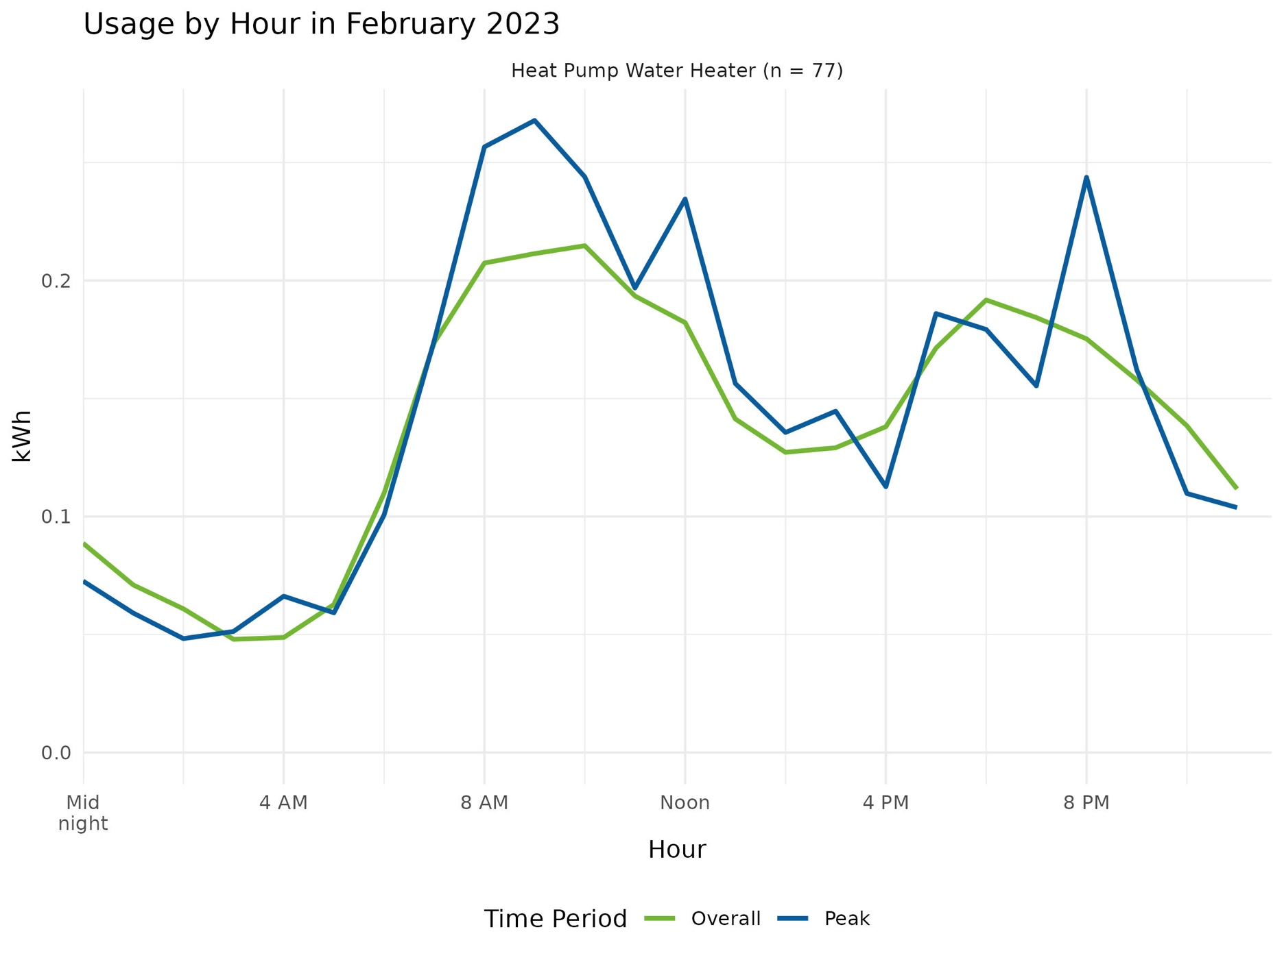

Ductless Heat Pump Usage Increases Significantly on Very Cold Days
Ductless heat pumps are used significantly more on very cold days compared to normal winter days, and this difference persists during all hours of the day and night. In the overnight hours, the study team observed a nearly 150 percent increase in usage, and during the daytime and evening hours, the study team observed an approximately doubling of usage (216 percent). Households who use their ductless heat pump as the only source of heat, the primary source of heat, or as supplemental sources of heat all contributed to this increase; when it is cold, ductless heat pumps are used more frequently.
If the ductless heat pumps installed as retrofit measures are replacing or supplementing electric resistance heating sources (i.e., electric baseboards or an electric furnace), then this would need to be compared to usage of such baseline electric HVAC technologies during extremely cold days to assess whether the heat pump is delivering savings at these extreme conditions. Our assumption is that the less efficient baseline technologies would have also been used more during extremely cold days to provide heat, and thus the more efficient ductless heat pumps should lead to reductions in energy use during these more extreme weather events.
However, if the measures are replacing or offsetting usage from natural gas or delivered fuel heating sources such as boilers and furnaces, these ductless heat pumps would cause increases in overall daily electric usage during these extremely cold days. Therefore, the peak impacts of the ductless heat pump measures are directly related to baseline assumptions regarding what the heat pumps are replacing.
Figure 9: Ductless Air Source Heat Pump Usage on Very Cold Days Versus Regular Winter Days (n=74)
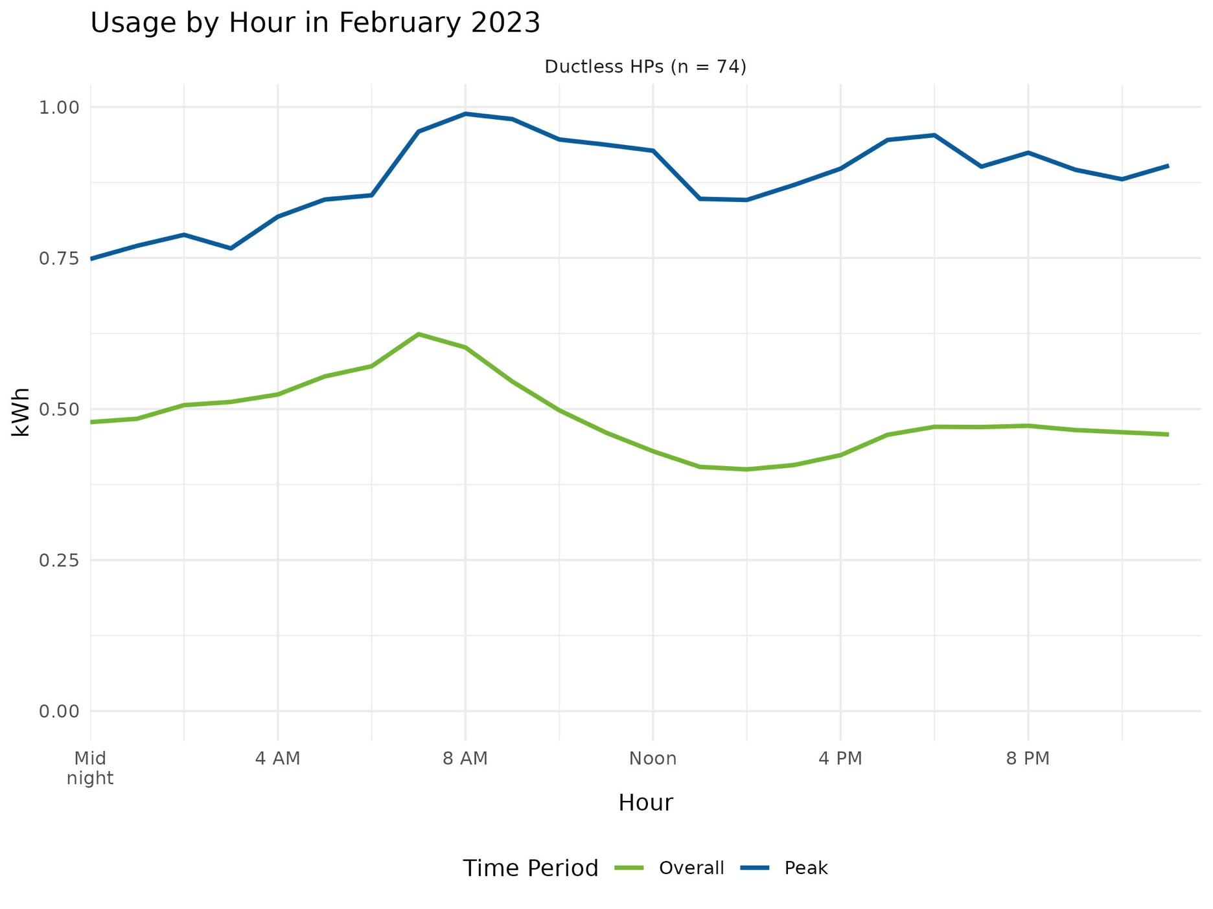

Ducted Air Source Heat Pump Usage Increases in the Afternoon on Very Cold Days
The study team also analyzed ducted air source heat pump usage on very cold days and compared the results to normal winter days (like for ductless heat pumps and HPWHs). The results, shown in Figure 10, indicate that ducted air source heat pump usage overnight in the winter is very similar regardless of extreme weather. However, during the middle of the day and the evening (from about 10am until 11pm), ducted air source heat pump usage was observed to be significantly higher on extremely cold days compared to normal winter days.
As with ductless heat pumps, the implications for the grid may be important to account for when these ducted air source heat pumps are replacing fossil fuel-based HVAC technologies.
Figure 10: Ducted Air Source Heat Pump Usage on Very Cold Days Versus Regular Winter Days (n=10)
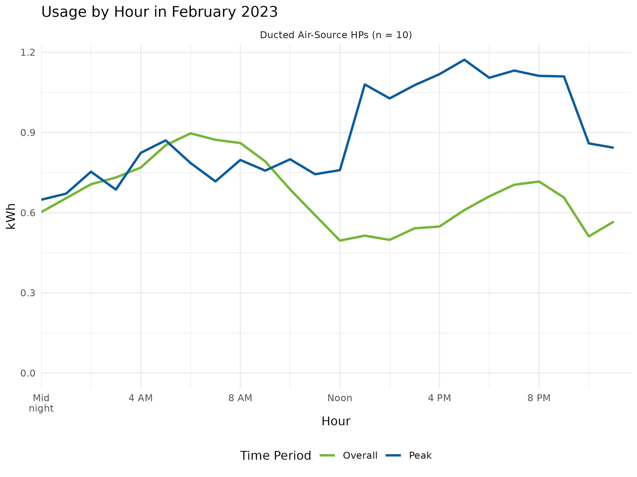

Conclusions and Potential Next Steps

The study team will conduct a second analysis and develop a second report in April 2024. The findings from this analysis addressing PSD assumptions will be updated based on the additional year of monitoring. Additionally, the study team will likely be able to incorporate more extreme weather conditions in the analysis, such as very hot days in summer, to help improve the understanding of heat pump operation in Connecticut on extreme weather days. Lastly, the second and final analysis provides an opportunity to address research objectives that are not addressed in this analysis.

PSD Assumption Updates
The study objectives included assessing current PSD measure assumptions for HPWHs, ductless air source heat pumps, and ducted heat pumps (both air and ground source). The specific objectives and the associated conclusions are provided in Table 14.
Table 14: Summary of PSD Assumption Updates
Objective | Parameter | Updated Estimate | Existing PSD Estimate
Estimate HPWH energy savings (kWh) | kWh Savings for 55 Gal + HPWHs (n=10) | 731 kWh | 197 kWh
 | kWh Savings for Below 55 Gal (n=64) | 1,723 kWh | 1,818 kWh
Estimate ductless air source heat pump heating effective full load hours (EFLH_{h}) in full displacement scenarios. | Ductless Heat Pump Heating EFLH (n=20) | 1,099 | 535

Heat Pump Operation on Extreme Cold Days
Ductless and ducted air source heat pump are used more on extremely cold days, as their primary function—keeping the conditioned space of the home at a comfortable temperature—requires that they operate more on very cold days. The study team observed that ductless heat pumps are used more for heating during extreme cold days at all hours of the day and night, whereas for ducted heat pumps the study team found that their overnight operation is nearly identical on normal winter days as on extreme winter days, but afternoon and evening usage was significantly higher on the extreme days.
Hot water usage in a household is less directly linked to outdoor temperatures and extreme weather conditions than HVAC equipment; HPWHs were found to have similar load shapes of similar magnitudes on regular winter days and extremely cold days. Both the morning and evening hot water heater peaks were slightly more pronounced on the extreme weather days.
The implications of the significant increases in use of efficient heat pump-based heating equipment on extreme cold days are different depending on the baseline equipment replaced by the retrofit measures. If the replaced or supplemented HVAC equipment is less efficient electric heating, the study team would expect the heat pumps to reduce peak electric usage on the very coldest days of the year. If the replaced or supplemented HVAC equipment is a fossil fuel-based heating system, the study team would expect to see a slight increase in peak electric usage on extremely cold days.

Next Steps
Next steps for the R1982 Residential DHW/HVAC Performance and Potential Study include:
- Estimate ducted air source heat pump and ground source heat pump heating effective full load hours (direct PSD inputs).
- Assess whether and how to integrate ducted air and ground source cooling effective full load hours into a future PSD measure and provide relevant assumptions. The PSD currently uses a central AC measure for heat pump cooling assumptions.
- Determine if cold climate heat pump low temperature usage (offsetting traditional electric resistance and fossil fuel backup heating) should be accounted for differently in a future PSD methodology update, and discuss the rationale, approach, and study limitations with the CT EEB. Coordinate with the R2246 Residential Heat Pump Study to recommend a revised approach and to assess how this study’s data can inform savings estimations.

Appendix A: Energy Monitoring Approach

This section describes the recruitment and installation procedures that resulted in the collection of on-site data used in this analysis.

Protocol Development
The study team developed detailed protocols that the study team leveraged for this study for household engagement and recruiting, setup and installation of monitoring equipment, and testing the data streams before leaving the premise. Site data collection was completed by a local electrician with Evergreen team members being available to address questions from the electrician during the installation.

Equipment Configuration and Technical Infrastructure Development
The Evergreen team procured the equipment needed for the study and Evergreen team members at Michaels Energy assembled and configured all components of the monitoring system. The metering equipment suite includes the eGauge energy meter, Dent current transducers (CTs), and remote Monnit environmental sensors. Each monitoring system was pre-configured based on the information collected during the customer recruitment and this information was confirmed by the Evergreen team following installation.

Recruitment
The study team developed introductory materials and a recruitment script for engaging potential study participants. The Michaels Energy call center conducted recruitment and scheduling calls. For customers that agreed to participate, the study team collected information about the customer’s electrical panel, as well as the nameplate information and configuration. This included having customers take pictures of electrical panels, equipment nameplates, and equipment locations, if possible. This information was used to identify the specific equipment that will be metered at a customer site and configure the metering equipment prior to the site visit.

On-site Meter Installations
Prior to the onsite metering installation, the installing electrician reviewed the pre-configured metering equipment as well as the site-specific installation protocol developed by the site engineer. The electrician also reviewed the site pictures and notes collected during recruitment.
Orientation Survey with Occupant. Upon arrival to the site, the electrician confirmed the information about the location of the electrical service and electrical panel(s), and the targeted electrical end-use equipment.
Site Assessment and Installation. The site electrician then determined the most appropriate location for the monitoring equipment and obtained verbal approval from the occupant. A site engineer from the Evergreen team was available via video conference throughout the site visit. When necessary, the site engineer helped address various issues, including:
- Equipment not on an individual circuit as expected.
- Equipment different than the make or model anticipated.
- Unusual configurations or locations.
- Any other issue that requires a unique metering configuration.
At the end of the installation, the Evergreen team engineer verified the device configurations and ensured that the monitoring equipment was functioning properly and reporting to the online database. Finally, the installing electrician provided the occupant with a $100 incentive.

Appendix B: Ductless Heat Pumps by Capacity

Table 15 provides the observed heating EFLHs for ductless air source heat pumps by heating capacity and for both coastal and inland. The study team compared the average heating EFLH to the current PSD estimate, as well. Our observed overall average heating EFLH of 686 full load hours is 28 percent higher than the assumed PSD value of 535 full load hours.
Table 15: Ductless Air Source Heat Pump Heating EFLH by Heating Capacity and Climate Zone
Heating Capacity | Coastal (n=28) | Inland (n=34) | Average | Current PSD Estimate
1.0 ton | 244 | 926 | 699
1.5 ton | 565 | 747 | 669
2.0 ton | 780 | 704 | 739
2.5 ton |  | 1,174 | 1,174
3.0 ton | 1,032 | 460 | 918
4.0 ton | 1,453 | 1,315 | 1,384
5.0 ton or greater | 1,428 |  | 1,428
Overall | 789 | 841 | 817 | 535

Table 16 provides cooling EFLH estimates by cooling capacity and climate zone, and the overall average cooling EFLH is estimated to be 454 full load hours.
Table 16: Ductless Air Source Heat Pump Cooling EFLH by Heating Capacity and Climate Zone
Cooling Capacity | Coastal (n=28) | Inland (n=34) | Average | Current PSD Estimate
1.0 ton | 823 | 605 | 692
1.5 ton | 265 | 185 | 228
2.0 ton | 435 | 259 | 313
2.5 ton |  | 135 | 135
3.0 ton | 288 | 297 | 291
4.0 ton or greater | 650 |  | 650
Overall | 468 | 363 | 410 | 218

Appendix C: Sample Points

In this section the study team provides tables of the sample points used in the primary analysis contained in this report (i.e., the updates to the PSD assumptions).

Table 17: Heat Pump Water Heater Points List
Site ID | Unit ID | Tier | HP UEF | Baseline HP UEF | Baseline ER UEF | HP kWh (observed) | ER kWh (observed) | Baseline kWh | Installed kWh (observed) | Savings kWh | Climate Zone | Occupants
EE00227 | #1 | 55 Gal + | 3.45 | 2.0 | 0.945 | 1158.6 | 1388.9 | 3387.4 | 2547.5 | 840.0 | Inland | Unknown
EE00491 | #1 | Below 55 Gal | 3.45 | 0.945 | 0.945 | 831.4 | 97.8 | 3132.9 | 929.1 | 2203.7 | Coastal | 2
EE00611 | #1 | Below 55 Gal | 3.45 | 0.945 | 0.945 | 999.2 | 896.9 | 4544.7 | 1896.1 | 2648.6 | Inland | 5
EE00724 | #1 | 55 Gal + | 3 | 2.0 | 0.945 | 676.9 | 1328.4 | 2343.7 | 2005.3 | 338.4 | Coastal | 2
EE00789 | #1 | Below 55 Gal | 3.42 | 0.945 | 0.945 | 407.7 | 1104.8 | 2580.3 | 1512.5 | 1067.8 | Inland | Unknown
EE01076 | #1 | Below 55 Gal | 3.55 | 0.945 | 0.945 | 736.8 | 508.8 | 3276.8 | 1245.7 | 2031.2 | Inland | Unknown
EE01078 | #1 | 55 Gal + | 3.45 | 2.0 | 0.945 | 633.6 | 2.9 | 1095.8 | 636.4 | 459.3 | Inland | 4
EE01236 | #1 | Below 55 Gal | 3.45 | 0.945 | 0.945 | 616.5 | 393.1 | 2644.0 | 1009.7 | 1634.3 | Inland | 3
EE01277 | #1 | 55 Gal + | 3.45 | 2.0 | 0.945 | 1716.5 | 113.4 | 3074.3 | 1829.8 | 1244.4 | Inland | 4
EE01277 | #2 | Below 55 Gal | 3.45 | 0.945 | 0.945 | 1188.8 | 0.2 | 4340.1 | 1188.9 | 3151.2 | Inland | 4
EE01380 | #1 | Below 55 Gal | 3.45 | 0.945 | 0.945 | 579.7 | 667.7 | 2784.2 | 1247.4 | 1536.7 | Inland | 2
EE01418 | #1 | Below 55 Gal | 3.55 | 0.945 | 0.945 | 383.1 | 132.9 | 1572.0 | 516.0 | 1056.0 | Inland | 1
EE01422 | #1 | Below 55 Gal | 3.55 | 0.945 | 0.945 | 617.2 | 306.6 | 2625.2 | 923.8 | 1701.4 | Inland | 3
EE01535 | #1 | Below 55 Gal | 3.55 | 0.945 | 0.945 | 289.0 | 71.5 | 1157.0 | 360.5 | 796.5 | Inland | 2
EE01570 | #1 | Below 55 Gal | 3.75 | 0.945 | 0.945 | 989.4 | 202.0 | 4128.0 | 1191.3 | 2936.6 | Inland | 4
EE01685 | #1 | Below 55 Gal | 3.42 | 0.945 | 0.945 | 743.2 | 50.6 | 2740.4 | 793.8 | 1946.6 | Inland | Unknown
EE01710 | #1 | Below 55 Gal | 3.55 | 0.945 | 0.945 | 557.6 | 330.8 | 2425.4 | 888.3 | 1537.0 | Inland | Unknown
EE01814 | #1 | Below 55 Gal | 3.42 | 0.945 | 0.945 | 679.8 | 200.0 | 2660.3 | 879.9 | 1780.5 | Coastal | Unknown
EE01847 | #1 | Below 55 Gal | 3.42 | 0.945 | 0.945 | 682.2 | 330.3 | 2799.3 | 1012.5 | 1786.7 | Inland | 2
EE01911 | #1 | Below 55 Gal | 3.42 | 0.945 | 0.945 | 606.4 | 182.9 | 2377.6 | 789.3 | 1588.3 | Coastal | 2
EE01969 | #1 | Below 55 Gal | 3.45 | 0.945 | 0.945 | 426.8 | 16.5 | 1574.6 | 443.3 | 1131.3 | Coastal | 1
EE02341 | #1 | Below 55 Gal | 3.45 | 0.945 | 0.945 | 486.9 | 187.5 | 1965.2 | 674.4 | 1290.8 | Inland | 1
EE02403 | #1 | 55 Gal + | 3.45 | 2.0 | 0.945 | 1654.2 | 567.6 | 3421.0 | 2221.7 | 1199.3 | Inland | Unknown
EE02534 | #1 | Below 55 Gal | 3.45 | 0.945 | 0.945 | 395.7 | 383.7 | 1828.4 | 779.4 | 1049.0 | Inland | 4
EE02538 | #1 | Below 55 Gal | 3.45 | 0.945 | 0.945 | 164.8 | 1299.0 | 1900.9 | 1463.9 | 437.0 | Inland | 2
EE02572 | #1 | Below 55 Gal | 3.45 | 0.945 | 0.945 | 634.3 | 64.4 | 2380.2 | 698.8 | 1681.5 | Inland | 2
EE02739 | #1 | Below 55 Gal | 3.45 | 0.945 | 0.945 | 464.6 | 26.7 | 1722.9 | 491.3 | 1231.6 | Inland | 2
EE02840 | #1 | Below 55 Gal | 3.42 | 0.945 | 0.945 | 308.9 | 505.3 | 1623.3 | 814.2 | 809.1 | Inland | 1
EE02846 | #1 | Below 55 Gal | 3.55 | 0.945 | 0.945 | 772.1 | 738.7 | 3639.3 | 1510.8 | 2128.5 | Inland | Unknown
EE02939 | #1 | Below 55 Gal | 3.42 | 0.945 | 0.945 | 771.2 | 135.0 | 2926.2 | 906.3 | 2019.9 | Coastal | 2
EE02969 | #1 | 55 Gal + | 3.45 | 2.0 | 0.945 | 518.9 | 517.4 | 1412.4 | 1036.2 | 376.2 | Inland | 2
EE02992 | #1 | Below 55 Gal | 3.42 | 0.945 | 0.945 | 786.5 | 298.6 | 3145.1 | 1085.2 | 2060.0 | Coastal | Unknown
EE03197 | #1 | Below 55 Gal | 3.45 | 0.945 | 0.945 | 970.8 | 72.0 | 3616.3 | 1042.9 | 2573.4 | Inland | Unknown
EE03197 | #2 | Below 55 Gal | 3.45 | 0.945 | 0.945 | 412.3 | 2.1 | 1507.3 | 414.4 | 1092.9 | Inland | Unknown
EE03342 | #1 | Below 55 Gal | 3.45 | 0.945 | 0.945 | 598.9 | 1282.8 | 3469.1 | 1881.6 | 1587.4 | Inland | 3
EE03430 | #1 | Below 55 Gal | 3.42 | 0.945 | 0.945 | 689.2 | 599.8 | 3094.1 | 1289.0 | 1805.1 | Inland | 2
EE03606 | #1 | Below 55 Gal | 3.55 | 0.945 | 0.945 | 419.3 | 108.3 | 1683.5 | 527.6 | 1155.9 | Inland | 3
EE03628 | #1 | Below 55 Gal | 3.55 | 0.945 | 0.945 | 242.5 | 132.3 | 1043.3 | 374.8 | 668.5 | Coastal | Unknown
EE03739 | #1 | Below 55 Gal | 3.45 | 0.945 | 0.945 | 902.3 | 82.6 | 3376.6 | 984.9 | 2391.8 | Inland | 2
EE03740 | #1 | 55 Gal + | 3.45 | 2.0 | 0.945 | 1802.2 | 3748.5 | 6857.3 | 5550.7 | 1306.6 | Inland | 5
EE03785 | #1 | Below 55 Gal | 3.45 | 0.945 | 0.945 | 687.1 | 73.5 | 2581.8 | 760.6 | 1821.2 | Inland | 2
EE03880 | #1 | Below 55 Gal | 3.55 | 0.945 | 0.945 | 912.2 | 1079.6 | 4506.3 | 1991.8 | 2514.5 | Inland | Unknown
EE03967 | #1 | Below 55 Gal | 3.42 | 0.945 | 0.945 | 747.4 | 448.6 | 3153.5 | 1196.0 | 1957.5 | Coastal | 3
EE03971 | #1 | Below 55 Gal | 3.45 | 0.945 | 0.945 | 545.5 | 2.9 | 1994.5 | 548.4 | 1446.0 | Inland | 2
EE03982 | #1 | Below 55 Gal | 3.45 | 0.945 | 0.945 | 1530.4 | 1109.5 | 6696.5 | 2639.8 | 4056.6 | Inland | 3
EE03992 | #1 | Below 55 Gal | 3.45 | 0.945 | 0.945 | 803.9 | 67.5 | 3002.2 | 871.3 | 2130.9 | Inland | Unknown
EE04018 | #1 | Below 55 Gal | 3.5 | 0.945 | 0.945 | 872.2 | 312.4 | 3542.9 | 1184.6 | 2358.2 | Coastal | 2
EE04074 | #1 | Below 55 Gal | 3.42 | 0.945 | 0.945 | 177.6 | 12.5 | 655.3 | 190.1 | 465.2 | Coastal | 5
EE04089 | #1 | Below 55 Gal | 3.55 | 0.945 | 0.945 | 723.4 | 522.0 | 3239.7 | 1245.5 | 1994.3 | Inland | Unknown
EE04091 | #1 | Below 55 Gal | 3.45 | 0.945 | 0.945 | 539.3 | 0.0 | 1968.7 | 539.3 | 1429.4 | Inland | Unknown
EE04104 | #1 | 55 Gal + | 3.45 | 2.0 | 0.945 | 557.1 | 25.7 | 986.7 | 582.8 | 403.9 | Inland | Unknown
EE04183 | #1 | Below 55 Gal | 3.55 | 0.945 | 0.945 | 843.9 | 837.7 | 4008.0 | 1681.6 | 2326.3 | Coastal | 3
EE04185 | #1 | Below 55 Gal | 3.75 | 0.945 | 0.945 | 390.9 | 0.4 | 1551.6 | 391.3 | 1160.3 | Inland | Unknown
EE04193 | #1 | 55 Gal + | 3.45 | 2.0 | 0.945 | 1173.0 | 373.5 | 2396.9 | 1546.5 | 850.4 | Coastal | Unknown
EE04285 | #1 | Below 55 Gal | 3.42 | 0.945 | 0.945 | 701.7 | 31.2 | 2570.8 | 733.0 | 1837.9 | Inland | 2
EE04367 | #1 | Below 55 Gal | 3.39 | 0.945 | 0.945 | 472.0 | 981.9 | 2675.2 | 1454.0 | 1221.3 | Inland | 2
EE04422 | #1 | 55 Gal + | 3.26 | 2.0 | 0.945 | 467.5 | 1783.5 | 2545.4 | 2250.9 | 294.5 | Inland | 4
EE04469 | #1 | Below 55 Gal | 3.45 | 0.945 | 0.945 | 838.5 | 106.9 | 3168.2 | 945.4 | 2222.8 | Inland | 2
EE04547 | #1 | Below 55 Gal | 3.42 | 0.945 | 0.945 | 1209.4 | 1664.8 | 6041.5 | 2874.2 | 3167.4 | Inland | Unknown
EE04560 | #1 | Below 55 Gal | 3.42 | 0.945 | 0.945 | 484.7 | 0.7 | 1754.9 | 485.4 | 1269.5 | Inland | 2
EE04565 | #1 | Below 55 Gal | 3.45 | 0.945 | 0.945 | 1031.9 | 882.8 | 4650.0 | 1914.7 | 2735.3 | Inland | Unknown
EE04581 | #1 | Below 55 Gal | 3.55 | 0.945 | 0.945 | 258.9 | 62.3 | 1034.7 | 321.2 | 713.6 | Inland | Unknown
EE04605 | #1 | Below 55 Gal | 3.55 | 0.945 | 0.945 | 534.7 | 0.0 | 2008.6 | 534.7 | 1473.9 | Coastal | Unknown
EE04617 | #1 | Below 55 Gal | 3.55 | 0.945 | 0.945 | 601.1 | 897.9 | 3156.1 | 1499.0 | 1657.1 | Inland | Unknown
EE04743 | #1 | Below 55 Gal | 3.39 | 0.945 | 0.945 | 377.9 | 0.0 | 1355.7 | 377.9 | 977.8 | Coastal | Unknown
EE04787 | #1 | Below 55 Gal | 3.55 | 0.945 | 0.945 | 1020.7 | 555.5 | 4390.0 | 1576.3 | 2813.7 | Inland | 4
EE04844 | #1 | Below 55 Gal | 3.55 | 0.945 | 0.945 | 702.8 | 150.0 | 2790.1 | 852.8 | 1937.3 | Coastal | 2
EE04985 | #1 | Below 55 Gal | 3.45 | 0.945 | 0.945 | 316.5 | 1.7 | 1157.2 | 318.2 | 839.0 | Coastal | 1
EE05071 | #1 | Below 55 Gal | 3.55 | 0.945 | 0.945 | 490.1 | 226.2 | 2067.2 | 716.3 | 1350.9 | Coastal | Unknown
EE05107 | #1 | Below 55 Gal | 3.45 | 0.945 | 0.945 | 448.7 | 86.5 | 1724.5 | 535.2 | 1189.3 | Inland | Unknown
EE05139 | #1 | Below 55 Gal | 3.45 | 0.945 | 0.945 | 776.9 | 87.9 | 2924.4 | 864.8 | 2059.5 | Coastal | 2
EE05161 | #1 | Below 55 Gal | 3.55 | 0.945 | 0.945 | 492.3 | 89.9 | 1939.1 | 582.1 | 1357.0 | Coastal | 3
EE05185 | #1 | Below 55 Gal | 3.42 | 0.945 | 0.945 | 845.4 | 191.3 | 3250.7 | 1036.6 | 2214.0 | Coastal | 3
EE05225 | #1 | Below 55 Gal | 3.45 | 0.945 | 0.945 | 402.1 | 30.0 | 1497.8 | 432.1 | 1065.8 | Inland | 2

Table 18: Ductless Air Source Heat Pump Points List (Weather Normalized Values)
Site ID | Unit ID | System Type | HSPF | Heating Capacity | Annual EFLH Heating | SEER | Cooling Capacity | Annual EFLH Cooling | Climate Zone | Occupants
EE00042 | #1 | Unknown | 13 | 21600 | 292.0 | 24 | 18000 | 125.8 | Coastal | 5
EE00066 | #1 | Unknown | 10.3 | 36400 | 1392.2 | 20 | 35200 | 113.8 | Coastal | 2
EE00078 | #1 | Unknown | 11.4 | 13600 | 228.4 | 22.7 | 12000 | 14.6 | Coastal | 3
EE00227 | #1 | Primary Heating | 12 | 18000 | 1716.7 | 22 | 15000 | 439.3 | Inland | Unknown
EE00412 | #1 | Supplementary Heating | 12 | 20200 | 2102.8 | 21 | 17200 | 101.9 | Inland | 2
EE00611 | #1 | Supplementary Heating | 10.5 | 21600 | 1893.8 | 20 | 18000 | 297.6 | Inland | 5
EE00718 | #1 | Primary Heating | 9.5 | 24000 | 909.7 | 18 | 22000 | 217.9 | Inland | 1
EE00780 | #1 | Primary Heating | 12 | 18000 | 902.9 | 22 | 15000 | 302.1 | Coastal | 2
EE00902 | #1 | Supplementary Heating | 10.3 | 45000 | 490.0 | 19.7 | 40500 | 392.7 | Coastal | 1
EE00947 | #1 | Supplementary Heating | 9.5 | 24000 | 46.9 | 18 | 22000 | 131.8 | Coastal | 4
EE00947 | #2 | Supplementary Heating | 9.3 | 22000 | 54.7 | 18 | 18000 | 99.3 | Coastal | 4
EE01066 | #1 | Primary Heating | 10.5 | 31000 | 685.3 | 21 | 27000 | 148.1 | Inland | 2
EE01238 | #1 | Primary Heating | 10 | 22000 | 1066.1 | 20 | 18000 | 278.1 | Coastal | 1
EE01344 | #1 | Primary Heating | 14 | 16000 | 175.0 | 29.3 | 12000 | 1808.3 | Coastal | 2
EE01344 | #2 | Primary Heating | 14 | 16000 | 1607.5 | 29.3 | 12000 | 698.1 | Coastal | 2
EE01535 | #1 | Primary Heating | 9.8 | 25000 | 1145.4 | 20 | 22000 | 141.8 | Inland | 2
EE01535 | #2 | Primary Heating | 9.8 | 25000 | 1096.7 | 20 | 22000 | 195.9 | Inland | 2
EE01704 | #1 | Primary Heating | 10 | 25000 | 1223.0 | 19 | 22000 | 311.2 | Inland | 2
EE01814 | #1 | Primary Heating | 10.3 | 36400 | 1183.1 | 20 | 35200 | 104.7 | Coastal | Unknown
EE01814 | #2 | Primary Heating | 10.3 | 36400 | 1061.8 | 20 | 35200 | 462.7 | Coastal | Unknown
EE01847 | #1 | Only Heating | 11 | 48000 | 2608.0 | 19 | 42000 | 50.3 | Inland | 2
EE01847 | #2 | Only Heating | 11.3 | 45000 | 455.5 | 19.1 | 36000 | 136.7 | Inland | 2
EE01876 | #1 | Supplementary Heating | 12 | 12000 | 942.2 | 26 | 9000 | 1062.0 | Inland | Unknown
EE01876 | #2 | Supplementary Heating | 12 | 16000 | 79.0 | 25 | 12000 | 1073.9 | Inland | Unknown
EE01876 | #3 | Supplementary Heating | 12 | 12000 | 994.4 | 26 | 9000 | 1534.2 | Inland | Unknown
EE01911 | #1 | Primary Heating | 11 | 54000 | 1428.2 | 18.9 | 48000 | 649.6 | Coastal | 2
EE01921 | #1 | Supplementary Heating | 9.5 | 24000 | 1856.8 | 18 | 22000 | 198.2 | Coastal | 1
EE01925 | #1 | Supplementary Heating | 9.8 | 25000 | 139.1 | 20 | 22000 | 524.3 | Inland | 1
EE02042 | #1 | Supplementary Heating | 12.5 | 13600 | 443.8 | 26.1 | 12000 | 861.6 | Coastal | 4
EE02042 | #2 | Supplementary Heating | 12 | 20200 | 493.2 | 21 | 17200 | 152.4 | Coastal | 4
EE02079 | #1 | Unknown | 11 | 48000 | 2299.8 | 19 | 42000 | 96.7 | Coastal | 2
EE02113 | #1 | Unknown | 14 | 16000 | 77.7 | 29.3 | 12000 | 524.9 | Inland | Unknown
EE02113 | #2 | Unknown | 14 | 16000 | 79.4 | 29.3 | 12000 | 408.1 | Inland | Unknown
EE02214 | #1 | Supplementary Heating | 11 | 48000 | 880.9 | 19 | 42000 | 702.0 | Inland | 2
EE02341 | #1 | Supplementary Heating | 11 | 18000 | 95.1 | 22 | 15000 | 32.0 | Inland | 1
EE02341 | #2 | Supplementary Heating | 10 | 10900 | 1910.6 | 26 | 9000 | 168.3 | Inland | 1
EE02490 | #1 | Supplementary Heating | 12 | 20200 | 1587.7 | 21 | 17200 | 52.3 | Inland | 3
EE02582 | #1 | Supplementary Heating | 10.3 | 36400 | 460.1 | 20 | 35200 | 297.7 | Inland | 2
EE02592 | #1 | Supplementary Heating | 13.4 | 18000 | 146.4 | 25.3 | 14500 | 1058.3 | Coastal | 3
EE02592 | #2 | Supplementary Heating | 14.2 | 12000 | 230.4 | 33 | 9000 | 1616.8 | Coastal | 3
EE02612 | #1 | Primary Heating | 11 | 28600 | 1662.9 | 18 | 28400 | 121.0 | Inland | 1
EE02752 | #1 | Supplementary Heating | 10.5 | 21600 | 144.7 | 20 | 18000 | 86.2 | Coastal | Unknown
EE02752 | #2 | Supplementary Heating | 11 | 12000 | 74.1 | 23 | 9000 | 37.3 | Coastal | Unknown
EE02859 | #1 | Supplementary Heating | 11 | 21600 | 33.4 | 20.3 | 18000 | 297.8 | Inland | 4
EE02969 | #1 | Supplementary Heating | 10.3 | 24000 | 575.4 | 23 | 24000 | 220.6 | Inland | 2
EE03074 | #1 | Supplementary Heating | 9.8 | 25000 | 1493.4 | 20 | 22000 | 470.5 | Coastal | 2
EE03419 | #1 | Supplementary Heating | 10.3 | 36400 | 492.7 | 20 | 35200 | 468.4 | Coastal | 2
EE03439 | #1 | Supplementary Heating | 12.5 | 14400 | 28.5 | 23 | 12000 | 664.1 | Inland | 2
EE03439 | #2 | Supplementary Heating | 12.5 | 24000 | 125.1 | 18 | 24000 | 223.8 | Inland | 2
EE03611 | #1 | Supplementary Heating | 12.5 | 10900 | 2180.2 | 30.5 | 9000 | 700.2 | Inland | 3
EE03686 | #1 | Supplementary Heating | 11.7 | 18000 | 67.6 | 21.6 | 14000 | 487.2 | Coastal | 2
EE03731 | #1 | Supplementary Heating | 9.3 | 22000 | 1154.7 | 18 | 18000 | 780.9 | Coastal | 2
EE03967 | #1 | Primary Heating | 11.3 | 45000 | 1568.8 | 19.1 | 36000 | 378.2 | Coastal | 3
EE04219 | #1 | Supplementary Heating | 10.5 | 21600 | 166.2 | 20 | 18000 | 75.3 | Inland | 2
EE04219 | #2 | Supplementary Heating | 15 | 9000 | 383.5 | 38 | 9000 | 82.8 | Inland | 2
EE04219 | #3 | Supplementary Heating | 11 | 16000 | 241.5 | 22 | 12000 | 143.7 | Inland | 2
EE04474 | #1 | Primary Heating | 9.8 | 25000 | 595.0 | 20 | 22000 | 227.2 | Inland | 2
EE04474 | #2 | Primary Heating | 9.8 | 25000 | 549.1 | 20 | 22000 | 264.7 | Inland | 2
EE04560 | #1 | Primary Heating | 12.8 | 10900 | 329.4 | 24.6 | 9000 | 486.0 | Inland | 2
EE04667 | #1 | Supplementary Heating | 10 | 22000 | 1595.2 | 20 | 18000 | 297.3 | Coastal | 2
EE05182 | #1 | Supplementary Heating | 14 | 12200 | 638.4 | 30.5 | 12000 | 413.2 | Inland | 2
EE05186 | #1 | Supplementary Heating | 9.5 | 24000 | 100.3 | 18 | 22000 | 938.0 | Coastal | 2

Energize CT. 2022. Connecticut’s 2022 Program Savings Document. https://energizect.com/sites/default/files/documents/Final%202022%20PSD%20FILED%20030122.pdf
Ibid.
The remainder, including for central ducted heat pumps, either do not have sufficient data for the analysis (yet) or were not classified as full or partial displacement by the participant.
Energize CT. 2022. Connecticut’s 2022 Program Savings Document. https://energizect.com/sites/default/files/documents/Final%202022%20PSD%20FILED%20030122.pdf
Energize CT. 2022. Connecticut’s 2022 Program Savings Document. https://energizect.com/sites/default/files/documents/Final%202022%20PSD%20FILED%20030122.pdf
Due to small sample sizes and only one year of data, the study team is unable to achieve this objective in this first report. With an additional full year of data, the study team will have sufficient sample sizes to provide meaningful insights—and most likely updates to the PSD parameters—for these measures.
NMR Group. 2019. R1706 Residential Appliance Saturation Survey & R1616/R1708 Residential Lighting Impact Saturation Studies. https://energizect.com/sites/default/files/documents/R1706%20and%20R1616-R1708%20CT%20RASS%20Lighting_Final%20Report_10.1.19.pdf
Excel file available here: https://www.energystar.gov/sites/default/files/asset/document/ESTAR%20HPWH_calculator.xlsx
U.S. Department of Energy. 2020. Energy Conservation Program: Energy Conservation Standards for Consumer Water Heaters. https://www.govinfo.gov/content/pkg/FR-2020-05-21/pdf/2020-10564.pdf
The amount of energy used in electric resistance mode is assumed to remain the same in the pre and post.
The HPWH Efficiency Factor can be directly applied to the observed heat pump annualized kWh to estimate savings for each HPWH in the study. However, to demonstrate savings the study team also estimate baseline energy use.
Energize CT. 2022. Connecticut’s 2022 Program Savings Document. https://energizect.com/sites/default/files/documents/Final%202022%20PSD%20FILED%20030122.pdf
We were unable to install vapor line or exhaust temperature monitors during the COVID-19 pandemic as the study team had to rely on an electrician-only installations.
West Hill Energy and Computing. 2018. CT HVAC and Water Heating Process and Impact Evaluation Report. https://energizect.com/sites/default/files/R1614-1613_ResHVAC_Report_Final_8.29.18.pdf
Cadmus. 2016. Ductless Mini-split Heat Pump Impact Evaluation. https://ripuc.ri.gov/sites/g/files/xkgbur841/files/eventsactions/docket/4755-TRM-DMSHP-Evaluation-Report-12-30-2016.pdf
The input parameters include HSPF, SEER, nominal heating capacity, and nominal cooling capacity.
The relatively small sample size and single year of monitoring means that the study team were unable to include the ducted ASHPs measure in our EFLH analysis, but it is included here for illustrative purposes and to begin to develop a better understanding of how ducted ASHPs are used during extreme conditions.

